Supplementary Movies
Supplementary Video 1 40x confocal image video of MDCK cyst inflating isotropically under medium current stimulation. Green: membrane dye (Memglow 488); cyan: nuclei (Hoechst 33342). Electrical stimulation indicated with “Field ”. 3h stimulation on. 10 min/frame. Scale bar = 50um.
Supplementary Video 2 40x confocal image video of MDCK cyst undergoing structural asymmetry as it inflates under medium current stimulation. Green: membrane dye (Memglow 488); cyan: nuclei (Hoechst 33342). Electrical stimulation indicated with “Field ”. 3h stimulation on. 10 min/frame. Scale bar = 50um.
Supplementary Video 3 10x transmitted light image video and binarization of inflating MDCK cyst under medium current stimulation. Electrical stimulation indicated with “Field ”. 1h stimulation off, 4h stimulation on, 3h stimulation off. 10 min/frame. Scale bar = 50um.
Supplementary Video 4 10x transmitted light (left; grey) and EthD-1 live imaging (right; red) for cellular viability check. Structure inflates steadily with electrical stimulation. Electrical stimulation indicated with “Field ”. 1h stimulation off, 4h stimulation on, 3h stimulation off. 10 min/frame. Scale bar = 50um.
Supplementary Video 5 10x transmitted light (left; grey) and EthD-1 live imaging (right; red) for cellular viability check. Structure inflates rapidly, ruptures, and deflates in the presence of electrical stimulation. Electrical stimulation indicated with “Field ”. 1h stimulation off, 4h stimulation on, 3h stimulation off. 10 min/frame. Scale bar = 50um.
Supplementary Video 6 5x phase image video MDCK dome under medium current stimulation. Domes are shown to deflate with stimulation and reestablish when stimulation stops. Electrical stimulation indicated with “Field ”. 1h stimulation off, 4h stimulation on, 3h stimulation off. 10 min/frame. Scale bar = 200um.
Supplementary Video 7 10x transmitted light image video and binarization of inflating MDCK cyst treated with 1uM jasplakinolide under medium current stimulation. Acini are shown to instantly inflate and become damaged with electrical stimulation. Electrical stimulation indicated with “Field ”. 1h stimulation off, 4h stimulation on, 3h stimulation off. 10 min/frame. Scale bar = 50um.
Supplementary Video 8 10x transmitted light image video and binarization of inflating MDCK cyst treated with 5nM Calyculin A under medium current stimulation. Heterogenous responses can be seen as some acini inflate while others are damaged. Electrical stimulation indicated with “Field ”. 1h stimulation off, 4h stimulation on, 3h stimulation off. 10 min/frame. Scale bar = 50um.
Supplementary Video 9 Simulation of ion concentration dynamics within MDCK cyst under electrical stimulation. Color plot displaying 2D axisymmetric electric field streamlines (green curves) outside a spherical shell fixed in space representing a lumenized structure, and the dimensionless cation c+ concentration in the spherical shell. The directed electric field generates an asymmetric distribution of ions in the epithelium and electric stresses at the basal surface. See SI Appendix for further details on the non-dimensionalization of the system of equations solved numerically.
Supplementary Video 10 40x confocal image video of inflating RFP-Ecadherin MDCK cyst under oscillating directional field at 1.1mA/mm^2 stimulation. Direction of electrical stimulation indicated with “Field ” and “Field ”. 15 min control, 1h stimulation with field going to the right, 1h stimulation with field going to the left, 1h stimulation off. 15 min/frame. Scale bar = 50um.
Supplementary Video 11 20x transmitted light image video of inflating mouse intestinal stem cell organoid under medium current stimulation. Left crypt inflates significantly with stimulation. Electrical stimulation indicated with “Field ”. 30 min stimulation off, 2h 30 min stimulation on, 1h stimulation off. 1 min/frame. Scale bar = 100um.
Supplementary Video 12 20x transmitted light image video of inflating mouse intestinal stem cell organoid under medium current stimulation. Left crypt inflates significantly with stimulation. Electrical stimulation indicated with “Field ”. 30 min stimulation off, 2h 30 min stimulation on, 1h stimulation off. 1 min/frame. Scale bar = 100um.

Supplementary Figure 1 Individual components of the electric bioreactor setup. Silver/silver-chloride electrodes connected directly to a current supply were submerged into a PBS reservoir on either side of the PDMS microfluidics chamber to deliver electric field through agarose salt bridges.

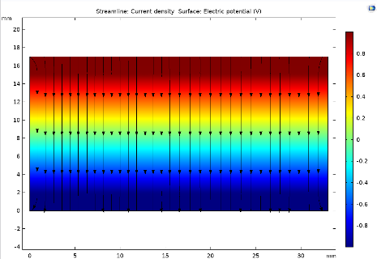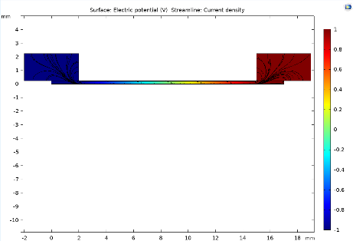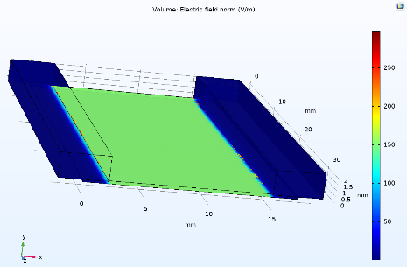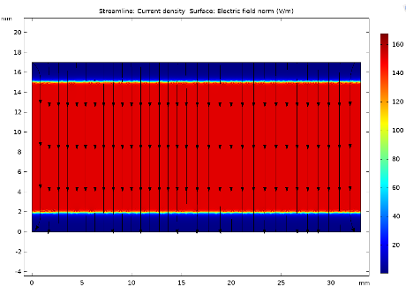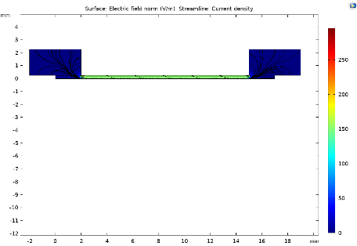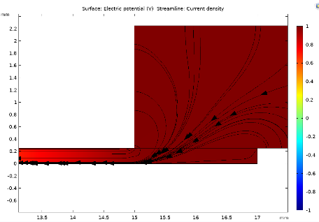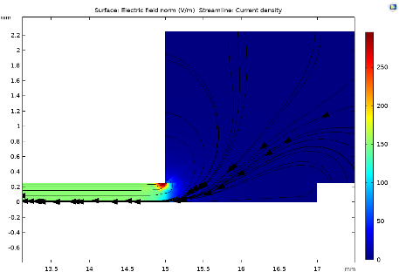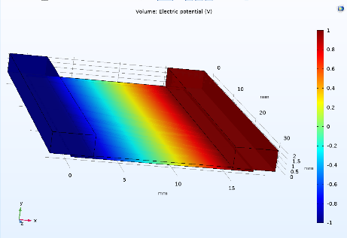Supplementary Figure 2 Left: 3D Finite Element simulation of Electric Potential (Top) and Field Strength (Bottom) in the bioreactor used for Cyst stimulation. Middle: Top-down view of current density (black streamlines) within the microfluidic channel where cysts are cultured and stimulated. Right: Cross-sectional side view of current density (black streamlines) within the microfluidic channel where cysts are cultured and stimulated. (Inset) Current density at the salt bridge-electrolyte interface shows slight fringing far from the region of the device containing the cysts.

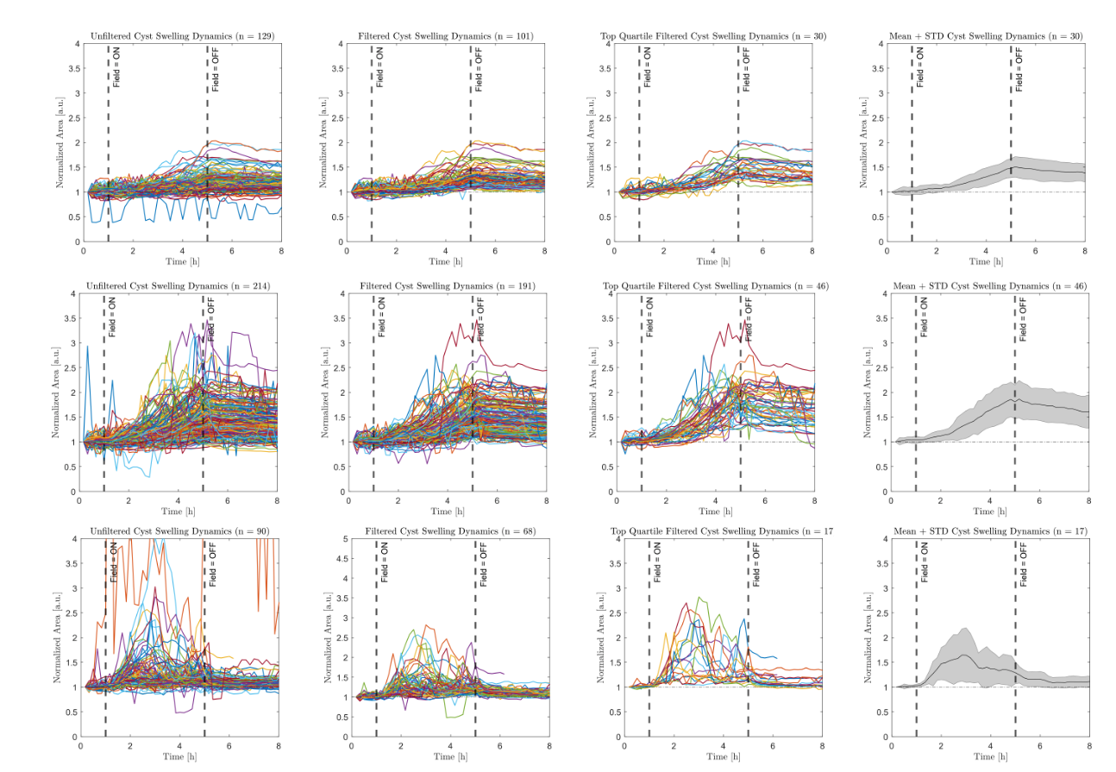Supplementary Figure 3 Raw, filtered, top quartile, and averaged (left to right) plots for low, medium, and high stimulation (top to bottom). For all experiments, all cysts were binarized to produce raw area plots throughout the duration of the experiment. The raw cyst area plots were filtered for irregularities that arise from image processing, then filtered for the top quartile. The top quartile was then averaged and calculated for standard deviation and standard error of the mean to produce the final plot.

Supplementary Figure 4 Comparison between MDCK acini stimulated at medium current for 4h (red; stimulation on from 1h – 5h) and for 5.5h (purple; stimulation on from 1h – 6.5h).

Supplementary Figure 5 Normalized area as a function of time capturing deflation dynamics of MDCK acini electrically stimulated at medium current stimulation. Stimulation is applied at the 1h mark, maintained for 4h, then removed. Deflation is slow and gradual. Area dynamics during long relaxation is bimodal. Top: Averaged normalized area plot of all cysts electrically stimulated then relaxed (green) and cysts with no electrical stimulation (grey) Bottom left: Individual cysts’ normalized area plots with rapid deflation, where relaxing cysts suddenly drop in volume. Bottom right: Individual cysts’ normalized area plots with steady deflation, where they drop in volume slowly.

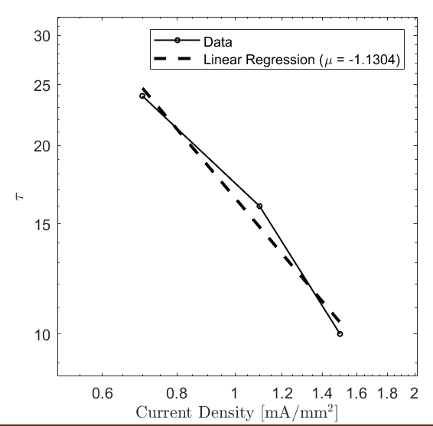

Supplementary Figure 6 Linear regression of threshold time Τ as a function of current density, plotted in log-log form. Τ is defined to be the time at which the normalized area curve for each current density reaches some arbitrary threshold normalized area. The slope of the fit is then used to rescale the normalized area curves onto a single master curve (see Fig. 1C).

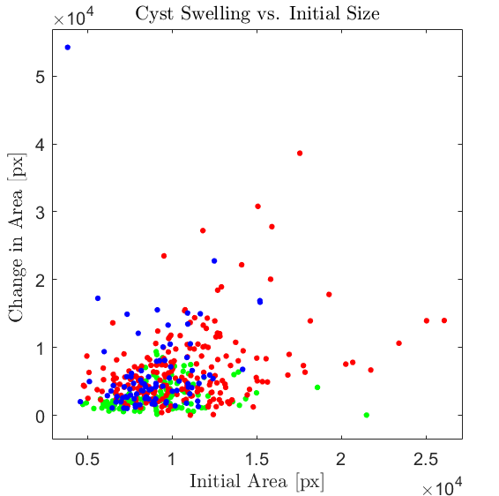
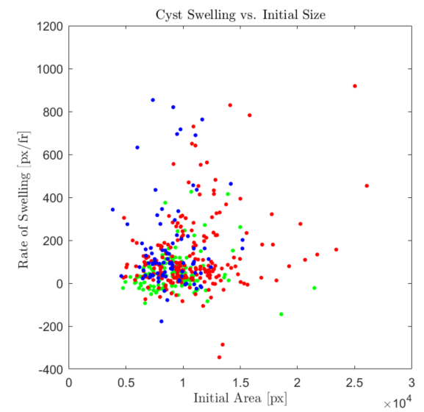

Supplementary Figure 7 Left: Maximum normalized area vs. initial area of each cyst after 3 hours of stimulation at low (green), medium (red), and high (blue) current. Initial size has little to no effect on the final size of the cyst. Right: Mean rate of swelling in the first hour of stimulation for all cysts across low (green), medium (red), and high (blue) current. Initial cyst area does not affect the rate of swelling within each experimental condition.

Supplementary Figure 8 Comparison between 100uM forskolin treatment (purple) and electrical stimulation at medium current (red). Electrical stimulation and chemical stimulation is applied at the 1h mark and maintained for 4h.

Supplementary Figure 9 Lookup table of p-values for all experimental conditions. Colors represent significance as measured by a pairwise parametric t-test with Welch’s correction. Data distributions were verified to be gaussian by fitting using MATLAB.

Supplementary Figure 10 Normalized area as a function of time obtained from experiments (curves) and 1D model (triangles) considering a Maxwell material. In the model, we consider that the osmotic pressure increases drastically due to stimulation but remains constant over time. When the field is turned off, the osmotic pressure is decreased drastically, e.g., due to ion rearrangement or fluid leakage. The build-up hydrostatic normal stress overcomes the osmotic pressure, thus driving cyst shrinkage. See Supplementary Information for further details.

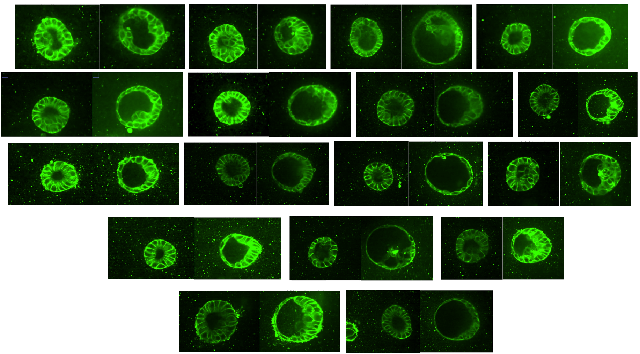

Supplementary Figure 11 The heterotypic response of electrically stimulated cysts. Some cysts undergo significant areal increase with a radially symmetric response, whereas some cysts do not swell as much, and will instead thicken on the cathode-facing half and thin on the anode-facing half.

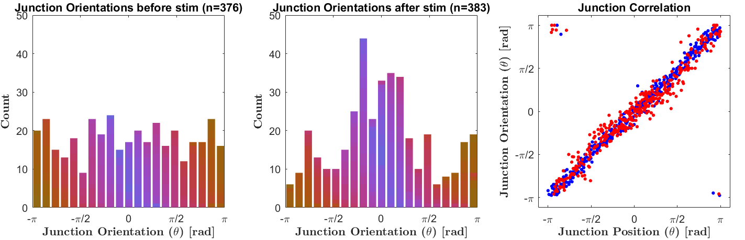
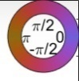
Supplementary Figure 12 Left: Uniform distribution of junction orientations before stimulation. Middle: Distribution of junction orientations after stimulation shows that junctions on the cathode-facing half of the cyst tend to be more horizontally oriented. Right: Scatter plot of junction orientation vs. junction position. Before (blue) and after (red) stimulation, there is a linear relationship between position and orientation.

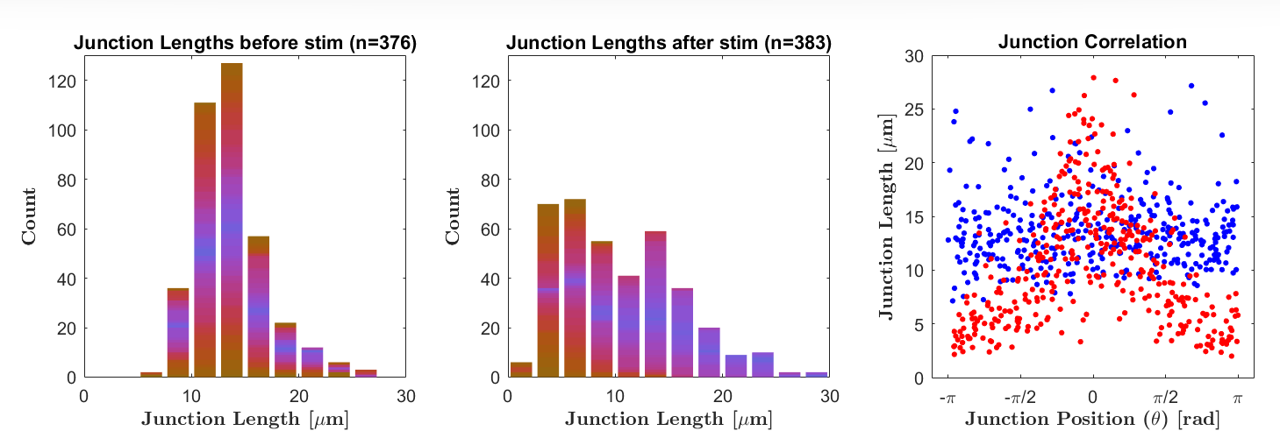
Supplementary Figure 13 Left: Distribution of junction lengths before stimulation showing that junctions throughout the perimeter of the cyst tend to have a mean length of ~15um. Middle: Distribution of junction lengths after stimulation showing that junctions on the anode-facing half of the cyst tend to be shorter than the original mean length of ~15um whereas junctions on the cathode-facing half of the cyst tend to be longer than ~15um. Right: Scatter plot of junction length vs. junction position. Before (blue) stimulation, there is no relationship between junction length and position in the cyst circumference, whereas after (red) stimulation, junctions tend to be longer on the cathode-facing half of the cyst (-π/2 < θ < π/2).

Supplementary Figure 14 Comparison of inflation dynamics among direct current stimulation at low, medium, and high currents in direct current mode and stimulation at medium current oscillating every 10ms. Stimulation is applied at the 1h mark, maintained for 4h, then removed.

