Supplementary information of the manuscript ‘Theoretical investigation of the MXene precursors Mo_{x}V_{4-x}AlC₃ (0≤x≤4)’
Ma. Guadalupe Moreno-Armenta ª, J. Guerrero-Sanchez ª, S. J. Gutierrez-Ojeda ª, H. N. Fernandez-Escamilla ^{b}, Do Minh Hoat ^{c, d}, R. Ponce-Perezª
a) Centro de Nanociencias y Nanotecnología, Universidad Nacional Autónoma de México, Apartado Postal 14, Código Postal, Ensenada, Baja California 22800, México
b) Facultad de Ciencias Físico Matemáticas, Universidad Autónoma de Nuevo Leon, San Nicolas de los Garza, San Nicolas de los Garza, Nuevo León, 66451, México.
c) Institute of Theoretical and Applied Research, Duy Tan University, Ha Noi, 100000, Vietnam
d) Faculty of Natural Sciences, Duy Tan University, Da Nang, 550000, Vietnam

* Corresponding email: moreno@ens.cnyn.unam.mx (MGMA), rponce@ens.cnyn.unam.mx (RPP)

ELF isosurface with a value of 0.6 a.u. for the V₄AlC₃ MAX compound is shown in figure S1, an ionic interaction is observed between V and C atoms, while the Al monolayer posessess a metallic behavior.
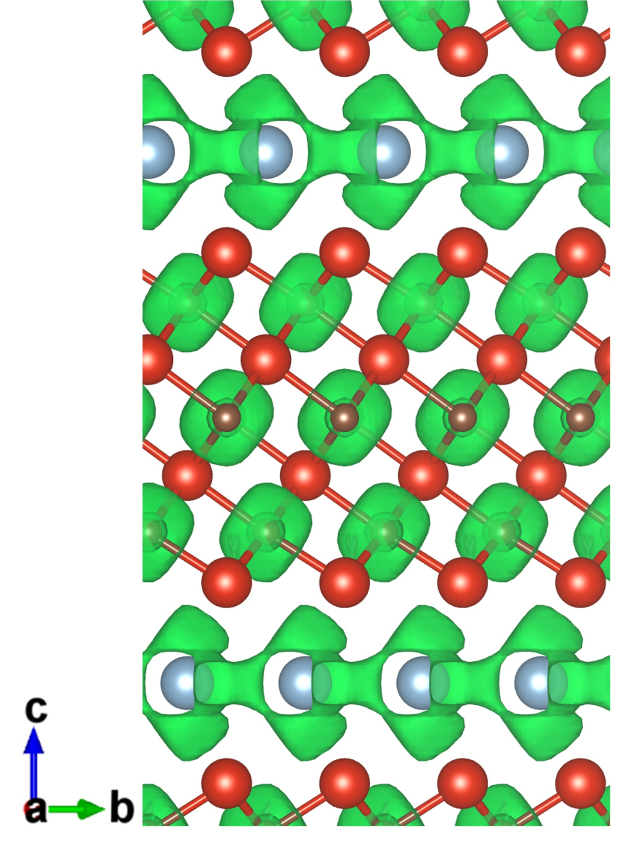
Figure S1. ELF isosurface, isovalue 0.6 a.u., for the V₄AlC₃ MAX compound.

Figure S2 shows the atomistic models for the most stable configurations considered in the formation of the Mo_{x}V_{4-x}AlC₃ in the range from x= 0.5 to x= 2, while figure S3 displays the most stable configurations in the range from x= 2.5 to x= 3.5. In both cases, the structures are ordered from left to right in order of stability. Note that in the most stable configurations the Mo occupies the V_{I} sites randomly until it forms the double-ordered Mo₂V₂AlC₃ MAX alloy (x=2). After that, Mo starts to occupy the V_{II} sites where, again, occupy the sites in a random order.
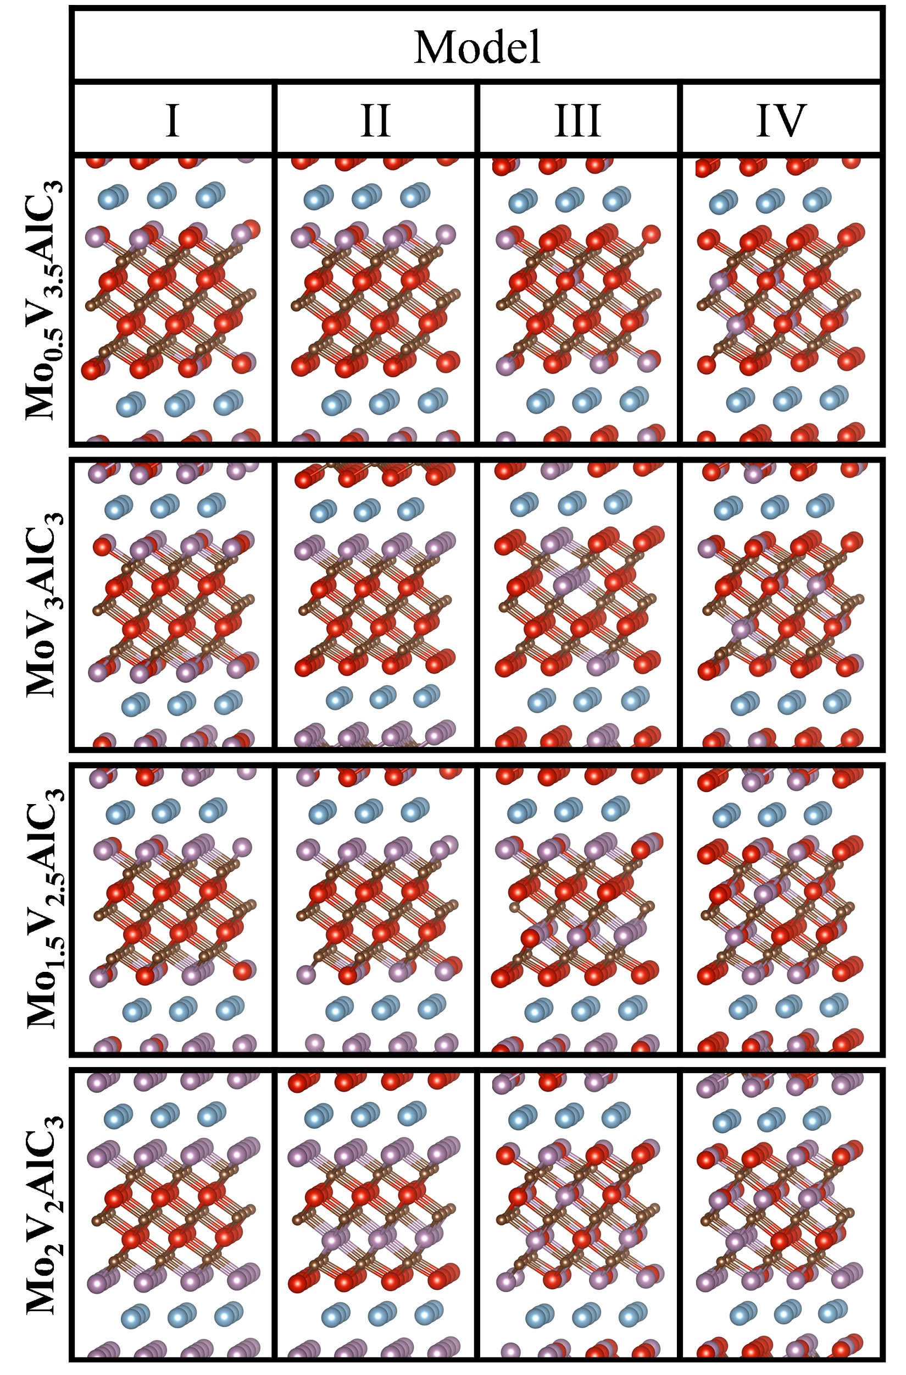
Figure S2. The first four stable models considered in the calculations for the Mo_{x}V_{4-x}AlC₃ in the range 0.5≤x≤2. In all cases the stability order is from left to right.

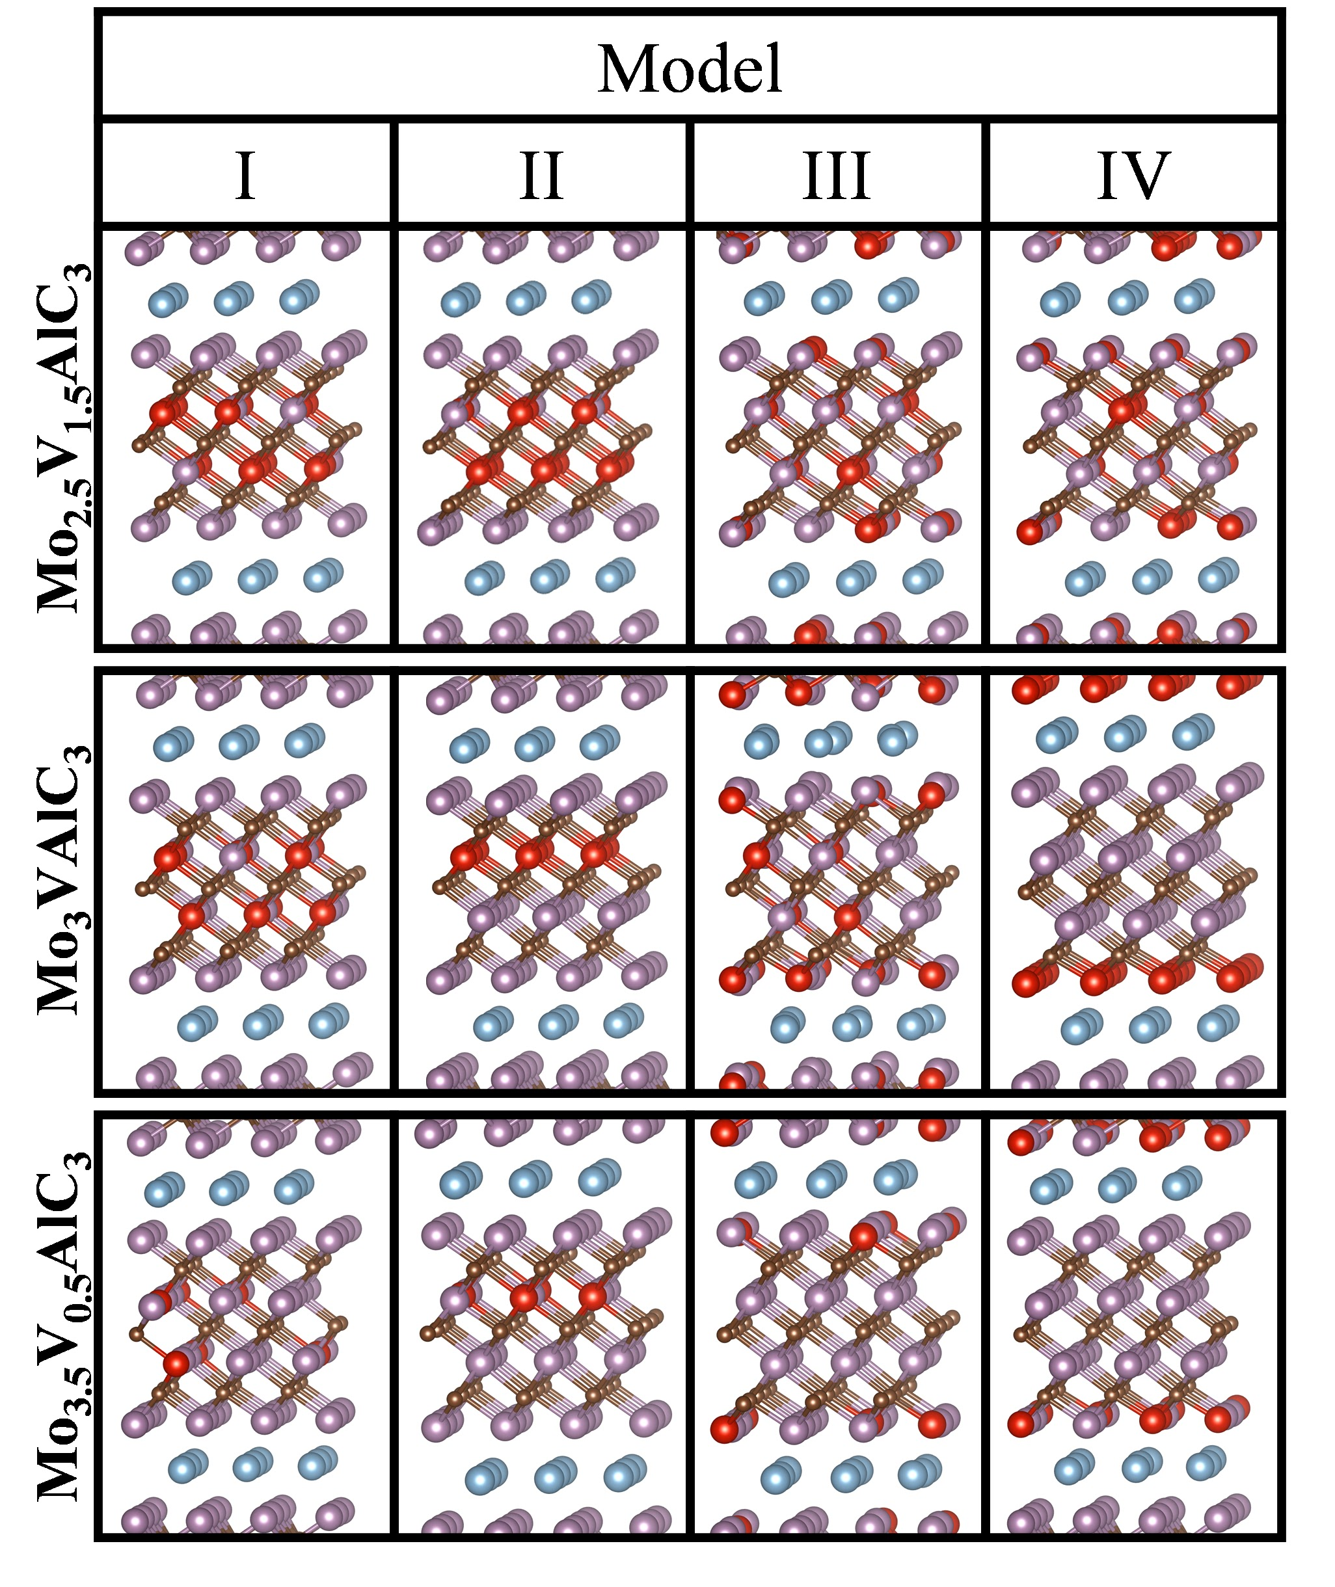
Figure S3. The first four stable models considered in the calculations for the Mo_{x}V_{4-x}AlC₃ in the range 2.5≤x≤3.5. In all cases the stability order is from left to right.

The three-dimensional representation of the DFE for the Mo_{x}V_{4-x}AlC₃ alloy is shown in figure S4, where each plane represents a different alloy. According to the DFE formalism, the most stable structures provide the lowest energy values, therefore, we focus in the bottom part of the graph, the colors purple, red, green, blue, cyan, magenta, dark yellow, navy and black corresponds to V₄AlC₃, Mo_{0.5}V_{3.5}AlC₃, MoV₃AlC₃, Mo_{1.5}V_{2.5}AlC₃, Mo₂V₂AlC₃, Mo_{2.5}V_{1.5}AlC₃, Mo₃VAlC₃, Mo_{3.5}V_{0.5}AlC₃, Mo₄AlC₃, respectively.

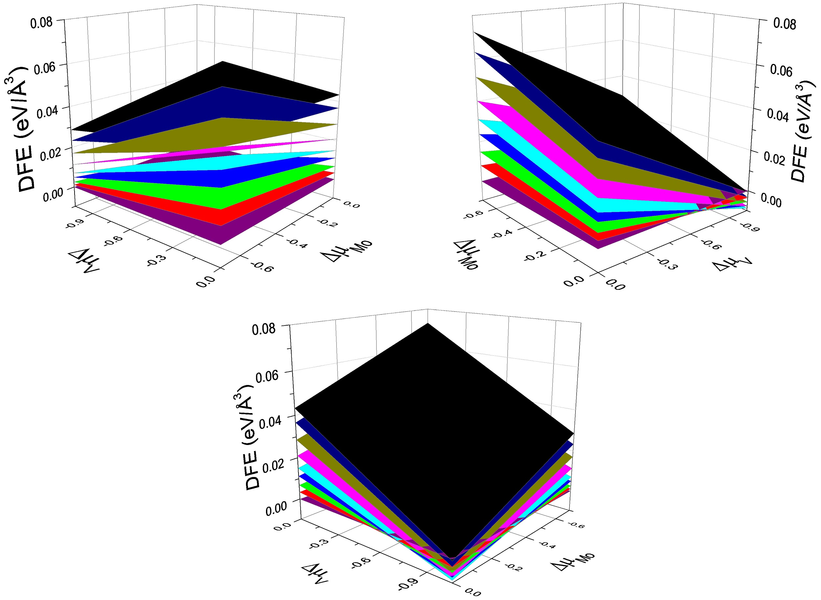Figure S4. DFE graphs in a three-dimensional representation, where each plane represents a different MAX alloy. According to the formalis, the most stable modes have the lowest energy values.

The ELF line profiles corresponding to the double-ordered MAX Mo₂V₂AlC₃ alloy are displayed in figure S5. It is noticed a change in the bond nature from mainly ionic to mainly covalent, when Mo substitutes the V_{I} sites. On the other hand, the V_{II}-C interaction did not change, it remains ionic.
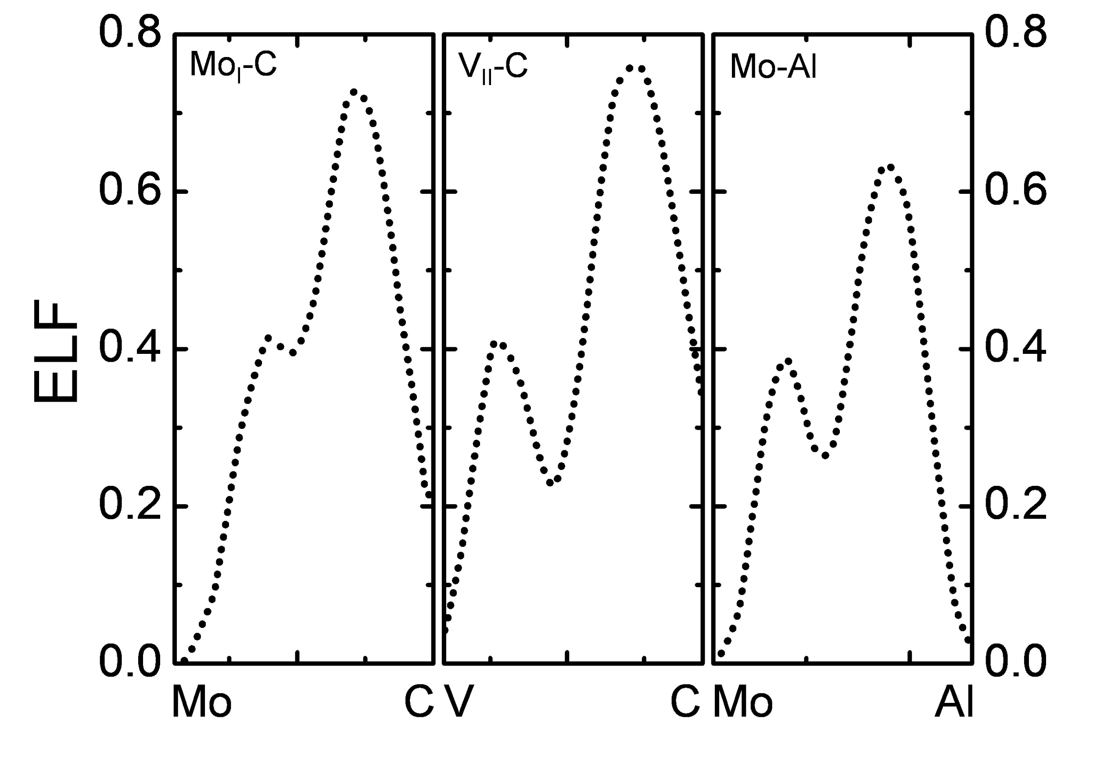
Figure S5. ELF line profiles for the interactions present in the double-ordered Mo₂V₂AlC₃ alloy.

