Supplementary Table 1: Plugins used in analysis pipelines as well as docker container location, and CWL tool (CLT) location.

Version | Plugin | Github Repository | DockerHub Location | CLT Location
0.1.7-GPU | UF – UNET Inference | https://github.com/PolusAI/polus-plugins-dl/tree/master/polus-unet-testing-plugin | labshare/polus-unet-testing-plugin | TBD
0.2.4-GPU | UF – UNET Training | https://github.com/PolusAI/polus-plugins-dl/tree/master/polus-unet-training-plugin | labshare/polus-unet-training-plugin | TBD
0.0.1 | SplineDist Inference | https://github.com/mmvih/polus-plugins/tree/splinedist-inference/polus-splinedist-inference-plugin | N/A | N/A
0.0.1 | SplineDist Training | https://github.com/mmvih/splinedist/tree/training_big | N/A | N/A
0.0.1 | CellPose | https://github.com/nishaq503/polus-plugins/tree/plugin/cellpose-inference/segmentation/polus-cellpose-inference-plugin | N/A | N/A
0.0.6 | Mesmer Inference | https://github.com/Vishakha6/polus-plugins/tree/mesmerInference/segmentation/polus-mesmer-inference-plugin | polusai/mesmer-inference-plugin | TBD
0.1.10 | AICS | https://github.com/PolusAI/polus-plugins/tree/master/segmentation/polus-aics-classic-seg-plugin | labshare/polus-aics-classic-seg-plugin | TBD
0.2.1 | ROI Evaluation Pulgin | https://github.com/Vishakha6/polus-plugins/tree/cellEvalPlugin/features/polus-cellular-evaluation-plugin | polusai/cellular-eval-plugin | TBD
0.1.8 | Pixel Eval Plugin | https://github.com/Vishakha6/polus-plugins/tree/pixelEvalPlugin/features/polus-pixelwise-evaluation-plugin | polusai/pixelwise-eval-plugin | TBD
0.1.9 | Feature Eval Plugin | https://github.com/Vishakha6/polus-plugins/tree/featureEvalPlugin/features/polus-feature-evaluation-plugin | polusai/feature-eval-plugin | TBD
0.2.4 | Nyxus | https://github.com/PolusAI/nyxus | polusai/nyxus | TBD

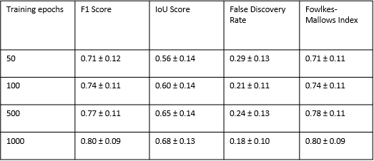
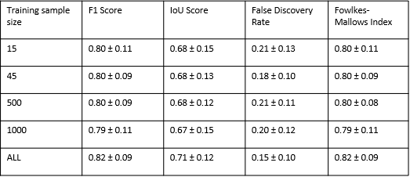
Supplementary Table 2 Supplementary Table 3

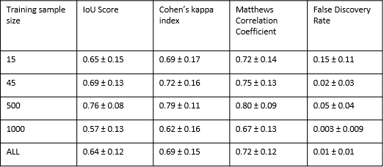
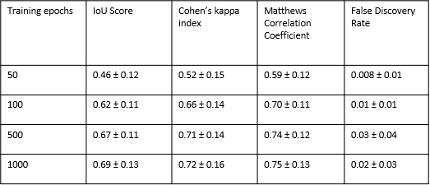
Supplementary Table 4 Supplementary Table 5

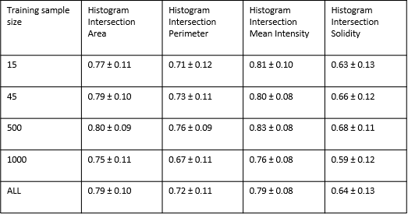
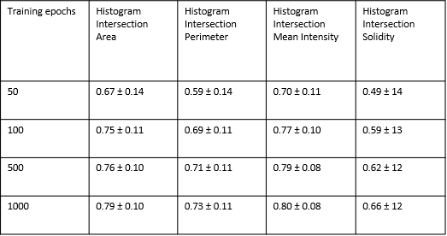
Supplementary Table 6 Supplementary Table 7

