Figure 1 SI. The number of mammalian species per taxonomic order sold in traditional medicine markets (TMM) and bushmeat markets (BM) from southern Benin.

Figure 2 SI. The number of mammalian species sold in traditional medicine markets (TMM) and bushmeat markets (BM) from southern Benin that occur in the listed bioclimatic zones.

Figure 3 SI. The number of mammalian species sold in traditional medicine markets (TMM) and bushmeat markets (BM) from southern Benin, according to their IUCN Red List occurrence status in Benin.

Figure 4 SI. The number of mammalian species sold in traditional medicine markets (TMM) and bushmeat markets (BM) from southern Benin, according to habitat. Species assigned to multiple habitat categories were counted more than once.

Figure 5 SI. The number of mammalian species sold in traditional medicine markets (TMM) and bushmeat markets (BM) from southern Benin, according to diet. Species assigned to multiple diet categories were counted more than once.
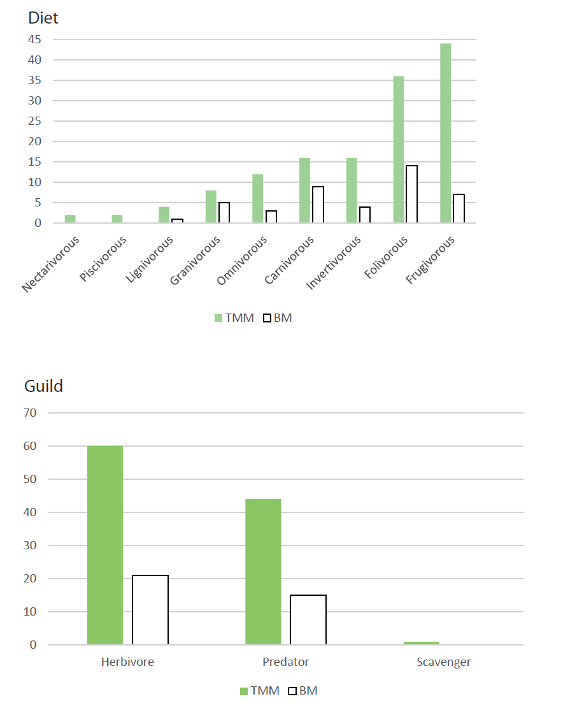

Figure 6 SI. The number of mammalian species sold in traditional medicine markets (TMM) and bushmeat markets (BM) from southern Benin, according to ecological function. Species assigned to multiple functional categories were counted more than once.

Figure 7 SI. Scattered boxplots of mean weight (kg) among the mammalian species sold in traditional medicine markets (TMM) and bushmeat markets (BM) from southern Benin.
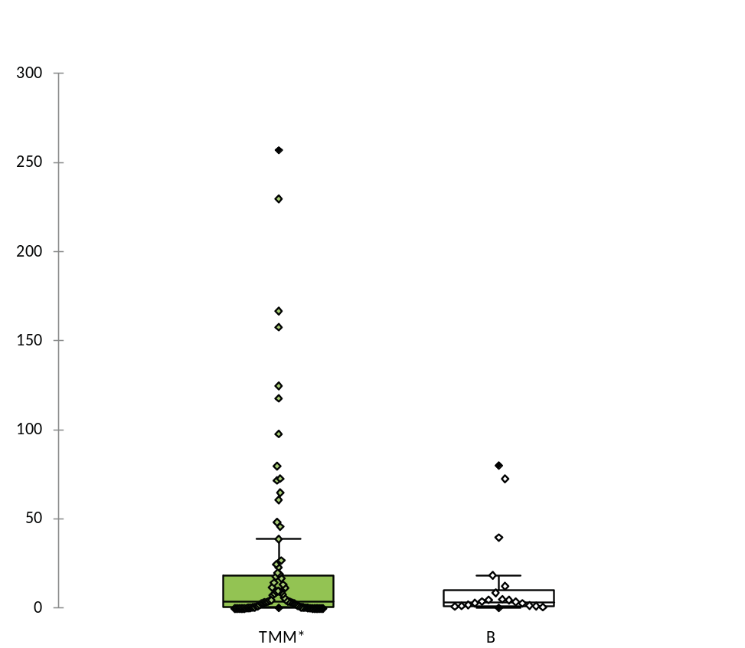
* Three species > 500 kg (Loxodonta africana, Hippopotamus amphibious, Syncerus caffer) were removed from TMM for visualization purpose.

Figure 8 SI. Scattered boxplots of generation length (yrs) among the mammalian species sold in traditional medicine markets (TMM) and bushmeat markets (BM) from southern Benin.
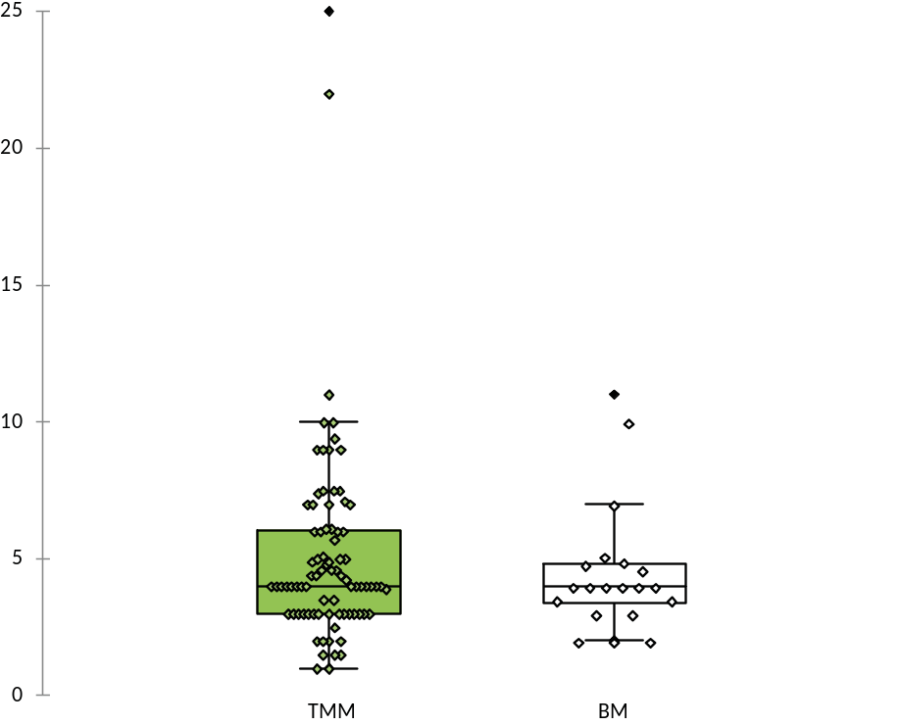

Figure 9 SI. Scattered boxplots of litter size per year among the mammalian species sold in traditional medicine markets (TMM) and bushmeat markets (BM) from southern Benin.
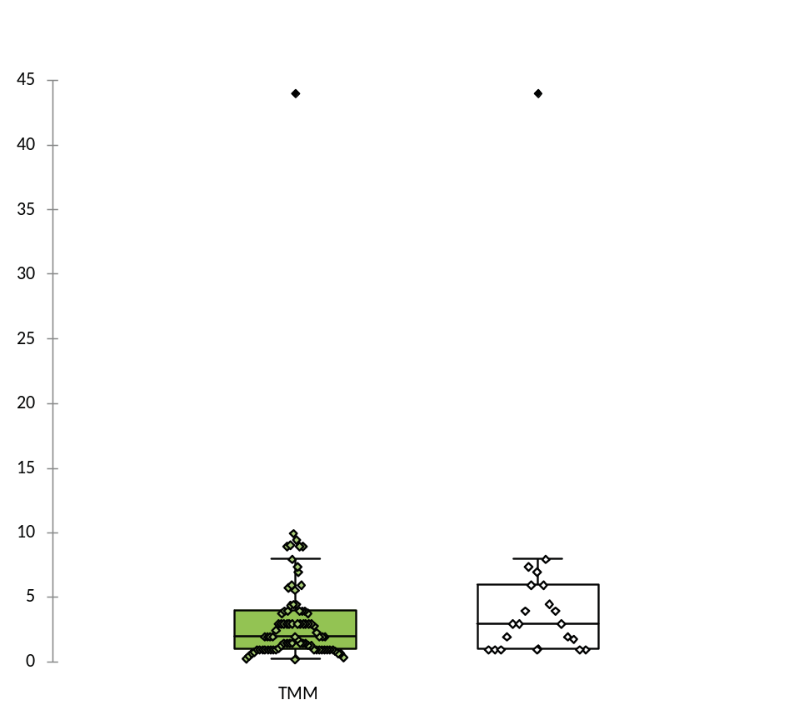

Figure 10 SI. Boxplot representation of mean weight (in kg) distribution across diet (top) and ecological function (bottom) categories within the mammalian species sold in traditional medicine markets (TMM; green boxes) and bushmeat markets (BM; white boxes) from southern Benin.

Three species > 500 kg (Loxodonta africana, Hippopotamus amphibious, Syncerus caffer) were removed from TMM for visualization purpose.

