Supplementary Information

Journal: Biodiversity and Conservation

Article title: Assessing the wildlife trade in western Africa through the prism of functional diversity: a comparative study between two types of markets from southern Benin

Authors: Chabi A. M. S. Djagoun^{a*}, Stanislas Zanvoª, Fortuné Azihouª, Gilles Nago^{b}, Joël Djagounª, Fifanou Vodouhê^{c}, Bruno Djossa^{a,d}, Achile Assogbadjoª, Fabien Leprieur^{e}, Brice Sinsinª, Philippe Gaubert^{f,g*}

ª Laboratory of Applied Ecology, University of Abomey-Calavi, Faculty of Agronomic Sciences, University of Abomey-Calavi, 01 BP 526, Cotonou, Benin
^{b} Laboratoire d’Ecologie, de Botanique et de Biologie végétale, Faculté d’Agronomie, Université de Parakou, BP 123 Parakou, République du Bénin
^{c} Laboratoire d’Analyse et de Recherche sur les Dynamiques Économiques et Sociales (LARDES), Faculté d’Agronomie, Université de Parakou, BP 123 Parakou, République du Bénin
^{d} Unité de Recherche en Foresterie et Conservation des Bioressources (U/RFCBio), Université Nationale d'Agriculture de Porto-Novo, Benin
^{e} MARBEC, Univ Montpellier, IRD, CNRS, IFREMER, Montpellier, France
^{f} Laboratoire Evolution et Diversité Biologique, UPS/CNRS/IRD, Université Paul Sabatier, 118 Route de Narbonne, Bat. 4R1, 31062 Toulouse, France
^{g} CIIMAR, Terminal de Cruzeiros Do Porto de Leixoes, Avenida General Norton de Matos s/n, 4450-208 Matosinhos, Portugal

*Corresponding authors: dchabi@gmail.com and philippe.gaubert@univ-tlse3.fr

Appendix 1. PCR amplification and sequencing procedures together with post-processing validation of the nucleotide sequences used in the study.

PCR mixture was carried out in 20 µl final volume with ~10-50 ng template DNA, 0.1 mg/mL BSA, 0.2 x 4 mM dNTPs, 0.5 x 2 µM primers, 1 X Flexi Go Taq Buffer, 1.5 mM MgCl2 and 0.5 U GoTaq® Flexi DNA polymerase (Promega, Charbonnières-les-Bains, France). Cycling conditions included a first step of denaturation (94 °C, 2 min), followed by 35 cycles of denaturation (92 °C, 30 s), annealing (30 s; 50°C for cyt b and COX1 and 52°C for 12S and 16S) and extension (72 °C, 30 s), and a final extension step (72 °C, 15 min). Amplicons were purified and sequenced in both direction on a 3730xl DNA Analyzer 96-capillary sequencer (Applied Biosystems, Foster City, CA) at Macrogen, Amsterdam, Netherlands (http://dna.macrogen.com/eng) and Genoscreen, Lille, France (https://www.genoscreen.fr/fr/). All the sequences produced in this study were deposited in Genbank under accession numbers XXX-XXX.
Sequences of cyt b and COX1 were edited and aligned manually using BioEdit 7.2.5. (Hall, 1999). We aligned the 12S and 16S fragments using MUSCLE (Edgar, 2004) at https://www.ebi.ac.uk/Tools/msa/muscle/ with default settings. In order to detect the presence of pseudogenes in cyt b and COX1 (coding genes), nucleotide sequence alignments were translated into amino-acids using MEGA 10.0.5 (Kumar et al., 2018), checking for putative stop codons and indels. We also checked atypical branch lengths and phylogenetic branching in the gene trees (see Material and Methods), a method applicable to genes without reading frames such as the 12S and 16S ribosomal subunits (Triant and DeWoody, 2007).

References
Edgar RC (2004) MUSCLE: multiple sequence alignment with high accuracy and high throughput. Nucleic Acids Research 32: 1792-1797.
Hall TA (1999) BioEdit: a user-friendly biological sequence alignment editor and analysis program for Windows 95/98/NT. Nucleic acids symposium series 41: 95-98.
Kumar S, Stecher G, Li M et al (2018) MEGA X: molecular evolutionary genetics analysis across computing platforms. Molecular Biology and Evolution 35: 1547. https://doi.org/10.1093%2Fmolbev%2Fmsy096
Triant DA, DeWoody JA (2007) The occurrence, detection, and avoidance of mitochondrial DNA translocations in mammalian systematics and phylogeography. J Mamm 88: 908-920. https://doi.org/10.1644/06-MAMM-A-204R1.1

Table S1. List of the 94 mammalian species identified on traditional medicine markets and bushmeat markets from southern Benin, together with their conservation status, ecological characteristics and functional traits. Taxonomy follows the IUCN Red List of Threatened Species. Domestic species are given in red. [Excel file]

Table S2. List of the 194 genetic samples collected as part of this study and identified through a four-gene DNA-typing approach. COX1: Cytochrome oxidase I; Cyt b: Cytochrome b. Final taxonomy follows the IUCN Red List of Threatened Species. [Excel file]

Figure 1 SI. Distribution of the mammalian species present in Traditional Medicine Markets (TMM) and Bushmeat Markets (BM) from southern Benin, according to taxonomic orders.
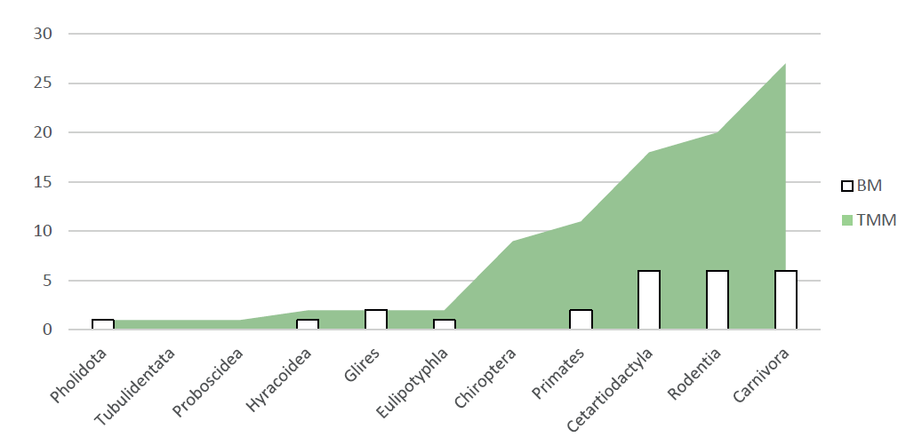

Figure 2 SI. Distribution of the mammalian species present in Traditional Medicine Markets (TMM) and Bushmeat Markets (BM) from southern Benin, according to bioclimatic zones. Top: Radar representation. Bottom: Histogram representation.
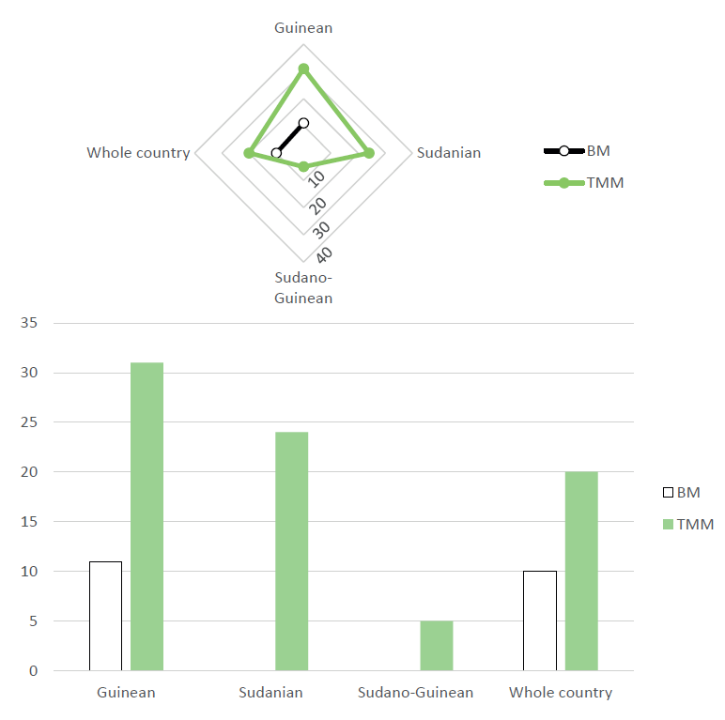

Figure 3 SI. Distribution of the mammalian species present in Traditional Medicine Markets (TMM) and Bushmeat Markets (BM) from southern Benin, according to their presence status in Benin based on IUCN.
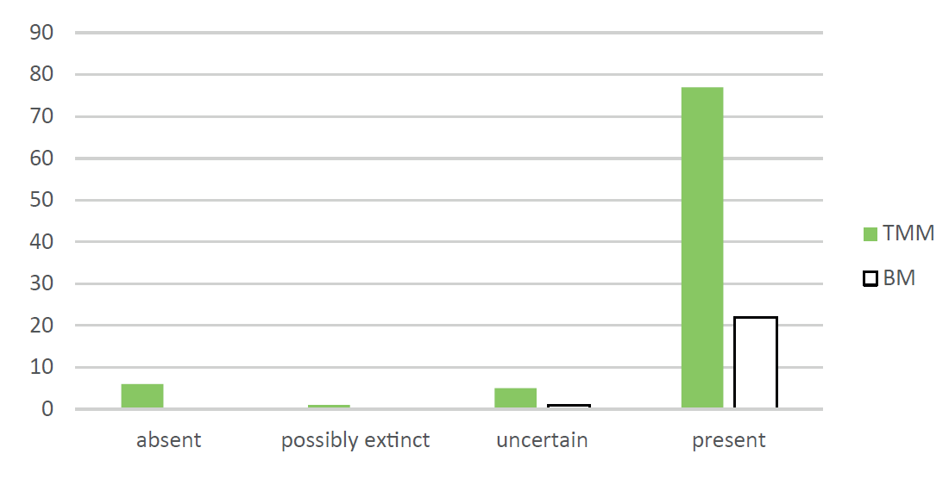

Figure 4 SI. Distribution of the mammalian species present in Traditional Medicine Markets (TMM) and Bushmeat Markets (BM) from southern Benin, according to habitat. Species assigned to multiple habitat categories were demultiplexed (i.e., counted more than once).
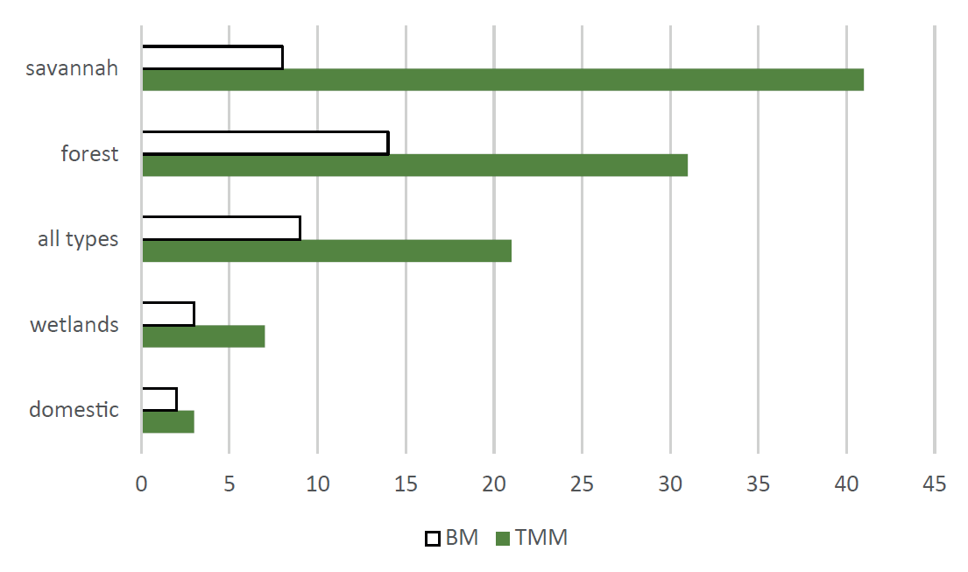

Figure 5 SI. Distribution of the mammalian species present in Traditional Medicine Markets (TMM) and Bushmeat Markets (BM) from southern Benin, according to diet. Species assigned to multiple diet categories were demultiplexed (i.e., counted more than once).
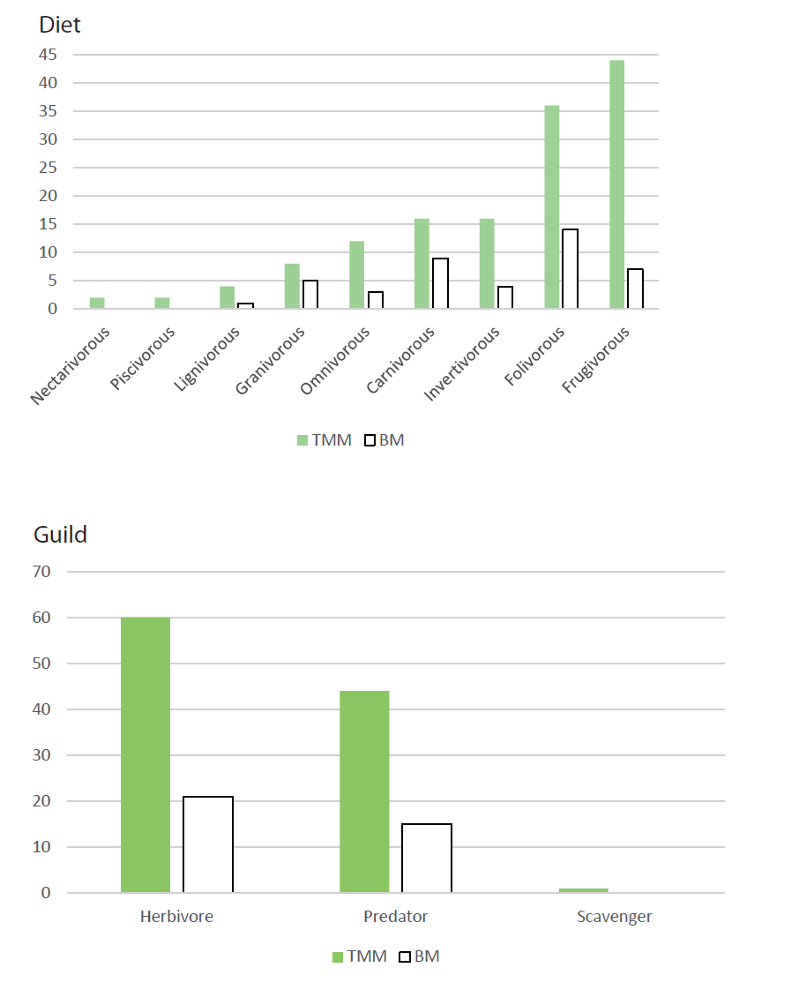

Figure 6 SI. Distribution of the mammalian species present in Traditional Medicine Markets (TMM) and Bushmeat Markets (BM) from southern Benin, according to ecological function. Species assigned to multiple functional categories were demultiplexed (i.e., counted more than once).
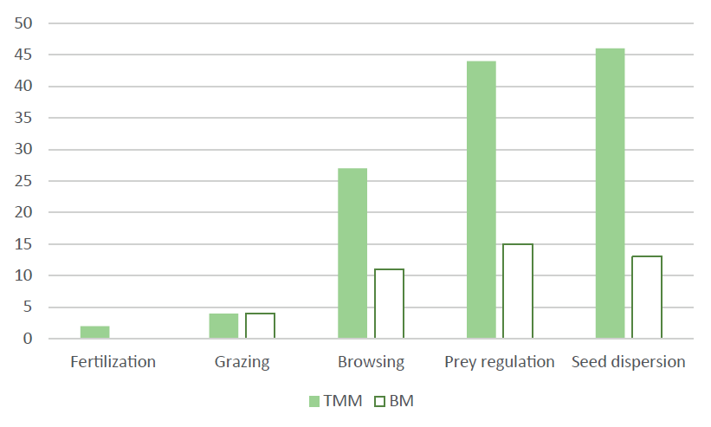

Figure 7 SI. Scattered boxplots of mean weight (kg) among the mammalian species present in Traditional Medicine Markets (TMM) and Bushmeat Markets (BM) from southern Benin.
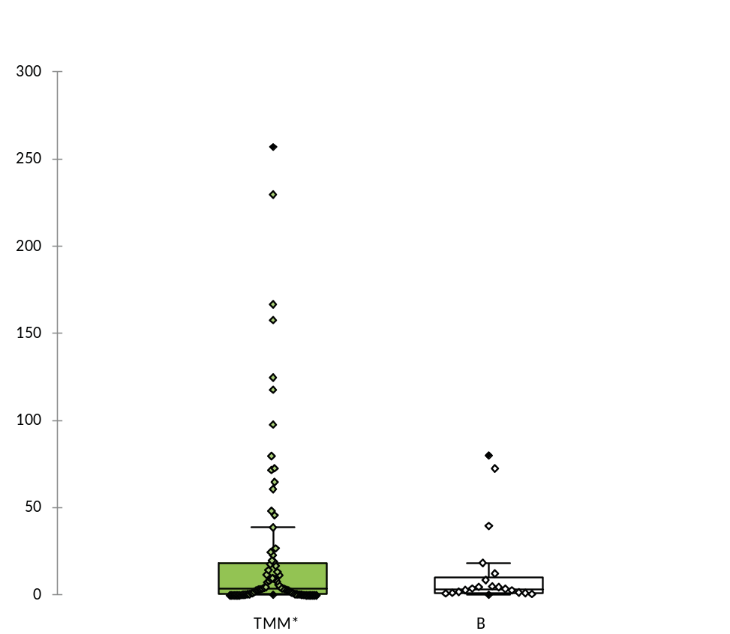
* Three species > 500 kg (Loxodonta africana, Hippopotamus amphibious, Syncerus caffer) were removed from TMM for visualization purpose.

Figure 8 SI. Scattered boxplots of generation length (yrs) among the mammalian species present in Traditional Medicine Markets (TMM) and Bushmeat Markets (BM) from southern Benin.
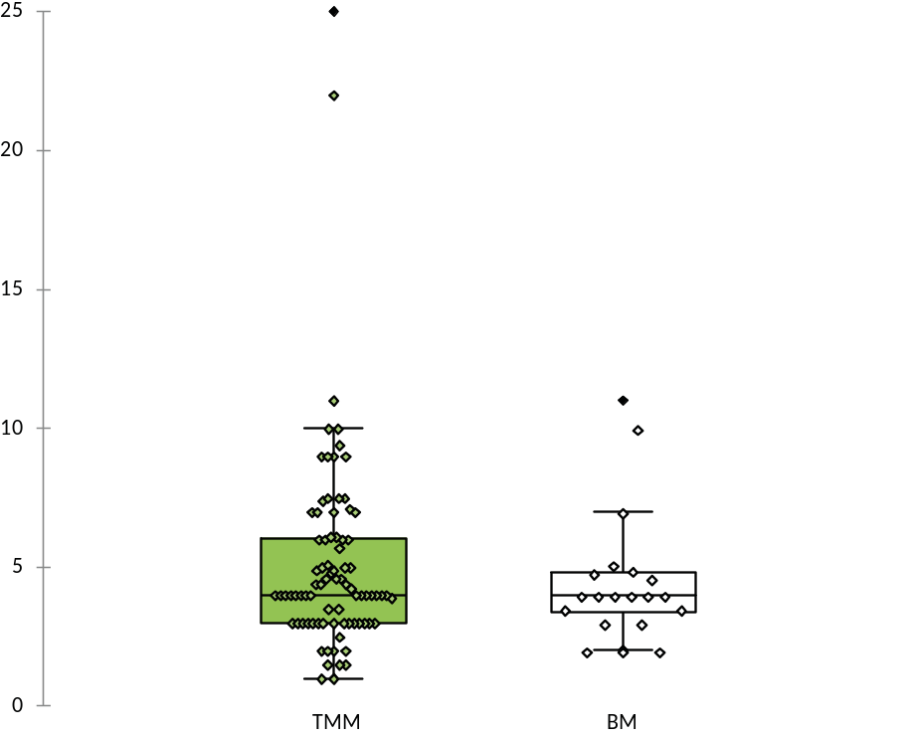

Figure 9 SI. Scattered boxplots of litter size per year among the mammalian species present in Traditional Medicine Markets (TMM) and Bushmeat Markets (BM) from southern Benin.
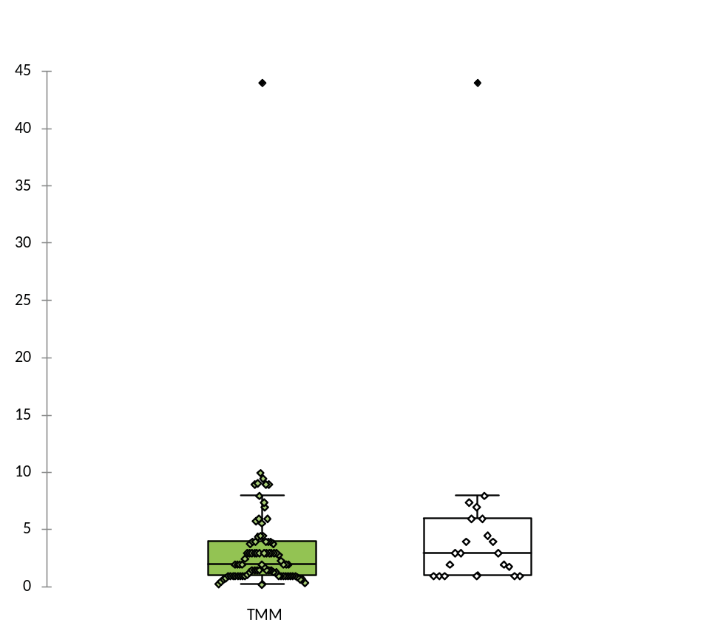

Figure 10 SI. Boxplot representation of mean weight (in kg) distribution across diet (top) and ecological function (bottom) categories within the mammalian species present in Traditional Medicine Markets (TMM; in green) and Bushmeat Markets (BM; in white) from southern Benin.

Three species > 500 kg (Loxodonta africana, Hippopotamus amphibious, Syncerus caffer) were removed from TMM for visualization purpose.

