Supplementary material

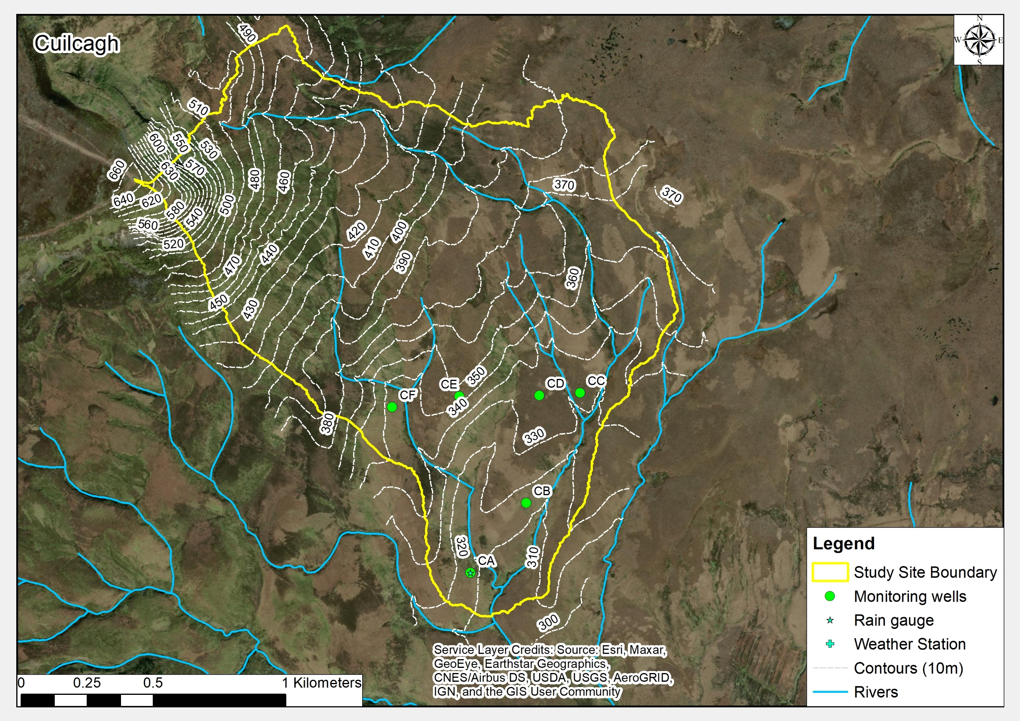
Figure S1 Detailed site overview map for Cuilcagh
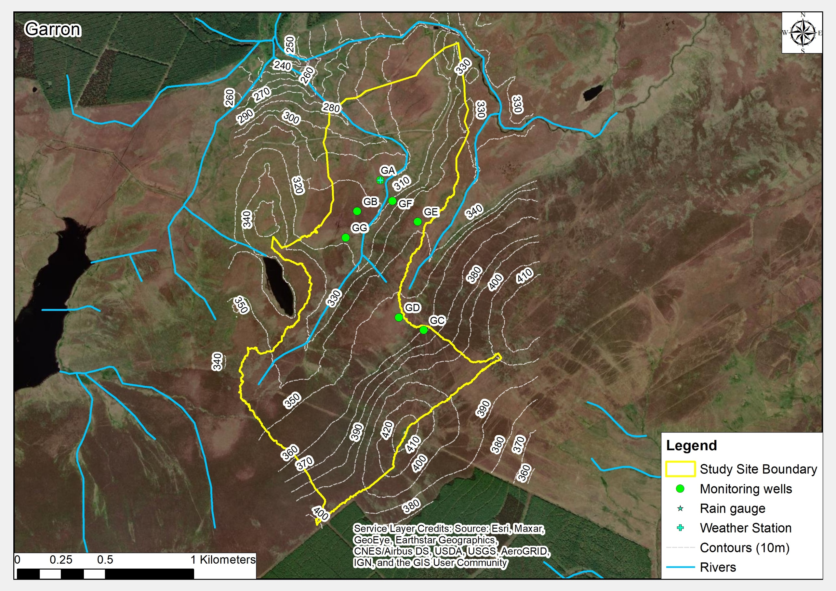
Figure S2 Detailed site overview map for Garron

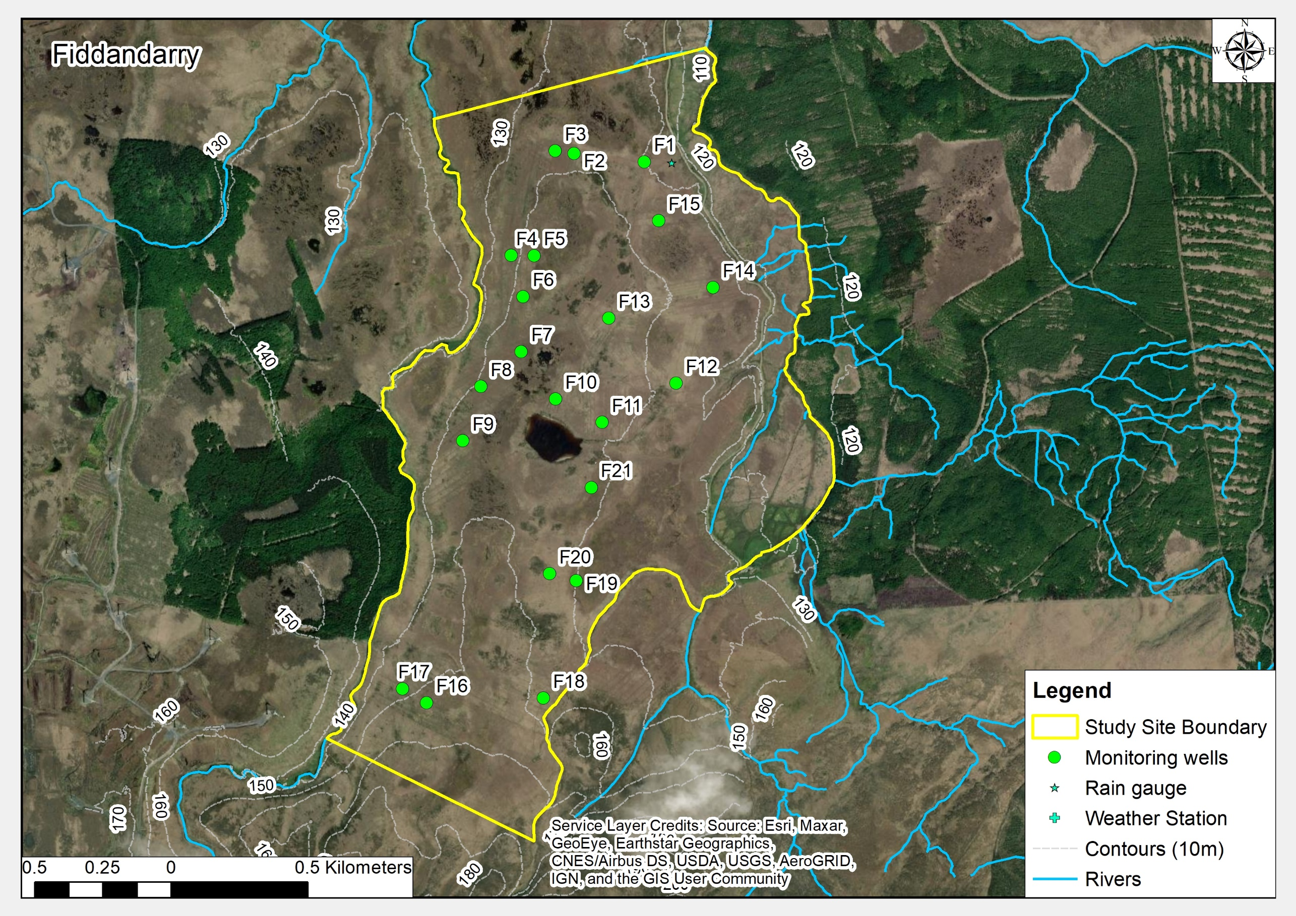
Figure S3 Detailed site overview map for Fiddandarry

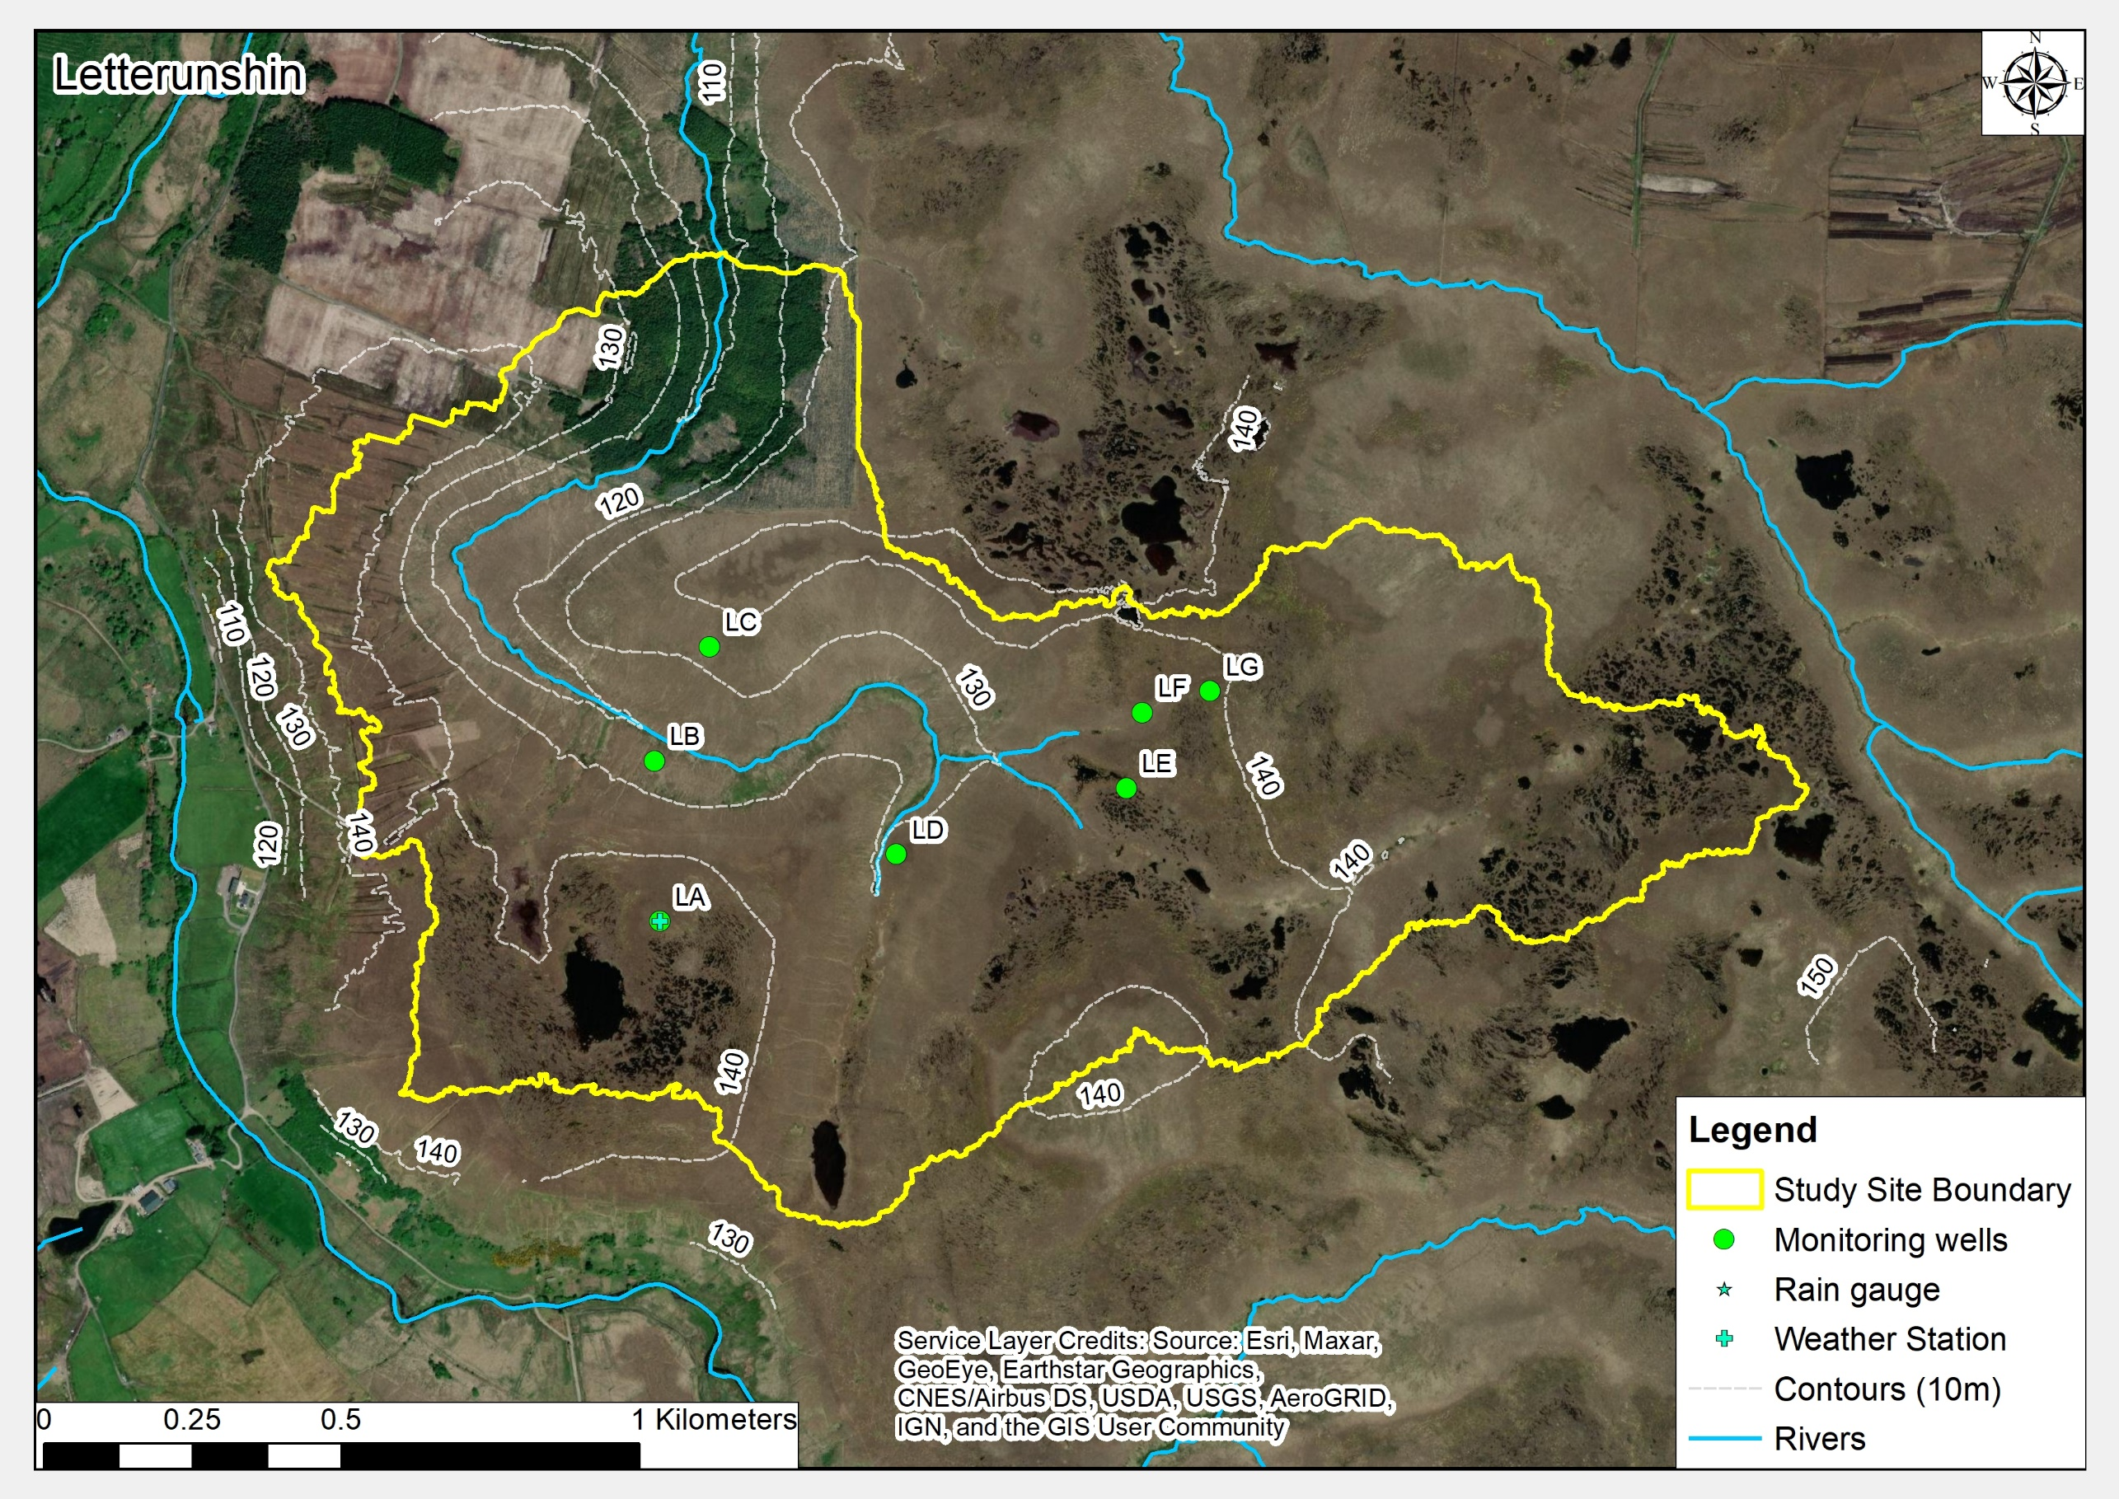
Figure S4 Detailed site overview map for Letterunshin

Table S1 Monthly meteorological measurements
Garron | Year | Jan | Feb | Mar | Apr | May | Jun | Jul | Aug | Sep | Oct | Nov | Dec | Total
Precipitation (mm) | 2019 | 86.8 | 99.7 | 157.0 | 87.6 | 58.0 | 88.0 | 87.6 | 124.2 | 119.2 | 99.0 | 162.2 | 98.8 | 1268.1
Et (mm) | 2019 | 8.7 | 19.5 | 34.0 | 58.4 | 76.9 | 79.9 | 74.6 | 63.5 | 40.3 | 25.6 | 12.3 | 8.5 | 502.4
Rain days (≥1mm) | 2019 | 18 | 12 | 20 | 10 | 13 | 16 | 13 | 20 | 21 | 18 | 17 | 18 | 196
Wet days (≥5mm) | 2019 | 5 | 8 | 12 | 8 | 6 | 8 | 6 | 11 | 12 | 4 | 11 | 8 | 99
Precipitation (mm) | 2020 | 64.2 | 176.0 | 84.2 | 27.6 | 30.8 | 113.4 | 108.2 | 168.4 | 96.6 | 209.6 | 110.8 | 112.8 | 1302.6
Et (mm) | 2020 | 9.1 | 18.1 | 31.7 | 64.0 | 95.5 | 75.0 | 65.9 | 58.5 | 46.2 | 22.4 | 9.9 | 7.3 | 503.6
Rain days (≥1mm) | 2020 | 13 | 25 | 16 | 7 | 8 | 15 | 18 | 16 | 16 | 22 | 21 | 19 | 196
Wet days (≥5mm) | 2020 | 5 | 12 | 7 | 3 | 2 | 8 | 8 | 11 | 7 | 17 | 10 | 9 | 99
Letterunshin | Year | Jan | Feb | Mar | Apr | May | Jun | Jul | Aug | Sep | Oct | Nov | Dec | Total
Precipitation (mm) | 2019 | 100.6 | 102.4 | 186.8 | 107.3 | 68.3 | 113.5 | 101.4 | 209.3 | 119.3 | 138.3 | 129.3 | 150.8 | 1526.9
Et (mm) | 2019 | 10.6 | - | 37.6 | 83.3 | 96.0 | 92.6 | 72.3 | 70.3 | 57.2 | 39.6 | 20.8 | 18.7 | 599.1
Rain days (≥1mm) | 2019 | 19 | 16 | 19 | 13 | 14 | 15 | 17 | 25 | 23 | 22 | 20 | 21 | 224
Wet days (≥5mm) | 2019 | 9 | 7 | 17 | 9 | 5 | 9 | 7 | 14 | 10 | 11 | 11 | 9 | 118
Precipitation (mm) | 2020 | 119.8 | 284.3 | 118.0 | 25.0 | 34.8 | 147.0 | 101.5 | 124.5 | 78.5 | 252.0 | 159.0 | 226.5 | 1670.7
Et (mm) | 2020 | 22.4 | 30.7 | 51.1 | 93.3 | 133.0 | 78.6 | 76.4 | 76.9 | 62.2 | 24.0 | 3.0 | 22.1 | 673.7
Rain days (≥1mm) | 2020 | 19 | 27 | 18 | 9 | 6 | 16 | 22 | 19 | 17 | 24 | 21 | 27 | 225
Wet days (≥5mm) | 2020 | 10 | 21 | 8 | 1 | 2 | 9 | 10 | 5 | 8 | 15 | 11 | 18 | 118
Fiddandarry* | Year | Jan | Feb | Mar | Apr | May | Jun | Jul | Aug | Sep | Oct | Nov | Dec | Total
Precipitation (mm) | 2019 | 99.2 | 101.0 | 182.4 | 105.7 | 68.1 | 111.7 | 104.2 | 215 | 114.2 | 133.4 | 128.4 | 139.2 | 1502.6
Rain days (≥1mm) | 2019 | 18 | 15 | 18 | 12 | 13 | 14 | 16 | 24 | 22 | 21 | 17 | 21 | 212
Wet days (≥5mm) | 2019 | 9 | 7 | 15 | 9 | 5 | 9 | 6 | 13 | 10 | 11 | 12 | 9 | 114
Precipitation (mm) | 2020 | 111 | 265 | 114.4 | 19.6 | 30.8 | 159.6 | 110 | 123 | 80.4 | 245.2 | 155.6 | 220.6 | 1635.2
Rain days (≥1mm) | 2020 | 17 | 26 | 19 | 4 | 8 | 16 | 21 | 19 | 18 | 23 | 20 | 26 | 217
Wet days (≥5mm) | 2020 | 9 | 17 | 10 | 1 | 2 | 9 | 10 | 5 | 6 | 14 | 10 | 16 | 109
Cuilcagh | Year | Jan | Feb | Mar | Apr | May | Jun | Jul | Aug | Sep | Oct | Nov | Dec | Total
Precipitation (mm) | 2019 | 141 | 200.8 | 332.2 | 115.6 | 17.8 | 74.6 | 105.4 | 316.6 | 245.2 | 228 | 182.6 | 275.2 | 2235.0
Rain days (≥1mm) | 2019 | 21 | 18 | 23 | 14 | 6 | 13 | 15 | 21 | 23 | 21 | 20 | 21 | 216
Wet days (≥5mm) | 2019 | 10 | 12 | 19 | 8 | 0 | 5 | 7 | 18 | 17 | 11 | 13 | 15 | 135
* Note records at Fiddandarry supplemented by establishing the relationship between records at Letterunshin and Fiddandarry using regression analysis (r2 > 0.91).

Figure S5 Water level duration curves for summer and winter monitoring periods for all monitoring plots illustrating water levels as a function of the proportion of time a particular water level (relative to ground surface) is equalled or exceeded (Negative values indicate depths below ground surface, positive values indicate height above ground surface measured from a fixed point).
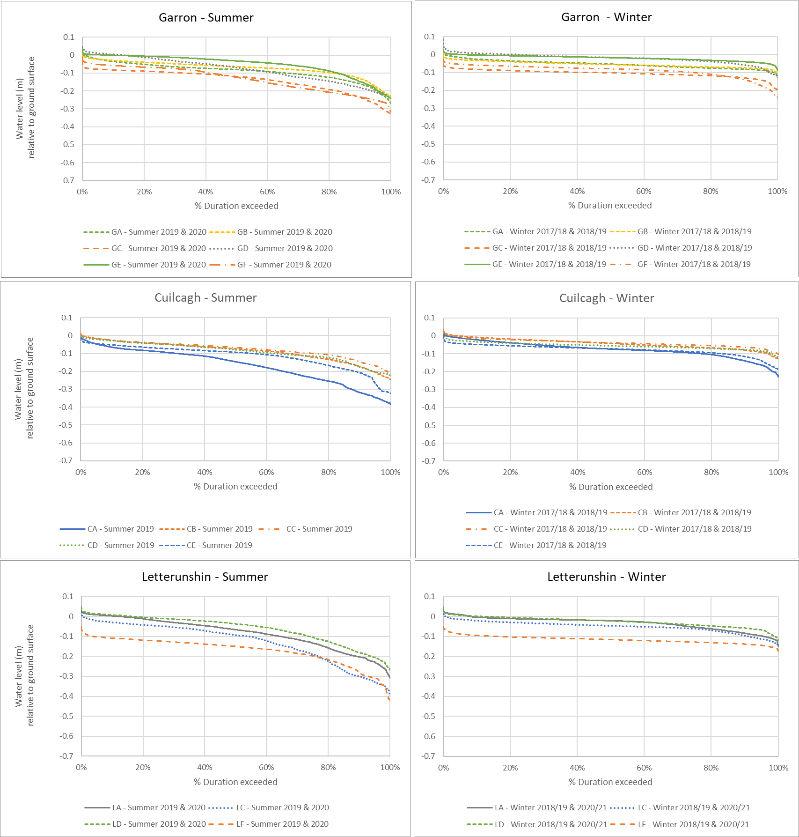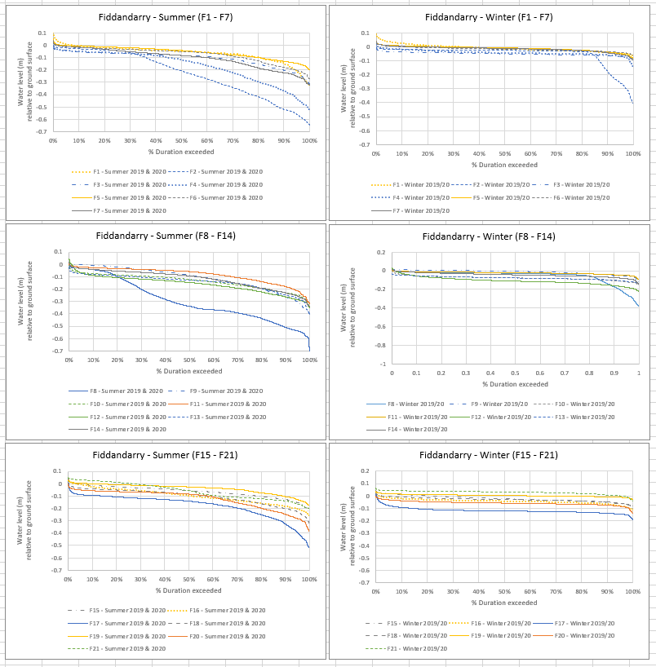

Table S2 Complete results from ecological surveys of monitoring plots. Ranges of parameters were recorded with mid-values used for correlation analysis.
 | Plot_ID | Microtopography | Acrotelm thickness (cm) | Peat thickness (m) | Ground softness | Total cover Molinia (%) | Total cover other grasses (%) | Total cover Calluna (%) | Height of Calluna (cm) | Total cover Erica spp. (%) | Height of Erica spp. (cm) | Total cover of Sphagna (%) | Total cover of bare peat (%) | Total cover of peat with algal mat (%) | Evidence of land use | MFAC (km)
Cuilcagh | C_1 | Low hummocks and Sphagnum lawns | 20 | 1.55 | 3(soft) | <1 | 40-50 | 10-20 | 20-30 | 5-10 | 5-10 | 80-90 | 0 | <1 | Light grazing, Juncus squarrosus (5%), sheep dropping in plot | 0.4
Cuilcagh | C_2 | Low hummocks | 0-5 | 0.45 | 2(hard to soft) | 0-5 | 15-30 | 10-20 | 20-30 | 5-10 | 5-10 | 30-40 | 0-5 | 0 | 35 | 0.1
Cuilcagh | C_3 | Low hummocks and hollows | 10-15 | >3.0 | 3(soft) | 0 | 0 | 0-5 | 20-30 | 0-5 | 5-10 | 40-50 | 0-5 | <1 | Light grazing | 1.9
Cuilcagh | C_4 | Low hummocks and Sphagnum lawns | >30 | 2.7 | 3(soft) | <1 | 30-40 | 0-5 | 20-30 | 0-5 | 5-10 | 80-90 | 0 | 0-5 | Light grazing | 1.7
Cuilcagh | C_5 | Low hummocks | 5 | 2.15 | 2(hard to soft) | 0 | 40-50 | 15-25 | 20-30 | 10-20 | 5-10 | 10-20 | 5-10 | 0 | Light grazing | 0.4
Cuilcagh | C_6 | Low hummocks | 5-10 | 1.2 | 2(hard to soft) | 0-5 | 25-35 | 30-40 | 30-40 | 0-5 | 5-10 | 30-40 | 0 | 0-5 | Light grazing | 0.1
Cuilcagh | C_7 | Low hummocks | 5 | 0.45 | 2(hard to soft) | 10-20 | 0 | 5-10 | 10-20 | 0-5 | 5-10 | 70-80 | 0-5 | 0 | Moderate grazing | 0.1
Cuilcagh | C_8 | Low hummocks | 5 | 2.4 | 2(hard to soft) | 0 | 20-30 | 20-30 | 20-30 | 5-10 | 5-10 | 20-25 | 0-5 | 0-5 | Light grazing | 1.0
Cuilcagh | C_11 | Low hummocks | 5-10 | 3 | 3(soft) | 0 | 15-25 | 20-30 | 10-20 | 0-5 | 5-10 | 40-45 | 0-5 | <1 | Light grazing | 1.2
Cuilcagh | C_12 | Low hummocks and Sphagnum lawns | 20-25 | 2.7 | 3(soft) | 10-20 | 15-25 | 0-5 | 20-30 | 0-5 | 5-10 | 70-80 | 0-5 | <1 | Light grazing, sheep droppings | 1.8
Cuilcagh | C_13 | Low hummocks | 10-15 | 1.6 | 2(hard to soft) | 0-5 | 5-15 | 20-30 | 20-30 | 0-5 | 5-10 | 80-90 | 0 | 0 | Light grazing, Juncus squarrosus (5-10), sheep dropping in plot | 0.3
Cuilcagh | C_14 | Low hummocks | 10-15 | >2.55 | 3(soft) | <1 | 15-25 | 10-20 | 20-30 | 5-10 | 5-10 | 80-90 | 0-5 | <1 | Light grazing | 1.2
Cuilcagh | C_15 | Low hummocks | 5 | 2.15 | 2(hard to soft) | <1 | 25-35 | 20-30 | 20-30 | 0-5 | 5-10 | 25-30 | <1 | <1 | Light grazing | 0.4
Cuilcagh | C_17 | Low hummocks | 20 | >3.0 | 3(soft) | <1 | 45-55 | 5-10 | 20-30 | 0-5 | 5-10 | 80-90 | 0 | 0 | None | 0.9
Cuilcagh | C_18 | Low hummocks | 5-10 | 0.45 | 2(hard to soft) | 10-20 | 25-35 | 10-20 | 20-30 | 5-10 | 5-10 | 50-60 | <1 | 0 | Light grazing, Juncus effusus (5-10), sheep dropping in plot | 0.2
Cuilcagh | C_2A | Low hummocks | 0-5 | 1.45 | 1(hard) | 0 | 40-50 | 60-70 | 30-40 | 0-5 | 20-30 | 5-10 | 0 | <1 | Light grazing | 0.7
Cuilcagh | C_1A | Low hummocks and hollows | 0.10-0.15 | >3.0 | 3(soft) | <1 | 5-15 | 15-20 | 20-30 | 0-5 | 5-10 | 80-90 | <1 | <1 | None | 0.7
Cuilcagh | C_2B | Low hummocks | 0-5 | 1.65 | 2(hard to soft) | <1 | n/a | <1 | 20-30 | 0-5 | 5-10 | 30-40 | <1 | n/a | Light grazing. Juncus squarrosus (5%). Likely to indicate overgrazing (perhaps more in the past) | 0.1
Cuilcagh | C_2C | Low hummocks and Sphagnum lawns | 10-20 | 2.2 | 3(soft) | 10-20 | n/a | 0 | 0 | 0-5 | 5-10 | 80-90 | 0 | n/a | Light grazing. Sheep droppings in square. | 0.3
Fiddandarry | F1 | Low hummocks/ Sphagnum hollows within an active flush system | 15 | 3 | 3 (soft) | 20-30 | 25-35 | 30-40 | 30-40 | 1 | 10-20 | 50-60 | 0 | 0 | Shallow infilling drain (15m) | 9.8
Fiddandarry | F2 | Low hummocks/Narthecium flats | 10 | 1.45 | 2 (hard to soft) | 40-50 | 25-35 | 10-20 | 20-30 | 5-10 | 10-20 | 40-50 | 0 | 0 | Shallow infilling drain (10m) | 0.4
Fiddandarry | F3 | Low hummocks/Narthecium flats | <5 | 1.7 | 1 (hard) | 20 | 40-50 | 20-30 | 10-20 | 1 | 10-20 | 0-5 | 10-15 | <1 | Shallow (0.75cm)drain (5m) | 0.9
Fiddandarry | F4 | Low hummocks/Narthecium flats | 5-10 | 2.36 | 1 (hard) | 40-50 | 15-25 | 30-40 | 10-20 | 0-5 | 10-20 | 20-30 | 1 | <1 | Shallow (0.75cm)drain (5m) | 0.5
Fiddandarry | F5 | High&Low hummocks/ Sphagnum&open water pools | 10-20 | 3.59 | 3 (soft) | 40-50 | 15-25 | 30-40 | 5-10 | 1 | 5-10 | 20-30 | 1 | <1 | Shallow infilling drain (5m) | 5.1
Fiddandarry | F6 | Low hummocks/Narthecium hollows | 10-20 | 2.8 | 2 (hard to soft) | 60-70 | 0 | 20-30 | 20-30 | 0-5 | 20-30 | 20-30 | 0 | 0 | Shallow infilling drain (10m) | 4.5
Fiddandarry | F7 | Low hummocks/open water pools/Narthecium hollows | <5 | 3.5 | 2 (hard to soft) | 5-10 | 30-40 | 40-50 | 5-10 | 5-10 | 5-10 | 10-20 | 5-10 | 0-5 | Shallow (0.75cm)drain (5m) | 49.8
Fiddandarry | F8 | Low hummocks/Narthecium flats | <5 | 1.5 | 1 (hard) | 30-40 | 5-15 | 20-30 | 10-20 | 0-5 | 10-20 | 0-5 | 0-5 | <1 | Shallow (0.75cm)drain (10m) | 0.2
Fiddandarry | F9 | High hummocks/Molinia hollows | 5-10 | 2.25 | 2 (hard to soft) | 70-80 | 0 | 30-40 | 10-20 | 0-5 | 10-20 | 20-30 | 0 | 0 | Shallow (0.75cm)drain (10m) | 0.8
Fiddandarry | F10 | High hummocks/Narthecium hollows | 5-10 | 4.36 | 2 (hard to soft) | 60-70 | 0 | 20-30 | 10-20 | 0-5 | 10-20 | 10-15 | 1 | <1 | Shallow (0.75cm)drain (5m) | 2.3
Fiddandarry | F11 | Low hummocks/Narthecium flats | <5 | 2.03 | 1 (hard) | 30-40 | 15-25 | 10-20 | 10-20 | 0-5 | 10-20 | 10-20 | 0-5 | <1 | Shallow (0.75cm)drain (5m) | 1.0
Fiddandarry | F12 | High hummocks/Molinia hollows | 10-20 | 2.42 | 2 (hard to soft) | 60-70 | 0 | 30-40 | 40-50 | 0-5 | 10-20 | 30-40 | 0 | 0 | Shallow infilling drain (5m) | 3.0
Fiddandarry | F13 | Molinia tussocks | 0 | 2.4 | 2 (hard to soft) | 90-100 | 0 | 0-5 | 20-30 | <1 | 10-20 | <1 | 0 | 0 | Shallow (0.75cm)drain (5m) | 1.2
Fiddandarry | F14 | Low hummocks & Narthecium hollows | 10-20 | 2.95 | 3 (soft) | 10-20 | 25-35 | 40-50 | 10-20 | 0-5 | 10-20 | 20-30 | 0-5 | <1 | Shallow (0.75cm)drain (1m), small amount of trampling | 5.2
Fiddandarry | F15 | High hummocks/Molinia hollows | <5 | 3.3 | 2 (hard to soft) | 70-80 | 0 | 10 | 20-30 | <1 | 10-20 | 5-10 | 0 | 0 | Shallow infilling drain (15m) | 5.6
Fiddandarry | F16 | High hummocks/Molinia&Sphagnum hollows | 10-20 | 1.99 | 2 (hard to soft) | 40-50 | 5-15 | 40-50 | 20-30 | 0-5 | 10-20 | 60-70 | 0 | 0 | Shallow infilling drain (10m) | 8.9
Fiddandarry | F17 | High hummocks/Molinia hollows | 5-10 | 1.95 | 2 (hard to soft) | 40-50 | 5-15 | 40-50 | 20-30 | 0-5 | 10-20 | 20-30 | 0 | 0 | Shallow infilling drain (15m) | 0.9
Fiddandarry | F18 | High hummocks/Molinia&Sphagnum hollows | 10-20 | 2.7 | 2 (hard to soft) | 50-60 | 5-15 | 30-40 | 20-30 | 0-5 | 10-20 | 40-50 | 0 | 0 | Shallow infilling drain (15m) | 4.3
Fiddandarry | F19 | Low hummocks/Sphagnum pools | >30 | 3.89 | 5 (quaking) | 0-5 | 15-30 | 10-15 | 10-20 | <1 | 10-20 | 90-100 | 0 | 0 | None | 5.3
Fiddandarry | F20 | Low hummock/Molinia hollows | 5-10 | 1.5 | 2 (hard to soft) | 60-70 | 5-15 | 10-20 | 20-30 | <1 | 10-20 | 20-30 | 0 | 0 | None | 1.5
Fiddandarry | F21 | Low hummocks/Sphagnum lawns | 20-30 | 2.5 | 5 (quaking) | 5-10 | 30-40 | 20-30 | 10-20 | 1 | 10-20 | 80-90 | <1 | 0 | None | 3.0
Fiddandarry | F22 | Low hummocks/Sphagnum pools | 5-10 | 3.9 | 4 (very soft to quaking) | 0 | 0 | 0-5 | 5-10 | <1 | 10-20 | 30-40 | 5-10 | <1 | Shallow (1m)drain (60m) | 4.0
Fiddandarry | F23 | Molinia tussocks | 0 | 2.9 | 2 (hard to soft) | 90-100 | 0 | 0 | 0 | <1 | 10-20 | <1 | 0 | 0 | Shallow (0.75cm)drain (10m) | 1.4
Fiddandarry | F24 | Low hummocks/Sphagnum lawns & pools | >30 | 4.18 | 5 (quaking) | <1 | 40-50 | 20-30 | 10-20 | 0-5 | 10-20 | 70-80 | <1 | <1 | None | 6.4
Fiddandarry | F25 | Low hummocks/Sphagnum&open water pools | 10-20 | 2.3 | 3 (soft) | 1-5 | 25-35 | 10-20 | 10-20 | 0-5 | 10-20 | 30-40 | 5-10 | 0-5 | None | 9.5
Fiddandarry | F26 | High hummocks/Sphagnum hollows | 10-20 | 2.08 | 2 (hard to soft) | 10-20 | 45-55 | 40-50 | 20-30 | 0-5 | 10-20 | 60-70 | 0 | 0 | Shallow infilling drain (5m). Ridges from past turf cutting evident. | 1.0
Fiddandarry | F27 | Low hummocks/Narthecium flats | <5 | 3.79 | 3 (soft) | 0 | 20-30 | 10-15 | 5-10 | 5-10 | 5-10 | 5-10 | 10 | 0-5 | Poaching | 5.9
Fiddandarry | F28 | Low hummocks/Sphagnum pools | 20-30 | 3.4 | 4 (very soft to quaking) | 0 | 40-50 | 10-15 | 5-10 | 5 | 5-10 | 30-40 | 5-10 | 0 | Light grazing but not obvious damage | 15.3
Fiddandarry | F29 | High hummocks/Sphagnum&open water pools/Narthecium flats | 10-20 | 5 | 4 (very soft to quaking) | 0 | 30-40 | 20-30 | 20-30 | <1 | 10-20 | 30-40 | 5-10 | 0-5 | Poaching | 3.9
Fiddandarry | F30 | Low hummocks/Sphagnum hollows/Narthecium flats | 5-10 | 3.24 | 2 (hard to soft) | 20-30 | 15-25 | 30-40 | 10-20 | 0-5 | 10-20 | 30-40 | 5-10 | <1 | Light grazing but not obvious damage | 3.4
Garron | G_1 | High hummocks | 10-15 | 1.20 | 2(hard to soft) | 30-40 | 30-40 | 0-5 | 20-30 | 0 | 0 | 40-50 | 0 | 0 | Moderate grazing | 0.3
Garron | G_2 | Low hummocks | 5-10 | 2.00 | 2(hard to soft) | 0 | 40-50 | 30-40 | 20-30 | 5-10 | 5-10 | 30-40 | 0 | 0 | None | 1.7
Garron | G_3 | High hummocks | 15 | 3.20 | 2(hard to soft) | 30-40 | 30-40 | 0-5 | 30-40 | <1 | 5-10 | 30-40 | 0 | 0 | None | 7.3
Garron | G_4 | High hummocks | 15-20 | 1.00 | 2(hard to soft) | <1 | 30-40 | 40-50 | 30-40 | 0-5 | 0-5 | 40-50 | 0 | 0 | None | 0.6
Garron | G_5 | Low hummocks | 0-5 | 4.47 | 2(hard to soft) | 0 | 5-10 | 30-40 | 30-40 | 0-5 | 5-10 | 10-15 | <1 | 0 | None | 5.2
Garron | G_6 | High hummocks | 0-5 | 3.68 | 2(hard to soft) | 90-95 | <1 | 0 | 0 | 0-5 | 10-20 | 5-10 | 0 | 0 | Drain still functional 30m away | 2.9
Garron | G_7 | Low hummocks | 20-25 | 5.55 | 4 (very soft to quaking) | 0 | 70-80 | 15-20 | 30-40 | <1 | 10-20 | 30-35 | 0 | 0 | None | 16.7
Garron | G_8 | Low hummocks | 0 | 6.20 | 2(hard to soft) | 5-10 | 80-90 | 0 | 0 | 0-5 | 5-10 | 0-5 | <1 | 0 | None | 27.9
Garron | G_9 | Low hummocks | 0-5 | 0.90 | 1(hard) | 10-20 | 30-40 | 10-20 | 20-30 | 0-5 | 5-10 | 10-15 | 10 | 0 | Moderate grazing | 0.2
Garron | G_10 | Low hummocks | 0-5 | 2.25 | 2(hard to soft) | 0 | 30-40 | 20-30 | 30-40 | 0-5 | 5-10 | 20-30 | 0-5 | 0 | Light grazing | 4.4
Garron | G_11 | High hummocks | 5-10 | 1.12 | 2(hard to soft) | 0 | 20-30 | 70-80 | 30-40 | 0-5 | 10-20 | 60-70 | 0 | 0 | None | 0.7
Garron | G_12 | Low hummocks | 0-5 | 1.05 | 1(hard) | 99 | 0 | 10-15 | 30-40 | <1 | 10-20 | <1 | 0 | 0 | None | 0.4
Garron | G_13 | High hummocks | 5-10 | 1.60 | 2(hard to soft) | 0 | 5-10 | 60-70 | 30-40 | <1 | <1 | 70-80 | 0 | 0 | None | 0.9
Garron | G_14 | Low hummocks | 0-5 | 5.37 | 2(hard to soft) | 90-95 | 5-10 | <1 | 20-30 | <1 | 10-20 | 20-25 | 0 | 0 | None | 4.3
Garron | G_15 | Low hummocks | 5-10 | 3.35 | 3(soft) | 0 | 40-50 | 30-40 | 20-30 | 0-5 | 10-20 | 30-35 | 0-5 | 0 | None | 6.9
Garron | G_16 | High hummocks | 0-5 | 1.20 | 2(hard to soft) | 0 | 10-15 | 60-70 | 30-40 | <1 | <1 | 30-40 | 0 | 0 | None | 0.8
Garron | G_17 | High hummocks | 5-10 | 2.50 | 2(hard to soft) | 0 | 10-15 | 70-80 | 30-40 | <1 | 20-30 | 50-60 | 0 | 0 | None | 4.4
Garron | G_18 | Low hummocks | 0-5 | 2.80 | 1(hard) | 0 | 60-70 | 20-30 | 20-30 | 0-5 | 10-20 | 20-30 | 5-10 | 0 | None | 3.0
Garron | G_19 | Low hummocks | 0-5 | 1.90 | 2(hard to soft) | 0 | 60-70 | 30-40 | 20-30 | 0-5 | 10-20 | 30-35 | 5-10 | 0 | None | 1.7
Garron | G_20 | Low hummocks | 0-5 | 1.00 | 2(hard to soft) | 30-40 | 5-10 | 30-40 | 20-30 | 5-10 | 10-20 | 50-60 | 0 | 0 | None | 0.5
Garron | G_21 | Low hummocks | 0-5 | 1.10 | 1(hard) | 90-95 | <1 | 10-20 | 30-40 | <1 | 20-30 | 5-10 | 0 | 0 | None | 0.9
Letterunshin | L_1 | Low hummocks and bare peat/ Narthecium flats | <1.0 | 3 | 2(hard to soft) | <1 | 15-25 | 10-20 | 20-30 | 10-20 | 5-10 | 10-15 | 10-20 | <1 | Light grazing | 6.8
Letterunshin | L_2 | Low hummocks | 0-5 | 2.65 | 2(hard to soft) | 5-10 | 0 | 10-20 | 20-30 | 10-20 | 5-10 | 10-20 | 5-10 | 0 | Light grazing | 1.5
Letterunshin | L_3 | Low hummocks | 0-5 | >3.0 | 2(hard to soft) | 10-20 | 0 | 10-20 | 20-30 | 10-20 | 5-10 | 20-25 | <1 | 0 | Light grazing | 0.8
Letterunshin | L_4 | High hummocks | 0-5 | 1.6 | 1(hard) | 10-20 | 0 | 10-20 | 20-30 | 5-10 | 5-10 | 25-30 | 0-5 | 0 | Moderate grazing | 0.3
Letterunshin | L_5 | High hummocks | 0-5 | >3.0 | 1(hard) | 40-50 | 5-15 | 20-30 | 20-30 | 5-10 | 5-10 | 30-40 | <1 | 0 | Light grazing | 2.6
Letterunshin | L_6 | High hummocks | 0-5 | 1.2 | 1(hard) | 40-50 | 0 | 40-50 | 30-40 | 0-5 | 20-30 | 10-15 | 0 | 0 | 45 | 0.5
Letterunshin | L_7 | Low hummocks | 0-5 | 1.6 | 2(hard to soft) | 60-70 | 5-15 | 20-30 | 20-30 | 5-10 | 5-10 | 30-40 | 0 | 0 | Light grazing | 0.3
Letterunshin | L_8 | Low hummocks and Sphagnum lawns | 10-15 | >3.0 | 4 (very soft to quaking) | 0-5 | 0 | 10-20 | 10-20 | 5-10 | 5-10 | 70-80 | <1 | <1 | None | 2.1
Letterunshin | L_9 | Low hummocks and Sphagnum lawns | 20-30 | >3.0 | 5 (quaking) | <1 | 0 | 10-20 | 10-20 | 5-10 | 5-10 | 50-60 | 5-10 | 0 | None | 3.5
Letterunshin | L_10 | Low hummocks | 5-10 | >3.0 | 2(hard to soft) | 10-20 | n/a | 20-30 | 20-30 | 5-10 | 5-10 | 20-30 | <1 | n/a | Light grazing | 1.2
Letterunshin | L_11 | Low hummocks and Sphagnum pools | 20-30 | >3.0 | 5 (quaking) | <1 | n/a | 20-30 | 20-30 | 5-10 | 5-10 | 80-90 | <1 | n/a | None | 1.5
Letterunshin | L_12 | Low hummocks and Sphagnum pools | 20-30 | >3.0 | 5 (quaking) | <1 | n/a | 20-30 | 20-30 | 0-5 | 5-10 | 90-100 | <1 | n/a | None | 4.5
Letterunshin | L_13 | Low hummocks | 0-5 | 3 | 2(hard to soft) | <1 | n/a | 30-40 | 20-30 | 5-10 | 5-10 | 20-30 | 0-5 | n/a | None | 1.7
Letterunshin | L_14 | Low hummocks | 0-5 | 1.95 | 2(hard to soft) | 50-60 | n/a | 20-30 | 10-20 | 5-10 | 5-10 | 30-40 | <1 | n/a | None | 0.6
Letterunshin | L_15 | Low hummocks | 0-5 | 2.05 | 1(hard) | 70-80 | n/a | 10-20 | 20-30 | 0-5 | 5-10 | 10-15 | <1 | n/a | Evidence of old burning | 0.9
Letterunshin | L_16 | High hummocks and open water pools | 5-10 | >3.0 | 2(hard to soft) | 0 | n/a | 30-40 | 10-20 | 5-10 | 5-10 | 10-20 | 20-25 | n/a | Light grazing and evidence of burning. | 11.6
Letterunshin | L_17 | Low hummocks and Sphagnum hollows | 20-25 | >3.0 | 4 (very soft to quaking) | 0-5 | n/a | 30-40 | 10-20 | 5-10 | 5-10 | 50-60 | <1 | n/a | Light grazing | 2.2
Letterunshin | L_21 | Low hummocks and narthecium/bare peat flats | 5-10 | >3.0 | 4 (very soft to quaking) | 0 | n/a | 40-50 | 20-30 | 5-10 | 5-10 | 30-35 | 10-20 | n/a | None | 7.2
Letterunshin | L_22 | Low hummocks and narthecium/bare peat flats | 5-10 | >3.0 | 4 (very soft to quaking) | 0 | n/a | 10-20 | 20-30 | 10-20 | 5-10 | 20-30 | 5-10 | n/a | None | 8.2
Letterunshin | L_4A | High hummocks | 0-5 | 1.35 | 1(hard) | 40-50 | n/a | 20-30 | 30-40 | <1 | 20-30 | 10-15 | 0 | n/a | Light grazing | 0.2

