Supplemental Material

Table S1. Specimens included in the analyses.
Specie | UICN | Guilda | Strat | Skull | Jaw | Collection-number
Anoura caudifer | LC | Nect | CSPA | included | included | ZUFMS-CHI03481
Anoura caudifer | LC | Nect | CSPA | included | included | ZUFMS-CHI03477
Anoura caudifer | LC | Nect | CSPA | included | included | ZUFMS-CHI03478
Anoura caudifer | LC | Nect | CSPA | included | included | ZUFMS-CHI03479
Anoura caudifer | LC | Nect | CSPA | included | included | ZUFMS-CHI03482
Anoura caudifer | LC | Nect | CSPA | included | included | ZUFMS-CHI03483
Anoura caudifer | LC | Nect | CSPA | included | non-included | ZUFMS-CHI03484
Anoura caudifer | LC | Nect | CSPA | included | included | ZUFMS-CHI03485
Anoura caudifer | LC | Nect | CSPA | included | included | ZUFMS-CHI03487
Anoura caudifer | LC | Nect | CSPA | included | included | ZUFMS-CHI03489
Anoura caudifer | LC | Nect | CSPA | included | included | UNIDERP-544
Anoura caudifer | LC | Nect | CSPA | included | included | UNIDERP-567
Anoura caudifer | LC | Nect | CSPA | included | included | ZUFMS-461
Anoura geoffroyi | LC | Nect | CSPA | included | included | ZUFMS-CHI03490
Artibeus cinereus | LC | Fru | CSPA | included | included | ZUFMS-421
Artibeus cinereus | LC | Fru | CSPA | included | included | ZUFMS-422
Artibeus cinereus | LC | Fru | CSPA | included | included | ZUFMS-423
Artibeus lituratus | LC | Fru | CSPA | included | included | ZUFMS-CHI03493
Artibeus lituratus | LC | Fru | CSPA | included | included | ZUFMS-CHI03495
Artibeus lituratus | LC | Fru | CSPA | included | included | ZUFMS-CHI03492
Artibeus lituratus | LC | Fru | CSPA | included | included | ZUFMS-CHI03496
Artibeus lituratus | LC | Fru | CSPA | included | included | ZUFMS-CHI03497
Artibeus lituratus | LC | Fru | CSPA | included | included | ZUFMS-CHI03498
Artibeus lituratus | LC | Fru | CSPA | included | included | ZUFMS-CHI03499
Artibeus lituratus | LC | Fru | CSPA | included | included | UNIDERP-1
Artibeus lituratus | LC | Fru | CSPA | included | included | UNIDERP-9
Artibeus lituratus | LC | Fru | CSPA | included | included | ZUFMS-CHI03494
Artibeus planirostris | LC | Fru | CSPA | included | included | ZUFMS-CHI03500
Artibeus planirostris | LC | Fru | CSPA | included | included | ZUFMS-CHI03501
Artibeus planirostris | LC | Fru | CSPA | included | included | ZUFMS-CHI03502
Artibeus planirostris | LC | Fru | CSPA | included | included | ZUFMS-CHI03503
Artibeus planirostris | LC | Fru | CSPA | included | included | ZUFMS-CHI03504
Artibeus planirostris | LC | Fru | CSPA | included | included | ZUFMS-CHI03506
Artibeus planirostris | LC | Fru | CSPA | included | included | ZUFMS-CHI03507
Artibeus planirostris | LC | Fru | CSPA | included | included | ZUFMS-CHI03508
Artibeus planirostris | LC | Fru | CSPA | included | included | ZUFMS-CHI03509
Artibeus planirostris | LC | Fru | CSPA | included | included | ZUFMS-CHI03510
Carollia perspicillata | LC | Fru | CSPA | included | included | ZUFMS-CHI03521
Carollia perspicillata | LC | Fru | CSPA | included | included | ZUFMS-CHI03511
Carollia perspicillata | LC | Fru | CSPA | included | included | ZUFMS-CHI03522
Carollia perspicillata | LC | Fru | CSPA | included | included | ZUFMS-CHI03535
Carollia perspicillata | LC | Fru | CSPA | included | included | ZUFMS-CHI03512
Carollia perspicillata | LC | Fru | CSPA | included | included | ZUFMS-CHI03523
Carollia perspicillata | LC | Fru | CSPA | included | included | ZUFMS-CHI03516
Carollia perspicillata | LC | Fru | CSPA | included | included | ZUFMS-CHI03536
Carollia perspicillata | LC | Fru | CSPA | included | included | ZUFMS-CHI03517
Carollia perspicillata | LC | Fru | CSPA | included | included | ZUFMS-CHI03528
Carollia perspicillata | LC | Fru | CSPA | included | included | ZUFMS-CHI03530
Carollia perspicillata | LC | Fru | CSPA | included | included | ZUFMS-CHI03532
Carollia perspicillata | LC | Fru | CSPA | included | included | ZUFMS-CHI03533
Carollia perspicillata | LC | Fru | CSPA | included | included | ZUFMS-CHI03534
Carollia perspicillata | LC | Fru | CSPA | included | included | ZUFMS-CHI03519
Carollia perspicillata | LC | Fru | CSPA | included | included | ZUFMS-CHI03520
Carollia perspicillata | LC | Fru | CSPA | included | included | ZUFMS-CHI03513
Carollia perspicillata | LC | Fru | CSPA | included | included | ZUFMS-CHI03514
Chiroderma doriae | LC | Fru | CSPA | included | included | ZUFMS-395
Chiroderma doriae | LC | Fru | CSPA | included | included | ZUFMS-800
Chiroderma doriae | LC | Fru | CSPA | included | included | ZUFMS-1061
Chiroderma doriae | LC | Fru | CSPA | included | included | ZUFMS-1553
Chiroderma doriae | LC | Fru | CSPA | included | included | ZUFMS-moo493
Chiroderma villosum | LC | Fru | CSPA | included | included | ZUFMS-159
Chiroderma villosum | LC | Fru | CSPA | included | included | ZUFMS-208
Chiroderma villosum | LC | Fru | CSPA | included | included | ZUFMS-238
Chiroderma villosum | LC | Fru | CSPA | included | included | ZUFMS-1904
Chrotopterus auritus | LC | Ani | CSP | included | included | ZUFMS-CHI03537
Chrotopterus auritus | LC | Ani | CSP | included | included | UNIDERP-1534
Chrotopterus auritus | LC | Ani | CSP | included | included | ZUFMS-254
Chrotopterus auritus | LC | Ani | CSP | included | included | ZUFMS-391
Chrotopterus auritus | LC | Ani | CSP | included | included | ZUFMS-807
Chrotopterus auritus | LC | Ani | CSP | included | included | ZUFMS-964
Chrotopterus auritus | LC | Ani | CSP | included | included | ZUFMS-973
Chrotopterus auritus | LC | Ani | CSP | included | included | ZUFMS-1194
Desmodus rotundus | LC | Ani | CSA | included | included | ZUFMS-CHI03540
Desmodus rotundus | LC | Ani | CSA | included | included | ZUFMS-CHI03541
Desmodus rotundus | LC | Ani | CSA | included | included | ZUFMS-CHI03542
Desmodus rotundus | LC | Ani | CSA | included | included | ZUFMS-CHI03543
Desmodus rotundus | LC | Ani | CSA | included | included | ZUFMS-CHI03538
Desmodus rotundus | LC | Ani | CSA | included | included | ZUFMS-CHI03539
Desmodus rotundus | LC | Ani | CSA | included | included | UNIDERP-990
Desmodus rotundus | LC | Ani | CSA | included | included | UNIDERP-1037
Desmodus rotundus | LC | Ani | CSA | included | included | UNIDERP-1038
Eptesicus brasiliensis | LC | Ins | CSA | included | included | ADW-124398
Eptesicus brasiliensis | LC | Ins | CSA | included | included | UFES-922
Eptesicus furinalis | LC | Ins | CSA | included | included | UNIDERP-1132
Eptesicus furinalis | LC | Ins | CSA | included | included | UNIDERP-3338
Eptesicus furinalis | LC | Ins | CSA | included | included | UNIDERP-3581
Eptesicus furinalis | LC | Ins | CSA | included | included | ZUFMS-2357
Eptesicus furinalis | LC | Ins | CSA | included | included | ZUFMS-2358
Glossophaga soricina | LC | Nect | CSPA | included | included | ZUFMS-CHI03546
Glossophaga soricina | LC | Nect | CSPA | included | included | ZUFMS-CHI03547
Glossophaga soricina | LC | Nect | CSPA | included | included | ZUFMS-CHI03548
Glossophaga soricina | LC | Nect | CSPA | included | included | ZUFMS-CHI03550
Glossophaga soricina | LC | Nect | CSPA | included | included | ZUFMS-CHI03551
Glossophaga soricina | LC | Nect | CSPA | included | included | ZUFMS-CHI03552
Glossophaga soricina | LC | Nect | CSPA | included | included | ZUFMS-CHI03544
Glossophaga soricina | LC | Nect | CSPA | included | included | ZUFMS-CHI03553
Glossophaga soricina | LC | Nect | CSPA | included | included | ZUFMS-CHI03554
Glossophaga soricina | LC | Nect | CSPA | included | included | ZUFMS-CHI03555
Glossophaga soricina | LC | Nect | CSPA | included | included | ZUFMS-CHI03556
Glossophaga soricina | LC | Nect | CSPA | included | included | ZUFMS-CHI03557
Glossophaga soricina | LC | Nect | CSPA | included | included | ZUFMS-CHI03545
Glossophaga soricina | LC | Nect | CSPA | included | included | ZUFMS-CHI03558
Glossophaga soricina | LC | Nect | CSPA | included | included | ZUFMS-CHI03559
Lonchophylla dekeyseri | EN | Nect | CSPA | included | included | ZUFMS-moo280
Lonchophylla dekeyseri | EN | Nect | CSPA | included | included | ZUFMS-moo522
Lophostoma brasiliense | LC | Ins | CSP | included | included | ZUFMS-CHI03562
Lophostoma brasiliense | LC | Ins | CSP | included | included | ZUFMS-CHI03561
Lophostoma brasiliense | LC | Ins | CSP | included | included | UNIDERP-521
Lophostoma brasiliense | LC | Ins | CSP | included | included | ZUFMS-1286
Lophostoma silvicola | LC | Ins | CSP | included | included | ZUFMS-CHI03565
Lophostoma silvicola | LC | Ins | CSP | included | included | ZUFMS-CHI03563
Lophostoma silvicola | LC | Ins | CSP | included | included | UNIDERP-1191
Lophostoma silvicola | LC | Ins | CSP | included | included | UNIDERP-1550
Lophostoma silvicola | LC | Ins | CSP | included | included | UNIDERP-1560
Lophostoma silvicola | LC | Ins | CSP | included | included | UNIDERP-1720
Lophostoma silvicola | LC | Ins | CSP | included | included | UNIDERP-1728
Lophostoma silvicola | LC | Ins | CSP | included | included | UNIDERP-2479
Lophostoma silvicola | LC | Ins | CSP | included | included | ZUFMS-110
Lophostoma silvicola | LC | Ins | CSP | included | included | ZUFMS-821
Lophostoma silvicola | LC | Ins | CSP | included | included | ZUFMS-1159
Micronycteris microtis | LC | Ins | CSP | included | included | UFLA-4
Micronycteris microtis | LC | Ins | CSP | included | included | UFLA-831
Micronycteris microtis | LC | Ins | CSP | included | included | UFLA-1110
Micronycteris microtis | LC | Ins | CSP | non-included | included | UFLA-2087
Micronycteris microtis | LC | Ins | CSP | included | non-included | UFLA-2825
Micronycteris microtis | LC | Ins | CSP | included | non-included | UFLA-2827
Micronycteris microtis | LC | Ins | CSP | included | included | UFLA-3273
Micronycteris microtis | LC | Ins | CSP | included | included | UFLA-3541
Micronycteris microtis | LC | Ins | CSP | included | included | UFLA-3543
Micronycteris sanborni | LC | Ins | CSP | included | included | ECOLOGIA-acb124
Micronycteris sanborni | LC | Ins | CSP | included | included | ZUFMS-161
Molossops temminckii | LC | Ins | USA | included | included | ZUFMS-2380
Molossops temminckii | LC | Ins | USA | included | included | ZUFMS-2381
Molossops temminckii | LC | Ins | USA | included | included | ZUFMS-2382
Molossops temminckii | LC | Ins | USA | included | included | ZUFMS-2386
Molossops temminckii | LC | Ins | USA | included | included | ZUFMS-2387
Molossus molossus | LC | Ins | USA | included | included | ZUFMS-CHI03568
Molossus molossus | LC | Ins | USA | included | included | ZUFMS-30
Myotis nigricans | LC | Ins | CSA | included | included | ZUFMS-CHI03571
Myotis nigricans | LC | Ins | CSA | included | included | ZUFMS-CHI03570
Myotis nigricans | LC | Ins | CSA | included | included | ZUFMS-CHI03572
Myotis nigricans | LC | Ins | CSA | included | included | ZUFMS-CHI03573
Myotis nigricans | LC | Ins | CSA | included | included | ZUFMS-CHI03569
Myotis nigricans | LC | Ins | CSA | included | included | ZUFMS-CHI03574
Myotis nigricans | LC | Ins | CSA | included | included | UNIDERP-151
Myotis nigricans | LC | Ins | CSA | included | included | UNIDERP-156
Myotis nigricans | LC | Ins | CSA | included | included | UNIDERP-190
Myotis nigricans | LC | Ins | CSA | included | included | UNIDERP-460
Myotis nigricans | LC | Ins | CSA | included | included | UNIDERP-705
Myotis nigricans | LC | Ins | CSA | included | included | UNIDERP-722
Myotis nigricans | LC | Ins | CSA | included | included | ZUFMS-2391
Myotis nigricans | LC | Ins | CSA | included | included | ZUFMS-2394
Noctilio leporinus | LC | Ani | CSA | included | included | UNIDERP-1381
Noctilio leporinus | LC | Ani | CSA | included | included | UNIDERP-1382
Noctilio leporinus | LC | Ani | CSA | included | included | UNIDERP-1384
Noctilio leporinus | LC | Ani | CSA | included | included | UNIDERP-2483
Noctilio leporinus | LC | Ani | CSA | included | included | UNIDERP-2484
Noctilio leporinus | LC | Ani | CSA | included | included | UNIDERP-2486
Noctilio leporinus | LC | Ani | CSA | included | included | UNIDERP-2490
Noctilio leporinus | LC | Ani | CSA | included | included | UNIDERP-cd32
Noctilio leporinus | LC | Ani | CSA | included | included | ZUFMS-1411
Noctilio leporinus | LC | Ani | CSA | included | included | ZUFMS-1570
Nyctinomops laticaudatus | LC | Ins | USA | included | included | ZUFMS-mmx360
Peropteryx macrotis | LC | Ins | USA | included | included | ZUFMS-CHI03575
Peropteryx macrotis | LC | Ins | USA | included | included | UNIDERP-2875
Peropteryx macrotis | LC | Ins | USA | included | included | ZUFMS-958
Peropteryx macrotis | LC | Ins | USA | included | included | ZUFMS-960
Phyllostomus discolor | LC | Omn | CSPA | included | included | ZUFMS-CHI03576
Phyllostomus discolor | LC | Omn | CSPA | included | included | UNIDERP-1670
Phyllostomus discolor | LC | Omn | CSPA | included | included | UNIDERP-1740
Phyllostomus discolor | LC | Omn | CSPA | included | included | ZUFMS-177
Phyllostomus discolor | LC | Omn | CSPA | included | included | ZUFMS-235
Phyllostomus discolor | LC | Omn | CSPA | included | included | ZUFMS-278
Phyllostomus hastatus | LC | Omn | CSPA | included | included | UNIDERP-313
Phyllostomus hastatus | LC | Omn | CSPA | included | included | UNIDERP-454
Phyllostomus hastatus | LC | Omn | CSPA | included | included | UNIDERP-456
Phyllostomus hastatus | LC | Omn | CSPA | included | included | UNIDERP-457
Phyllostomus hastatus | LC | Omn | CSPA | included | included | UNIDERP-651
Phyllostomus hastatus | LC | Omn | CSPA | included | included | ZUFMS-1115
Phyllostomus hastatus | LC | Omn | CSPA | included | included | ZUFMS-1312
Platyrrhinus helleri | LC | Fru | CSPA | included | included | ZUFMS-CHI03577
Platyrrhinus helleri | LC | Fru | CSPA | included | included | ZUFMS-CHI03591
Platyrrhinus helleri | LC | Fru | CSPA | included | included | ZUFMS-2293
Platyrrhinus helleri | LC | Fru | CSPA | included | included | ZUFMS-moo158
Platyrrhinus helleri | LC | Fru | CSPA | included | included | ZUFMS-moo241
Platyrrhinus helleri | LC | Fru | CSPA | included | included | ZUFMS-moo443
Platyrrhinus helleri | LC | Fru | CSPA | included | included | ZUFMS-pb1698
Platyrrhinus helleri | LC | Fru | CSPA | included | included | ZUFMS-pb311
Platyrrhinus lineatus | LC | Fru | CSPA | included | included | ZUFMS-CHI03580
Platyrrhinus lineatus | LC | Fru | CSPA | included | included | ZUFMS-CHI03595
Platyrrhinus lineatus | LC | Fru | CSPA | included | included | ZUFMS-CHI03584
Platyrrhinus lineatus | LC | Fru | CSPA | included | included | ZUFMS-CHI03585
Platyrrhinus lineatus | LC | Fru | CSPA | included | included | ZUFMS-CHI03586
Platyrrhinus lineatus | LC | Fru | CSPA | included | included | ZUFMS-CHI03587
Platyrrhinus lineatus | LC | Fru | CSPA | included | included | ZUFMS-CHI03588
Platyrrhinus lineatus | LC | Fru | CSPA | included | included | ZUFMS-CHI03589
Platyrrhinus lineatus | LC | Fru | CSPA | included | included | ZUFMS-CHI03590
Platyrrhinus lineatus | LC | Fru | CSPA | included | included | ZUFMS-CHI03596
Platyrrhinus lineatus | LC | Fru | CSPA | included | included | ZUFMS-CHI03597
Platyrrhinus lineatus | LC | Fru | CSPA | included | included | ZUFMS-CHI03598
Platyrrhinus lineatus | LC | Fru | CSPA | included | included | ZUFMS-CHI03592
Platyrrhinus lineatus | LC | Fru | CSPA | included | included | ZUFMS-CHI03579
Pygoderma bilabiatum | LC | Fru | CSPA | included | included | UFLA-181
Pygoderma bilabiatum | LC | Fru | CSPA | included | included | UFLA-183
Pygoderma bilabiatum | LC | Fru | CSPA | included | included | UFLA-282
Pygoderma bilabiatum | LC | Fru | CSPA | included | included | UFLA-309
Pygoderma bilabiatum | LC | Fru | CSPA | included | included | UFLA-1170
Pygoderma bilabiatum | LC | Fru | CSPA | included | included | UFLA-3043
Sturnira lilium | LC | Fru | CSPA | included | included | ZUFMS-CHI03602
Sturnira lilium | LC | Fru | CSPA | included | included | ZUFMS-CHI03603
Sturnira lilium | LC | Fru | CSPA | included | included | ZUFMS-CHI03619
Sturnira lilium | LC | Fru | CSPA | included | included | ZUFMS-CHI03601
Sturnira lilium | LC | Fru | CSPA | included | included | ZUFMS-CHI03605
Sturnira lilium | LC | Fru | CSPA | included | included | ZUFMS-CHI03606
Sturnira lilium | LC | Fru | CSPA | included | included | ZUFMS-CHI03620
Sturnira lilium | LC | Fru | CSPA | included | included | ZUFMS-CHI03607
Sturnira lilium | LC | Fru | CSPA | included | included | ZUFMS-CHI03608
Sturnira lilium | LC | Fru | CSPA | included | included | ZUFMS-CHI03609
Sturnira lilium | LC | Fru | CSPA | included | included | ZUFMS-CHI03610
Sturnira lilium | LC | Fru | CSPA | included | included | ZUFMS-CHI03611
Sturnira lilium | LC | Fru | CSPA | included | included | ZUFMS-CHI03612
Sturnira lilium | LC | Fru | CSPA | included | included | ZUFMS-CHI03613
Sturnira lilium | LC | Fru | CSPA | included | included | ZUFMS-CHI03614
Sturnira lilium | LC | Fru | CSPA | included | included | ZUFMS-CHI03615
Sturnira lilium | LC | Fru | CSPA | included | included | ZUFMS-CHI03616
Sturnira lilium | LC | Fru | CSPA | included | included | ZUFMS-CHI03604
Sturnira lilium | LC | Fru | CSPA | included | included | PELD-without number
Tonatia bidens | DD | Ani | CSP | included | included | ZUFMS-CHI03621
Tonatia bidens | DD | Ani | CSP | included | included | UNIDERP-941
Tonatia bidens | DD | Ani | CSP | included | included | ZUFMS-407
Tonatia bidens | DD | Ani | CSP | included | included | ZUFMS-409
Tonatia bidens | DD | Ani | CSP | included | included | ZUFMS-412
Vampyressa pusilla | DD | Fru | CSPA | included | included | ZUFMS-CHI03622
Vampyressa pusilla | DD | Fru | CSPA | included | included | UNIDERP-3328

Table S2. Species of bats from Serra da Bodoquena, southwestern Brazil.
Family | Subfamily | Specie
Phyllostomidae | Micronycterinae | Micronycteris sanborni
Phyllostomidae | Micronycterinae | Micronycteris microtis
Phyllostomidae | Phyllostominae | Chrotopterus auritus
Phyllostomidae | Phyllostominae | Lophostoma brasiliense
Phyllostomidae | Phyllostominae | Lophostoma silvicolum
Phyllostomidae | Phyllostominae | Phyllostomus discolor
Phyllostomidae | Phyllostominae | Phyllostomus hastatus
Phyllostomidae | Phyllostominae | Tonatia bidens
Phyllostomidae | Desmodontinae | Desmodus rotundus
Phyllostomidae | Glossophaginae | Anoura caudifer
Phyllostomidae | Glossophaginae | Anoura geoffroyi
Phyllostomidae | Glossophaginae | Glossophaga soricina
Phyllostomidae | Lonchophyllinae | Lonchophylla dekeyseri
Phyllostomidae | Carolliinae | Carollia perspicillata
Phyllostomidae | Stenodermatinae | Artibeus lituratus
Phyllostomidae | Stenodermatinae | Artibeus planirostris
Phyllostomidae | Stenodermatinae | Artibeus cinereus
Phyllostomidae | Stenodermatinae | Chiroderma doriae
Phyllostomidae | Stenodermatinae | Chiroderma villosum
Phyllostomidae | Stenodermatinae | Platyrrhinus helleri
Phyllostomidae | Stenodermatinae | Platyrrhinus lineatus
Phyllostomidae | Stenodermatinae | Pygoderma bilabiatum
Phyllostomidae | Stenodermatinae | Sturnira lilium
Phyllostomidae | Stenodermatinae | Vampyressa pusilla
Molossidae | Molossinae | Molossops temminckii
Molossidae | Molossinae | Molossus molossus
Molossidae | Molossinae | Nyctinomops laticaudatus
Vespertilionidae | Myotinae | Myotis nigricans
Vespertilionidae | Vespertilioninae | Eptesicus furinalis
Vespertilionidae | Vespertilioninae | Eptesicus brasiliensis
Emballonuridae | Emballonurinae | Peropteryx macrotis
Noctilionidae |  | Noctilio leporinus

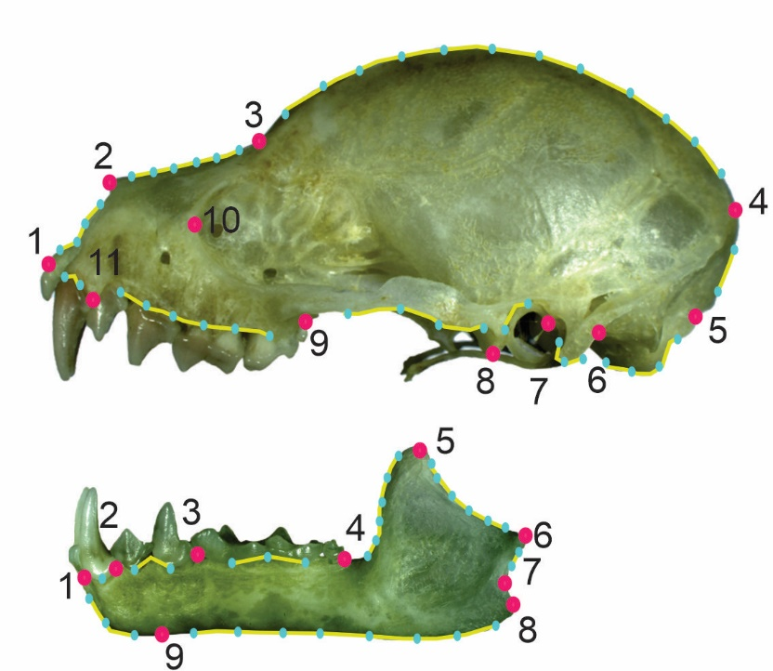
Figure S1. Placement of landmarks (pink dots) and semilandmarks (blue dots). Definitions of landmarks can be found in Table S1. Yellow lines represent semilandmarks between two landmarks.
Table S3. Landmarks definition for lateral view of the skull.
Landmarks | Definition
1 | Anterior most point of the premaxilla.
2 | Point of inflection between nostrils and the nasal bone.
3 | Point of inflection between the nasal and frontal bone.
4 | Crest occipital.
5 | Posterior most point of the foramen magnum.
6 | Intersection between the paracondylar process and the exoccipital bone.
7 | Anterior most point of the malleus.
8 | Most anterior point of process of zygomatic arch and squamosal region.
9 | Most posterior point of the maxillary last molar.
10 | Posterior most point of the foramen lacrimal.
11 | Posterior point of canine, at the level of insertion into the maxillary bone.

Figure S2. Placement of landmarks (pink dots) and semilandmarks (blue dots). Definitions of landmarks can be found in Table S2. Yellow lines represent semilandmarks between two landmarks.
Table S4. Landmarks definition for lateral view of the jaw.
Landmarks | Definition
1 | Anterior most point of the ramus, at the insertion of the lower internal incisors.
2 | Midpoint between canine and premolar 1, in the insertion of the ramus.
3 | Midpoint between the last premolar and the first molar, in the insertion of the ramus.
4 | Most posterior point of the last molar, at the level of insertion into the ramus.
5 | Superior tip of the coronoid process.
6 | Posterior most point of the condylar processes.
7 | Point of maximum curvature at the sigmoid notch.
8 | Posterior most point of the angular process.
9 | Posterior most point of the symphysis mandibular, at the level of the anterior point of the masseter scar.

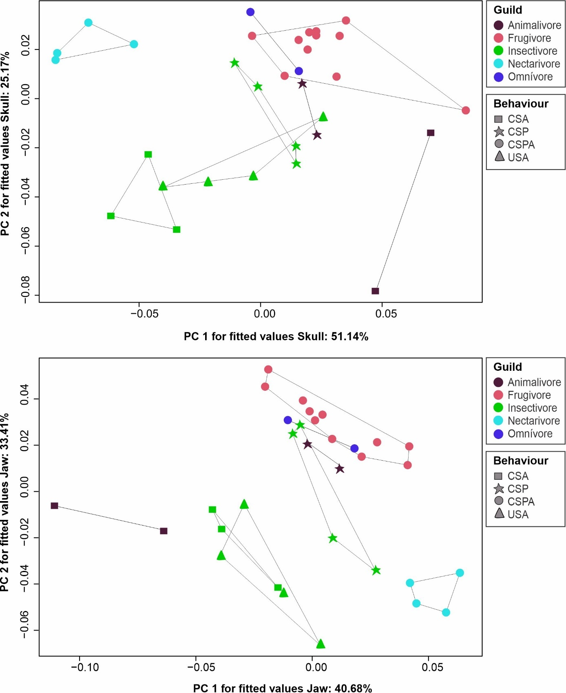
Figure S3. Pairwise phylogenetic results for bat species skull (top) and jaw (bottom) in relation to trophic guild factors and foraging behavior.

Table S4. Results of Anova for allometric trajectory of bat skull. ResDf: Residual of degrees of freedom; SS: sum of squares; MS: mean squares; R2: coefficient of determination; F: Fisher statistic; Z: Z statistic (effect size); P: significance.
 | ResDf | Df | RSS | SS | MS | R2 | F | Z | P
shape ~ size + guild * strategy (Null) | 23 | 1 | 0.040 | - | - | 0.000 | - | - | -
shape ~ size * guild * strategy | 16 | 7 | 0.025 | 0.014 | 0.002 | 0.116 | 1.349 | 1.058 | 0.144
Total | 31 | - | 0.127

Table S5. Results of Anova for allometric trajectory of bat jaw. ResDf: Residual of degrees of freedom; SS: sum of squares; MS: mean squares; R2: coefficient of determination; F: Fisher statistic; Z: Z statistic (effect size); P: significance.
 | ResDf | Df | RSS | SS | MS | R2 | F | Z | P
shape ~ size + guild * strategy (Null) | 23 | 1 | 0.040 | - | - | 0.000 | - | - | -
shape ~ size * guild * strategy | 16 | 7 | 0.023 | 0.020 | 0.002 | 0.161 | 1.972 | 1.861 | 0.030
Total | 31 | - | 0.124

