Three-Dimensional-Printed Calcium Alginate/Graphene Oxide Porous Adsorbent with Super-High Lead Ion Adsorption Ability in Aqueous Solution

Na Wang ^{1, 2, †}, Fuxiang Song ^{1, 2, †}, Yuxin Niu ^{1, 2}, Zezhou Hu^{1, 2}, Wenjie Chen ^{1, 2}, Bin Liu ^{1, 2,}*, Weibo Xie ^{1, 3,}*

a School/Hospital of Stomatology, Lanzhou University, Lanzhou 730000, P. R. China
b Key Laboratory of Dental Maxillofacial Reconstruction and Biological Intelligence Manufacturing, School of Stomatology, Lanzhou University, Lanzhou 730000, P. R. China
c Second Hostipal of Lanzhou University, Lanzhou 730000, P. R. China

Keywords: 3D printing CA/GO; porous structure; Pb²⁺; oral medical wastewater
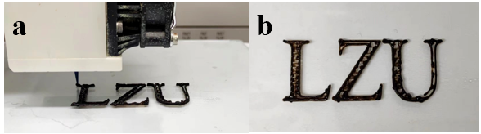
Fig. S1 (a) The 3D system setup of printing procedure. (b) The samples of the 3D CA/GO, “LZU” is the abbreviation of Lanzhou University.
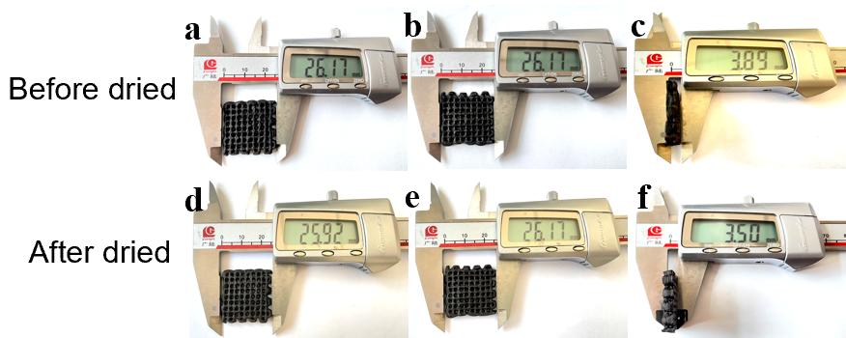
Fig. S2 The measurement of volumetric shrinkage of the 3D CA/GO between primary mold and the final sample. The first row and second row are photos of 3D CA/GO for primary mold and final sample size measurements.

V1 and V2 represent the volume of the primary mold and the final sample respectively. The volume shrinkage rate is calculated by the formula ((V1-V2)/V1×100%) to be 10.03%.

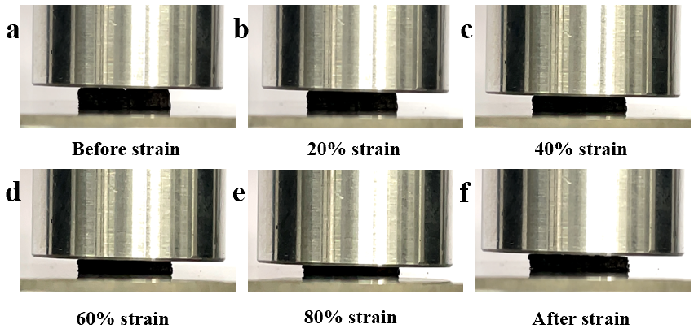
Fig. S3 The test process to measure the compression performance of 3D CA/GO. (a-f) the pictures of 3D CA/GO is compressed by 20%, 40%, 60%, and 80%, and the pictures recovered after compression.
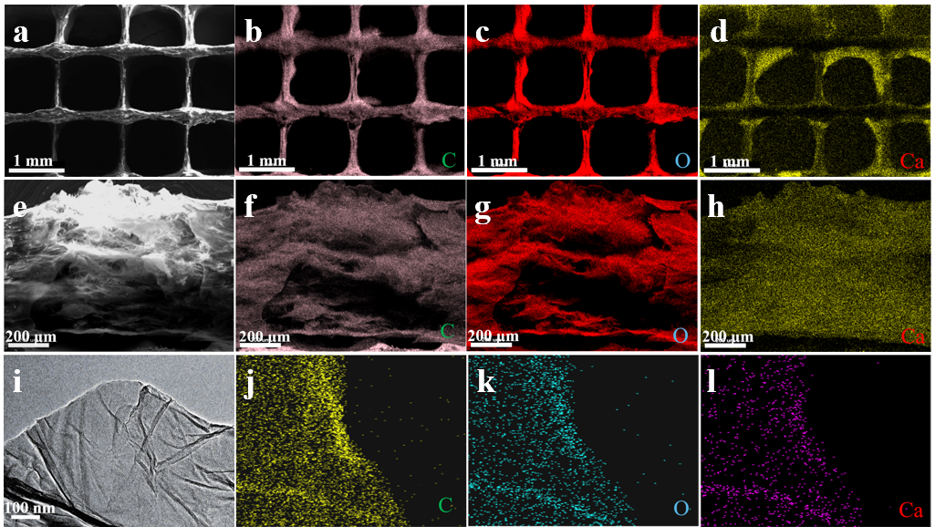
Fig. S4. (a-h) SEM and mapping characterization results of 3D CA/GO. (i-l) TEM and mapping characterization results of CA/GO sheets.

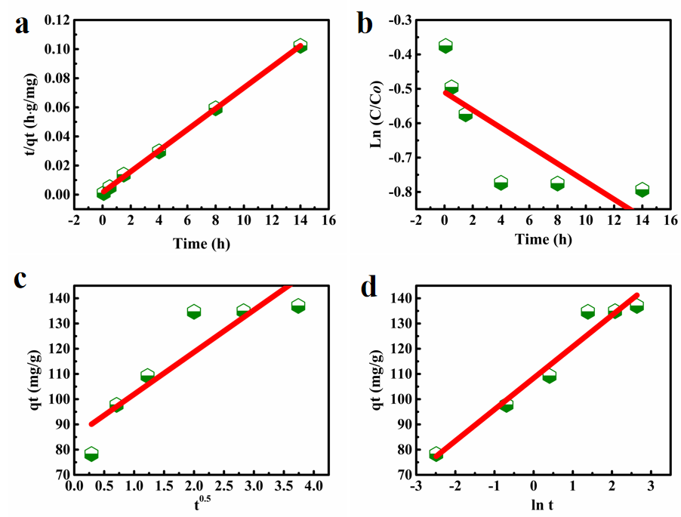
Fig. S5 The Kinetic model fitting curve: (a) Pseudo-second-order model, (b) Pseudo-first-order model, (c) Intra-particle diffusion model, (d) Elovich model, respectively.
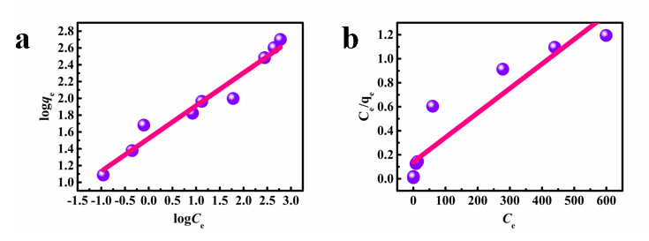
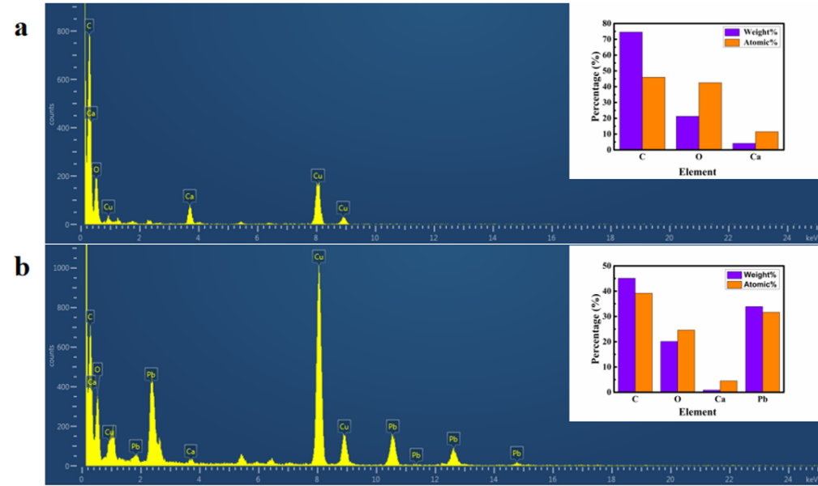
Fig. S6 The Isotherm model fitting curve: (a) Freundilich and (b) Langmuir model.
Fig. S7 EDX characterization results of 3D CA/GO before and after Pb²⁺ adsorption.
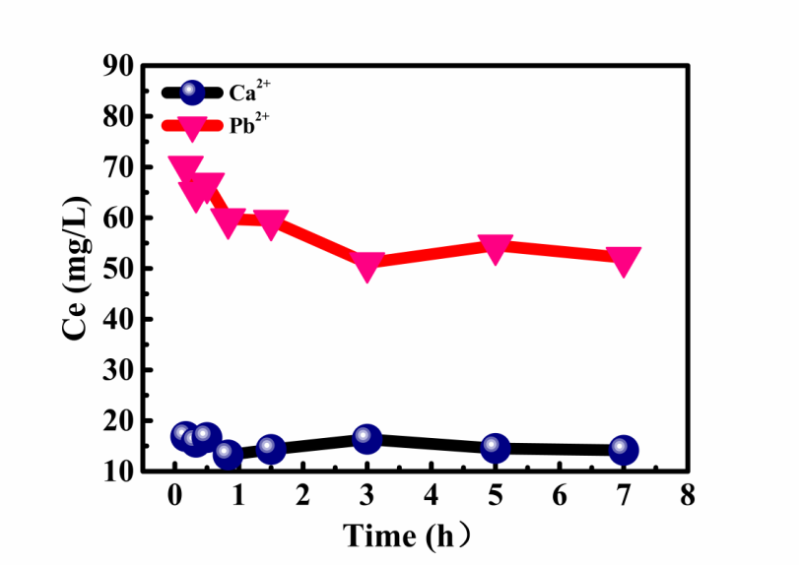
Fig. S8 Results of Ca²⁺ release experiments.

Table S2 List of concentrations of major heavy metal ions in collected medical wastewater before and after adsorption by 3D CA/GO.
Ionic | Concentration
Ionic | Before adsorption (mg/L) | After adsorption (mg/L)
Pb²⁺ | 0.023925 | 0.002
Mo⁴⁺ | 0.03 | 0.02
Cd²⁺ | 0.07 | 0.06
Co³⁺ | 0.01 | 0.009
Ni²⁺ | 0.095 | 0.09
Sr²⁺ | 0.5 | 0.45
Ti²⁺ | 0.02 | 0.02
Cr²⁺ | 0.02 | 0.02

* Corresponding authors: liubkq@lzu.edu.cn; jiewb@lzu.edu.cn

