Systematic analysis of paralogous regions in 41,755 exomes uncovers clinically relevant variation

Supplemental data

Supplemental data T1. Genomic coordinates of single nucleotide variant calls (not due to a gene conversion).
Column A (recurrence) represents the number of times the variant is observed in the study cohort. Column B shows the genomic coordinate of the variant (Ensembl default notation; hg19).

Supplemental data T2. Genomic coordinates of gene conversion calls.
Column A (recurrence) represents the number of times the event is observed in the study cohort. Column B, C and D respectively represent the chromosome, genomic start and genomic end of the event.

Supplemental data T3. Genomic coordinates of SNVs introduced by gene conversions.
Column A (recurrence) represents the number of times the variant is observed in the study cohort. Column B shows the genomic coordinate of the variant (Ensembl default notation; hg19).

Supplemental data T4. Genomic coordinates of deletion calls.
Column A (recurrence) represents the number of times the event is observed in the study cohort. Column B, C and D respectively represent the chromosome, genomic start and genomic end of the event.

Supplemental data T5. Overview of technical validation for SNVs not due to a gene conversion
Column A indicates in which sample the variant was identified. Column B displays the variant call. In column C the corresponding variant in the paralogous region can be found. Column D indicates whether or not the variant was found in the VCF file of the LRS data. If so, the variant call is validated (column E). If not, the variant was manually checked in the BAM file using IGV. Column F indicates whether or not the variant was clearly visible in the reads. If so, the variant call is validated (column G). Column H summarizes the total validation status (column E OR column G). Column I indicates whether or not the variant is rare (cohort allele frequency ≤ 0.5%).

Supplemental data T6. Overview of technical validation for gene conversions and deletions.
Column A indicates in which sample the variant was identified. Column B indicates whether the call is predicted to be a deletion or a gene conversion. Column F indicates whether or not the call is validated.

Supplemental data T7. Technical overview of SNVs (not due to a gene conversion) in the trios.
Column A shows the identifier for the particular child in each trio. There are 6,980 child-parent trios in total. Column B and D indicate the number of SNV calls in the particular proband (for 10% and 0.5% respectively). Column C and E indicate the number of variants that are not observed in the parents despite 60x read depth in the masked alignment (for 10% and 0.5% respectively; Methods). Overall, 99% of the variation that is observed in the child is inherited from one of the parents.

Supplemental data T8. Variants with ambiguous positions.
Every variant call in the table either corresponds to a missense or LoF-variant (Genomic coordinate in column B; Ensembl consequence in column C; Canonical transcript in column D), or to a variant in the non-coding space of the genome (Genomic coordinate in column F; Ensembl consequence in column G; Canonical transcript in column H). LRS data allows us to evaluate which one of these 2 possible variants is the actual genomic alteration causing the variant call by Chameleolyser (column E for the coding and column I for the non-coding space).

Supplemental data T9. Number of synonymous, missense and LoF variants identified by GATK in the full exome.
Column A shows the identifier for the individual in the study cohort. Column B, C and D respectively represent the number of synonymous, missense and LoF variants in the exome.

Supplemental data T10. Number of synonymous, missense and LoF VAPs identified by Chameleolyser.
Column A shows the identifier for the individual in the study cohort. Column B, C and D respectively represent the number of synonymous, missense and LoF variants in the paralogous regions of the exome as determined by Chameleolyser.

Supplemental data T11. Overview of the cohort of 41,755 WES samples.
Column A shows the identifier for the individual in the study cohort. Column B represents an identifier for the family. Column C indicates which member of the family the sample is (Child, father, mother or single sample). In column D the enrichment kit can be found. The type of sequencing machine that is used to generate the underlying data can be found in column E. Read length of the respective sequencing reads are displayed in column F. The molecular status before we conducted our analysis is displayed in column G.

Supplemental data T12. SNVs (not due to gene conversions) of clinical interest.
Column A indicates in which sample the variant was identified. Column B corresponds to the variant call. Column C is the other possible genetic variant that could give rise to the variant call in column B (VAP). The gene symbol is displayed in column D. The Ensembl consequence of the variant, relative to the canonical transcript (column F) is represented in column E. The variant allele fraction of the variant in the masked alignment is indicated in column G. The number of times that the variant is observed in the study cohort can be found in column H. Whether or not the variant is wet-lab tested is depicted in column I. In case the variant is confirmed as an alteration of the protein coding gene, a ‘1’ is displayed in the very last column.

Supplemental data T13. Homozygous ectopic gene conversions of clinical interest.
Column A indicates in which sample the variant was identified. Column B, C and D respectively represent the chromosome, genomic start and genomic end of the ectopic gene conversion event. The number of times the event is observed in our study cohort can be seen in column E. The variant that is introduced by means of the gene conversion can be found in column F. Gene symbol and the Ensembl consequence of the variant (relative to the canonical transcript) can respectively be found in columns G and H.

Supplemental data T14. STRC and STRCP1 coverage for the study cohort.
Data table corresponding to supplementary figure 4. Column A represents the sample. Column B represents the number of reads that uniquely align onto the last 6 exons of STRC. The number of reads that align uniquely onto the paralogous sequence of STRCP1 are displayed in column C. The ratio (column B divided by column C) can be found in column D. The percentage of all reads that originate from STRC can be found in column E (B/(B+C)). Based on this, the number of STRC and STRCP1 copies can be estimated (the estimate corresponds to the closest theoretical ratio, see supplementary figure 4). In case the deafness disease gene panel was requested, a ‘1’ is displayed in column H.

Supplemental data T15. Homozygous deletions of clinical interest.
Column A indicates in which sample the deletion was identified. Column B, C and D respectively represent the chromosome, genomic start and genomic end of the event. The number of times the event is observed in our study cohort can be seen in column E. The gene symbol of the gene that is affected by the deletion can be found in column F.

Supplemental data T16. Homozygous STRC deletions and gene conversions in patients with hearing impairment.
Amongst the group of patients with hearing impairment, 58 homozygous STRC deletions were identified with WES. MLPA confirmed these events (column F). With Cameleolyser, 22 of these events are predicted to be gene conversions instead of deletions (column E). Respective sample and genomic coordinates can be found in columns A-D.

Supplemental data T17. Homozygous conversions from STRCP1 to STRC that do not introduce LoF variants into STRC
In our cohort of 41,755 we identified 47 ectopic gene conversions from STRCP1 to STRC that do not introduce LoF variants into STRC. Column A represents the identifier of the individual. Columns B, C and D correspond to respectively the chromosome, genomic start and genomic end of each event. For clarity it is also indicated that all of these events are called as homozygous gene conversion events with Chameleolyser (column E) and homozygous deletions with Exome Depth (column F).

Supplemental data T18. Overview of all genes implicated in the homology analysis.
Column A represents the gene symbol of the gene that is affected by sequence homology and therefore incorporated in our homology study. In column B the type of the gene product can be found (Ensembl 97). Ensembl stable gene id and stable canonical transcript id can respectively be found in columns C and D. If coding exons of the canonical transcript are affected, they are listed in column E. Column F represents the ratio of exons that are involved in the analyses and the total number of exons in the canonical transcript. The total number of coding exons, over all transcripts, is displayed in column G. The number of coding bases can be found in column H. The phenotype that is linked to the respective gene is shown in the last column.

Supplemental data T19. Genomic alignment between CELA3A (chr1:22338346-22339613) and CELA3B (chr1:22315158-22316429).
An ectopic gene conversion from CELA3B to CELA3A introduces variants into CELA3A, i.e. the sequence differences between both genes.

Supplemental data T20. List of variant calling regions.
Column A, B and C respectively represent the chromosome, start and end of the variant calling regions in this study.

Supplemental data T21. List of regions for read extraction.
Column A, B and C respectively represent the chromosome, start and end of the read extraction regions in this study.

Supplemental data T22. List of regions to be masked in re-alignment of extracted reads.
Column A, B and C respectively represent the chromosome, start and end of the regions that are masked in the reference sequence in the re-alignment of the extracted reads.

Supplemental data T23. Overview of subregions for deletion and gene conversion calling.
Regions in which deletion and gene conversion identification was conducted. All regions come in pairs: exactly 2 regions that are homologous.

Supplemental figures
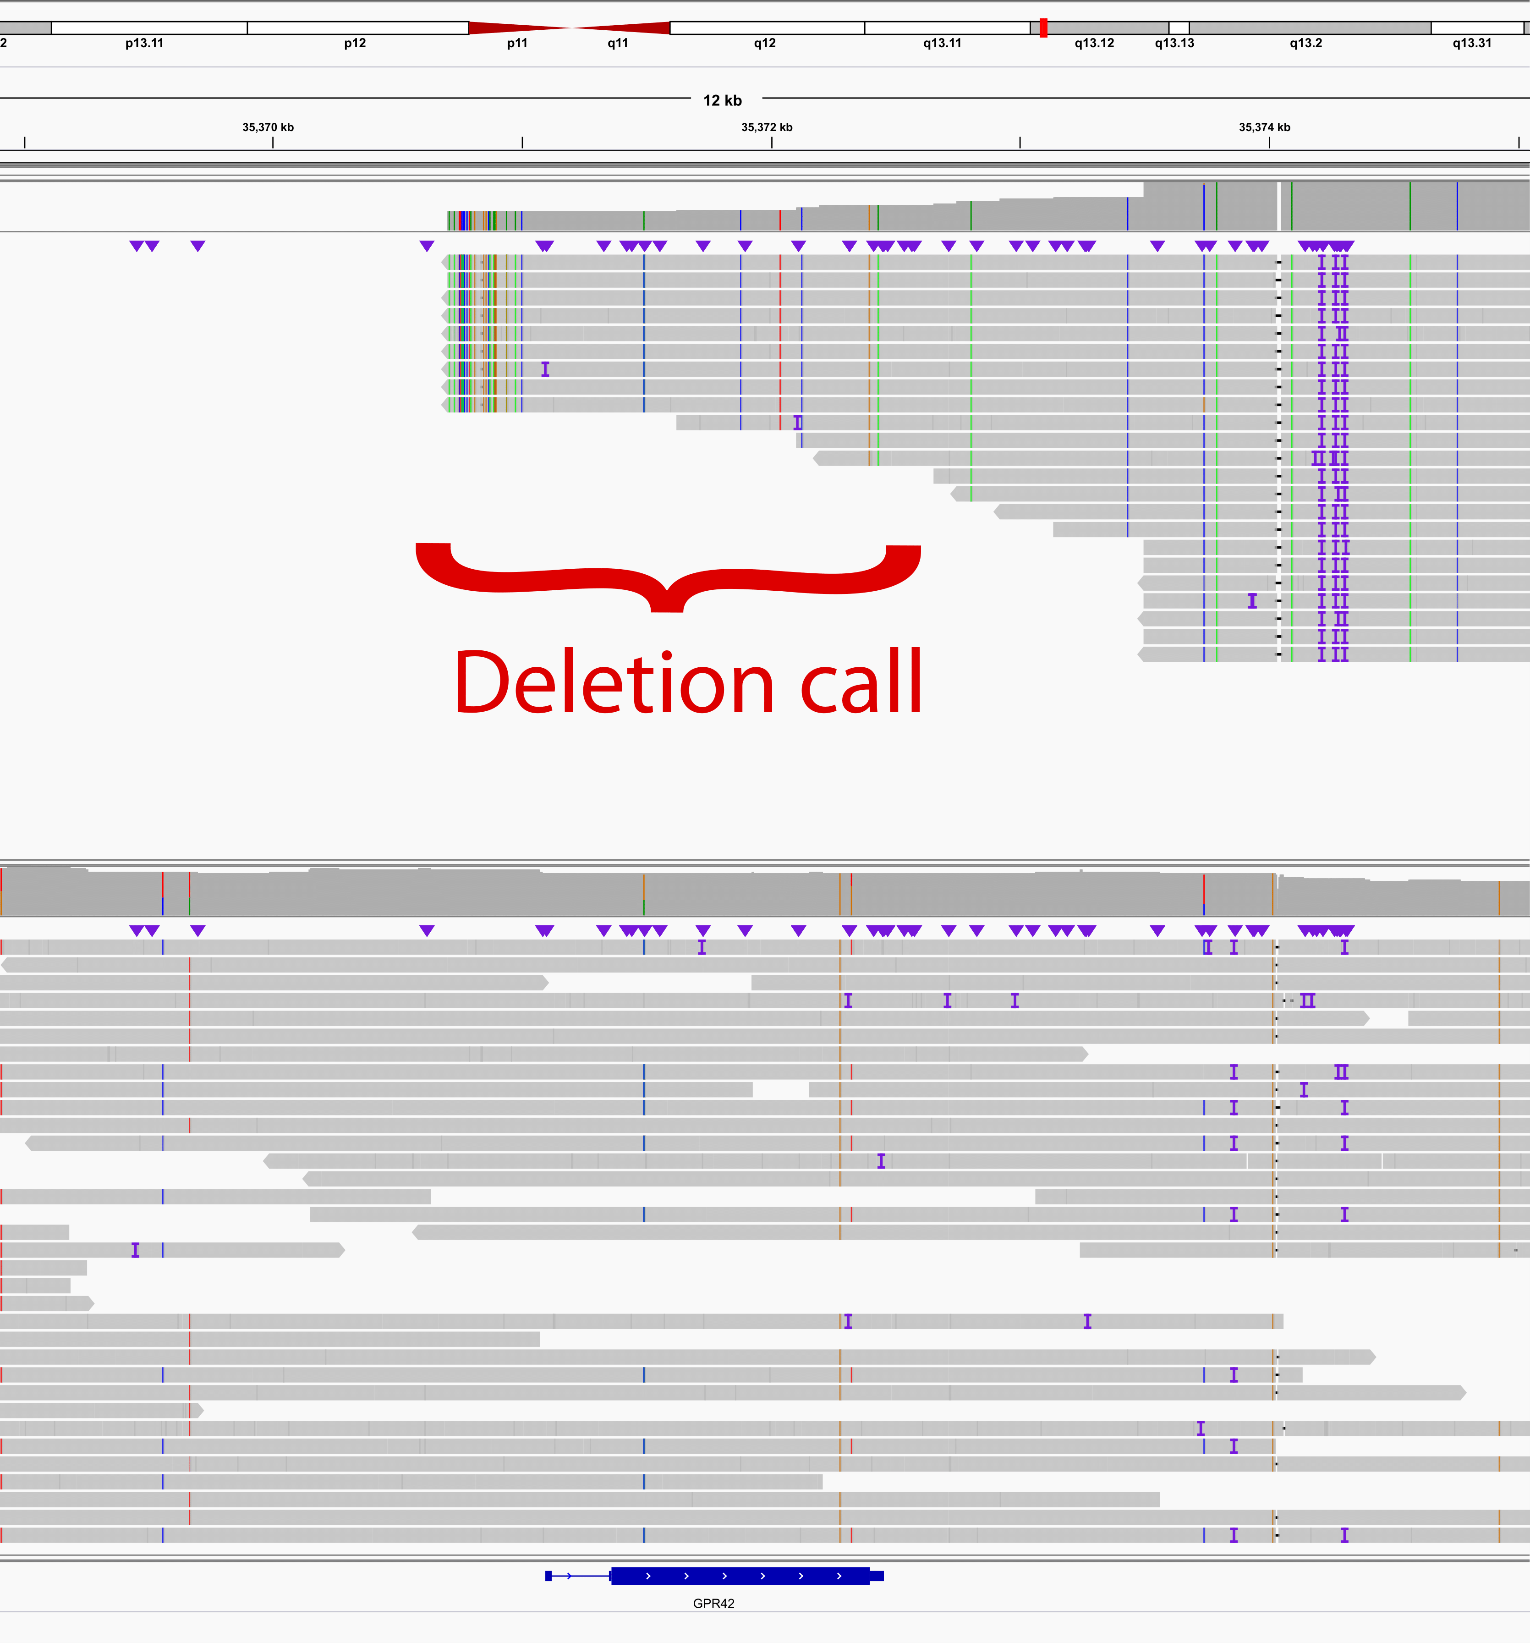

Supplemental figure 1. Possible discrepancy between Chameleolyser and LRS for a single homozygous deletion.
LRS reads are visualized for 2 individuals. In the upper half of the figure, an individual in which Chameleolyser identified a homozygous deletion of the GPR42 gene is visualized. The lower half corresponds to an individual without a deletion call for this gene. The genomic region of the variant call is indicated with a brace. It is clear that there is indeed a deletion in the individual that is displayed in the upper half of the figure. However, we cannot be completely sure about the fact that the genomic region within the brace is indeed homozygously deleted. The coverage track on the image however strongly suggests that the deletion comprises GPR42 and thus that the call of Chameleolyser is correct.

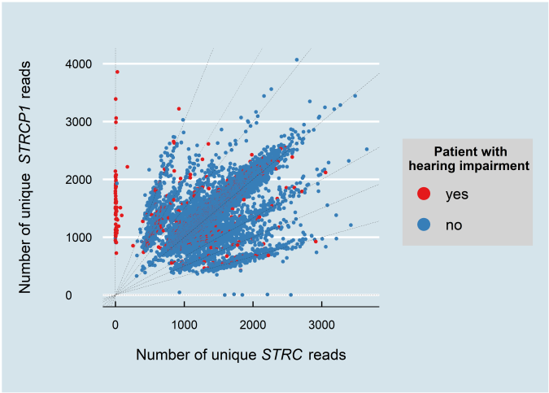

Supplemental figure 2. The number of unique STRC versus STRCP1 reads.
The horizontal axis represents the absolute number of uniquely aligned reads onto the last 6 exons of STRC (ENST00000450892). The vertical axis corresponds to the number of reads that uniquely align onto the homologous region of STRCP1. Each dot is an individual in the study cohort. The visualization is illustrative for the number of STRC and STRCP1 copies each individual has. Patients with hearing impairment are coloured red. Point clouds are formed due to the (discrete) genetic nature of the events.
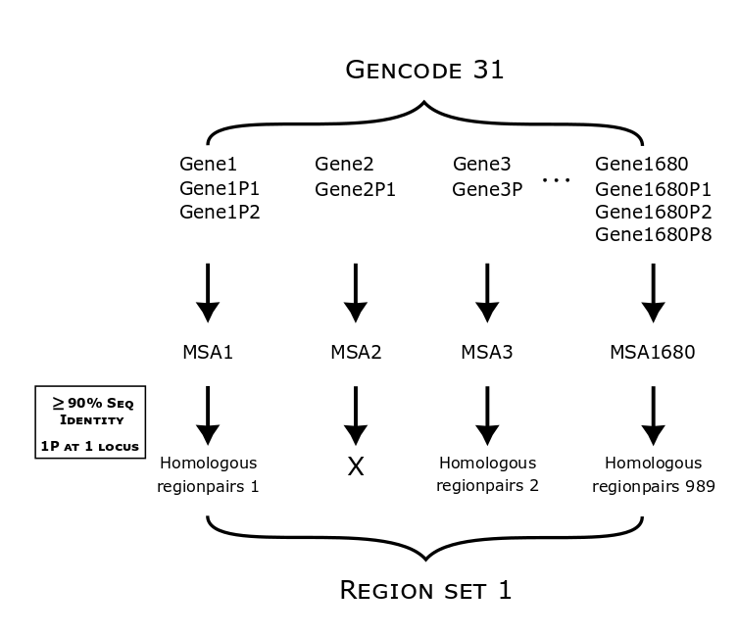

Supplemental figure 3. Graphical summary of the derivation of region set I
This figure is a graphical representation of the derivation of region set I: regions in protein coding genes with known pseudogenes (Methods).

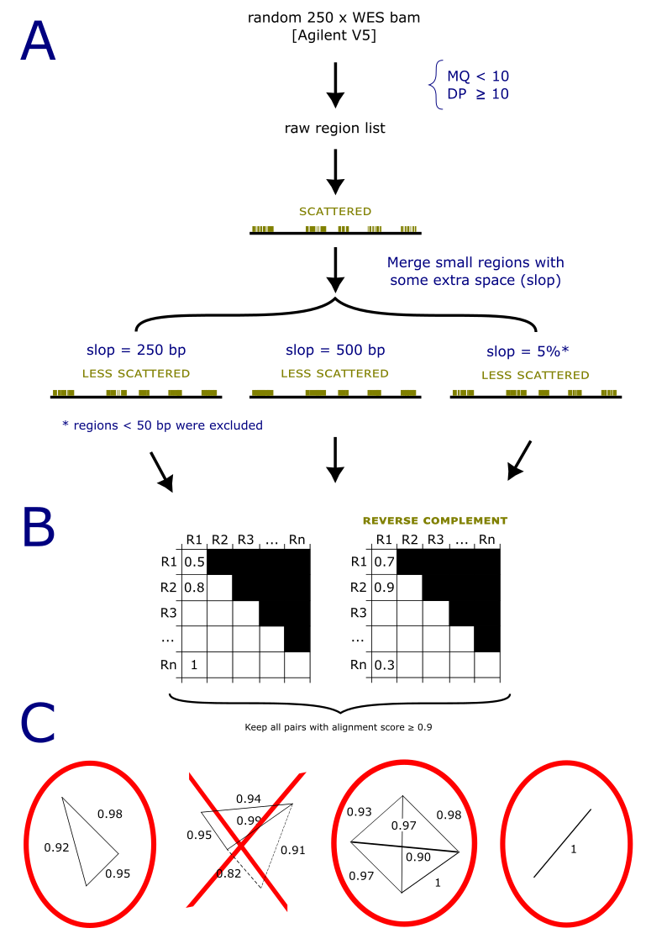

Supplemental figure 4. Graphical summary of the derivation of region set II
This figure is a graphical representation of the derivation of region set II: regions that are associated with low mapping qualities (Methods).

