Additional File2_Supplementary Material
Figure 1 [Supplementary Material]. Healthcare workers’ (HCW) acceptability of mandatory vaccination (quite or very favourable) against measles, pertussis, varicella and influenza for HCW according to region; study in healthcare facilities, France, 2019
1.a Vaccination against measles |  | 1.b Vaccination against pertussis
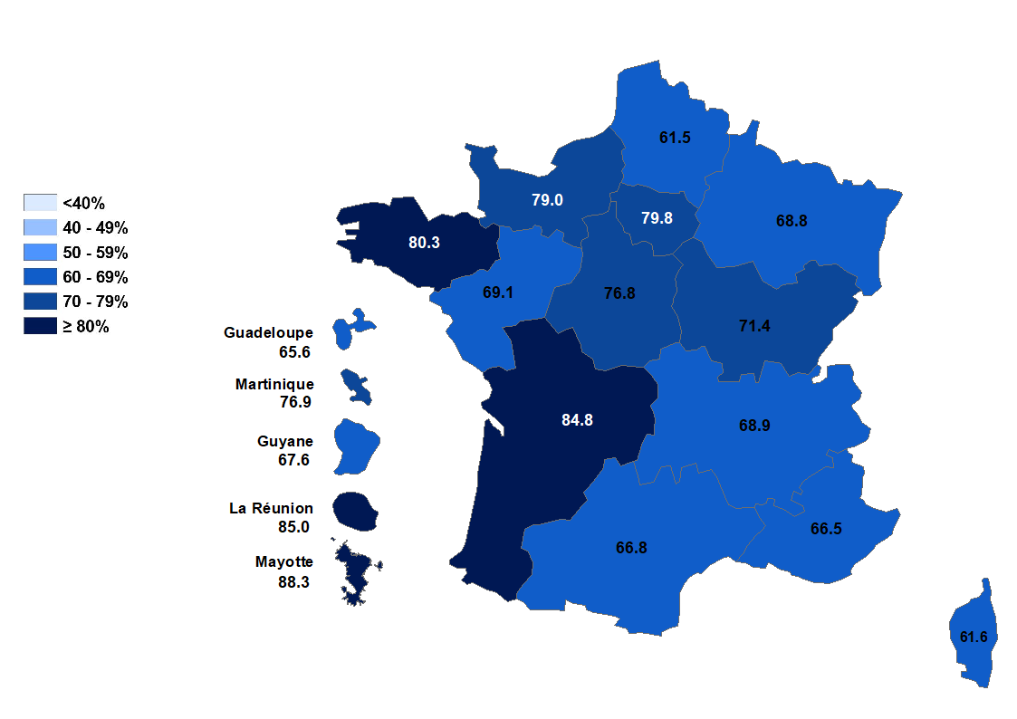 | 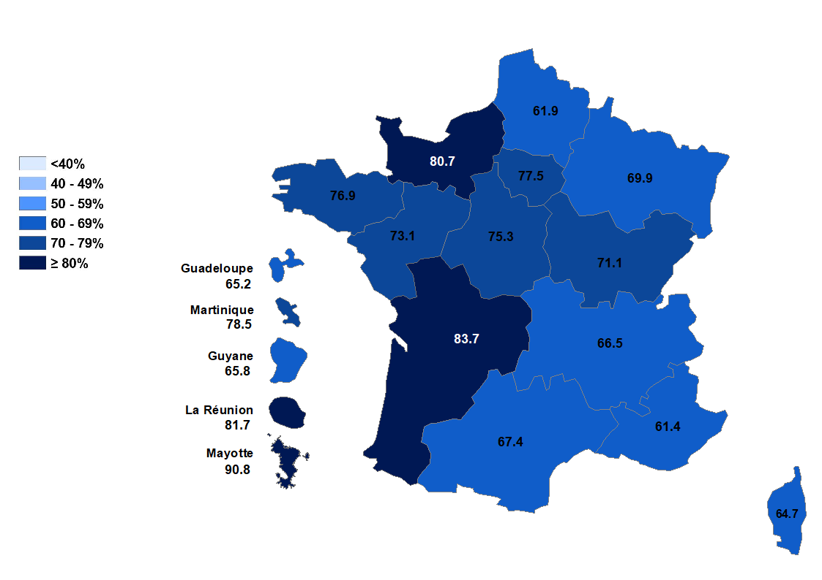
1.c Vaccination against varicella |  | 1.d Vaccination against influenza
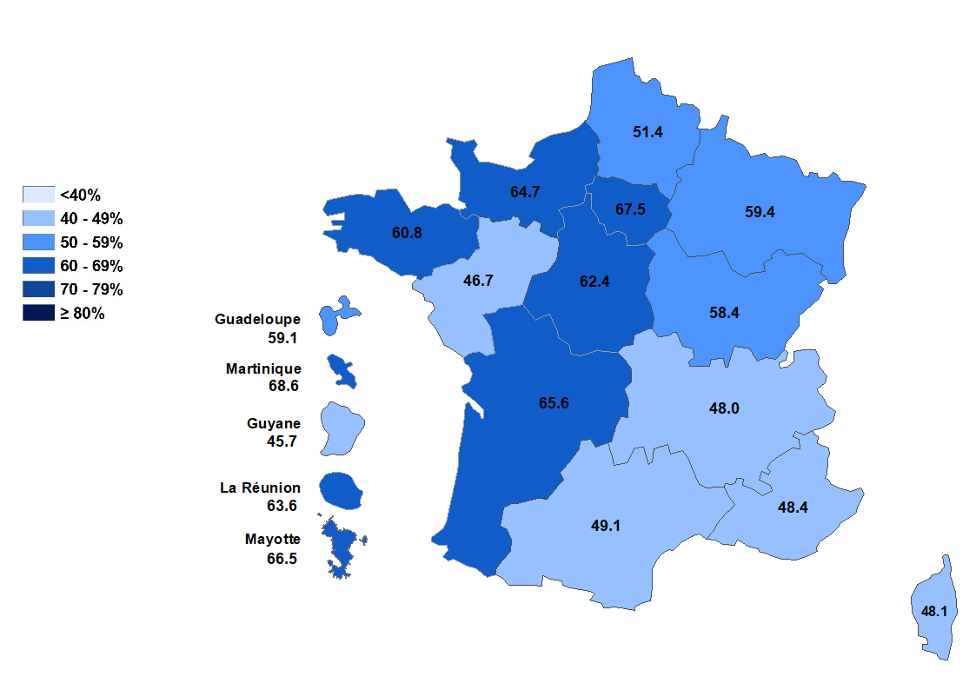 |  | 