Supplementary information
Inhalable SARS-CoV-2 vaccine for single-dose dry powder aerosol immunization

Tong Ye,^{1,2,#} Zhouguang Jiao,^{1,#} Xin Li,^{1,3,#} Zhanlong He,^{4,#} Yanyan Li,⁴ Fengmei Yang,⁴ Xin Zhao,⁴ Youchun Wang,⁵ Weijin Huang,⁵ Meng Qin,⁶ Yingmei Feng,⁷ Yefeng Qiu,⁸ Wenhui Yang,⁹ Lingfei Hu,⁹ Yaling Hu,¹⁰ Yu Zhai,¹⁰ Erqiang Wang,¹⁰ Di Yu,^{11,12} Shuang Wang,¹ Hua Yue,¹ Yishu Wang,^{1,2} Hengliang Wang,^{3,*} Li Zhu,^{3,*} Guanghui Ma,^{1,2,*} Wei Wei ^{1,2,*}

¹ State Key Laboratory of Biochemical Engineering, Institute of Process Engineering, Chinese Academy of Sciences, Beijing 100190, China
² School of Chemical Engineering, University of Chinese Academy of Sciences, Beijing 100049, China
³ State Key Laboratory of Pathogen and Biosecurity, Beijing Institute of Biotechnology, Beijing 100071, China
⁴ Yunnan Key Laboratory of Vaccine Research Development on Severe Infectious Disease, Institute of Medical Biology, Peking Union Medical College, Chinese Academy of Medical Sciences, Kunming 650118, China
⁵ Division of HIV/AIDS and Sex-Transmitted Virus Vaccines, Institute for Biological Product Control, National Institutes for Food and Drug Control (NIFDC) and WHO Collaborating Center for Standardization and Evaluation of Biologicals, Beijing 102629, China
⁶ Beijing Advanced Innovation Center for Soft Matter Science and Engineering, College of Life Science and Technology, Beijing University of Chemical Technology, Beijing 100029, China
⁷ Beijing Youan Hospital, Capital Medical University, Beijing 100069, China
⁸ Laboratory Animal Center, Academy of Military Medical Science, Beijing 100071, China
⁹ State Key Laboratory of Pathogen and Biosecurity, Beijing Institute of Microbiology and Epidemiology, Beijing 100071, China
¹⁰ Sinovac Life Sciences Coperation Ltd., Beijing 100085, China
¹¹ Frazer Institute, Faculty of Medicine, The University of Queensland, Brisbane, Queensland 4072, Australia
¹² Ian Frazer Centre for Children's Immunotherapy Research, Child Health Research Centre, Faculty of Medicine, The University of Queensland, Brisbane, Queensland 4072, Australia
# These authors contributed equally
*Correspondence: weiwei@ipe.ac.cn (W.W.), ghma@ipe.ac.cn (G.M.), jewly54@bmi.ac.cn (L.Z.), wanghl@bmi.ac.cn (H.W.)

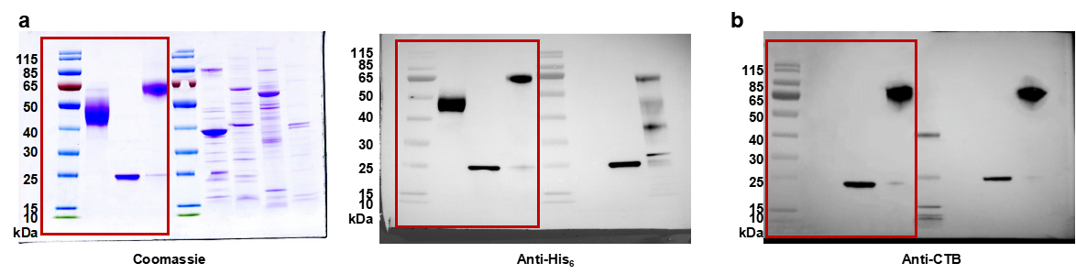
SI Figure 1. Uncropped immunoblots from Figure 1b and Extended Data Figure 1a.

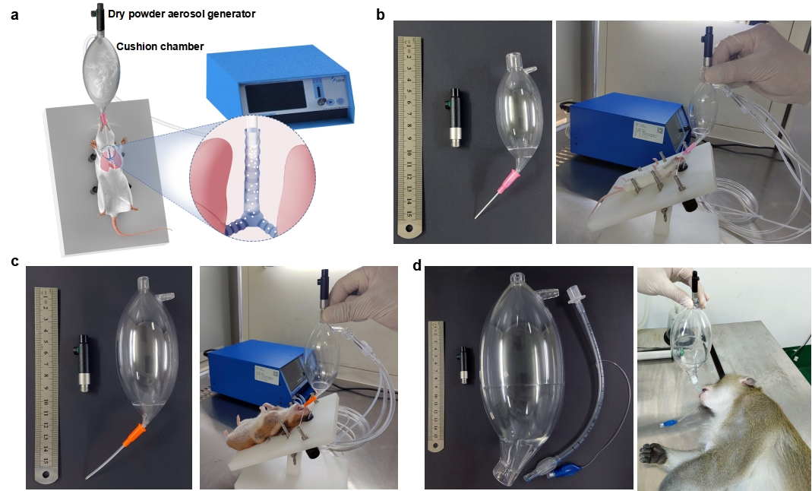
SI Figure 2. Dry powder inhaler (DPI) device diagram and its applications.
(a) DPI device diagram.
(b) DPI device for mouse immunization.
(c) DPI device for hamster immunization.
(d) DPI device for monkey immunization.

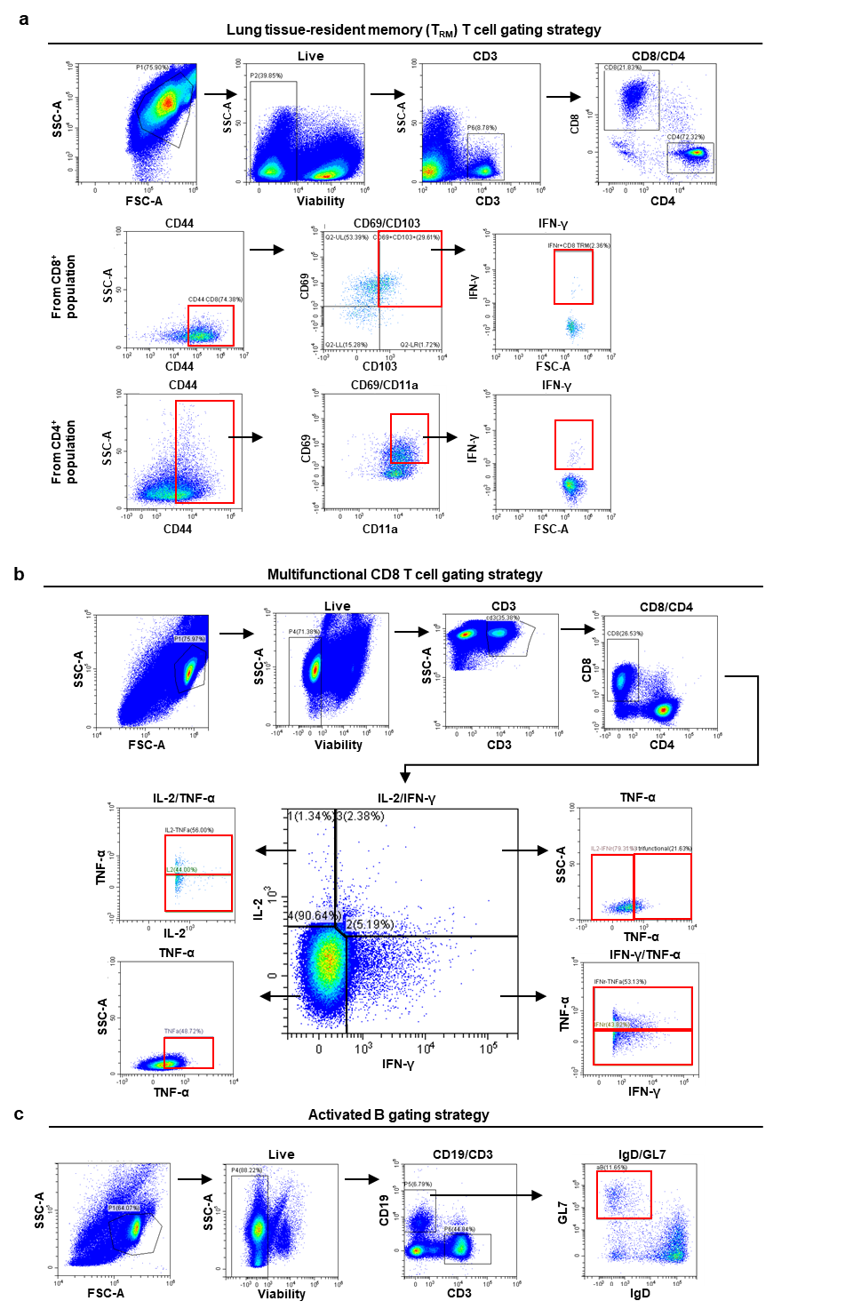
SI Figure 3. Flow cytometric gating strategies, related to Figures 2 and Extended Data Figure 5.
(a) Gating strategy used in this study to distinguish lung tissue-resident T cells.
(b) Gating strategy in this study used to distinguish multifunctional CD8⁺ T cells.
(c) Gating strategy in this study used to distinguish activated B cells.
The example shown is representative of BALB/c mice vaccinated with R-CNP@M via inhalation.

