Supplementary Information

Effects of various transition metals on the thermal oxidative stabilization of polyacrylonitrile nanofibers

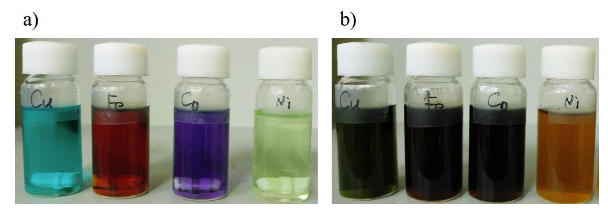
Fig S1. (a) Digital images of copper acetate monohydrate, iron acetate, cobalt acetate, and nickel acetate tetrahydrate dissolving in DMF N, N-dimethylformamide (DMF) solvent, respectively. (b) Digital images of PAN/DMP solutions containing copper acetate monohydrate, iron acetate, cobalt acetate, and nickel acetate tetrahydrate additives, respectively.

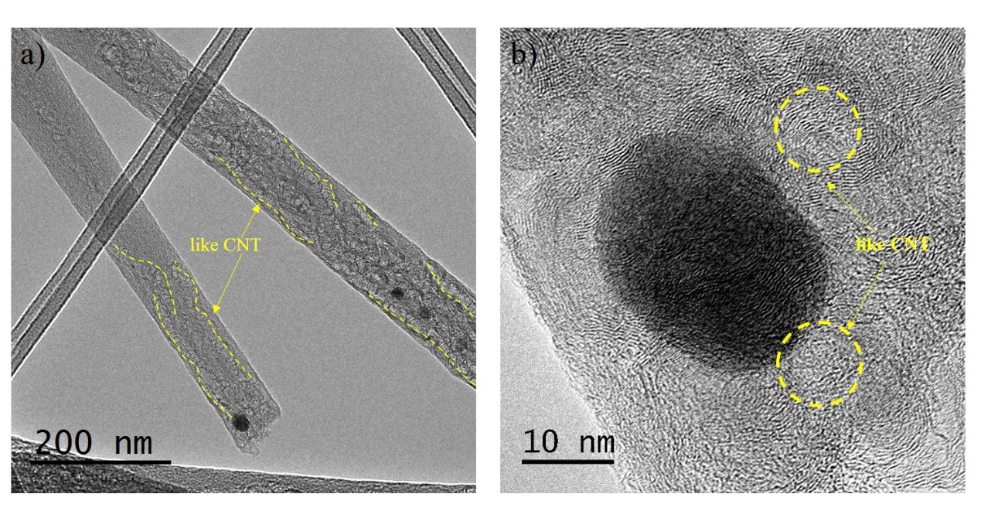
Fig S2. TEM images of carbon nanofibers with iron nanoparticles.

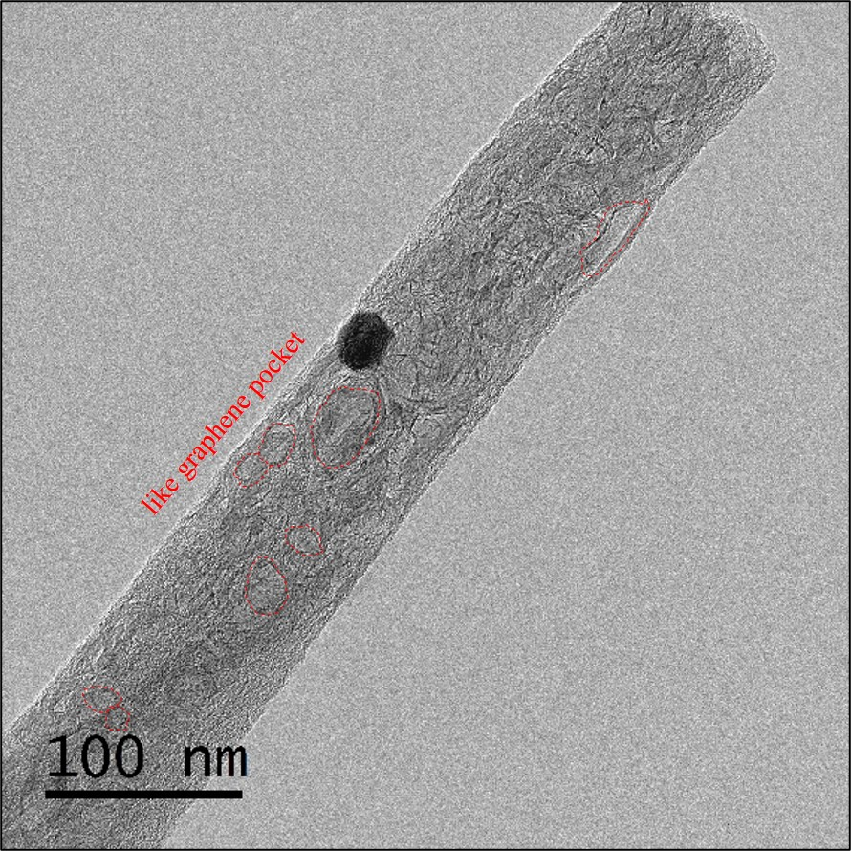
Fig S3. TEM images of carbon nanofibers with cobalt nanoparticles.

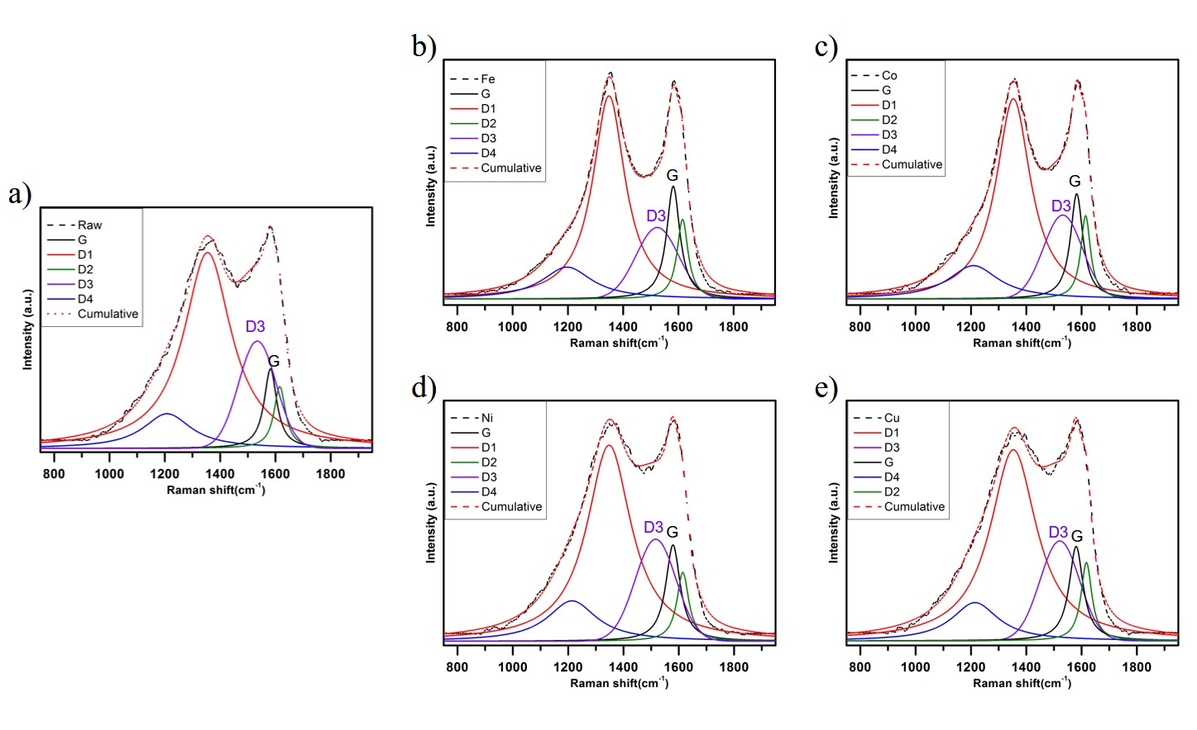
Fig S4. Raman spectroscopy of (a) raw carbon nanofibers, and carbon nanofibers with (b) iron, (c) cobalt, (d) nickel nanoparticles, and with (e) copper acetate monohydrate as addictive.

