Ambient and household air pollution on early-life determinants of stunting – a systematic review and meta-analysis
Vivian C. Pun; Russell Dowling, Sumi Mehta
Supplementary materials
S1 Figure. Odds ratios and 95% confidence intervals (CI) for stunting per 10 μg/m³ increase in ambient PM₁₀ concentration, by exposure period; pooled estimates of odds ratios are indicated by vertical points of diamonds and 95% CI are represented by horizontal points; size of shaded area around point estimate is proportional to weight in calculating pooled estimate.
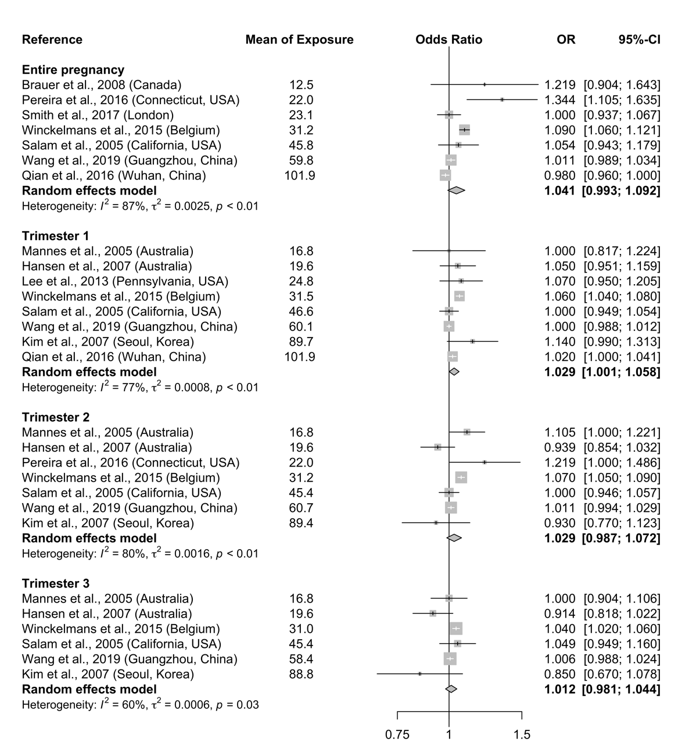
S2 Figure. Odds ratios and 95% confidence intervals (CI) for severe stunting associated with exposure to household air pollution from solid fuel use compared with cleaner fuels during entire pregnancy; pooled estimates of odds ratios are indicated by vertical points of diamonds and 95% CI are represented by horizontal points; size of shaded area around point estimate is proportional to weight in calculating pooled estimate.
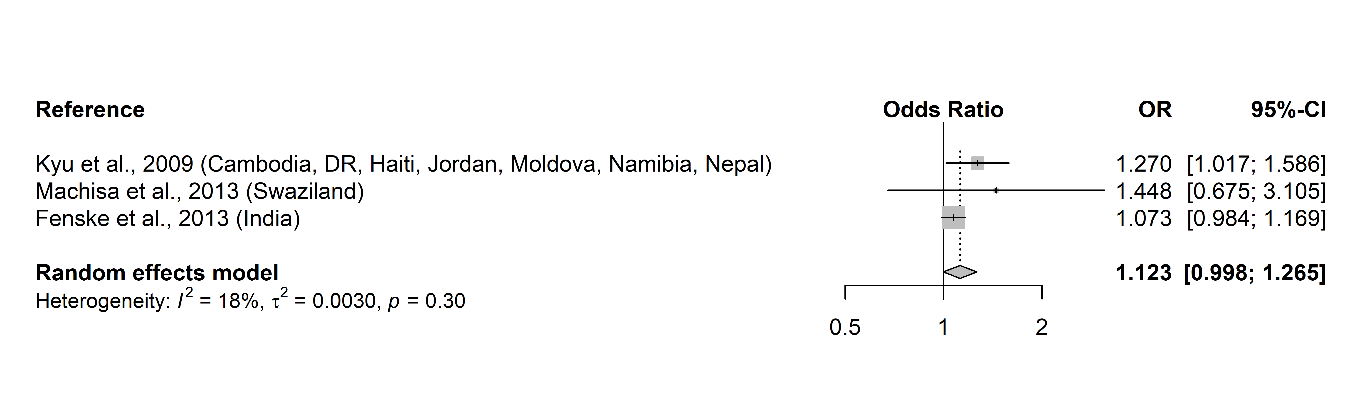

S3 Figure. Sensitivity analysis for SGA and PM_{2.5} (continuous) exposure during trimester 1.

S4 Figure. Sensitivity analysis for HAZ and household air pollution.

