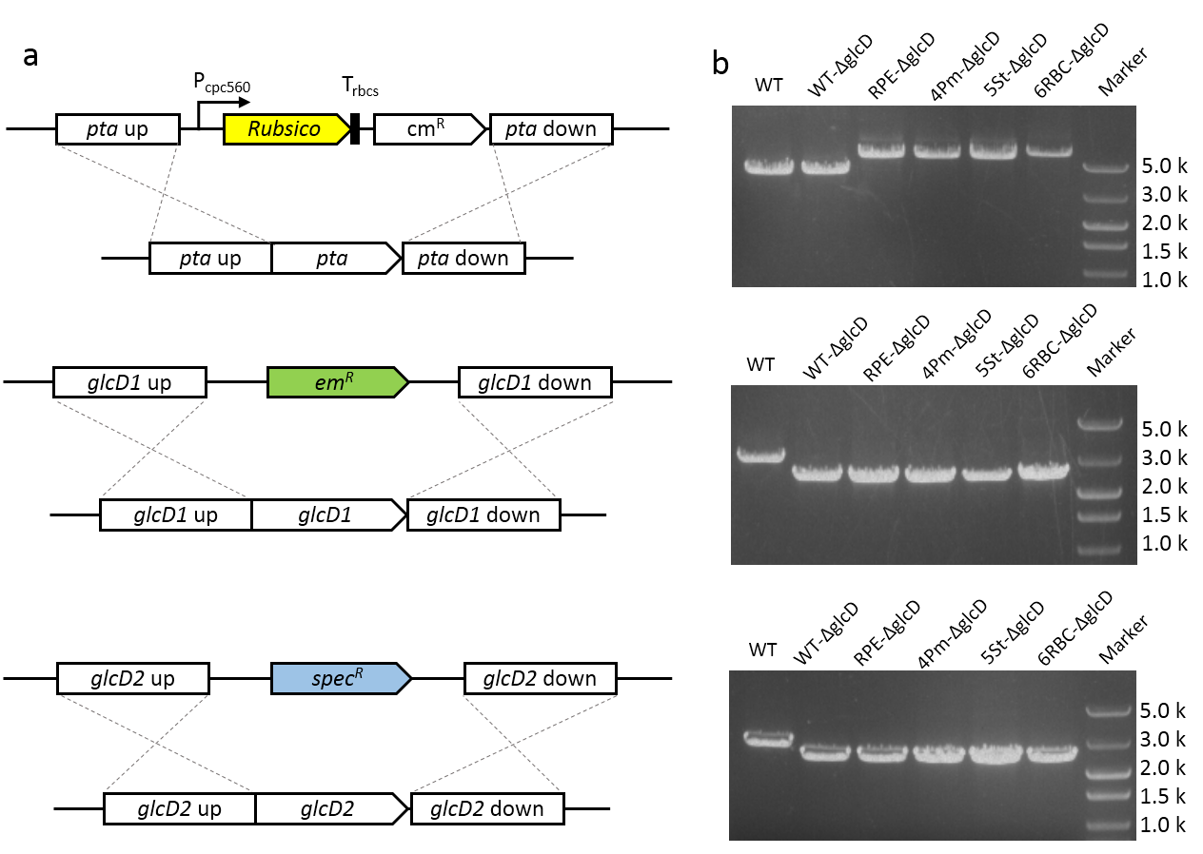
Fig. S1 The genetic modifications in glycolate-producing strains. (A) Genetic modifications. (B) Colony PCR verification of the recombinant cassette at the sites of pta, glcD1 and glcD2. One primer which is 100 bp upstream the recombinant cassette and the other primer which is located in the recombinant cassette were used to confirm the complete segregation of all mutants.

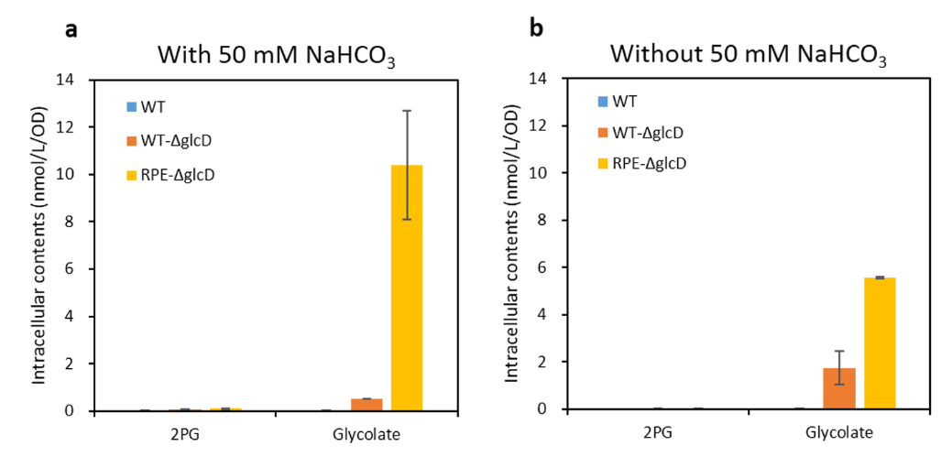
Fig S2. The intracellular contents of 2PG and glycolate in strains WT, WT-ΔglcD and RPE-ΔglcD. Samples were taken after 3 days cultivation with (A) or without (B) different concentration of NaHCO₃ under 100 μmol protons m⁻²s⁻¹ light intensity.
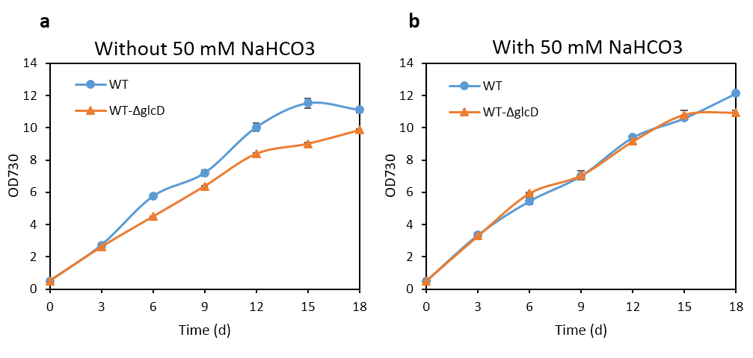
Fig. S3 Growth profile of the WT strain and strain WT-ΔglcD without (A) and with (B) 50 mM NaHCO₃. Cells were cultivated at 30ºC under 100 μmol protons m⁻²s⁻¹ light intensity. Error bars represent standard deviations from biological triplicates conducted in three independent experiments.

Supplemental Table 1 Strains and Plasmids Used in This Study.
Strains and plasmids | Relevant characteristics | Reference
Strains
E. coli DH5α | Commercial strain for plasmid construction | Lab storage
Synechocystis sp. PCC6803 | Wild type | Lab storage
WT-△glcD | glcD1::Em^{r}; glcD2::Spec^{r} | This work
RPE△glcD | pta::Pcpc-rpe, Cm^{r}  glcD1::Em^{r}; glcD2::Spec^{r} | This work
4Pm△glcD | pta::Pcpc-4pm, Cm^{r}  glcD1::Em^{r}; glcD2::Spec^{r} | This work
5St△glcD | pta::Pcpc-5St, Cm^{r}  glcD1::Em^{r}; glcD2::Spec^{r} | This work
6RBC△glcD | pta::Pcpc-6rbc, Cm^{r}  glcD1::Em^{r}; glcD2::Spec^{r} | This work
RPE-GFP | pta::Pcpc-rpe-gfp, Cm^{r} | This work
6RBC-GFP | pta::Pcpc-6rbc-gfp, Cm^{r} | This work
Plasmids
pUC57-pta | pUC57 derivate, Amp^{r} Cm^{r}, containing pta knockout cassette | This work
pUC57-glcD1 | pUC57 derivate, Amp^{r} Em^{r}, containing glcD1 knockout cassette | This work
PUC57-glcD2 | pUC57 derivate, Amp^{r} Spec^{r}, containing glcD2 knockout cassette | This work
pta-RPE | pUC57-pta derivate, containing Pcpc-rpe expression cassette | This work
pta-4Pm | pUC57-pta derivate, containing Pcpc-4pm expression cassette | This work
pta-5St | pUC57-pta derivate, containing Pcpc-5st expression cassette | This work
pta-6RBC | pUC57-pta derivate, containing Pcpc-6rbc expression cassette | This work
pta-RPE-GFP | pUC57-pta derivate, containing Pcpc-rpe-gfp expression cassette | This work
pta-6RBC-GFP | pUC57-pta derivate, containing Pcpc-6rbc-gfp expression cassette | This work

Supplemental Table 2 Primers Used in This Study.
Primers | Sequence (5’-3’)
ptaCm-1 | cgacgttgtaaaacgacggccagtgaattccgggaaggggtaggcattac
ptaCm-2 | gttcattatcaactaattgacaattgacaattccccac
ptaCm-3 | caattgtcaattagttgataatgaactgtgctg
ptaCm-4 | attaagagtaaaaatcgaatttctgccattc
ptaCm-5 | gcagaaattcgatttttactcttaattagttaaaatgatcc
ptaCm-6 | aacagctatgaccatgattacgccaagcttttggctttatttcccgatac
RPE-1 | acgttgaggttatttaaattgagctcacctgtagagaagagtccctgaatatcaaaatggtggg
RPE-2 | tgaattaatctcctacttgac
RPE-3 | taaagtcaagtaggagattaattcaatggcattagaccaaaccaatcg
RPE-4 | gtaattgccaaaactgtaactcaaggatccttacttgtgtacgcccag
4Pm-1 | acgttgaggttatttaaattgagctcacctgtagagaagagtccctgaatatcaaaatggtggg
4Pm-2 | tgaattaatctcctacttgac
4Pm-3 | taaagtcaagtaggagattaattcaatggaccagtcttctcgttac
4Pm-4 | gtaattgccaaaactgtaactcaaggatccttagtcgatacccagacg
5St-1 | acgttgaggttatttaaattgagctcacctgtagagaagagtccctgaatatcaaaatggtggg
5St-2 | tgaattaatctcctacttgac
5St-3 | taaagtcaagtaggagattaattcaatgtcccttgaccaaacc
5St-4 | gtaattgccaaaactgtaactcaaggatccttatttgtgcacgcccag
6Rbc-1 | acgttgaggttatttaaattgagctcacctgtagagaagagtccctg
6Rbc-2 | tgaattaatctcctacttgac
6Rbc-3 | taaagtcaagtaggagattaattcaatggtacaagccaaagcag
6Rbc-4 | taatctcctacttgactttttagagggtatccatggc
6Rbc-5 | ggataccctctaaaaagtcaagtaggagattaattcaatgaaaactttacccaaagagc
6Rbc-6 | gtaattgccaaaactgtaactcaaggatccttagtaacggccttggttttg

