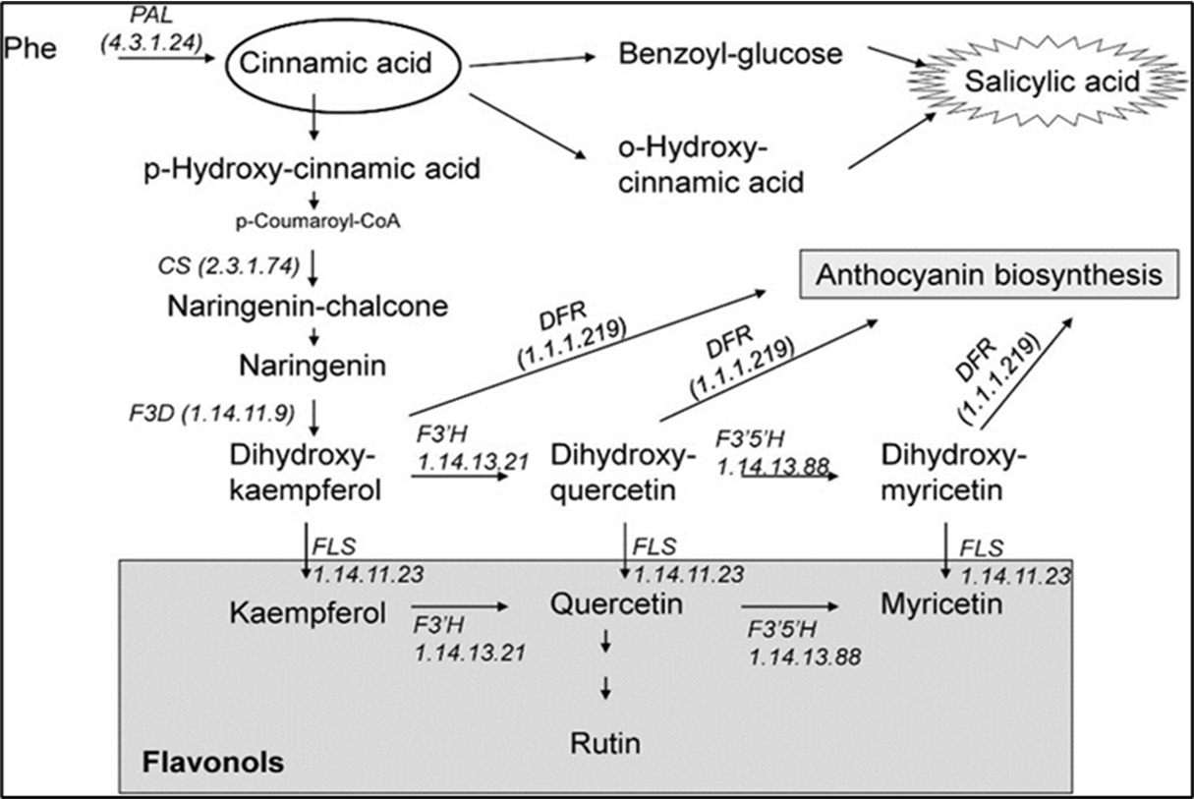
Supplementary Figures

Supp. Fig.1 - Biosynthesis and degradation pathways of kaempferol retrieved from KEGG database.

- (B)
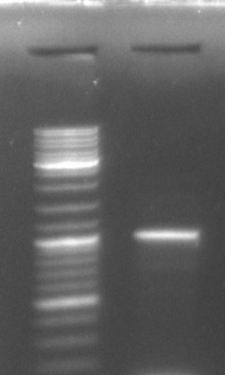
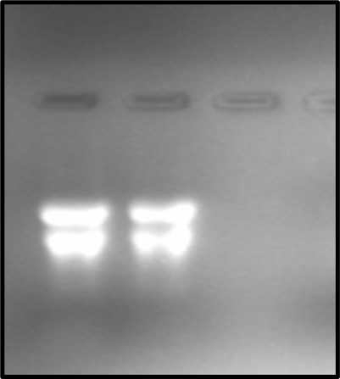
48⁰
(C) Sanger sequencing
952bp

Supp. Fig.2 - (A) Total RNA extracted using TRIzol Method from leaf sample of Milletia pinnata (B) PCR amplification, annealing temp. 48 ºC (C) The sequencing of the amplified gene
Bioinformatics Analysis of the FLS sequence obtained after sanger sequencing
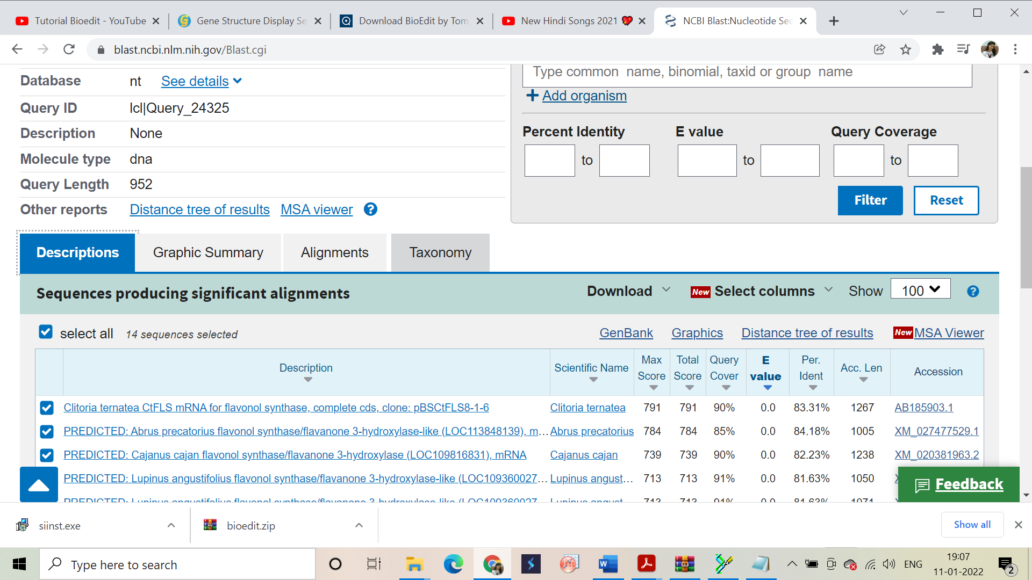

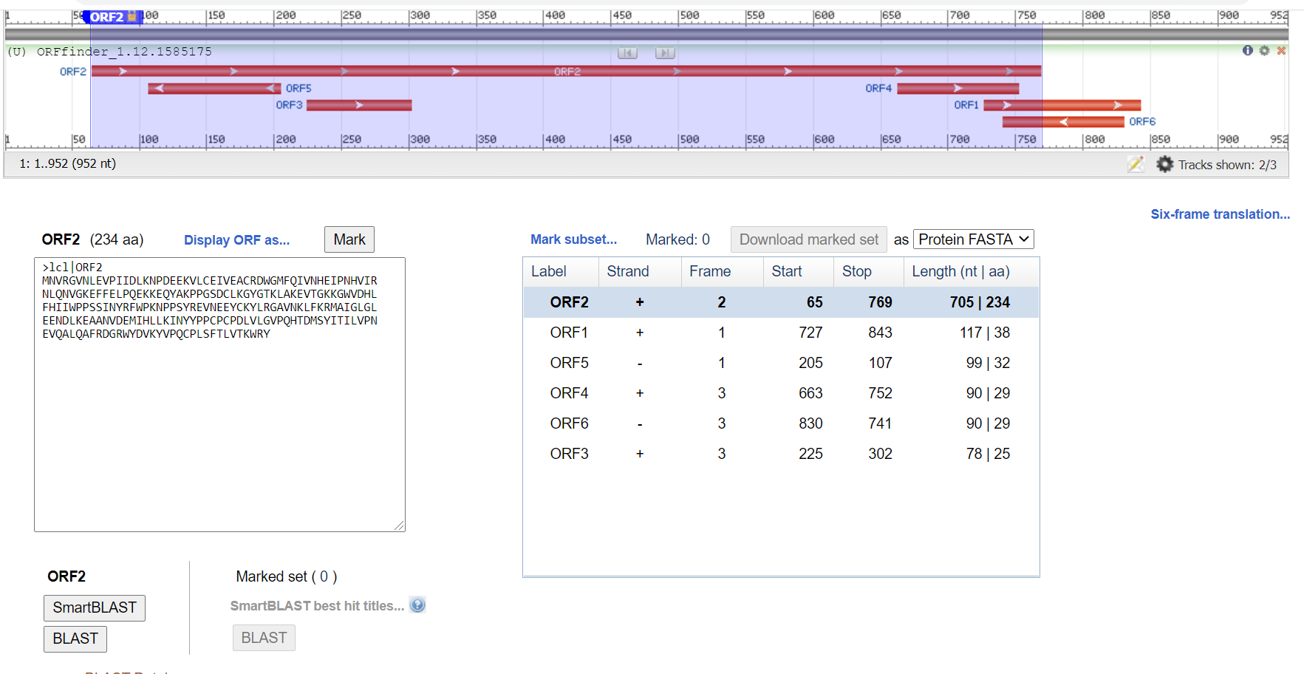
Supp. Fig.3 - Nucleotide blast of the FLS sequence
Supp. Fig.4 - ORFs finding in the sequence.
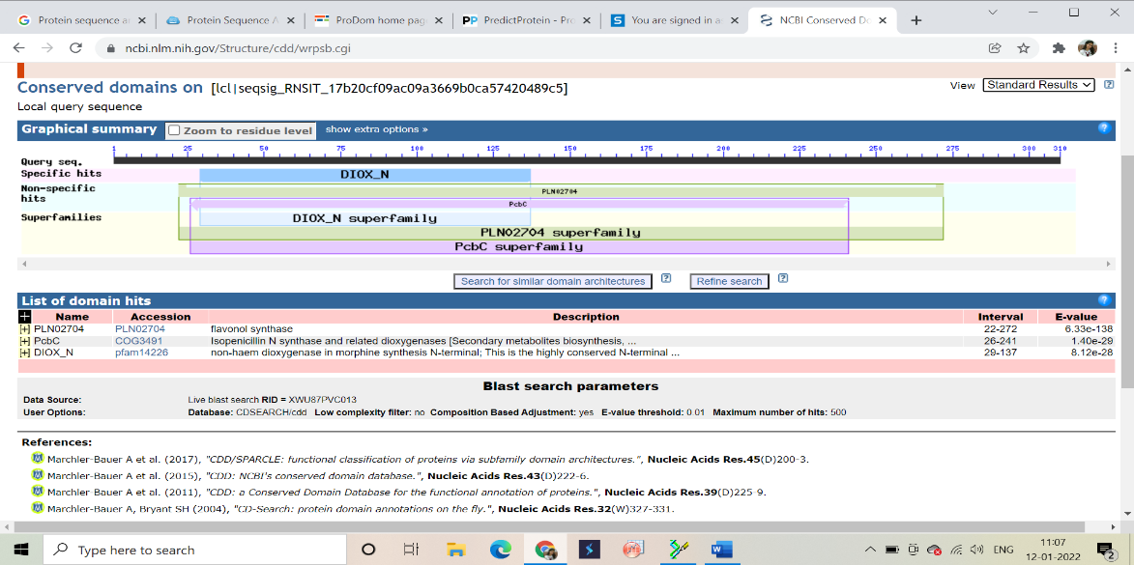
Supp. Fig.5 – The conserve domain identification in the FLS sequence.
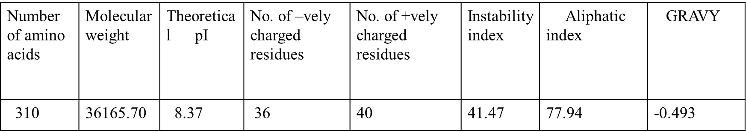

Supp. Fig.6 – The physico-chemical characterization of the FLS sequence.
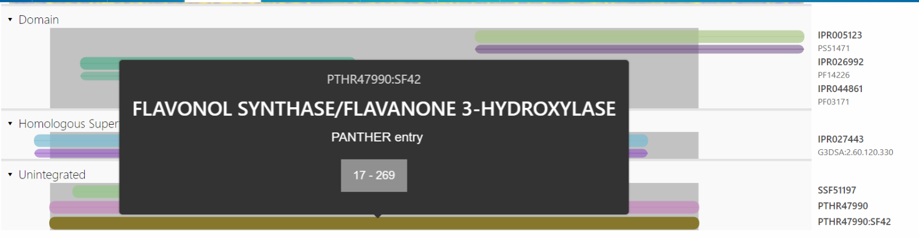
Supp. Fig.7 – The identification of Protein superfamily by InterPro scan server.

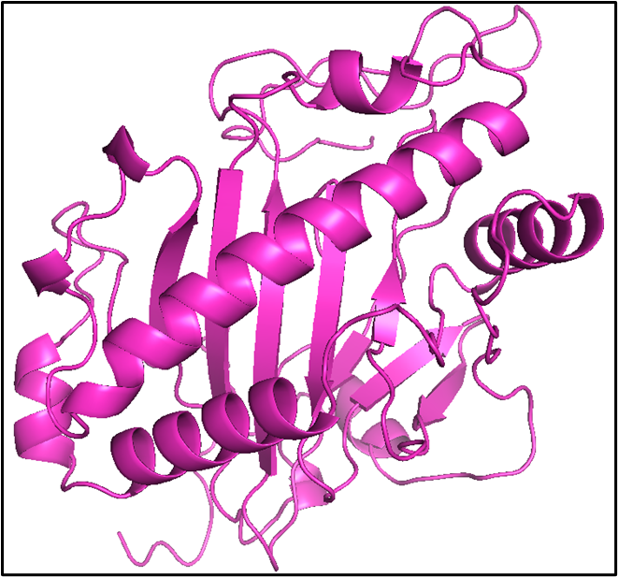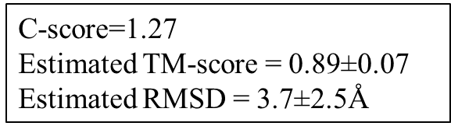
Supp. Fig. 8 – The 3D structure prediction of FLS using I-TASSER online server.
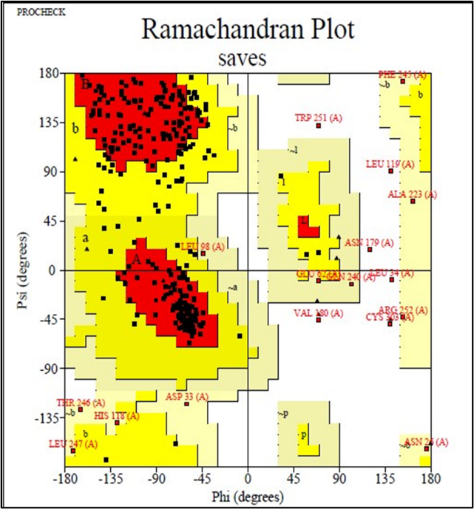

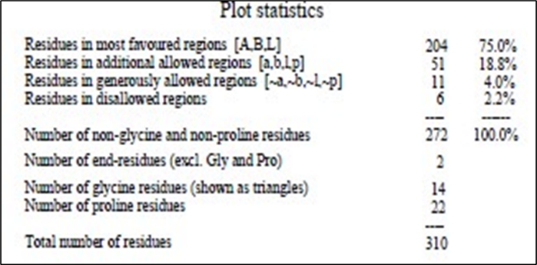

Supp. Fig. 9 – The validation of the 3D structure using Ramachandran plot.
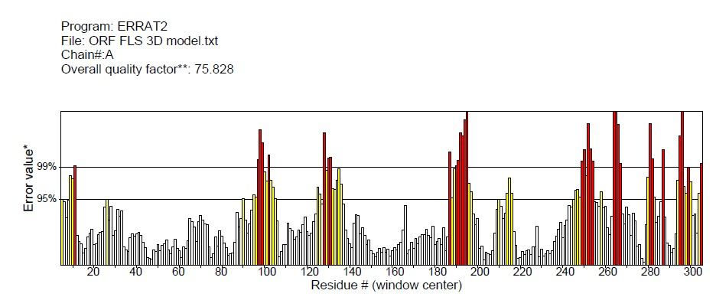

Supp. Fig. 10 – The validation of the 3D structure by ERRAT plot.

