Electronic Supplementary Material
Submit to BMC Ecology as research article
Title: Scraping and Grazing Herbivorous/Detritivorous Fish Display Opposite Feeding Behaviours under Different Protection Regulations

Authors: Nathan William Price¹, Kao-Sung Chen², Chaolun Allen Chen^{1,3*}, Colin Kuo-Chang Wen^{1,4*}

- Department of Life Science, Tunghai University, Taichung, Taiwan
- Planning and Information Division, Fisheries Research Institute, COA, Keelung, Taiwan
- Biodiversity Research Center, Academia Sinica, Taipei 11529, Taiwan
- Center for Ecology and Environment, Tunghai University, Taichung, Taiwan

*Corresponding author
CA Chen
TEL: 886-2-2789-9549
E-mail: cac@gate.sinica.edu.tw.

CKC Wen
TEL: 886-4-23590121# 32413
E-mail: ckcwen@thu.edu.tw
ORCID: 0000-0002-7684-8820

Fig. S1 Boxplots of abundance of (a) juvenile scrapers and (b) juvenile grazers across protection status and habitat type.
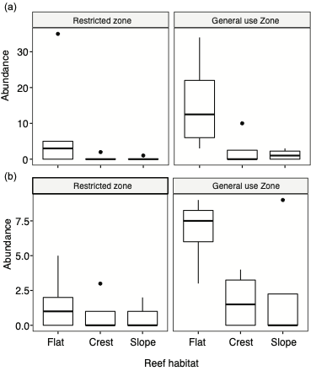

Fig. S2 Zero bite data of scrapers and grazers with factors (a) protection status, (b) habitat type, (c) life stage, (d) body length and (e) group status. Hurdle analysis showed body length had significant effects on zero and non-zero feeding rate of grazers and group status (solitary or schooling) had a significant effect on scrapers and grazers (p < 0.05).
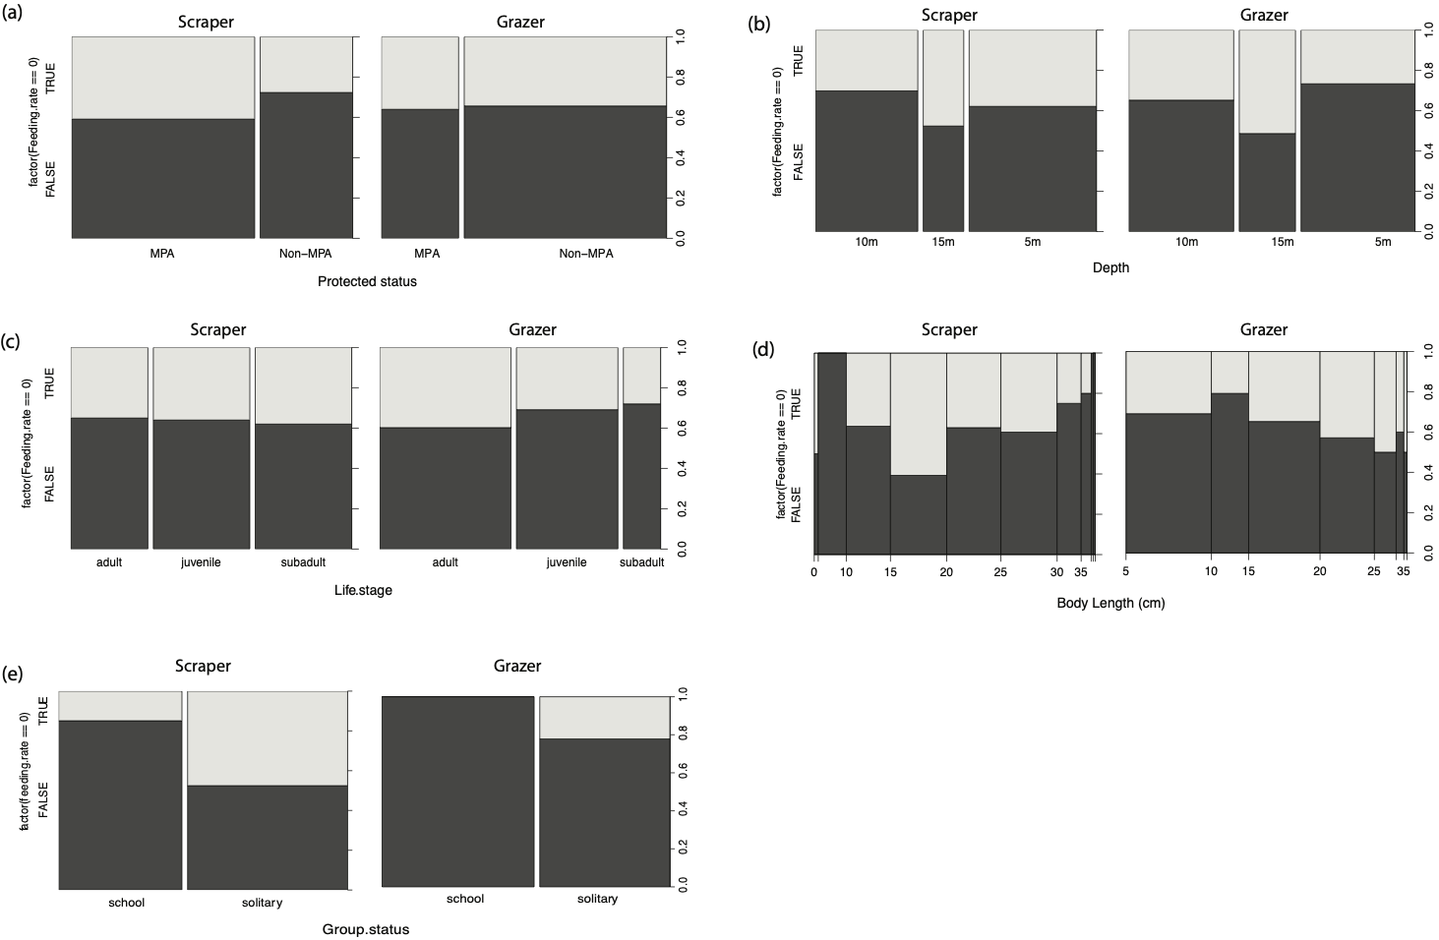

Fig. S3 Boxplots of body size (TL) range for (a) scrapers and (b) grazers across protection status and habitat type.
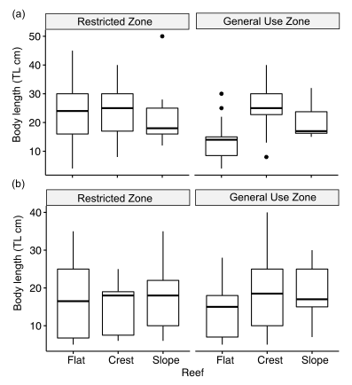

Fig. S4. Consumed algae from herbivorous fishes, (a) filamentous Gracilaria sp. (Rhodophyta) from a grazer; (b) foliose Gracilaria sp. from a grazer; (c) Laurencia sp. (green), Amphiroa sp. (white; possibly by-catch) from a scraper; (d) Sargassum sp. from a scraper; (e) foliose Dictyopteris sp. (Ochrophyta) from a browser and (f) filamentous Gracilaria sp. from a browser.
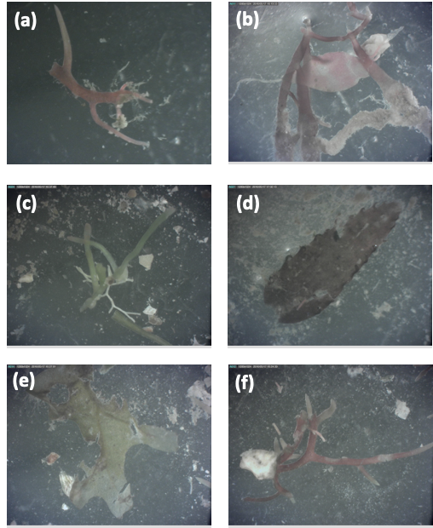
Fig. S5 Dominant herbivorous/detritivorous fish diurnal feeding rate in Kenting (adapted from Wen et al. 2016). To investigate feeding rate (bites/minute) at different times, we recorded frequency at various depths in the morning (8am-10am), noon (11am-1pm) and afternoon (3pm-5pm) on the reef flat. A GLM was used to analyse different time periods, reef types and fish length with feeding rate. The number of samples for Scaridae were n=20, 23, 18, and Acanthuridae n=4, 6, 6. Time factor did not contribute to the feeding rate of Scaridae or Acanthuridae from the best model with AIC selection. All data collected during different time periods were combined to analyse the effects of other habitats and fish abundance on feeding behaviour.
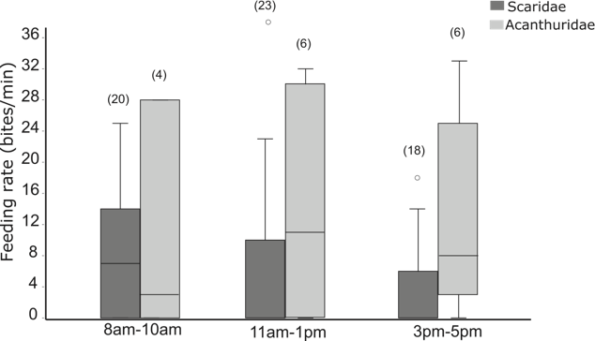

Fig. S6 The most parsimonious GLM of feeding rates of scrapers in the (a) restricted zone and (b) general use zone and feeding rates of grazers in the (c) restricted zone and (d) general use zone were examined for their assumptions and fitness (outliers). Residual plot (Residuals vs Fitted) indicated the assumption of linear regression of models. The qq-plot indicated the normal distribution of residuals. Scale-location plot indicated the assumption of equal variance (homoscedasticity) if the distribution of data were equally spreaded. Another residuals plot (residuals vs leverage) indicated the influenced data if that point was outside of Cook’s distance of regression.

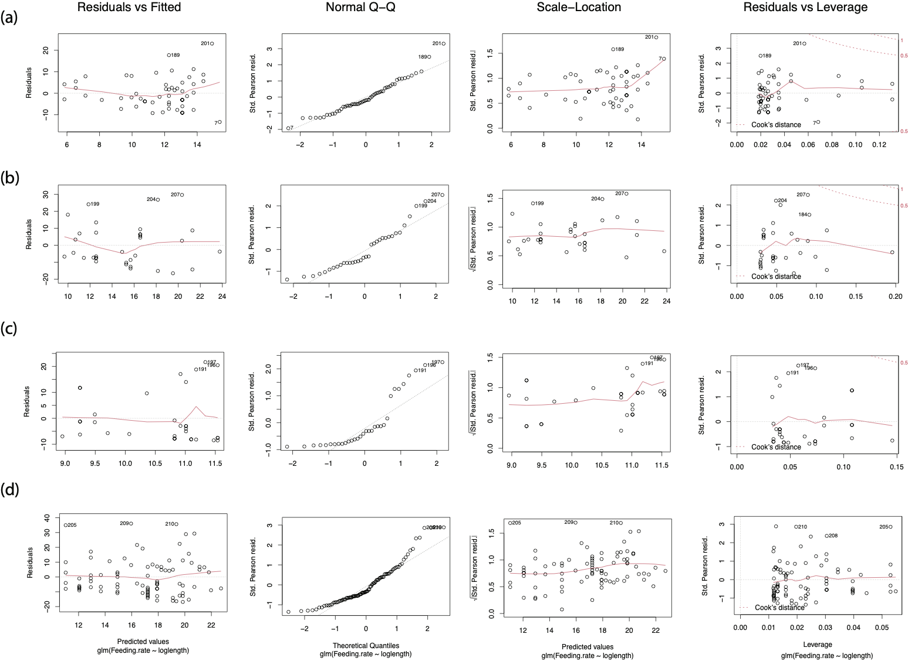

Fig. S7 The most parsimonious GLM of log gut content-log body length of a) scapers, b) grazers and c) browsers were examined following the process in Fig. S3.

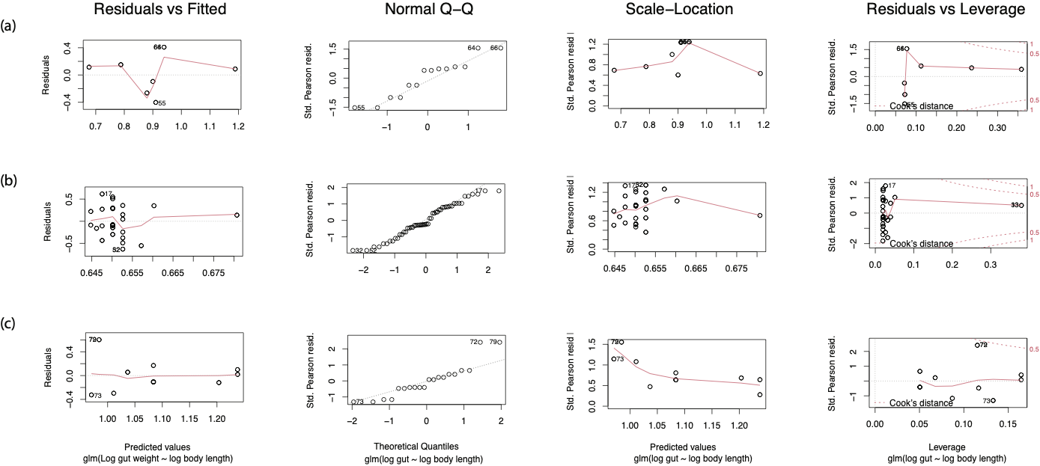

Table S1 Mixed model results of abundance of functional groups with factors 1) habitat type and 2) protection status.

Functional group | Best goodness-of-fit model | Model family | df.residual | AICc | Akaike weight
Scraper | Abundance~ Habitat type | Negative binomial | 24 | 128.67 | 0.460
Grazer | Abundance~ Protected status | Zero-inflated native binomial | 23 | 127.44 | 0.412
Browser | Abundance~ Protected status+Habitat type | Zero-inflated Poisson | 32 | 144.35 | 0.774

Table S2 GLM results of feeding rate of juvenile and sub/adult functional groups with factors 1) habitat type and 2) protection status.

Functional group | Best goodness-of-fit model | Model family | df.residual | AIC
Scraper (juvenile) | Feeding rate~Protected status | Negative binomial | 30 | 226.00
Scraper (subadult/adult) | Feeding rate ~1 | Negative binomial | 56 | 389.66
Grazer (juvenile) | Feeding rate~Protected status | Negative binomial | 45 | 337.70
Grazer (subadult/adult) | Feeding rate ~ Protected status +Habitat type | Negative binomial | 67 | 520.86

Table S3. GLM results of body length of two major functional groups with factors 1) habitat type and 2) protection status.

Functional group | Best goodness-of-fit model | Model family | df | AICc
Scraper | Body length ~ Habitat type + Protected zone | Poisson | 140 | 1021.9
Grazer | Body length ~ Habitat type | Poisson | 180 | 1270.1

Table S4. GLM results of algae coverage with factors 1) habitat type, 2) protection status and 3) abundance of two major functional groups in restricted and general use zones.

Best goodness-of-fit model | Model family | df | AICc
Algae cover ~ Habitat type + Fish abundance | Negative binomial | 156 | 1071
Algae cover (restricted zone) ~ Scraper | Negative binomial | 11 | 79.59
Algae cover (general use zone) ~ Grazer | Negative binomial | 9 | 96.42

