Supplementary Tables and Figures.
Supplemental Table 1 Primer sequences of target genes.
Number | Genes | Primer sequence (5′–3′)
1 | Aldh1b1_F | TCGGATTTAGGAGGCTGCAT
1 | Aldh1b1_R | TGACAACCACGGTATTCCCA
2 | Lgals5_F | CATACCCGAACCTAGCTGTACC
2 | Lgals5_R | GAGTGTTTCGGACCACAGCA
3 | Slec25a25_F | ACCCGGCATTCCCTACTCTT
3 | Slec25a25_R | CTGCTTGCACAATTTTCTGCTTC
4 | Pim3_F | ACTGACTTTGATGGCACCCG
4 | Pim3_R | GGAATGTCCCCACACACCAT
5 | Oaf _F | TCGCGGATTTCAAGAAGGATG
5 | Oaf _R | CTGGAACTGACTTTGCCCCT
6 | GAPDH_F | TCTCTGCTCCTCCCTGTTCT
6 | GAPDH_R | CCGATACGGCCAAATCCGTT

Supplementary Table 2 The relationship between DEGs and serum biochemistry.
Gene | ALT |  | AST |  | Gene | ALT |  | AST |  | Gene | ALT |  | AST |  | Gene | ALT |  | AST
Gene | r | P value | r | P value | Gene | r | P value | r | P value | Gene | r | P value | r | P value | Gene | r | P value | r | P value
Sebox | 0.37 | 0.07 | 0.59 | 0.00 | Nr1d2 | 0.17 | 0.42 | 0.33 | 0.11 | Hsd17b11 | 0.05 | 0.82 | 0.25 | 0.23 | Dbp | 0.09 | 0.69 | 0.14 | 0.51
Hcn3 | 0.44 | 0.03 | 0.49 | 0.01 | Ahsp | 0.62 | 0.00 | 0.33 | 0.11 | Tubb2a | 0.24 | 0.25 | 0.25 | 0.23 | Mif | -0.03 | 0.90 | 0.13 | 0.52
LOC100364769 | -0.41 | 0.04 | -0.49 | 0.01 | LOC103694855 | 0.56 | 0.00 | 0.32 | 0.11 | Alas2 | 0.54 | 0.01 | 0.25 | 0.24 | Pir | -0.03 | 0.89 | 0.13 | 0.53
Cyp1a1 | -0.04 | 0.87 | -0.49 | 0.01 | Klf15 | 0.26 | 0.21 | 0.32 | 0.11 | Klf10 | 0.23 | 0.26 | 0.24 | 0.24 | Gale | 0.49 | 0.01 | 0.12 | 0.55
Mmd2 | 0.33 | 0.11 | 0.47 | 0.02 | Cavin3 | 0.34 | 0.10 | 0.32 | 0.12 | Sds | 0.06 | 0.79 | 0.24 | 0.24 | Fdx1 | 0.07 | 0.74 | 0.12 | 0.57
Aldh1b1 | 0.59 | 0.00 | 0.46 | 0.02 | Hbb-bs | 0.61 | 0.00 | 0.32 | 0.12 | Tcim | 0.38 | 0.06 | 0.24 | 0.25 | Tmem254 | 0.45 | 0.03 | 0.11 | 0.60
LOC500035 | -0.22 | 0.28 | -0.46 | 0.02 | Kynu | 0.32 | 0.12 | 0.32 | 0.12 | Lpin2 | 0.30 | 0.14 | 0.24 | 0.25 | Zwint | 0.04 | 0.84 | 0.11 | 0.60
Lgals5 | 0.63 | 0.00 | 0.45 | 0.02 | MGC94199 | -0.03 | 0.90 | -0.32 | 0.12 | Il6r | 0.31 | 0.13 | 0.22 | 0.28 | RGD1560925 | -0.37 | 0.07 | 0.10 | 0.62
Mtmr7 | 0.33 | 0.11 | 0.44 | 0.03 | Srebf1 | 0.48 | 0.02 | 0.31 | 0.13 | Rhbg | -0.06 | 0.79 | -0.22 | 0.30 | Ltb | 0.04 | 0.84 | -0.10 | 0.64
Slc25a25 | 0.50 | 0.01 | 0.42 | 0.03 | Ybx3 | 0.46 | 0.02 | 0.31 | 0.13 | Ppp1r3b | 0.43 | 0.03 | 0.21 | 0.30 | Slc2a5 | 0.18 | 0.39 | 0.10 | 0.64
Pim3 | 0.53 | 0.01 | 0.41 | 0.04 | Slc16a5 | -0.39 | 0.05 | -0.31 | 0.13 | Dipk2a | 0.20 | 0.34 | 0.21 | 0.31 | Alox15 | 0.46 | 0.02 | 0.09 | 0.65
Oaf | 0.52 | 0.01 | 0.41 | 0.04 | Errfi1 | 0.41 | 0.04 | 0.31 | 0.14 | Per1 | 0.29 | 0.16 | 0.20 | 0.34 | Cyp17a1 | 0.00 | 1.00 | 0.09 | 0.66
Bpgm | 0.57 | 0.00 | 0.39 | 0.05 | Pcdh1 | 0.28 | 0.17 | 0.30 | 0.14 | Ly75 | -0.30 | 0.14 | 0.20 | 0.35 | Nqo1 | 0.04 | 0.87 | -0.08 | 0.70
Tat | 0.47 | 0.02 | 0.39 | 0.05 | Aldh3a1 | -0.38 | 0.06 | -0.30 | 0.14 | Fgl1 | 0.10 | 0.62 | 0.19 | 0.36 | Gstt3 | 0.13 | 0.55 | 0.08 | 0.71
RGD1560795 | 0.05 | 0.81 | -0.39 | 0.05 | Nr1d1 | 0.15 | 0.47 | 0.30 | 0.14 | Glyatl2 | 0.00 | 0.99 | 0.19 | 0.37 | G0s2 | 0.21 | 0.32 | 0.08 | 0.71
Sgk2 | 0.66 | 0.00 | 0.39 | 0.06 | Herpud1 | 0.45 | 0.03 | 0.30 | 0.14 | AC109891.1 | 0.25 | 0.22 | 0.18 | 0.38 | Zfp354a | 0.16 | 0.44 | 0.07 | 0.73
Thrsp | 0.63 | 0.00 | 0.39 | 0.06 | Hba-a1 | 0.61 | 0.00 | 0.30 | 0.15 | Mafb | 0.17 | 0.42 | 0.18 | 0.38 | Mt-nd6 | 0.31 | 0.14 | -0.07 | 0.73
Kcnk5 | 0.45 | 0.02 | 0.38 | 0.06 | C2cd2l | 0.52 | 0.01 | 0.30 | 0.15 | Mfsd2a | 0.36 | 0.08 | 0.18 | 0.40 | Noct | 0.35 | 0.09 | 0.07 | 0.74
Hes6 | 0.59 | 0.00 | 0.38 | 0.06 | LOC100134871 | 0.56 | 0.00 | 0.29 | 0.15 | Slc38a2 | 0.29 | 0.17 | 0.18 | 0.40 | Pik3r1 | 0.28 | 0.18 | 0.07 | 0.75
Pik3c3 | -0.09 | 0.68 | 0.38 | 0.06 | Slc7a2 | -0.02 | 0.91 | 0.29 | 0.15 | Npas2 | 0.17 | 0.42 | 0.17 | 0.41 | Ces1d | 0.03 | 0.87 | 0.07 | 0.75
Tubb2b | 0.25 | 0.23 | 0.37 | 0.07 | Grin2c | 0.07 | 0.73 | -0.29 | 0.16 | Rnf125 | 0.06 | 0.79 | 0.17 | 0.42 | Ddhd1 | 0.49 | 0.01 | 0.06 | 0.78
Gkn3 | 0.44 | 0.03 | 0.36 | 0.07 | Mgat4b | 0.37 | 0.07 | 0.29 | 0.16 | Cyp3a9 | -0.03 | 0.87 | 0.17 | 0.42 | Akr7a3 | 0.01 | 0.95 | -0.05 | 0.80
Nr0b2 | 0.38 | 0.06 | 0.36 | 0.08 | Per3 | 0.15 | 0.47 | 0.28 | 0.17 | Tsc22d1 | 0.26 | 0.21 | 0.17 | 0.43 | Inhbe | 0.14 | 0.51 | 0.05 | 0.81
Cend1 | 0.38 | 0.06 | 0.36 | 0.08 | AABR07031193.1 | -0.45 | 0.02 | -0.28 | 0.18 | Ubxn8 | -0.28 | 0.18 | -0.16 | 0.43 | Dusp1 | 0.12 | 0.57 | 0.04 | 0.84
Csrnp1 | 0.49 | 0.01 | 0.35 | 0.08 | Slc25a10 | 0.36 | 0.08 | 0.28 | 0.18 | Cyp1a2 | 0.16 | 0.44 | -0.16 | 0.44 | Blvrb | -0.10 | 0.65 | 0.03 | 0.87
Gsta3 | -0.01 | 0.95 | -0.35 | 0.08 | Cry1 | -0.39 | 0.06 | -0.27 | 0.19 | Mk1 | 0.19 | 0.36 | 0.16 | 0.46 | AABR07044001.4 | -0.12 | 0.57 | 0.03 | 0.88
Extl1 | 0.25 | 0.23 | 0.35 | 0.09 | Dnah9 | 0.27 | 0.19 | 0.27 | 0.19 | Ddah1 | 0.06 | 0.79 | 0.16 | 0.46 | Gstm3l | -0.30 | 0.14 | -0.03 | 0.89
Hbb | 0.64 | 0.00 | 0.35 | 0.09 | Hba-a2 | 0.59 | 0.00 | 0.27 | 0.19 | Cdkn1a | 0.20 | 0.34 | 0.15 | 0.49 | Epm2a | -0.06 | 0.79 | -0.03 | 0.89
Slc37a4 | 0.48 | 0.02 | 0.34 | 0.09 | Igfbp2 | 0.11 | 0.60 | 0.26 | 0.20 | Osgin1 | -0.07 | 0.73 | 0.14 | 0.50 | Nupr1 | -0.09 | 0.67 | 0.02 | 0.92
Rdh16 | 0.05 | 0.81 | 0.34 | 0.09 | Vom2r37 | 0.20 | 0.34 | 0.26 | 0.20 | LOC103694877 | -0.05 | 0.81 | 0.14 | 0.50 | Anxa7 | -0.04 | 0.83 | 0.02 | 0.93
Sik1 | 0.22 | 0.29 | 0.34 | 0.09 | Adrm1 | 0.18 | 0.40 | 0.26 | 0.21 | Cyp2b1 | -0.04 | 0.87 | -0.14 | 0.50 | Hsd17b2 | 0.11 | 0.59 | 0.01 | 0.97
Bmf | 0.44 | 0.03 | 0.34 | 0.10 | Rdh5 | 0.12 | 0.57 | 0.25 | 0.22 | Rasl10b | 0.30 | 0.15 | 0.14 | 0.51 | Per2 | 0.06 | 0.78 | 0.01 | 0.97

Supplementary Table 3 The relationship between metabolites and serum biochemistry.
Metabolites | ALT |  | AST |  | Metabolites | ALT |  | AST
Metabolites | r | P | r | P | Metabolites | r | P | r | P
Phosphatidate | 0.55 | 0.00 | 0.54 | 0.00 | Lanosterin | -0.62 | 0.00 | -0.43 | 0.01
(R)-4'-Phosphopantothenoyl-L-cysteine | -0.29 | 0.07 | 0.16 | 0.34 | L-Serine | -0.21 | 0.20 | 0.23 | 0.17
12(S)-HETE | 0.10 | 0.53 | 0.05 | 0.78 | L-Urobilinogen | 0.22 | 0.16 | -0.13 | 0.43
1-Acyl-sn-glycero-3-phosphocholine | -0.34 | 0.03 | 0.00 | 0.99 | Methylcysteine | -0.12 | 0.45 | -0.07 | 0.67
2-Methoxyestradiol | -0.30 | 0.06 | -0.02 | 0.89 | Methylglyoxal | -0.41 | 0.01 | -0.15 | 0.36
3,4-Dihydroxymandelate | 0.09 | 0.57 | -0.31 | 0.06 | Glucaric acid | -0.22 | 0.16 | 0.24 | 0.15
3-Carboxy-1-hydroxypropylthiamine diphosphate | 0.25 | 0.11 | 0.04 | 0.81 | N6-Acetyl-L-lysine | -0.30 | 0.05 | -0.24 | 0.15
3-Hydroxy-L-kynurenine | -0.02 | 0.92 | -0.27 | 0.09 | N-Acylsphingosine | -0.53 | 0.00 | -0.43 | 0.01
5-Aminolevulinate | -0.17 | 0.27 | -0.11 | 0.49 | Phosphatidylcholine | -0.60 | 0.00 | -0.47 | 0.00
5-Hydroxy-N-formylkynurenine | -0.58 | 0.00 | -0.26 | 0.11 | Phosphatidylethanolamine | 0.08 | 0.62 | 0.01 | 0.95
beta-D-Glucuronoside | -0.58 | 0.00 | -0.35 | 0.03 | Phosphorylcholine | -0.33 | 0.04 | 0.04 | 0.81
Bilirubin | 0.10 | 0.53 | 0.28 | 0.09 | Prostaglandin E2 | -0.15 | 0.33 | -0.41 | 0.01
Biliverdin | -0.61 | 0.00 | -0.36 | 0.03 | Pyridoxal | -0.52 | 0.00 | -0.27 | 0.09
Cholic acid | -0.51 | 0.00 | -0.29 | 0.08 | Riboflavin-5-phosphate | -0.14 | 0.39 | 0.15 | 0.35
D-Glucosamine 6-phosphate | -0.39 | 0.01 | 0.10 | 0.56 | Tetrahydrocorticosterone | -0.35 | 0.02 | 0.01 | 0.95
D-Leucate | -0.58 | 0.00 | -0.42 | 0.01 | Thyroxine | -0.39 | 0.01 | -0.22 | 0.18
Docosapentaenoic acid (22n-3) | -0.69 | 0.00 | -0.32 | 0.05 | Tyramine | -0.15 | 0.35 | -0.31 | 0.06
D-Xylitol | -0.14 | 0.38 | 0.18 | 0.27 | Uracil | 0.49 | 0.00 | 0.50 | 0.00
gamma-Aminobutyric acid | -0.61 | 0.00 | -0.37 | 0.02 | Uridine | 0.26 | 0.10 | -0.02 | 0.91
N1-(5-Phospho-a-D-ribosyl)-5,6-dimethylbenzimidazole | 0.49 | 0.00 | 0.49 | 0.00 | α-Ketoglutarate | -0.05 | 0.74 | 0.12 | 0.47

Supplementary Table 4 Metabolic pathways of BGZ in the treatment of Yin_{syn} in rats.
Comparison | Pathways | Number of metabolites | P value | Impact
Yin_{syn}+BGZ vs Yin_{syn} | Pantothenate and CoA biosynthesis | 2 | 0.05 | 0.18
Yin_{syn}+BGZ vs Yin_{syn} | Sphingolipid metabolism | 2 | 0.06 | 0.27
Yin_{syn}+BGZ vs Yin_{syn} | Riboflavin metabolism | 1 | 0.07 | 0.50
Yin_{syn}+BGZ vs Yin_{syn} | Alanine, aspartate and glutamate metabolism | 2 | 0.09 | 0.09
Yin_{syn}+BGZ vs Yin_{syn} | Glycine, serine and threonine metabolism | 2 | 0.12 | 0.22
Yin_{syn}+BGZ vs Yin_{syn} | Ascorbate and aldarate metabolism | 1 | 0.14 | 0.00
Yin_{syn}+BGZ vs Yin_{syn} | Arachidonic acid metabolism | 2 | 0.14 | 0.00
Yin_{syn}+BGZ vs Yin_{syn} | Glycerophospholipid metabolism | 2 | 0.14 | 0.15
Yin_{syn}+BGZ vs Yin_{syn} | Vitamin B6 metabolism | 1 | 0.16 | 0.49
Yin_{syn}+BGZ vs Yin_{syn} | Pyrimidine metabolism | 2 | 0.16 | 0.09
Yin_{syn}+BGZ vs Yin_{syn} | Tryptophan metabolism | 2 | 0.18 | 0.11
Yin_{syn}+BGZ vs Yin_{syn} | Tyrosine metabolism | 2 | 0.18 | 0.03
Yin_{syn}+BGZ vs Yin_{syn} | Butanoate metabolism | 1 | 0.25 | 0.03
Yin_{syn}+BGZ vs Yin_{syn} | Glycerolipid metabolism | 1 | 0.26 | 0.01
Yin_{syn}+BGZ vs Yin_{syn} | Pentose and glucuronate interconversions | 1 | 0.29 | 0.17
Yin_{syn}+BGZ vs Yin_{syn} | Citrate cycle (TCA cycle) | 1 | 0.32 | 0.09
Yin_{syn}+BGZ vs Yin_{syn} | beta-Alanine metabolism | 1 | 0.33 | 0.00
Yin_{syn}+BGZ vs Yin_{syn} | Pyruvate metabolism | 1 | 0.34 | 0.03
Yin_{syn}+BGZ vs Yin_{syn} | Phosphatidylinositol signaling system | 1 | 0.41 | 0.00
Yin_{syn}+BGZ vs Yin_{syn} | Porphyrin and chlorophyll metabolism | 1 | 0.44 | 0.05
Yin_{syn}+BGZ vs Yin_{syn} | Glyoxylate and dicarboxylate metabolism | 1 | 0.46 | 0.04
Yin_{syn}+BGZ vs Yin_{syn} | Cysteine and methionine metabolism | 1 | 0.47 | 0.02
Yin_{syn}+BGZ vs Yin_{syn} | Amino sugar and nucleotide sugar metabolism | 1 | 0.51 | 0.03
Yin_{syn}+BGZ vs Yin_{syn} | Arginine and proline metabolism | 1 | 0.52 | 0.02
Yin_{syn}+BGZ vs Yin_{syn} | Steroid biosynthesis | 1 | 0.55 | 0.06
Yin_{syn}+BGZ vs Yin_{syn} | Primary bile acid biosynthesis | 1 | 0.59 | 0.00
Yin_{syn}+BGZ vs Yin_{syn} | Aminoacyl-tRNA biosynthesis | 1 | 0.60 | 0.17
Yin_{syn}+BGZ vs Yin_{syn} | Purine metabolism | 1 | 0.71 | 0.06
Yin_{syn}+BGZ vs Yin_{syn} | Steroid hormone biosynthesis | 1 | 0.81 | 0.01

Supplementary Table 5 Metabolic pathways of BGZ in the treatment of Yang_{syn} in rats.
Comparison | Pathways | Number of metabolites | P value | Impact
Yang_{syn}+BGZ vs Yang_{syn} | Glycerophospholipid metabolism | 5 | 0.00 | 0.37
Yang_{syn}+BGZ vs Yang_{syn} | Arachidonic acid metabolism | 3 | 0.02 | 0.00
Yang_{syn}+BGZ vs Yang_{syn} | Pantothenate and CoA biosynthesis | 2 | 0.04 | 0.18
Yang_{syn}+BGZ vs Yang_{syn} | Riboflavin metabolism | 1 | 0.06 | 0.50
Yang_{syn}+BGZ vs Yang_{syn} | Alanine, aspartate and glutamate metabolism | 2 | 0.07 | 0.05
Yang_{syn}+BGZ vs Yang_{syn} | Linoleic acid metabolism | 1 | 0.08 | 0.00
Yang_{syn}+BGZ vs Yang_{syn} | Porphyrin and chlorophyll metabolism | 2 | 0.08 | 0.10
Yang_{syn}+BGZ vs Yang_{syn} | D-Glutamine and D-glutamate metabolism | 1 | 0.09 | 0.00
Yang_{syn}+BGZ vs Yang_{syn} | Vitamin B6 metabolism | 1 | 0.14 | 0.49
Yang_{syn}+BGZ vs Yang_{syn} | Tyrosine metabolism | 2 | 0.15 | 0.02
Yang_{syn}+BGZ vs Yang_{syn} | alpha-Linolenic acid metabolism | 1 | 0.19 | 0.00
Yang_{syn}+BGZ vs Yang_{syn} | Arginine biosynthesis | 1 | 0.20 | 0.00
Yang_{syn}+BGZ vs Yang_{syn} | Glycosylphosphatidylinositol (GPI)-anchor biosynthesis | 1 | 0.20 | 0.00
Yang_{syn}+BGZ vs Yang_{syn} | Butanoate metabolism | 1 | 0.22 | 0.00
Yang_{syn}+BGZ vs Yang_{syn} | Glycerolipid metabolism | 1 | 0.23 | 0.01
Yang_{syn}+BGZ vs Yang_{syn} | Pentose and glucuronate interconversions | 1 | 0.25 | 0.14
Yang_{syn}+BGZ vs Yang_{syn} | Citrate cycle (TCA cycle) | 1 | 0.28 | 0.06
Yang_{syn}+BGZ vs Yang_{syn} | beta-Alanine metabolism | 1 | 0.29 | 0.00
Yang_{syn}+BGZ vs Yang_{syn} | Phosphatidylinositol signaling system | 1 | 0.37 | 0.00
Yang_{syn}+BGZ vs Yang_{syn} | Glycine, serine and threonine metabolism | 1 | 0.42 | 0.00
Yang_{syn}+BGZ vs Yang_{syn} | Amino sugar and nucleotide sugar metabolism | 1 | 0.46 | 0.03
Yang_{syn}+BGZ vs Yang_{syn} | Pyrimidine metabolism | 1 | 0.47 | 0.07
Yang_{syn}+BGZ vs Yang_{syn} | Purine metabolism | 1 | 0.66 | 0.06
Yang_{syn}+BGZ vs Yang_{syn} | Steroid hormone biosynthesis | 1 | 0.76 | 0.00

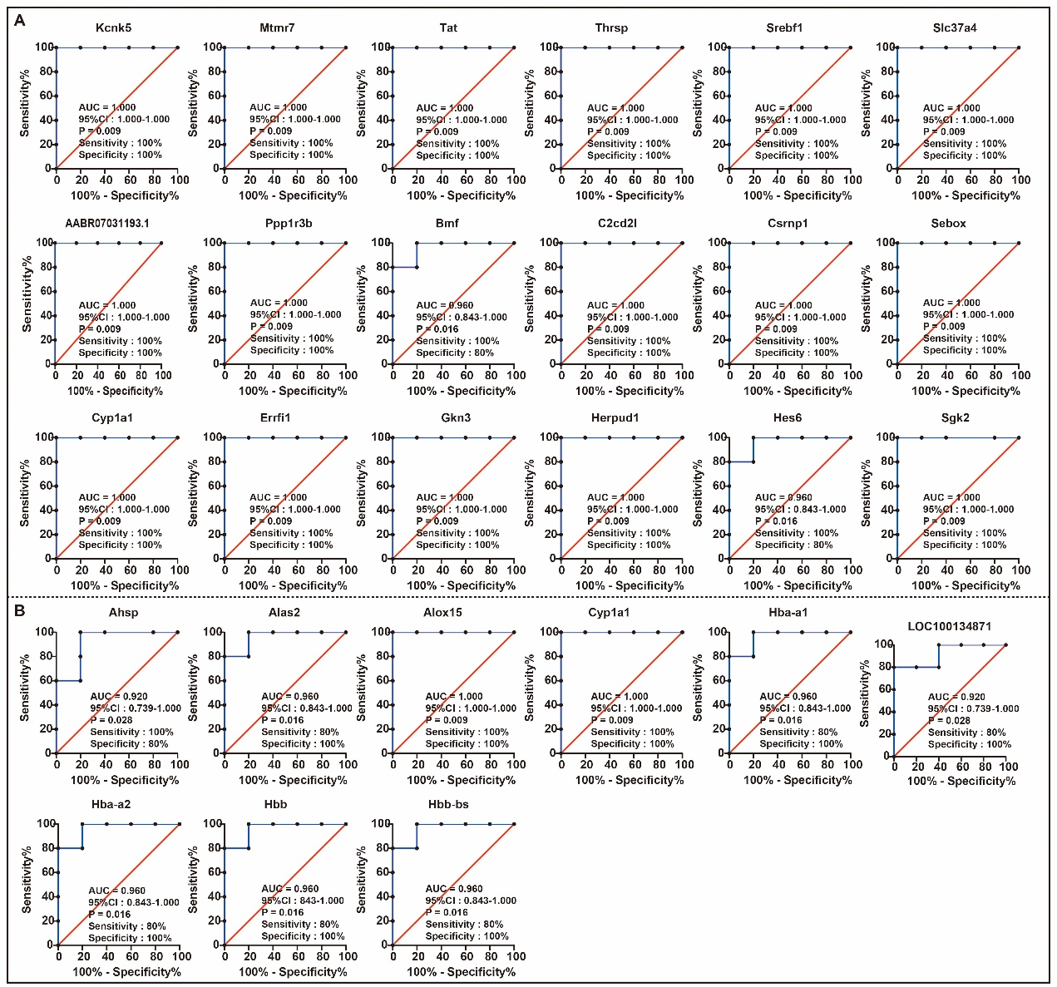
Supplementary Figure 1 ROC analysis of DEGs. (A) the DEGs between the Yang_{syn}+BGZ group and the Yang_{syn} group; (B) the DEGs between the Yin_{syn}+BGZ group and the Yin_{syn} group. DEGs: differentially expressed genes; ROC: receiver operating characteristic; AUC: area under the ROC curve; CI: confidence interval.

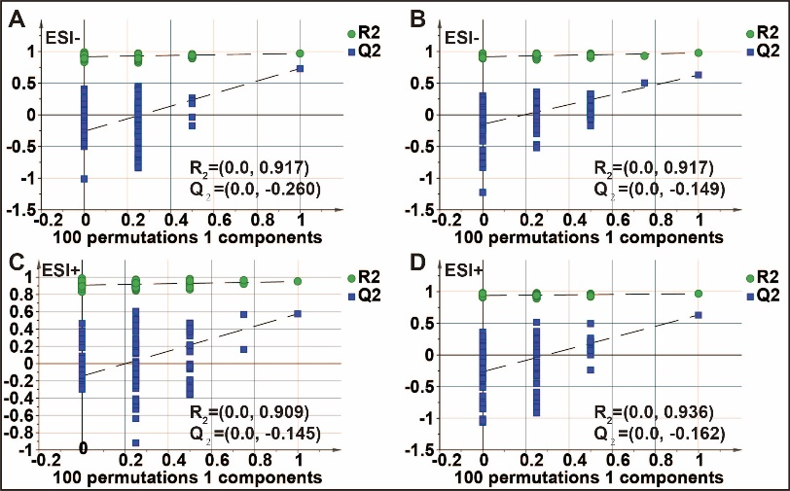
Supplementary Figure 2 (A) The 100-permutation test for Yang_{syn}+BGZ group and Yang_{syn} group in ESI- mode; (B) The 100-permutation test for Yin_{syn}+BGZ group and Yin_{syn} group in ESI- mode; (C) The 100-permutation test for Yang_{syn}+BGZ group and Yang_{syn} group in ESI+ mode; (D) The 100-permutation test for Yin_{syn}+BGZ group and Yin_{syn} group in ESI+ mode.
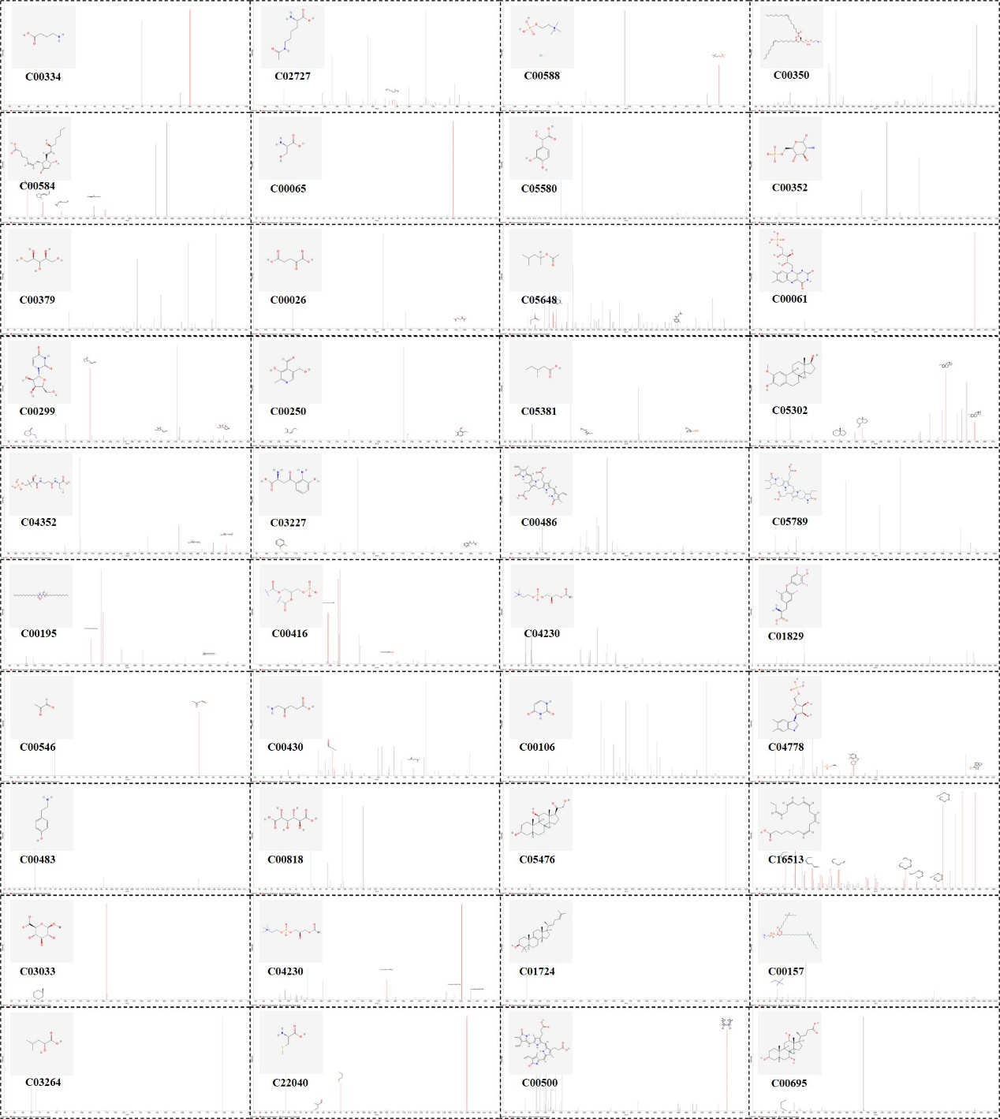
Supplementary Figure 3 Secondary fragment ions characteristic maps of identified metabolites.

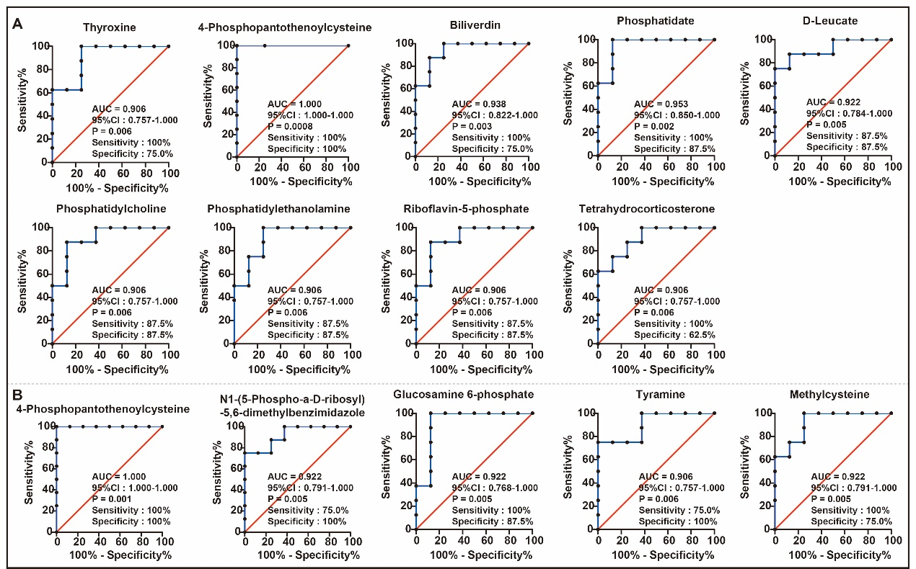
Supplementary Figure 4 ROC analysis of metabolites. (A) the metabolites between the Yang_{syn}+BGZ group and the Yang_{syn} group; (B) the metabolites between the Yin_{syn}+BGZ group and the Yin_{syn} group. ROC: receiver operating characteristic; AUC: area under the ROC curve; CI: confidence interval.

