Supporting information
Synthesis of hierarchical micro-mesoporous ZSM-5 zeolite and its catalytic activityinbenzylation of mesitylene

Manikandan Krishnamurthy ^{ab*} M.Swaminathan ^{a*}
ªNanomaterials Laboratory, Department of Chemistry, International Research Centre,
Kalasalingam Academy of Research and Education, Krishnankoil-626126
^{b}Division of Nano Optoelectronic Materials, Institute of Advanced Materials (IAM), 5 Xin Mo Fan Road, Nanjing Tech University, Nanjing 210009, China
*Corresponding Author Email: m.swaminathan@klu.ac.in, k.manikandan@klu.ac.in,

1. Materials
Tetraethylorthosilicate (98%), tetrapropylammonium hydroxide (40% in H₂O),) sodium aluminate (Al₂O₃ = 50-56%), and poly (diallyldimethylammoniumchloride) (20 wt% in H₂O) were procured from Sigma-Aldrich, India. Benzyl alcohol (99.8%), 1, 3, 5 trimethylbenzene or mesitylene (98%) were obtained from SD Fine Chemicals, India. Agricultural waste such as (Corn plants) were collected from farmers and made powder using liquid nitrogen and this powders stored in containers.
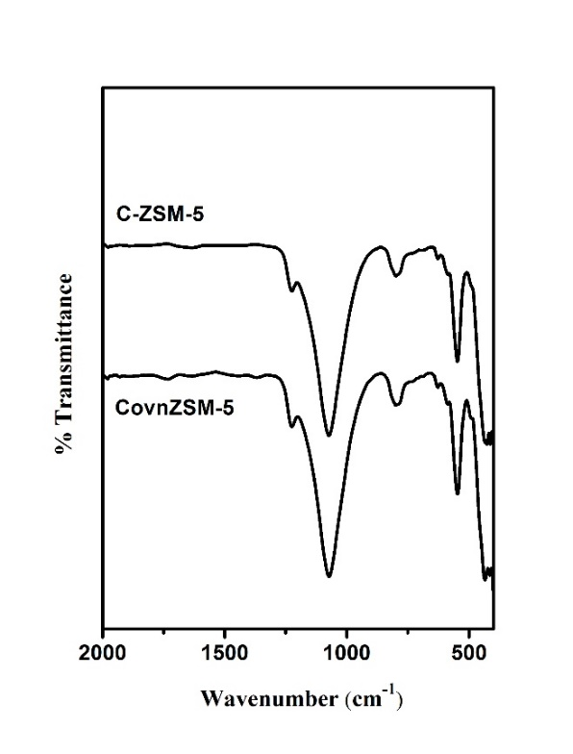
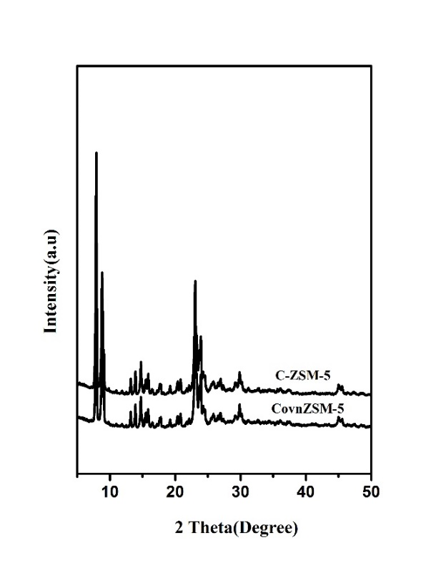

Fig. S2 Framework FTIR spectrum of zeolites
Fig. S1 XRD Patterns of Zeolites

2. Catalyst Characterization
X-ray diffraction (XRD) analysis has been carried out using Bruker D8 advance powder X-ray diffractometer. Shimadzu IR Affinity-1 instrument with attenuated total reflection (ATR) mode used to record FT-IR spectra. Tecnai, G2 20 Twin TEM instrument utilised to capture TEM images. Quantochrome, Autosorb iQ-Chemi instrument (77 K) used for nitrogen adsorption-desorption studies. Initially the samples were outgassed at 250 ºC for 5 h. Autosorb iQ-Chemi instrument utilised to perform TPD-NH₃ analysis. Before chemisorption of NH₃, the materials were outgassed at 250°C for 2 hours, after cooling down to 100 °C, 20% NH₃ in helium with flow rate of 15 ml/ min passed on the materials for 30 min. After adsorption of ammonia, desorption process performed by gradually heating the prepared materials from100 to 550 ℃ at the rate of 20 ℃/min. The ammonia desorbed was continuously monitored by using a thermal conductivity detector. ²⁷Al MAS NMR analysis carried out by Jeol Resonance NMR spectrophotometer.¹HNMR and ¹³CNMR analysis was carried out by FT-NMR 400MHz (Bruker).
3. Bezylation of mesitylene with benzyl alcohol
The liquid phase reaction of benzyl alcohol with mesitylene was carried out in a double-necked round bottom (RB) flask equipped with a reflux condenser. In a typical experiment, methylene (20 mmol) and benzyl alcohol (5 mmol) were added to a RB flask and heated to 100ºC followed by addition of 100 mg of the catalyst. The reaction started immediately after catalyst addition. After 3 h of the reaction, the mixture was quenched to room temperature. The mole ratio of mesitylene: benzyl alcohol was 4:1. The reaction mixture was analyzed using a gas chromatograph (GC-2010 plus) equipped with a flame ionization detector (FID). n- Nonane has been used as an internal standard, added to the reaction mixtures after completion of the reaction.
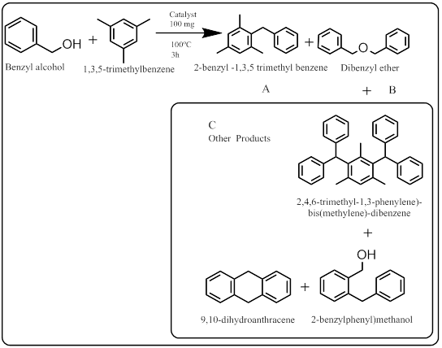

Reaction Conditions: Amount of Catalyst 100 mg, Time 3 h, Temp 100 ºC, Mesitylene or 1,3,5-trimethylbenzene : benzyl alcohol(BA)ratio= 4:1(A) 2-Benzyl-1,3,5-trimethylbenzene; (B) dibenzyl ether; (C) others: (2,4,6-trimethyl-1,3-phenylene)-bis(methylene)-dibenzene;(2-benzylphenyl)methanol; 9,10 dihydroanthracene

Scheme S1. Benzylation of mesitylene with benzyl alcohol over catalysts

Catalyst | Total surface  area  (m²/g) | External surface area (m²/g) | Micropore  Surface area (m²/g) | Micropore  Volume | Total pore volume(cc/g) | Si/Al ratio
C-ZSM-5 | 385 | 207 | 176 | 0.08 | 0.20 | 25
ConvZSM-5 | 330 | 68 | 262 | 0.10 | 0.16 | 25
Catalyst | No of run | BA Conversion  (%) | Selectivity of products (%)
Catalyst | No of run | BA Conversion  (%) | A | B | C
ConvZSM-5 | 1st | 33 | 32 | 66 | 2
ConvZSM-5 | 2nd | 30 | 28 | 64 | 8
ConvZSM-5 | 3rd | 29 | 22 | 68 | 10
C-ZSM-5 | 1st | 88 | 73 | 16 | 11
C-ZSM-5 | 2nd | 87 | 72 | 19 | 9
C-ZSM-5 | 3rd | 85 | 70 | 14 | 16
Table. S2 Recycle studies of prepared zeolites

Table.S1 Textural properties of prepared zeolite

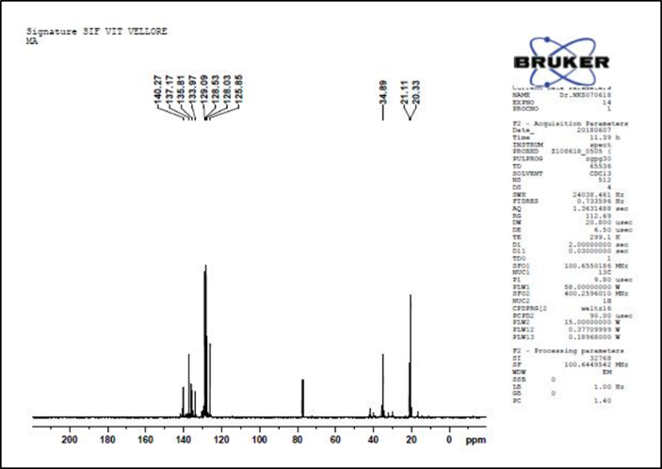

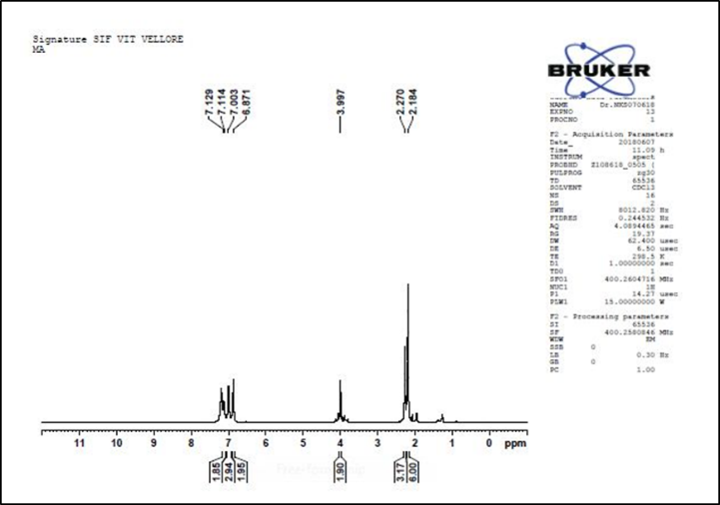
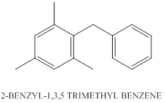
Fig. S4 ¹H NMR spectra of 2-benzyl-1, 3, 5 tri methyl benzene

Fig.S3 Recycle studies of prepared zeolite
Fig. S4 ¹³C NMR spectra of 2-benzyl-1, 3, 5 tri methyl benzene

