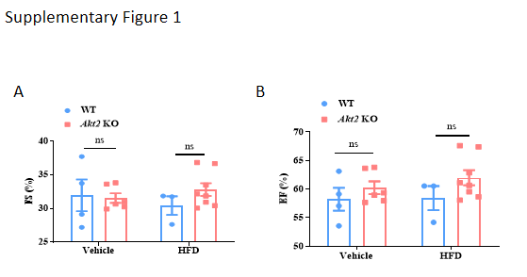

Supplementary Figure 1. (A-B) At the end of 12-week ND or HFD treatment, mice were anesthetized with isoflurane and cardiac geometry and function were evaluated using echocardiography: fractional shortening (FS); ejection fraction (EF) (WT, n=4; WT-HFD, n=3; Akt2 KO, n=6; Akt2 KO-HFD, n=9)

