Appendix 1: Overview of FSV Data Analysis Flowchart
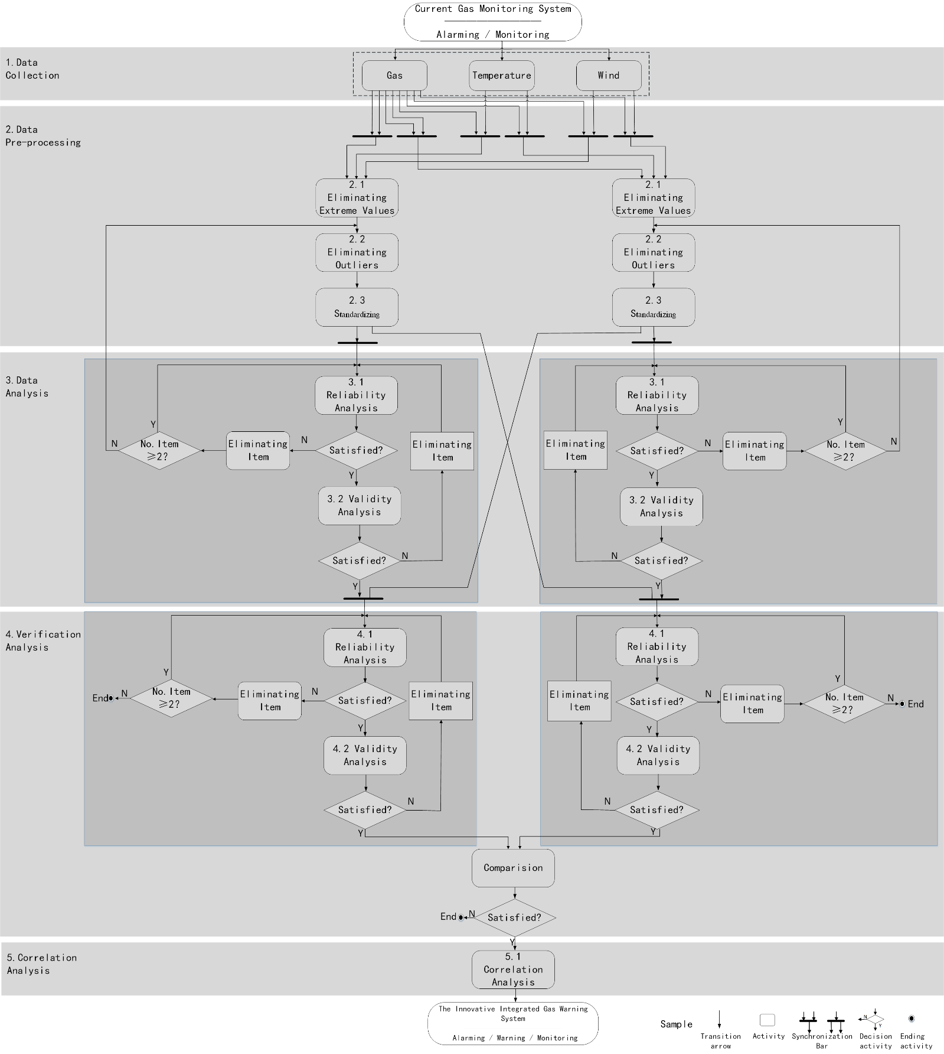
Appendix 2: Gas Data on 5 Feb 2022
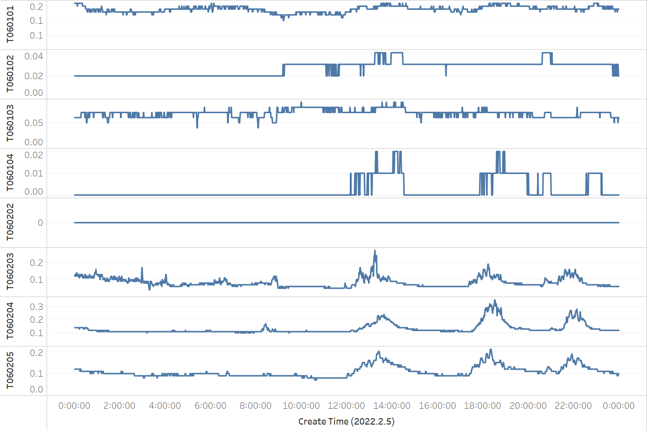
Appendix 3: Temperature Data on 5 Feb 2022
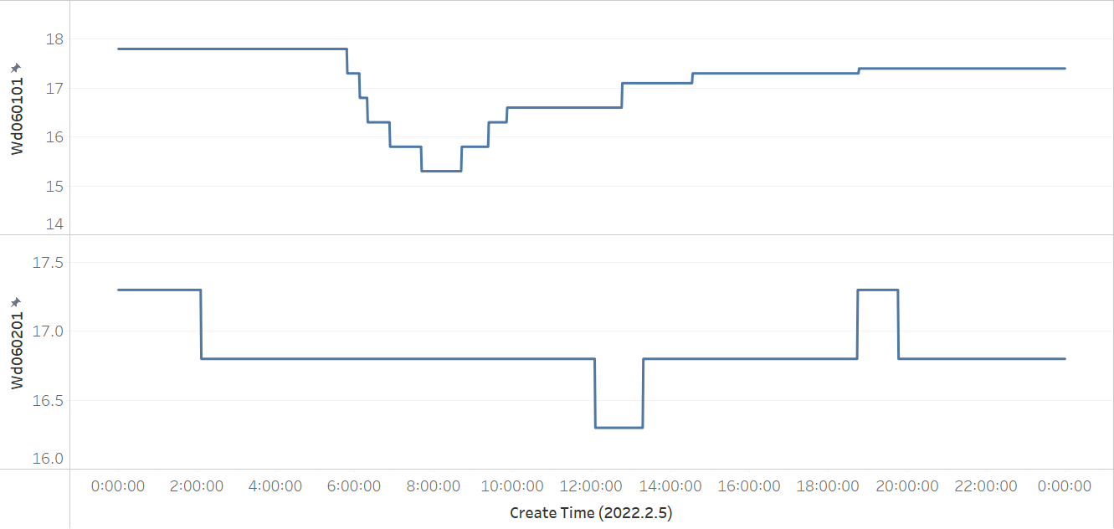
Appendix 4: Wind Data on 5 Feb 2022
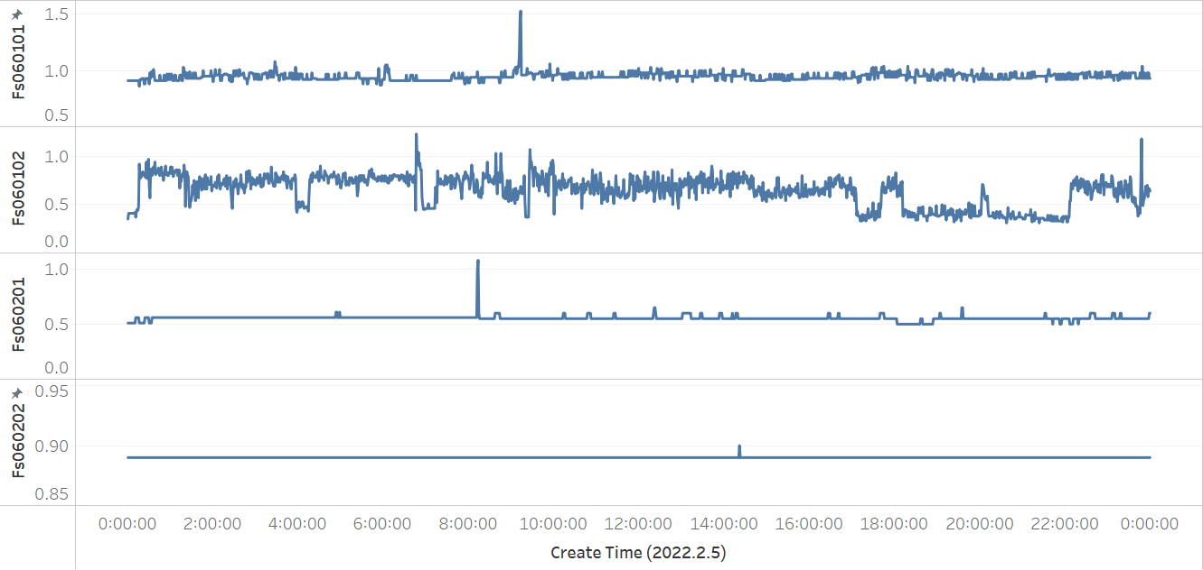
Appendix 5: Gas Data on 6 Feb 2022
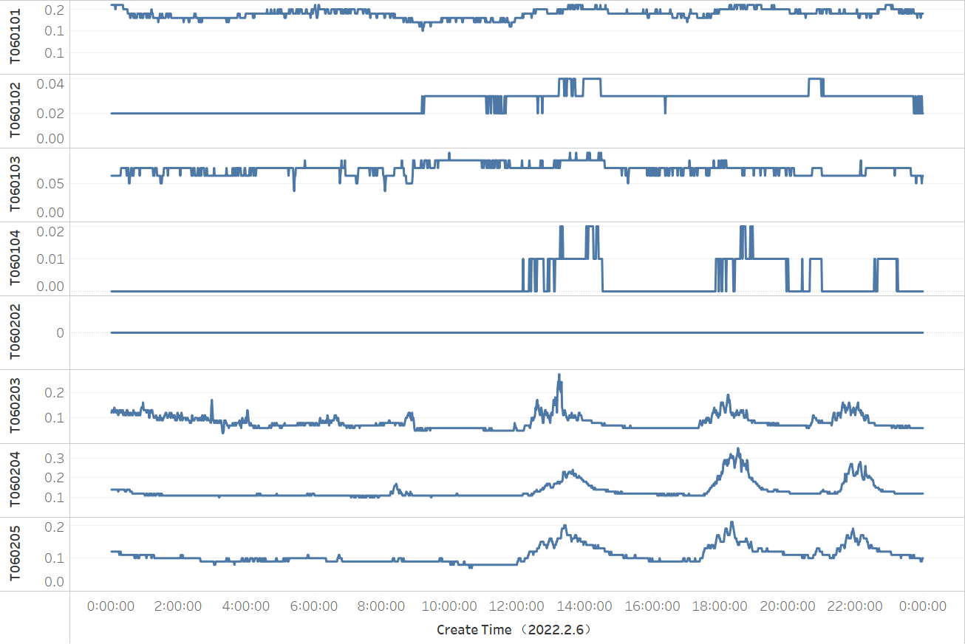
Appendix 6: Temperature Data on 6 Feb 2022
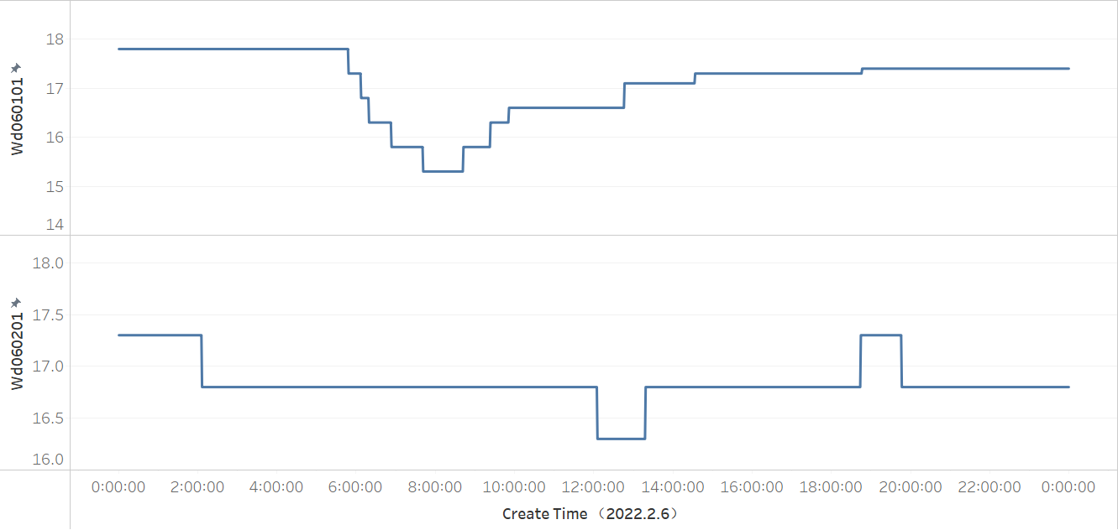

Appendix 7: Wind Data on 5 Feb 2022
