Supplementary Methods
CT image acquisition
The scan range was from the upper edge of the kidney to the lower edge of the ischial tuberosity, and non-contrast CT was received with a 64-slice MDCT scanner (Discovery CT 750 HD, GE Healthcare, USA). The relevant CT imaging acquisition parameters were as follows: tube voltage, 100-120 kV; Automatic tube current, 200-350mA; Rotation time, 0.5 s; Scan slice thickness, 5mm; and reconstruction thickness, 5mm.
Stone composition detection
All the stones were detected by the infrared spectroscopy automatic analysis system (LIIR-20, Lamoride Company, Tianjin, China) in the lithotrig center of our hospital. Before testing, the stained residues on the surface of the stone were washed with clean water and distilled water, dried, and dried in an oven at 70-100 ° C. 1.0-1.5mg of stone samples were removed and 200-300mg of pure potassium bromide, which was fully dried in advance, was thoroughly ground and mixed in an agate mortar. Subsequently, the mixture was pressurized by 20MPa with a tablet press for 1min to make a tablet with a thickness of 35mm and a translucent shape, which was quickly placed into an infrared spectral slot for scanning. The stone composition was automatically analyzed and reported by computer. If the uric acid component exceeded 50% of the total stone composition, it was considered the major component. Because most of the stones submitted for examination were mixed stones, this study took one component with the most content of urinary stones as the main component, which were calcium oxalate stones, carbonate apatite, hydroxyapatite, magnesium ammonium phosphate hexahydrate, and cystine stones. The composition of nUA is shown in Figure S1
Supplementary Figure

Fig.S1 Proportion of components of non-uric acid stones in the included samples

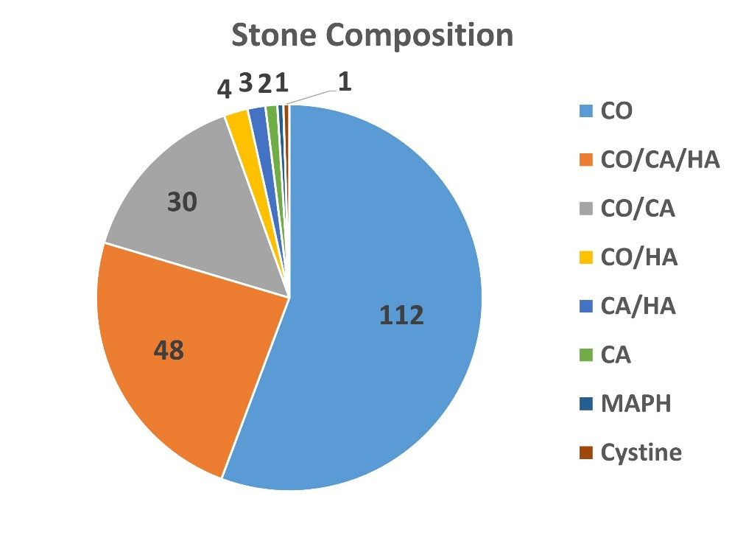
CO Calcium Oxalate, CA Carbonate Apatite, HA Hydroxy Apatite, MAPH Magnesium Ammonium Phosphate Hexahydrate,

Supplementary Table
Table S1 Clinical baseline data of patients with urinary calculi
Characteristic | UA Stone | Non-UA Stone | p
n | 169 | 201
Gender, n (%) |  |  | 0.754
Female | 52 (14.1%) | 66 (17.8%)
Male | 117 (31.6%) | 135 (36.5%)
HP, n (%) |  |  | 0.011
N | 110 (29.7%) | 156 (42.2%)
Y | 59 (15.9%) | 45 (12.2%)
Age, median (IQR) | 57 (50, 65) | 51 (42, 59) | < 0.001
BMI, mean ± SD | 26.19 ± 3.77 | 25.09 ± 3.42 | 0.004
WBC, median (IQR) | 8.32 (6.32, 11.76) | 8.23 (5.94, 11.16) | 0.378
FBG, median (IQR) | 5.39 (4.87, 6.63) | 5.23 (4.72, 6.08) | 0.081
b-UA, median (IQR) | 391.9 (329, 469) | 354 (287, 426.8) | < 0.001
TG, median (IQR) | 1.47 (0.95, 2.1) | 1.28 (0.86, 2) | 0.086
LDL, mean ± SD | 2.99 ± 0.83 | 3.06 ± 0.87 | 0.445
U-PH, median (IQR) | 5.5 (5, 6) | 6 (5.5, 6.5) | < 0.001
U-WBC, median (IQR) | 27.7 (8.58, 90.3) | 31.9 (16.7, 86.1) | 0.058
BMI, Body Mass Index; HBP, High Blood Pressure; WBC, White Blood Cell; FBG, Fasting Blood Glucose; b-UA, Blood Uric Acid; TG, Triglyceride; LDL, Low Density Lipoprotein; U-PH, Urine pH; U-WBC, Urine WBC

Table S Selection results of radiomics features and coefficients for Rad-score building
Radscore | Coefficient
original_shape_Sphericity | -0.34597
original_firstorder_InterquartileRange | -0.36217
original_glcm_Id | 0.220968
original_glcm_InverseVariance | 0.363713
wavelet-LLH_firstorder_InterquartileRange | -0.39689
wavelet-LLH_firstorder_Mean | 0.173423
wavelet-LHL_firstorder_Median | -0.20132
wavelet-LHL_firstorder_Skewness | 0.03605
wavelet-LHL_gldm_DependenceNonUniformityNormalized | 0.168037
wavelet-LHL_gldm_SmallDependenceEmphasis | -0.27441
wavelet-LHH_glcm_Correlation | 0.188649
wavelet-LHH_glszm_SizeZoneNonUniformityNormalized | -0.10998
wavelet-HLL_firstorder_Median | -0.29616
wavelet-HLL_glszm_SmallAreaEmphasis | -0.03293
wavelet-HHL_firstorder_Median | -0.36485
wavelet-LLL_gldm_LargeDependenceLowGrayLevelEmphasis | -0.52797
intercept | -0.18652

