Supporting Information:
Table of Contents

1. Tables and Figures S2
2. Experimental Section S18
3. Figures of Characterization of ligands and homogeneous catalysts S25
4. Figures of NMR and of copolymers S30
5. GPC of copolymers. S41

1. Tables and Figures.
Table S1. Ethylene polymerization studies with the Ni catalysts.ª
Ent | Cat. | P | Yied/g^{b} | Act. ^{b}  ×10⁶ | T_{m} ^{c} /ºC | M_{n}^{d} (10⁴) | M_{w}^{d} | M_{w} /M_{n}^{d}
1 | Ni1 | 8 | 0.68 | 8.2 | 135.6 | 29.2 | 67.1 | 2.3
2 | Ni2 | 8 | 0.55 | 6.6 | 135.5 | 11.6 | 26.7 | 2.3
3 | Ni3 | 8 | 0.53 | 3.2 | 123.1 | 1.0 | 1.6 | 1.6
4 | Ni1-MgO | 8 | 0.88 | 52.8 | 138.3 | 241.0 | 556.9 | 2.3
5 | Ni2-MgO | 8 | 0.50 | 31.2 | 136.2 | 86.5 | 177.9 | 2.1
6 | Ni3-MgO | 8 | 0.17 | 10.2 | 126.7 | 1.1 | 2.3 | 2.1
7 | Ni1/Ni2-MgO(1:2) | 8 | 0.70 | 42.0 | 136.2 | 34.8 | 267.8 | 7.7
8 | Ni1/Ni2-MgO(1:1) | 8 | 0.75 | 45.0 | 135.7 | 62.2 | 594.7 | 9.6
9 | Ni1/Ni2-MgO(2:1) | 8 | 0.97 | 58.2 | 136.7 | 91.2 | 449.3 | 4.9
10 | Ni1/Ni2-MgO(1:1) | 30 | 1.55 | 93.0 | 135.0 | 87.8 | 638.4 | 7.2
11 | Ni1/Ni3-MgO(1:1) | 8 | 0.32 | 19.2 | 133.9 | 3.6 | 329.7 | 92.4
12 | Ni1/Ni3-MgO(1:2) | 8 | 0.50 | 12.0 | 132.1 | 5.5 | 232.5 | 42.7
13 | Ni1/Ni3-MgO(1:5) | 8 | 0.72 | 43.2 | 128.8 | 0.7 | 107.7 | 143.1
14 | Ni1/Ni3-MgO(1:1) | 30 | 0.45 | 15.6 | 134.7 | 5.9 | 397.2 | 67.1
15 | Ni1/Ni3-MgO(1:5) | 30 | 1.01 | 59.4 | 130.3 | 2.9 | 164.9 | 57.1
16 | Ni2/Ni3-MgO(1:1) | 8 | 0.43 | 25.8 | 133.6 | 2.5 | 64.1 | 25.6
17 | Ni1/Ni3 | 8 | 0.60 | 7.2 | 126.5/136.2 | 3.5 | 31.3 | 8.9
18 | Ni2-MgO/Ni3-MgO | 8 | 0.46 | 27.6 | 125.9/135.8 | 6.8 | 78.9 | 11.7
ª Conditions: 1-3, 17, catalyst 0.5 µmol; 4-16, 18, catalyst 0.1 µmol; 5 mL Hex.; t = 10min; T=80ºC; ^{b} Yields are the average of at least two runs. Activity is in units of 10⁶ g/(mol cat. × h). ^{c} Determined by differential scanning calorimetry (DSC, second heating). ^{d}M_{n}: 10⁴ g mol⁻¹, M_{n} and M_{w}/M_{n} determined by GPC in trichlorobenzene at 160 ºC

Table S2. Ethylene copolymerization with Ni catalysts.ª
Ent | Cat. | Comom.[M] | Yield  /g ^{b} | Act. ^{b} (10⁵) | Incorp. %^{c} | T_{m}^{d}/ºC | M_{n}^{e}(10⁴) | M_{w}^{e}(10⁴) | M_{w} /M_{n}^{e}
1 | Ni1 | UAE0.5 | 0.77 | 6.2 | 0.5 | 132.9 | 8.1 | 24.3 | 3.0
2 | Ni2 | UAE0.5 | 0.61 | 4.9 | 0.5 | 127.8 | 6.6 | 14.5 | 2.2
3 | Ni3 | UAE0.5 | 0.38 | 3.0 | 0.7 | 122.0 | 0.9 | 2.6 | 2.9
4 | Ni1/Ni3 | UAE0.5 | 0.58 | 4.6 | 0.6 | 125.0/132.9 | 2.4 | 15.4 | 6.4
ª Conditions: 2.5 µmol; 5 mL Hex.; t = 30 min; T = 80 ºC; 8 atm. ^{b} Yields are the average of at least two runs. Activity is in units of 10⁵ g/(mol cat. × h).^{c} Incorporation ratios of comonomers were determined from ¹H NMR spectra. ^{d} Determined by differential scanning calorimetry (DSC, second heating) ^{e} M_{n}: 10⁴ g mol⁻¹, M_{n}, M_{w} and M_{w}/M_{n} were determined by gel permeation chromatography (GPC) in 1,2,4-trichlorobenzene at 160 ºC.

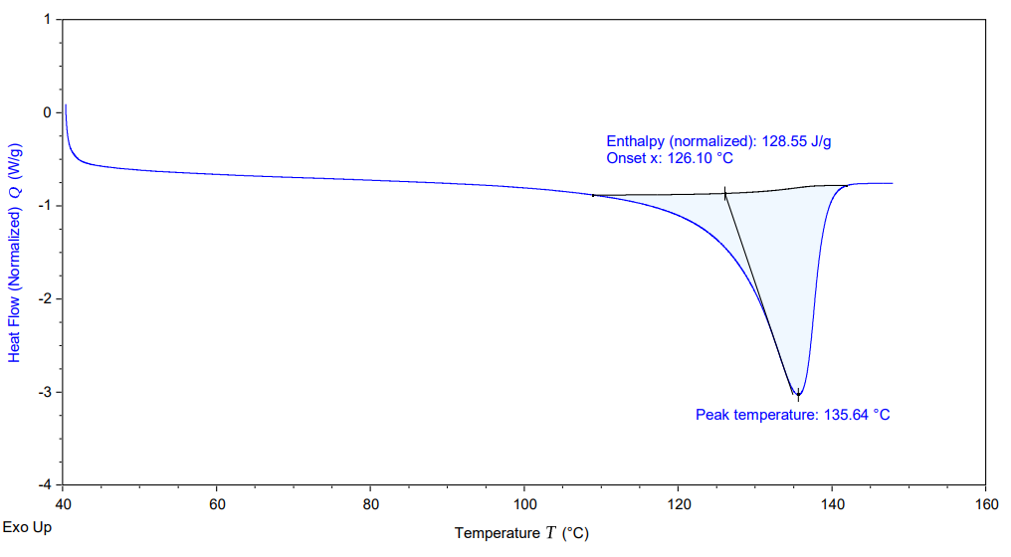
Figure S1. DSC of the polymer from Table S1, Entry 1.
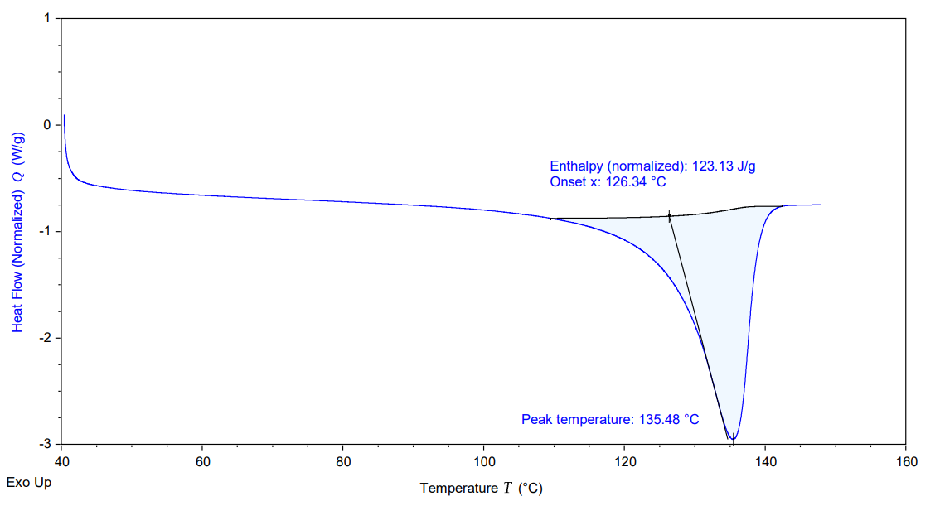
Figure S2. DSC of the polymer from Table S1, Entry 2.
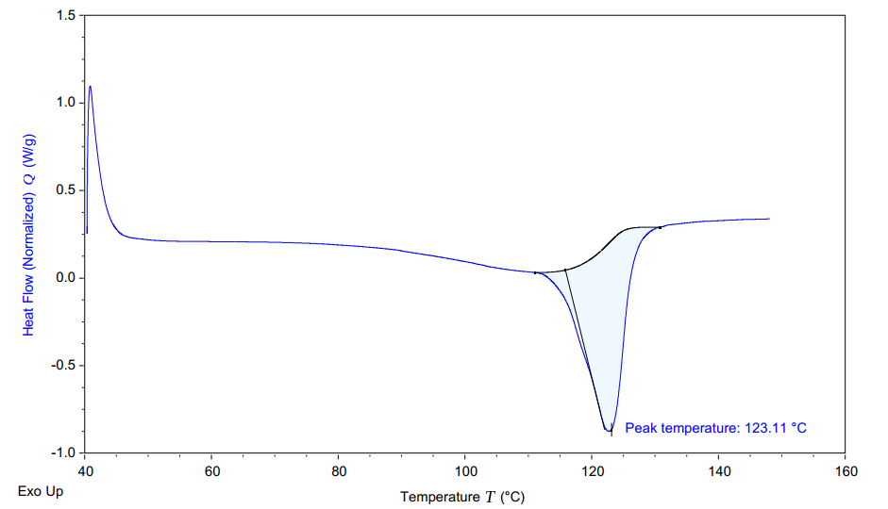
Figure S3. DSC of the polymer from Table S1, Entry 3.

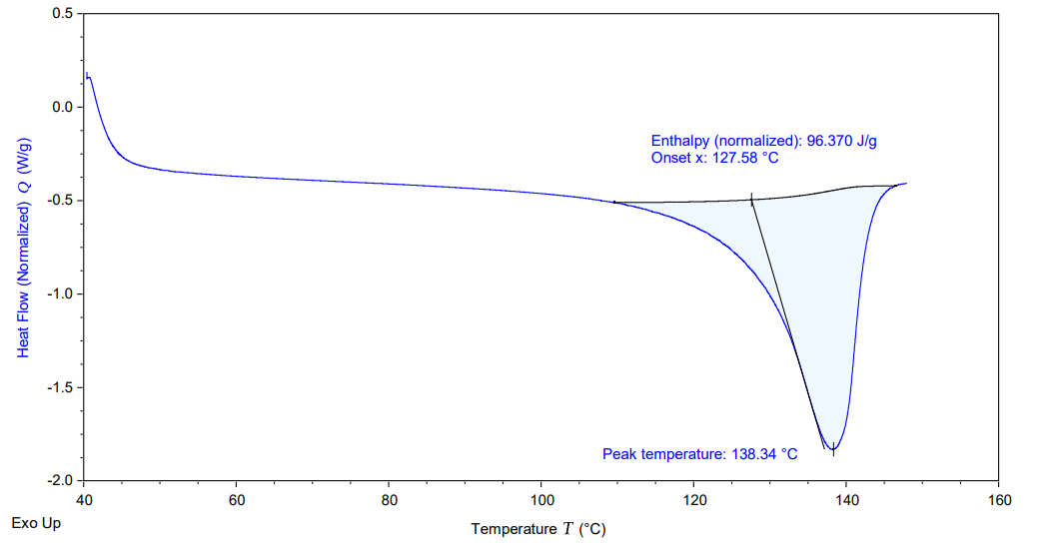
Figure S4. DSC of the polymer from Table S1, Entry 4.

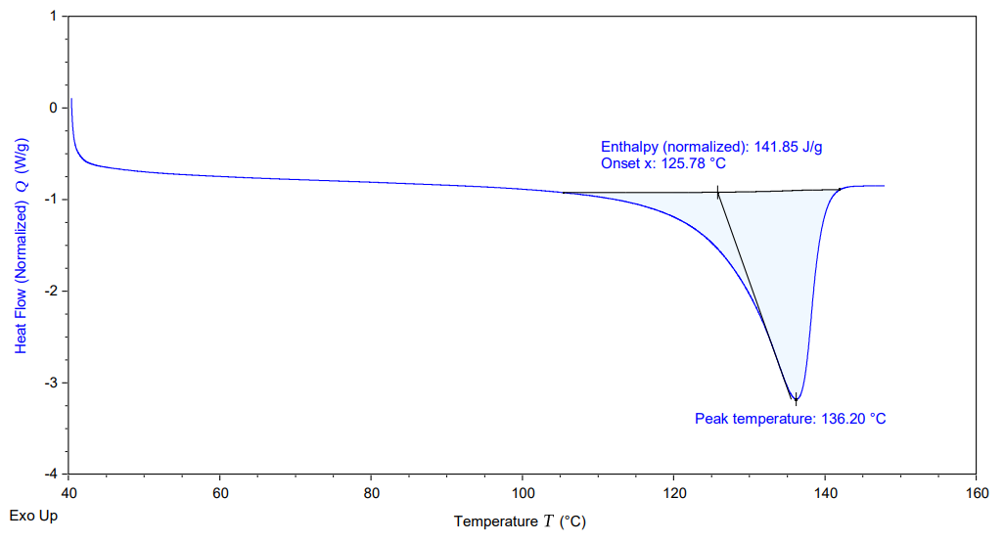
Figure S5. DSC of the polymer from Table S1, Entry 5.

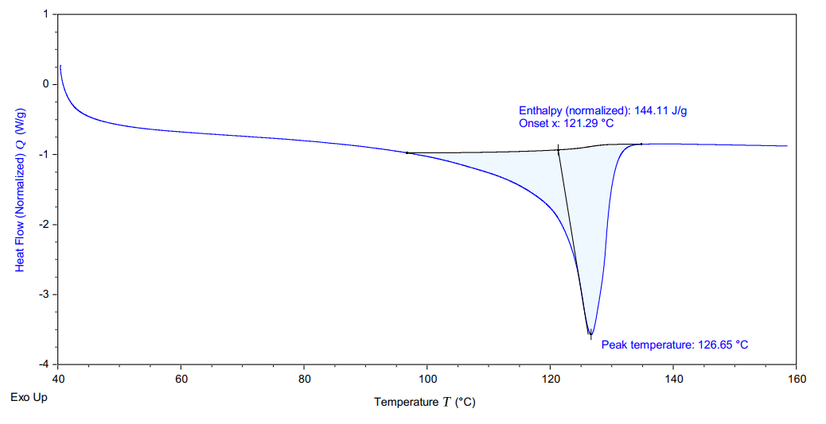
Figure S6. DSC of the polymer from Table S1, Entry6.

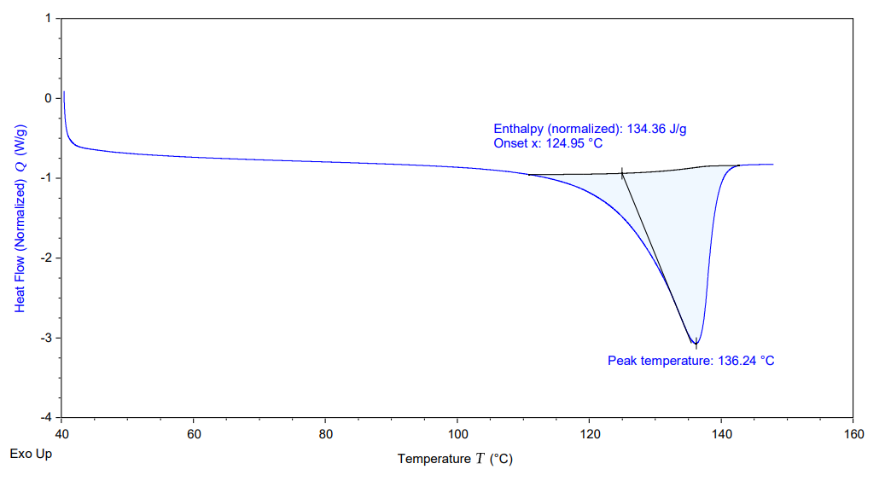
Figure S7. DSC of the polymer from Table S1, Entry 7.

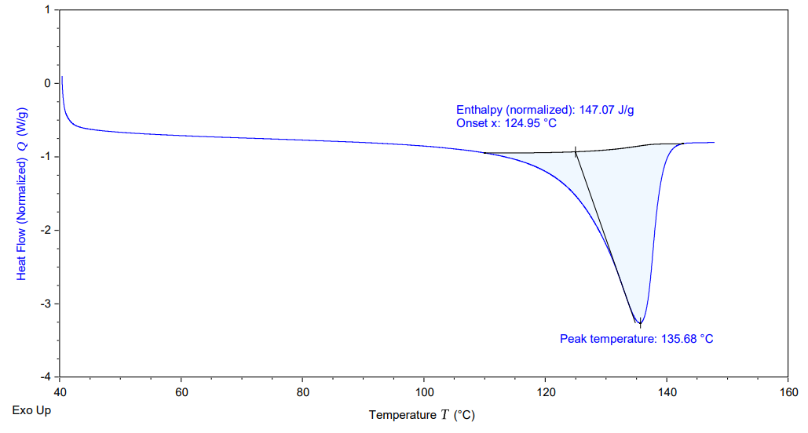
Figure S8. DSC of the polymer from Table S1, Entry 8.
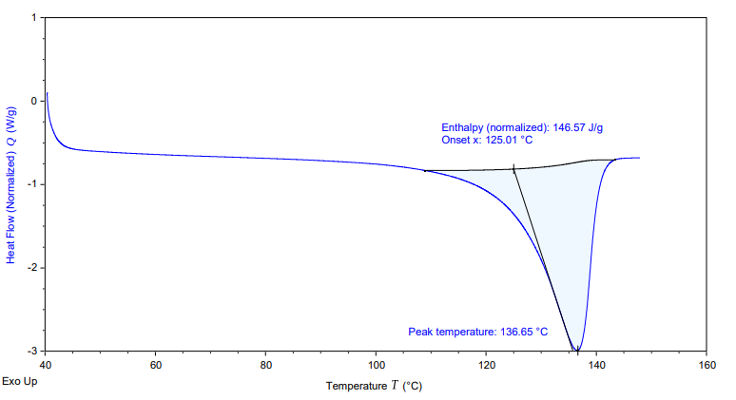
Figure S9. DSC of the polymer from Table S1, Entry 9.
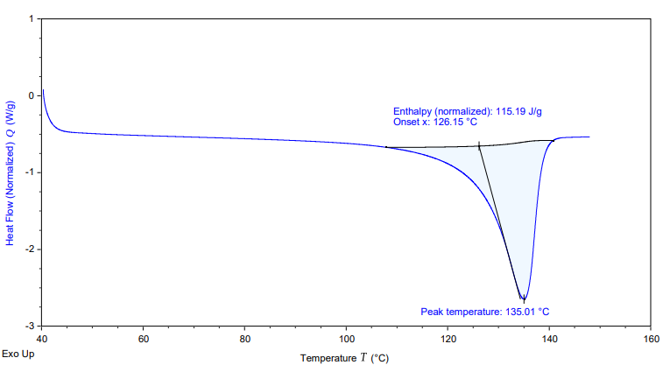
Figure S10. DSC of the polymer from Table S1, Entry 10.
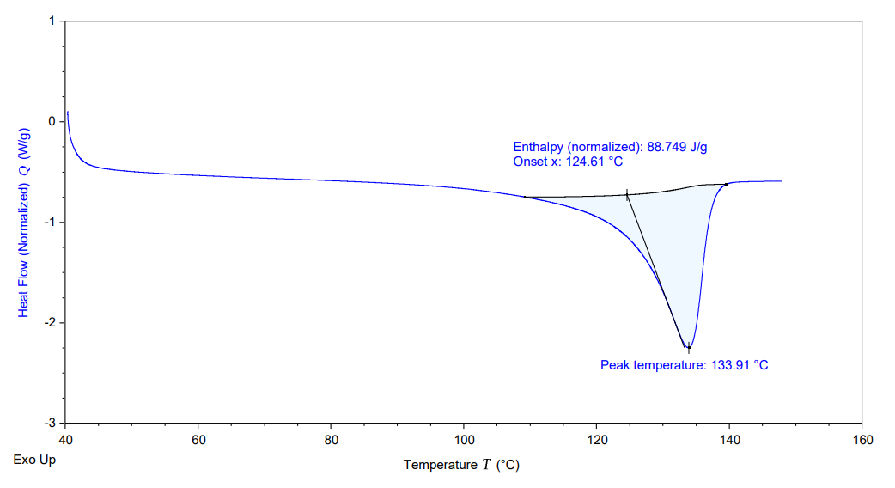

Figure S11. DSC of the polymer from Table S1, Entry 11.
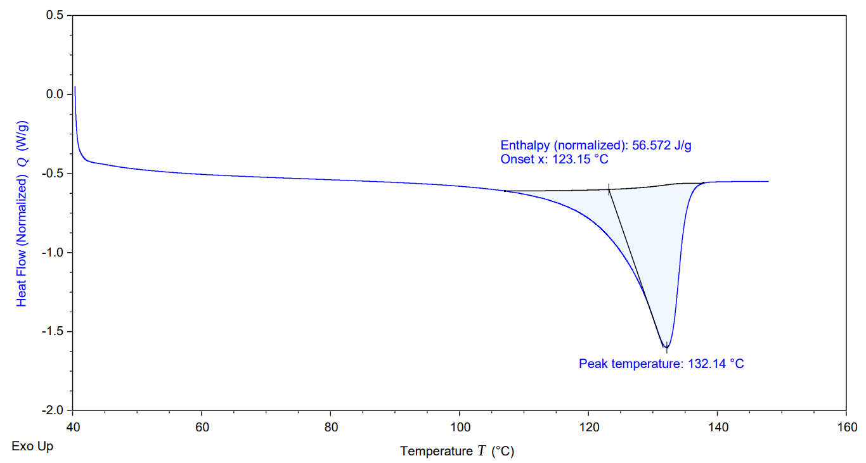
Figure S12. DSC of the polymer from Table S1, Entry 12.
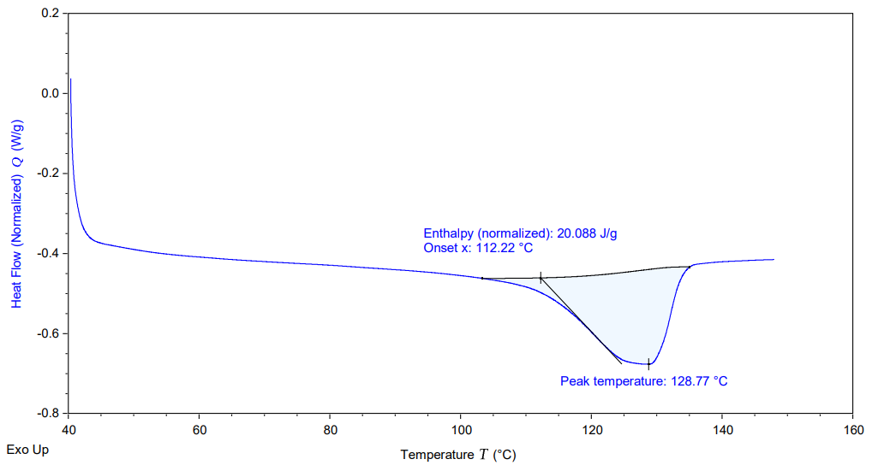
Figure S13. DSC of the polymer from Table S1, Entry 13.
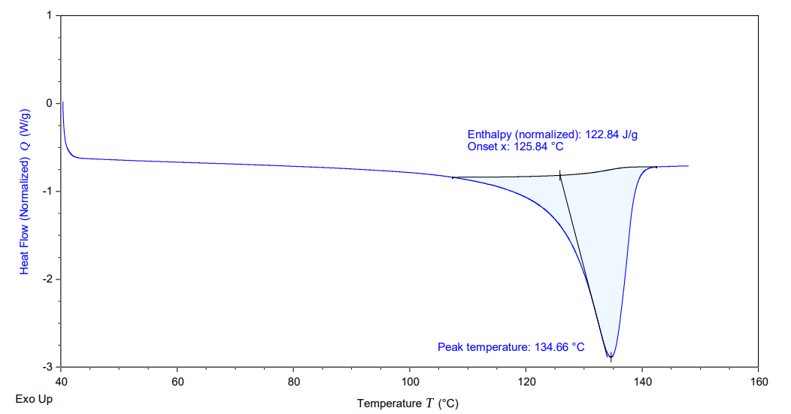
Figure S14. DSC of the polymer from Table S1, Entry 14.
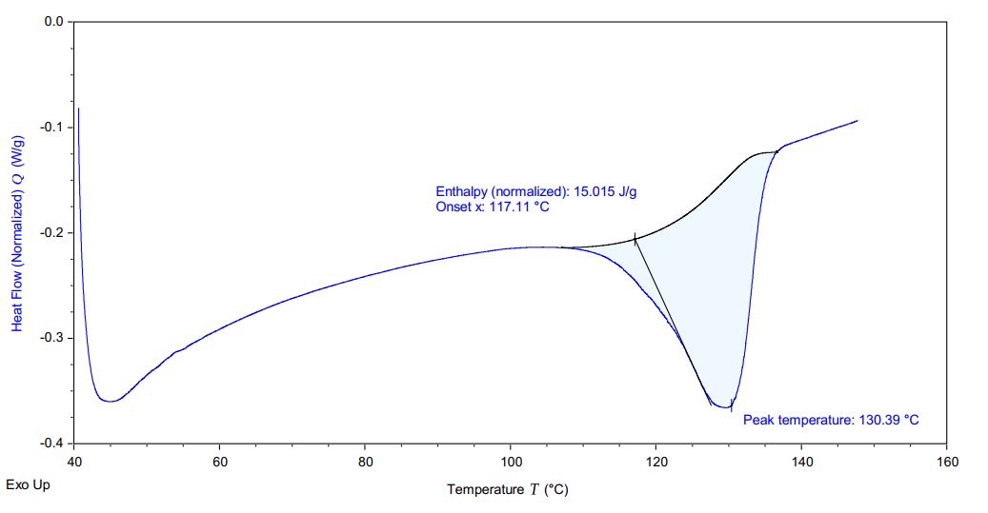

Figure S15. DSC of the polymer from Table S1, Entry 15.

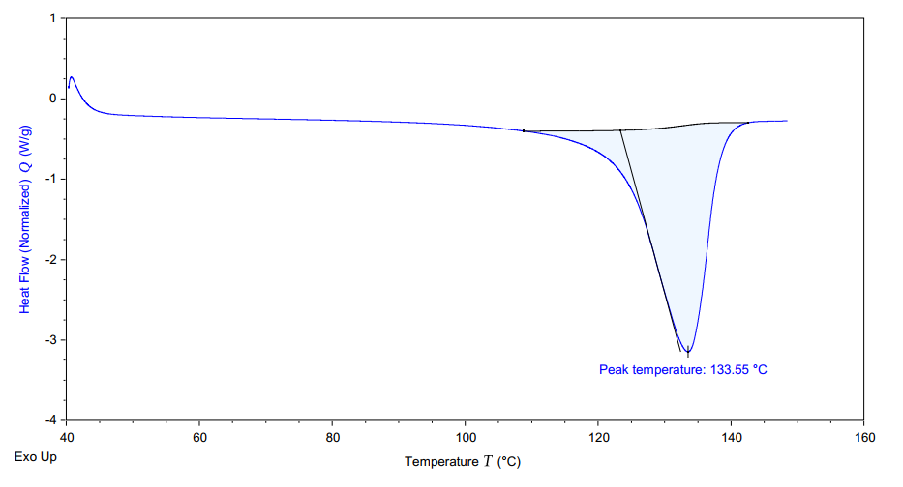
Figure S16. DSC of the polymer from Table S1, Entry 16.

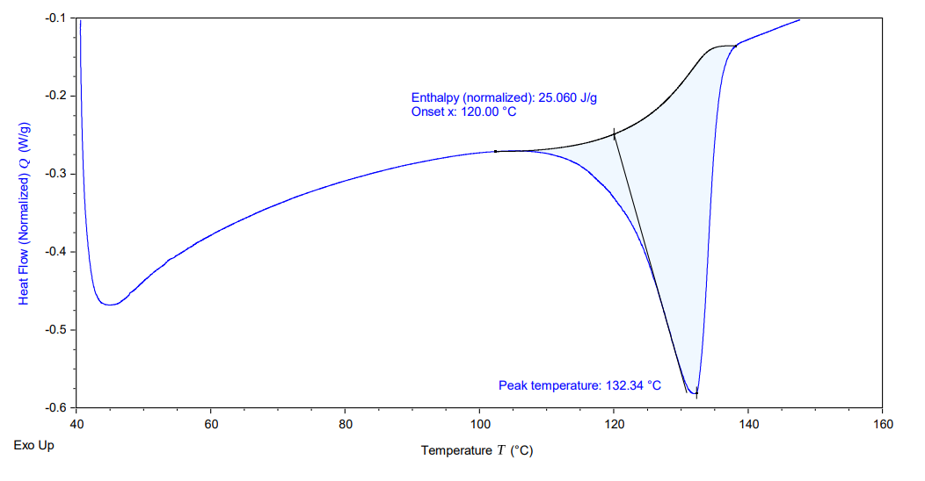
Figure S17. DSC of the polymer from Table S2, Entry 1.

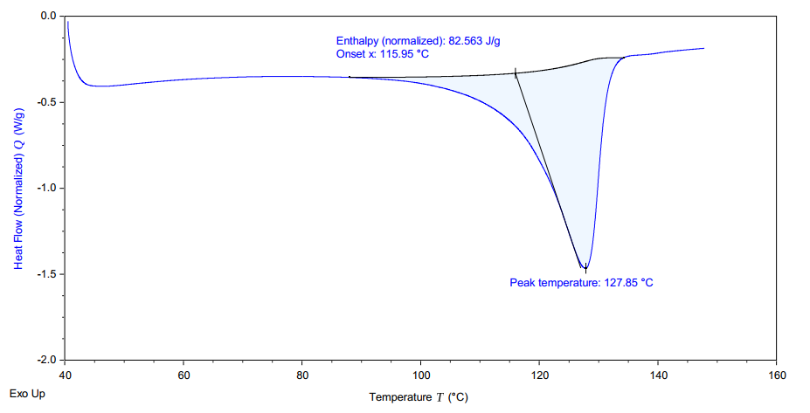
Figure S18. DSC of the polymer from Table S2, Entry 2.
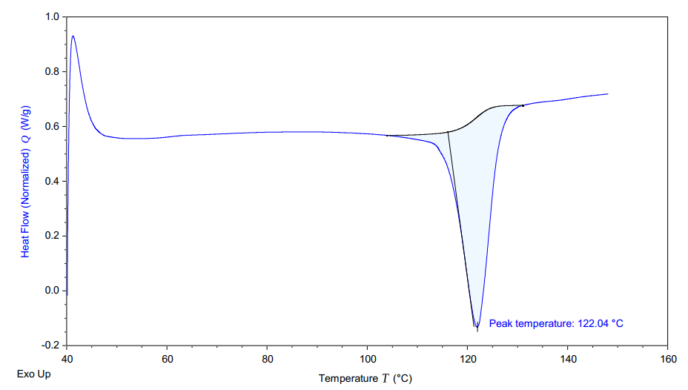
Figure S19. DSC of the polymer from Table S2, Entry 3.

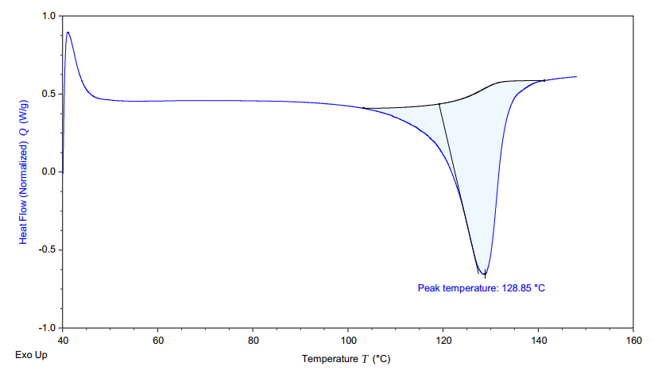
Figure S20. DSC of the polymer from Table 1, Entry 1.

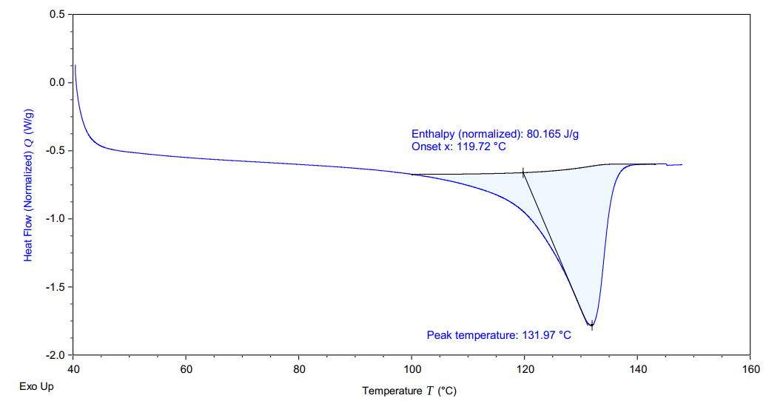
Figure S21. DSC of the polymer from Table 1, Entry 2.

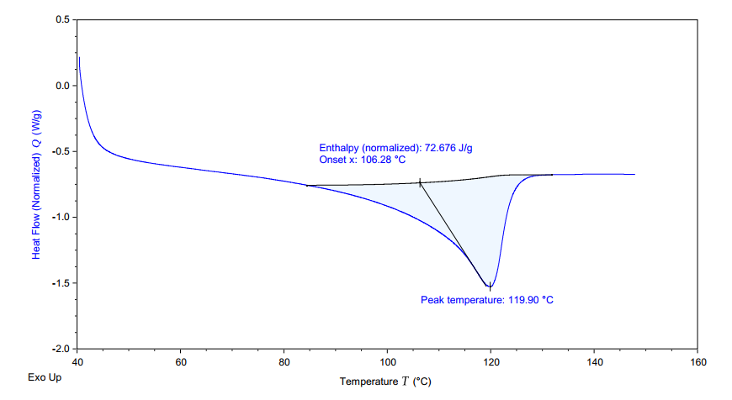
Figure S22. DSC of the polymer from Table 1, Entry3.
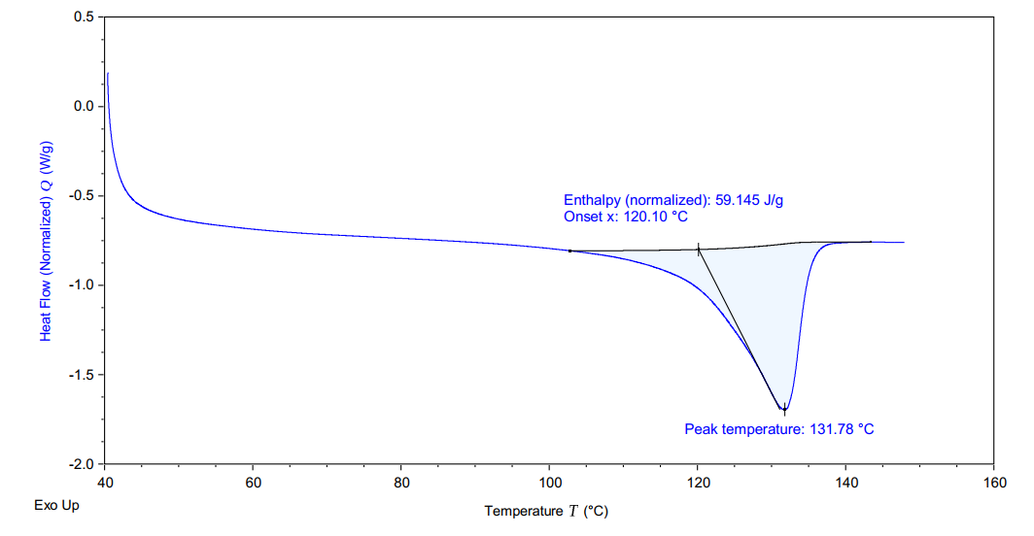
Figure S23. DSC of the polymer from Table 1, Entry 4.

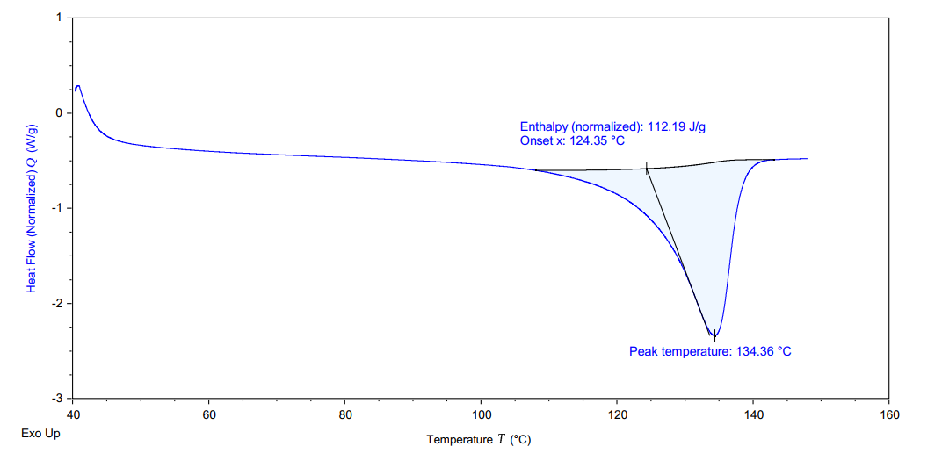
Figure S24. DSC of the polymer from Table 1, Entry 5.

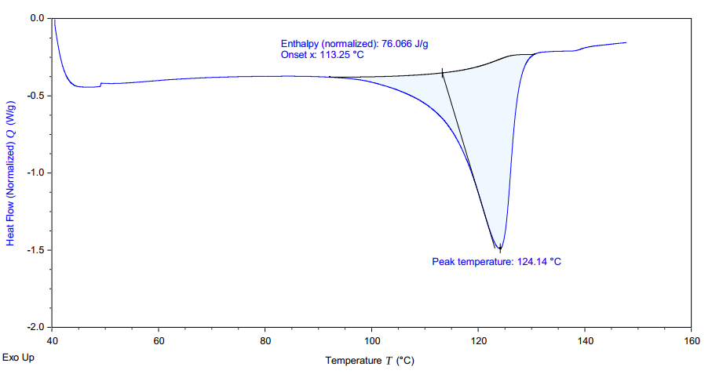
Figure S25. DSC of the polymer from Table 1, Entry 6.

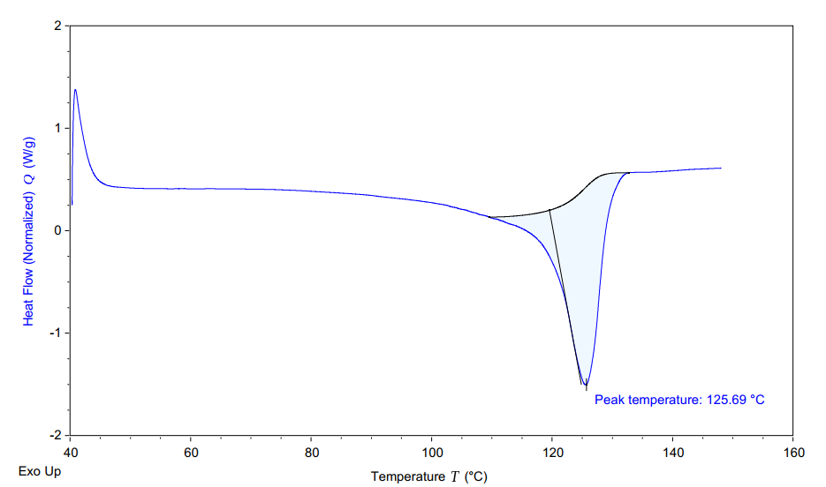
Figure S26. DSC of the polymer from Table 1, Entry 7.

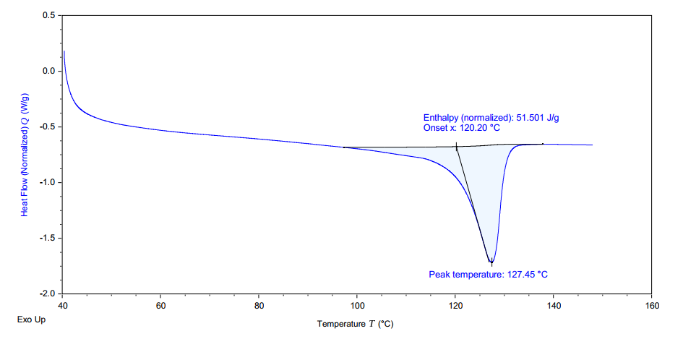
Figure S27. DSC of the polymer from Table 1, Entry 8.
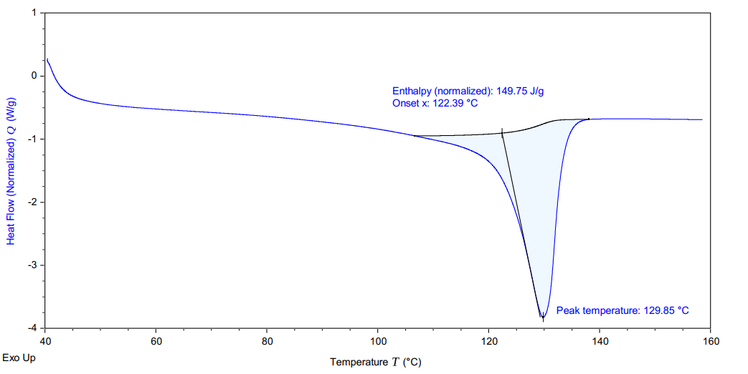
Figure S28. DSC of the polymer from Table 1, Entry 9.

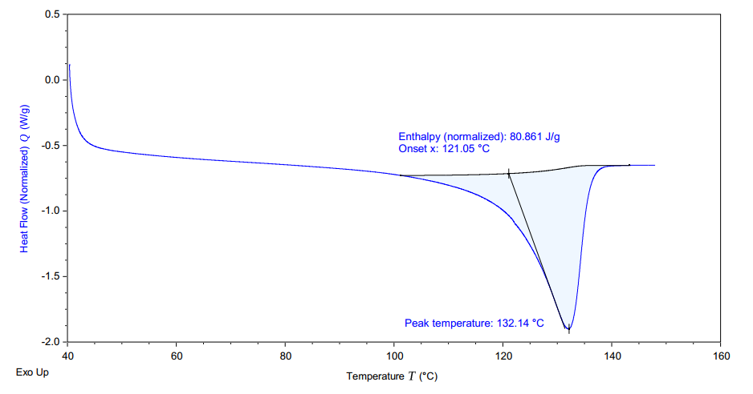
Figure S29. DSC of the polymer from Table 1, Entry 10.
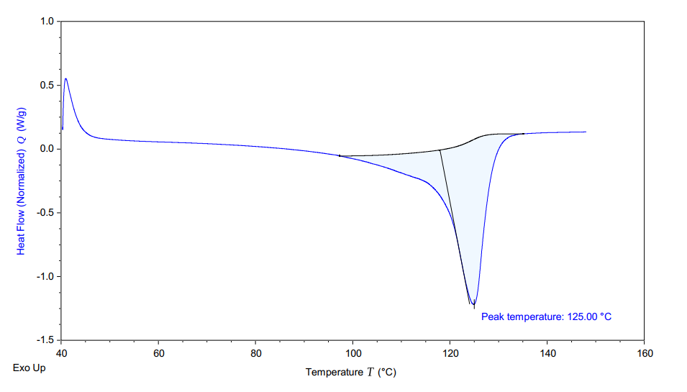
Figure S30. DSC of the polymer from Table 1, Entry 11.

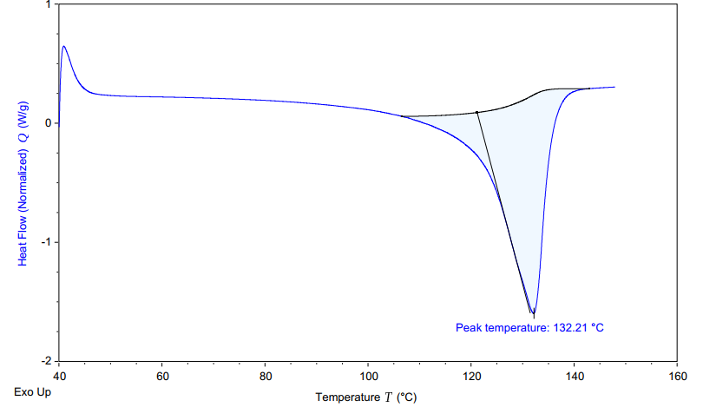
Figure S31. DSC of the polymer from Table 1, Entry 12.
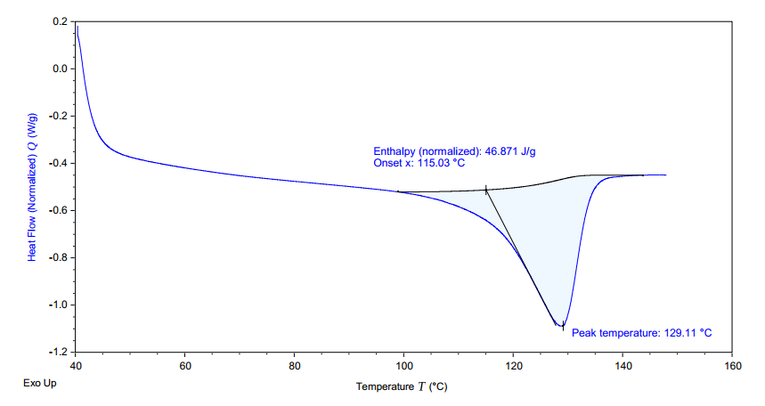
Figure S32. DSC of the polymer from Table 1, Entry 13.
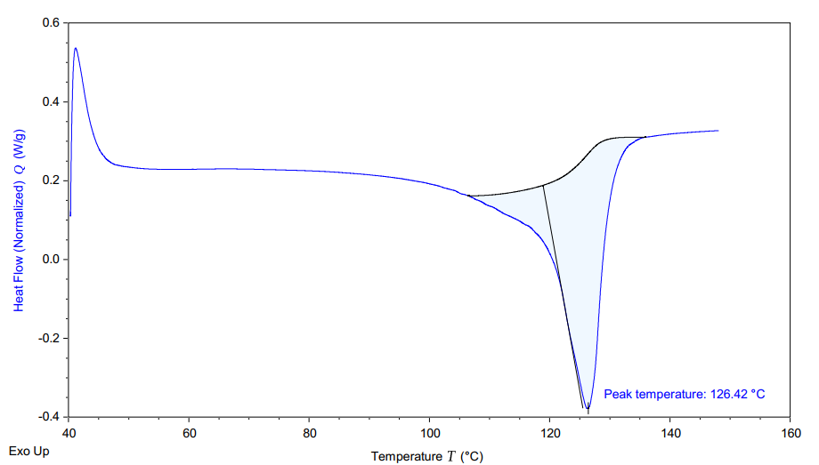
Figure S33. DSC of the polymer from Table 1, Entry 14.

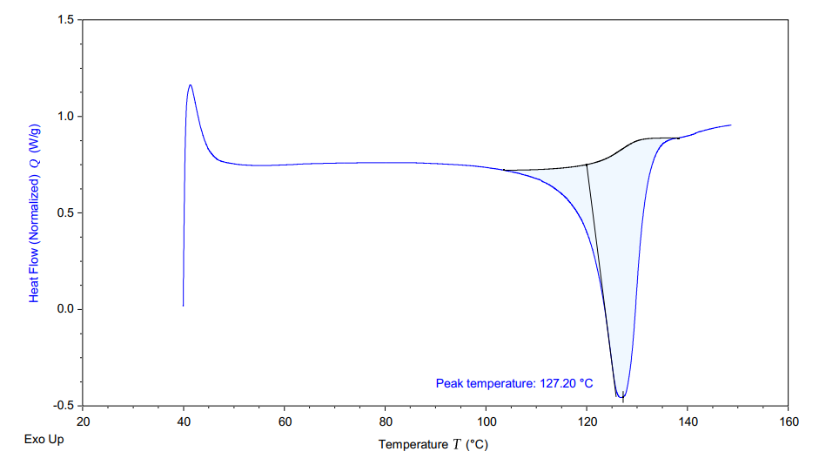
Figure S34. DSC of the polymer from Table 1, Entry 15.
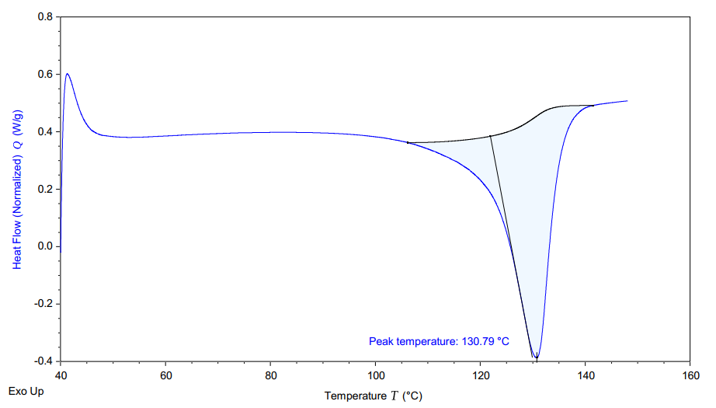
Figure S35. DSC of the polymer from Table 1, Entry 16.
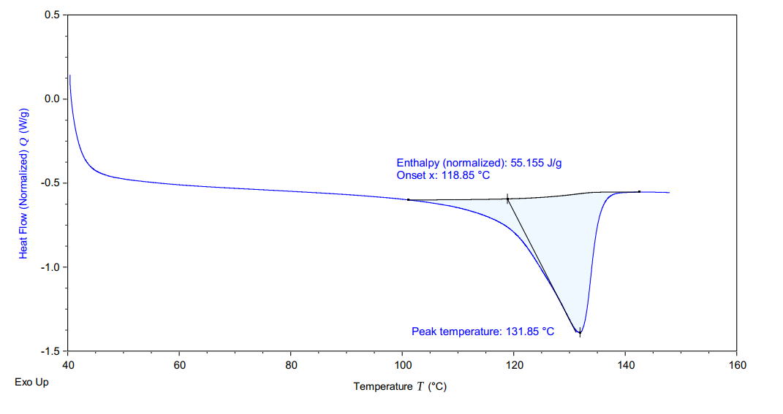
Figure S36. DSC of the polymer from Table 1, Entry 17.

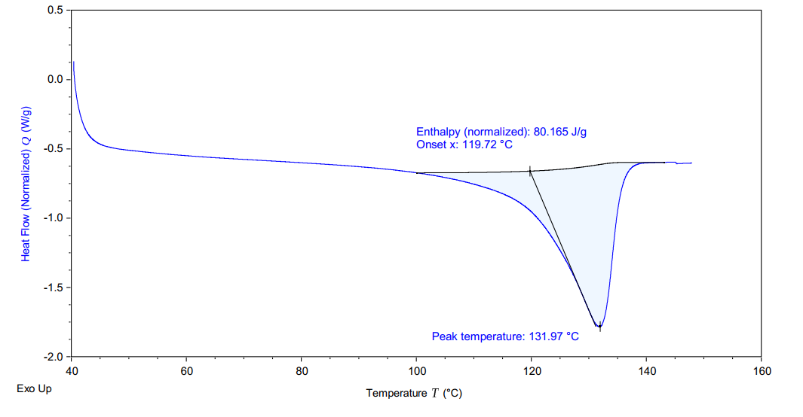
Figure S37. DSC of the polymer from Table 1, Entry 18.

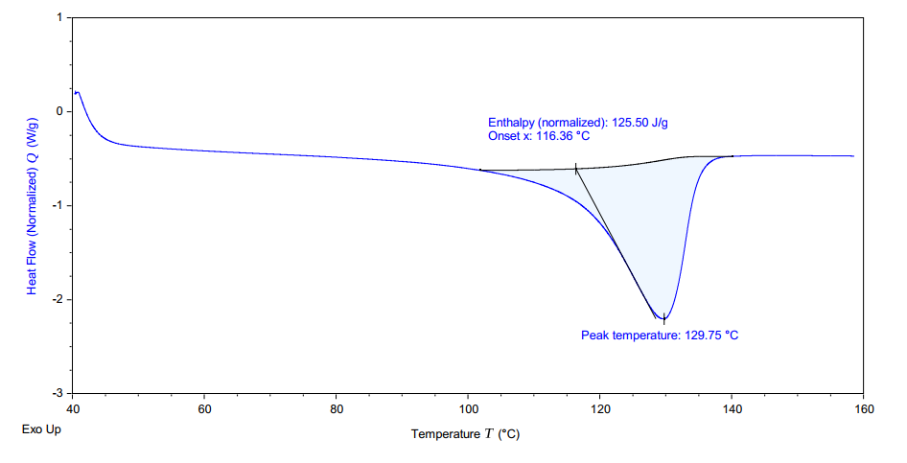
Figure S38. DSC of the polymer from Table 1, Entry 19.

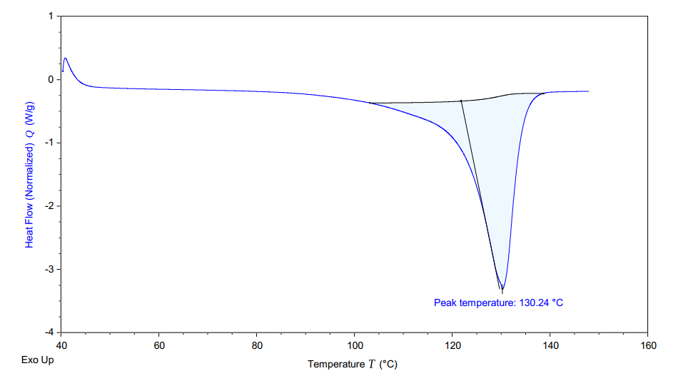
Figure S39. DSC of the polymer from Table 1, Entry 20.

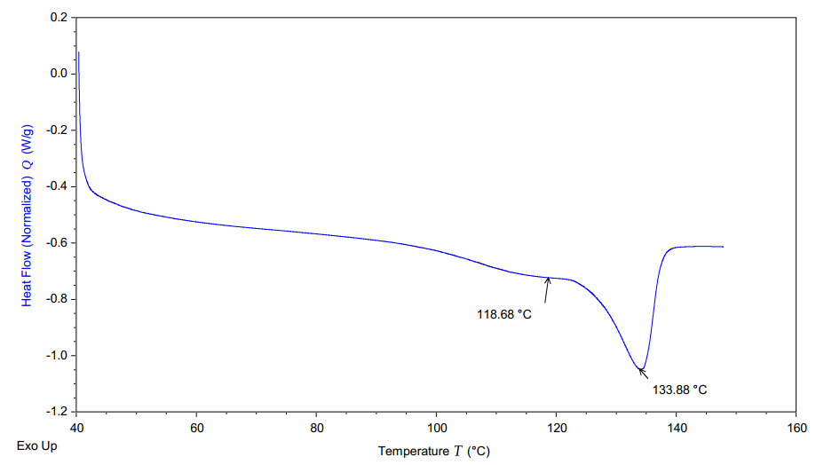
Figure S40. DSC of the polymer from Table 1, Entry 21, prepared by mixed heterogeneous catalyst Ni2-MgO/Ni3-MgO.
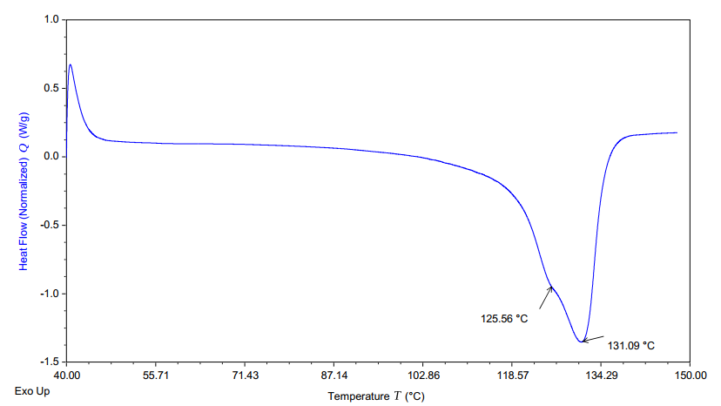
Figure S41. DSC of the polymer from Table 1, Entry 22, prepared by mixed heterogeneous catalyst Ni2-MgO/Ni3-MgO.
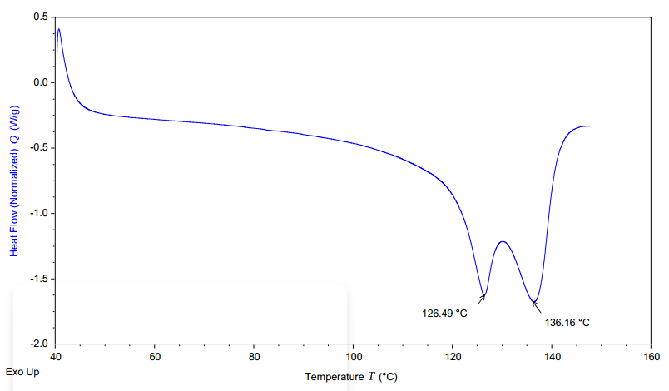
Figure S42. DSC of the polymer from Table S1, Entry 17, prepared by mixed homogeneous catalyst Ni1/Ni3.

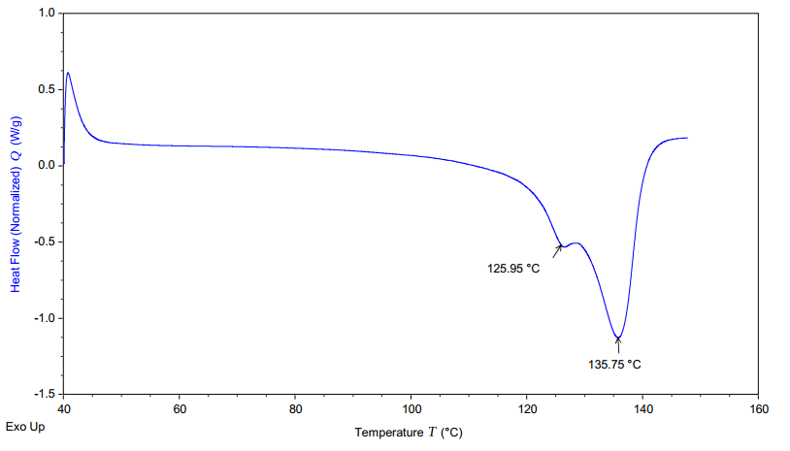
Figure S43. DSC of the polymer from Table S1, Entry 18, prepared by mixed heterogeneous catalyst Ni2-MgO/Ni3-MgO.
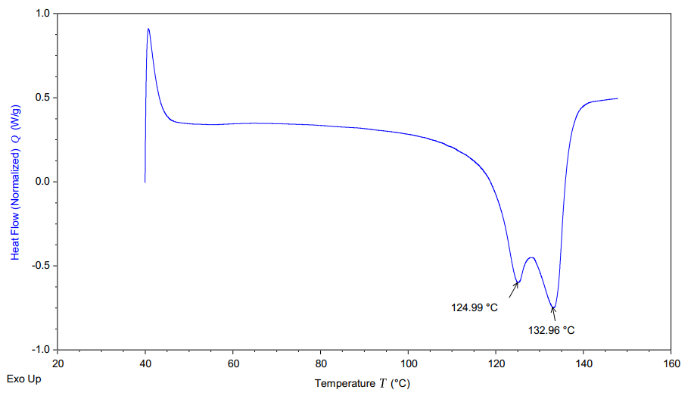
Figure S44. DSC of the polymer from Table S2, Entry 4, prepared by mixed homogeneous catalyst Ni1 /Ni3.

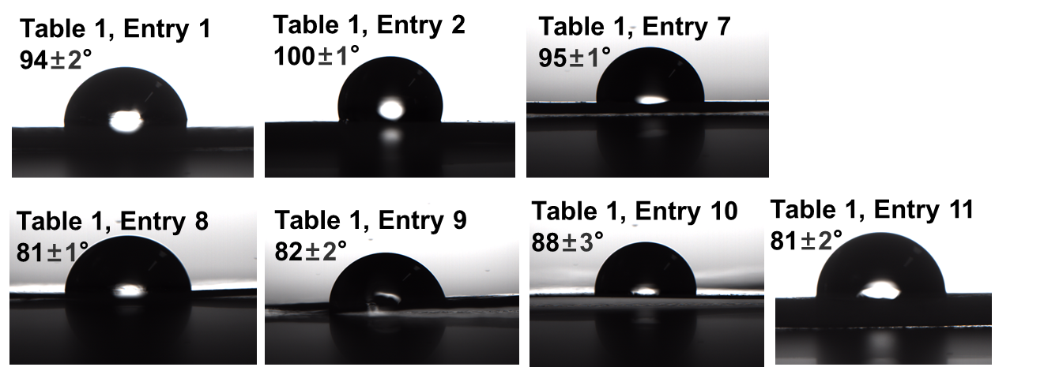
Figure S45. Pictures of water contact angle measurement.

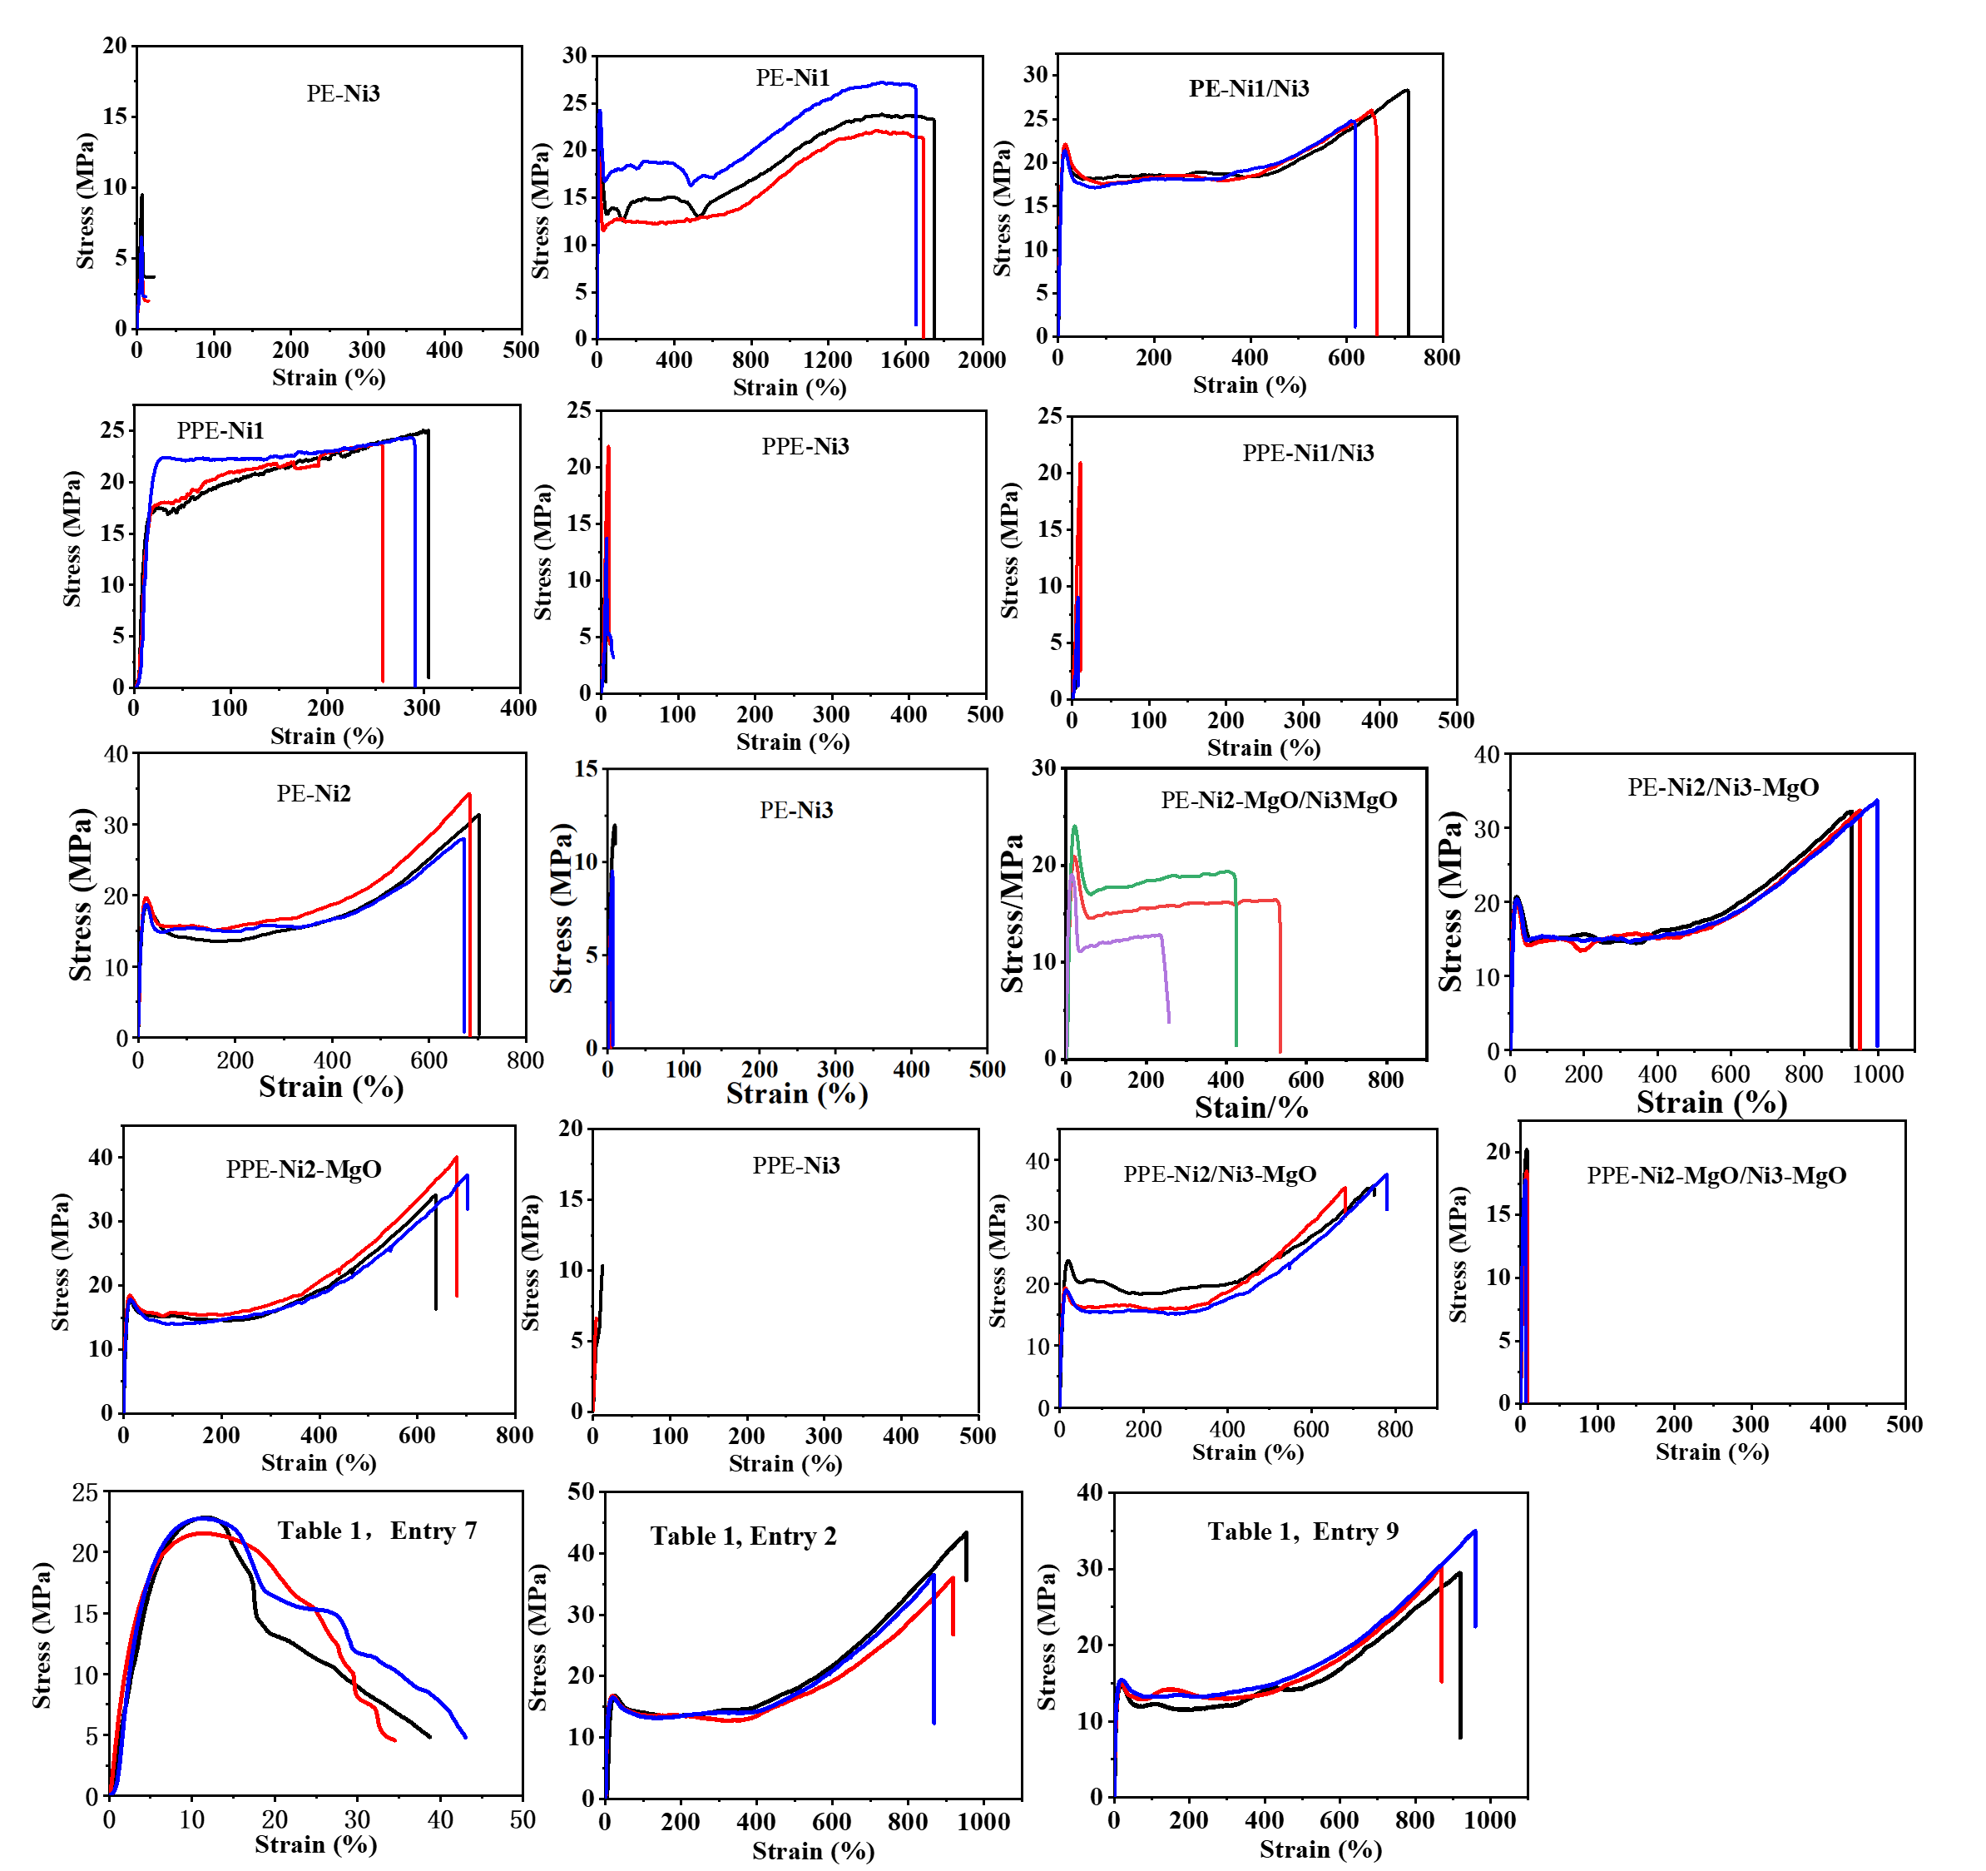
Figure S46. Original data of stress-strain curve.

2. Experimental Section
Preparation of homogeneous catalysts.
Ni1: Under nitrogen, 2,2'-((2-(tert-butyl)-1,4-phenylene)bis(oxy))bis(tetrahydro-2H-pyran)(3.34g,10 mmol) was dissolved in 50 mL of dried THF. n-BuLi (4.6mL,2.4 M in hexane,11 mmol, 1.1 equiv.) was added dropwise and the reaction mixture was stirred for 2 h at 0 ºC. The flask was transferred to a -78 ºC bath, and a THF solution of chloro(2',6'-dimethoxy-[1,1'-biphenyl]-2-yl)(phenyl)phosphane (11 mmol,1.1 equiv) was added dropwise. The mixture was stirred for 1 hour, and warmed to room temperature to react for 12 h. After quenching, the suspension was transferred to a round bottom flask and the THF was evaporated on a rotary evaporator. The crude material was extracted with CH₂Cl₂ (3 x 200 mL), washed with H₂O (3 x 100 mL), and the organic phase was collect and dried over Na₂SO₄. After filtration and concentration, the crude product of the protected ligand can be obtained, which can be directly used for the next reaction without further purification. The protected ligand was dissolved in methanol under nitrogen, 3 equiv. of p-toluenesulfonic acid was added to react for 6 hours. The reaction solution was evaporated with a rotary evaporator to evaporate methanol. The crude material was extracted with CH₂Cl₂ (3 x 200 mL), washed with H₂O (3 x 100 mL), and the organic phase was collected and dried over Na₂SO₄. After filtration and concentration, pure ligand 1 was obtained by column chromatography as a white solid (2.19 g, 45%). Under nitrogen, a toluene solution of 1 mmol (487 mg) ligand 1 and 1.2 eq. Py₂NiMe₂ was stirred for 1 hour at room temperature. After concentrating, recrystallization with n-hexane resulted in the formation of Ni1 (543 mg, 85%) as a yellow solid. ligand 1: ¹H NMR (600 MHz, Chloroform-d) δ 7.41 (dd, J = 7.5, 1.5 Hz,1H), 7.29-7.24(m, 5H), 7.24-7.16(m, 4H)6.76 (d, J = 3.0 Hz, 1H), 6.51 (dd, J = 8.3, 4.3 Hz, 2H), 6.24 (dd, J = 4.2, 3.0 Hz, 1H), 6.16 (d, J = 10.5 Hz, 1H), 4.41 (s, 1H), 3.51 (s, 3H, -MeO), 3.45 (s, 3H, -MeO), 1.32 (s, 9H, -tBu).³¹P NMR (243 MHz, CDCl₃) δ -37.22.¹³C NMR (151 MHz, Chloroform-d) δ 157.75, 157.71, 152.29, 152.15, 148.32, 141.42, 141.21, 137.48, 135.97, 133.66, 133.54, 133.49, 131.14, 131.10, 129.60, 129.55, 128.46, 128.33, 128.29, 127.65, 122.03, 118.57, 117.37, 116.43, 103.92, 103.82, 55.66, 55.46, 34.93, 29.55. ESI-MS (m/z): [M+H]⁺ Calcd for C30 H32 O4 P, 487.20327; Found: 487.20386. Ni1: ¹H NMR (400 MHz, C₆D₆) δ 8.11 (s, 2H), 7.30 (s, 2H), 7.23-7.09 (m, 1H), 6.91 (dt, J = 14.1, 6.6 Hz, 2H), 6.78 - 6.61 (m, 5H), 6.53 (s, 2H), 6.42 - 6.19 (m, 4H), 6.07 (d, J = 8.2 Hz, 1H), 3.09 (s, 3H), 2.73 (s, 3H), 1.15 (9, 3H), -1.12 (s, 3H, Ni-Me). ³¹P NMR (162 MHz, C₆D₆) δ 22.62. ¹³C NMR (101 MHz, C₆D₆) δ 159.51, 158.03, 150.50, 141.41, 141.30, 137.58, 136.71, 135.84, 134.82, 132.91, 132.35, 132.29, 129.48, 128.92, 128.04, 127.92, 127.76, 127.60, 126.33, 122.55, 119.90, 114.72, 103.08, 102.91, 54.66, 54.19, 34.85, 29.57, -14.72 (d, J = 36.6 Hz, Ni-Me). Anal. Calcd for C36H38NNiO4P: C, 67.73; H, 6.00; N, 2.19. Found: C, 67.52; H, 6.11; N, 2.25. The characterization results of Ni1 are consistent with those reported in literature.^{[1]}
Ni2: Under nitrogen, 2-(2-tert-butylphenoxy)-tetrahydro-2H-pyran (2.34 g, 10 mmol) was dissolved in 50 mL dried THF. n-BuLi (4.6 mL, 2.4 M in hexane, 11 mmol, 1.1 equiv.) was added dropwise and the reaction mixture was stirred for 2 h at 0 ºC. The flask was transferred to a -78 ºC bath, and a THF solution of chloro(2',6'-dimethoxy-[1,1'-biphenyl]-2-yl)(4-((tetrahydro-2H-pyran-2-yl)oxy)phenyl)phosphane (11 mmol,1.1 equiv) was added dropwise. The mixture was stirred for 1 hour, and warmed to room temperature to react for 12 hours. After quenching, the suspension was transferred to a round bottom flask and the THF was evaporated on a rotary evaporator. The crude product was extracted with CH₂Cl₂ (3 x 200 mL), washed with H₂O (3 x 100 mL), and the organic phase was collected and dried over Na₂SO₄. After filtration and concentration, the crude product of the protected ligand can be obtained, which was used for the next reaction without further purification. The protected ligand was dissolved in methanol under nitrogen, and 3. eq of p-toluenesulfonic acid was added to react for 6 hours. The reaction solution was evaporated with a rotary evaporator to evaporate methanol. The crude material was extracted with CH₂Cl₂ (3 x 200 mL), washed with H₂O (3 x 100 mL), and the organic phase was collected and dried over Na₂SO₄. After filtration and concentration, the pure ligand 2 was obtained by column chromatography as a white solid (2.59 g, 53%). Under nitrogen, a toluene solution of 1 mmol (486 mg) ligand 2 and 1.2 eq. Py₂NiMe₂ was stirred for 1 hour at room temperature. After concentration, the addition of n-hexane for recrystallization resulted in the formation of Ni2 (510 mg, 80%) as a yellow solid. ligand 2: ¹H NMR (400 MHz, Chloroform-d) δ 7.42 (ddd, J = 7.5, 3.7, 2.0 Hz, 1H), 7.29 (ddd, J = 8.2, 5.8, 2.2 Hz, 2H), 7.25-7.17 (m, 3H), 7.08 (ddd, J = 11.0, 7.2, 2.6 Hz, 2H), 6.89-6.80 (m, 1H), 6.82 -6.73 (m, 1H), 6.71 (ddt, J = 8.7, 3.1, 1.5 Hz, 2H), 6.54 (ddt, J = 13.6, 8.5, 2.3 Hz, 3H), 5.40 (s, 1H,-OH), 3.61 (m, 3H, -OMe), 3.40 (m, 3H,-OMe), 1.45-1.27 (m, 9H, tBu). ¹³C NMR (101 MHz, CDCl₃) δ 157.96, 157.76, 157.67, 157.60, 156.20, 141.09, 140.78, 136.27, 135.52, 135.31, 133.23, 132.30, 130.95, 130.89, 129.44, 129.18, 127.98, 127.50, 125.54, 122.11, 119.72, 118.72, 115.54, 115.46, 103.97, 103.78, 55.69, 55.38, 34.80, 29.61. ³¹P NMR (162 MHz, CDCl₃) δ -40.71. Ni2: ¹H NMR (400 MHz, C₆D₆) δ 8.33 (s, 1H, Py), 7.57 (s, 1H), 7.31 (s, 2H), 7.05 (s, 3H), 6.86 (s, 3H), 6.57-6.70 (m, 4H), 6.41 (s, 2H), 6.31 (m, 2H), 6.22 (m, 2H), 3.25 (s, 3H,-OMe), 2.86 (s, 3H,-OMe), 1.37 (s, 9H, tBu), -0.80 (s, 3H, NiMe). ³¹P NMR (162 MHz, C₆D₆) δ 20.8. ¹³C NMR (101 MHz, C₆D₆) δ 174.20, 174.07, 168.19, 159.17, 158.05, 150.60, 149.66, 141.09, 140.99, 136.69, 136.31, 135.75, 134.58, 134.20, 132.87, 130.52, 129.08, 128.77, 128.02, 127.90, 127.74, 127.57, 126.00, 123.78, 122.59, 121.84, 121.50, 119.94, 112.34, 102.83, 54.64, 53.87, 34.78, 29.66, 1.09, -14.22(NiMe). Anal. Calcd for C36H37NNiO4P: C, 67.84; H, 5.85; N, 2.20, Found: C, 67.58; H, 5.91; N, 2.18.
Ni3: Under nitrogen, 2,2'-((2-(tert-butyl)-1,4-phenylene)bis(oxy))bis(tetrahydro-2H-pyran)(3.34g, 10 mmol) was dissolved in 50 mL of dried THF. n-BuLi(4.6mL, 2.4 M in hexane, 11 mmol, 1.1 equiv) was added dropwise and the reaction mixture was stirred for 2 h at 0 ºC. The flask was transferred to a -78 ºC bath, and the THF solution of chlorodiphenylphosphane (11 mmol, 1.1 equiv) was added dropwise. The mixture was stirred for 1 hour, and warmed to room temperature to react for 12 hours. After quenching, the suspension was transferred to a round bottom flask and the THF was evaporated on a rotary evaporator. The crude material was then extracted with DCM (3 x 200 mL), washed with H₂O (3 x 100 mL), and then collect the organic phase and dried with Na₂SO₄. After filtration and concentration, the crude product of the protected ligand can be obtained, which can be directly used for the next reaction without further purification. Then, the protected ligand was dissolved in methanol under nitrogen, 3. eq of p-toluenesulfonic acid was added to react for 6 hours. Then, the reaction solution was evaporated with a rotary evaporator to evaporate methanol, the crude material was then extracted with DCM (3 x 200 mL), washed with H₂O (3 x 100 mL), and then collect the organic phase and dried with Na₂SO₄. After filtration and concentration, the pure ligand 3 was obtained by column chromatography as a white solid (1.80 g, 51%). Under nitrogen, a toluene solution of 1 mmol (350 mg) of the ligand and 1.0 eq. Ni(COD)₂ was stirred for 1 hour at room temperature , and then drain to obtain catalyst Ni3 (470 mg, 93%) as a yellow solid. ligand 3: ¹H NMR (400 MHz, Chloroform-d) δ 8.33 (s, 1H), 7.37-7.29 (m, 10H), 7.31 (s, 1H), 6.80 (s, 1H), 6.46 (s, 1H), 6.23 (s, 1H), 4.46 (s, 1H), 1.38 (s, 9H, -tBu). ³¹P NMR (162 MHz, C₆D₆) δ -30.01.¹³C NMR (101 MHz, CDCl₃) δ 152.36, 152.16, 148.59, 148.56, 138.07, 138.06, 134.84, 133.57, 133.39, 129.12, 128.80, 128.73, 121.86, 117.31, 117.29, 117.27, 117.21, 77.44, 77.33, 77.13, 76.81, 35.01, 34.99, 29.53. Ni3: ¹H NMR (400 MHz, C₆D₆) 7.65(s, 1H), 7.50(s, 1H), 7.38-7.20 (m, 3H), 7.15-6.99 (s, 2H), 6.86 (s, 3H), 6.65 (s, 3H), 6.24 (s, 1H), 2.23 (1, 1H), 2.11-1.95 (m,2H), 1.95(s, 9H), 1.89-1.55 (m, 3H), 1.62-1.30 (m, 2H), 0.80 (m, 1H), 0.20-0.11 (s,1H); ³¹P NMR (162 MHz, C₆D₆) δ 34.65. Anal. Calcd for C22H22NiO2P: C, 64.75; H, 5.43. Found: C, 64.51; H, 5.37.
Preparation of heterogeneous catalysts Ni1-MgO, Ni2-MgO and Ni3-MgO.
To a toluene solution of homogeneous nickel catalyst, 1.2 equiv. NaH was added and stirred for 1 hour to obtain ONa functionalized catalyst solution. To this solution, a suspended solid support in toluene was added dropwise and stirred for 1 h. The supported heterogeneous catalysts (Ni1-MgO, Ni2-MgO and Ni3-MgO) were filtered, dried under vacuum and re-suspended in heptane for polymerization. The loading content (1 μmol catalyst per 30 mg support) is less than maximum supporting capacity for all cases..
Preparation of heterogeneous catalysts with the co-anchoring strategy.
Ni1/Ni2-MgO (1:1). Catalysts Ni1 and Ni2 (1:1) were dissolved in toluene. 1.2 equivalent NaH was added and stirred for 1 hour to obtain ONa functionalied catalyst solution. To this solution, a suspended solid support in toluene was added dropwise and stirred for 1 h. The co-anchored heterogeneous catalysts were filtered, dried under vacuum and re-suspended in heptane for polymerization. Ni1/Ni3-MgO, Ni2/Ni3-MgO, Ni1/Ni2/Ni3-MgO, Ni2/Ni3-APP (Ammonium polyphosphate), Ni2/Ni3-GF (Glass fiber), Ni2/Ni3-TiO₂, Ni2/Ni3-lignin were all prepared according to the above method.

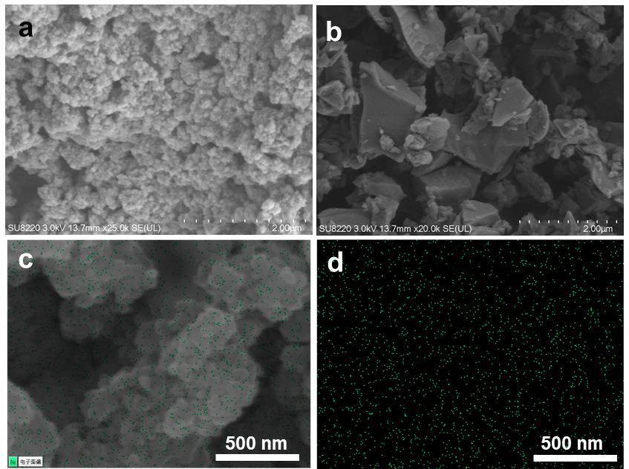
Figure S47. (a) and (b) SEM images of heterogeneous catalysts Ni1/Ni3-MgO (1:1) and Ni2/Ni3-GF (1:1). (c) and (d) Energy Dispersive Spectroscopy (EDS) of heterogeneous catalysts Ni1/Ni3-MgO (1:1), green represents the distribution of nickel.

3. Figures of Characterization of ligands and homogeneous catalysts

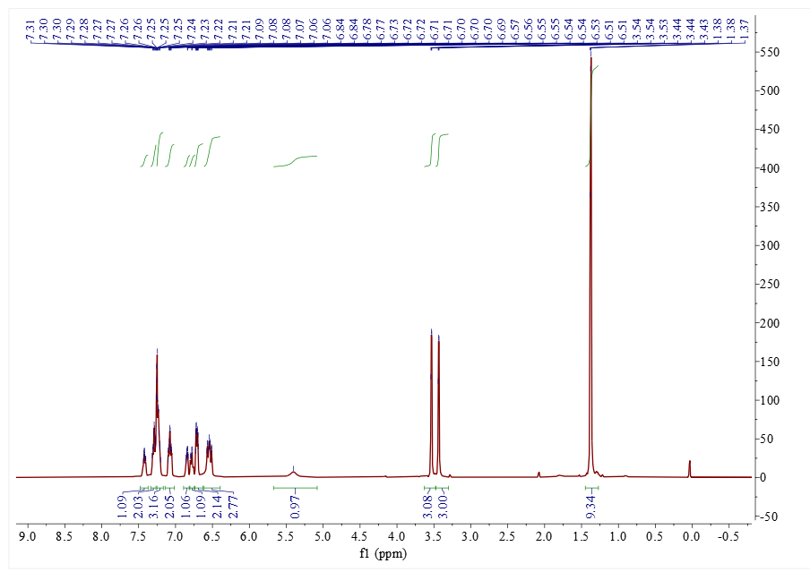
Figure S48.¹H NMR spectrum of the ligand 2. (CDCl₃, 400 MHz)

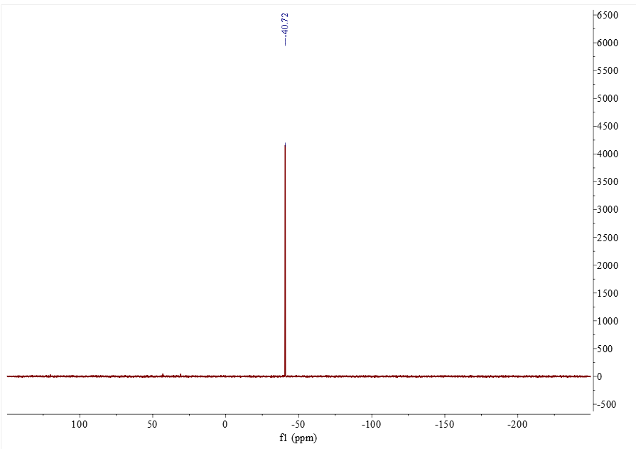
Figure S49.³¹P NMR spectrum of the ligand 2. (CDCl₃, 162 MHz)

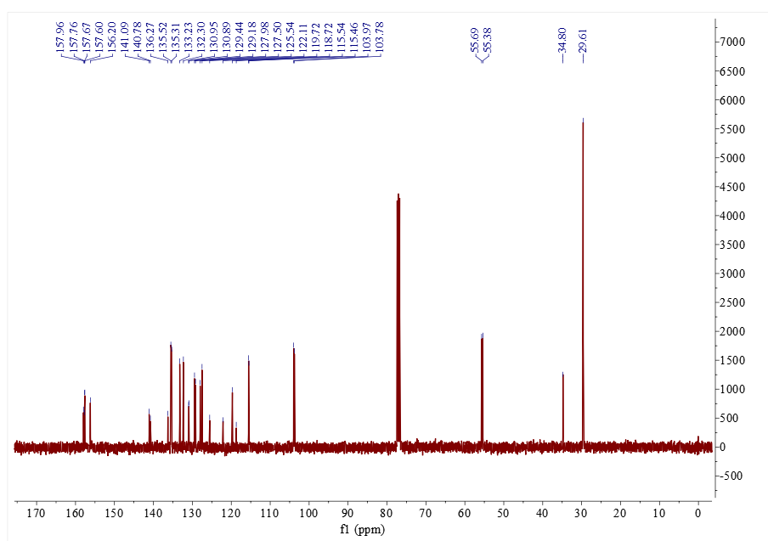
Figure S50.¹³C NMR spectrum of the ligand 2. (CDCl₃, 101 MHz)

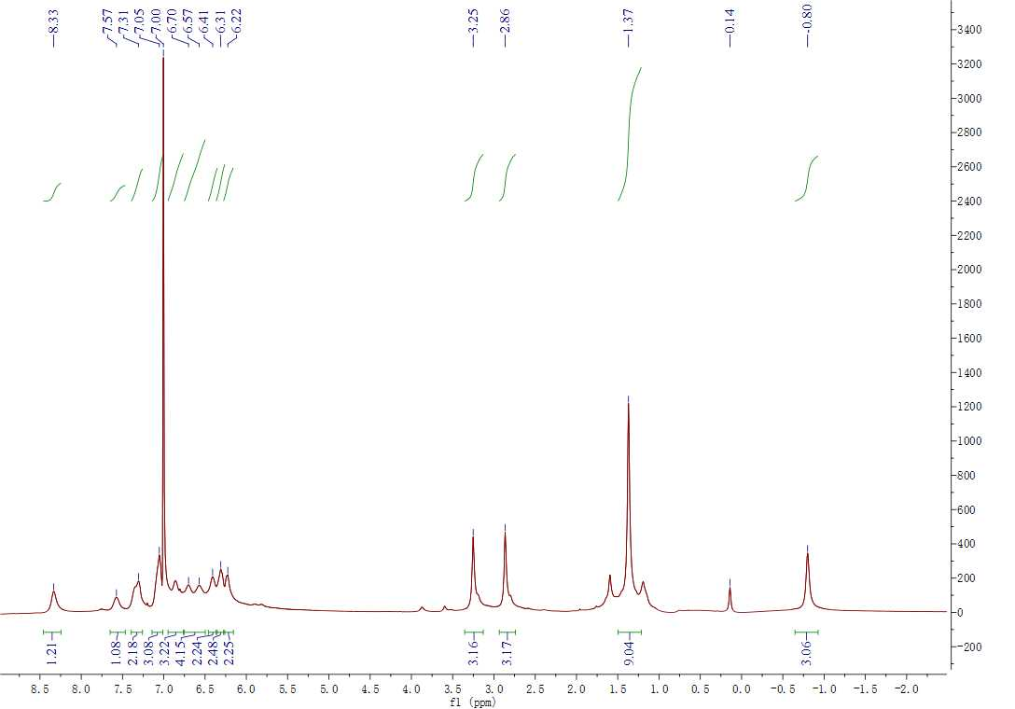
Figure S51.¹H NMR spectrum of the Ni 2. (C₆D₆, 400 MHz)

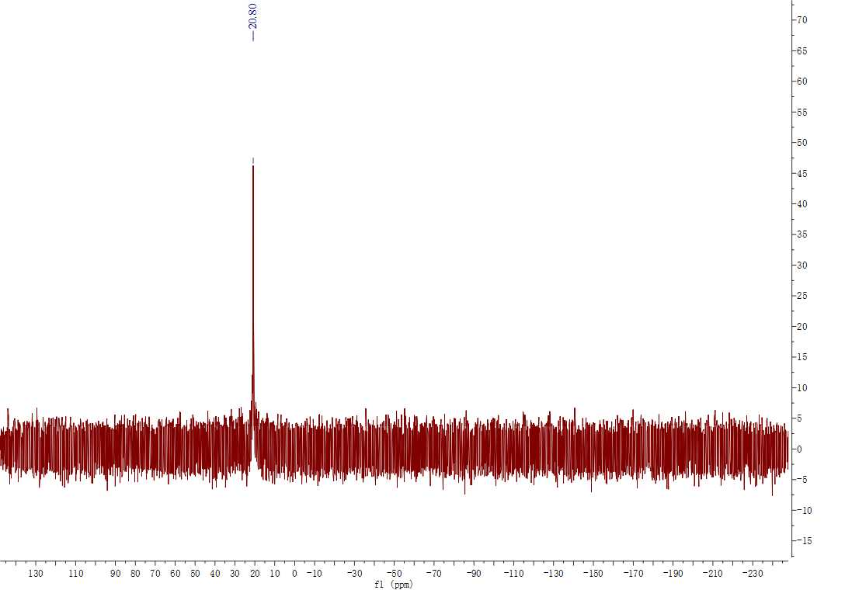
Figure S52. ³¹P NMR spectrum of the Ni 2. (C₆D₆, 162 MHz)

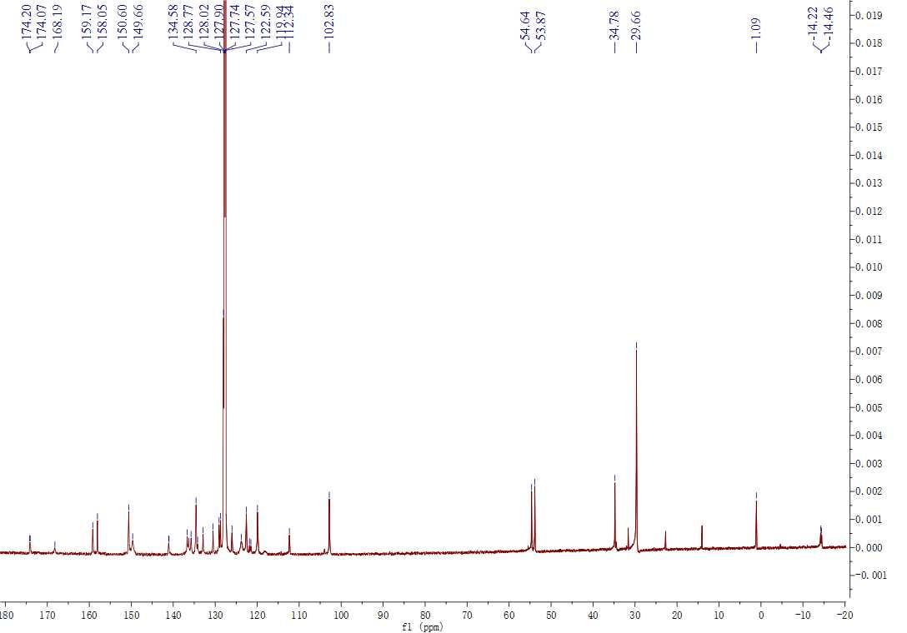
Figure S53.¹³C NMR spectrum of the Ni 2. (C₆D₆, MHz)

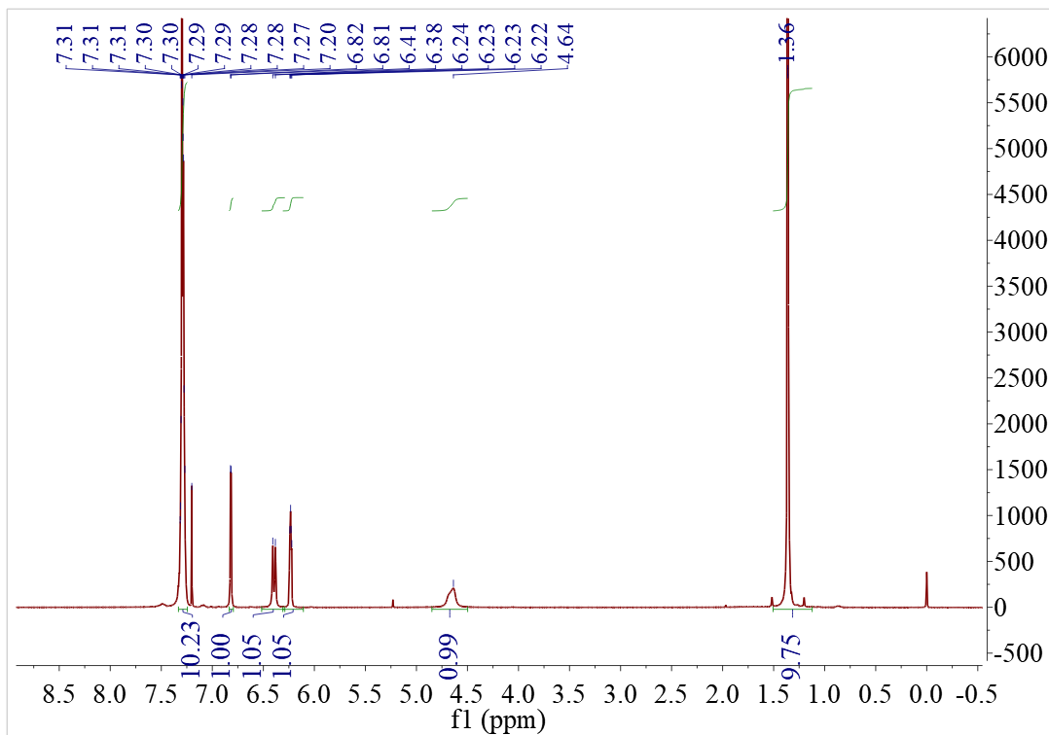
Figure S54.¹H NMR spectrum of the ligand 3. (CDCl₃, 400 MHz)

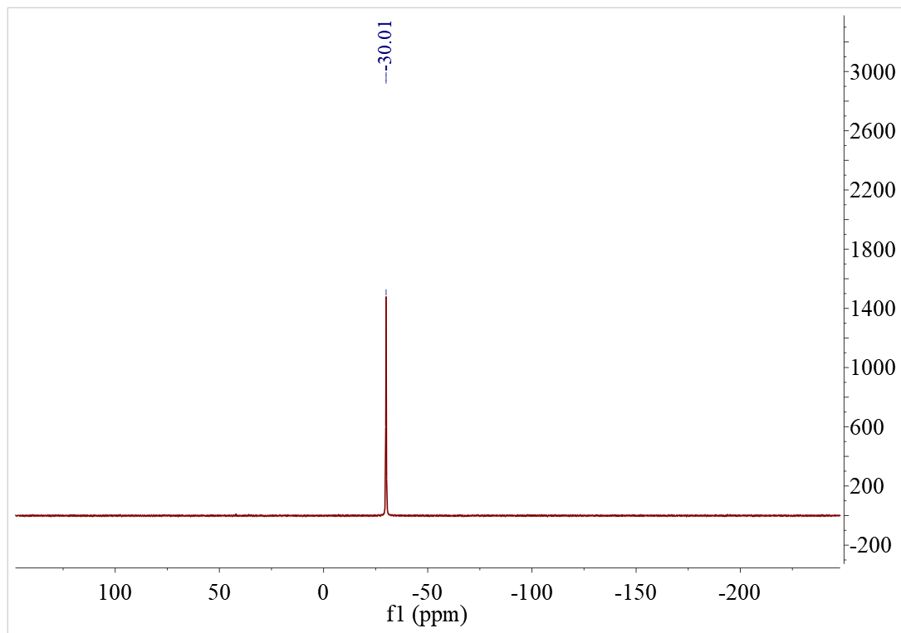
Figure S55.³¹P NMR spectrum of the ligand 3. (CDCl₃, 162 MHz)

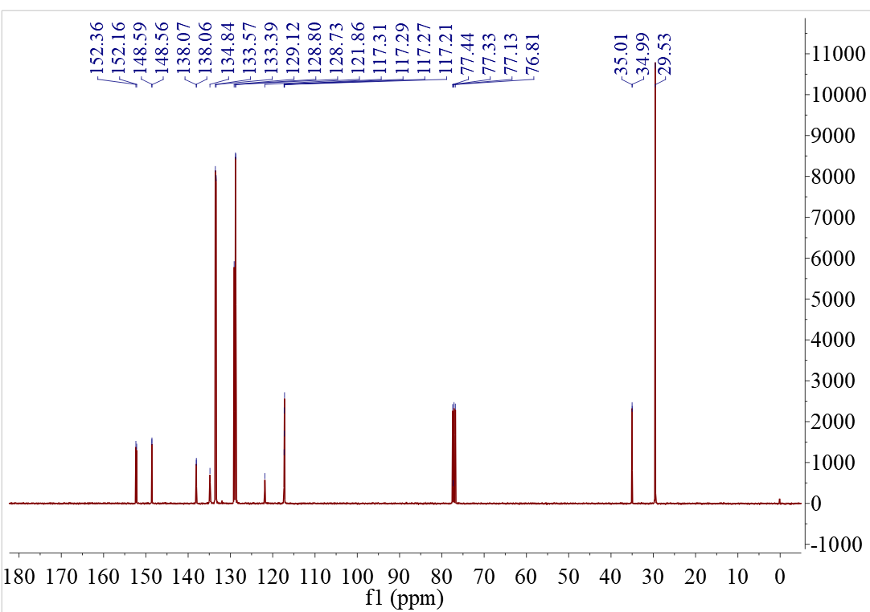
Figure S56.¹³C NMR spectrum of the ligand 3. (CDCl₃, 101 MHz)

4 Figures of NMR and of copolymers

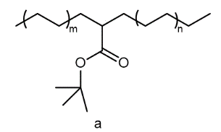
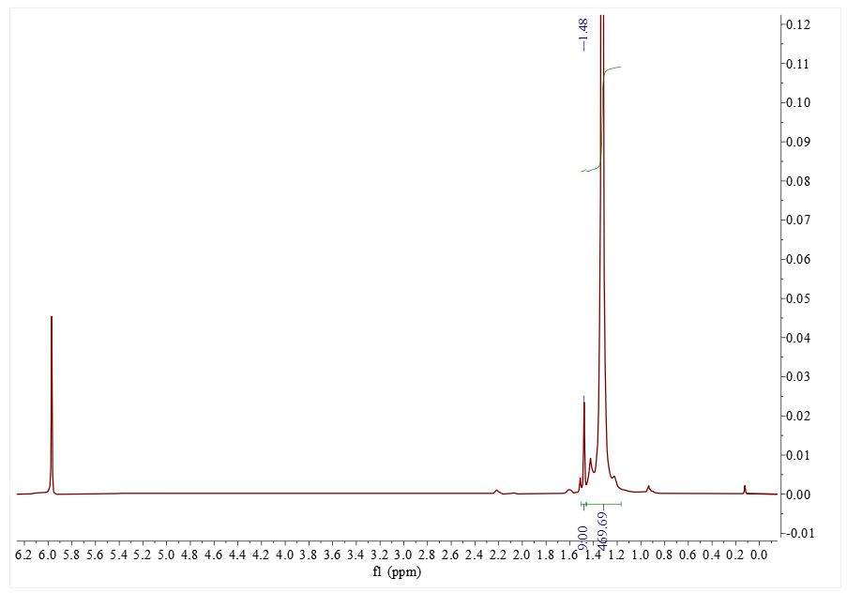
a

Figure S57. ¹H NMR spectrum of the polymer from Table 1, Entry 1 (C₂D₂Cl₄, 120ºC).
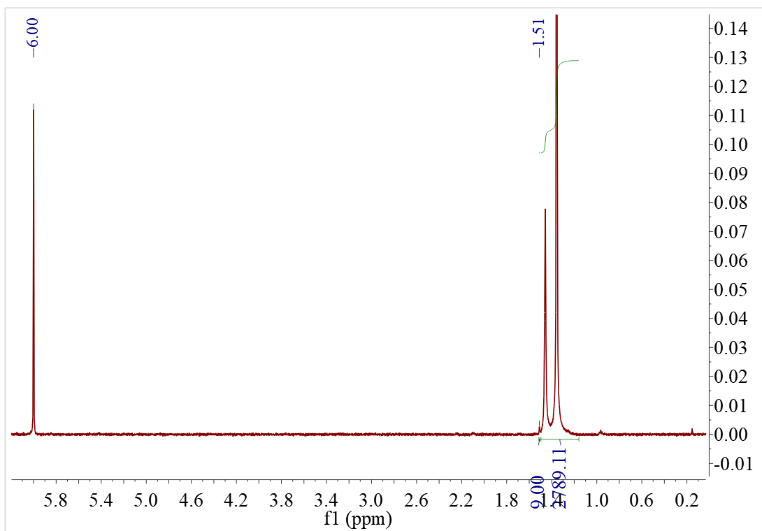
a
Figure S58. ¹H NMR spectrum of the polymer from Table 1, Entry 2(C₂D₂Cl₄, 120ºC).

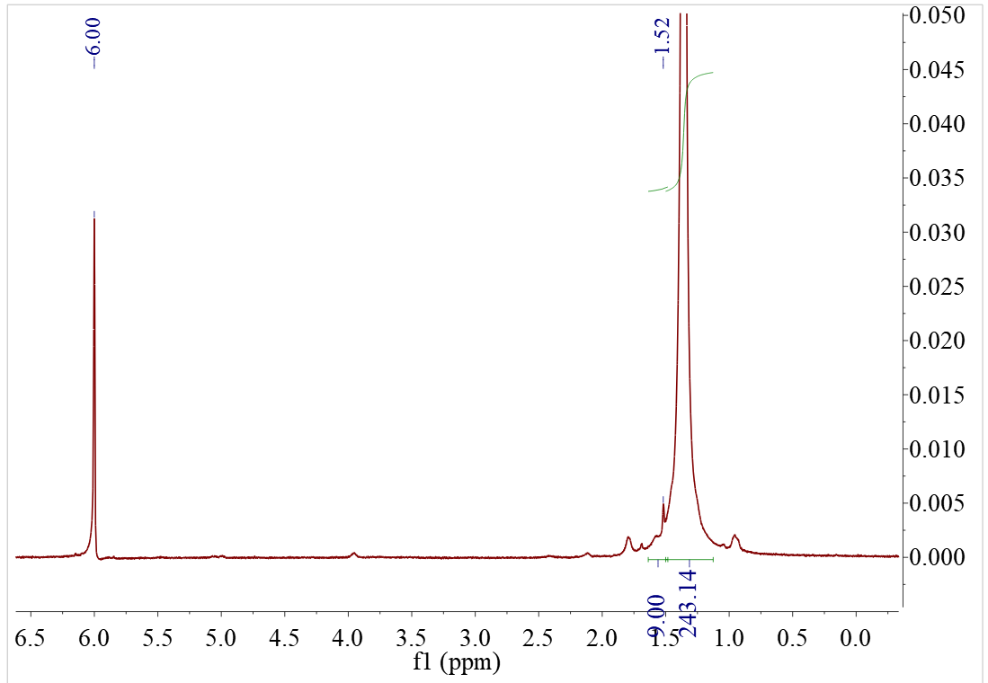
a
Figure S59. ¹H NMR spectrum of the polymer from Table 1, Entry 3 (C₂D₂Cl₄, 120ºC).
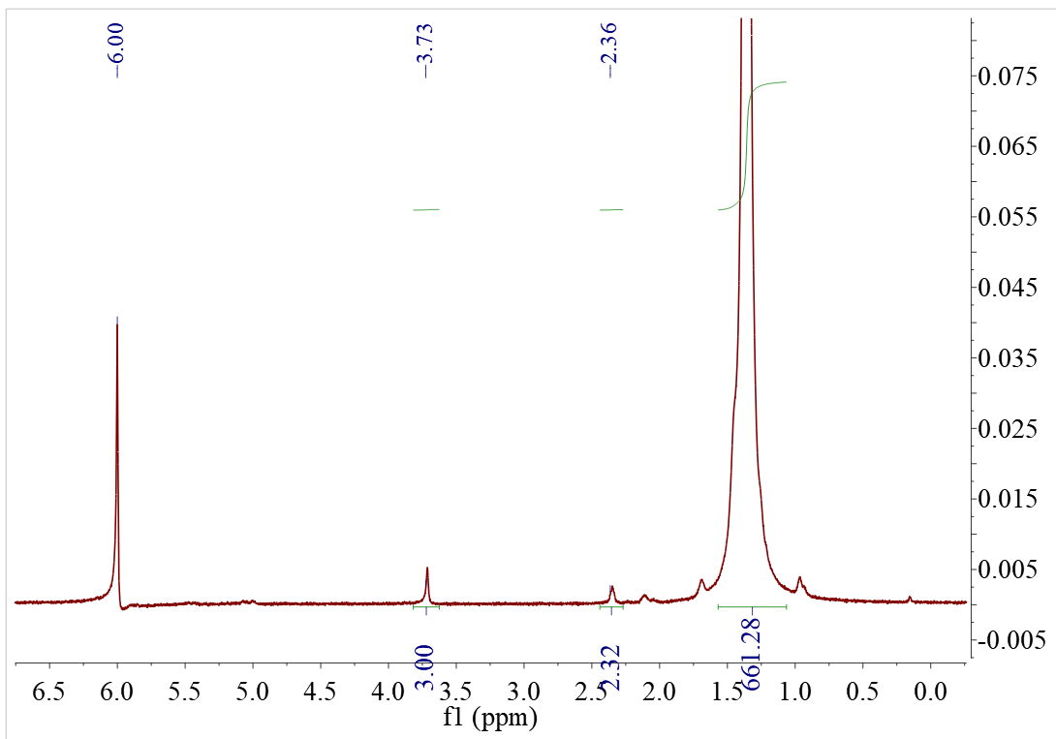
b
a
Figure S60. ¹H NMR spectrum of the polymer from Table 1, Entry 4 (C₂D₂Cl₄, 120ºC).

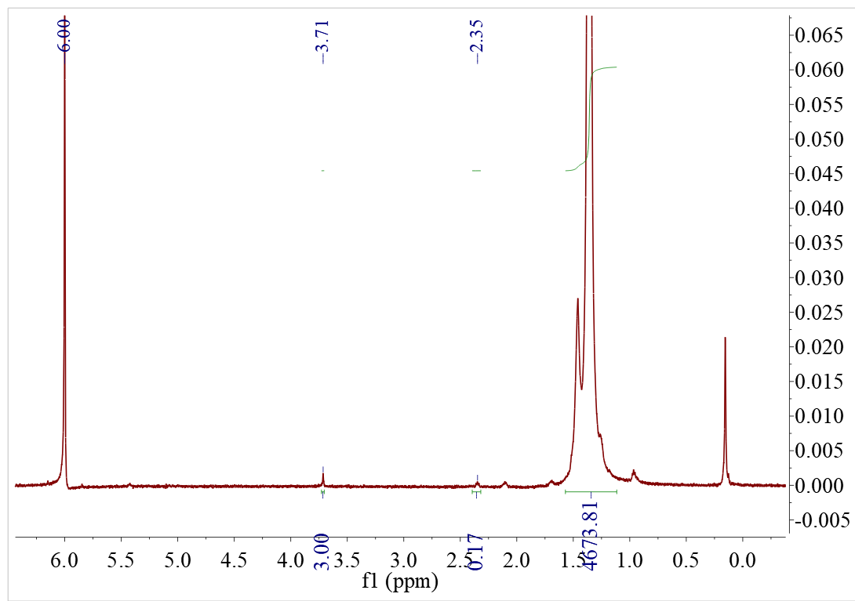
b
a
Figure S61. ¹H NMR spectrum of the polymer from Table 1, Entry 5 (C₂D₂Cl₄, 120ºC).

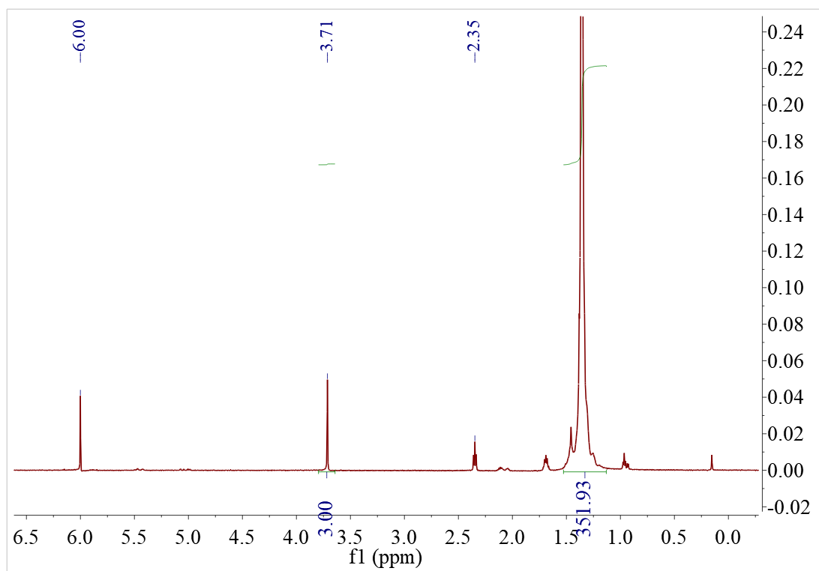
b
a
Figure S62. ¹H NMR spectrum of the polymer from Table 1, Entry 6 (C₂D₂Cl₄, 120ºC).
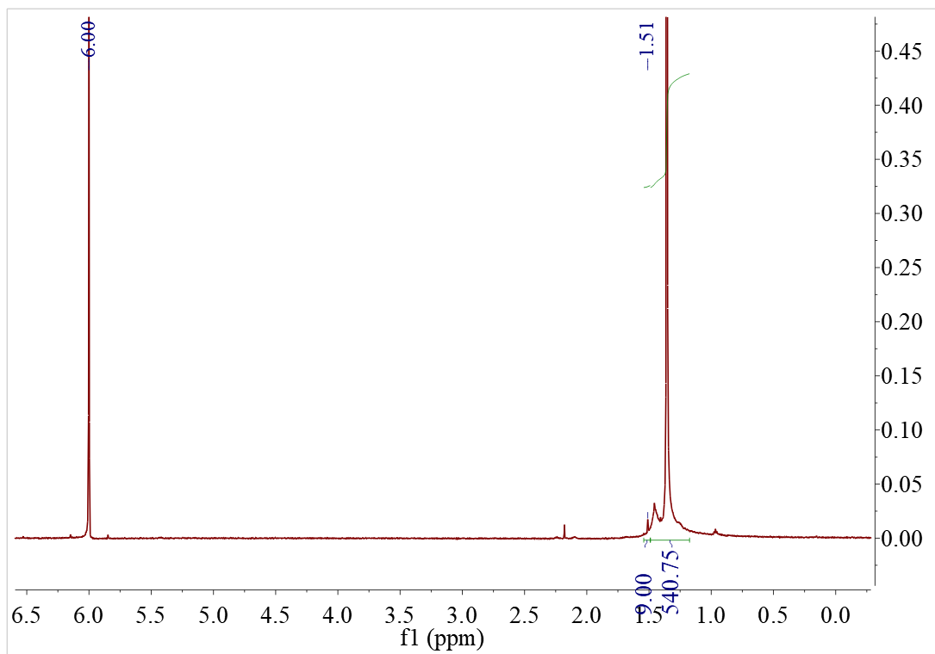
a
Figure S63. ¹H NMR spectrum of the polymer from Table 1, Entry 7 (C₂D₂Cl₄, 120ºC).
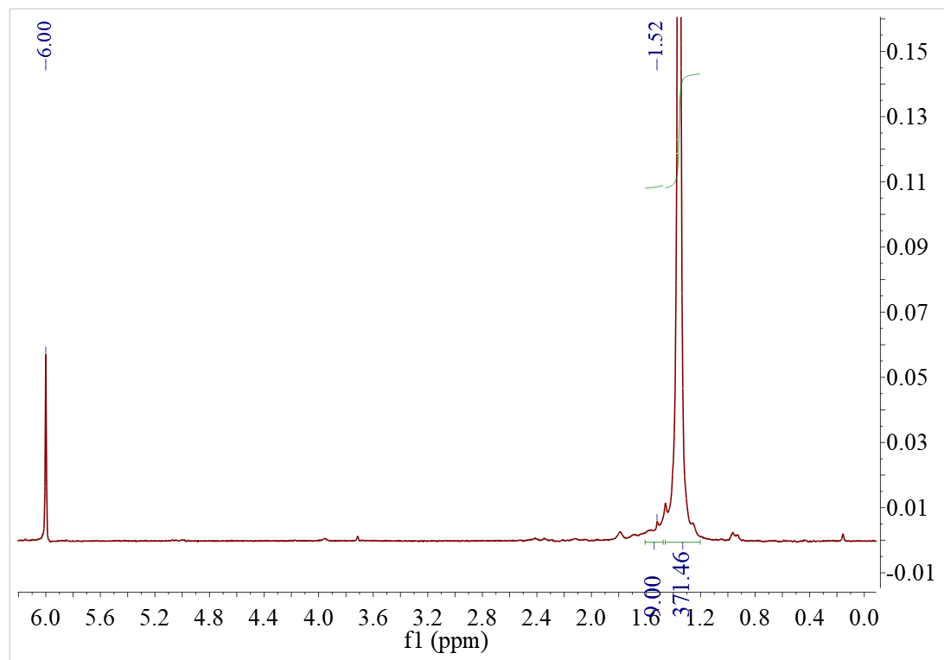
a
Figure S64. ¹H NMR spectrum of the polymer from Table 1, Entry 8 (C₂D₂Cl₄, 120ºC).
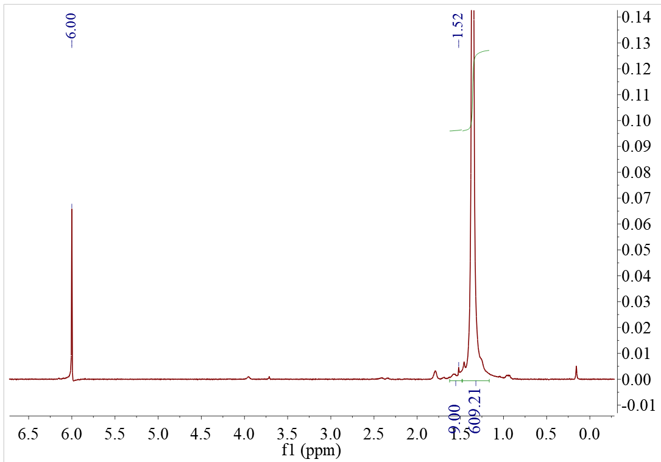
a
Figure S65. ¹H NMR spectrum of the polymer from Table 1, Entry 9(C₂D₂Cl₄, 120ºC).

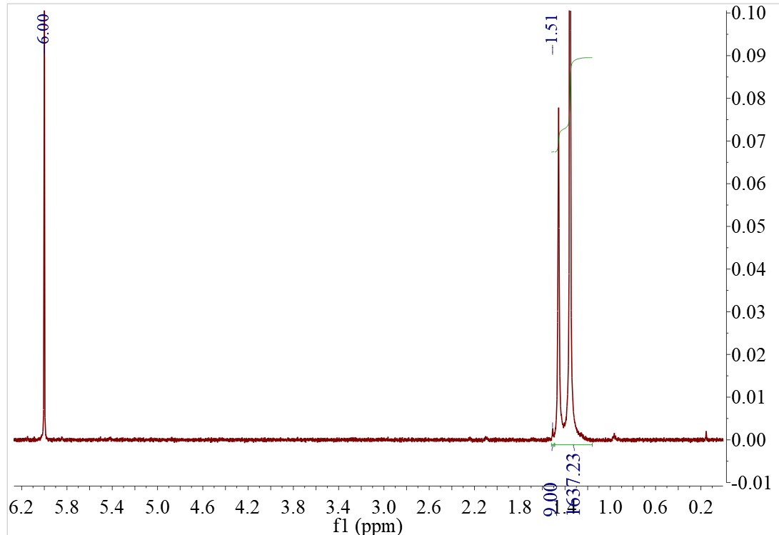
a
Figure S66. ¹H NMR spectrum of the polymer from Table 1, Entry 10 (C₂D₂Cl₄, 120ºC).
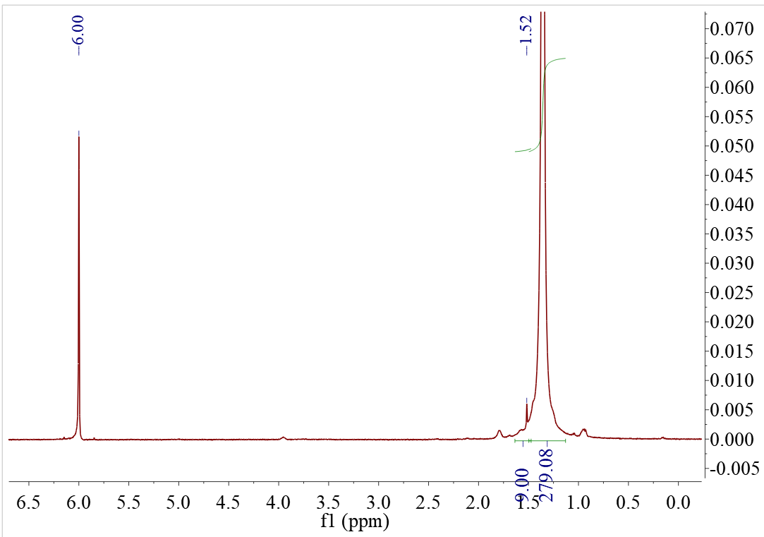
a
Figure S67. ¹H NMR spectrum of the polymer from Table 1, Entry 11 (C₂D₂Cl₄, 120ºC).

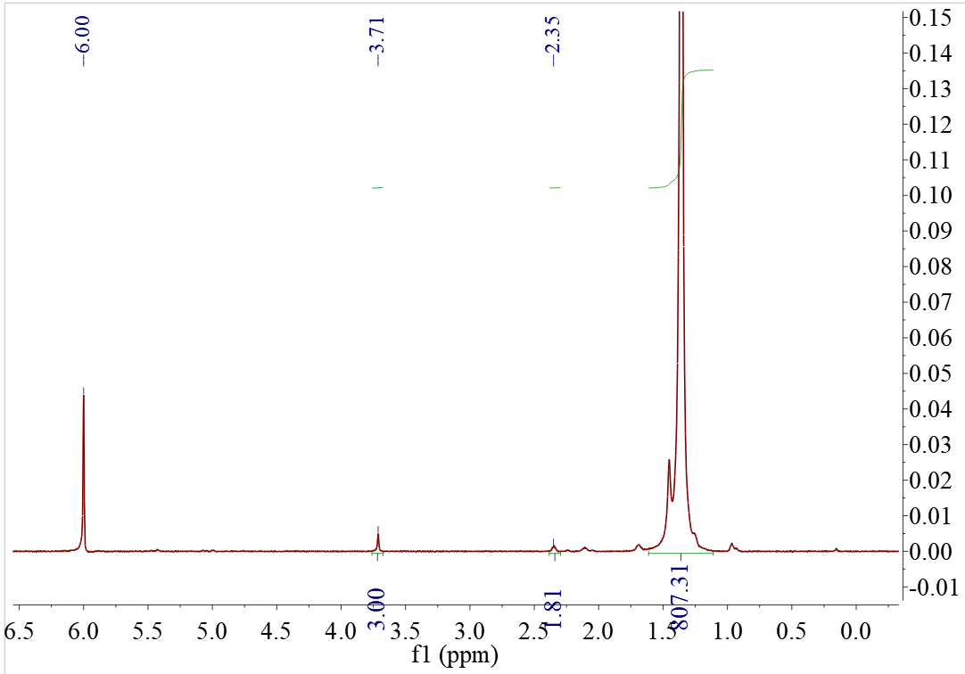
b
a
Figure S68. ¹H NMR spectrum of the polymer from Table 2, Entry 12 (C₂D₂Cl₄, 120ºC).
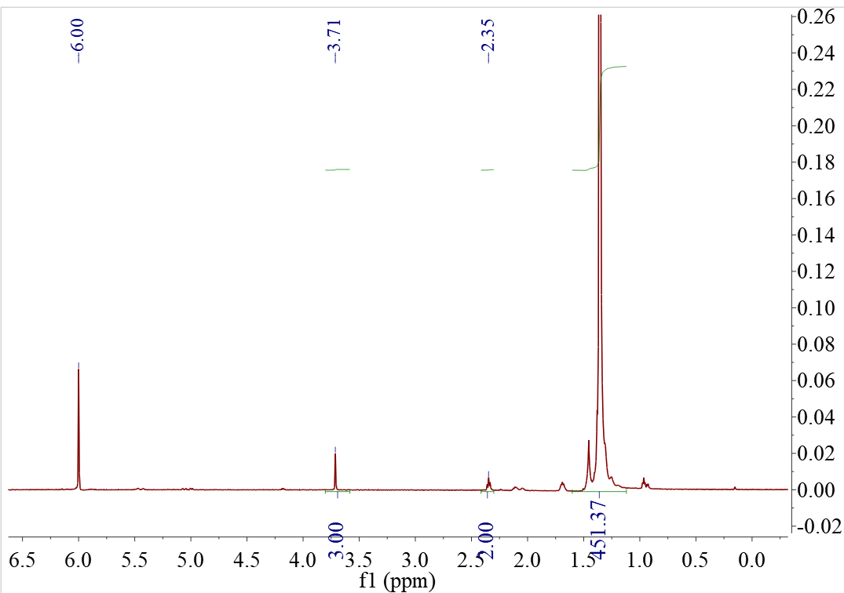
b
a
Figure S69. ¹H NMR spectrum of the polymer from Table 1, Entry 13 (C₂D₂Cl₄, 120ºC).

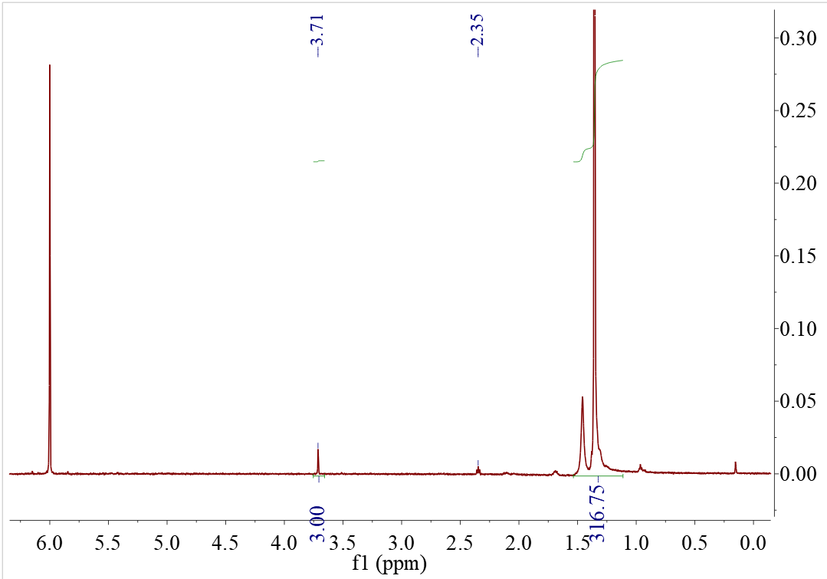
b
a

Figure S70. ¹H NMR spectrum of the polymer from Table 1, Entry 14 (C₂D₂Cl₄, 120ºC).

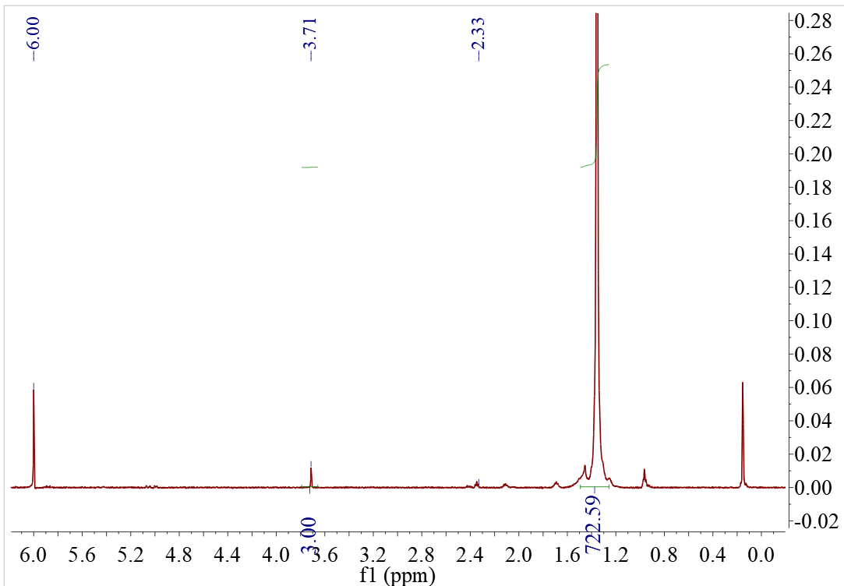
b
a
Figure S71. ¹H NMR spectrum of the polymer from Table 1, Entry 15 (C₂D₂Cl₄, 120ºC).
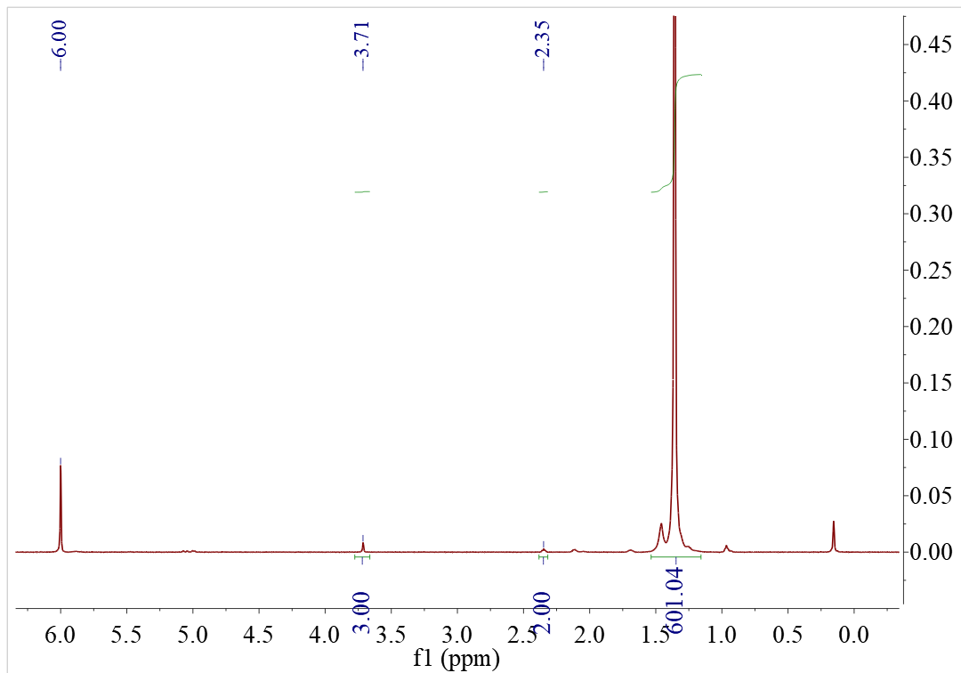
b
a
Figure S72. ¹H NMR spectrum of the polymer from Table 1, Entry 16 (C₂D₂Cl₄, 120ºC).

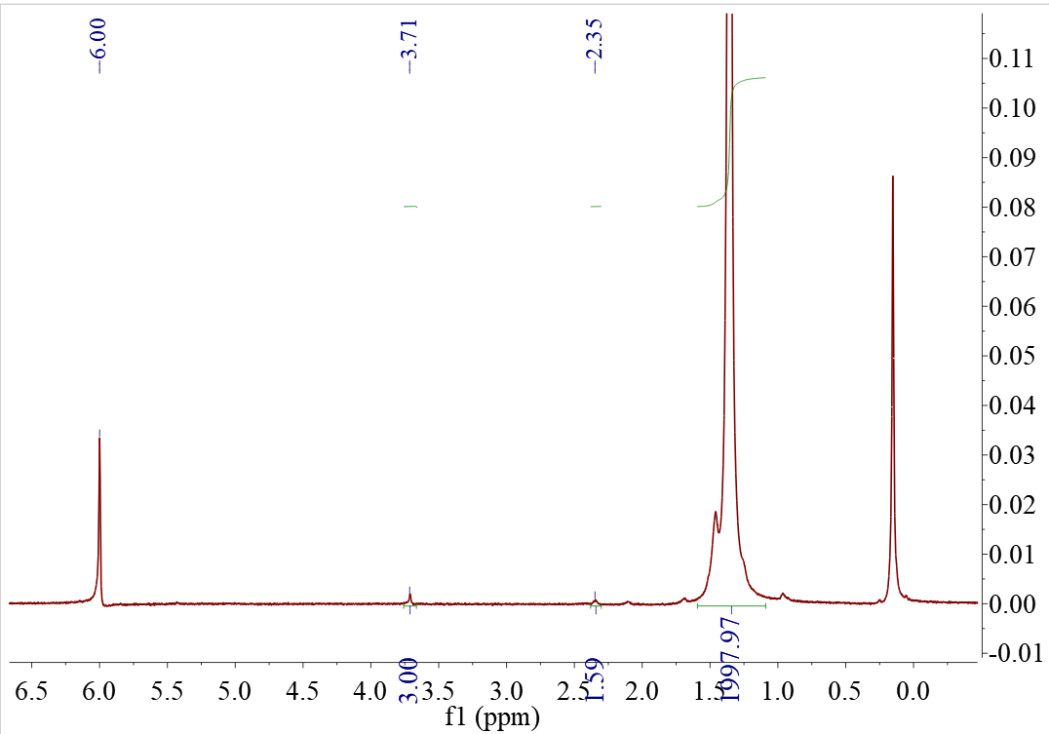
b
a
Figure S73. ¹H NMR spectrum of the polymer from Table 1, Entry 17(C₂D₂Cl₄, 120ºC).
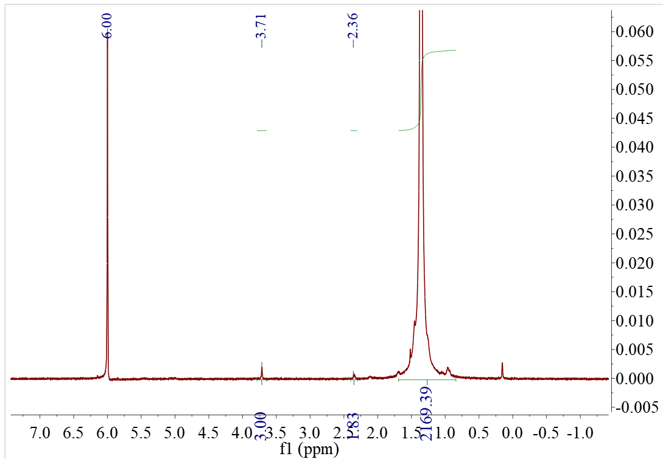
b
a
Figure S74. ¹H NMR spectrum of the polymer from Table 1, Entry 18(C₂D₂Cl₄, 120ºC).
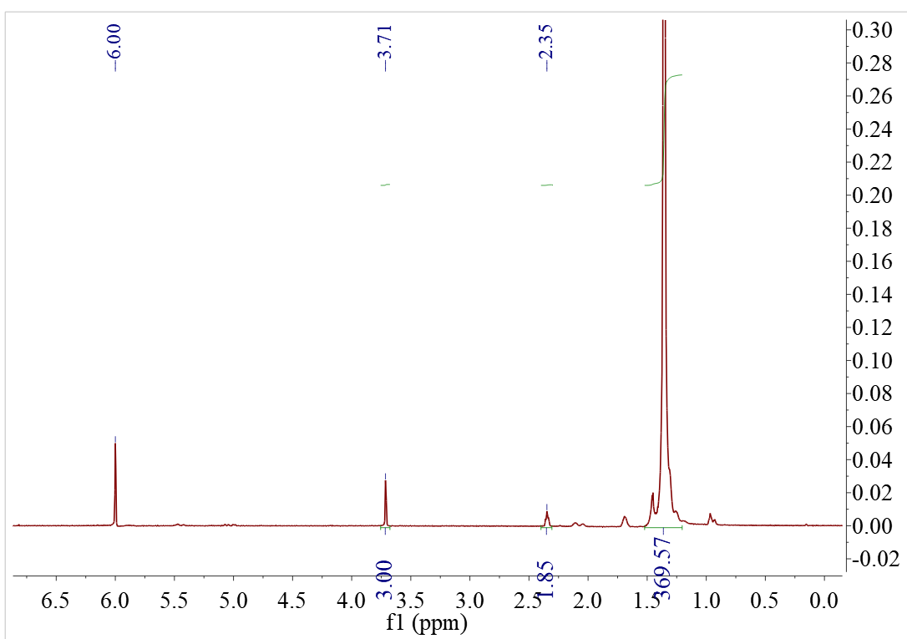
b
a
Figure S75. ¹H NMR spectrum of the polymer from Table 1, Entry 19(C₂D₂Cl₄, 120ºC).
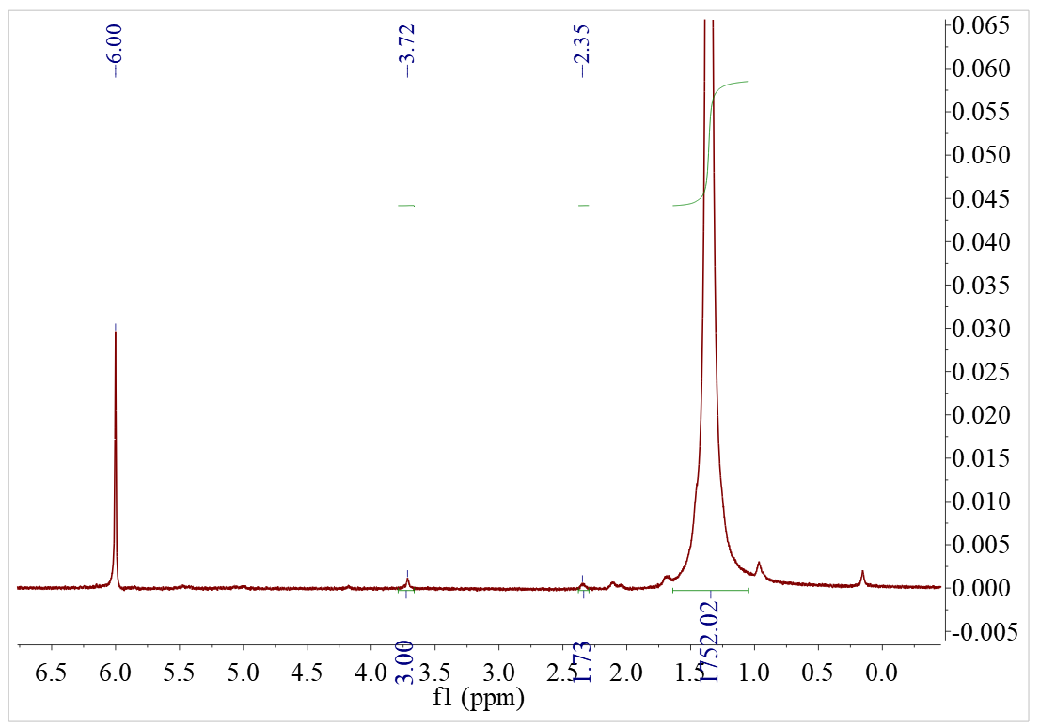
a
b
Figure S76. ¹H NMR spectrum of the polymer from Table 1, Entry 20(C₂D₂Cl₄, 120ºC).
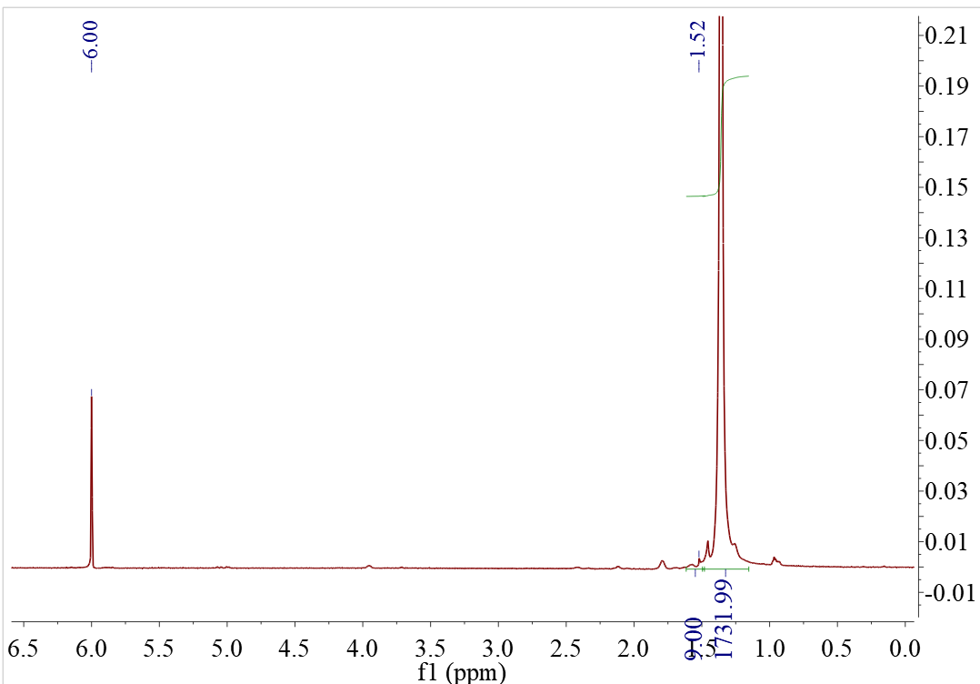
a
Figure S77. ¹H NMR spectrum of the polymer from Table 1, Entry 21 (C₂D₂Cl₄, 120ºC).

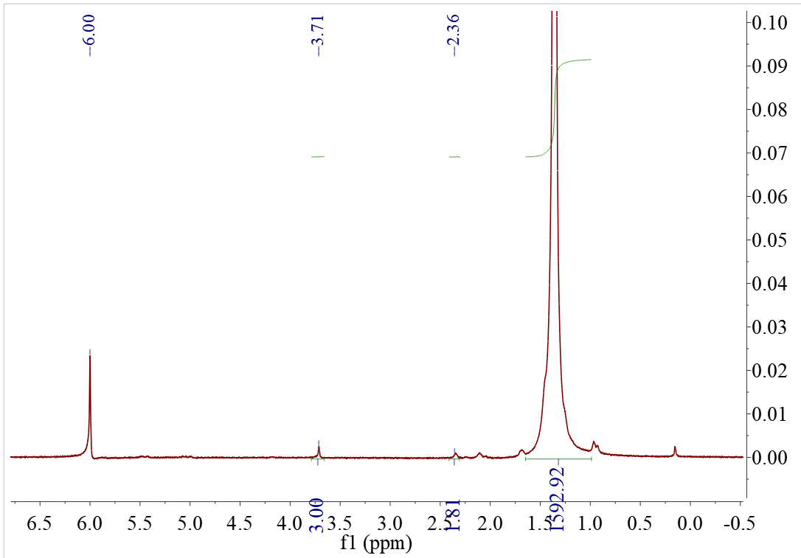
b
a
Figure S78. ¹H NMR spectrum of the polymer from Table 1, Entry 22(C₂D₂Cl₄, 120ºC).

5 GPC of polymers.
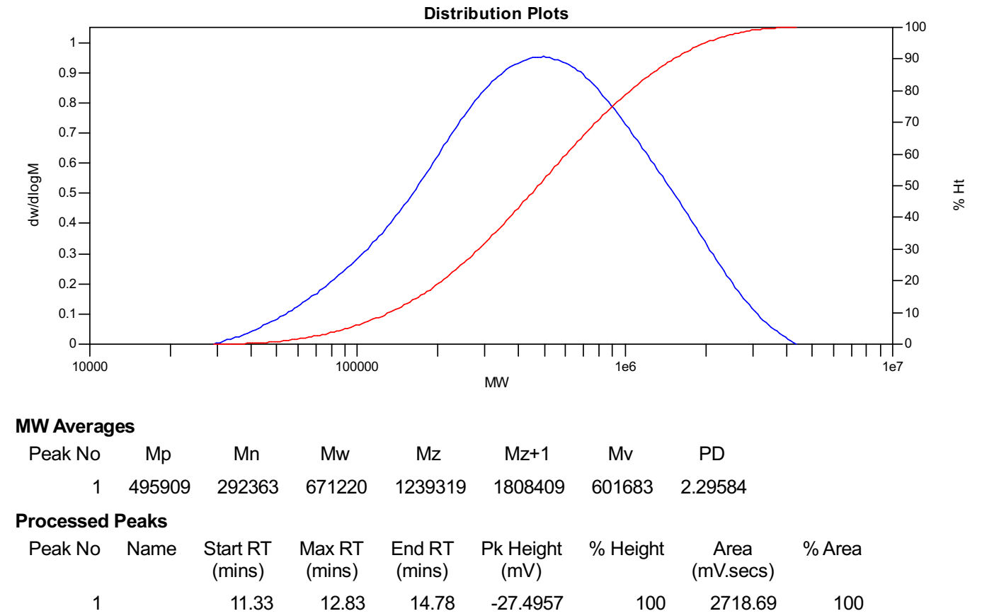
Figure S79. GPC of the polymer from Table S1, Entry 1.
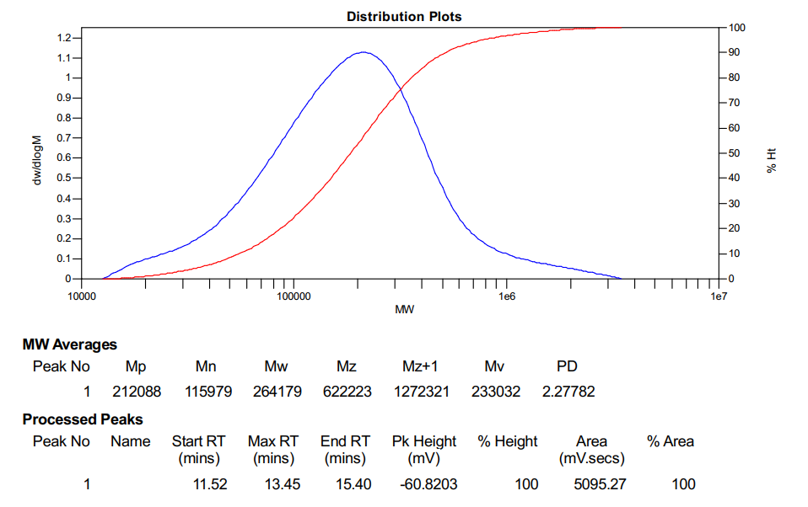
Figure S80. GPC of the polymer from Table S1, Entry 2.

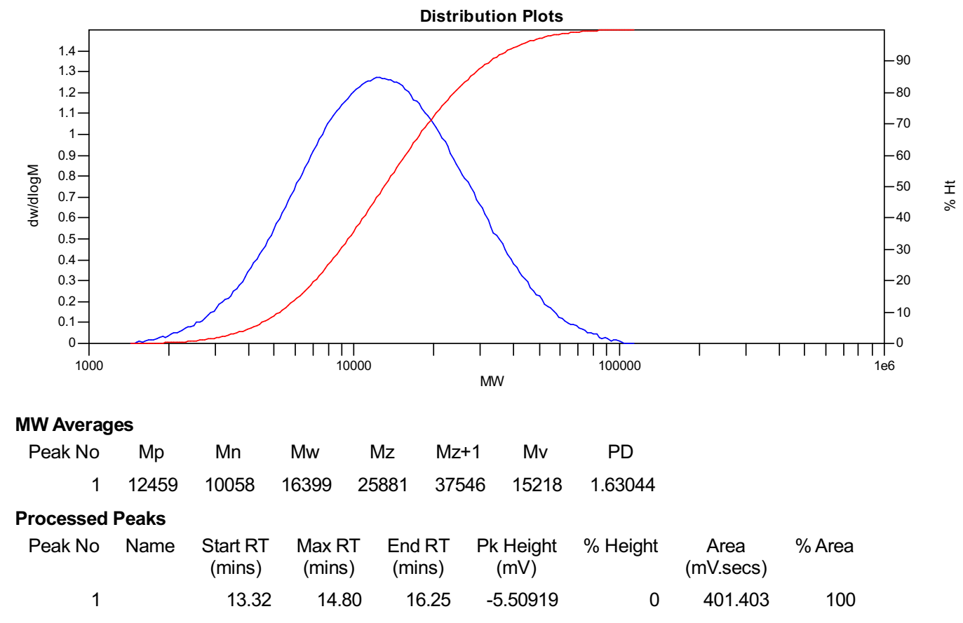
Figure S81. GPC of the polymer from Table S1, Entry 3.
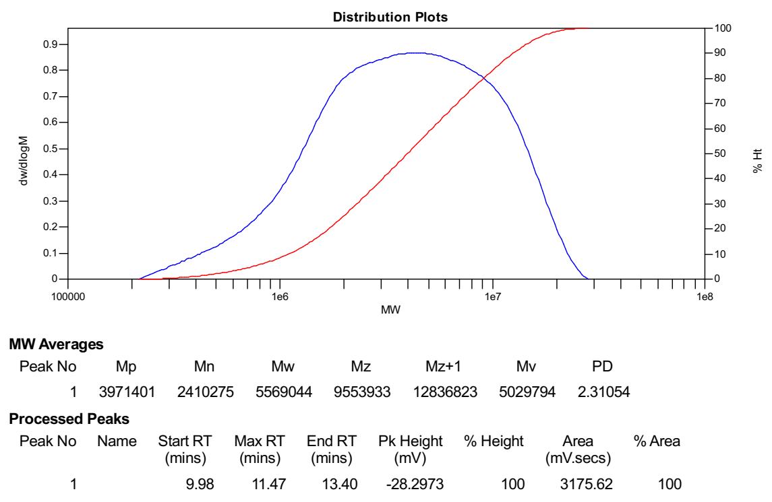
Figure S82. GPC of the polymer from Table S1, Entry 4.

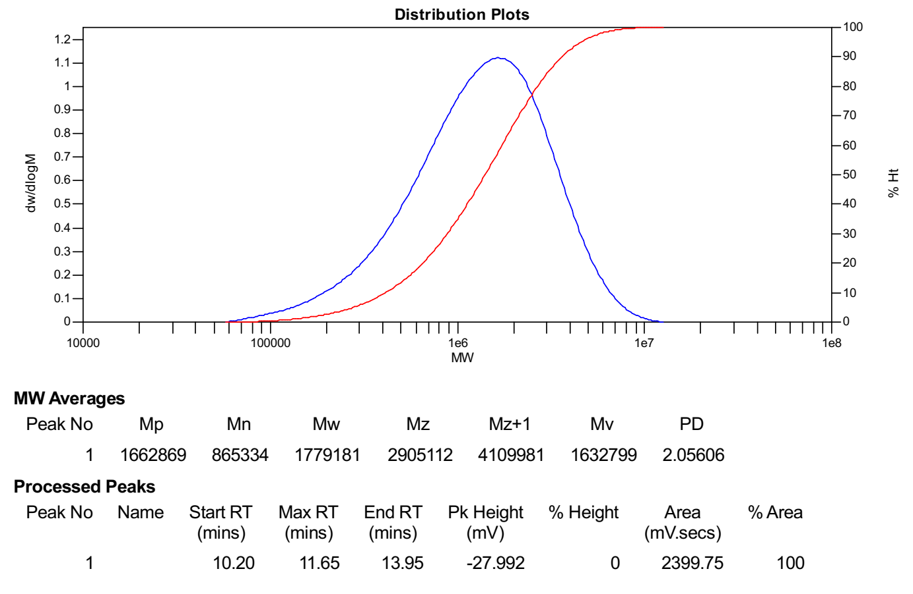
Figure S83. GPC of the polymer from Table S1, Entry 5.
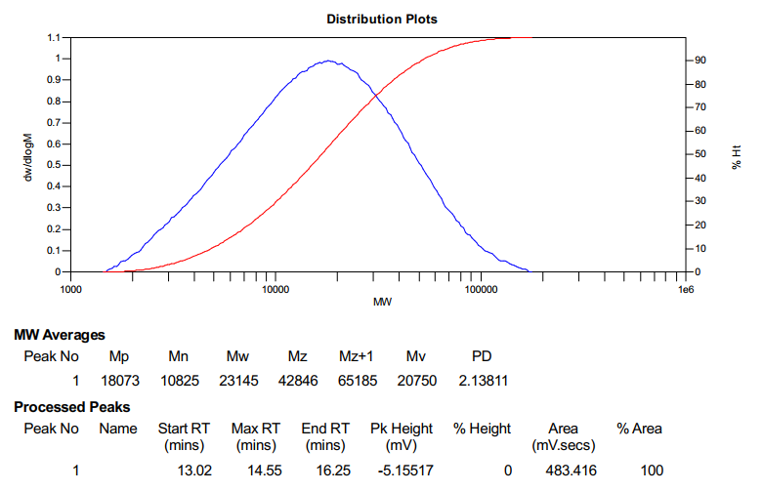
Figure S84. GPC of the polymer from Table S1, Entry 6.

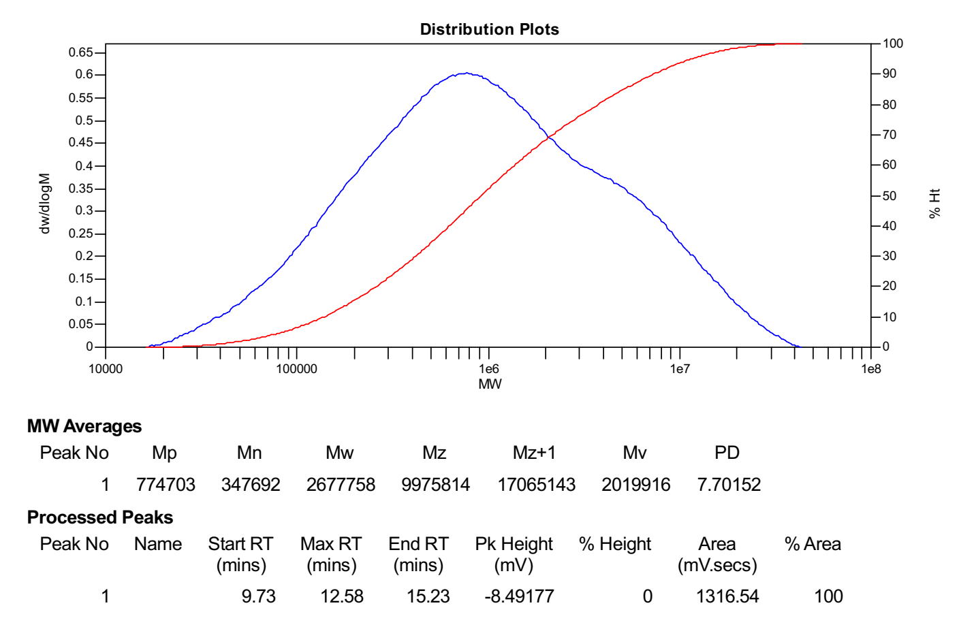
Figure S85. GPC of the polymer from Table S1, Entry 7.

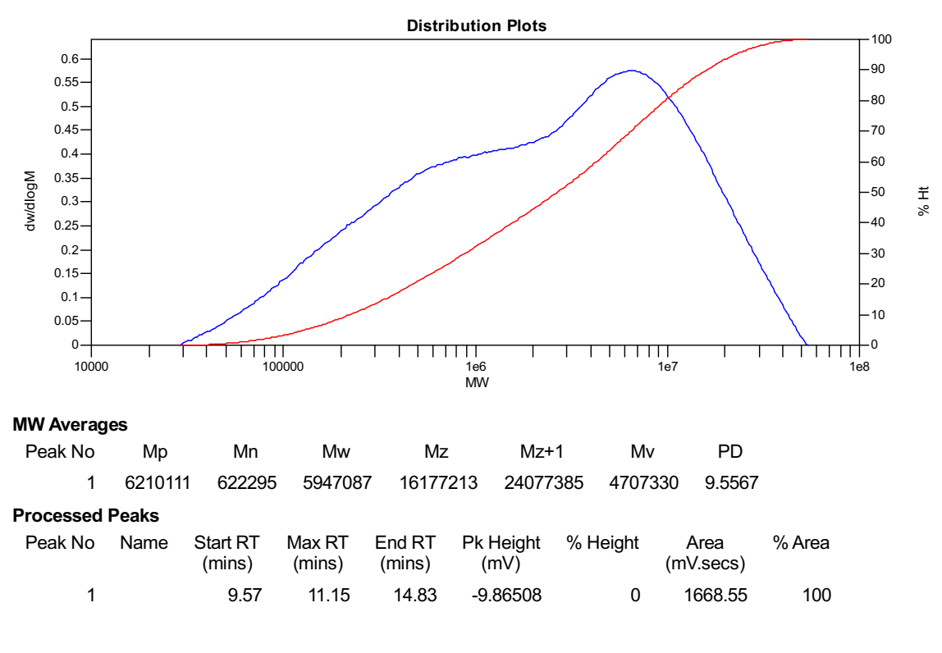
Figure S86. GPC of the polymer from Table S1, Entry 8.

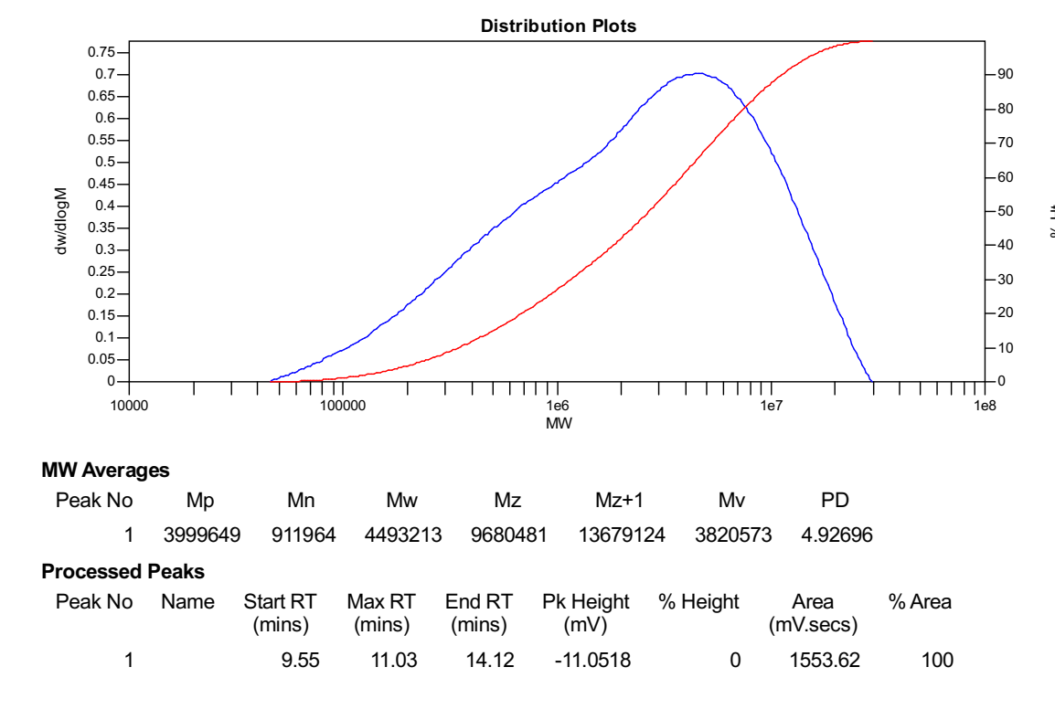
Figure S87. GPC of the polymer from Table S1, Entry 9.
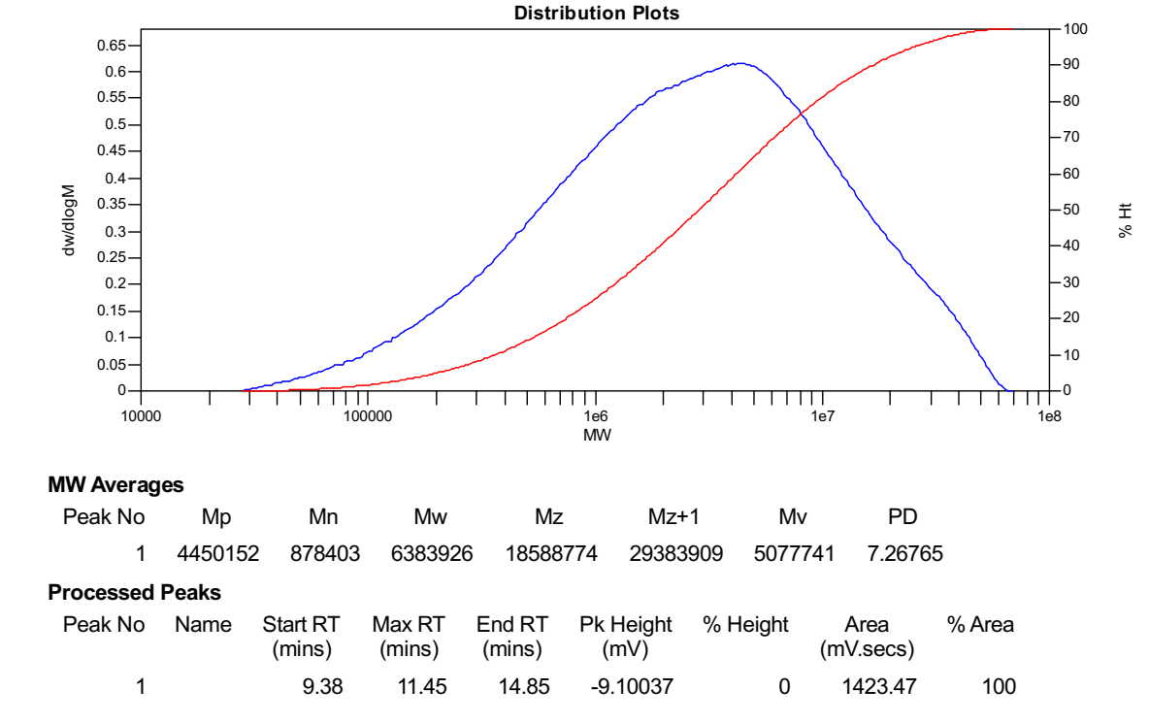
Figure S88. GPC of the polymer from Table S1, Entry 10.

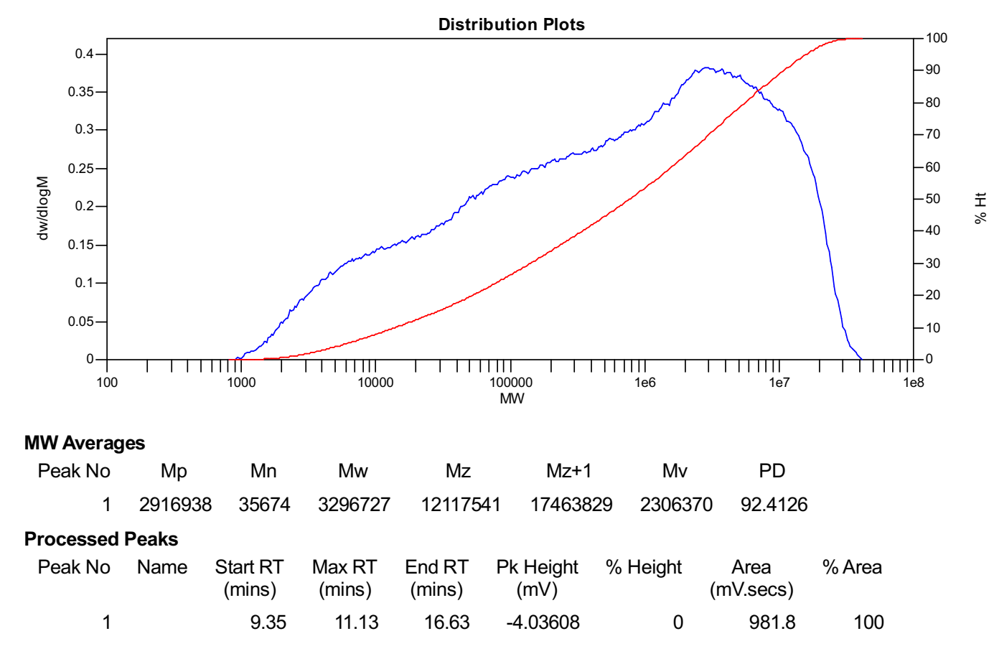
Figure S89. GPC of the polymer from Table S1, Entry 11.

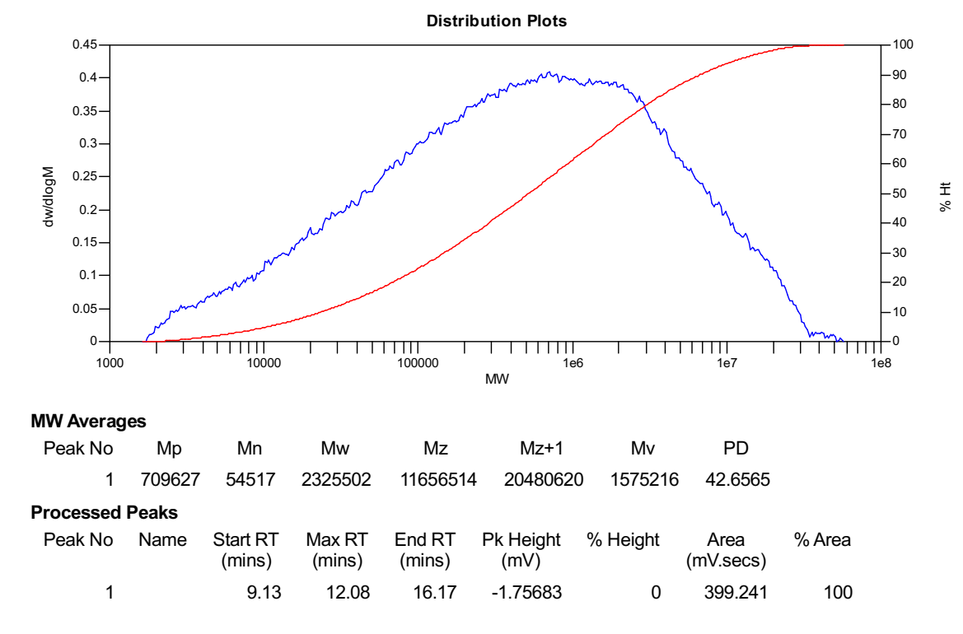
Figure S90. GPC of the polymer from Table S1, Entry 12.
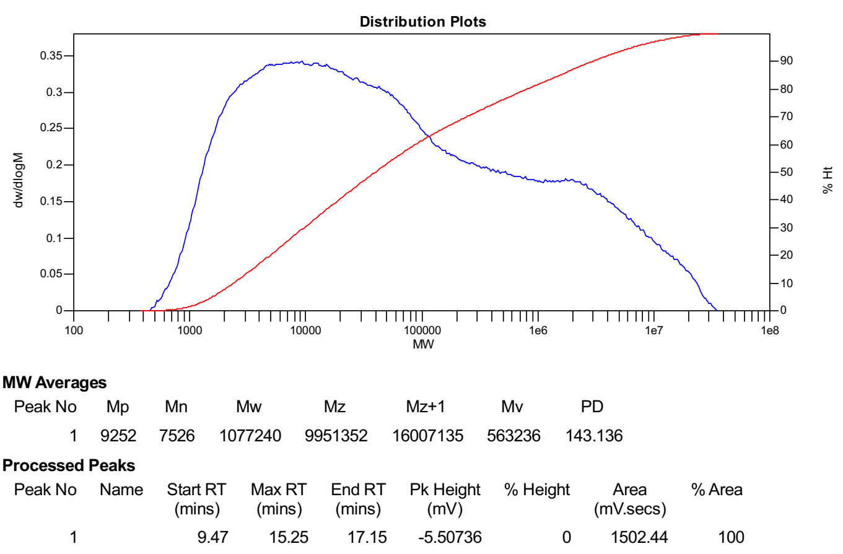
Figure S91. GPC of the polymer from Table S1, Entry 13.
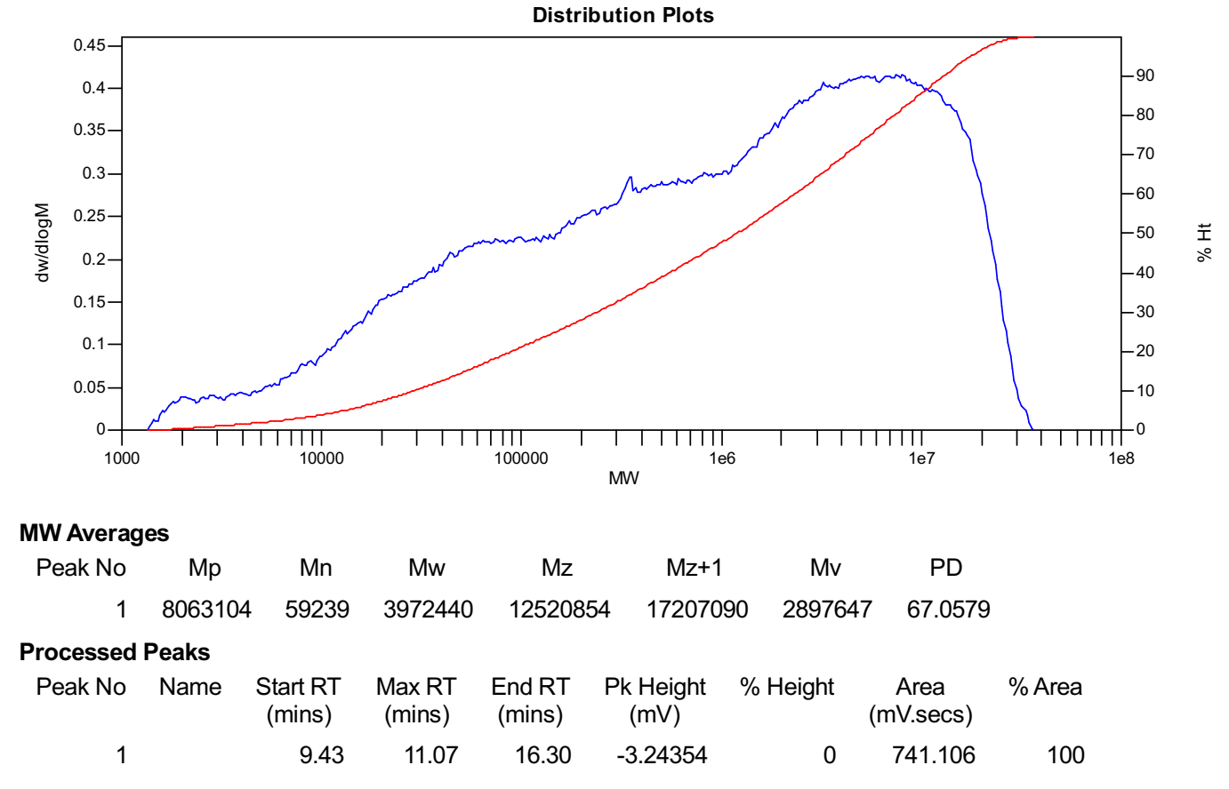
Figure S92. GPC of the polymer from Table S1, Entry 14.

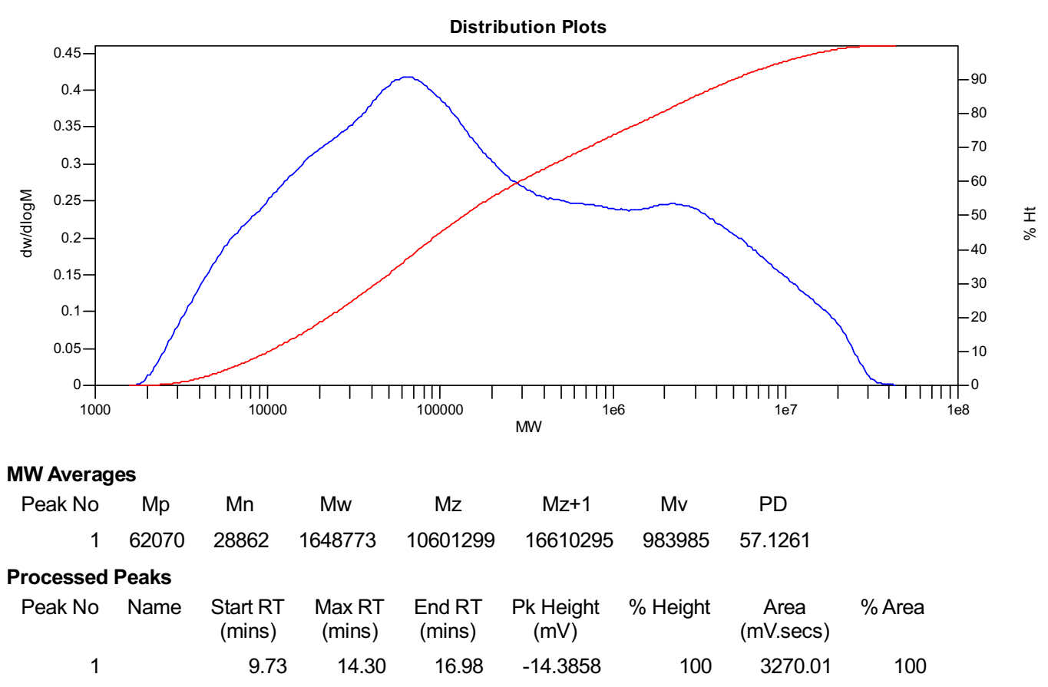
Figure S93. GPC of the polymer from Table S1, Entry 15.

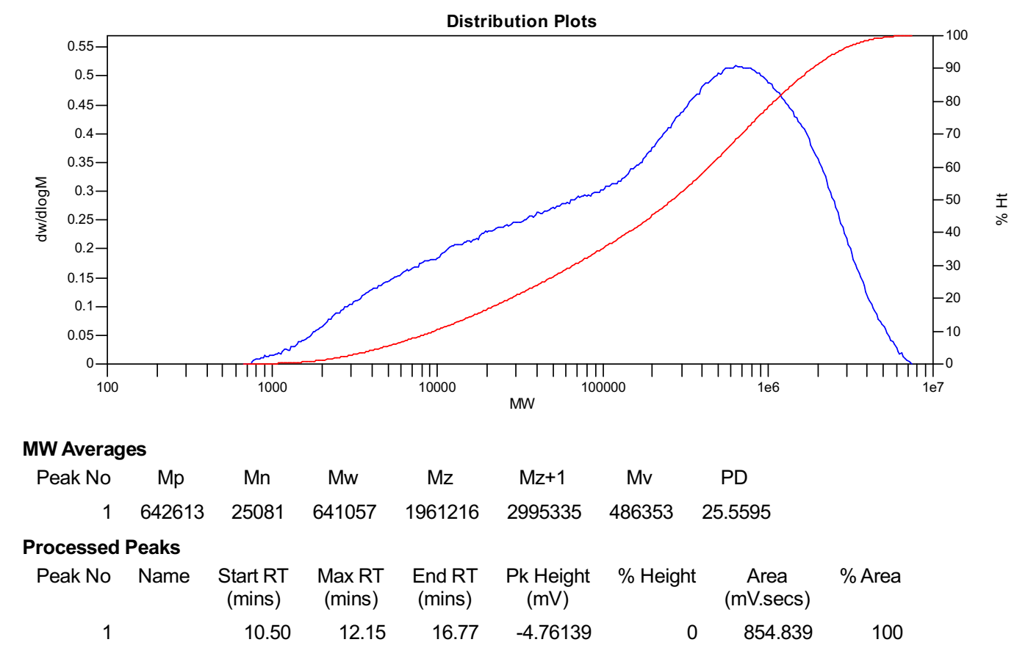
Figure S94. GPC of the polymer from Table S1, Entry 16.
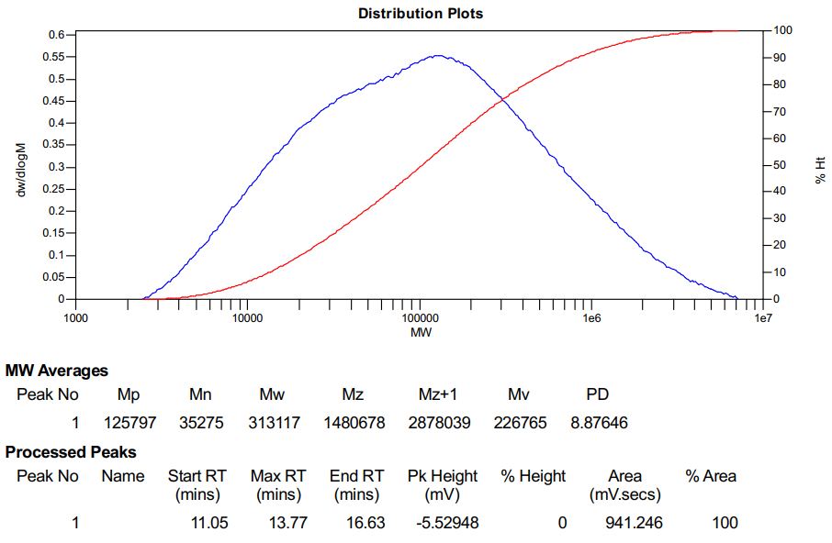
Figure S95. GPC of the polymer from Table S1, Entry 17.

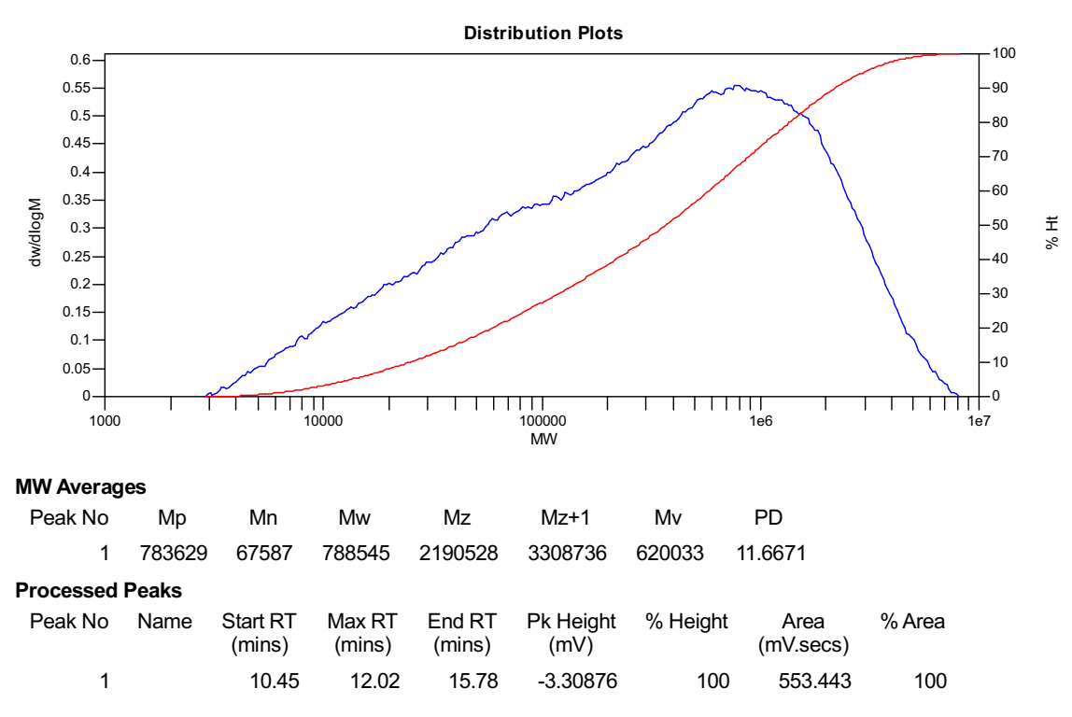
Figure S96. GPC of the polymer from Table S1, Entry 18.

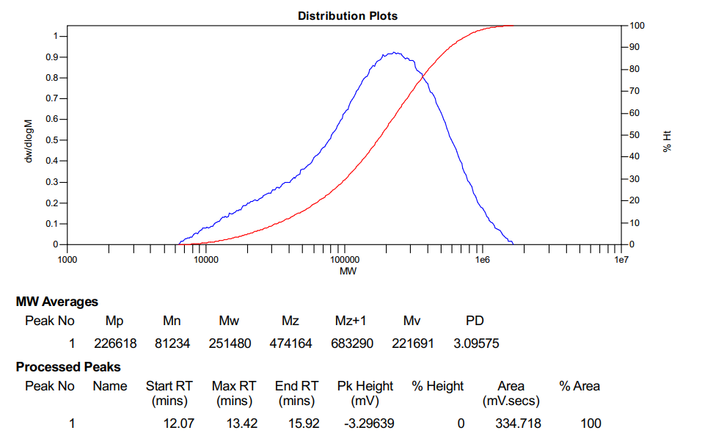
Figure S97. GPC of the polymer from Table S2, Entry 1.

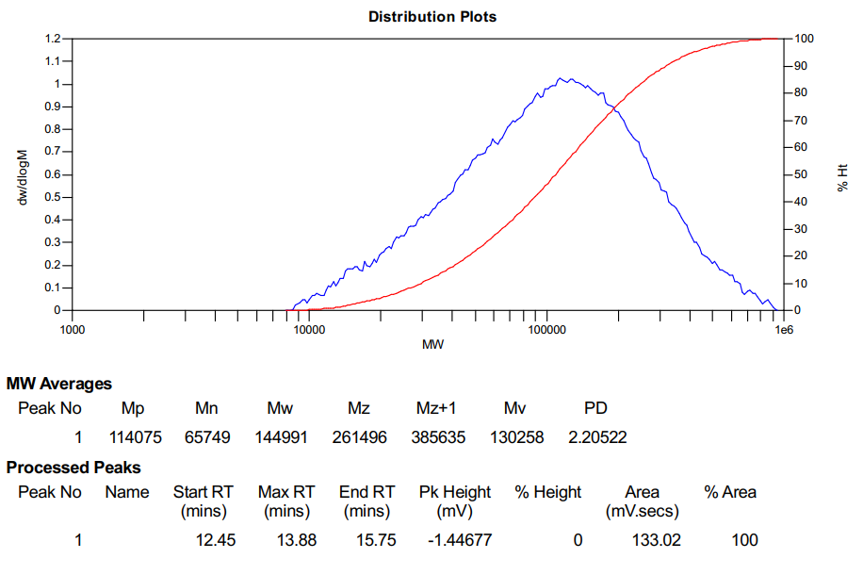
Figure S98. GPC of the polymer from Table S2, Entry 2.

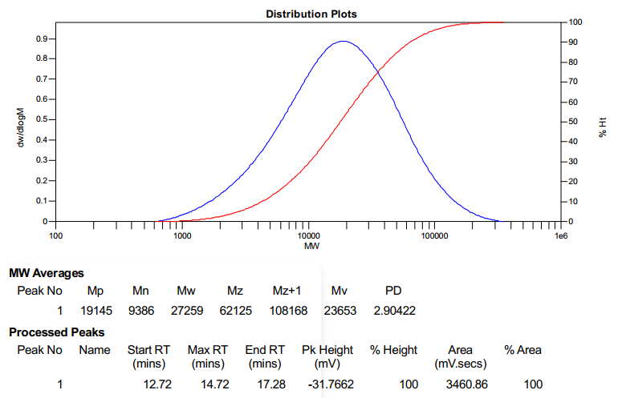
Figure S99. GPC of the polymer from Table S2, Entry 3.

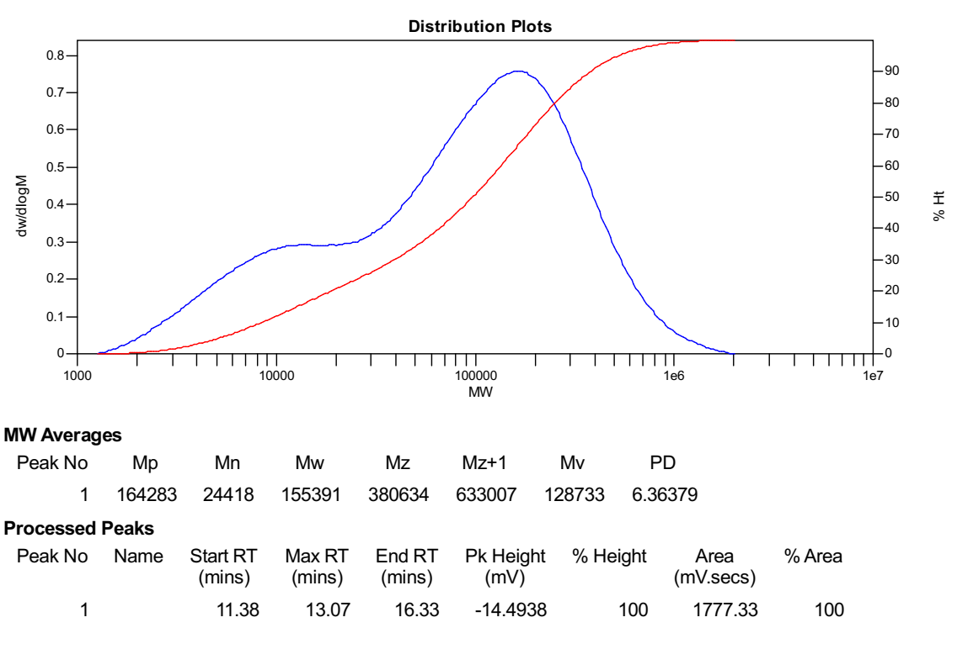
Figure S100. GPC of the polymer from Table S2, Entry 4.

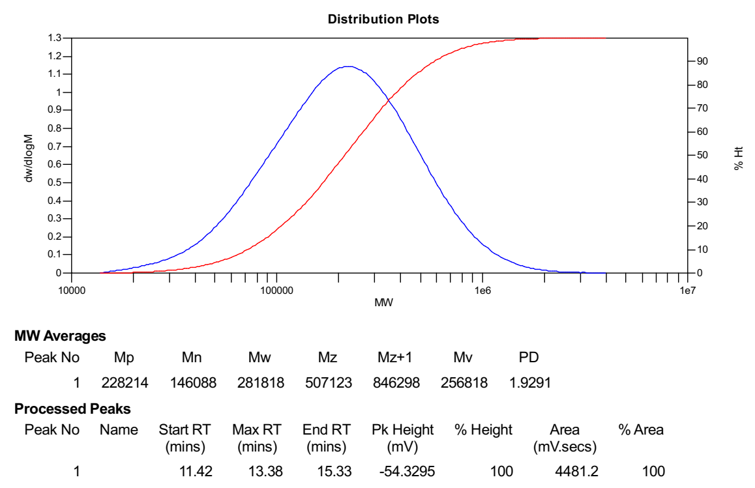
Figure S101. GPC of the polymer from Table 1, Entry 1.
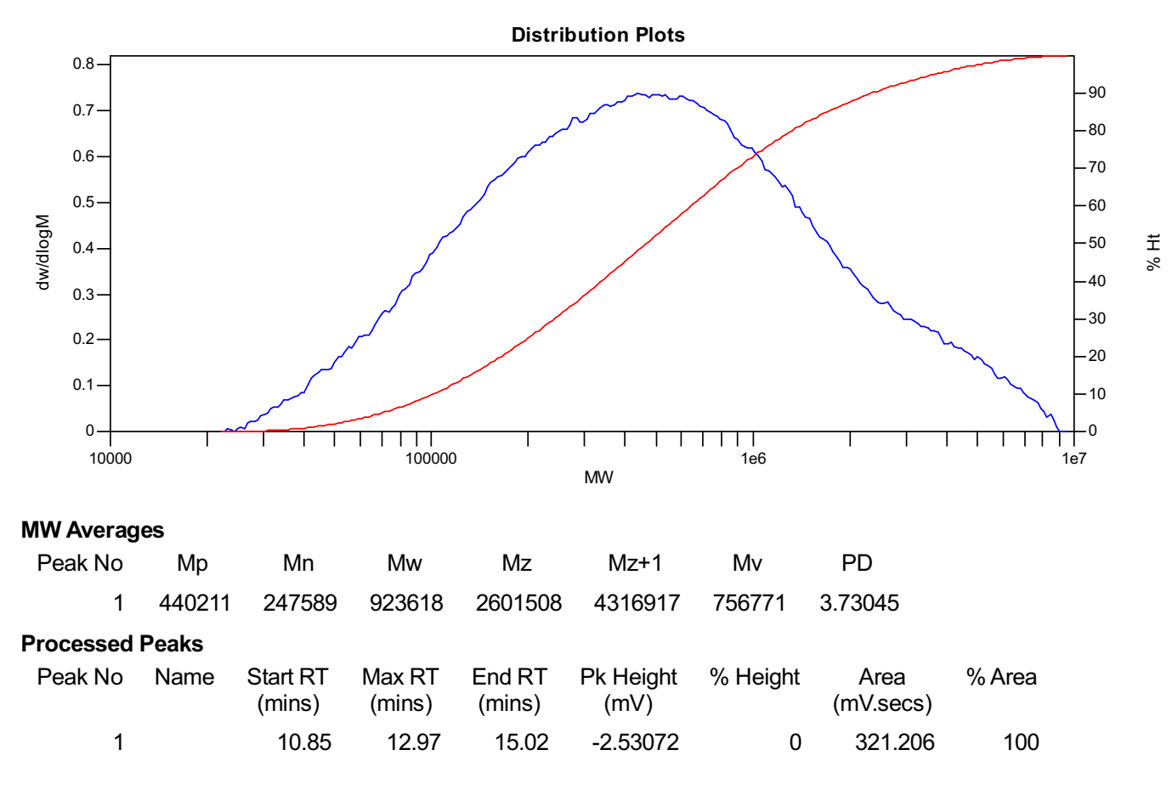
Figure S102. GPC of the polymer from Table 1, Entry 2.

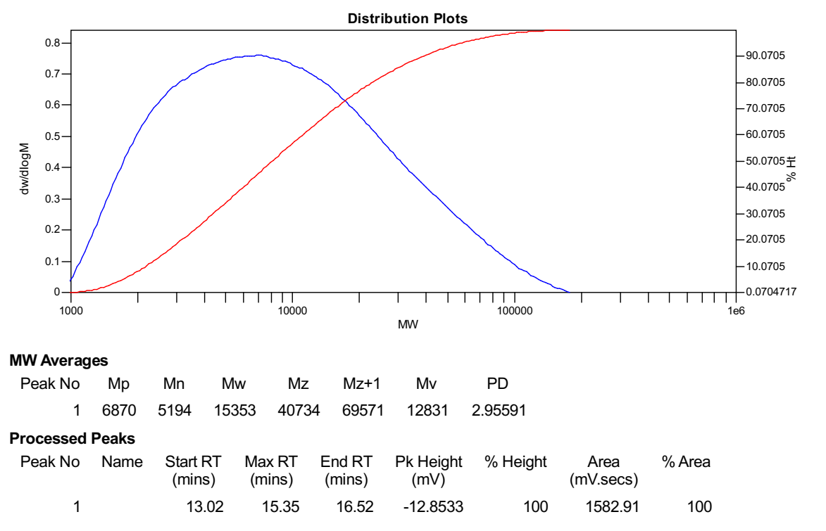
Figure S103. GPC of the polymer from Table 1, Entry 3.

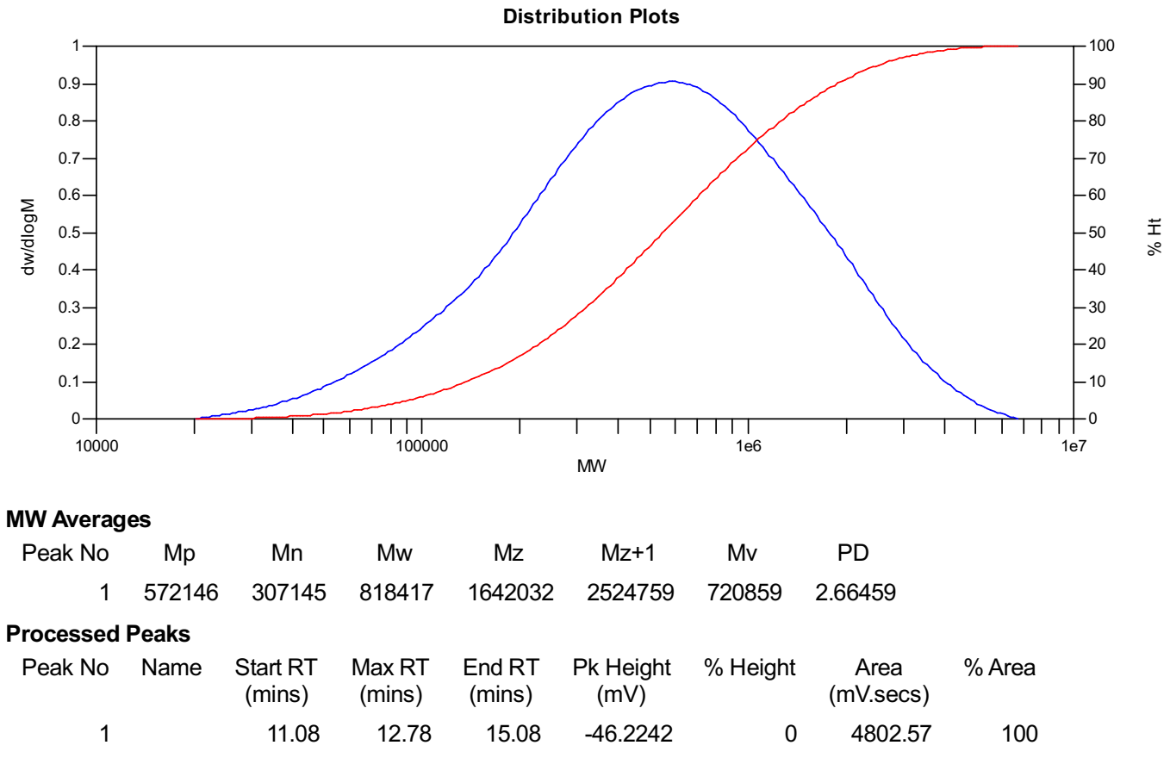
Figure S104. GPC of the polymer from Table 1, Entry 4.

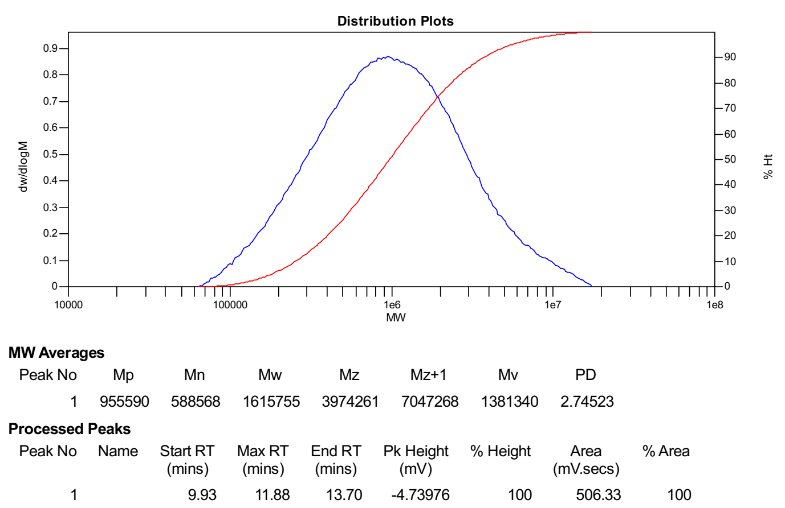
Figure S105. GPC of the polymer from Table 1, Entry 5.

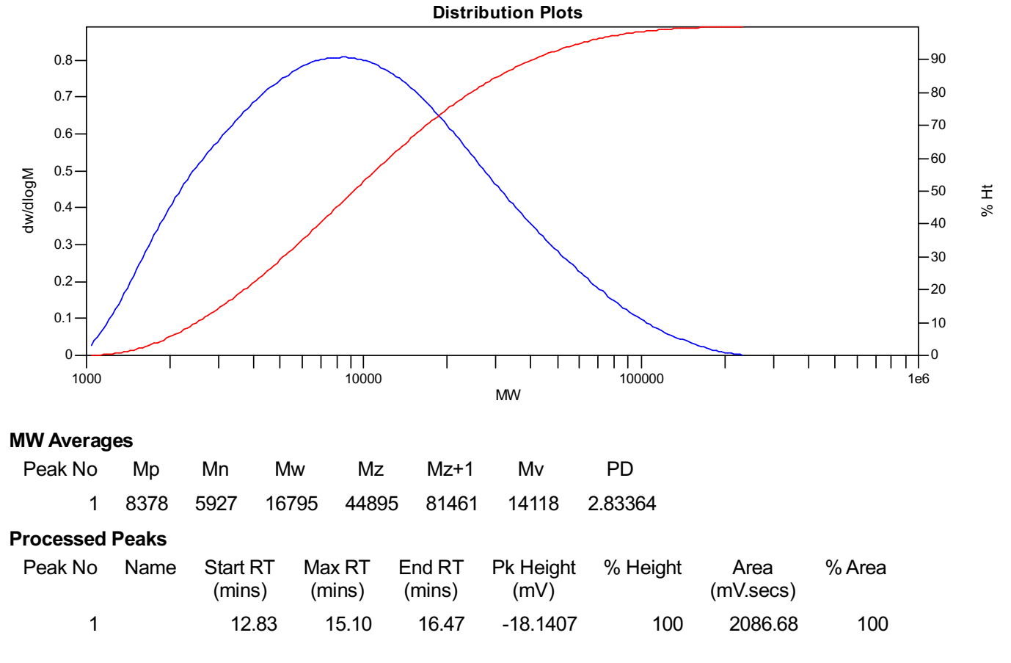
Figure S106. GPC of the polymer from Table 1, Entry 6.
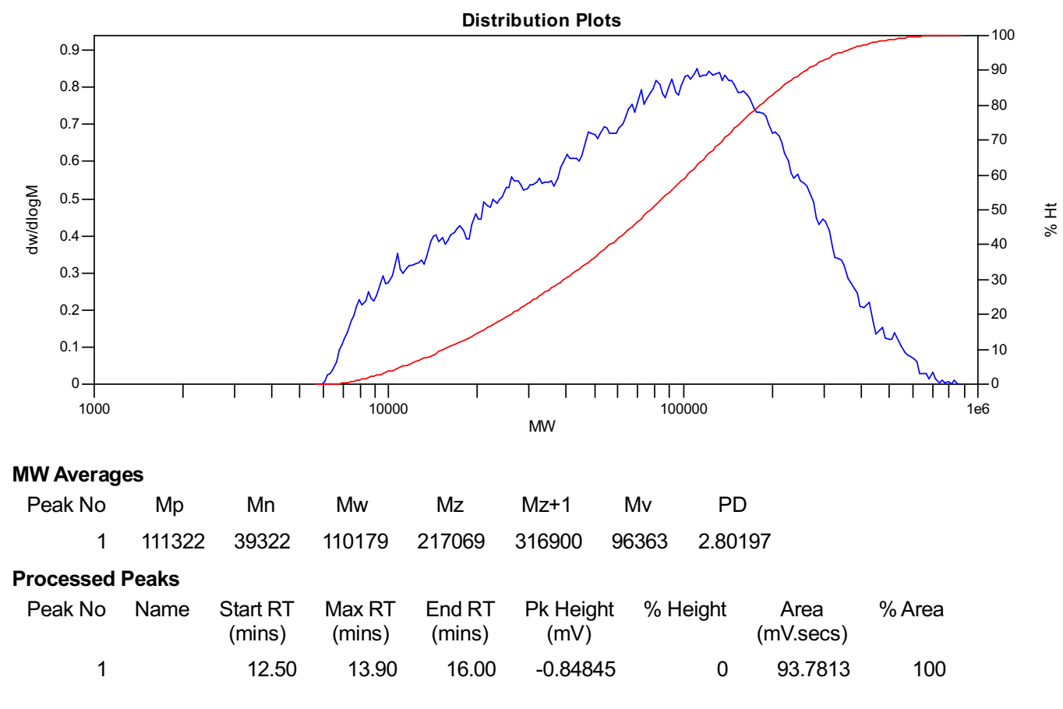
Figure S107. GPC of the polymer from Table 1, Entry 7.

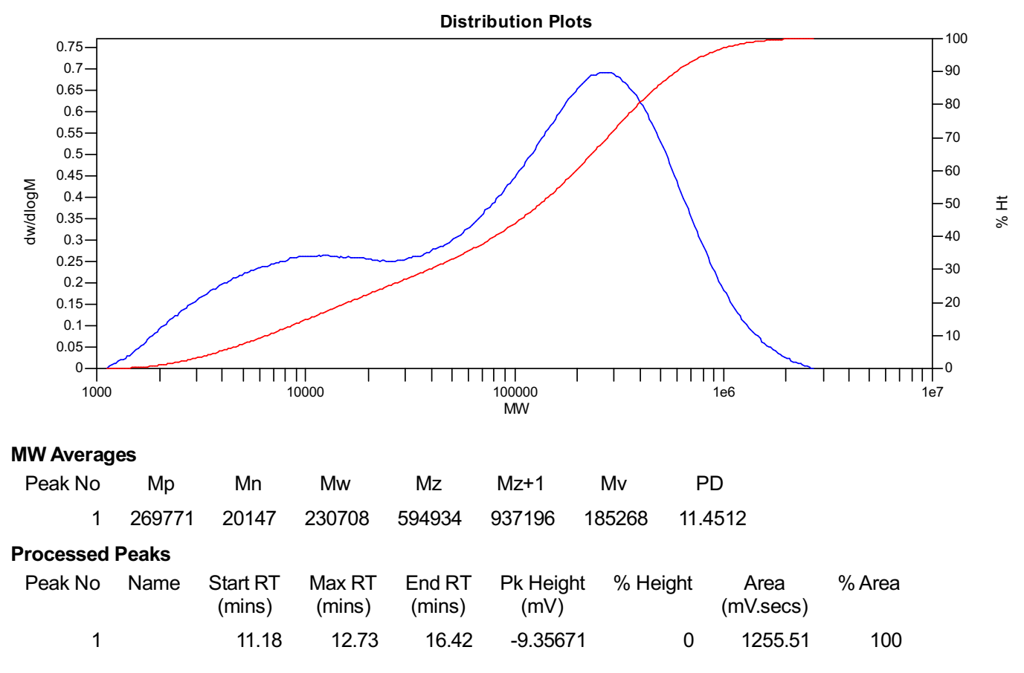
Figure S108. GPC of the polymer from Table 1, Entry 8
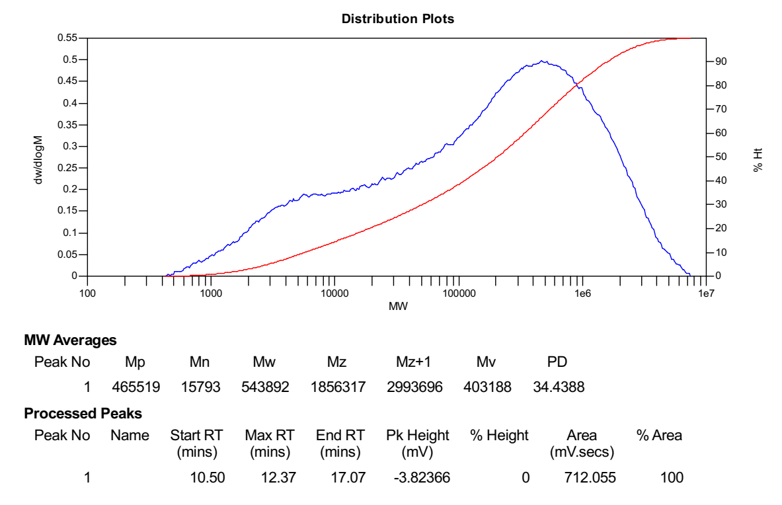
Figure S109. GPC of the polymer from Table 1, Entry 9.

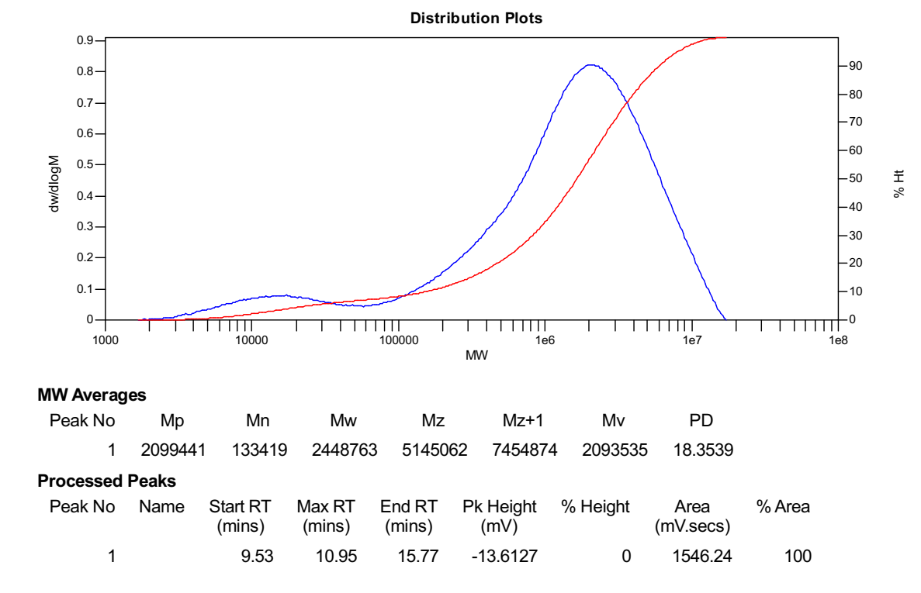
Figure S110. GPC of the polymer from Table 1, Entry 10.
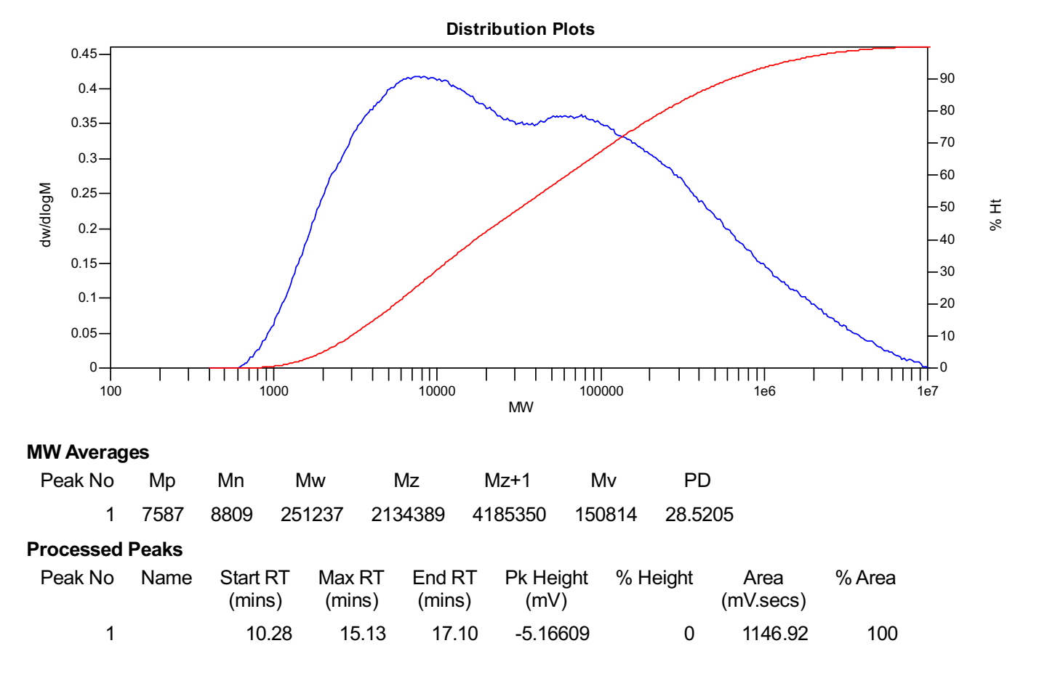
Figure S111. GPC of the polymer from Table 1, Entry 11.

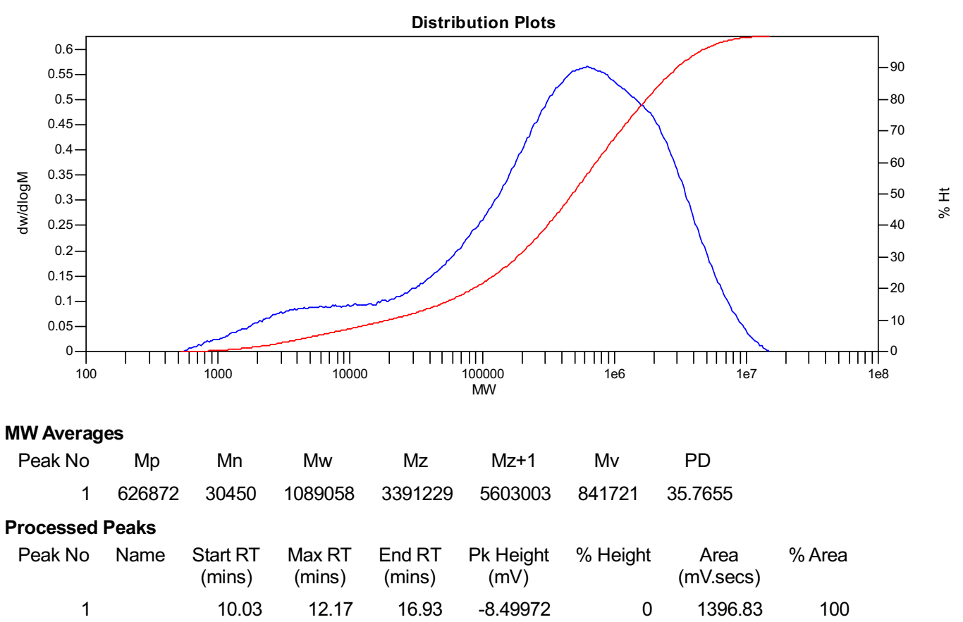
Figure S112. GPC of the polymer from Table 1, Entry 12.

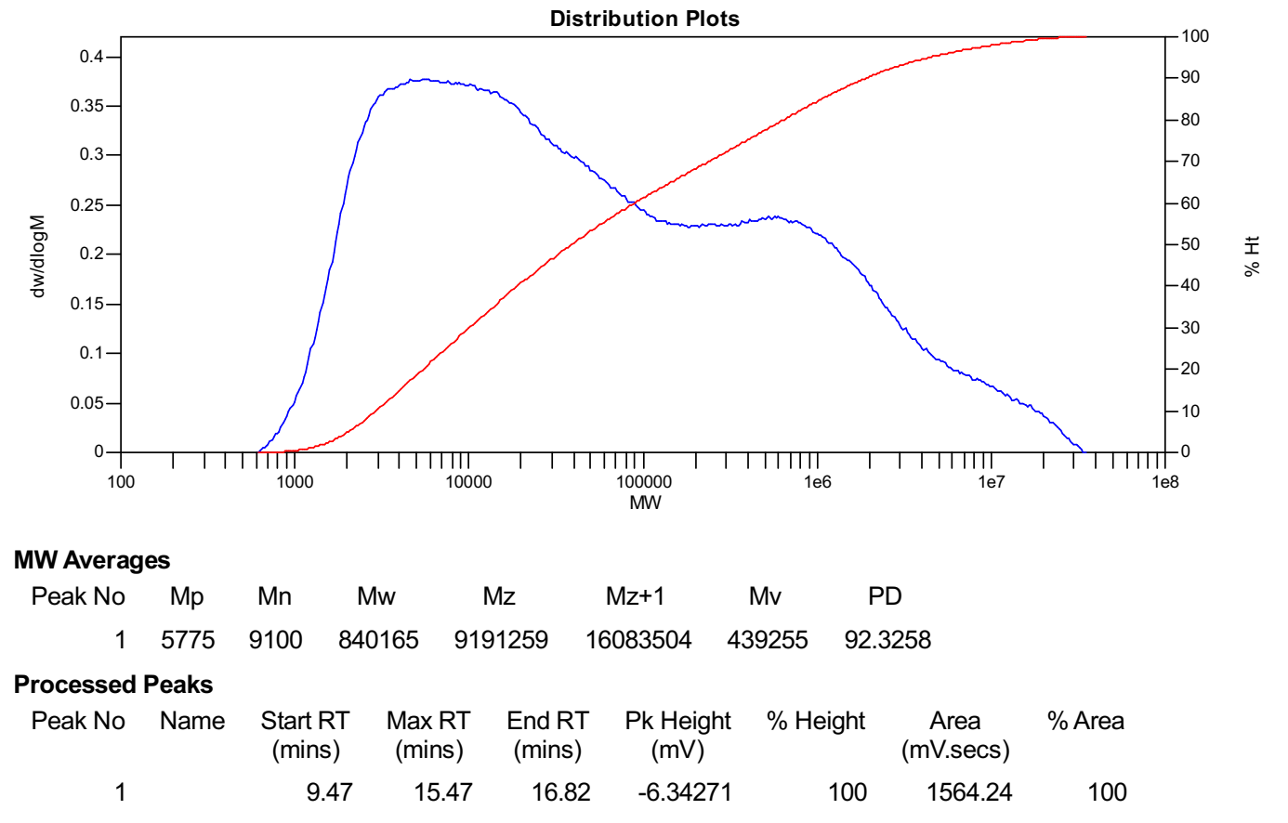
Figure S113. GPC of the polymer from Table 1, Entry 13.

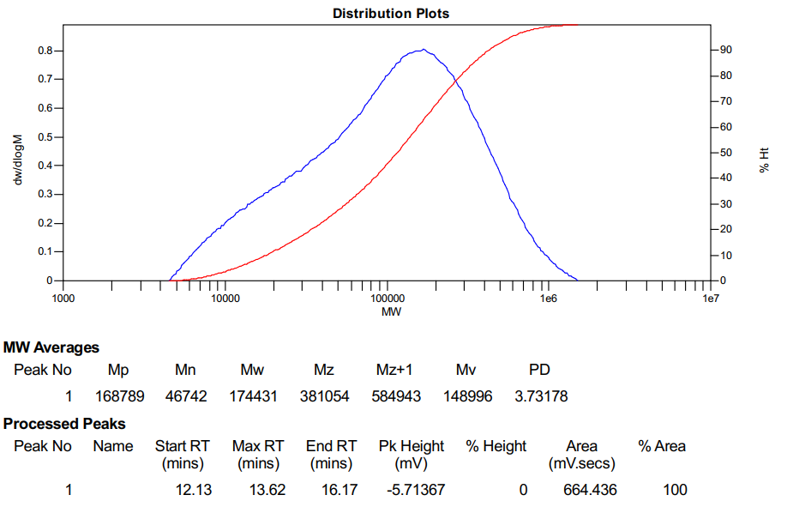
Figure S114. GPC of the polymer from Table 1, Entry 14.

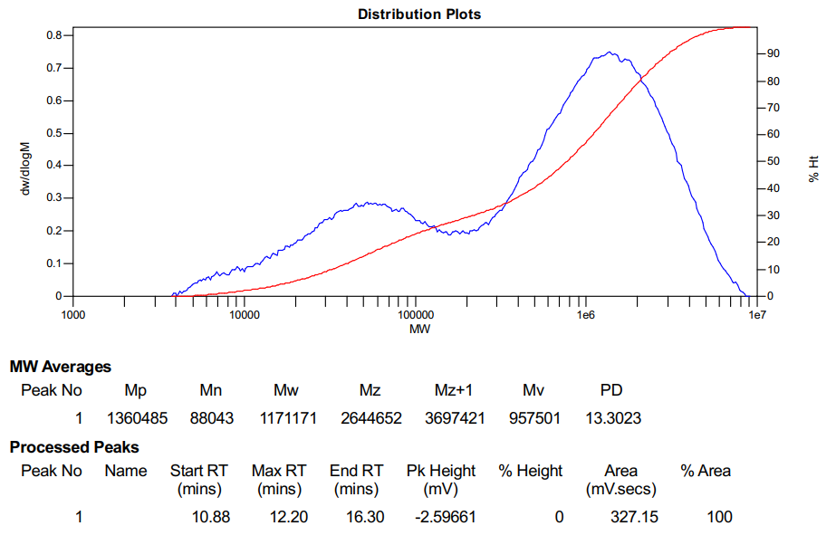
Figure S115. GPC of the polymer from Table 1, Entry 15.

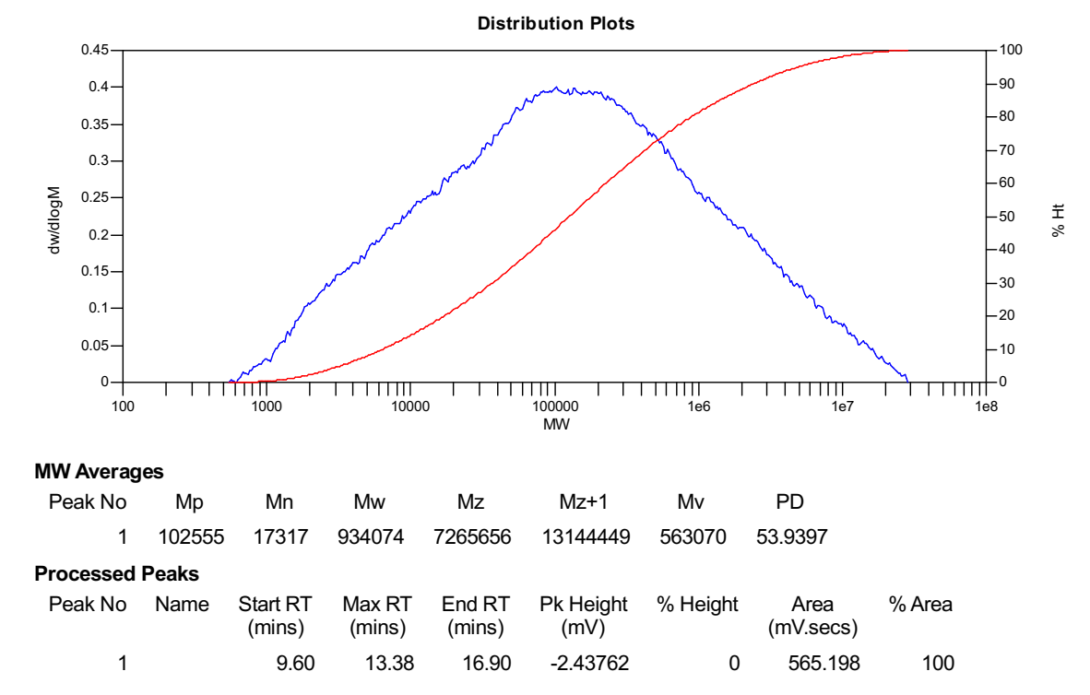
Figure S116. GPC of the polymer from Table 1, Entry 16.
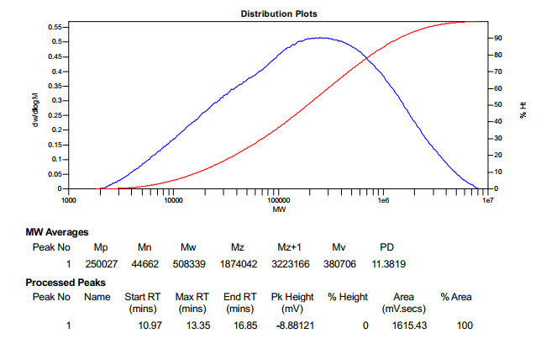
Figure S117. GPC of the polymer from Table 1, Entry 17.

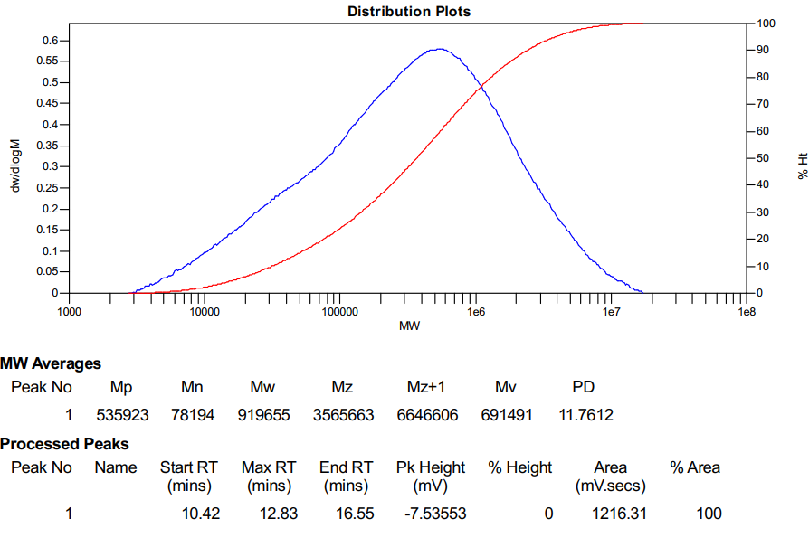
Figure S118. GPC of the polymer from Table 1, Entry 18.
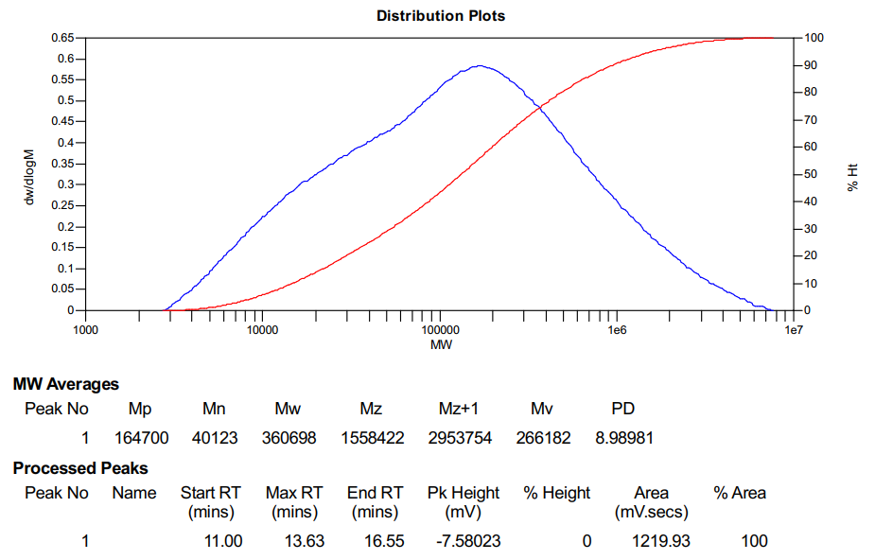
Figure S119. GPC of the polymer from Table 1, Entry 19.

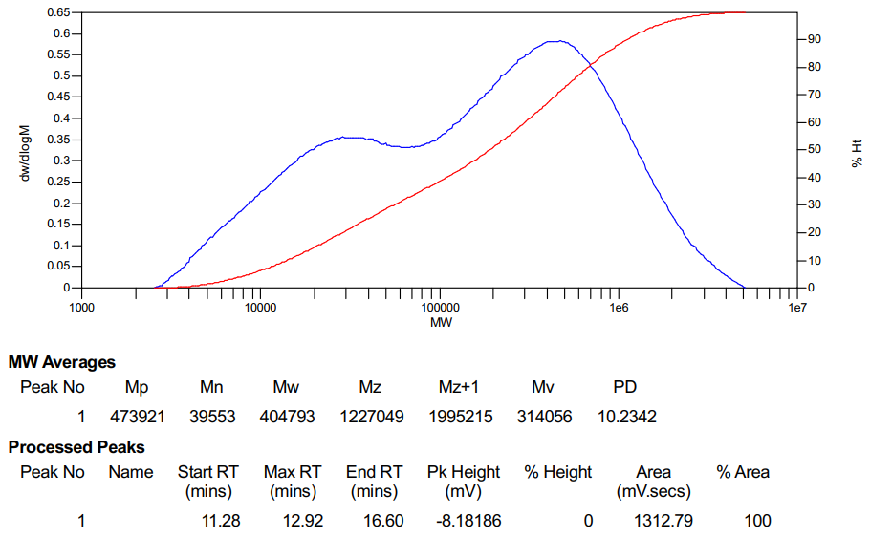
Figure S120. GPC of the polymer from Table 1, Entry 20.

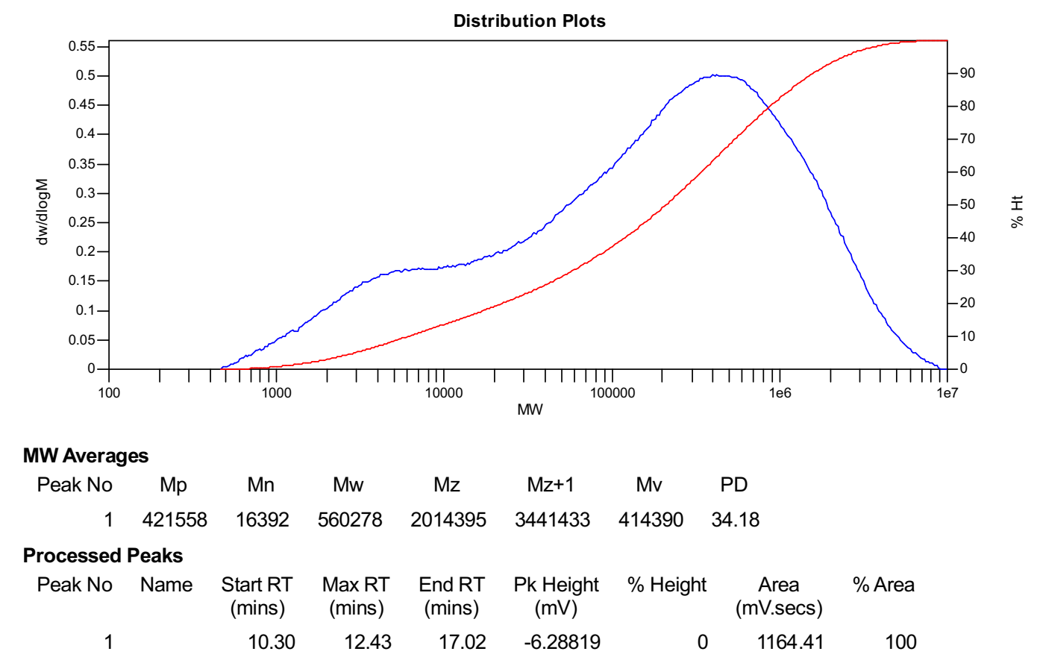
Figure S121. GPC of the polymer from Table 1, Entry 21.
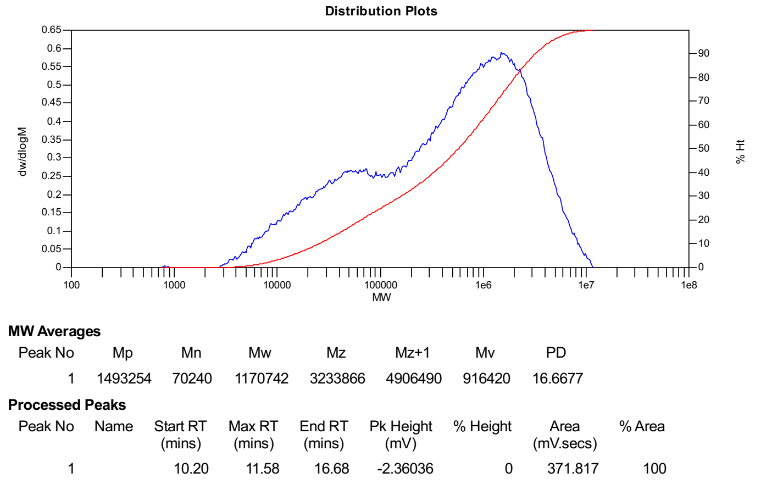
Figure S122. GPC of the polymer from Table 1, Entry 22.

Reference
- Zou, C.; Si, G. F.; Chen, C. L. A general strategy for heterogenizing olefin polymerization catalysts and the synthesis of polyolefins and composites. Nat. Commun. 2022, 13, 1954.

