Supporting Information

Uniquely trigger the death of cancer cells by destruction of lysosomes
Ying-Ying Du¹ ² ⁺, Ying-Pu Wang¹⁺, En-Yun Xing¹, Juan-Juan Yin¹, Xu Jiang¹, Ning Wang¹, Yan-Xin Lin¹, Rui-Jie Shi¹, Ping Wang³, Xiang-Qian Xiao⁴, Ya-Qing Feng¹, Shu-Xian Meng¹*
1. School of Chemical Engineering and Technology, Tianjin University, Tianjin 300050 (P.R. China), Corresponding Author, Shu-Xian Meng, Email: msxmail@tju.edu.cn
2. Tianjin Institute of Pharmaceutical Research Co., Ltd, Tianjin 300450, China and Technology R&D Center of Tianjin Taipu Pharmaceutical Co., Ltd, Tianjin 300450, China
3. Tianjin Modern Innovation TCM Technology Co. Ltd.，Tianjin, 300392, China
4. School of Department of Environment and Life Sciences, Beijing Industry University, Email: xiaoxq@bjut.edu.cn
Synthesis of FA-CS
Activated folic acid ester was synthesized by the esterification reaction of folic acid, and reacted with the active amine group on the chitosan to form an amide bond, thereby preparing folate-conjugated chitosan. Briefly, FA (2.0 g), and NHS (0.80 g) and EDC·HCL (1.34 g) were dissolved in anhydrous DMSO (37.2 mL) containing triethylamine (2.8 mL), the reaction mixture was kept in the dark for 32 hrs at room. Under ice bath conditions, a mixture of ice-cold anhydrous ether and acetone (7:3) is slowly added to the reaction solution until precipitation occurs. At last, activated folic acid ester was filtered and dried under vacuum for 24 hrs.
CS (1.0 g) was dissolved in 1% acetic acid (200 mL) and brought to pH 9.0 by drop wise addition of diluted aqueous NaOH. Activated folic acid ester (2.0 g) was added to above solution under stirring at 45℃ in the dark for 48 hrs. Finally, the resulting mixture was brought to pH 9.0 by drop wise addition of diluted aqueous NaOH. The sediment was dialyzed first against phosphate buffe (pH 7.4) for 3 days and then against water for 3 days. FA-CS was subsequently obtained by lyophilization.

Figure S1 Synthetic route of FA-CS.

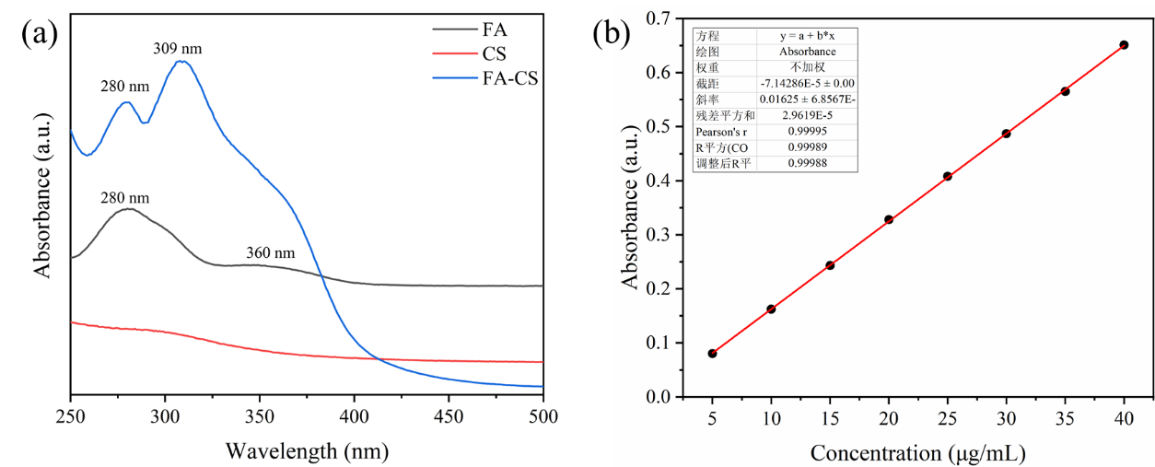
Figure S2 (a) UV–vis spectroscopy of FA, CS and FA-CS. (b) standard curve of FA.
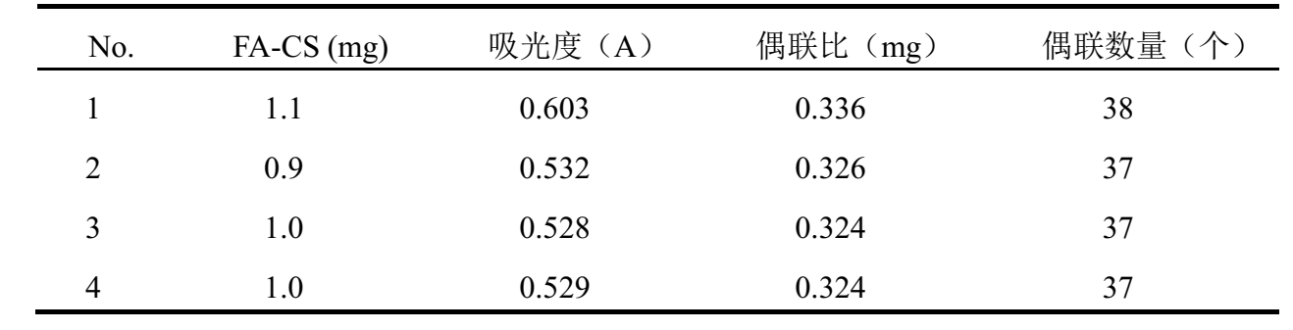

Figure S3 Calculation of folic acid coupling ratio and coupling quantity of FA-CS.

Figure S4 FTIR spectra of (1) MgO, (2) CMC and (3) CMC/MgO NPs.

Figure S5 EDS spectrum of the (a) CMC/MgO and (b)FA-CS/BODIPY@CMC/MgO nanocomplexes.

Figure S6 UV-vis spectra and standard curve of (a) FA-CS and (b) BODIPY under different content.

Figure S7 (a) Structural formula of BODIPY. (b) Room temperature photoluminescent spectra of BODIPY (λ_{ex} = 510nm).

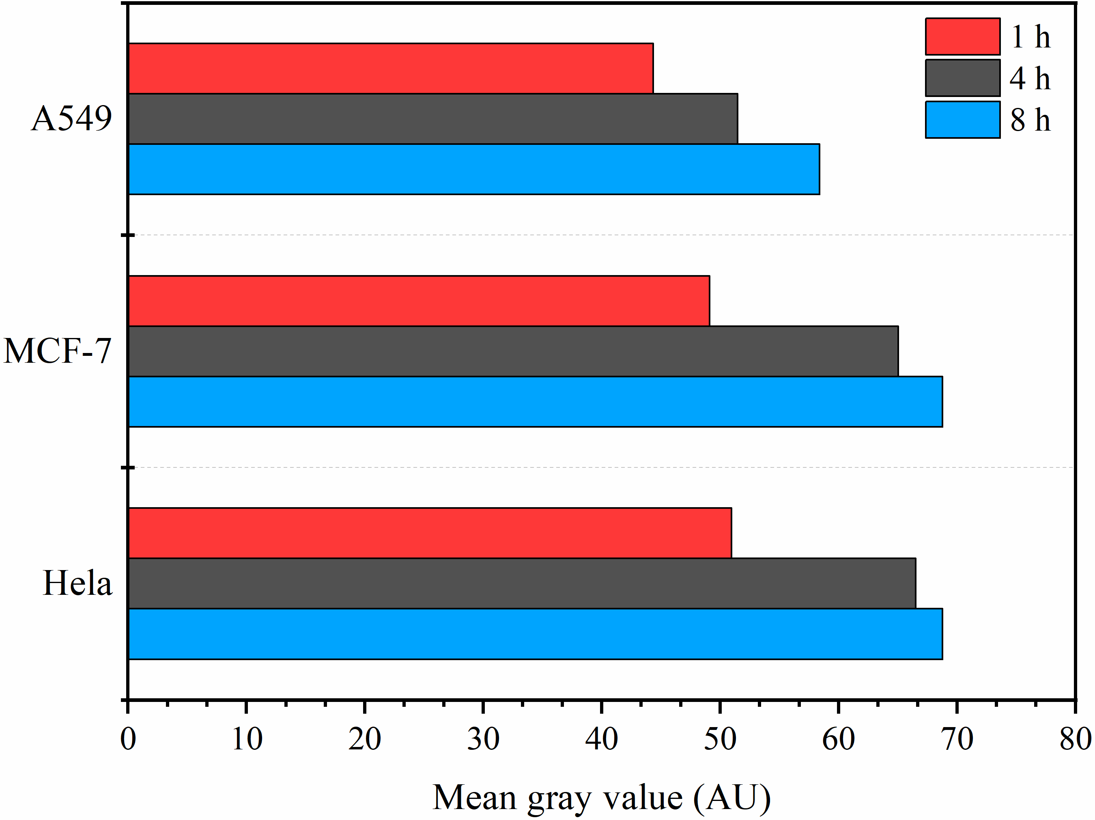
Figure S8 Mean fluorescence intensity of CMC/MgO @ FA-CS/BODIPY NPs uptaked by cells at different times (1, 4 and 8 hrs).

Figure S9 Cellular uptake of FA-CS/BODIPY@CMC/MgO NPs in MCF-7 cells after incubation for 6 hrs.

