NONCLINICAL In Vitro SAFETY ASSESMENT SUMMARY of HEMP DERIVED (R/S)-HEXAHYDROCANNABINOL ((R/S)-HHC)

Arianna C. Collins, Tesfay T. Tesfatsion, Giovanni A. Ramirez, Kyle P. Ray, Westley Cruces*

Colorado Chromatography Labs, 10505 S. Progress Way Unit 105, Parker, Colorado 80134

*Corresponding authors: Westley Cruces
Email: wes@coloradochromatography.com

Table of Contents:
- HPLC and NMR……………………………………………………………………...….S2
- GC Data………………………….…………………………...…...……………………..S3
- hERG and Cytotoxicity Data……………………………........…………………..……...S4

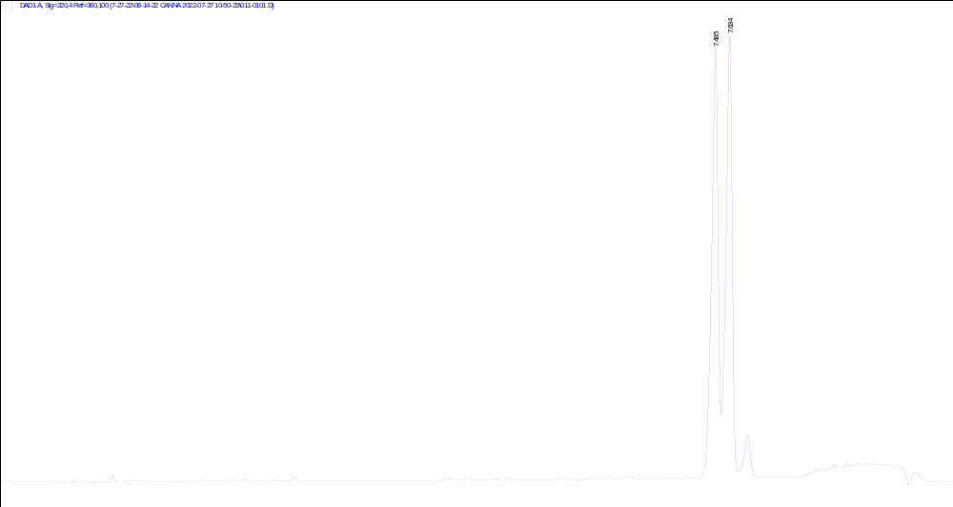
High Performance Liquid Chromatography (HPLC) of (R/S)-HHC

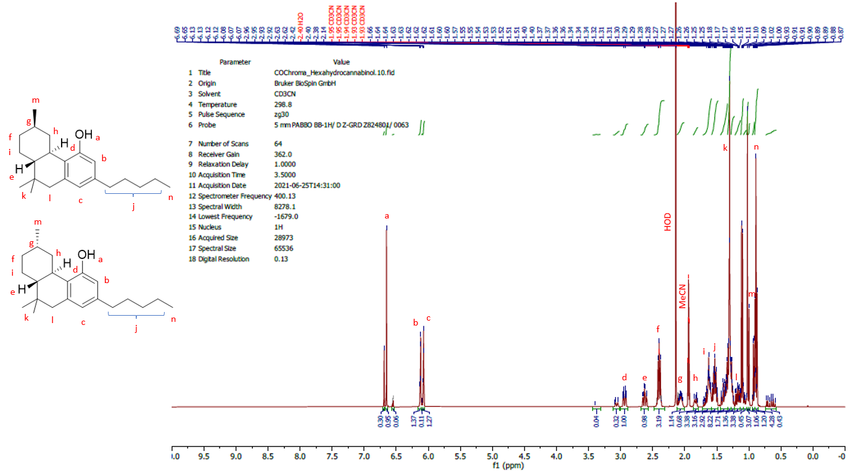
¹H NMR spectrum of (R/S)-HHC

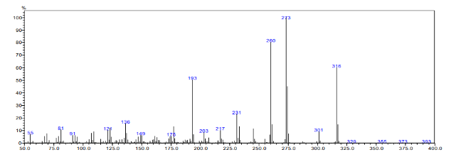
GC-MS data

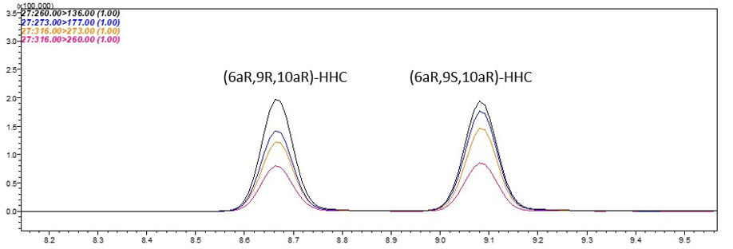

GC-FID analysis

Effects of (R/S)-HHC on hERG Ion Channel Current
Test Article | IC₅₀ (µM) | n | Conc (μM) | Mean % hERG Inhibition | Standard Deviation | Standard Error
(R/S)-HHC | >50 | 9 | 6.25 | 4.8 | 3.0 | 1.0
(R/S)-HHC | >50 | 7 | 12.5 | 5.7 | 2.5 | 0.9
(R/S)-HHC | >50 | 3 | 25 | 2.3 | 3.8 | 2.2
(R/S)-HHC | >50 | 4 | 50 | 6.4 | 5.4 | 2.7
Cisapride (positive control) | <0.05 | 4 | 0.05 | 64.1 | 7.6 | 3.8

Summary of cell viability (cytotoxicity) in fibroblasts following hour incubation.
Cell Line | Compound ID | IC₅₀  (µM) | Cytotoxicity  (at 50 µM)
Fibroblasts | (R/S)-HHC | 14.4 | 74.8%
Fibroblasts | Chropromazine (control) | 14.3 | 86.4%

Summary of cell viability (cytotoxicity) in human hepatocytes following 48 hours incubation
Compound | Incubation Time | Cell Lines | IC₅₀ (μM) | Cytotoxicity (at 50 μM) | Comments
(R/S)-HHC | 48 hrs | Plated human hepatocytes | Not determined | 8.9% | Nontoxic
Terfenadine | 48 hrs | Plated human hepatocytes | 15.8 | 99.9% | Showed toxicity as expected

