Sensitivity of mid-ocean ridge hydrothermal system controlled by the detachment fault to the glacial cycle

Xianhui Yang^{1,2♀}, Chunhui Tao^{1,2♀*}, Shili Liao², Fernando J.A.S. Barriga³, Xianmin Deng², Jin Liang², Zhikui Guo², Mingxu Wang^{1,2}, Weifang Yang²
1 School of Oceanography, Shanghai Jiao Tong University, Shanghai 200030, China.
2 Key Laboratory of Submarine Geosciences, Second Institute of Oceanography, Ministry of Natural Resources, Hangzhou 310012, Zhejiang, China.
3 Instituto Dom Luiz and Department of Geology, Faculty of Sciences, University of Lisbon, FCUL, Campo Grande, Edificio C6, 1749-016 Lisboa, Portugal.
♀These authors contributed equally: Xianhui Yang and Chunhui Tao.
*Corresponding Email: taochunhui@sio.org.cn

Supplementary materials
Lists
Supplementary Table 1. Content of major elements in the sediment cores.
Supplementary Table 2. Content of trace elements sediment cores.
Supplementary Table 3. Content of major and trace elements of basalt and ultramafic rock in the Southwest Indian Ridge.
Supplementary Figure 1. Ternary diagrams of the carbonate-free fraction of the sediments.
Supplementary Figure 2. Sediment cores position for oxygen isotope testing.
Supplementary Figure 3. Planktonic foraminiferal δ¹⁸O in the sediment cores.
Supplementary Figure 4. Age model of core 65gc02.
Supplementary Figure 5. Age-depth model of core 65gc02 and core 58gc01.
Supplementary Figure 6. Scatter plot of hydrothermal deposition flux and Cr/Al, Al₂O₃.
Table S1 Content of major elements in the sediment cores
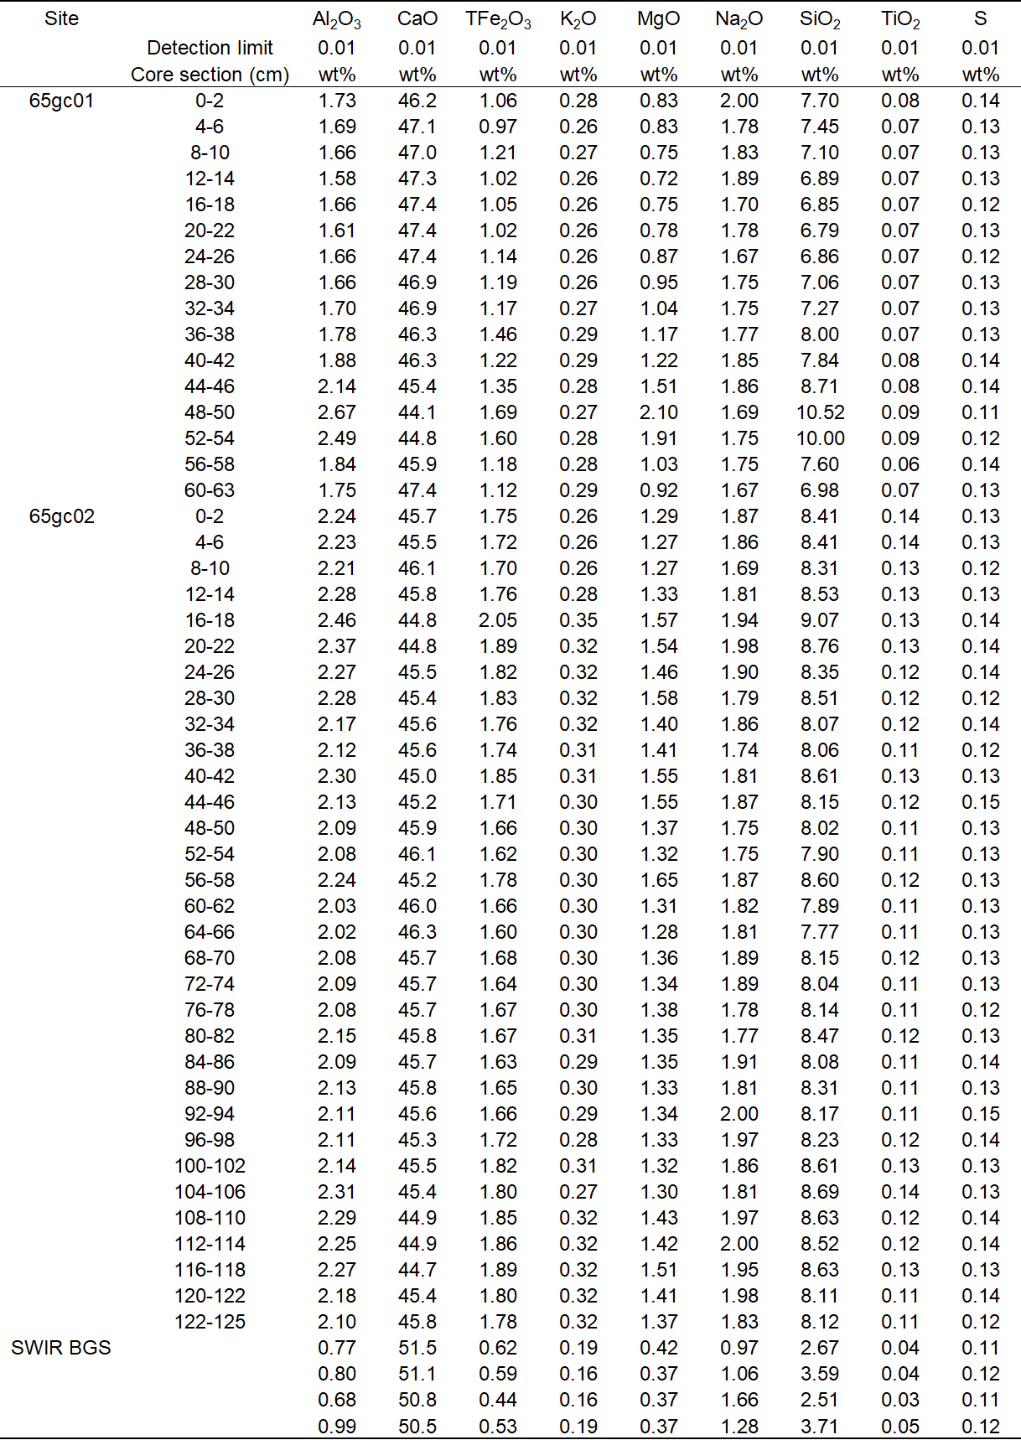
Note: SWIR BGS: background sediment in the Southwest Indian Ridge, data from ref.1.

Table S2 Content of trace elements of sediment cores
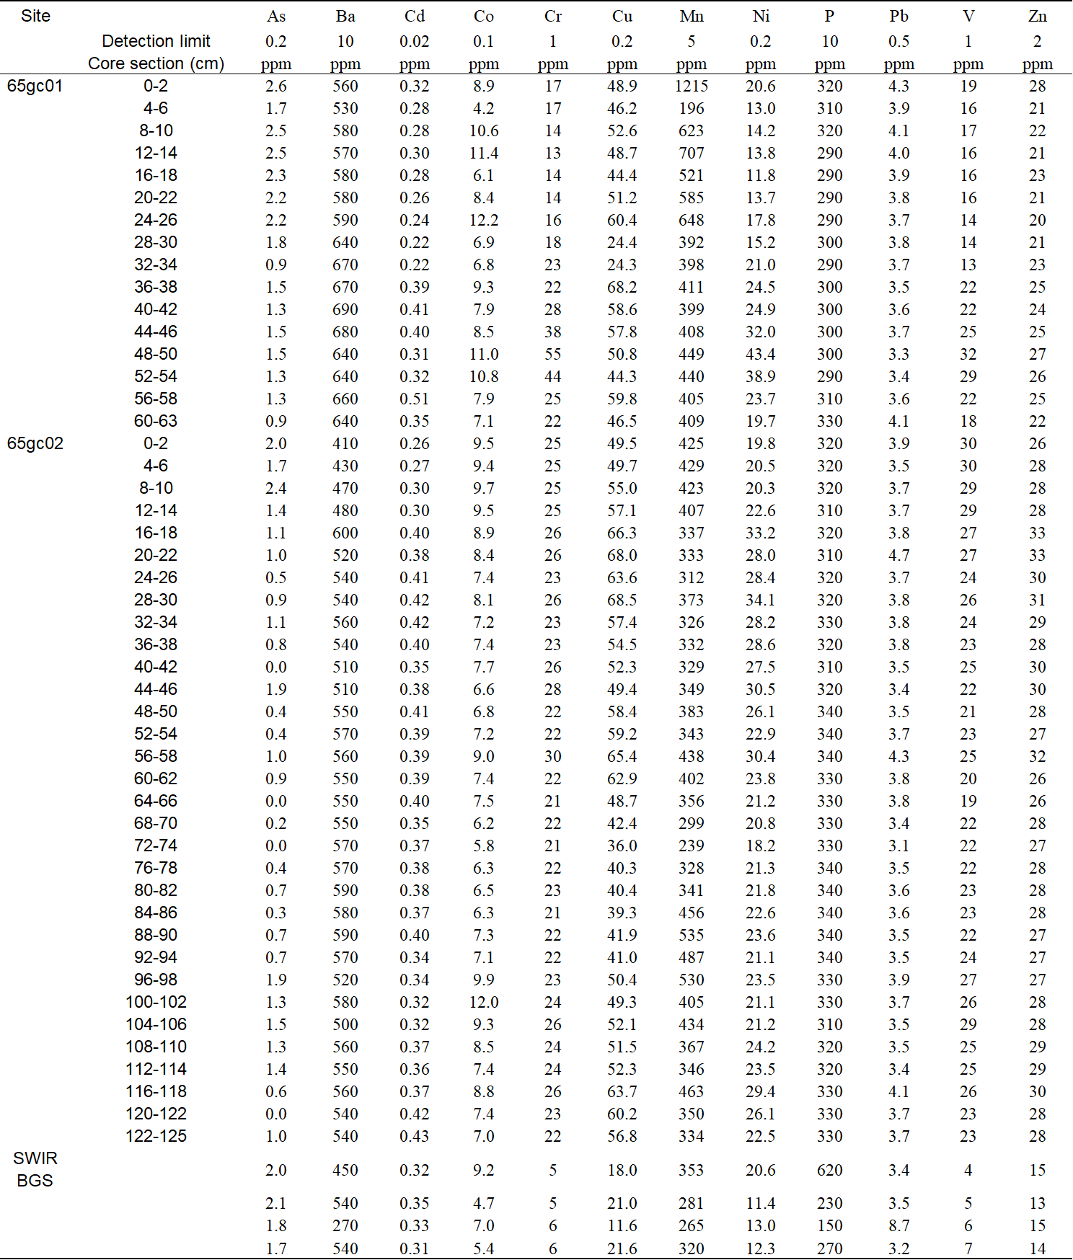
Note: SWIR BGS: background sediment in the Southwest Indian Ridge, data from ref.1.

Table S3 Content of major and trace elements of basalt and ultramafic rock in the Southwest Indian Ridge
Note: The data were downloaded and selected from the PetDB Database (www.earthchem.org/petdb)
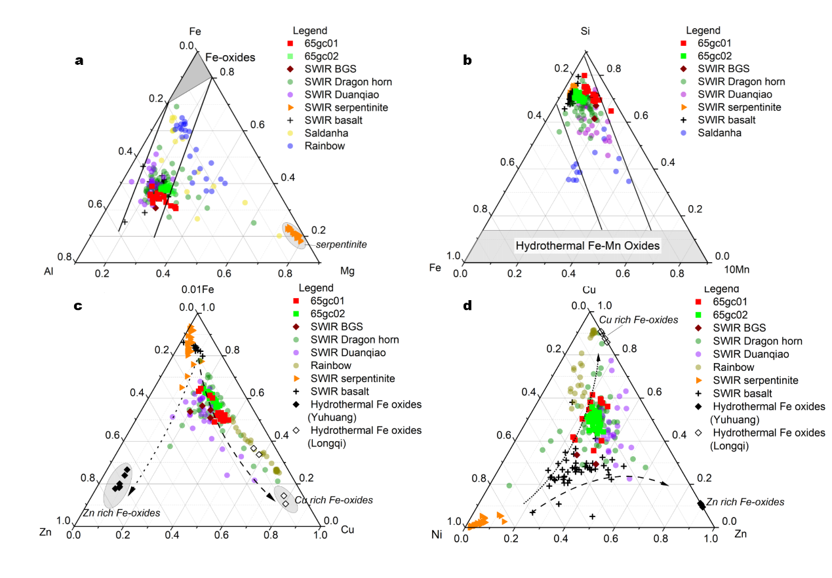
Fig.S1 Ternary diagrams of the carbonate-free fraction of the sediments. a Fe–Al–Mg, b Si–Fe–10Mn, and c 0.01Fe-Zn-Cu , d Cu–Ni–Zn. Recalculated content of an element or element oxide in the sample: [element (oxide)] cfb=[element (oxide)] total/(100–CaCO₃)× 100%, assuming all CaO is present as calcite (CaCO₃=CaO× 1.7848). SWIR BGS: background sediment in the Southwest Indian Ridge, data from ref. 1; SWIR Dragon Horn data from ref. 1; SWIR Duanqiao area data from ref. 4; SWIR serpentine and basalt data from the PetDB Database (www.earthchem.org/petdb); Hydrothermal Fe oxides (Yuhuang) from ref. 5. Hydrothermal Fe oxides(Longqi) from ref. 6. The Rainbow data is from ref. 7.

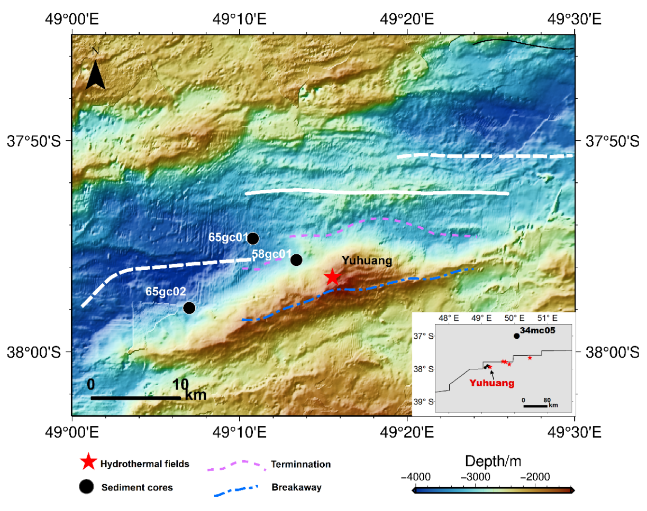
Fig.S2 Sediment cores position for oxygen isotope testing. The data of core 58gc01, core 65gc01, and core 65gc02 comes from this study. The data of 34mc05 comes from ref.2. The white line represents the ridge axis.
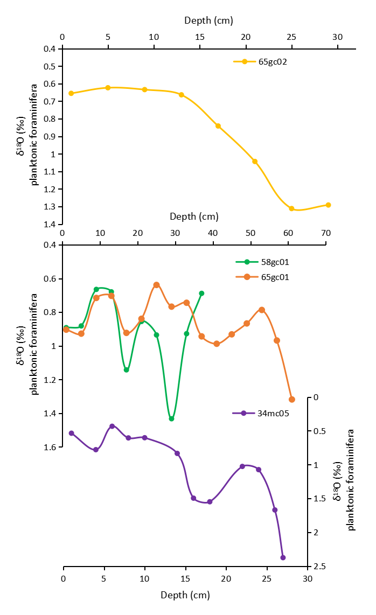
Fig.S3 Planktonic foraminiferal δ¹⁸O in the sediment cores. The data of core 58gc01, core 65gc01, and core 65gc02 comes from this study. The data of 34mc05 comes from ref.2.
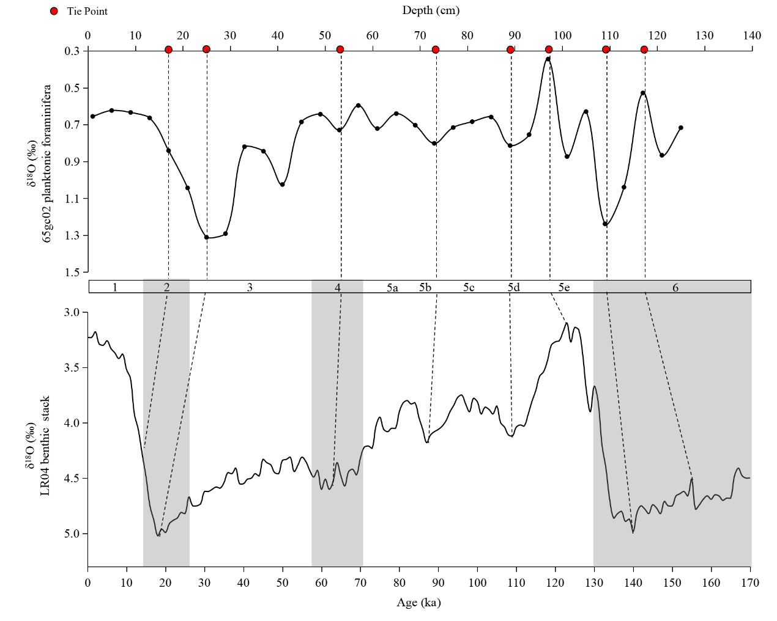
Fig.S4 Age model of core 65gc02. The global LR04 benthic δ¹⁸O stack comes from ref.3.

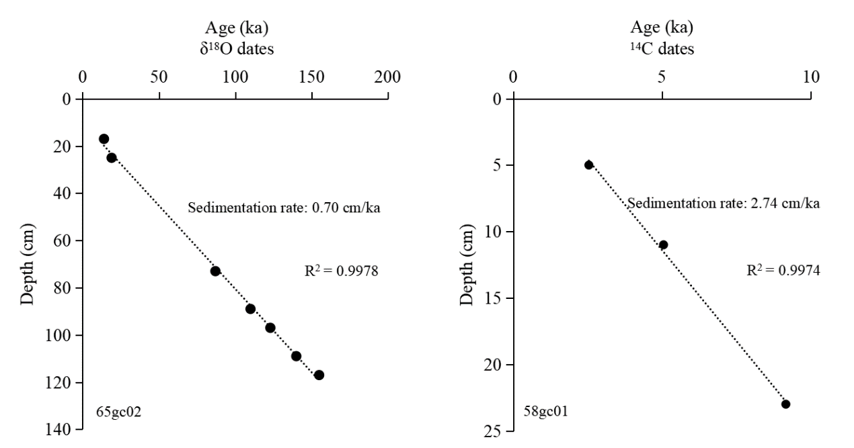
Fig.S5 Age-depth model of core 65gc02 and core 58gc01. The data of core 65gc02 comes from the tie points of Fig S4.
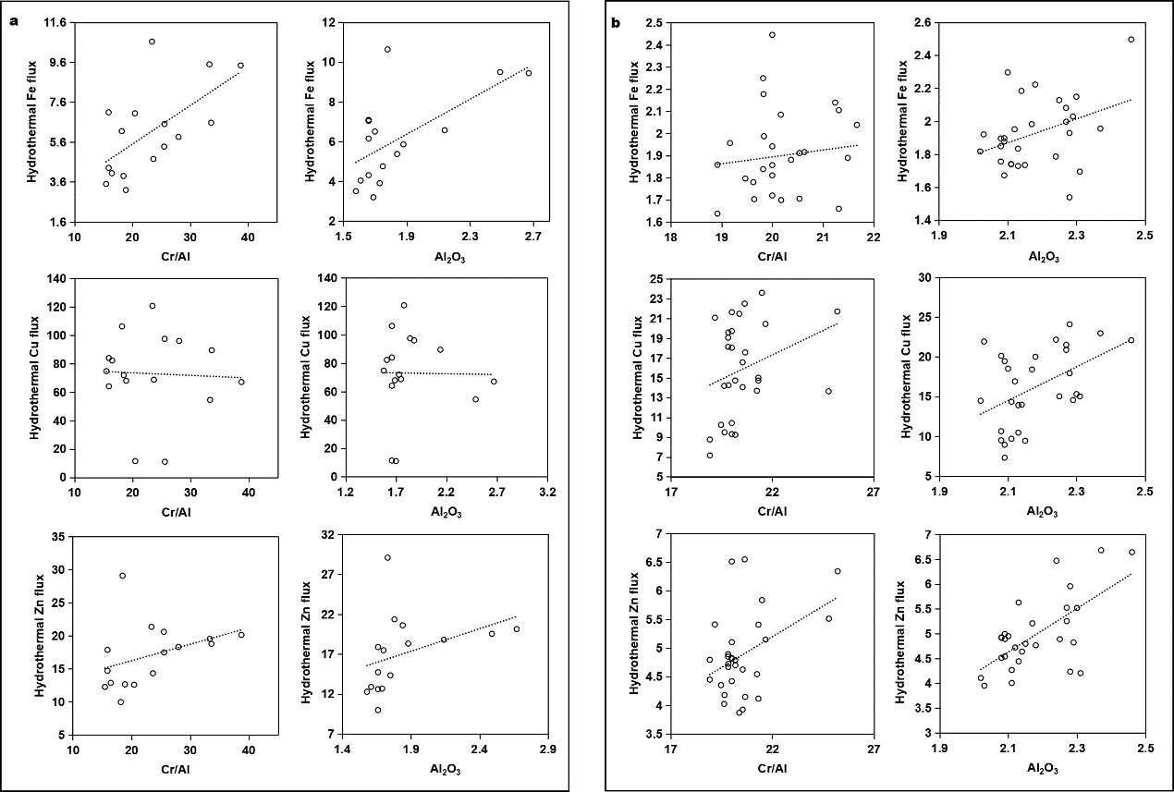
Fig.S6 Scatter plot of hydrothermal deposition flux and Cr/Al, Al₂O₃. a core 65gc01; b core 65gc02.

References
1 Liao, S. et al. Surface sediment geochemistry and hydrothermal activity indicators in the Dragon Horn area on the Southwest Indian Ridge. Mar. Geol. 398, 22-34(2018).
2 Jie, Z. Foraminiferal Assemblages in the Southwest Indian ocean Sediments and Their Paleoenrivonmental Implications since Late Pleistocene, China University of Geosciences (Beijing) (2017).
3 Lisiecki, L. E. & Raymo, M. E. A Pliocene-Pleistocene stack of 57 globally distributed benthic δ18O records. Paleoceanography 20(2005).
4 Liao, S. et al. Surface sediment composition and distribution of hydrothermal derived elements at the Duanqiao-1 hydrothermal field, Southwest Indian Ridge. Mar. Geol. 416(2019).
5 Hu, S., Tao, C., Liao, S., Zhu, C. & Qiu, Z. Transformation of minerals and mobility of heavy metals during oxidative weathering of seafloor massive sulfide and their environmental significance. Science of the Total Environment 819, 153091(2022).
6 Ye, J. Mineralization of polymetallic sulfides on ultra-slow spreading southwest indian ridge at 49.6°E(Chineses) doctor of philosophy thesis, Graduate university of Chinese academy of sciences, (2010).
7 Chavagnac, V., German, C. R., Milton, J. A. & Palmer, M. R. Sources of REE in sediment cores from the Rainbow vent site (36 degrees 14 ' N, MAR). Chem. Geol. 216, 329-352(2005).

