Supplementary Information

Escherichia coli BL21(DE3) Optimized Deletion Mutant as the Host for Whole cell biotransformation of N‑acetyl‑D‑neuraminic Acid

Qiong Zhang¹, Jiao Zhang¹, Yanhong Shao¹, Guangdong Shang^{1*}
¹Jiangsu Key Laboratory for Microbes and Functional Genomics, College of Life Sciences, Nanjing Normal University, Nanjing 210023, China

*Corresponding Author. Tel.: +86-25-85898332. Fax: +86-25-85891526. E-mail: shangguangdong@njnu.edu.cn.
ORCID: 0000-0001-6142-3785

Chemicals
Vector Construction
Table S1. PCR primers and oligonucleotides used in the study
Fig. S1 Schematic presentation of the recombineering and I-SceI-mediated gene deletion and genotype analysis of the deletion mutant
Fig. S2 Confirmation of Δnan mutant
Fig. S3 Confirmation of ΔmanXYZ operon mutant
Fig. S4 Confirmation of ΔnagEABC operon mutant
Fig. S5 Confirmation of ΔpoxB mutant
Fig. S6 Outline of the ssDNA recombineering and CRISPR/Cas9-mediated gene deletion
Fig. S7 Confirmation of ΔldhA mutant
Fig. S8 Confirmation of ΔackA mutant
References

Chemicals
Antibiotics were supplemented as follows: ampicillin (Ap, 100 μg/mL), chloramphenicol (Cm, 25 μg/mL), kanamycin (Km, 30 μg/mL), and spectinomycin (Spc, 100 μg/mL). Neu5Ac, L-(+)-arabinose and IPTG (isopropyl-β-D-1-thiogalactopyranoside) were ordered from Sigma-Aldrich (USA); restriction enzymes, T4 ligase and PCR enzymes were bought from NEB (USA); GlcNAc, Pyr. Na, chlortetracycline (cTc), gel extraction and purification kit, plasmid extraction kit, and other chemicals were purchased from Sangon (China). cTc was dissolved in LB and prepared as a 500 μg/mL stock solution and autoclaved before using at a final concentration of 25 μg/mL for the induction of homing endonuclease I-SceI to cure of the sgRNA expression plasmid.

Vector Construction
Molecular biology manipulations, including chemical and electrocompetent cells preparation, DNA transformation, plasmid extraction and DNA gel electrophoresis, were performed as per the standard protocols [1]. We firstly modified BT0453 and nanA expression vector pLS2845 [2] to pLS4106 by adding restriction enzyme recognition sites to facilitate gene cloning. Based on pLS4106, vectors with BT0453 coupled with two nanA genes, and slr1975 and bAGE each coupled with one nanA or two copies of nanA genes were generated. For simplicity, hereafter the abbreviations by combing the first letters of three AGE genes (BT0453, slr1975 and bAGE) and nanA gene are applied to denote the expression vectors. Thus BN, BNN, sN, sNN, bN and bNN are used throughout, with B, s, and b denote BT0453, slr1975, and bAGE, respectively; while N indicates nanA.
With pLS2825 [2] as template, primers C354F–C354R amplified a nanA fragment (with SaII engineered at the 5'-end) which was cloned into pMD19T Simple, getting pLS4105. The BT0453 gene isolated as a NcoI–SalI fragment from pLS2824 [2] and nanA gene isolated as SaII–HindIII fragment from pLS4105 were ligated and sandwiched cloning into the NcoI–HindIII sites of pET28a(+), resulting in BN expression vector pLS4106. With pLS2825 as template, primers C355F–C355R amplified a nanA fragment (with PstI engineered at the 5'-end) which was cloned into pMD19T Simple, obtaining pLS4107. The KpnI–PstI excised nanA fragment from pLS4105 and PstI–HindIII excised nanA fragment from pLS4107 were ligated and sandwiched cloning into the KpnI–HindIII sites of pBluescript KS(–), rendering pLS4108. The BT0453 isolated as a NcoI–SalI fragment from pLS2824 and two nanA genes isolated as a SaII–HindIII fragment from pLS4108 were ligated and sandwiched cloning into the NcoI–HindIII sites of pET28a(+), giving BNN expression vector pLS4109.
With pLS2815 [2] as template, primers C356A–C356B, C356C–C356D and C356E–C356F PCR amplified three parts of slr1975 gene. The three fragments were combined as templates, with C356A–C356F as PCR primers, the 1.2 kb slr1975 amplicon (with the two NcoI sites inside slr1975 were eliminated) was amplified. The amplicon was digested with BamHI-SaII and cloned into the same treated pBluescript KS(–), giving pLS4110. The slr1975 was then excised as an NcoI–SaII fragment from pLS4110 and used to replace the NcoI–SaII fragment of BT0453 in pLS4106 and pLS4109, obtaining sN expression vector pLS4111 and sNN expression vector pLS4112, respectively.
With pLS2817 [2] as template, primers C366F–C366R PCR amplified the bAGE fragment, which was digested with BamHI-SaII and cloned into the same treated pBluescript KS(–), giving pLS4113. The bAGE was excised as an NcoI–SaII fragment from pLS4113 and used to replace the NcoI–SaII fragment of BT0453 in pLS4106 and pLS4109, forming bN expression vector pLS4114 and bNN expression vector pLS4115, respectively.
With pLS3545 [2] as template, primers C371–C286 and primers C374–C286 each PCR amplified a 0.4 kb fragment, which upon SpeI–PstI digestion, was separately cloned into the same sites of pLS3545, yielding ldhA gene sgRNA expression vector pLS4119, and ackA gene sgRNA expression vector pLS4121, respectively.

Table S1 PCR primers and oligonucleotides used in the study
Name | Sequence (5'3')ª | Purpose
C354F | GGAGTCGACGAGATGGCGCCCAACAGTCCC | Construction of  pLS4105
C354R | GGAAAGCTTCTGCAGTCACCCGCGCTCTTGCATCAAC | Construction of  pLS4105
C355F | GGACTGCAGGAGATGGCGCCCAACAGTCCC | Construction of  pLS4107
C355R | GGAAAGCTTTCACCCGCGCTCTTGCATCAAC | Construction of  pLS4107
C356A | GAAGGATCCCCATGGTTGCCCATCGCCGTCAG | Construction of  pLS4110
C356B | GCTAAAAAATCAGCACCATGTCGGGCAATTTCTAACCATTGG | Construction of  pLS4110
C356C | CCAATGGTTAGAAATTGCCCGACATGGTGCTGATTTTTTAGC | Construction of  pLS4110
C356D | GCATATTGACTAAAGGCCATAGCGGCGAAGCAATCGGAAAAAACG | Construction of  pLS4110
C356E | CGTTTTTTCCGATTGCTTCGCCGCTATGGCCTTTAGTCAATATGC | Construction of  pLS4110
C356F | GAAGTCGACTTAACTAACCGGAAGTTGGAG | Construction of  pLS4110
C366F | GGCGGATCCATGGGGAAAAACTTACAAGCAC | Construction of  pLS4113
C366R | GGAGTCGACTCAACTCAACGCCTCGAACTG | Construction of  pLS4113
C371 | GGAACTAGTGCGATGCTGCGCATTCTGAAGTTTTAGAGCTAGAAATAGC | Construction of  pLS4119
C286 | GGGCTAGTCTGCAGATAAAACG | Construction of  pLS4119
C374 | GGAACTAGTGGCAAAAATGCTGAACAAACGTTTTAGAGCTAGAAATAGC | Construction of  pLS4121
s203F | CGCAGGATGTAACCCAGCAGACGGTAATGACTGTACTTCACCCATCATCACATTCTGTAAGGTCAGTGTGATTAACATCATCAGTGACATAACAAATAGGGGTTCCGCGC | Δnan targeting DNA PCR
s203R | GGCCTTATGAACGCATTTGATTCGCAAACCGAAGATTCTTACCTGCAATTCCTTAGTTCCTATTCCGAAG | Δnan targeting DNA PCR
s204F | GTCGCCCTGTAATTCGTAACG | Δnan genotyping
s204R | AACGGCAGATTGAAAACAACG | Δnan genotyping
s205F | TGACTAAATCGTTTTTGGCG | nanT PCR 620 bp, inside nan operon
s205R | TGCTTTCCTCTACTCATGGC | nanT PCR 620 bp, inside nan operon
206F | ATACATCTGGCACGTTGAGGTGTTAACGATAATAAAGGAGGTAGCAAGTGTAAGACTGTTGTACACTACCGGGGCCTTTTGGCCCCGTTTAACAAATAGGGGTTCCGCGC | ΔmanXYZ targeting  DNA PCR
s206R | CAGTCCCAGCAGGCCGCAAGCGTAACCAGCGATACCGATGACGAAGAAGCTCCTTAGTTCCTATTCCGAAG
s207F | ATAAATCGCGAAACGCAGGG | ΔmanXYZ genotyping
s207R | GTGCGGCGATGAAAAGAATC | ΔmanXYZ genotyping
s208F | GGACTACCCAGAATATTGACAACAATAAGCGCCACTATAAAAGCACATTATAATCTGCTTTATGCCTGATGCGACGCTTGAGCGTCGCATAACAAATAGGGGTTCCGCGC | Δnag targeting DNA PCR
s208R | CTTTTTGATTTCATACAGCGGTGTTTGACCCGCCACAACATGGCCCTGAGTCCTTAGTTCCTATTCCGAAG | Δnag targeting DNA PCR
s209F | ATCCCGTGCAAAAATTCCGC | Δnag genotyping
s209R | TATAAGCGGGACAGGCTGAC | Δnag genotyping
s210F | ACCTTTGATATTTTCTGCTTC | nagB PCR 800 bp,  inside nag operon
s210R | GAATAATGAGACTGATCCCC | nagB PCR 800 bp,  inside nag operon
s211F | TACTTACACATCCCGCCATC | ΔldhA genotyping
s211R | CCCAGCATGGGTAGTTAATATC | ΔldhA genotyping
s212 | T*A*G*T*AGCTTAAATGTGATTCAACATCACTGGAGAAAGTCTTATGTAATCTTGCCGCTCCCCTGCAACCCAGGGGAGCTGATTCAGATA | ΔldhA oligo
s213F | AAATCAATCATGGCATGTCCTTATTATGACGGGAAATGCCACCCTTTTTACATGGTTCTCCATCTCCTGAATGTGATAACGGTAACAAGTAACAAATAGGGGTTCCGCGC | ΔpoxB targeting DNA PCR
s213R | AAACAAACGGTTGCAGCTTATATCGCCAAAACACTCGAATCGGCAGGGGTTCCTTAGTTCCTATTCCGAAG | ΔpoxB targeting DNA PCR
s214F | AGAGCATTAACGGTAGGGTC | ΔpoxB genotyping
s214R | CCGAAATCGCTGAAGGTTACG | ΔpoxB genotyping
s215F | ACGCAAAATGGCATAGACTC | ΔackA genotyping
s215R | CGATAGGTTTGAAAACGCTC | ΔackA genotyping
s216 | C*C*T*G*ACGTTTTTTTAGCCACGTATCAATTATAGGTACTTCCATGTGATTTCACACCGCCAGCTCAGCTGGCGGTGCTGTTTTGTAACC | ΔackA oligo
ª Restriction enzyme recognition sites are underlined. Spacer sequence for CRISPR/Cas9 is shown in blue. The left and right HA in Red-cas9 are shown in italic and bold italic, respectively. The 50bp HA in Red-I-SceI are shown in italic, the 40 bp B sequence used for DSBR (double strand break repair) is shown in bold italic.

Fig. S1 Schematic presentation of the recombineering and I-SceI-mediated gene deletion and genotype analysis of the deletion mutant. For deletion gen of interest (GOI), targeting DNA consisting of 50 bp upstream homologous arm (HA) A, 50bp downstream HA C, two homing endonuclease I-SceI cleavage sites (S), kanamycin resistance gene (neo) and 50 bp B sequence (behind C) was amplified. The targeting DNA was electroplated into IPTG induced, recombinase-proficient electrocompetent cells harboring pTKRed [3], GOI was replaced by the targeting cassette under kanamycin selection via the recombinase-catalyzed homologous recombination between the HAs in the targeting DNA and the alleles in the chromosome. After sequence confirmation, I-SceI was induced via 0.2% (w/v) L-arabinose, which cuts at the two S, creating double strand break (DSB). Under such pressure, the strain’s inherent recombination system catalyzed the homologous recombination between the two 50 bp B, leading to DSB repair (DSBR), generating the deletion mutant which was confirmed by PCR and sequencing. The genotyping primers (Pa and Pb) were designed about 100 bp away from the deletion junctions
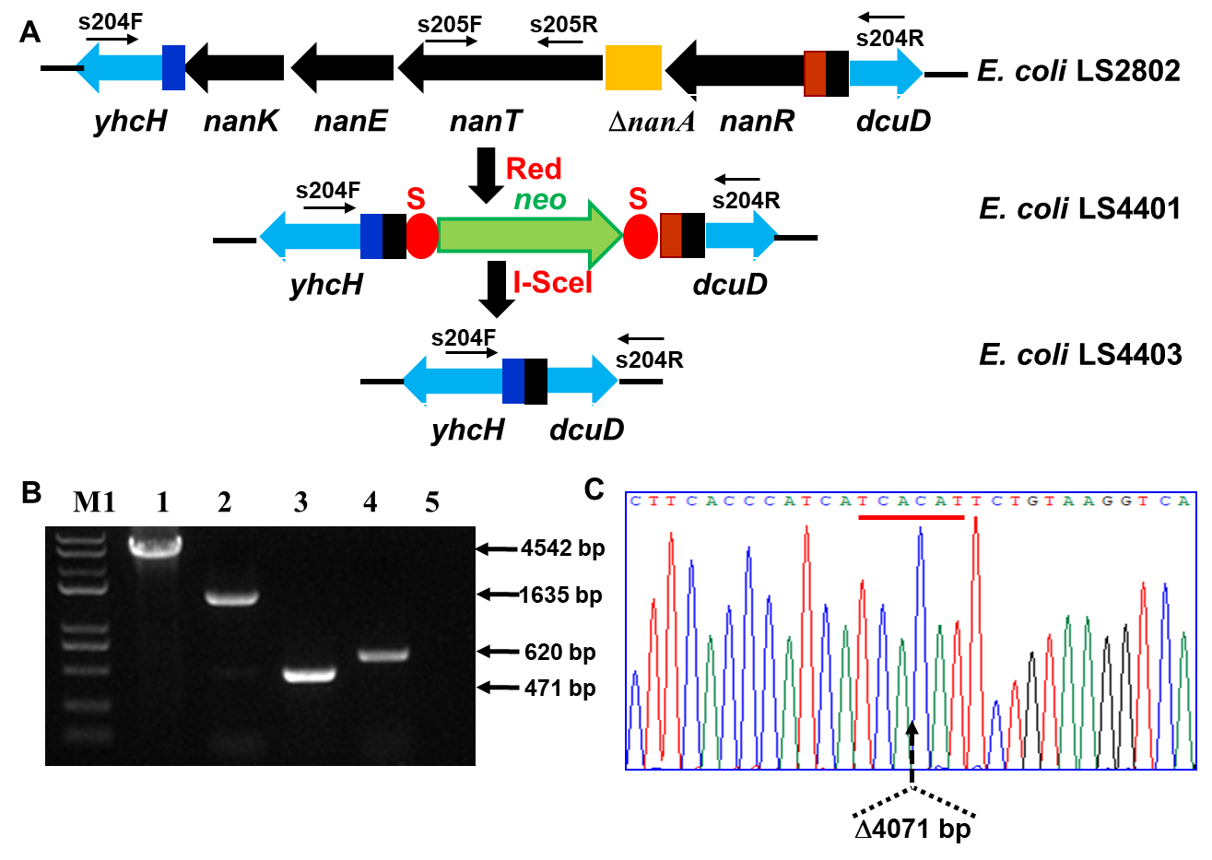

Fig. S2 Confirmation of Δnan mutant. (A) Genetic organization of nan operon with ΔnanA. (B) Genotyping of Δnan mutant. Lanes 1, 2, and 3 denote the s204F–s204R primers amplified PCR products from E. coli LS2802, E. coli LS4401 (Km^{R}), and E. coli LS4403 (Km^{S}, Δnan), respectively. Lane 4 and 5 denote the s205F–s205R primers amplified nanT region PCR products from E. coli LS2802 and E. coli LS4403 (Km^{S}, Δnan), respectively. No nanT region left in the deletion mutant E. coli LS4403. M1, Trans2K Plus DNA molecular marker (Tiangen, China) with sizes are 8.0, 5.0, 3.0, 2.0, 1.0, 0.75, 0.5, 0.25, and 0.1 kb. (C) Sequencing of Δnan mutant. Dotted lines indicate the borders of left residues with only the underlined start codon of nanK and stop codon of nanR open reading frames are left (both shown as reverse complement sequences). The deletion size of 4071 bp is indicated below
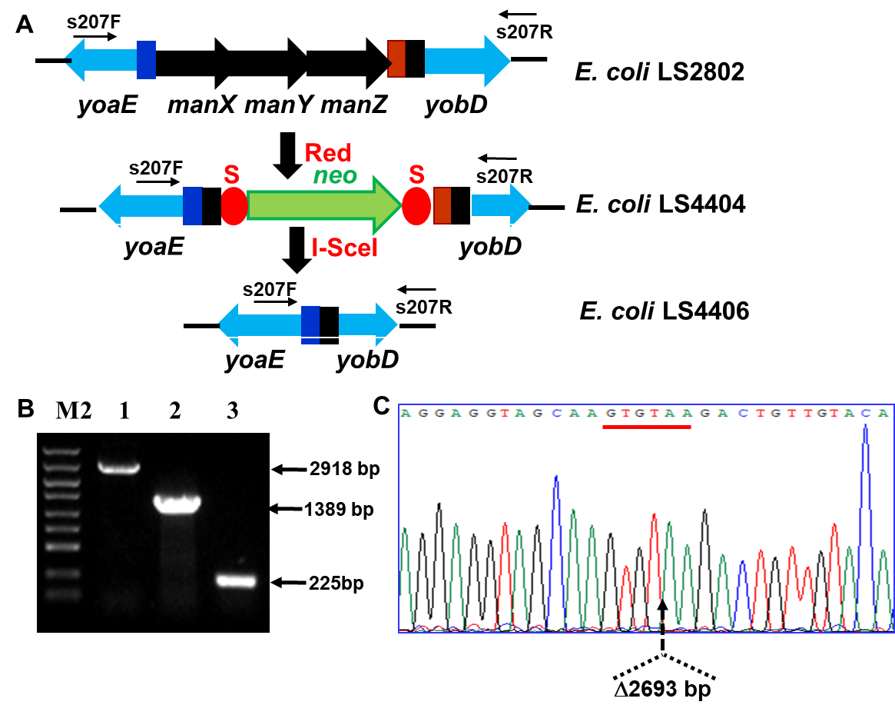

Fig. S3 Confirmation of ΔmanXYZ operon mutant. (A) Genetic organization of manXYZ operon. (B) Genotyping of ΔmanXYZ. Lanes 1, 2, and 3 denote the s205F–s205R primers amplified PCR products from E. coli LS2802, E. coli LS4404 (Km^{R}), and E. coli LS4406 (Km^{S}, Δman), respectively. M2, DL5000 DNA molecular marker (Takara) with sizes are 5.0, 3.0, 2.0, 1.5, 1.0, 0.75, 0.5, 0.25, and 0.1 kb. (C) Sequencing of ΔmanXYZ mutant. Dotted lines indicate the borders of left residues with only the underlined start codon of manX and stop codon of manZ are left. The deletion size of 2693 bp is indicated below.

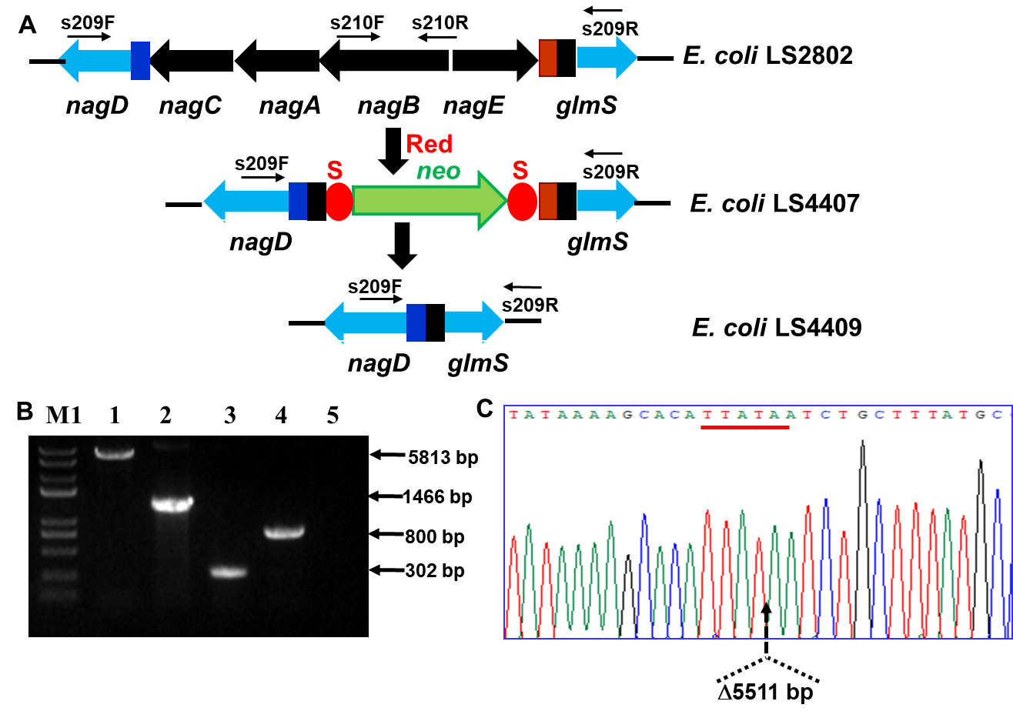

Fig. S4 Confirmation of ΔnagEABC operon mutant. (A) Genetic organization of nagEABC operon. (B) Genotyping of ΔnagEABC. Lanes 1, 2, and 3 denote the s209F–s209R primers amplified PCR products from E. coli LS2802, E. coli LS4407 (Km^{R}), and E. coli LS4409 (Km^{S}, Δnag), respectively. Lane 4 and 5 denote the s210F–s210R primers amplified nagB region PCR products from E. coli LS2802 and E. coli LS4409 (Km^{S}, Δnag), respectively. No nagB region left in the deletion mutant E. coli LS4409. M1, Trans2K Plus DNA molecular marker. (C) Sequencing of ΔnagEABC mutant. Dotted lines indicate the borders of left residues with only the underlined start codon of nagC (shown as reverse complement sequences) and stop codon of nagE are left. The deletion size of 5511 bp is indicated below

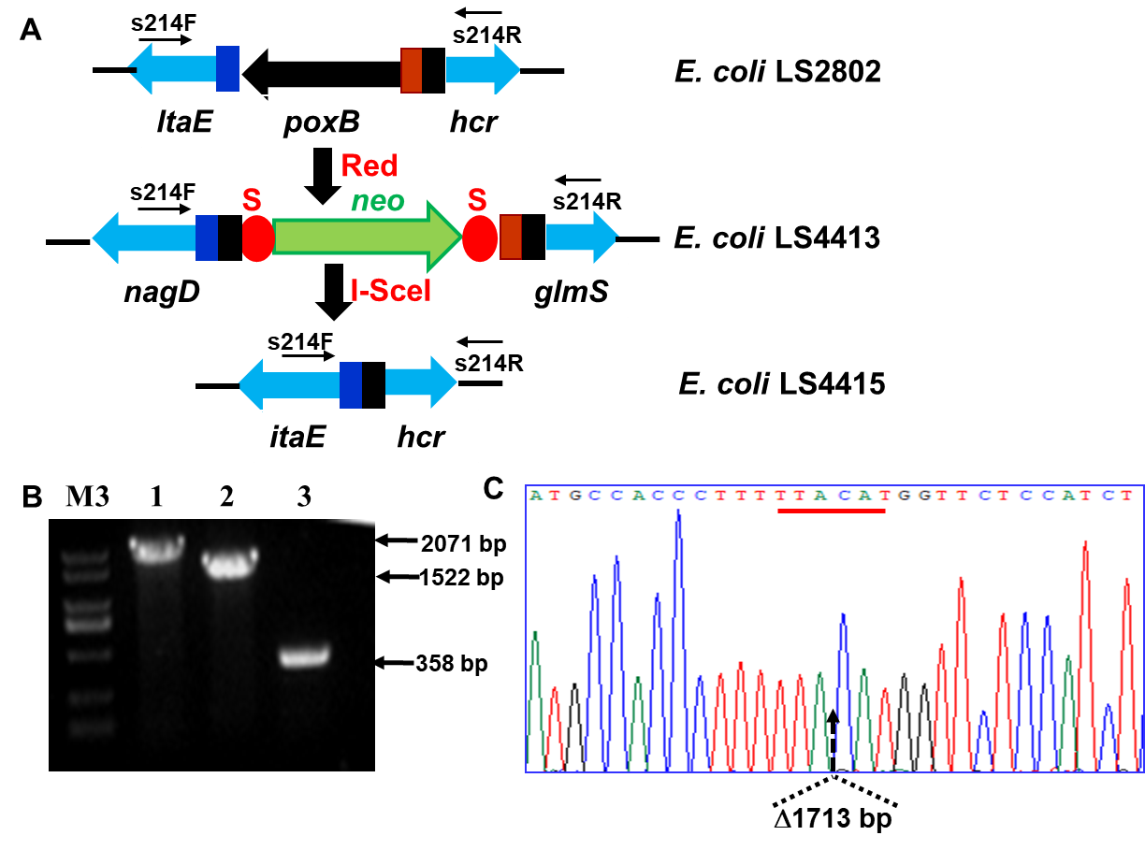

Fig. S5 Confirmation of ΔpoxB mutant. (A) Genetic organization of poxB. (B) Genotyping of ΔpoxB. Lanes 1, 2, and 3 denote the s214F–s214R primers amplified PCR products from E. coli LS2802, E. coli LS4413, and E. coli LS4415 (Km^{S}, ΔpoxB), respectively. M3. DL2000 DNA molecular marker (Takara) with sizes are 2.0, 1.5, 1.0, 0.75, 0.5, 0.25, 0.1 kb. (C) Sequencing of ΔpoxB mutant. Dotted lines indicate the borders of left residues with only the underlined start codon and stop codon are left (both shown as reverse complement sequences). The deletion size of 1713 bp is indicated below

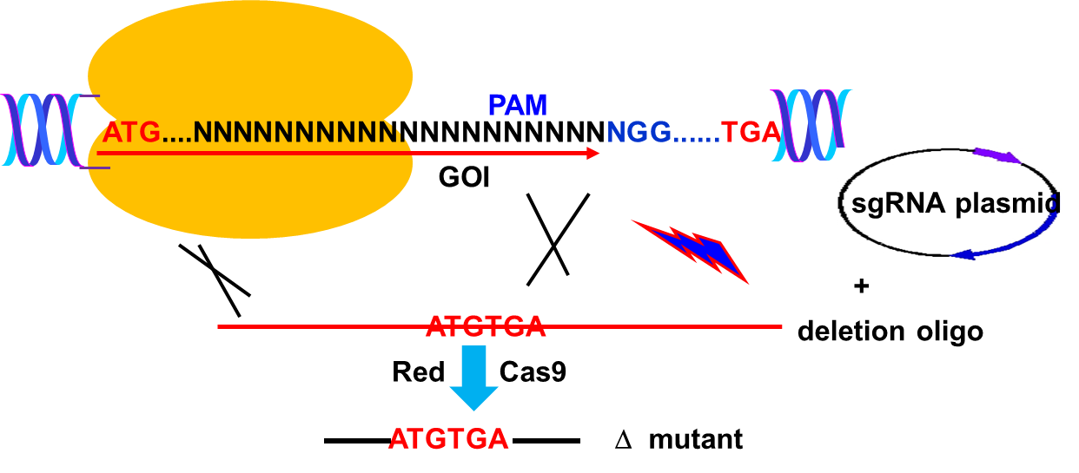

Fig. S6 Outline of the ssDNA recombineering and CRISPR/Cas9-mediated gene deletion. The sgRNA expression plasmid was pUC plasmid backbone-based, and contains chlortetracycline (cTc)-induced I-SceI gene cassette and two I-SceI cleavage sites. The deletion oligonucleotide was designed as an 88 nt oligonucleotide which consists of 44 nt upstream HA (ended as the start codon of the open reading frame of GOI, take ATG as an example herein), and 44 nt downstream HA (started as the end codon of the open reading frame of GOI, take TAG as an example herein). The first four bases of the deletion oligonucleotide were phosphorothioated to protect degradation by endonuclease. After co-electroporation of sgRNA expression plasmid and deletion oligo into the recombinase and Cas9-proficient electrocompetent cells harboring pLS3535 [4], the recombinase-catalyzed homologous recombination resulted in the GOI deletion. The recombination efficiency was normally 10^{–4}, which means that the majority DNAs were none-edited. Cas9 acts as a counterselection marker to eliminate those none-edited clones. Cas9-sgRNA complex recognizes the spacer sequence in the GOI, and cleaved at the three nucleotide upstream of the PAM (protospacer adjacent motif) sequence NGG (N denotes A/G/C/T), creating DSB, thus only the deleted mutants which the PAM containing sequences were deleted would survive. The edited clones were subsequently characterized via target region PCR and sequencing. After gene deletion, the strain harboring the p15-bakbone-based, Cm^{R}, recombinase and cas9 expression plasmid pLS3535 and Ap^{R}, sgRNA expression plasmid was transformed with a p15A backbone-based, Km^{R} plasmid pLS3550 [4]which also cloned with cTc-induced I-SceI gene cassette and two I-SceI cleavage sites. Both the sgRNA expression plasmid and pLS3550 are “self-cleavage” type plasmids. The Km^{R} Cm^{S} clone was cultured and supplemented with heat activated cTc to induce I-SceI which cleaved its recognition sites in sgRNA expression plasmid and pLS3550 and destroyed the two plasmids. The Ap^{S}Km^{S} clones obtained via duplication were the final strains cured of inside e sgRNA expression plasmid and pLS3550

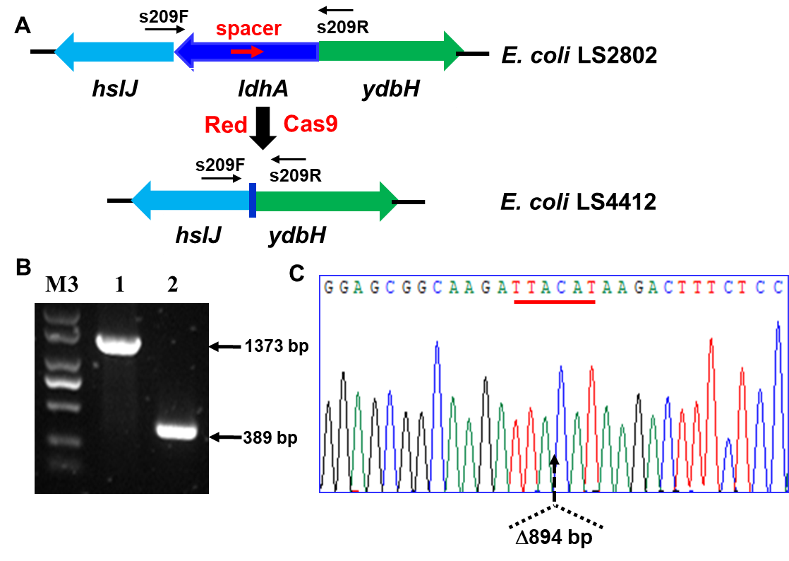

Fig. S7 Confirmation of ΔldhA mutant. (A) Genetic organization of ldhA. (B) Genotyping of ΔldhA. Lanes 1, 2, and 3 denote the s211F–s211R primers amplified PCR products from E. coli LS2802, E. coli LS4412 (ΔldhA), respectively. M3. DL2000 DNA molecular marker (Takara). (C) Sequencing of ΔldhA. Dotted lines indicate the borders of left residues with only the underlined start codon and stop codon of the ORF are left (both shown as reverse complement sequences). The deletion size of 894 bp is indicated below.

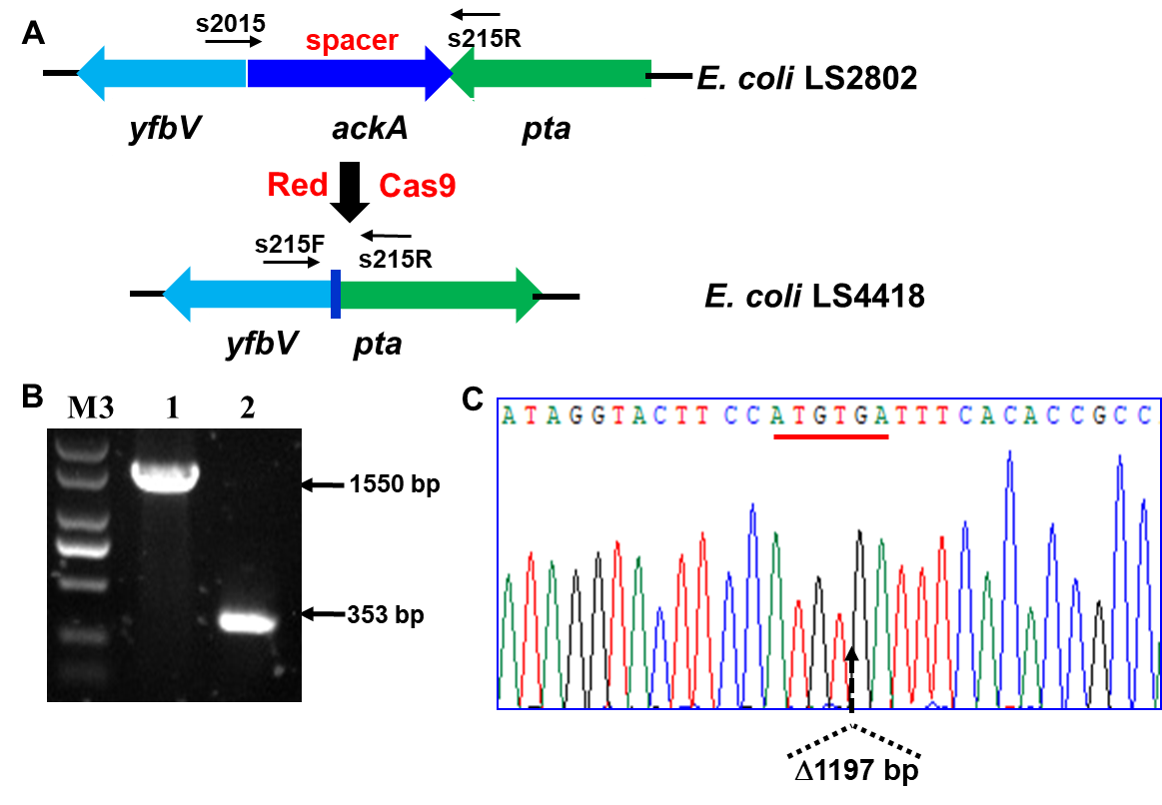

Fig. S8 Confirmation of ΔackA mutant. (A) Genetic organization of ackA. (B) Genotyping of ΔackA. Lanes 1, 2, and 3 denote the s215F–s215R primers amplified PCR products from E. coli LS2802, E. coli LS4418 (ΔackA), respectively. M3. DL2000 DNA molecular marker (Takara). (C) Sequencing of Δ ackA. Dotted lines indicate the borders of left residues with only the underlined start codon and stop codon of the ORF are left. The deletion size of 1197 bp is indicated below

References
1. Sambrook, J. & Russell, D. W. (2001). Molecular cloning: a laboratory manual, 3rd edn. Cold Spring Harbor, Cold Spring Harbor Laboratory.
2. Gao, X., Zhang, F., Wu, M., Wu, Z. & Shang, G. (2019). Production of N-acetyl-D-neuraminic acid by whole cells expressing Bacteroides thetaiotaomicron N-acetyl-D-glucosamine 2-epimerase and Escherichia coli N-acetyl-D-neuraminic acid aldolase. Journal of Agricultural and Food Chemistry, 67, 6285–6291.
3. Kuhlman, T. E. & Cox, E. C. (2010). Site-specific chromosomal integration of large synthetic constructs. Nucleic Acids Research, 38, e92.
4. Li, J., Sun, J., Gao, X., Wu, Z. & Shang, G. (2019). Coupling ssDNA recombineering
with CRISPR-Cas9 for Escherichia coli DnaG mutations. Applied Microbiology and Biotechnology, 103, 3559–3570.

