COM-0120-19
GynTools GyniTM system performance comparison
for the diagnosis of vaginitis

Authorization
 | Name | Signature | Date
Issued by: | Ahinoam Lev-Sagie, MD |  | 22-Aug-2021

Revision History
Rev # | Description | Date
3.0 | Protocol updates (colored in yellow. Page numbers refer to updated protocol)  - The protocol was translated to English  - The following sections were added: Synopsis, Safety, protocol acknowledgment /confidentiality, Statement of compliance  - a. Page 7: Seven possible conditions have been replaced to 6. Addition of the option to diagnose mixed conditions.  - b. Page 8: The three types of results will be provided to a third party for comparison of results (instead of Dr. Ben Chetrit), the sample will be up to 200 instead of 200.  - c. Pages 9,10: The sample size will be up to 200 patients.  - d. Page 12: The PI's responsibility of comparing the results of the study was deleted.  - The title of the system components was added  - Page 13: The cartridge image was updated | 13-Apr-2020
4.0 | - Gyntools Ltd. Address updated in pages: 2,4,6, and 8  - Intended enrollment was expanded to include up to 400 participants, updated in pages : 5, 6, 9 and 10  - The protocol reflects additional investigators, specializing in vulvovaginal disorders, updated in pages: 5, 8, 9 and 12  - Updated Figure 3 image  - Updated technical appendix description in pages 12, 13 and 14  - Omission of “PCR” in pages 8 and 10 | 14-Jun-2021
5 | - Change in # of sites  - Addition of Cytolytic Vaginosis  - Addition of PCR | 22-Aug-2021

PROTOCOL ACKNOWLEDGMENT / CONFIDENTIALITY
I confirm that I have read this protocol and its appendices and agree to adhere to the requirements.

I will assure that the protocol and all the relevant information regarding the device, relating to pre-clinical and prior clinical experience provided by the Sponsor, GynTools Ltd., will be available to the participating site personnel under my supervision.

I will discuss this material with them to assure that they are fully informed regarding the study device and the conduct of the study.
I will conduct the study in accordance and with compliance to this protocol, the ICH-GCP [1] guidelines and the local regulation requirements. I would also accept respective revisions of this protocol, approved by authorized sponsor personnel and by the regulatory authorities.
This document contains information that is privileged or confidential. As such, it may not be disclosed, copied or shared without prior permission granted in writing by GynTools Ltd. or if such disclosure is required by federal or other laws or regulations. To whom any of this information is to be disclosed must first be informed that the information is confidential and agree to sign a confidentially agreement. These restrictions on disclosure will apply equally to all future information supplied, which is indicated as privileged or confidential.
PRINCIPAL INVESTIGATOR | Name: _____________________________  Signature: ___________________________  Date: _______________________________

Statement of compliance
The trial will be conducted in compliance with the approved protocol, Declaration of Helsinki, ICH GCP and local applicable regulatory requirements.
The clinical trial will not be initiated before all the required approvals or favorable opinions from the EC/IRB have been obtained, including any local or national regulatory authority approvals or notifications applicable.
The Sponsor has obtained clinical trial insurance that will cover expenses in the event of any physical or injury resulting from research product and procedures.

Synopsis

Study Title: | A pilot study of Gyntools Gyni image system performance comparison for the diagnosis of vaginitis
Protocol Number: | CL00000-05
Device Name: | Gyni^{TM.} system
Indication: | Diagnosis of vaginitis
Background: | About a third of the women referring to gynecological clinics present with vulvovaginal inflammation symptoms (vaginitis) possibly caused by a candida yeast infection, bacterial vaginosis, purulent vaginitis or trichomoniasis.  There is limited ability to correctly identify the specific cause for vaginitis due to similarity of symptoms and signs on one hand and lack of an effective and rapid diagnostic equipment on the other hand.  GynTools Gyni^{TM is} an automated in vitro diagnostic system intended for the qualitative direct detection of one or more of the following vaginitis pathogens/conditions at the point of care: Bacterial Vaginosis, Candida albicans vaginitis, Candida non-albicans vaginitis, Trichomoniasis, Atrophic Vaginitis (Atrophy), Cytolytic vaginosis and Desquamative Inflammatory Vaginitis (DIV). The system will provide a non-expert physician with the means to obtain an accurate, fast and inexpensive diagnosis which is unavailable today.
No. of Subjects: | Up to 400 female patients
No. of sites: | Up to 4 sites in Israel
Study Objectives: | The evaluation of the diagnostic ability of the GyniTM system to identify various vulvovaginal inflammations in comparison to microscopy-based clinic diagnosis as well as to lab test results.
Study Endpoint: | The trial endpoint is the rate of the accurate diagnoses of the different conditions: BV/Candida albicans/Candida non albicans/Atrophy/Cytolytic vaginosis/DIV/Trichomonas/Normal discharge) by the Gyni™ system compared to the following gold Standard of Care (SOC)
Study Design: | A Pilot study for the evaluation of the Gyni™ system diagnostic performance in comparison to microscopic based clinic diagnosis as well as to lab test results. The study will include a single visit in which in addition to the standard diagnosis procedure, a vaginal discharge sample will be obtained for the Gyni™ diagnostic scan.  The diagnoses provided by Gyni™ will be disclosed to an external sponsor designee which will perform the results comparison after the collection of samples from up to 400 patients to prevent any results bias and to maintain blinding. Trial time frame has been estimated as of up to 1 year from conduct approval.
Eligibility Criteria: | Inclusion Criteria:  1. Women with vaginal complaints: Discharge, malodor, itch, burn, pain or dryness.  2. 18 years old and above.  Exclusion Criteria:  1. Patients under the age of 18 years  2. Patient is unfit to provide an informed consent  3. Uninterpretable sample (e.g. patients who used vaginal creams or lubricants before the visit or insufficient sampling material.).
Study Sponsor: | GynTools Ltd,  Hartum 19  Jerusalem 9777518

Background and scientific rationale for the trial
About one third of the women referring to gynecological clinics present with vulvovaginal inflammation symptoms (vaginitis) possibly caused by a candida yeast infection, bacterial vaginosis, purulent vaginitis or trichomoniasis.
There is a limited ability to correctly identify the specific cause for vaginitis due to similarity of symptoms and signs on one hand and lack of an effective and rapid diagnostic equipment on the other hand. The typical vaginitis symptoms are abnormal vaginal discharge, odor, vulvovaginal itch, burning, irritation pain or dryness and according to those, it is difficult and sometimes impossible to accurately diagnose the specific cause for the inflammation.
Accurate visual identification of related causes can be done via a bright field microscope, except for in expert clinics, is in fact not performed due to lack of training and equipment. Alternatively, it is possible to use lab tests which only provides results after several days or use other highly expensive equipment. As a result, in many cases using an “educated guess” leads to misdiagnosis of vaginitis, redundant and wrong medication treatment, repeated clinic visits, lack of curative treatment and unwanted expenses.
GynTools Ltd is an Israeli company developing a rapid and accurate point of care diagnostic device for the detection of one of seven different possible causes for vaginitis and mixed conditions, each requiring a different treatment.
The system called Gyni™. is comprised of the following components (please see figure 4- Technical appendix) :
- A patent pending sample collection cartridge, which includes a cytobrush and a transparent optical cartridge (see figure.1)
- A tabletop scanner into which the cartridge is inserted. The scanner performs optical detection, and pH level measurement. (please see figures 2 and 3)
- Web application providing a user interface, where the user enters related clinical information
- A cloud-based algorithm which analyses the data arriving from the scanner and the web application, and returns a result to the physician within minutes, with an expected accuracy of 90% or more, in order to allow correct treatment prescription. The algorithm imitates the reasoning of a vulvovaginal expert by using machine learning technology.
The Gyni™ system will provide a non-expert physician with the means to obtain an accurate, fast and inexpensive diagnosis which is unavailable today.

Trial Objective
The clinical trial objective is to evaluate the diagnostic ability of the Gyni™ system to identify various vulvovaginal inflammations in comparison to microscopy-based clinic diagnosis as well as to lab test results.

The Investigational Device
Device Name: Gyni™
Device Purpose: Automated diagnostic system intended for the identification of one or more of the following vaginitis pathogens/conditions at the point of care.
Device Description: Automated in vitro diagnostic system intended for the qualitative direct detection of one or more of the following vaginitis pathogens/conditions at the point of care: Bacterial Vaginosis, Candida albicans vaginitis, Candida non-albicans vaginitis, Trichomoniasis, Atrophic Vaginitis, Cytolytic vaginosis and Desquamative Inflammatory Vaginitis (DIV). The system uses vaginal swab specimens, obtained by a primary care practitioner from a symptomatic woman, for the automated preparation and evaluation of designated microscopic slides within its proprietary smart sampler.
The device is intended for use by primary care practitioners, in physician’s offices, clinics, hospital outpatient clinics and urgent care centers as an aid in the diagnosis of the above-listed pathogens/conditions in women with clinical presentations consistent with vaginitis, in conjunction with other clinical and laboratory findings.
The Gyni™ system is comprised of the following five components: 1) Cytobrush for vaginal discharge collection 2) Sampling Cartridge with internal dilution compartments 3) Tabletop scanner 4) Web application user interface 5) Deep learning algorithm running in the cloud.
Materials in physical contact with patient’s body: The soft tip of a nylon cytobrush, identical to that used in Israeli HMOs up to recently for PAP tests.
Manufacture Details
Manufacturer details: GynTools Ltd, Hartum 19 Jerusalem 9777518, ISRAEL
BN number- 515507945
- Device version # 1.0
- Program version # 1.0
Trial Endpoint
The trial endpoint is the rate of the accurate diagnoses of the different conditions: BV/Candida albicans/Candida non albicans/Atrophy/Cytolytic vaginosis/DIV/ Trichomonas/Normal discharge and mixed conditions) by the Gyni™ system compared to the following gold Standard of Care (SOC) :
- Compare Gyni™ diagnosis with microscopy-based physician diagnosis
- Compare the physician diagnosis to Lab results (Vaginal culture and PCR)
- Compare the Gyni™ diagnosis with the Lab results
The following indicators will then be calculated: Sensitivity, Specificity, Positive predictive value and Negative predictive value.

Methods and trial description
The trial will take place at the clinic of Dr. Ahinoam Lev-Sagie in the Women’s health center of Clalit HMO, in Ramat Eshkol, Jerusalem and in up to 3 additional specializing vulvovaginal clinics.
During clinic visits, symptomatic patients with vulvovaginal complaints will be asked to participate in the trial. After signing an informed consent form, they will undergo a gynecologic speculum exam, as part of the standard of care in the clinic. During this routine standard clinical diagnostic process, discharge samples are taken for wet mount microscopy and pH tests together with sample for vaginal yeast culture and STD panel lab tests. Those are taken by a delicate touch of a soft swab against the vaginal wall. During the clinic visit an additional discharge sample will be taken using the Gyni™ soft cytobrush in order to be scanned by the device. The cytobrush will be pulled through the cartridge which will be inserted and scanned by the dedicated tabletop scanner. The device suggested diagnosis will only be saved in the cloud and will not be available to the physician in order to prevent bias.
Each patient will be diagnosed by the physician and will be treated according to the physician’s recommendation.
Lab tests will not be performed specifically for the trial but only as part of the standard clinical diagnostic process.
The three types of results (the physician, by the Gyni™ device and Lab results) will be collected and summarized by an external sponsor designee after all the samples are collected in order to prevent any kind of results bias and to maintain the blinding of both PI and SI.
The participating patients will be coded numerically using their identifying Gyni™ test number generated by the app. GynTools results numbering will be based on this code as well. Patient's details together with her trial test code will be kept in a sealed envelope in the trial folder, available to investigators only in order to record lab results. Upon receiving lab results those will be recorded only by the patient's code without any identifying details such as name or ID.

Population- inclusion and exclusion criteria
We intend to recruit up to 400 patients. The trial will only include Clalit HMO insured patients. All samples will be collected in each of the clinics by the vulvovaginal specialist.
Inclusion criteria:
- Women with vaginal complaints: Discharge, malodor, itch, burn, pain or dryness.
- 18 years old and above.
Exclusion criteria:
1. Patients under the age of 18 years
2. Patient is unfit to provide an informed consent
3. Uninterpretable sample (e.g. patients who used vaginal creams or lubricants before the visit or insufficient sampling material.).

Patients Recruitment
Women with typical complaints of vaginal inflammation examined in the Vulvovaginal disease clinic as part of regular standard of care will be asked to participate in the trial and will be informed regarding the trial procedures, including the need to obtain an additional sample for trial purposes. The study will use vaginal discharge samples that are taken as part of the microscopic examination in the clinic and vaginal cultures, all of which are done as part of the routine diagnostic process in the clinic. In addition, another smear will be used for immediate use in the GynTools system.
Patients will receive an explanation about the study and will be asked to sign an informed consent form prior to the gynecological examination and sampling.
The laboratory tests performed are a part of the routine test and not for trial purposes.
Trial timeframe
One year to complete recruiting up to 400 patients, from obtaining ethics committee approval.
Biological samples
Biologic samples will not be kept during the clinic visits, both Gyni™ cytobrush and cartridge will be disposed immediately after being used.

Laboratory Tests
Information on vaginal culture results and PCR lab test results performed as part of routine clinical examination will be collected and used . No further tests will be done for study purposes. The laboratory tests performed are pH measurement and microscopic examination of the vaginal discharge during the visit and as part of the routine examination.

Safety evaluation
Information regarding patients’ safety would be collected and reported by the investigator as follows:
1. The investigator will document and report in Adverse/Serious Adverse Device (ADE/SADE) Effects or Device Deficiency (D) events only when such will be evaluated as related to study device or during study visit. Device deficiency (DD) events. Events details should be documented in CRF. Post visit safety follow up will not be performed.
2. In case of SADE, the investigator should also report to sponsor’s monitor by phone/email regarding the event within 24h since awareness date.
3. In case of an Unanticipated Serious Adverse Device Effect (USADE), sponsor will inform the participating sites within a week and a semiannual report of these events would be submitted to local EC.
The safety events are defined as follows:
1. Adverse Device Effect (ADE): an adverse event related to the use of an investigational medical device. - This includes any adverse event resulting from insufficiencies or inadequacies in the instructions for use, the deployment, the implantation, the installation, the operation, or any malfunction of the investigational medical device - This includes any event that is a result of a use error or intentional misuse.
Severity of ADE
Mild: Minor discomfort noticed but does not interfere with normal daily activity
Moderate: Discomfort reducing or affecting normal daily activity
Severe: Incapacitating with inability to work or perform normal daily activity
2. Serious Device Adverse Effect (SADE): an adverse device effect that has resulted in any of the consequences characteristic of a serious adverse event that:
• Led to death
• Resulted in a life-threatening illness or injury, or - resulted in a permanent impairment of a body structure or a body function
- Required in-patient hospitalization or prolongation of existing hospitalization, or - resulted required in medical or surgical intervention to prevent life threatening illness or injury or permanent impairment to a body structure or a body function
- Led to fetal distress, fetal death or a congenital abnormality or birth defect.
3. Unanticipated Serious Adverse Device Effect (USADE): Inadequacy of a medical device related to its identity, quality, durability, reliability, safety or performance, such as malfunction, misuse or use error and inadequate labeling.
4. Device Deficiency (DD): Inadequacy of a medical device related to its identity, quality, durability, reliability, safety or performance, such as malfunction, misuse or use error and inadequate labeling.

Risk assessment
In the proposed trial, there are no foreseeable risks to the participating patients but the slight discomfort as part of the sample collection procedure performed as part of clinic’s SOC. GyniTM system cytobrush was manufactured identically to the one used in Israeli HMOs up to recently for PAP tests, underwent biocompatibility testing and complies with ISO10993 as described in the investigator brochure (IB).

Information security
During the trial, the information collected will include: symptoms, examination findings, patient age, ethnicity, pH level, microscopic based diagnosis, and lab tests. The data will be captured in the trial’s Case Report Form (CRF).
Patient's name or other identifying details will not be captured in the CRF. Study log containing the participants' codes and identifying details will be filled in the investigator's site file. This record will be kept in an envelope in the study folder placed in a locked cabinet in the participating investigators clinics.

Analysis and information processing
The study is a preliminary study aimed at comparing the diagnostic accuracy of the device with a lab gold standard as well as a microscopy based diagnosis by a vulvovaginal disorders expert physician. For this purpose the following parameters will be calculated: sensitivity, specificity, positive predictive value and negative predictive value. A sample size calculation will follow.

Ethical considerations
This is an observational study and as such it will not change the current standard of care. The study involves taking an additional discharge sample which may add a minor discomfort to the patient.
We do not intend to collect any additional patient’s details except for their symptoms, diagnosis by the physician and lab results. Collected samples will be disposed immediately after being used. Patients will receive an explanation about the study and only upon expressing their agreement to volunteer, will fill in and sign an informed consent form. An additional sample will not be collected in case the patient did not voluntarily agreed to participate.

Product components

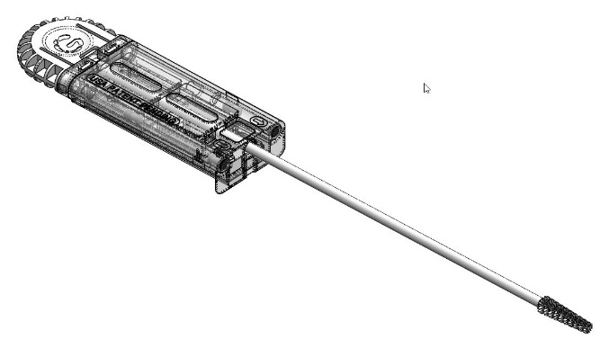
Figure 1a: Patent pending sample collection kit, including a cytobrush and sampling cartridge

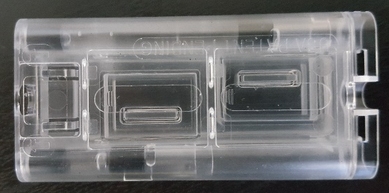
Figure 1b: The cartridge providing an optical surface

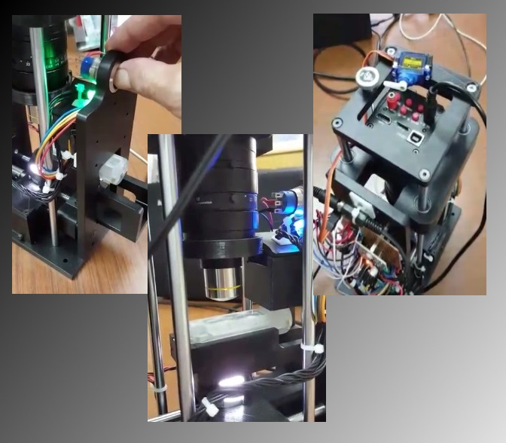
Figure 2: First prototype of tabletop scanner that loads and scans the cartridge

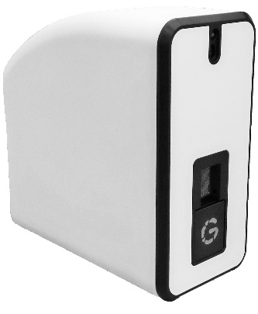
Figure 3: Planned model of tabletop scanner

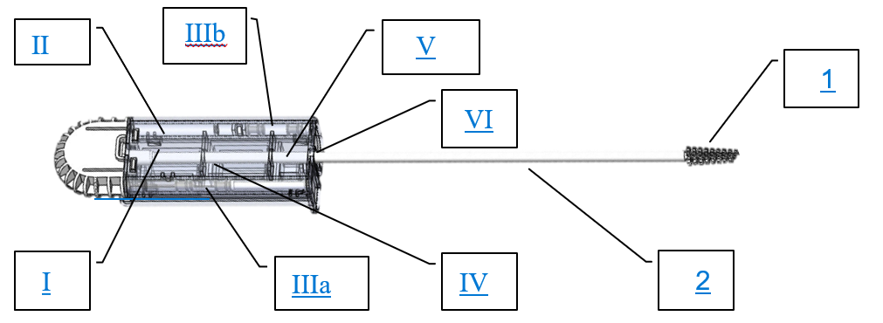
Figure 4:
Technical appendix
Plastic cartridge consisting of
    - A “floating” transparent optical tray,
    - A transparent cover,
    - Two diluent containers, each sealed by a silicone seal on one side and a miniature value with a spray nozzle on the other side.
      - One with 0.9% saline (0.25 ml)
      - The other with KOH (Potassium hydroxide) 10% (0.1 ml),
    - Inner- autofocus marked-targets,
    - A pre-assembled litmus paper for determination of pH value and;
    - A removable L-shaped protection foil

