Decellularization of kidney tissue: Comparison of sodium lauryl ether sulfate and sodium dodecyl sulfate for allotransplantation in rat

Mohammad Amin Keshvari^{1,*}, Alireza Afshar^{1,2*}, Sajad Daneshi^{3,*}, Arezoo Khoradmehr^{1,*}, Mandana Baghban^{4,*}, Mahdi Muhaddesi^{1,2}, Pouya Behrouzi^{1,2}, Mohammad Reza Miri¹, Hossein Azari¹, Iraj Nabipour¹, Reza Shirazi⁵, Mehdi Mahmudpour^{6,†}, Amin Tamadon^{1,†}

1- The Persian Gulf Marine Biotechnology Research Center, The Persian Gulf Biomedical Sciences Research Institute, Bushehr University of Medical Sciences, Bushehr, Iran
2- Percia Vista Biotechnology Company, Bushehr, Iran
3- Department of Anatomical Sciences, Shiraz University of Medical Sciences, Shiraz, Iran
4- Department of Obstetrics and Gynecology, School of Medicine, Shiraz University of Medical Sciences, Shiraz, Iran
5- Department of Anatomy, School of Medical Sciences, Medicine, UNSW Sydney, Sydney, Australia
6- The Persian Gulf Tropical Medicine Research Center, The Persian Gulf Biomedical Sciences Research Institute, Bushehr University of Medical Sciences, Bushehr, Iran

* These authors have same contributions to this work as the first authors.

† Corresponding authors:
Amin Tamadon, DVM, PhD; The Persian Gulf Marine Biotechnology Research Center, The Persian Gulf Biomedical Sciences Research Institute, Bushehr University of Medical Sciences, Bushehr, Iran; Postal Code: 7514633196; Tel/fax: +98-77-3332-8724; Email: amintamaddon@yahoo.com
Mehdi Mahmudpour, MD; The Persian Gulf Tropical Medicine Research Center, The Persian Gulf Biomedical Sciences Research Institute, Bushehr University of Medical Sciences, Bushehr, Iran; Postal Code: 7514633196; Tel/fax: +98-77-3332-8724; Email: mehdimpr@gmail.com

Supplementary Table

Table S1.
The 3D printing parameter of sectioning matrix in the Simplify3D software
Parameter name | Value
Infill percentage | 20%
Nozzle diameter | 0.40mm
Include raft | No
Generate support | No
Extruder temperature | 190 °C
Heated build platform temperature | Not used (N/A)
Default printing speed | 1080 mm/min
X/Y axis movement speed | 1440 mm/min
Z axis movement speed | 300 mm/min
Retraction speed | 540 mm/min

Supplementary Figures

Figure S1.
Preview of the sectioning matrix 3D reconstruction in Simplify3D

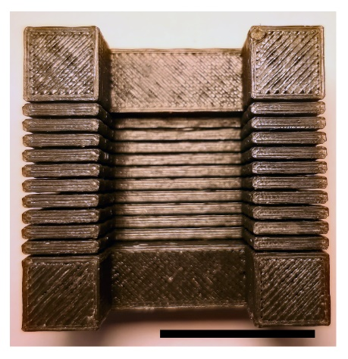

Figure S2.
The 3D printed of sectioning matrix printed by fused deposition modeling (FDM) 3D printer. Scale bar: 2 cm

