SUPPLEMENTAL MATERIAL

Material and Methods

Evaluation of the bioluminescence kinetics of hIDPSC transfected with Luciferase

To determine the BLI character of the cells as a function of time, BLM kinetics were performed in the Luc-hIDPSC after the application of D-luciferin at different concentrations of cells per well. The sensitivity of this technique as a function of the number of cells was determined by the maximum intensity of BLM at each of the concentrations. The expression of the BLI signal in Luc-hIDPSC was evaluated at the following cell/well concentrations in 24-well plates: 5x10⁴, 1x10⁵, and 5x10⁵ cells. The BLM signal was obtained after adding 10 μL of D-luciferin (30 mg/ml) (XenoLight, PerkinElmer) to each well. The parameters for image acquisition were: exposure time of 2ms, binning of 2, and f/stop of 4. The kinetics were analyzed in a total time of 480 minutes using the Living Image software version 4.3.1 (IVIS Imaging System) in an absolute amount of radiation (photons/s). After adding D-luciferin to the Luc-hIDPSC it was possible to confirm the presence of the BLI signal in these cells relative to the non-transfected cells (Supplementary figure 1). Furthermore, 5 minutes after adding D-luciferin to Luc-hIDPSC with a value of 2.25x10⁸ photons/s for a cell concentration of 5x10⁴, suitable intensity for in vivo studies, the maximum signal of BLI was found (Supplementary figure 1).

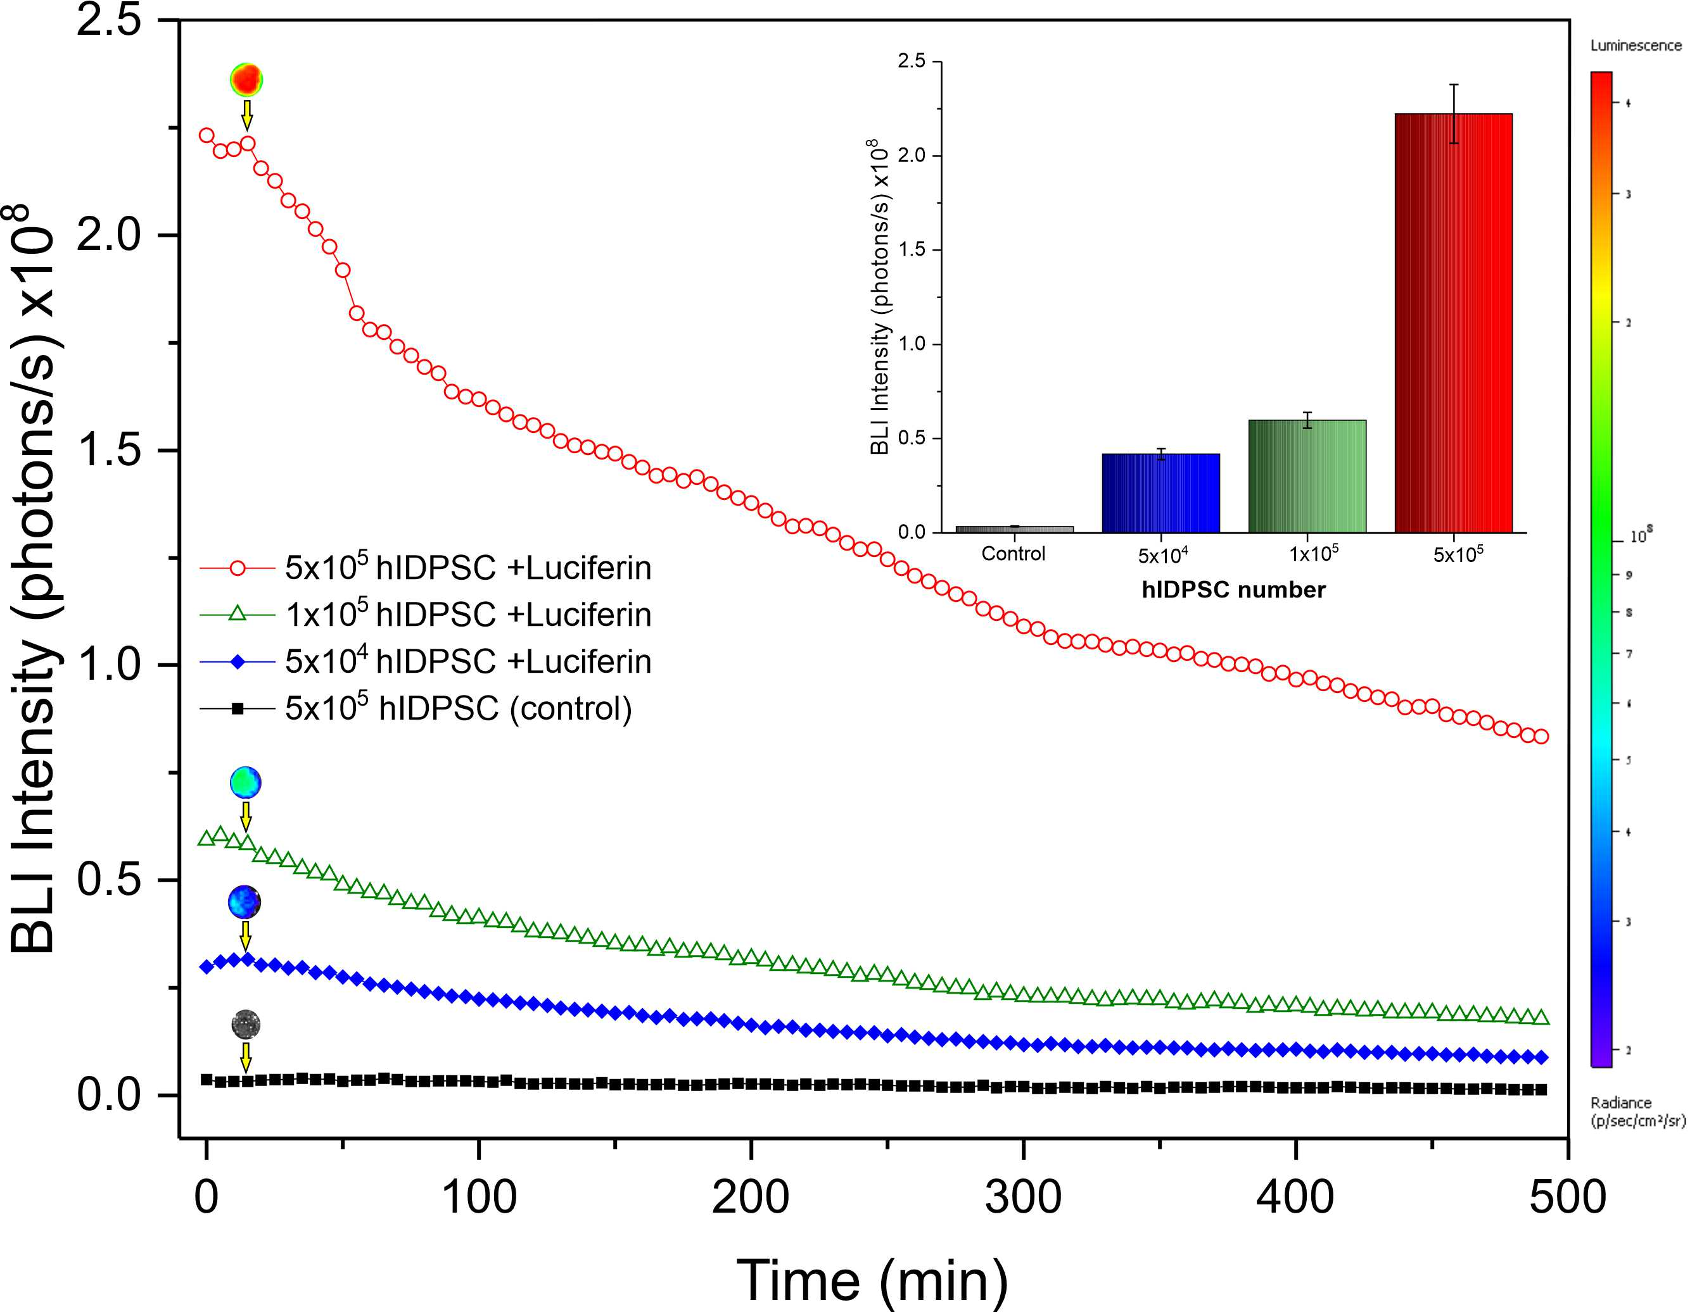
Supplementary figure 1. Expression of the BLM signal as a function of the number of Luc-hIDPSC over 480 minutes, thus indicating peak intensity 5 minutes after D- luciferin administration. Inset Quantification of peak BLM signal intensities in chest at Luc-hIDPSC concentrations of 5x10⁴, 1x10⁵, and 5x10⁵ detected 5 minutes after D- luciferin administration.

The dispersion of the BLM signal in the chest over time shown in the Box plot (Supplementary figure 1, Inset) confirms what was presented in Supplementary table 1. It is noted that the G6 group (not induced with 3-NPA) showed greater signal variability of BLM over time compared to the G4 group (induced with 3-NPA). It was noted that the head BLM signal was smaller than the chest BLM signal in the order of 10x (Supplementary table 2). In the evaluation of the repeated measures ANOVA test, it was observed that there was no significant difference for the time factor (p=0.791), group factor (p=0.592) and in the group/time interaction (p=0.713).

Supplementary table 1 Repeated measures ANOVA test of temporal analysis (4, 24h and 30 days) of groups G4 (with 3-NPA induction) and G6 (without 3-NPA induction) in the evaluation of the chest BLI signal
Intra-group effect
 | sum of squares | DF* | Means of squares | F* | P
Time | 6.154E11 | 2 | 3.077E11 | 0.727 | 0.492
Time ✻ Groups | 9.261E10 | 2 | 4.631E10 | 0.109 | 0.897
Residue | 1.185E13 | 28 | 4.232E11
Intra-group effect
Groups | 2.342E12 | 1 | 2.342E12 | 2.264 | 0.155
Residue | 1.448E13 | 14 | 1.034E12
*DF: degrees of freedom; F: F-Test

Supplementary table 2. ANOVA of repeated measures of the temporal evolution (4, 24h and 30 days) of groups G4 (with 3-NPA) and G6 (without 3-NPA) in the evaluation of the BLM signal of the animals' heads
Intra-group effect
 | Sum of squares | DF* | Means of squares | F* | p
Time | 1.674E10 | 2 | 8.370E9 | 0.236 | 0.791
Time ✻ Groups | 2.428E10 | 2 | 1.214E10 | 0.343 | 0.713
Residue | 9.918E11 | 28 | 3.542E10
Intra-group effect
Groups | 5.238E10 | 1 | 5.238E10 | 0.301 | 0.592
Residue | 2.436E12 | 14 | 1.740E11
*DF: degrees of freedom; F: F-Test

Evaluation of the internalization of nanoparticles in MNP-hIDPSC

After labeling the hIDPSC with MNP and staining with Prussian Blue, the internalization of the MNP was verified with bright field microscopy. MNP-hIDPSC showed blue/green colors around the nucleus (Supplementary figure 2).

Supplementary figure 2. Brightfield microscopy of MNP-hIDPSC (NP750) (A). Blue staining shows the presence of NP750 at various magnifications: A (20x), B (10x), C (40x). (D) The fluorescent labeling of cell nuclei by DAPI (4',6-diamidino-2-phenylindole); 40 µg Fe/mL were used for labeling (40x).

Evaluation of the viability of hIDPSC labeled with MNP: MTT and Bioluminescence

The evaluation of the viability of MNP-hIDPSC was performed with MTT and BLM assays. In the MTT assay, hIDPSC were grown in 96-well plates until subconfluent and MNPs were added to the cells at defined concentrations of 30, 40, and 50 μg Fe/mL, followed by overnight incubation. After incubation, the culture medium was discarded and 100 μL of fresh medium per well was added to the cells, after thorough washing with PBS. Then, 100 μL of MTT reagent (1 mg/mL - final concentration) was added per well and the plate was incubated for four hours at 37°C in 5% CO2. Actinomycin D (Sigma-Aldrich) was used as a positive control for cell death in this assay.
The concentration of "cell death dose" identified in this assay was 0.25 µg/mL. After incubation, the medium was discarded from the wells and 100 µL of dimethylsulfoxide (DMSO Hybri-Max - Sigma-Aldrich) was added to solubilize the crystals that formed. Readings were then performed with a DTX 880 Multimode Detector reader (Beckman Coulter) at 490 nm, with subtraction for plate absorbance at 650 nm. The percentage of cell viability was calculated as the ratio of the average absorbance of triplicate readings to the average absorbance of control wells, as cell viability = (sample/control) × 100.
The viability tests were also verified by the BLM technique. Samples similar to those used in the MTT assays were used for the BLM assay, adding 100 mL of D-luciferin to each well and acquiring the BLM images with the IVIS®Lumina LT Series III instrument. For BLM intensity analysis (photons/s), a region of interest (ROI) of 2.5 cm2 was selected. The percentage of viability was calculated using the formula (sample/control) × 100.
Cell viability affected by NPM labeling was determined by the MTT and BLM assay. Figure SM3 shows 99% (30 µg Fe/mL), 98.3% (40 µg Fe/mL) and 97.7% (50 µg Fe/mL) viability compared to the control. Similar values ​​are presented by the BLM technique, indicating viability of 98.6% (30 µg Fe/mL), 98% (40 µg Fe/mL) and 97.6% (50 µg Fe/mL) in relation to the control (Supplementary figure 3). Thus, we can say that the presence of NPM did not interfere with cell viability and for the in vivo study, the labeling of CTIPDh with a concentration of 40 µg NPM/mL was used, showing a viability of 98%.

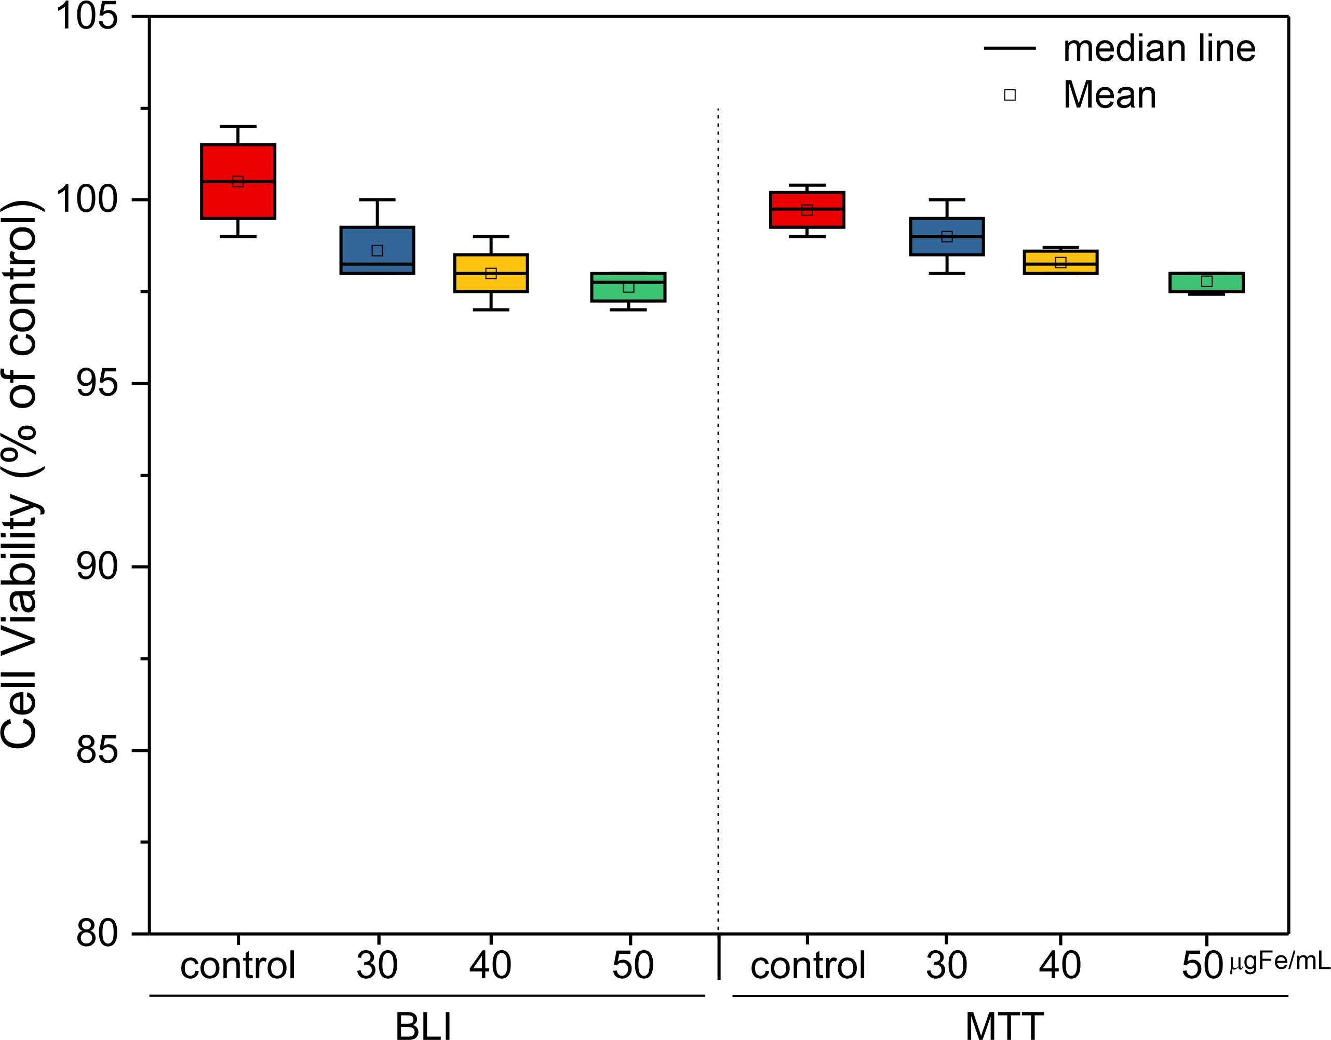
Supplementary figure 3. Evaluation of cell viability by BLM and MTT techniques, after 48 hours of labeling the hIDPSC with MNP at concentrations of 30, 40 and 50 µg Fe/mL.

Quantification of iron load using the ICP-MS technique

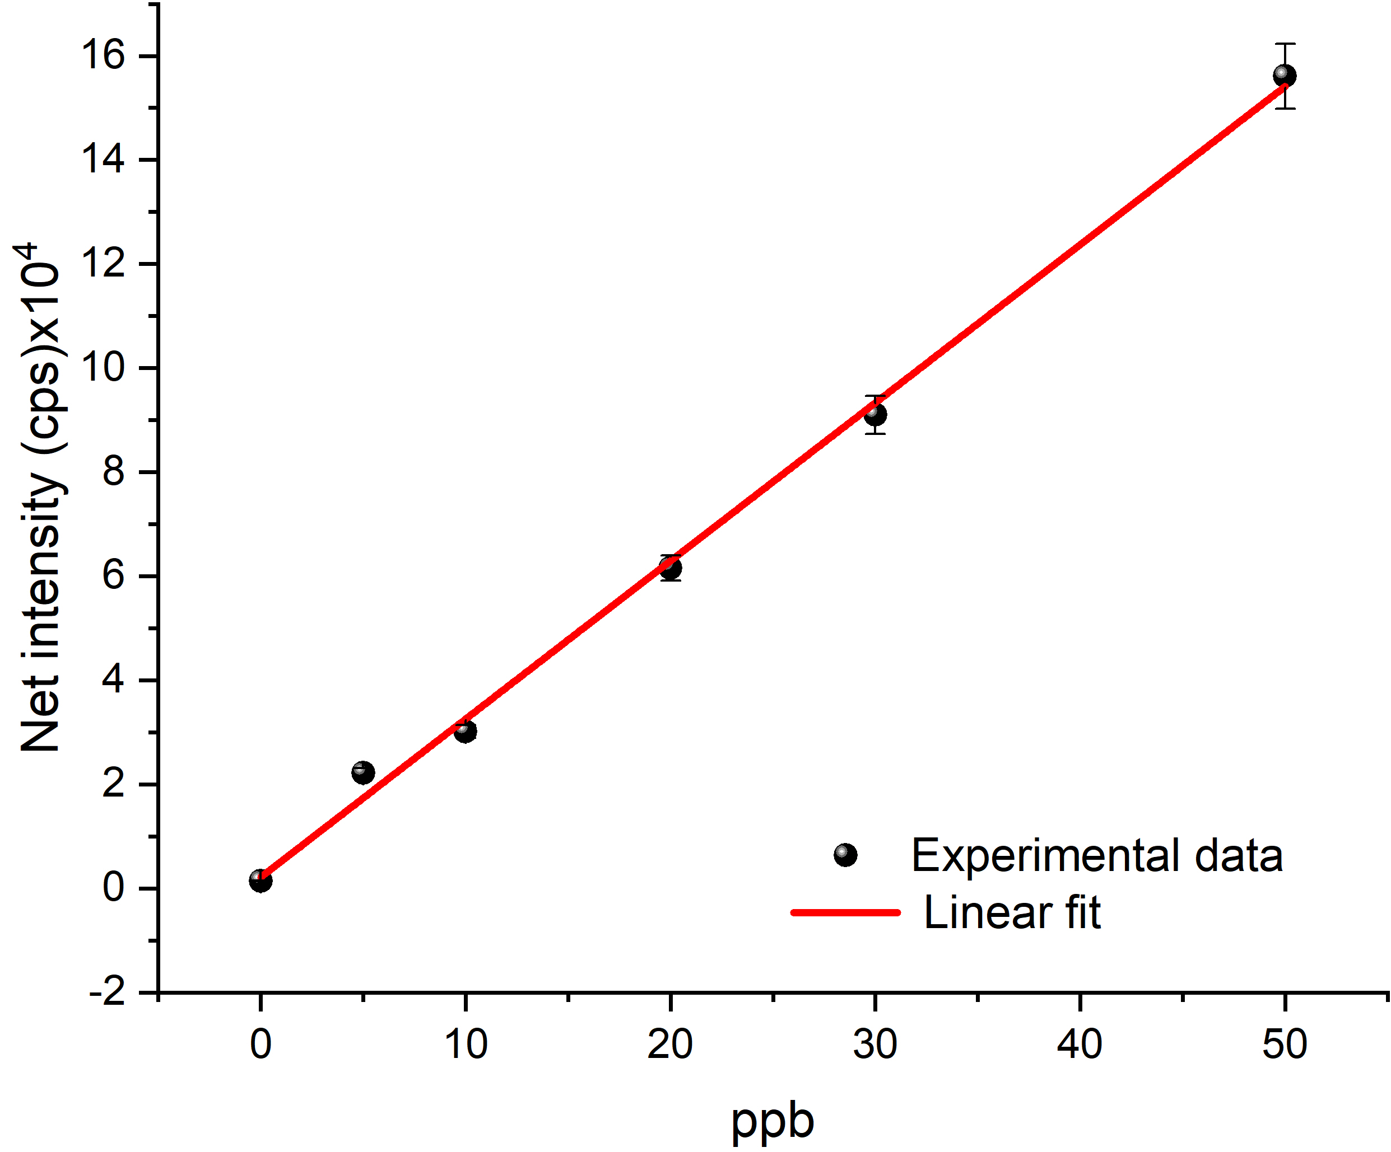
Supplementary figure 4. Calibration curve produced at concentrations 0.5, 10, 20, 30 and 50 ngFe/mL from the standard MNP sample.

Biodistribution of hIDPSC by BLM in G1, G2, G4 and G6

Considering the importance of neuronal degeneration in regions typically affected in HD – striatum and cortex – we performed a histopathological analysis in animals treated with 3-NPA. Analysis detected minimal, multifocal, vacuolar neuronal degeneration with gliosis. Figure SM5 shows a histological section of the striatum of a 6-week-old C57BL/6 female who showed neuronal vacuolization in the striatum, indicated by the two arrows.
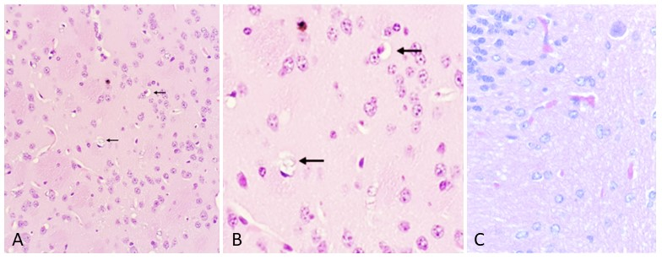
Supplementary figure 5. Left (A): Neuronal vacuolization in the striatum found in the 6-week-old female C57BL/6. In (B) high magnification in (A), and, on the right: normal brain, without histopathological changes (control animal). Arrows in (A, B) indicate neuronal vacuolization. (C) – Negative control, striatum of the animal not treated with 3-NPA.

Biodistribution of hIDPSC demonstrated by ICP-MS in G6

To estimate the amount of hIDPSC per organ the in vitro value of 10pg Fe per cell was established. After 4 hours of intravenous administration of MNP-hIDPSC into G6 animals, it was possible to observe a large presence of cells in the lungs of mice. This presence was reduced with time until reaching minimum values in 30 days. The same pattern was seen in all organs, with more cells found from the liver, followed by kidney, heart and brain (Supplementary table 3, Supplementary figure 6).

Supplementary figure 3. Mean quantification by ICP-MS of MNP-hIDPSC in animal organs in G6.
Organ | Euthanasia
Organ |  |  | 3 days | 7 days | 30 days
Brain | 0.63 ± 0.05 | 0.49 ± 0.04 | 0.27 ± 0.03 | 0.13 ± 0.01 | 0.02 ± 0.00
Liver | 6.31 ± 0.61 | 5.73 ± 0.45 | 3.90 ± 0.38 | 3.34 ± 0.18 | 0.05 ± 0.01
Kidney | 4.53 ± 0.39 | 3.92 ± 0.36 | 2.98 ± 0.34 | 1.47 ± 0.07 | 0.04 ± 0.00
Heart | 2.78 ± 0.29 | 2.30 ± 0.26 | 1.48 ± 0.16 | 0.67 ± 0.03 | 0.03 ± 0.00
Lung | 61.65 ± 7.35 | 54.82 ± 7.09 | 44.93 ± 5.73 | 14.37 ± 1.03 | 0.35 ± 0.03
Data expressed in 10,000 cells as mean ± standard deviation. As 10,000 cells correspond to 1% of the 1 million cells administered, the numbers also represent a percentage of the total administered.
Supplementary figure 6. Box plot of the biodistribution of MNP-hIDPSC in the brain, liver, kidney, heart and lung and quantification of cells by the ICP-MS technique at 4, 24 and 72 hours, 7 and 30 days.
ICP-MS analysis of G6 confirmed the findings of G4 with an accumulation of cells in the lung at 4 hours and a fall over time. In other organs such as the liver, kidney, and heart, cells were detected by the ICP-MS technique, however, in smaller numbers. In the brain, the values found were the lowest recorded at all time points and lowest, when compared with G4.

