Heterogenization of water-soluble porphyrins in Ti/TiO₂ nanotubes electrodes: experimental and theoretical insights for atrazine degradation
Ana Luísa Almeida Lageª, Juliana Martins Ribeiro^{b}, Tairine Fernanda da Silva Magalhães^{c}, Elaine Maria de Souza-Fagundes^{b}, Mateus Fernandes Venâncio^{d}, Michelle Fernanda Brugnera^{c}, Dayse Carvalho da Silva Martinsª
ª Departamento de Química, Instituto de Ciências Exatas, Universidade Federal de Minas Gerais, 31270-901, Belo Horizonte, MG, Brazil
^{b} Departamento de Fisiologia e Biofísica, Instituto de Ciências Biológicas, Universidade Federal de Minas Gerais, 31270-901, Belo Horizonte, MG, Brazil
^{c} Departamento de Química, Instituto de Ciências Exatas, Universidade Federal do Mato Grosso, 78060-900, Cuiabá, MT, Brazil
^{d}Departamento de Físico-Química, Instituto de Química, Universidade Federal da Bahia, Campus Universitário de Ondina, 40170-110, Salvador, BA, Brazil

Corresponding author: Dayse Carvalho da Silva Martins
E-mail: daysequimica@ufmg.br

Supplementary Material

(a) | (b)
(c) | (d)
Figure S1. ﻿UV–vis spectra of (a) pure Ti/TiO₂, (b) Ti/TiO₂-H₂P, (c) Ti/TiO₂-MnP1, and (d) Ti/TiO₂-MnP2 electrodes; the corresponding ﻿plot’s for band gap energy data obtained from diffuse reflectance (inset) of each electrode.

Figure S2. ﻿ Photocurrent vs. potential curves obtained (a) without irradiation and for (b) Ti/TiO₂ bare, (c) Ti/TiO₂-H₂P, (d) Ti/TiO₂-MnP1, and (e) Ti/TiO₂-MnP2 under UV illumination in 0.01 mol L⁻¹ NaCl, scan rate = 10 mV s⁻¹.

Table S1. Atrazine degradation through the photolysis, photocatalysis (PC), and photoelectrocatalysis (PEC) reactions mediated by porphyrin-modified Ti-TiO₂ electrodes after 60 minutes.
Systems | Atrazine degradation (%)
Photolysis | 92
Ti/TiO₂ (PC) | 86
Ti/TiO₂-H₂P (PC) | 80
Ti/TiO₂-MnP1 (PC) | 92
Ti/TiO₂-MnP2 (PC) | 89
Ti/TiO₂ (PEC) | 91
Ti/TiO₂-H₂P (PEC) | 91
Ti/TiO₂-H₂P (PEC) (in surface water) | 91
Ti/TiO₂-MnP1 (PEC) | 87
Ti/TiO₂-MnP2 (PEC) | 74

Table S2. The kinetics plots for first-order or second order for atrazine degradation light-mediated through photolysis (PH), photocatalysis (PC), and photoelectrocatalysis (PEC) in the presence of Ti/TiO₂ or Ti/TiO₂-porphyrins electrodes
System | Kinetics plots
Photolysis (PH) | 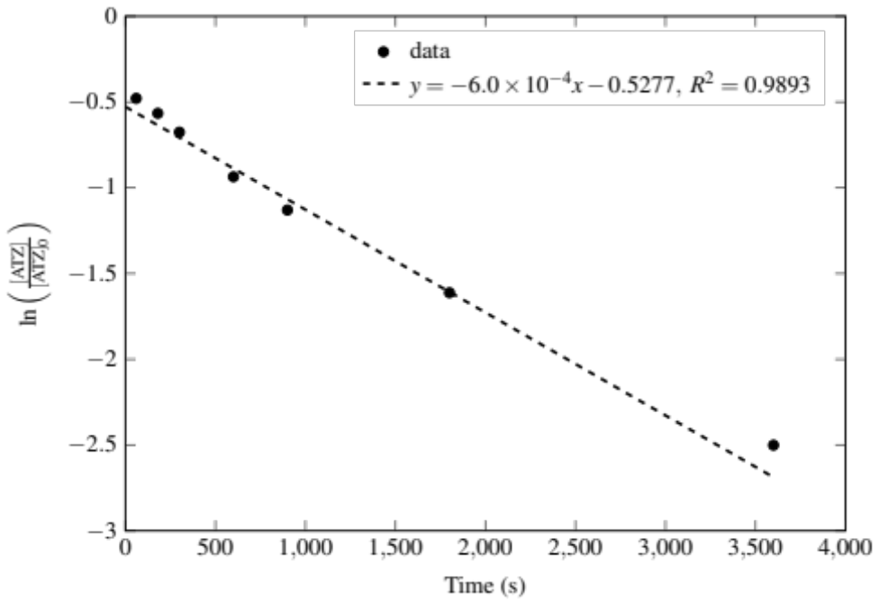
Ti/TiO₂ (PC) | 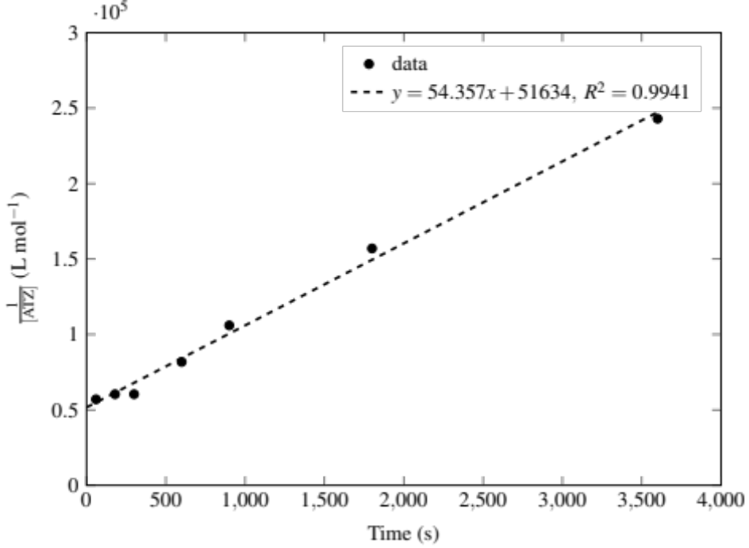
Ti/TiO₂-MnP1 (PC) | 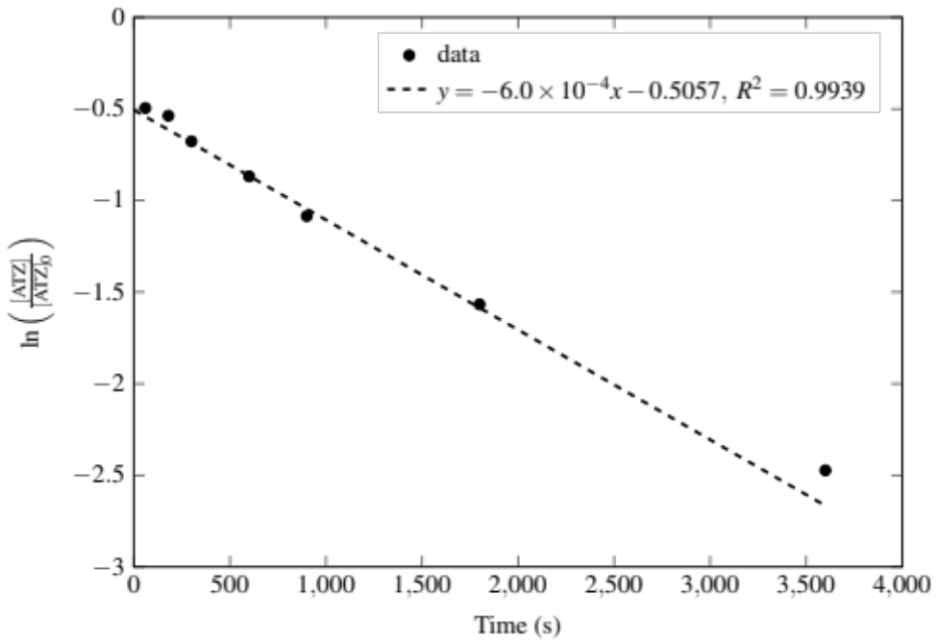
Ti/TiO₂-MnP2 (PC) | 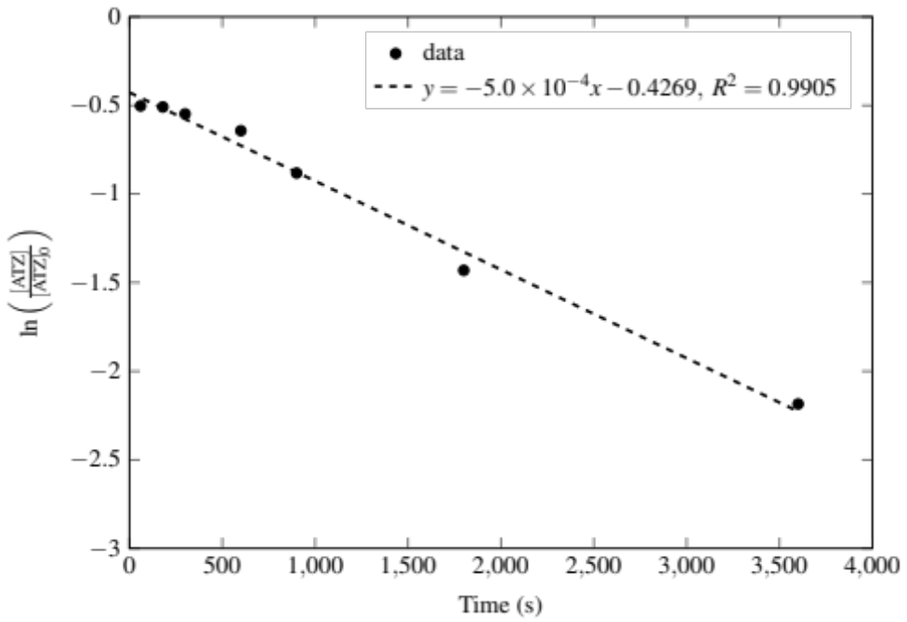
Ti/TiO₂ (PEC) | 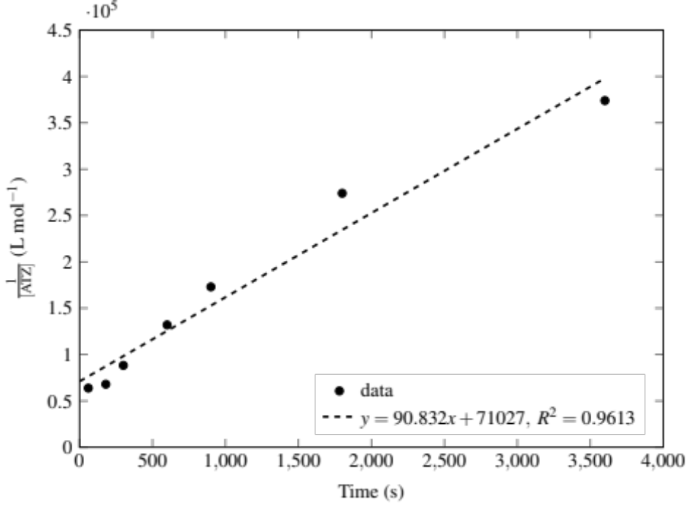
Ti/TiO₂-MnP1 (PEC) | 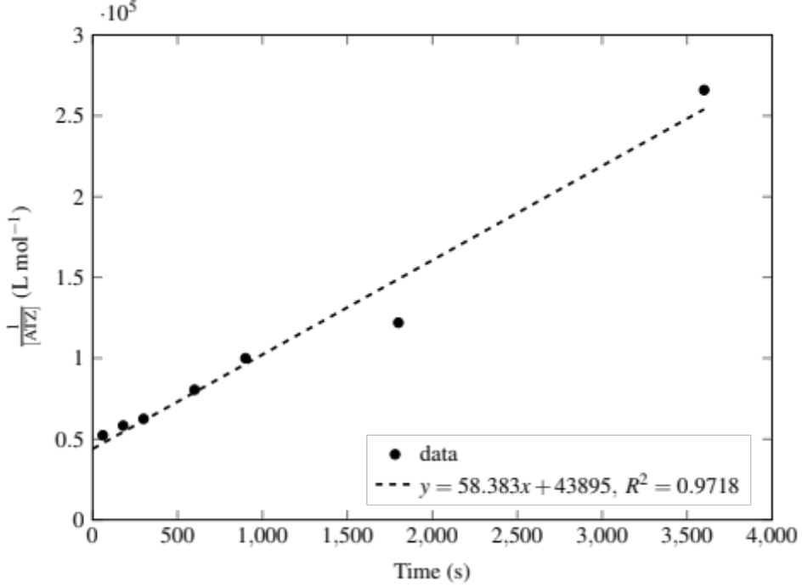
Ti/TiO₂-MnP2 (PEC) | 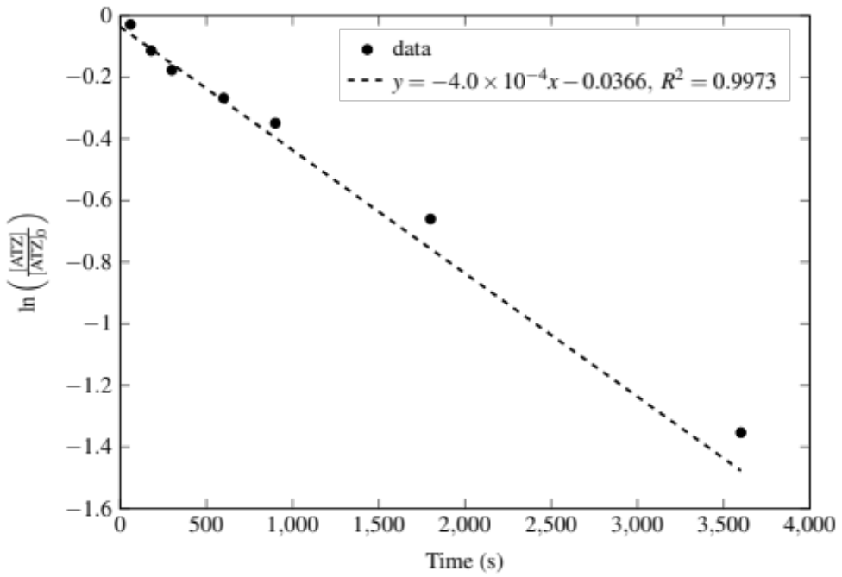
Ti/TiO₂-H₂P (PC) | 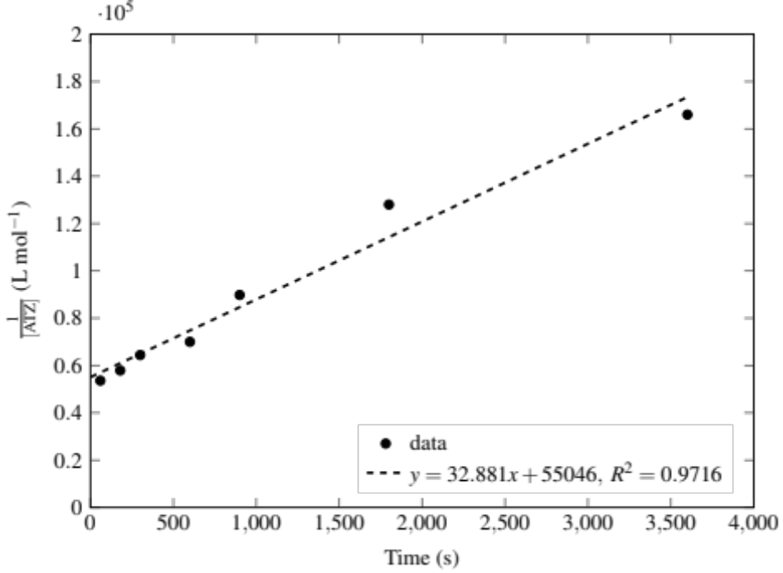
Ti/TiO₂-H₂P (PEC) | 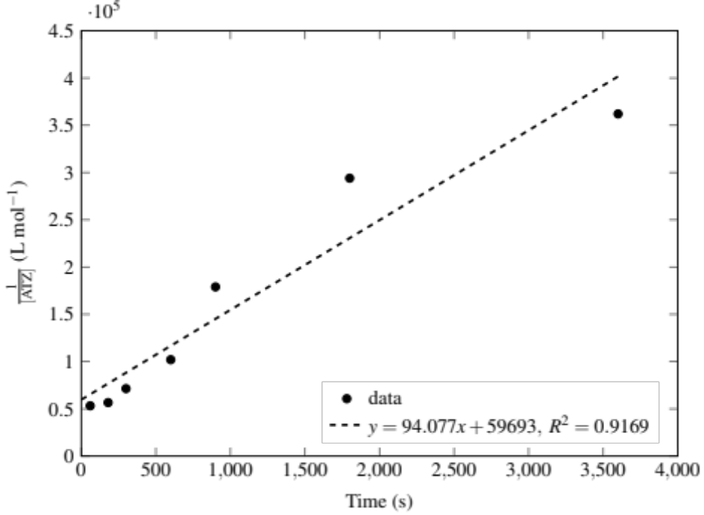
Ti/TiO₂-H₂P (PEC) (in surface water) | 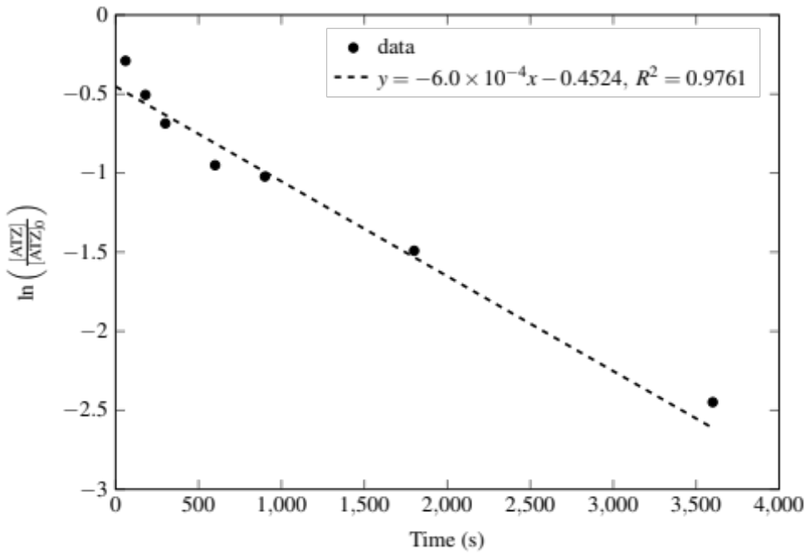

Table S3. Photo(electron)catalytic systems for atrazine degradation.
Methods | Catalyst | Conditions | Atrazine degradation (%)ª | Kinetic constantsª | Order^{b} | Reference
Photoelectrocatalysis | TiO₂ nanotube arrays | Illumination  intensity of 80 mW cm⁻²,  magnetic stirring, 0.01 M Na₂SO₄ as  the electrolyte. The initial [atrazine] was 10 mg L⁻¹. | ~ 50 (60 min) | 0.704 h⁻¹ | Pseudo-first | Lu et al. (2008)
Photoelectrocatalysis | B-doped (1.5 at.%) TiO₂ nanotube arrays |  | ~ 65 (60 min) | 0.863 h⁻¹ | Pseudo-first | Lu et al. (2008)
Photoelectrocatalysis | B-doped (3.8 at.%) TiO₂ nanotube arrays |  | ~ 65 (60 min) | 0.907 h⁻¹ | Pseudo-first | Lu et al. (2008)
Photoelectrocatalysis | B-doped (3.1 at.%) TiO₂ nanotube arrays |  | ~ 65 (60 min) | 1.08 h⁻¹ | Pseudo-first | Lu et al. (2008)
Photocatalysis only | B-doped (3.1 at.%) TiO₂ nanotube arrays |  | ~ 55% (60 min) | 0.705 h⁻¹ | nd | Lu et al. (2008)
Photolysis only | B-doped (3.1 at.%) TiO₂ nanotube arrays |  | ~ 35% (60 min) | 0.420 h⁻¹ | nd | Lu et al. (2008)
Electrochemical only | B-doped (3.1 at.%) TiO₂ nanotube arrays |  | < 5 (60 min) | 0.0186 h⁻¹ | nd | Lu et al. (2008)
Photoelectrocatalysis | Boron-fluorine co-doped TiO₂ nanotube arrays | 500 W xenon lamp irradiation,  magnetic stirring. The initial [atrazine] was 5 mg L⁻¹. | ~ 15 (60 min)  ~ 22 (120 min) | 0.0054 min⁻¹ (pH = 2; current of 0.02A; 0.1 M Na₂SO₄ as  the electrolyte) | nd | Wang et al (2019a)
Photoelectrocatalysis | Boron-fluorine co-doped TiO₂ nanotube arrays |  | ~ 22 (60 min)  ~ 45 (120 min) | 0.0037min⁻¹ (pH = 4; current of 0.02A; 0.1 M Na₂SO₄ as  the electrolyte) | nd | Wang et al (2019a)
Photoelectrocatalysis | Boron-fluorine co-doped TiO₂ nanotube arrays | 500 W xenon lamp irradiation,  magnetic stirring. The initial [atrazine] was 5 mg L⁻¹. | ~ 50 (60 min)  ~75 (120 min) | 0.0084 min⁻¹ or 0.01168 min⁻¹ (pH = 6; current of 0.02A; 0.1 M Na₂SO₄ as  the electrolyte) | nd | Wang et al (2019a)
Photoelectrocatalysis | Boron-fluorine co-doped TiO₂ nanotube arrays |  | ~ 10 (60 min)  ~ 22 (120 min) | 0.0025 min⁻¹ or 0.01151 (pH = 8; current of 0.02A; 0.1 M Na₂SO₄ as  the electrolyte) | nd | Wang et al (2019a)
Photoelectrocatalysis | Boron-fluorine co-doped TiO₂ nanotube arrays | 500 W xenon lamp irradiation,  magnetic stirring. The initial [atrazine] was 5 mg L⁻¹. | ~ 17 (60 min)  ~ 25 (120 min) | 0.00222 min⁻¹ (pH = 6; current of 0.01A; 0.1 M Na₂SO₄ as  the electrolyte) | nd | Wang et al (2019a)
Photoelectrocatalysis | Boron-fluorine co-doped TiO₂ nanotube arrays |  | ~ 37 (60 min)  ~ 60 (120 min) | 0.076 min⁻¹ (pH = 6; current of 0.04A; 0.1 M Na₂SO₄ as  the electrolyte) | nd | Wang et al (2019a)
Photoelectrocatalysis | Boron-fluorine co-doped TiO₂ nanotube arrays | 500 W xenon lamp irradiation,  magnetic stirring. The initial [atrazine] was 5 mg L⁻¹. | ~ 25 (60 min)  ~ 48 (120 min) | 0.00414 min⁻¹ (pH = 6; current of 0.06A; 0.1 M Na₂SO₄ as  the electrolyte) | nd | Wang et al (2019a)
Photoelectrocatalysis | Boron-fluorine co-doped TiO₂ nanotube arrays |  | ~ 17 (60 min)  ~ 30 (120 min) | 0.0032 min⁻¹ (pH = 6; current of 0.06A; 0.01 M Na₂SO₄ as  the electrolyte) | nd | Wang et al (2019a)
Photoelectrocatalysis | Boron-fluorine co-doped TiO₂ nanotube arrays | 500 W xenon lamp irradiation,  magnetic stirring. The initial [atrazine] was 5 mg L⁻¹. | ~ 32 (60 min)  ~ 55 (120 min) | 0.00686 min⁻¹ (pH = 6; current of 0.06A; 0.05 M Na₂SO₄ as  the electrolyte) | nd | Wang et al (2019a)
Photoelectrocatalysis | Boron-fluorine co-doped TiO₂ nanotube arrays |  | ~ 27 (60 min)  ~ 43 (120 min) | 0.00487 min⁻¹ (pH = 6; current of 0.06A; 0.5 M Na₂SO₄ as  the electrolyte) | nd | Wang et al (2019a)
Photoelectrocatalysis | TiO₂ nanotubes | Light intensity: 100 mW cm⁻², 0.1 M Na₂SO₄; The initial [atrazine] was 2 ppm; - 1.3 eV. | 73.1 (300 min) | 0.265 h⁻¹ | nd | Wang et al (2019b)
Photoelectrocatalysis | Pd quantum dots modified TiO₂ nanotubes |  | 99.5 (300 min) | 1.036 h⁻¹ | Pseudo-first | Wang et al (2019b)
Electrochemical only | TiO₂ nanotubes | 0.1 M Na₂SO₄; The initial [atrazine] was 2 ppm; - 1.3 eV. | ~ 59 (300 min) | ~ 0.170 h⁻¹ | nd | Wang et al (2019b)
Electrochemical only | Pd quantum dots modified TiO₂ nanotubes | 0.1 M Na₂SO₄; The initial [atrazine] was 2 ppm; - 1.3 eV. | 96.0 (300 min) | 0.604 h⁻¹ | Pseudo-first | Wang et al (2019b)
Photoelectrocatalysis | Pd quantum dots modified TiO₂ nanotubes | 0.1 M Na₂SO₄; The initial [atrazine] was 2 ppm; - 0.5 eV. | 24.1 (300 min) | 0.060 h⁻¹ | Pseudo-first | Wang et al (2019b)
Electrochemical only | Pd quantum dots modified TiO₂ nanotubes | 0.1 M Na₂SO₄; The initial [atrazine] was 2 ppm; - 0.5 eV. | 2.3 (300 min) | 0.006 h⁻¹ | Pseudo-first | Wang et al (2019b)
Photoelectrocatalysis | Pd quantum dots modified TiO₂ nanotubes | 0.1 M Na₂SO₄; The initial [atrazine] was 2 ppm; - 0.9 eV. | 83.9 (300 min) | 0.329 h⁻¹ | Pseudo-first | Wang et al (2019b)
Electrochemical only | Pd quantum dots modified TiO₂ nanotubes | 0.1 M Na₂SO₄; The initial [atrazine] was 2 ppm; - 0.9 eV. | 32.6 (300 min) | 0.092 h⁻¹ | Pseudo-first | Wang et al (2019b)
Photoelectrocatalysis | Pd quantum dots modified TiO₂ nanotubes | 0.1 M Na₂SO₄; The initial [atrazine] was 2 ppm; - 1.5 eV. | 93.4 (300 min) | 0.541 h⁻¹ | Pseudo-first | Wang et al (2019b)
Electrochemical only | Pd quantum dots modified TiO₂ nanotubes | 0.1 M Na₂SO₄; The initial [atrazine] was 2 ppm; - 1.5 eV. | 97.6 (300 min) | 0.791 h⁻¹ | Pseudo-first | Wang et al (2019b)
Photocatalysis only | Pd quantum dots modified TiO₂ nanotubes | 0.1 M Na₂SO₄; The initial [atrazine] was 2 ppm. | 17.8 (300 min) | 0.032 h⁻¹ | nd | Wang et al (2019b)
Photocatalysis only | Ti/TiO₂ | UV radiation using a Hg lamp; the initial [atrazine] was 3.0 x 10⁻⁵ M;  0.05 M NaCl. | 86 (60 min) | 54.357 L mol-1 s-1 | Second | This work
Photocatalysis only | Ti/TiO₂-H₂P |  | 80 (60 min) | 32.881 L mol-1 s-1 | Second | This work
Photocatalysis only | Ti/TiO₂-MnP1 |  | 92 (60 min) | 0.0006 s⁻¹ | First | This work
Photocatalysis only | Ti/TiO₂-MnP2 |  | 89 (60 min) | 0.0005 s⁻¹ | First | This work
Photoelectrocatalysis | Ti/TiO₂ |  | 91 (60 min) | 90.832 L mol-1 s-1 | Second | This work
Photoelectrocatalysis | Ti/TiO₂-H₂P |  | 91 (60 min) | 94.077 L mol-1 s-1 | Second | This work
Photoelectrocatalysis | Ti/TiO₂-MnP1 |  | 87 (60 min) | 58.383 L mol-1 s-1 | Second | This work
Photoelectrocatalysis | Ti/TiO₂-MnP2 |  | 74 (60 min) | 0.0004 s-1 | First | This work
Photoelectrocatalysis | Ti/TiO₂-H₂P in surface water |  | 91 (60 min) | 0.0006 s-1 | First | This work
ª (~) was used since the data were collected by the presented graphs by visual deduction; ^{b} “nd”: not described by the authors.

References
Lu N, Zhao H, Li J et al (2008) ﻿Characterization of boron-doped TiO₂ nanotube arrays prepared by electrochemical method and its visible light activity. Sep Purif Technol. ﻿Doi:10.1016/j.seppur.2008.03.021
Wang HX, Zhu LN, Gui FG (2019a) ﻿Photoelectrocatalytic degradation of atrazine by boron-fluorine co-doped TiO₂ nanotube arrays. Environ Sci Pollut Res. ﻿https://doi.org/10.1007/s11356-018-2569-y
Wang H, Li J, Shi H et al (2019b) Enhanced photoelectrocatalytic reduction and removal of atrazine: effect of co-catalyst and cathode potential. ACS Appl Mater Interfaces. DOI: 10.1021/acsami.9b12139

