Supporting Information for
Horse Chestnut Tree Genome Reveals the evolutionary mechanism of Aescin and Aesculin biosynthesis

Wei Sun^{1,2,9} Qinggang Yin^{1,9} Huihua Wan^{1,9} Chao Xiong^{1,3,9} Chong Xie⁴ Xiangxiao Meng¹ Caixia Wang¹ Ranran Gao¹ Weiqiang Chen¹ Ziyan Xie⁵ Zheyong Xue⁵ Hui Yao⁶ Peng Sun¹ Xuehua Xie¹ Zhigang Hu⁷ David R. Nelson⁸ Zhichao Xu^{5*} Xinxiao Sun^{4*} Shilin Chen^{1,2*}

Email: Zhichao Xu (xuzhichao830@126.com); Xinxiao Sun (sunxx@mail.but.edu.cn); Shilin Chen (slchen@icmm.ac.cn)

This PDF file includes:
Figures S1 to S20
Tables S1 to S20
SI References

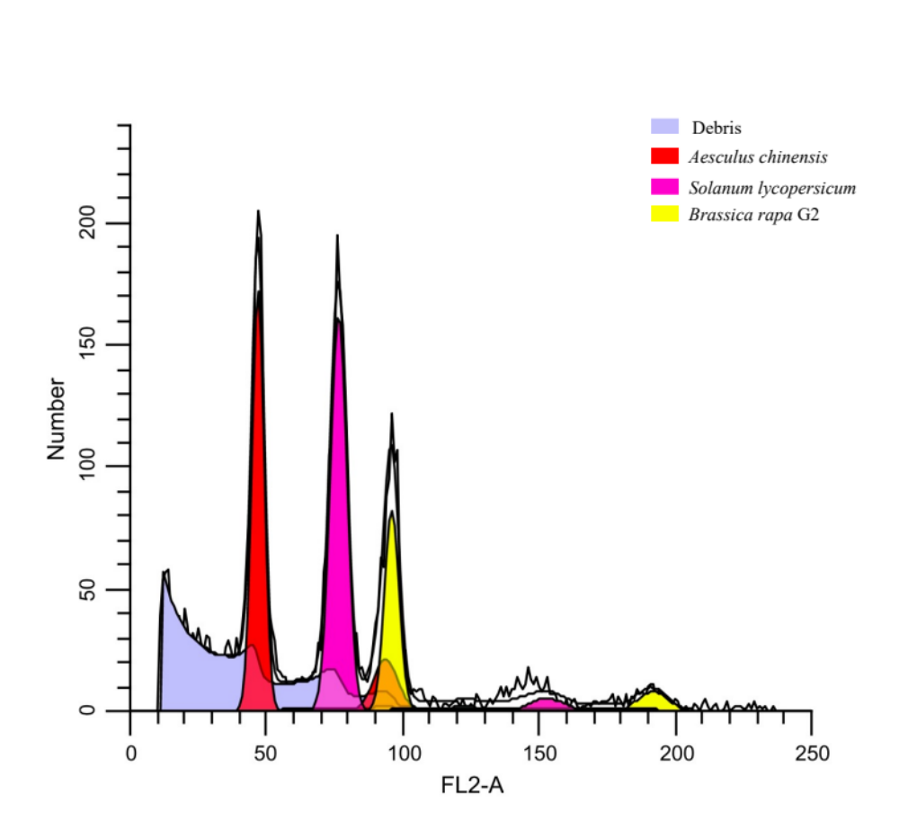
Figure S1. Flow cytometry is used to estimate the genome size of A. chinensis using Solanum lycopersicum (900 Mb) and Brassica rapa (485 Mb) as the standards. The yellow peak at FL2-A value of 47.10 for Brassica rapa was covered by the peak of A. chinensis (46.82). The genome size was estimated as 481.9 Mb.

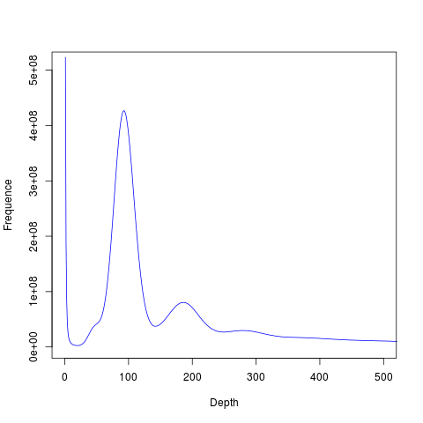
Figure S2. The genome size of A. chinensis estimated by 17 K-mer. We totally identified 47,364,609,904 K-mers and the peak depth of K-mer is 92. The genome size of A. chinensis was calculated as 514.83 Mb, and the revised genome size is 504.38 Mb.

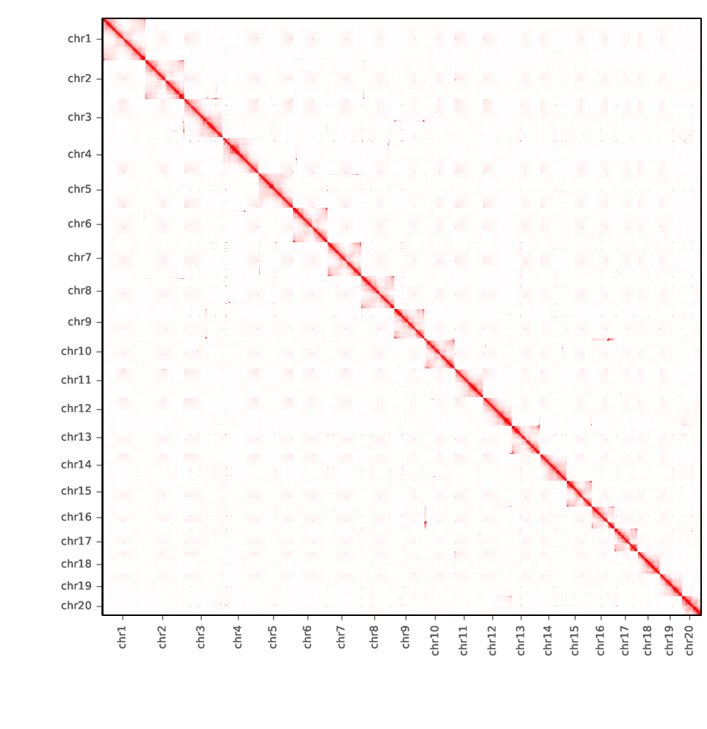
Figure S3. Heatmap of A. chinensis chromosome conformation capture analysis.

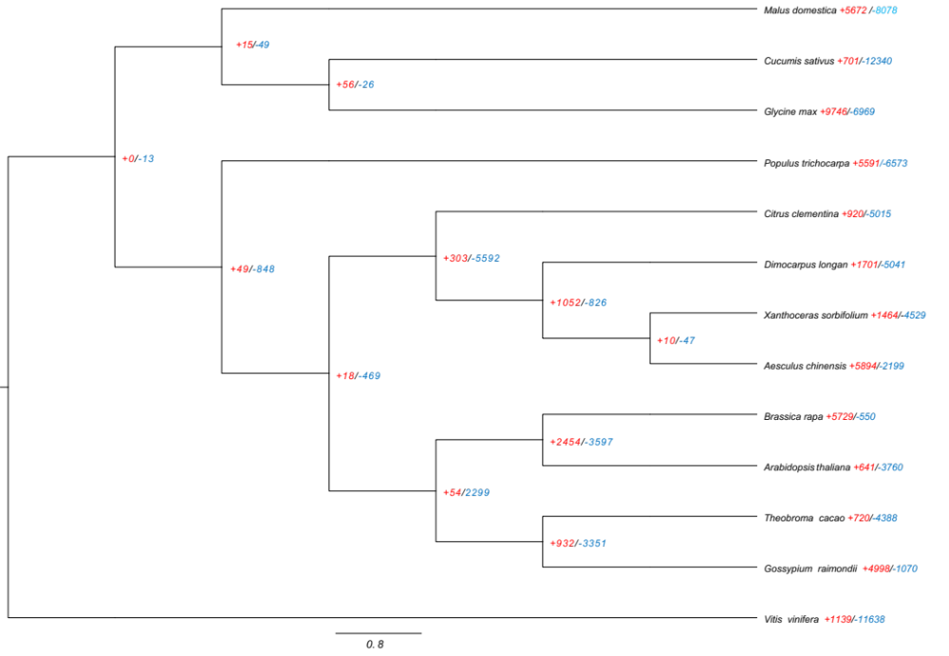
Figure S4. The orthologous genes and phylogenetic analysis among A. chinensis and other 12 angiosperms. The red and blue numbers present the expansion and contraction of gene families among 13 angiosperms respectively.

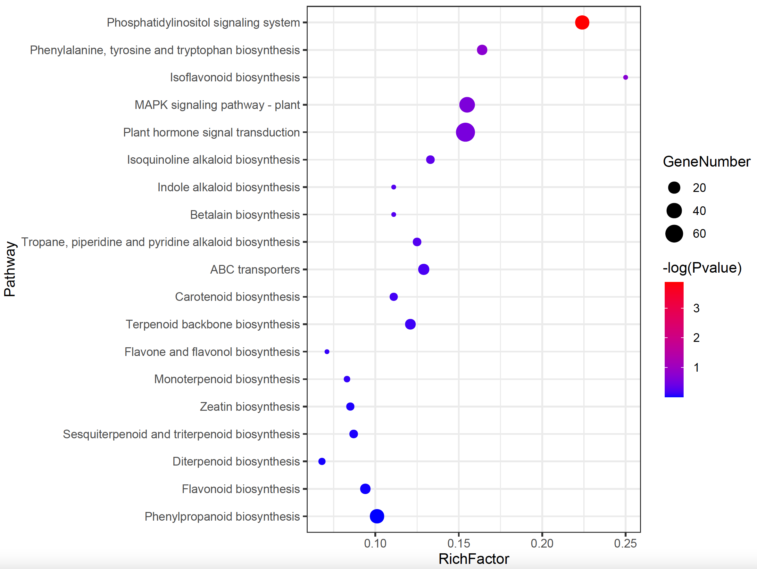
Figure S5. KEGG pathway enrichment analysis for the expanded gene families in A. chinensis genome. The size of each circle means the amounts of genes. The different color of each circle means the P-value. RichFactor means the number of genes in the enriched KEGG pathway divided by the number of background genes.

Figure S6. Synteny analysis among the A. chinensis, C. clementina, and X. sorbifolium genomes. Dot plots showed the syntenic orthologs between A. chinensis and C. clementina (A), and between C. clementina, and X. sorbifolium (B).

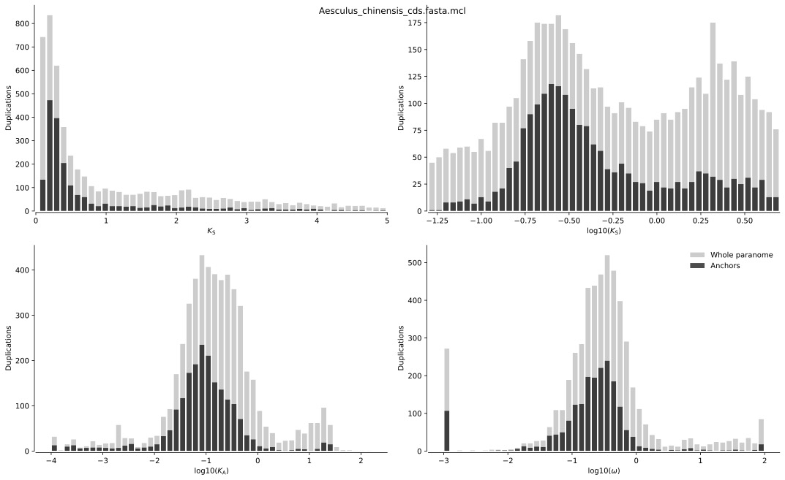
Figure S7. K_{S} distributions of whole paralogs (grey bars) and anchor-pair paralogs (black bars) for A. chinensis. Two obvious peaks in the log₁₀ (K_{S}) distributions indicated that there are at least two WGD events occurred during the evolution of A. chinensis.

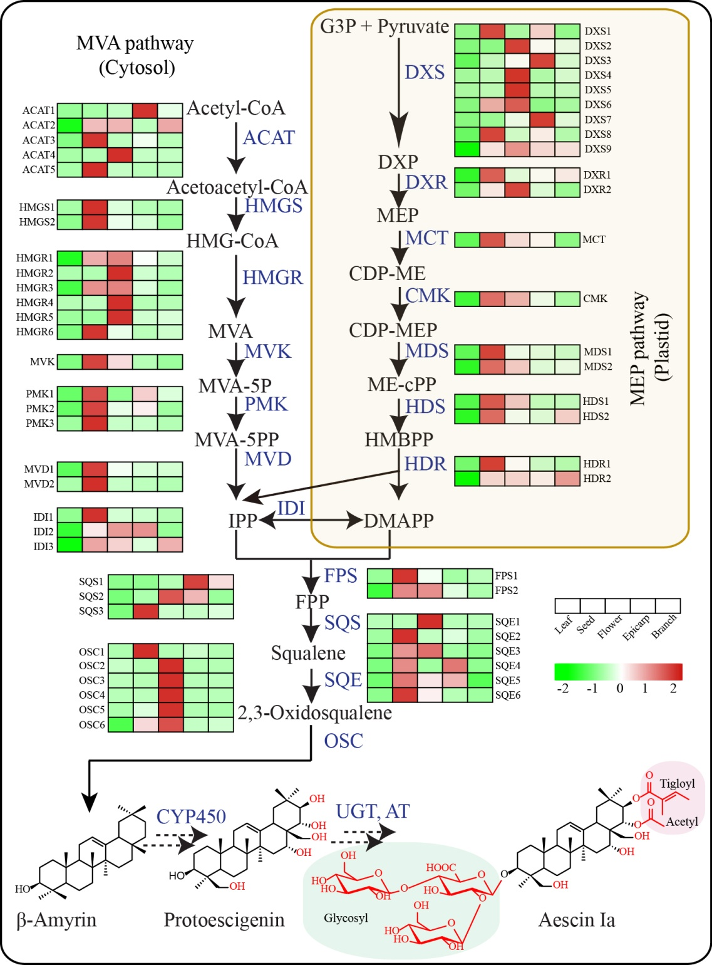
Figure S8. The gene expression heatmap of MEP and MVA genes contribute to biosynthesis of triterpenoids in A. chinensis.

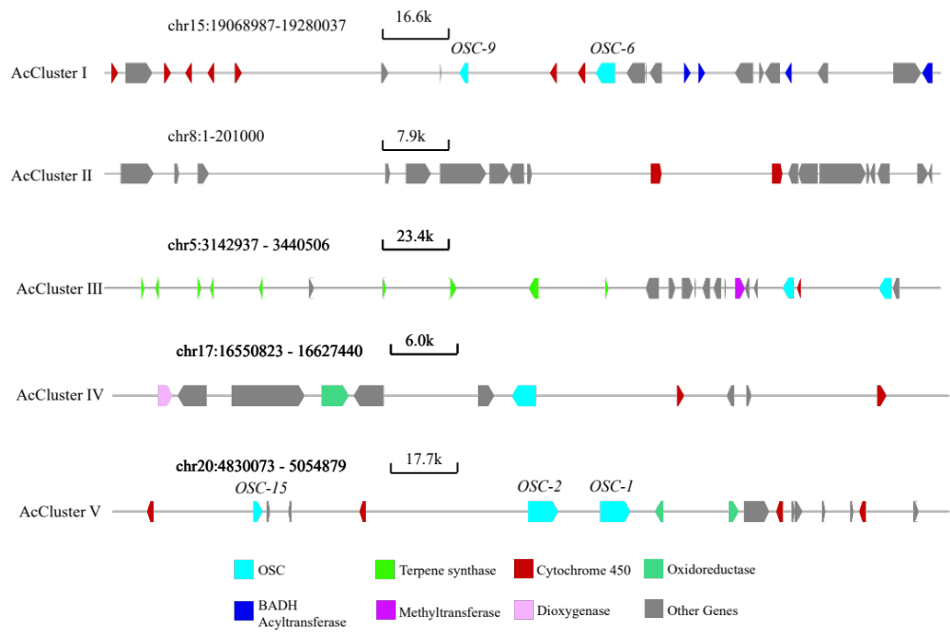
Figure S9. Five biosynthetic gene clusters (AcClusters I-V) related to triterpenoid biosynthesis in A. chinensis genome. AcClusters I-V except AcCluster II containing skeleton OSCs and tailoring genes were searched in each chromosome of A. chinensis genome via the online tools of plantiSMASH (http://plantismash.secondarymetabolites.org/). It was manually found that AcCluster II existed.

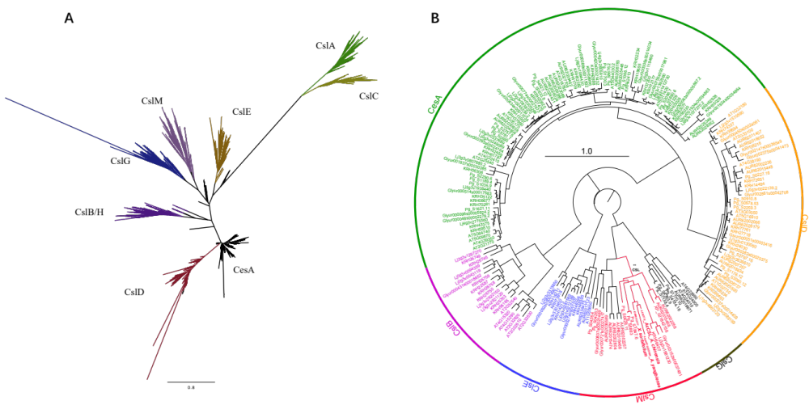

Figure S10. Phylogenetic analysis of cellulose-synthase genes. (A) Phylogenetic analysis of 6268 cellulose-synthase superfamily genes from 144 reported angiosperm genomes. (B) The phylogenetic position of AcCSL with other proteins reported in literature. The cellulose-synthase superfamily genes were annotated using PFAM of PF03552. Maximum likelihood tree was constructed using RAxML with 1000 bootstrap replicates.

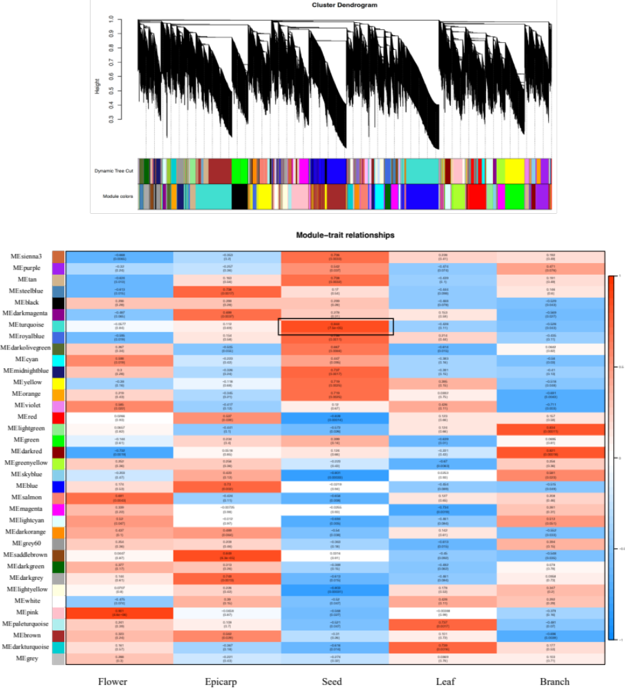
Figure S11. The WGCNA “turquoise” module associated with escin Ia biosynthesis, represented as a baits AcOSC6 and AcCLS1 connecting candidate P450, BAHDs and UGTs, see Table S16.

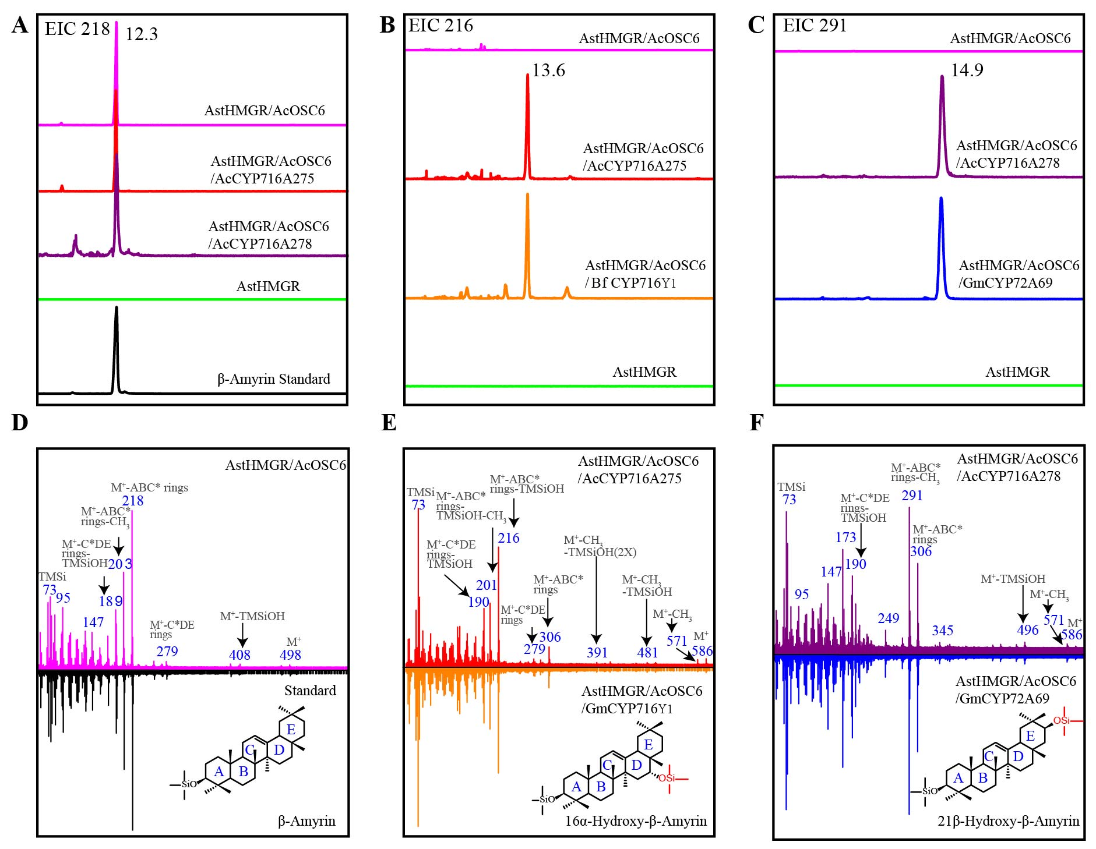
Figure S12. The function identification of AcOSC6, AcCYP716A25 and AcCYP716A28 through the N. benthamiana platform. (A) EIC of β-amyrin (m/z 218; positive ion mode) of samples from N. benthamiana leaves transiently expressing AstHMGR combined with AcOSC6, and with AcCYP716A25 or AcCYP716A28 compared to plants expressing AstHMGR alone and to β-amyrin standard. (B) EIC of 16α-hydroxy-β-amyrin (m/z 216; positive ion mode) of products from N. benthamiana leaves transiently expressing AstHMGR combined with AcOSC6, and with AcCYP716A25 or BfCYP716Y1. (C) EIC of 21β-hydroxy-β-amyrin (m/z 291; positive ion mode) of products from N. benthamiana leaves transiently expressing AstHMGR combined with AcOSC6, and with AcCYP716A28 or GmCYP72A69. (D, E, F) GC-MS results of β-amyrin, 16α-hydroxy-β-amyrin and 21β-hydroxy-β- amyrin.

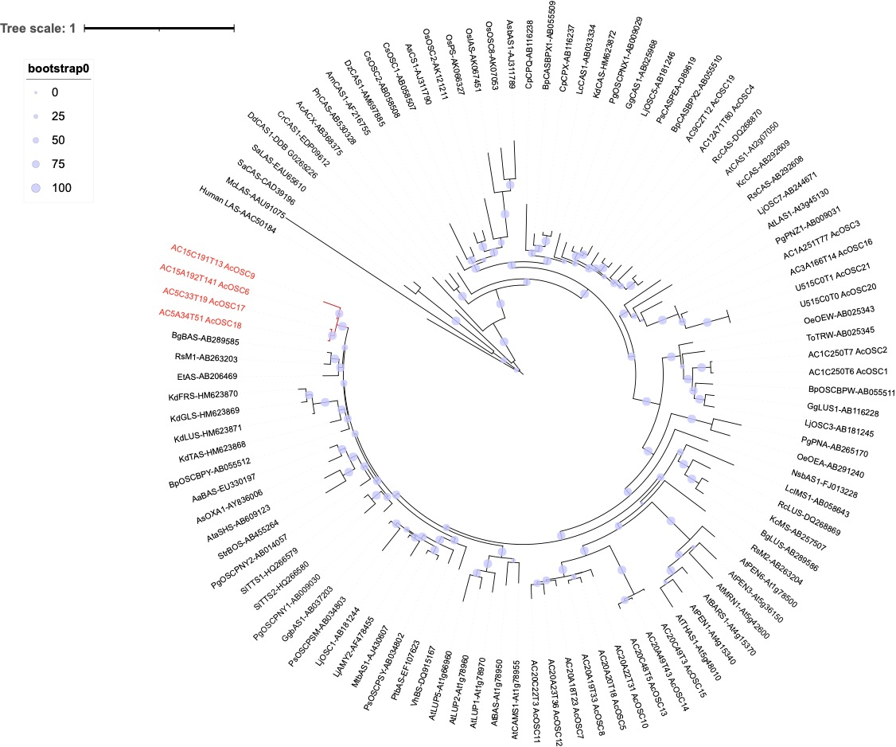
Figure S13. Phylogenetic analysis of OSC genes annotated from A. chinensis genome with the representatives of characterized OSC genes from different species.

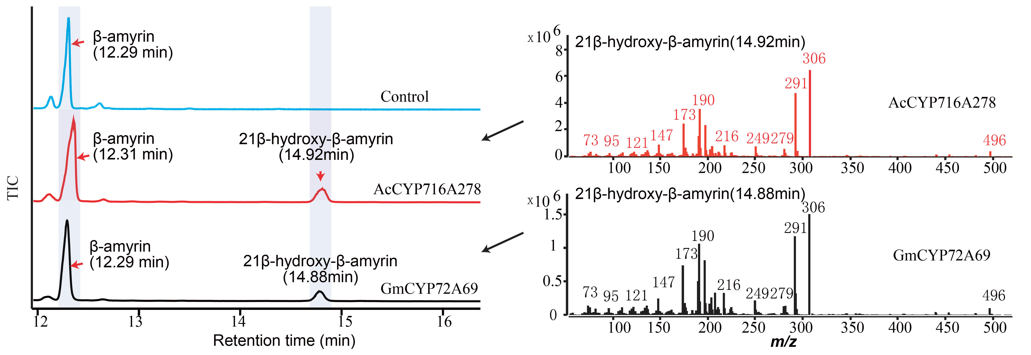
Figure S14. Expression of AcCYP716A278 results in accumulation of 21β-hydroxy-β-amyrin in engineered yeast strains with a matching retention time and mass spectrum to the products of GmCYP72A69.

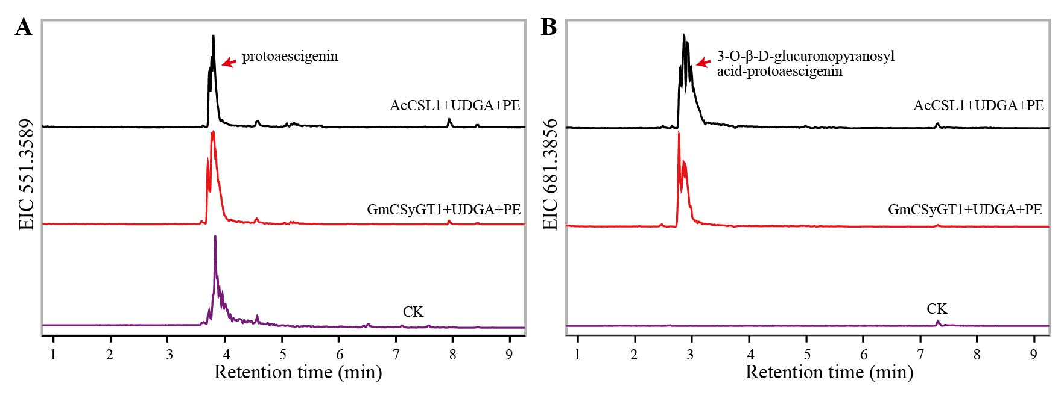
Figure S15. Enzymatic assays of AcCSL1 and GmCSyGT1-containing microsomes. (A) Overlay of LC-MS extracted ion chromatograms for protoaescigenin (m/z 551.3589) detected in microsomes expressing AcCSL1 and GmCSyGT1. (B) Overlay of LC-MS extracted ion chromatograms for 3-O-β-D-glucuronopyranosyl acid-protoaescigenin (m/z 681.3856) produced in microsomes expressing AcCSL1 and GmCSyGT1

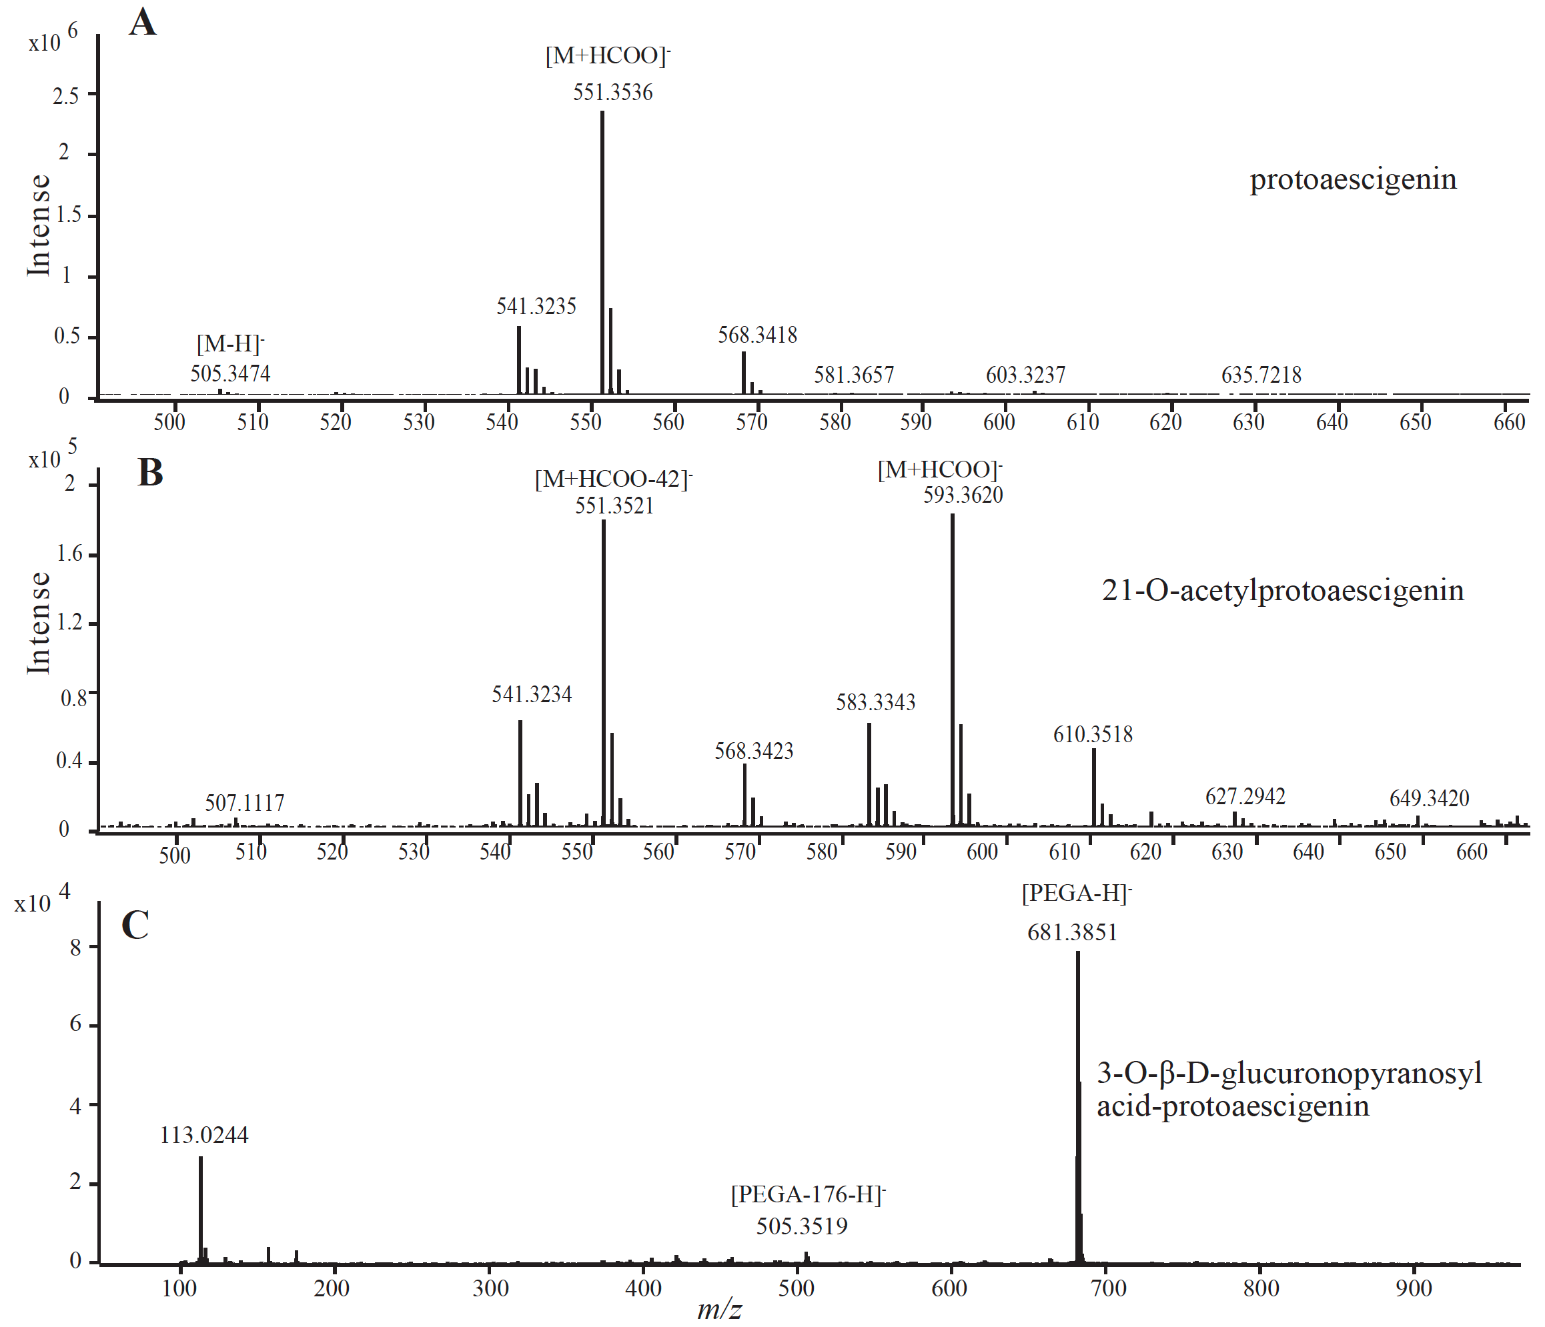
Figure S16. LC-MS results of protoaescigenin (A), 21-O-acetylprotoaescigenin (B) and 3-O-β-D-glucuronopyranosyl acid-protoaescigenin (C).

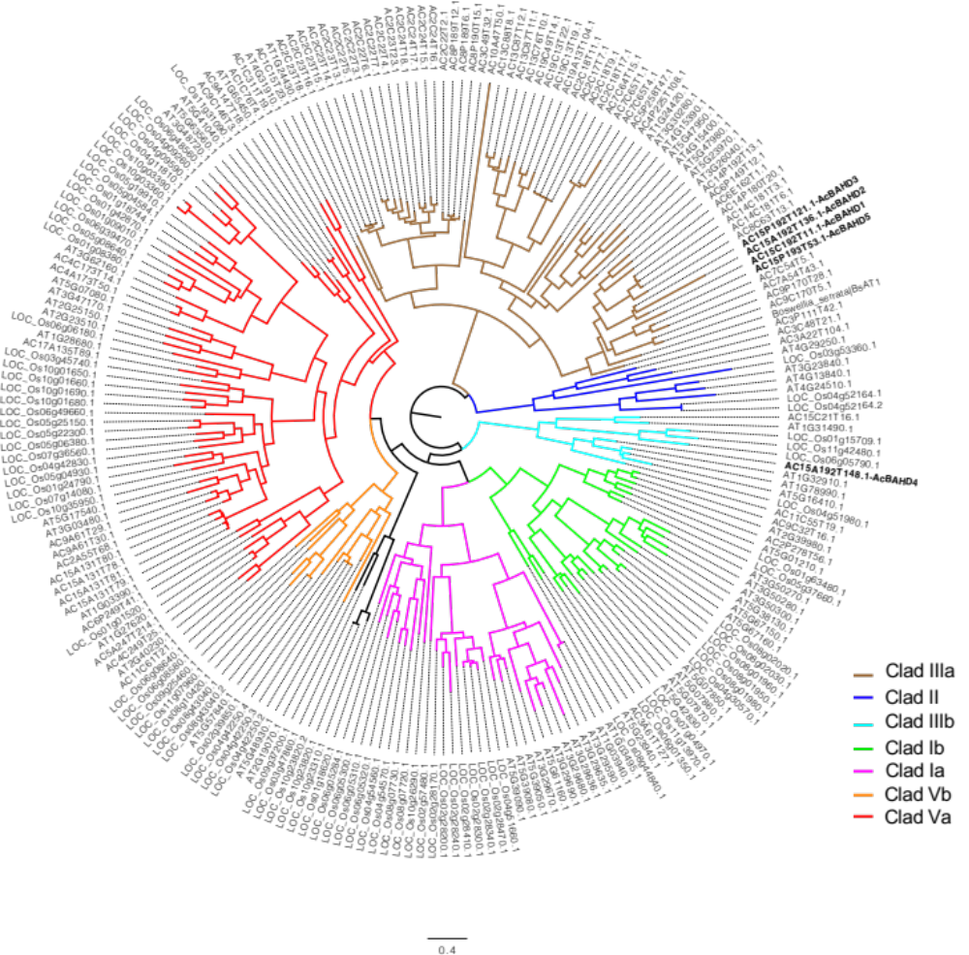
Figure S17. Phylogenetic analysis of BAHD genes annotated from A. chinensis genome with the representatives of characterized BAHD genes from different species.

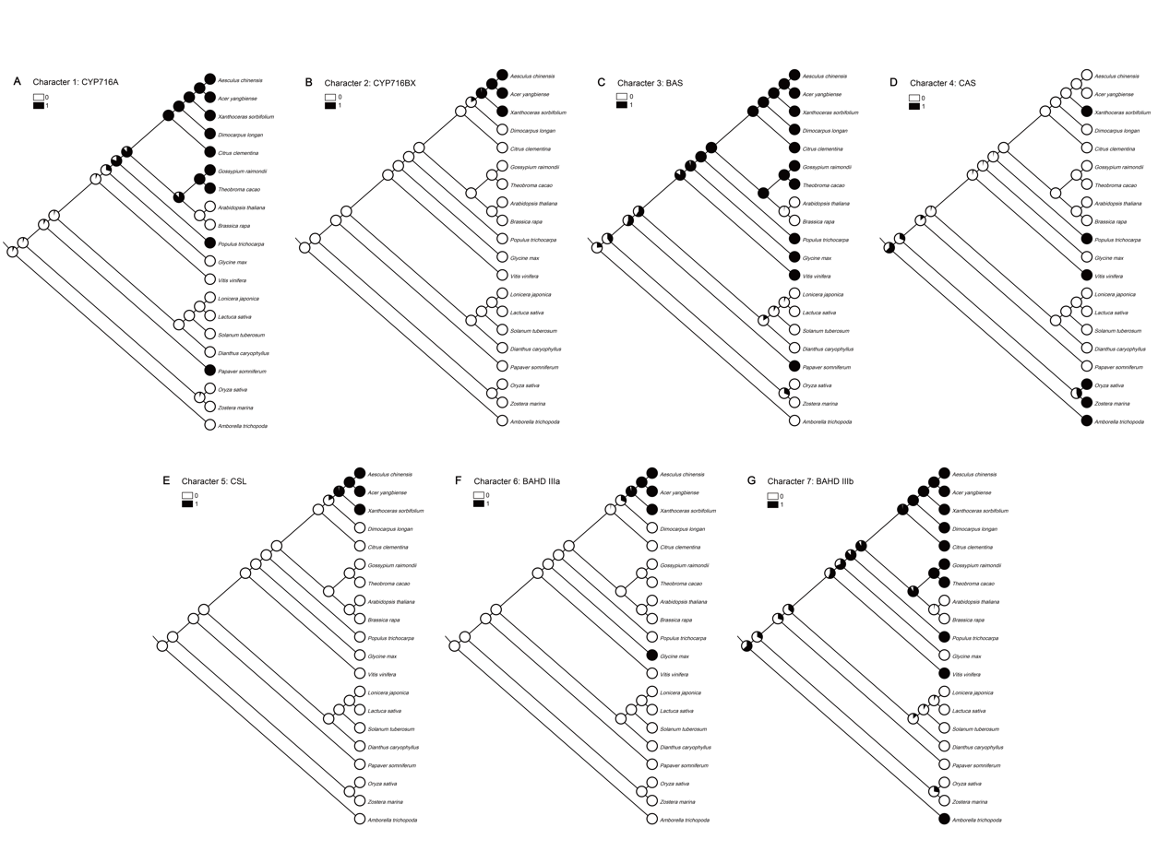

Figure S18. Ancestral state reconstructions of barrigenol-type triterpenoid biosynthetic gene clusters among angiosperms. The binary traits were assigned to each leaf according to the presence (=1) or absence (=0) of targeted genes. A: CYP716A, B: CYP716BX, C: BAS, D: CAS, E: CSL, F: BAHD IIIa, G: BAHD IIIb.

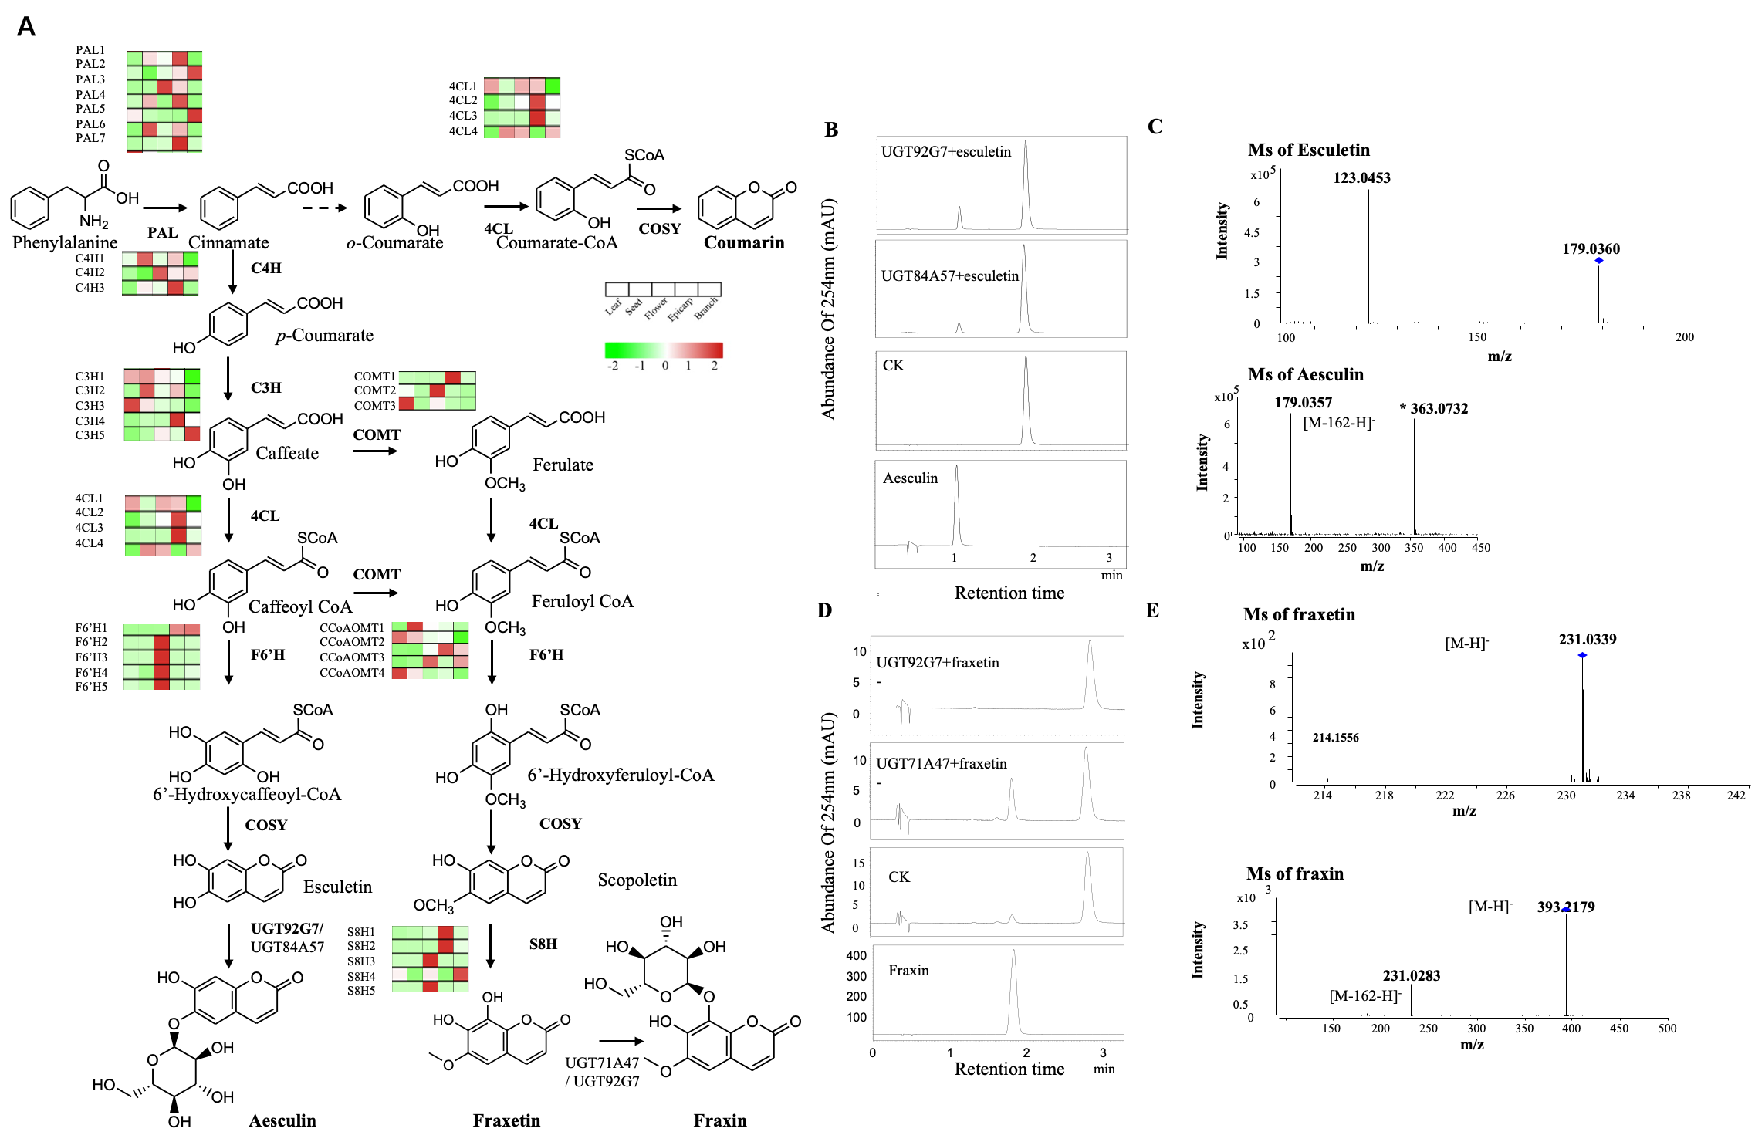
Figure S19. Genes involved in aesculin and fraxin biosynthesis. (A) The biosynthesis of aesculin and fraxin is represented in this simplified form. Genes associated with pathways identified by blastP. The expression value for each gene is indicated in color on log₁₀ (FPKM + 1) scale for five tissues: leaf, seed, flower, epicarp and branch. (B) UPLC spectrums for UGT92G7 and UGT84A57 enzyme activity analysis toward esculetin. (C) MS spectrums of esculetin and aesculin. (D) UPLC spectrums for UGT92G7 and UGT71A47 enzyme activity analysis toward fraxin. (E) MS spectrums of fraxetin and fraxin.

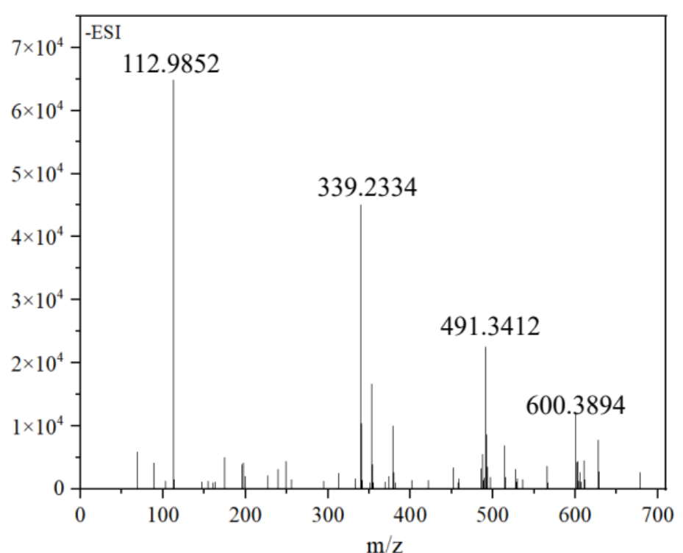
Figure S20. ESI-MS(-) results of aesculin sample. The theoretical molecular weights of the aesculin is 340.28.

Table S1. Compounds information for MALDI imaging.
Compound | Molecular  formula | Adduct ion | Theoretical Molecular Mass | Molecular Mass
Farxin | C₁₆H₁₈O₁₀ | [M+K]⁺ | 369.08271 | 370.31
Aesculiside A | C₅₂H₈₂O₂₄ | [M+K]⁺ | 1129.4839 | 1129.4776
Isoescin Ⅱb | C₅₄H₈₄O₂₃ | [M+K]⁺ | 1139.5046 | 1139.4988
Isoescin Ⅲa | C₅₅H₈₆O₂₃ | [M+K]⁺ | 1153.5203 | 1153.5127
Escin V | C₅₄H₈₆O₂₄ | [M+K]⁺ | 1157.5152 | 1157.5075
Escin Ia | C₅₅H₈₆O₂₄ | [M+K]⁺ | 1169.5152 | 1169.5088
Aesculioside G | C₅₆H₈₈O₂₄ | [M+K]⁺ | 1183.5308 | 1183.5275

Table S2. Linear ranges, calibration curves and correlation coefficients (R²) for escin Ia, escin Ib, protoescigenin, fraxetin, fraxin, esculetin, aesculin obtained by LC-QQQ-MS.

Compounds | Linear range (ug/mL) | Calibration curve | R²
Escin Ia | 9.96-1992 | y=6508.4x+11.635 | 0.9999
Escin Ib | 10.06-2012 | y=5321.9x+41.251 | 0.9998
Protoescigenin | 0.76-152 | y=76776x-32.278 | 0.9993
Fraxetin | 1.66-332 | y=55083x-89.664 | 0.9996
Fraxin | 1.96-392 | y=73364x-215.12 | 0.9992
Esculetin | 1.94-388 | y=94504x-170.37 | 0.9996
Aesculin | 1.78-356 | y=55604x-181.53 | 0.9992

Table S3. Parameters of the Multiple Reaction Monitoring (MRM) for escin Ia, escin Ib, protoescigenin, fraxetin, fraxin, esculetin, aesculin.

Compounds | Ion mode | Precursor ion (m/z) | Product Ion (m/z) | Fragmentor (V) | Collision energy voltage (V)
Protoescigenin | negative | 551.4 | 505.5/421.4 | 120 | 20/38
Escin Ia | positive | 1131.5 | 969.5/789.5 | 170 | 12/15
Escin Ib | positive | 1131.5 | 969.5/789.5 | 170 | 12/15
Fraxetin | negative | 206.9 | 192.1/107.9 | 90 | 20/30
Fraxin | negative | 369.1 | 206.8/191.9 | 90 | 20/30
Esculetin | negative | 339.1 | 176.9/163.1 | 90 | 20/30
Aesculin | negative | 177.1 | 133.1/104.9 | 120 | 20/20

Table S4. Statistics of A. chinensis genome sequence data.

Total reads from Nanopore platform | 3,662,658
Total bases of Nanopore reads (Gb) | 34.12
N50 length of Nanopore reads (bp) | 11740
Minimum read length (bp) | 1000
Maximum read length (bp) | 84,436
Corrected long reads using CANU | 1,229,382
Corrected bases (Gb) | 18.78
N50 length of corrected reads (bp) | 14455

Table S5. Statistics of A. chinensis genome assembly.

Assembly
# Contigs | 656
Total length (bp) | 470039413
Largest contig | 8581606
N50 length | 2030109
GC (%) | 35.55
#Polished contigs | 656
Total length (bp) | 470021348
Largest contig | 8583990
N50 length | 2049619
GC (%) | 35.54
# Hi-C
Clean Paired-end Reads | 326,228,655
Unique Mapped Paired-end Reads | 189,382,086
Valid Paired-end Reads | 174,576,440
chr1 (bp) | 31,807,429
chr2 (bp) | 29,407,995
chr3 (bp) | 29,233,014
chr4 (bp) | 27,081,713
chr5 (bp) | 26,184,402
chr6 (bp) | 26,484,559
chr7 (bp) | 25,384,139
chr8 (bp) | 24,827,435
chr9 (bp) | 23,046,765
chr10 (bp) | 22,692,868
chr11 (bp) | 21,891,486
chr12 (bp) | 21,749,535
chr13 (bp) | 21,256,607
chr14 (bp) | 20,301,677
chr15 (bp) | 19,447,847
chr16 (bp) | 16,939,248
chr17 (bp) | 17,460,947
chr18 (bp) | 17,149,361
chr19 (bp) | 16,763,800
chr20 (bp) | 14,195,357
Total anchored (bp) | 453,306,184
Unanchored (bp) | 14,542,953

Supplementary Table 6. Assessment of the A. chinensis genome quality using Benchmarking Universal Single-Copy Orthologs (BUSCO).

BUSCO notation | Number | Percent
Complete BUSCOs (C) | 1573 | 97.40%
Complete and single-copy BUSCOs (S) | 1306 | 80.90%
Complete and duplicated BUSCOs (D) | 267 | 16.50%
Fragmented BUSCOs (F) | 18 | 1.10%
Missing BUSCOs (M) | 23 | 1.50%
Total BUSCO groups searched | 1614 | 100%

Table S7. Annotation of A. chinensis TEs

Repeat Class | Elements number | Length occupied (bp) | Percentage of sequence
Retrotransposon | 112,183 | 125,858,360 | 26.90 %
LINE | 15,739 | 11,836,519 | 2.53 %
LTR | 96,444 | 114,021,841 | 24.37 %
LTR-Gypsy | 59,193 | 74,596,830 | 15.94 %
LTR-Copia | 34,880 | 37,310,178 | 7.97 %
DNA elements | 66,062 | 27,870,276 | 5.96 %
Unclassified TEs | 390,503 | 115,365,232 | 24.66 %
Small RNA | 429 | 182,497 | 0.04 %
Simple repeats | 137,943 | 5,556,512 | 1.19 %
Low complexity | 21,798 | 1,109,427 | 0.24 %
Total Repeats |  | 276,695,955 | 59.14 %
Note: TEs, transposable elements; LTR, long terminal repeat; LINE, long interspersed nuclear elements; SINE, short interspersed nuclear elements.

Table S8. Summary of gene annotation in A. chinensis genome.

Number of proteins | 36603
Average gene length (bp) | 2460.53
Average CDS length (bp) | 1098.19
Average exons per gene | 4.97
Average exon length (bp) | 221.09
Average intron length (bp) | 344.4
# BUSCO
Complete BUSCOs (C) | 1434 (88.80%)
Complete and single-copy BUSCOs (S) | 1208 (74.80%)
Complete and duplicated BUSCOs (D) | 226 (14.00%)
Fragmented BUSCOs (F) | 106 (6.60%)
Missing BUSCOs (M) | 74 (4.60%)
Total BUSCO groups searched | 1614 (100%)

Table S9. The functional annotation and GO enrichment analyses of the retained genes from the recent WGD event of A. chinensis genome.

# | GO ID | Description | out (465) | All (6417) | pvalue
1 | GO:0000075 | cell cycle checkpoint | 15 (3.23%) | 62 (0.97%) | 0.000025
2 | GO:0006412 | translation | 15 (3.23%) | 69 (1.08%) | 0.000094
3 | GO:0006518 | peptide metabolic process | 15 (3.23%) | 69 (1.08%) | 0.000094
4 | GO:0043043 | peptide biosynthetic process | 15 (3.23%) | 69 (1.08%) | 0.000094
5 | GO:0043603 | cellular amide metabolic process | 17 (3.66%) | 85 (1.32%) | 0.000099
6 | GO:0043604 | amide biosynthetic process | 15 (3.23%) | 77 (1.2%) | 0.000341
7 | GO:0002181 | cytoplasmic translation | 13 (2.8%) | 63 (0.98%) | 0.000469
8 | GO:1901566 | organonitrogen compound biosynthetic process | 19 (4.09%) | 116 (1.81%) | 0.000601
9 | GO:0010033 | response to organic substance | 6 (1.29%) | 17 (0.26%) | 0.000870
10 | GO:0000054 | ribosomal subunit export from nucleus | 5 (1.08%) | 13 (0.2%) | 0.001544
11 | GO:0033750 | ribosome localization | 5 (1.08%) | 13 (0.2%) | 0.001544
12 | GO:0033753 | establishment of ribosome localization | 5 (1.08%) | 13 (0.2%) | 0.001544
13 | GO:0051168 | nuclear export | 5 (1.08%) | 13 (0.2%) | 0.001544
14 | GO:0051656 | establishment of organelle localization | 5 (1.08%) | 13 (0.2%) | 0.001544
15 | GO:0071166 | ribonucleoprotein complex localization | 5 (1.08%) | 13 (0.2%) | 0.001544
16 | GO:0071426 | ribonucleoprotein complex export from nucleus | 5 (1.08%) | 13 (0.2%) | 0.001544
17 | GO:0071428 | rRNA-containing ribonucleoprotein complex export from nucleus | 5 (1.08%) | 13 (0.2%) | 0.001544
18 | GO:0044267 | cellular protein metabolic process | 40 (8.6%) | 345 (5.38%) | 0.001809
19 | GO:1901564 | organonitrogen compound metabolic process | 25 (5.38%) | 191 (2.98%) | 0.002645
20 | GO:0019538 | protein metabolic process | 40 (8.6%) | 355 (5.53%) | 0.003058
21 | GO:0000373 | Group II intron splicing | 6 (1.29%) | 22 (0.34%) | 0.003845
22 | GO:0000956 | nuclear-transcribed mRNA catabolic process | 9 (1.94%) | 50 (0.78%) | 0.008833
23 | GO:0006402 | mRNA catabolic process | 9 (1.94%) | 50 (0.78%) | 0.008833
24 | GO:0044085 | cellular component biogenesis | 32 (6.88%) | 288 (4.49%) | 0.009455
25 | GO:0051640 | organelle localization | 5 (1.08%) | 19 (0.3%) | 0.009707
26 | GO:0006401 | RNA catabolic process | 9 (1.94%) | 51 (0.79%) | 0.010059
27 | GO:0022402 | cell cycle process | 17 (3.66%) | 128 (1.99%) | 0.010528
28 | GO:0002237 | response to molecule of bacterial origin | 4 (0.86%) | 13 (0.2%) | 0.011494
29 | GO:0009617 | response to bacterium | 4 (0.86%) | 13 (0.2%) | 0.011494
30 | GO:0042254 | ribosome biogenesis | 24 (5.16%) | 205 (3.19%) | 0.012723
31 | GO:0019439 | aromatic compound catabolic process | 9 (1.94%) | 53 (0.83%) | 0.012891
32 | GO:0034655 | nucleobase-containing compound catabolic process | 9 (1.94%) | 53 (0.83%) | 0.012891
33 | GO:0044248 | cellular catabolic process | 9 (1.94%) | 53 (0.83%) | 0.012891
34 | GO:0044265 | cellular macromolecule catabolic process | 9 (1.94%) | 53 (0.83%) | 0.012891
35 | GO:0044270 | cellular nitrogen compound catabolic process | 9 (1.94%) | 53 (0.83%) | 0.012891
36 | GO:0046700 | heterocycle catabolic process | 9 (1.94%) | 53 (0.83%) | 0.012891
37 | GO:1901361 | organic cyclic compound catabolic process | 9 (1.94%) | 53 (0.83%) | 0.012891
38 | GO:0046907 | intracellular transport | 7 (1.51%) | 36 (0.56%) | 0.013284
39 | GO:0051649 | establishment of localization in cell | 7 (1.51%) | 36 (0.56%) | 0.013284
40 | GO:1902582 | single-organism intracellular transport | 7 (1.51%) | 36 (0.56%) | 0.013284
41 | GO:0001300 | chronological cell aging | 2 (0.43%) | 3 (0.05%) | 0.014965
42 | GO:0007568 | aging | 2 (0.43%) | 3 (0.05%) | 0.014965
43 | GO:0007569 | cell aging | 2 (0.43%) | 3 (0.05%) | 0.014965
44 | GO:0009607 | response to biotic stimulus | 12 (2.58%) | 85 (1.32%) | 0.018750
45 | GO:0000413 | protein peptidyl-prolyl isomerization | 8 (1.72%) | 49 (0.76%) | 0.023184
46 | GO:0018208 | peptidyl-proline modification | 8 (1.72%) | 49 (0.76%) | 0.023184
47 | GO:0022613 | ribonucleoprotein complex biogenesis | 26 (5.59%) | 240 (3.74%) | 0.024438
48 | GO:0000160 | phosphorelay signal transduction system | 10 (2.15%) | 69 (1.08%) | 0.025846
49 | GO:0042273 | ribosomal large subunit biogenesis | 11 (2.37%) | 79 (1.23%) | 0.026171
50 | GO:0002238 | response to molecule of fungal origin | 2 (0.43%) | 4 (0.06%) | 0.028499
51 | GO:0006091 | generation of precursor metabolites and energy | 2 (0.43%) | 4 (0.06%) | 0.028499
52 | GO:0009620 | response to fungus | 2 (0.43%) | 4 (0.06%) | 0.028499
53 | GO:0018193 | peptidyl-amino acid modification | 8 (1.72%) | 51 (0.79%) | 0.028867
54 | GO:0051641 | cellular localization | 7 (1.51%) | 42 (0.65%) | 0.029565
55 | GO:0000184 | nuclear-transcribed mRNA catabolic process, nonsense-mediated decay | 4 (0.86%) | 17 (0.26%) | 0.030388
56 | GO:0002831 | regulation of response to biotic stimulus | 4 (0.86%) | 17 (0.26%) | 0.030388
57 | GO:0002252 | immune effector process | 8 (1.72%) | 52 (0.81%) | 0.032042
58 | GO:0000470 | maturation of LSU-rRNA | 4 (0.86%) | 18 (0.28%) | 0.036901
59 | GO:0070925 | organelle assembly | 16 (3.44%) | 137 (2.13%) | 0.038348
60 | GO:0000209 | protein polyubiquitination | 10 (2.15%) | 74 (1.15%) | 0.039657
61 | GO:0016567 | protein ubiquitination | 10 (2.15%) | 74 (1.15%) | 0.039657
62 | GO:0032446 | protein modification by small protein conjugation | 10 (2.15%) | 74 (1.15%) | 0.039657
63 | GO:0044271 | cellular nitrogen compound biosynthetic process | 20 (4.3%) | 183 (2.85%) | 0.041405
64 | GO:0034645 | cellular macromolecule biosynthetic process | 17 (3.66%) | 151 (2.35%) | 0.045154
65 | GO:0000301 | retrograde transport, vesicle recycling within Golgi | 2 (0.43%) | 5 (0.08%) | 0.045241
66 | GO:0006891 | intra-Golgi vesicle-mediated transport | 2 (0.43%) | 5 (0.08%) | 0.045241
67 | GO:0048193 | Golgi vesicle transport | 2 (0.43%) | 5 (0.08%) | 0.045241
68 | GO:0006913 | nucleocytoplasmic transport | 5 (1.08%) | 28 (0.44%) | 0.048040
69 | GO:0016482 | cytoplasmic transport | 5 (1.08%) | 28 (0.44%) | 0.048040
70 | GO:0051169 | nuclear transport | 5 (1.08%) | 28 (0.44%) | 0.048040

Table S10. The K_{S} value for duplicated paralogous gene pairs related to terpene biosynthesis and coumarin biosynthesis in A. chinensis genome.

Gene_Name | Gene_ID | Gene_Name | Gene_ID | K_{S}
#Terpene biosynthesis
DXS | AC1C306T25 | DXS | AC3A21T134 | 0.280491
HDR | AC13A82T109 | HDR | AC19A18T145 | 0.241994
SQS | AC13A90T97 | SQS | AC19C11T29 | 0.2624
SQS | AC13A91T147 | SQS | AC19A11T157 | 0.32083
MCT | AC13A199T38 | MCT | AC19A148T47 | 0.459658
HMGR | AC13A102T193 | HMGR | AC19C0T21 | 0.30671
MVK | AC2C14T16 | MVK | AC3A41T160 | 0.477488
IDI | AC2A91T25 | IDI | AC9C133T12 | 0.192534
MDS | AC3C88T16 | MDS | AC5C231T33 | 0.207768
DXR | AC3C102T10 | DXR | AC5C219T15 | 0.23434
HMGS | AC3A137T80 | HMGS | AC5A191T108 | 0.18119
HMGR | AC4A263T167 | HMGR | AC5A260T348 | 0.292022
FPS | AC5A3T158 | FPS | AC8A245T219 | 0.183657
SQE | AC6A11T152 | SQE | AC10A9T132 | 0.455258
HMGR | AC6A222T217 | HMGR | AC14A0T85 | 0.27408
PMK | AC7A158T26 | PMK | AC12A79T156 | 0.156692
ACAT | AC7A246T98 | ACAT | AC12C88T31 | 0.247342
ACAT | AC7C41T19 | ACAT | AC16C106T6 | 0.228154
DXS | AC7A15T198 | DXS | AC16C149T14 | 0.37003
HDS | AC8A40T137 | HDS | AC15A169T136 | 0.22292
MVD | AC9C189T7 | MVD | AC11A73T149 | 0.303409
OSC | AC9C2T12 | OSC | AC12A71T80 | 0.170068
Average K_{S} |  |  |  | 0.2758
#Coumarin biosynthesis
CCoAOMT | AC1A278T196 | CCoAOMT | AC1A278T197 | 0.0256
CCoAOMT | AC1A278T196 | CCoAOMT | AC1A278T198 | 0.0536
CCoAOMT | AC1A278T196 | CCoAOMT | AC1A278T199 | 0.0278
CCoAOMT | AC1A278T197 | CCoAOMT | AC1A278T199 | 0.0077
CCoAOMT | AC1A278T197 | CCoAOMT | AC1A278T198 | 0.0372
CCoAOMT | AC1A278T197 | CCoAOMT | AC1A278T201 | 0.1156
CCoAOMT | AC1A278T198 | CCoAOMT | AC1A278T199 | 0.0404
CCoAOMT | AC1A278T198 | CCoAOMT | AC1A278T201 | 0.1022
CCoAOMT | AC1A278T199 | CCoAOMT | AC1A278T201 | 0.119
CHS | AC16P105T34 | CHS | AC16P105T36 | 0.0961
CHS | AC16P105T34 | CHS | AC7C42T8 | 0.1006
CHS | AC16P105T34 | CHS | AC7A42T60 | 0.1083
CHS | AC16P105T36 | CHS | AC7A42T60 | 0.011
CHS | AC16P105T36 | CHS | AC7C42T8 | 0.1159
CHS | AC16A105T59 | CHS | AC16P105T36 | 0.035
CHS | AC16A105T59 | CHS | AC7A42T60 | 0.0455
CHS | AC7A220T159 | CHS | AC7A221T118 | 0.0037
PAL | AC18C24T16 | PAL | AC18C24T18 | 0.0059
PAL | AC18C24T16 | PAL | AC18C24T19 | 0.0132
PAL | AC18C24T18 | PAL | AC18C24T19 | 0.0143
Average K_{S} |  |  |  | 0.0539

Table S11. Genome wide identification and expression analysis of OSC gene family members in A. chinensis genome.

Gene_name | Gene ID | Length (aa) | Full-length/ Partial | Flower | Epicarp | Seed | Leaf | Branch
AcOSC1 | AC1C250T6 | 757 | Full | 0.21 | 0.03 | 0.10 | 0.31 | 0.10
AcOSC2 | AC1C250T7 | 731 | Full | 0.00 | 0.00 | 0.00 | 0.00 | 0.00
AcOSC3 | AC1A251T77 | 710 | Full | 0.00 | 0.04 | 0.03 | 0.00 | 0.00
AcOSC4 | AC12A71T80 | 552 | Partial | 15.05 | 11.80 | 8.38 | 11.40 | 7.35
AcOSC5 | AC20A20T18 | 763 | Full | 4.88 | 3.38 | 0.00 | 0.00 | 10.94
AcOSC6 | AC15A192T141 | 765 | Full | 17.17 | 47.15 | 383.76 | 1186.64 | 23.55
AcOSC7 | AC20A18T23 | 775 | Full | 0.25 | 0.07 | 0.00 | 0.00 | 0.00
AcOSC8 | AC20A19T33 | 763 | Full | 0.29 | 0.07 | 0.00 | 0.05 | 2.69
AcOSC9 | AC15C191T13 | 296 | Partial | 0.00 | 0.05 | 0.40 | 0.97 | 2.37
AcOSC10 | AC20A22T31 | 159 | Partial | 0.00 | 0.00 | 0.00 | 0.00 | 0.00
AcOSC11 | AC20C22T3 | 377 | Partial | 0.00 | 0.00 | 0.00 | 0.00 | 0.00
AcOSC12 | AC20A23T36 | 338 | Partial | 0.12 | 0.00 | 0.00 | 0.00 | 0.05
AcOSC13 | AC20C48T5 | 236 | Partial | 0.00 | 0.00 | 0.00 | 0.00 | 0.00
AcOSC14 | AC20A49T43 | 761 | Full | 7.90 | 4.89 | 0.04 | 0.00 | 0.07
AcOSC15 | AC20C49T3 | 763 | Full | 0.00 | 0.00 | 0.00 | 0.00 | 0.00
AcOSC16 | AC3A166T14 | 218 | Partial | 0.00 | 0.00 | 0.00 | 0.00 | 0.00
AcOSC17 | AC5C33T19 | 765 | Full | 61.19 | 40.56 | 0.23 | 0.78 | 0.00
AcOSC18 | AC5A34T51 | 765 | Full | 6.85 | 3.94 | 0.24 | 0.95 | 0.00
AcOSC19 | AC9C2T12 | 757 | Full | 28.92 | 23.73 | 14.21 | 15.82 | 12.71
AcOSC20 | U515C0T0 | 369 | Partial | 0.00 | 0.00 | 0.00 | 0.00 | 0.00
AcOSC21 | U515C0T1 | 369 | Partial | 0.00 | 0.00 | 0.00 | 0.00 | 0.00

Table S12. Genome wide identification and expression analysis of CYP450s gene family members in A. chinensis genome.

Seq ID | Gene ID | Chr | Start | End | Strand | Flower | Epicarp | Seed | Leaf | Branch
AC11A99T98 | CYP51G1 | chr11 | 9968179 | 9970538 | + | 129.21 | 177.90 | 106.97 | 94.45 | 81.11
AC7A227T162 | CYP72A686 | chr7 | 22732066 | 22733663 | - | 1.98 | 2.38 | 1.01 | 4.33 | 4.80
AC5A67T44 | CYP72A688 | chr5 | 6707262 | 6709811 | + | 2.30 | 0.07 | 0.04 | 0.70 | 0.00
AC5C67T9 | CYP72A689 | chr5 | 6720687 | 6725935 | + | 4.14 | 0.03 | 0.11 | 0.50 | 0.00
AC15C37T4 | CYP72A823 | chr15 | 3690107 | 3694141 | - | 0.00 | 0.00 | 0.43 | 0.00 | 0.00
AC1A285T159 | CYP72D22 | chr1 | 28577985 | 28580046 | + | 1.13 | 0.63 | 0.52 | 0.00 | 0.05
AC1P295T133 | CYP72D23 | chr1 | 29518646 | 29520465 | - | 1.85 | 0.90 | 0.16 | 2.21 | 2.10
AC11A12T142 | CYP73A221v1 | chr11 | 1254578 | 1257016 | - | 77.61 | 114.28 | 158.21 | 80.20 | 16.06
AC17C169T13 | CYP73A221v2 | chr17 | 16923997 | 16926469 | + | 173.60 | 451.54 | 223.13 | 64.85 | 90.08
AC1P247T31 | CYP73A222 | chr1 | 24776984 | 24778732 | + | 17.75 | 9.94 | 0.90 | 4.60 | 11.07
AC4P244T75 | CYP74A112 | chr4 | 24405815 | 24407398 | - | 167.43 | 204.67 | 6.71 | 77.79 | 310.98
AC5P242T80 | CYP74A113 | chr5 | 24221369 | 24222940 | - | 14.49 | 56.59 | 65.46 | 20.62 | 87.79
AC15P142T36 | CYP75A96 | chr15 | 14213738 | 14215375 | - | 71.44 | 0.35 | 4.09 | 0.21 | 0.09
AC8C78T8 | CYP75A116 | chr8 | 7852163 | 7853833 | - | 0.02 | 0.00 | 0.47 | 0.00 | 0.00
AC8A79T41 | CYP75A-fragment1 | chr8 | 7928421 | 7929932 | - | 0.00 | 0.00 | 0.00 | 0.00 | 0.00
AC2A258T100 | CYP76A69 | chr2 | 25816199 | 25818442 | - | 0.03 | 0.03 | 0.00 | 0.00 | 0.00
AC2A258T102 | CYP76A70 | chr2 | 25851096 | 25852771 | - | 1.44 | 48.13 | 0.17 | 0.24 | 2.31
AC2A258T103 | CYP76A118 | chr2 | 25861387 | 25863980 | - | 0.00 | 0.00 | 0.74 | 0.41 | 0.00
AC2A258T101 | CYP76A-fragment1 | chr2 | 25827043 | 25828686 | - | 6.93 | 17.93 | 0.03 | 0.00 | 0.15
U3152A0T46 | CYP76F148v1 | utg3152 | 20545 | 22132 | - | 28.71 | 45.47 | 0.47 | 29.28 | 16.25
AC5C193T12 | CYP76F148v2 | chr5 | 19329232 | 19330819 | + | 35.71 | 96.14 | 0.54 | 37.12 | 25.21
AC5A193T98 | CYP76F149 | chr5 | 19342258 | 19343847 | + | 0.00 | 0.00 | 0.00 | 0.00 | 0.00
AC5A193T99 | CYP76F149 | chr5 | 19358325 | 19359888 | + | 0.00 | 0.00 | 0.00 | 0.07 | 0.00
AC12C10T14 | CYP76T-fragment1 | chr12 | 1040308 | 1043110 | + | 35.11 | 2.06 | 47.21 | 0.73 | 2.03
AC11C75T6 | CYP77A60 | chr11 | 7505330 | 7506877 | - | 61.68 | 0.99 | 3.45 | 1.26 | 0.53
AC11C21T25 | CYP77B44 | chr11 | 2134918 | 2136531 | - | 15.63 | 0.08 | 13.69 | 0.00 | 0.00
AC17P161T32 | CYP77B57 | chr17 | 16093991 | 16095505 | + | 41.96 | 0.49 | 1.37 | 0.00 | 0.00
AC4C228T17 | CYP78A287 | chr4 | 22867751 | 22869617 | + | 0.05 | 77.69 | 0.04 | 0.59 | 1.58
AC4A186T27 | CYP78A288 | chr4 | 18598112 | 18599798 | + | 0.02 | 8.00 | 1.76 | 0.00 | 0.00
AC12C30T15 | CYP78A289 | chr12 | 3034085 | 3035839 | + | 2.53 | 77.42 | 17.52 | 0.05 | 0.00
AC14A185T62 | CYP78A290 | chr14 | 18510059 | 18511766 | - | 0.16 | 0.00 | 2.02 | 0.00 | 0.00
AC5C239T36 | CYP78A291 | chr5 | 23973664 | 23975658 | - | 0.11 | 0.07 | 23.45 | 9.73 | 0.89
AC6C86T5 | CYP78A345 | chr6 | 8628286 | 8629977 | - | 0.00 | 0.00 | 0.00 | 0.00 | 0.00
AC3C282T1 | CYP78A402 | chr3 | 28193859 | 28195895 | + | 1.42 | 0.21 | 0.06 | 12.57 | 1.32
AC5A162T110 | CYP78A403v1 | chr5 | 16253729 | 16255455 | - | 0.60 | 0.05 | 0.11 | 0.08 | 0.17
AC5A162T111 | CYP78A403v2 | chr5 | 16266966 | 16268660 | - | 0.49 | 0.63 | 0.53 | 0.00 | 0.96
AC11A13T138 | CYP79D84 | chr11 | 1326072 | 1327744 | + | 75.45 | 11.93 | 0.03 | 0.04 | 1.96
AC11A13T134 | CYP79D85 | chr11 | 1291178 | 1292859 | + | 64.44 | 0.00 | 0.00 | 0.00 | 0.04
AC11A13T132 | CYP79D86 | chr11 | 1286162 | 1287855 | + | 0.13 | 0.00 | 0.00 | 0.00 | 0.00
AC19A19T144 | CYP82C83 | chr19 | 1967803 | 1969470 | - | 0.68 | 0.21 | 3.18 | 4.00 | 1.68
AC14A18T183a | CYP82C95 | chr14 | 1879447 | 1885321 | - | 0.00 | 0.00 | 0.00 | 0.00 | 0.00
AC5A211T126 | CYP82D190-fragment | chr5 | 21142330 | 21144042 | + | 45.74 | 1.56 | 0.00 | 46.66 | 0.94
AC18C102T2 | CYP85A66 | chr18 | 10236737 | 10239295 | + | 0.18 | 0.00 | 0.00 | 0.00 | 0.00
AC1C43T8 | CYP85A67 | chr1 | 4314793 | 4317088 | + | 0.00 | 0.33 | 88.29 | 0.00 | 0.00
AC2A193T30 | CYP85A82 | chr2 | 19338733 | 19341320 | - | 18.50 | 7.90 | 50.32 | 0.95 | 0.15
AC8C17T12 | CYP86A175 | chr8 | 1739169 | 1740707 | - | 5.46 | 11.46 | 0.03 | 0.28 | 0.86
AC15P185T118 | CYP86A176 | chr15 | 18579473 | 18581011 | + | 4.54 | 17.05 | 0.09 | 0.30 | 3.37
AC12C15T19 | CYP86A177 | chr12 | 1503352 | 1504992 | - | 9.28 | 0.25 | 15.00 | 0.04 | 0.00
AC5P230T67 | CYP86A178 | chr5 | 23004134 | 23005711 | - | 20.16 | 0.19 | 1.02 | 0.47 | 5.42
AC13A134T100 | CYP86A179 | chr13 | 13428765 | 13430990 | - | 3.58 | 11.23 | 0.05 | 0.07 | 4.11
AC1A60T77 | CYP86A180 | chr1 | 6028395 | 6030578 | - | 7.04 | 9.28 | 0.25 | 0.32 | 0.13
AC3C91T11 | CYP86A222 | chr3 | 9109743 | 9111332 | + | 23.94 | 4.44 | 0.97 | 2.72 | 0.93
AC12A0T67 | CYP88A105 | chr12 | 67668 | 70710 | - | 9.04 | 83.32 | 35.14 | 13.28 | 60.19
AC2C57T4 | CYP89A197 | chr2 | 5730709 | 5732265 | + | 94.01 | 30.39 | 18.24 | 23.86 | 12.77
AC2C57T10 | CYP89A198 | chr2 | 5747208 | 5748773 | - | 20.44 | 4.67 | 2.60 | 21.00 | 2.07
AC2C56T11 | CYP89A199 | chr2 | 5646140 | 5647705 | - | 13.53 | 4.23 | 0.35 | 8.43 | 10.30
AC2C57T6 | CYP89A200 | chr2 | 5759189 | 5760736 | + | 2.78 | 2.18 | 9.30 | 3.91 | 1.66
AC2C57T7 | CYP89A201 | chr2 | 5770244 | 5771794 | + | 4.40 | 11.20 | 0.06 | 3.91 | 9.92
AC2C70T8 | CYP89A276 | chr2 | 7055791 | 7057471 | + | 0.00 | 0.00 | 0.03 | 0.06 | 0.00
AC18A39T116 | CYP89L2-fragment | chr18 | 3952841 | 3954153 | + | 0.09 | 0.10 | 0.00 | 0.05 | 1.98
AC11A64T120 | CYP90A64 | chr11 | 6456664 | 6460088 | + | 122.41 | 126.05 | 8.55 | 6.89 | 4.37
AC9C51T10 | CYP90A65 | chr9 | 5184931 | 5187861 | - | 0.19 | 0.40 | 9.86 | 0.00 | 0.00
AC14C14T19 | CYP90B59 | chr14 | 1418227 | 1421122 | - | 2.97 | 2.56 | 3.95 | 15.11 | 0.05
AC14A9T204 | CYP90C35 | chr14 | 947642 | 951336 | - | 9.71 | 0.00 | 18.24 | 2.53 | 13.27
AC3A8T149 | CYP90D56 | chr3 | 788242 | 791216 | + | 0.18 | 0.14 | 0.00 | 0.06 | 0.60
AC20C128T15 | CYP90D57 | chr20 | 12851470 | 12855935 | - | 6.40 | 2.26 | 0.10 | 8.76 | 3.03
AC12C50T14 | CYP94A92 | chr12 | 5011306 | 5012840 | - | 1.37 | 0.34 | 0.00 | 0.79 | 0.20
AC15C59T14 | CYP94B86 | chr15 | 5959615 | 5961060 | - | 3.75 | 0.17 | 0.54 | 0.36 | 3.39
AC5P209T82 | CYP94B87 | chr5 | 20939466 | 20940986 | + | 11.53 | 1.01 | 0.09 | 0.36 | 1.05
AC3P112T131 | CYP94B88 | chr3 | 11275439 | 11276923 | - | 2.73 | 0.00 | 0.00 | 0.00 | 0.05
AC15P155T22 | CYP94C121 | chr15 | 15580408 | 15581877 | - | 51.65 | 17.00 | 89.45 | 124.14 | 8.10
AC15P155T12 | CYP94C122 | chr15 | 15558295 | 15559767 | - | 58.50 | 9.45 | 245.53 | 139.45 | 15.18
AC2P253T81 | CYP94C123 | chr2 | 25365415 | 25366857 | - | 0.42 | 0.20 | 0.00 | 0.88 | 0.15
AC18C36T6 | CYP94C124 | chr18 | 3654878 | 3656401 | + | 4.73 | 4.09 | 0.09 | 6.23 | 5.44
AC11C74T7 | CYP94C125 | chr11 | 7390825 | 7392246 | + | 6.07 | 0.26 | 0.13 | 0.13 | 0.27
AC10P156T49 | CYP94D168 | chr10 | 15674447 | 15675985 | - | 35.79 | 62.06 | 10.43 | 4.56 | 44.40
AC10P156T34 | CYP94D169 | chr10 | 15649529 | 15651076 | - | 0.16 | 0.08 | 0.00 | 2.34 | 0.10
AC15P131T38 | CYP94F15 | chr15 | 13174429 | 13175880 | + | 3.94 | 3.10 | 0.98 | 26.14 | 3.36
AC14P183T5 | CYP96A168 | chr14 | 18321445 | 18322881 | + | 17.47 | 7.51 | 4.55 | 14.35 | 4.37
AC6C69T6 | CYP96A169 | chr6 | 6960704 | 6962227 | - | 9.43 | 0.00 | 0.00 | 0.00 | 0.00
AC6P162T20 | CYP96A170 | chr6 | 16282015 | 16283499 | - | 4.32 | 0.03 | 0.21 | 0.00 | 0.00
AC6C70T5 | CYP96A171 | chr6 | 7043555 | 7045084 | + | 53.05 | 0.00 | 0.00 | 0.00 | 0.00
AC6C69T5 | CYP96A172 | chr6 | 6969633 | 6971200 | + | 0.00 | 0.00 | 0.00 | 0.09 | 0.00
AC6C69T1 | CYP96A173 | chr6 | 6912771 | 6914126 | + | 0.00 | 0.00 | 0.00 | 0.00 | 0.00
AC2C79T1 | CYP97A127 | chr2 | 7887143 | 7899196 | - | 21.43 | 26.74 | 25.60 | 25.88 | 5.27
AC2A228T77 | CYP97B138 | chr2 | 22870129 | 22879746 | - | 7.41 | 14.60 | 15.34 | 46.27 | 3.02
AC2A260T120 | CYP97C50 | chr2 | 26052532 | 26056983 | + | 3.00 | 5.09 | 5.16 | 21.24 | 1.33
AC12C18T13 | CYP98A125 | chr12 | 1869703 | 1872929 | + | 7.19 | 5.65 | 19.74 | 0.08 | 2.24
AC12A18T136 | CYP98A126 | chr12 | 1853314 | 1855762 | - | 4.32 | 4.54 | 5.80 | 7.45 | 1.22
AC5A241T167 | CYP701A78 | chr5 | 24149645 | 24152021 | - | 16.99 | 4.39 | 10.87 | 0.24 | 6.02
AC4C243T24 | CYP701A79 | chr4 | 24330351 | 24332829 | - | 14.16 | 3.38 | 96.72 | 8.38 | 13.86
AC12C32T14 | CYP703A35 | chr12 | 3242364 | 3245554 | + | 1.14 | 1.38 | 1.78 | 2.90 | 0.82
AC12A10T155 | CYP704A197 | chr12 | 996953 | 998914 | + | 0.21 | 0.39 | 2.21 | 0.40 | 1.22
AC10A200T151 | CYP704A198 | chr10 | 20036200 | 20038169 | + | 3.55 | 1.05 | 0.00 | 8.17 | 4.72
AC10A200T150 | CYP704A199 | chr10 | 20033057 | 20035078 | + | 0.59 | 1.46 | 1.12 | 1.33 | 3.03
AC4C209T16 | CYP704A200 | chr4 | 20950779 | 20952826 | - | 39.29 | 31.03 | 6.09 | 21.58 | 30.77
AC3A68T101 | CYP704A201 | chr3 | 6878208 | 6880239 | - | 9.39 | 23.42 | 23.87 | 62.32 | 0.28
AC1C34T15 | CYP704B50 | chr1 | 3411756 | 3414819 | + | 80.72 | 0.38 | 0.18 | 7.23 | 10.07
AC3A68T100 | CYP704G25 | chr3 | 6871572 | 6874181 | - | 28.24 | 24.83 | 18.20 | 123.75 | 168.21
AC11A3T112 | CYP707A190 | chr11 | 292584 | 294704 | - | 35.57 | 157.05 | 27.79 | 446.86 | 34.15
AC13A5T27 | CYP707A191 | chr13 | 537621 | 540227 | - | 0.03 | 0.00 | 0.03 | 0.04 | 0.00
AC19C24T17 | CYP707A192 | chr19 | 2432784 | 2434924 | + | 6.14 | 39.33 | 0.00 | 12.71 | 1.82
AC6A3T203 | CYP707A193 | chr6 | 360000 | 362356 | - | 2.03 | 4.19 | 0.00 | 17.79 | 8.68
AC12A26T144 | CYP709B12 | chr12 | 2635776 | 2638280 | + | 1.47 | 0.75 | 14.58 | 0.29 | 0.00
AC12A26T142 | CYP709F6 | chr12 | 2614532 | 2616879 | + | 0.00 | 0.00 | 0.00 | 0.00 | 0.00
AC12A26T143 | CYP709F7 | chr12 | 2631184 | 2633453 | + | 0.00 | 0.03 | 0.12 | 0.00 | 0.00
AC12A26T141 | CYP709F8 | chr12 | 2604726 | 2607188 | + | 0.00 | 0.00 | 0.46 | 0.00 | 0.00
AC17P104T14 | CYP710A134 | chr17 | 10437496 | 10439004 | + | 9.23 | 6.43 | 51.36 | 0.61 | 0.14
AC1A261T84 | CYP711A82 | chr1 | 26128941 | 26131835 | - | 0.00 | 0.00 | 30.18 | 9.46 | 30.30
AC14C3T23 | CYP711A83 | chr14 | 322889 | 329364 | - | 0.04 | 0.00 | 0.58 | 0.80 | 0.65
AC10C190T9 | CYP712C-fragment1 | chr10 | 19027459 | 19029426 | - | 0.00 | 0.00 | 0.00 | 0.00 | 0.00
AC10A190T104 | CYP712J6 | chr10 | 19052726 | 19054963 | - | 0.00 | 0.00 | 0.00 | 0.00 | 0.00
AC11A56T181 | CYP714A50 | chr11 | 5587764 | 5591198 | - | 3.12 | 5.96 | 9.22 | 1.16 | 240.54
AC3C174T3 | CYP714E44 | chr3 | 17477223 | 17480135 | + | 0.08 | 0.70 | 0.81 | 0.00 | 0.00
AC12C2T19b | CYP714E45 | chr12 | 202011 | 211302 | + | 0.00 | 0.00 | 0.00 | 0.00 | 0.00
AC7A48T87 | CYP714E46 | chr7 | 4811312 | 4814058 | - | 0.03 | 0.11 | 0.00 | 0.00 | 0.78
AC12A2T196 | CYP714E47 | chr12 | 199853 | 201637 | + | 3.24 | 4.23 | 0.50 | 9.79 | 1.97
AC11A11T172 | CYP714E48 | chr11 | 1151499 | 1153522 | - | 0.04 | 0.05 | 0.03 | 0.23 | 0.00
AC13C72T4 | CYP714E67 | chr13 | 7191780 | 7194598 | - | 2.20 | 4.15 | 3229.12 | 0.12 | 11.24
AC2C150T2 | CYP714M6 | chr2 | 14991926 | 14993758 | + | 1.32 | 2.87 | 3.77 | 0.42 | 0.09
AC20C137T16 | CYP714M7 | chr20 | 13708344 | 13711393 | - | 0.19 | 0.00 | 2.56 | 0.06 | 0.19
AC3C62T17 | CYP715A57 | chr3 | 6275394 | 6279196 | + | 3.88 | 0.53 | 0.00 | 0.86 | 0.05
AC15A190T159 | CYP716A274 | chr15 | 19070575 | 19072194 | + | 15.24 | 0.03 | 0.00 | 0.99 | 0.88
AC8C1T11 | CYP716A275 | chr8 | 159910 | 161528 | + | 31.75 | 257.90 | 3725.86 | 0.64 | 116.31
AC15A192T139 | CYP716A276 | chr15 | 19182177 | 19184024 | - | 13.74 | 0.00 | 0.00 | 0.50 | 0.00
AC15C192T9 | CYP716A277 | chr15 | 19189187 | 19191151 | - | 0.20 | 1.29 | 0.09 | 0.49 | 0.67
AC15C190T21 | CYP716A278 | chr15 | 19084020 | 19085618 | + | 36.15 | 281.04 | 4997.01 | 0.85 | 95.08
AC17A5T116 | CYP716A319 | chr17 | 582613 | 584269 | - | 0.55 | 0.31 | 0.16 | 1.94 | 0.20
AC20A50T64 | CYP716E55 | chr20 | 5007994 | 5009635 | - | 12.74 | 8.17 | 6.73 | 8.40 | 18.65
AC20A50T65 | CYP716E56 | chr20 | 5028146 | 5029793 | - | 5.54 | 6.35 | 6.31 | 15.85 | 9.74
AC4A265T178 | CYP716E57 | chr4 | 26535134 | 26536761 | + | 0.00 | 0.00 | 0.00 | 0.00 | 0.00
AC20A48T27 | CYP716E58 | chr20 | 4855159 | 4856720 | - | 59.37 | 0.34 | 0.00 | 44.48 | 0.26
AC20A49T46 | CYP716E59 | chr20 | 4906782 | 4908337 | - | 57.61 | 0.03 | 0.03 | 5.44 | 0.00
AC15A191T64 | CYP716BX1 | chr15 | 19089425 | 19091073 | - | 3.78 | 16.68 | 1677.30 | 0.00 | 0.30
AC8A1T121 | CYP716BX2 | chr8 | 130882 | 132594 | + | 81.29 | 391.95 | 5327.85 | 3.42 | 150.87
AC15C191T6 | CYP716BX3 | chr15 | 19094997 | 19096738 | - | 0.00 | 0.00 | 11.99 | 0.00 | 0.00
U174C8T7 | CYP716BX4 | utg174 | 817545 | 820606 | - | 0.00 | 0.00 | 0.03 | 0.00 | 0.00
U174A8T47 | CYP716BX5 | utg174 | 839745 | 841454 | + | 6.21 | 0.00 | 0.00 | 0.00 | 0.00
AC15C191T7 | CYP716BX6 | chr15 | 19101999 | 19103724 | + | 0.02 | 0.00 | 0.09 | 0.00 | 0.00
AC1A8T158 | CYP718A26 | chr1 | 791360 | 793022 | - | 0.87 | 0.17 | 0.06 | 0.06 | 0.60
AC3A247T8 | CYP720A9 | chr3 | 24768153 | 24770417 | + | 0.13 | 0.92 | 0.07 | 0.00 | 0.00
AC5C244T12 | CYP721A67 | chr5 | 24387782 | 24391085 | - | 0.04 | 0.29 | 0.00 | 11.18 | 0.00
AC5A243T197 | CYP721A68 | chr5 | 24375948 | 24377743 | - | 0.29 | 0.37 | 0.44 | 1.03 | 0.62
AC14C6T17 | CYP722A1 | chr14 | 683227 | 685650 | + | 2.96 | 35.65 | 2.31 | 11.69 | 99.72
AC14C10T14 | CYP722C12 | chr14 | 1054653 | 1056790 | + | 0.83 | 0.11 | 0.38 | 0.00 | 0.10
AC15A43T89 | CYP724A1 | chr15 | 4307739 | 4310783 | - | 0.00 | 0.00 | 0.00 | 0.04 | 0.00
AC7C212T15 | CYP724A4 | chr7 | 21220820 | 21223558 | - | 0.00 | 0.48 | 0.29 | 0.00 | 0.05
AC12C87T12 | CYP724B37 | chr12 | 8756505 | 8758991 | + | 0.22 | 1.33 | 42.15 | 0.00 | 0.05
AC7C123T6 | CYP727B17 | chr7 | 12362199 | 12369283 | + | 4.77 | 13.38 | 10.61 | 27.67 | 6.01
AC8A233T130 | CYP728B71 | chr8 | 23374318 | 23375995 | + | 0.05 | 0.12 | 0.23 | 0.13 | 0.32
AC8C233T18 | CYP728B72 | chr8 | 23377957 | 23379615 | + | 2.51 | 1.68 | 1.36 | 5.22 | 0.84
AC5A225T226 | CYP729A44 | chr5 | 22526655 | 22528857 | + | 2.68 | 10.64 | 15.99 | 1.43 | 2.54
AC3A95T146 | CYP729A59 | chr3 | 9499054 | 9501461 | - | 0.09 | 0.42 | 0.06 | 0.18 | 1.19
AC10C47T9 | CYP733A1 | chr10 | 4759453 | 4761805 | - | 0.49 | 0.26 | 0.48 | 0.64 | 1.56
AC1A263T76 | CYP734A78 | chr1 | 26350022 | 26353008 | - | 1.07 | 0.22 | 4.47 | 0.00 | 0.00
AC9A216T102 | CYP735A50 | chr9 | 21676987 | 21679600 | + | 0.00 | 0.00 | 0.00 | 0.00 | 0.00
U7117A0T12 | CYP735A50 | utg7117 | 25747 | 28202 | + | 0.00 | 0.00 | 0.00 | 0.00 | 0.00
U7117A0T11 | CYP735A50 | utg7117 | 888 | 3342 | + | 0.00 | 0.00 | 0.00 | 0.00 | 0.00
AC9A217T117 | CYP735A51 | chr9 | 21713061 | 21715450 | + | 1.91 | 2.48 | 0.00 | 0.00 | 0.00
AC10C225T0 | CYP735A74 | chr10 | 22565442 | 22567917 | - | 0.67 | 0.08 | 33.72 | 0.00 | 0.48
AC1C44T6 | CYP749A100 | chr1 | 4406070 | 4409063 | + | 0.00 | 0.00 | 0.07 | 0.00 | 0.00
AC1C44T4 | CYP749A101 | chr1 | 4391083 | 4393358 | + | 1.25 | 0.75 | 0.45 | 1.83 | 6.37

Supplementary Table 13. Genome wide identification and expression analysis of BAHDs gene family members in A. chinensis genome.
 | Flower | Epicarp | Seed | Leaf | Branch | Gene name
AC6E162T1 | 2.77 | 0.16 | 1070.02 | 0.00 | 0.00
AC15C192T11 | 5.26 | 35.45 | 972.86 | 0.09 | 2.39 | AcBAHD1
AC6P149T12 | 4.67 | 29.38 | 576.03 | 0.00 | 12.88
AC7C54T5 | 2.17 | 24.55 | 363.59 | 0.05 | 2.31
AC14P192T13 | 4.43 | 20.25 | 346.02 | 0.12 | 1.69
AC2C24T15 | 4.09 | 22.80 | 259.40 | 0.40 | 0.70
AC15P193T53 | 2.96 | 8.73 | 182.67 | 0.10 | 0.25 | AcBAHD5
AC14C181T6 | 10.47 | 62.25 | 166.91 | 0.33 | 0.00
AC8C63T13 | 5.73 | 23.99 | 122.02 | 0.12 | 0.42
AC14P180T20 | 3.98 | 25.20 | 91.52 | 0.00 | 0.07
AC2C23T14 | 0.83 | 7.39 | 80.39 | 0.00 | 0.06
AC15P192T121 | 3.03 | 46.39 | 73.61 | 0.00 | 0.00 | AcBAHD3
AC2C23T23 | 0.33 | 2.36 | 70.86 | 0.00 | 0.00
AC2C23T15 | 1.48 | 16.55 | 69.88 | 0.19 | 2.25
AC2C24T17 | 2.77 | 18.41 | 60.07 | 0.00 | 0.41
AC11C61T21 | 0.52 | 0.84 | 41.83 | 0.40 | 0.00
AC11C55T19 | 3.08 | 0.41 | 38.88 | 0.42 | 49.06
AC17A135T89 | 77.33 | 83.08 | 33.79 | 50.26 | 74.94
AC2C23T16 | 1.16 | 7.53 | 26.36 | 0.00 | 0.34
AC14C181T3 | 2.21 | 8.34 | 23.69 | 0.00 | 0.00
AC2C24T16 | 2.39 | 21.46 | 20.82 | 0.05 | 0.74
AC3A61T127 | 117.75 | 2.85 | 18.22 | 1.58 | 12.78
AC10A47T50 | 45.68 | 30.47 | 15.22 | 59.96 | 44.99
AC2C22T6 | 0.24 | 0.66 | 5.90 | 0.00 | 0.00
AC3C48T21 | 40.79 | 7.59 | 5.25 | 4.64 | 3.74
AC15C21T16 | 2.19 | 4.62 | 4.73 | 3.32 | 37.44
AC2C23T18 | 2.50 | 0.23 | 4.33 | 0.05 | 1.43
AC2C23T13 | 1.79 | 38.49 | 3.09 | 0.10 | 1.12
AC15A131T79 | 244.09 | 5.59 | 2.01 | 224.22 | 98.29
AC2A55T68 | 58.26 | 606.53 | 2.00 | 273.46 | 220.26
AC2C22T2 | 4.06 | 23.96 | 1.07 | 0.00 | 1.59
AC5A247T214 | 0.02 | 0.03 | 1.03 | 0.00 | 0.21
AC7A54T43 | 0.00 | 0.24 | 0.92 | 0.29 | 0.00
AC1C76T4 | 0.05 | 0.00 | 0.85 | 0.00 | 0.00
AC9C32T16 | 81.65 | 37.09 | 0.65 | 0.15 | 21.39
AC13C87T12 | 11.05 | 100.78 | 0.47 | 2.92 | 33.82
AC9A147T18 | 25.89 | 1.84 | 0.47 | 0.63 | 0.00
AC1C15T23 | 2.46 | 31.07 | 0.41 | 0.07 | 1.84
AC9C146T3 | 5.06 | 5.18 | 0.36 | 13.80 | 5.80
AC3P111T42 | 40.04 | 11.24 | 0.28 | 20.76 | 19.90
AC13C88T8 | 1.73 | 0.00 | 0.22 | 4.11 | 0.00
AC4C249T25 | 6.45 | 2.32 | 0.14 | 0.13 | 0.81
AC3A22T104 | 0.84 | 0.00 | 0.10 | 0.00 | 0.00
AC2C22T5 | 0.00 | 0.00 | 0.07 | 0.00 | 0.00
AC2P278T56 | 360.79 | 14.56 | 0.07 | 52.28 | 177.14
AC8P190T15 | 17.07 | 0.56 | 0.07 | 0.48 | 0.00
AC19C13T22 | 0.00 | 0.00 | 0.07 | 0.00 | 0.00
AC6P249T41 | 0.13 | 0.03 | 0.06 | 0.27 | 4.03
AC15A192T148 | 124.55 | 6.64 | 0.06 | 0.18 | 10.48 | AcBAHD4
AC9P170T28 | 0.00 | 0.00 | 0.04 | 0.00 | 0.00
AC4P225T108 | 0.26 | 2.70 | 0.03 | 0.00 | 0.12
AC15A131T78 | 44.65 | 0.39 | 0.03 | 121.28 | 9.16
AC15A131T81 | 0.99 | 0.00 | 0.03 | 23.63 | 0.00
AC9C170T5 | 0.00 | 0.00 | 0.00 | 0.00 | 0.00
AC9A61T30 | 0.12 | 0.00 | 0.00 | 0.00 | 0.06
AC9A61T29 | 0.03 | 0.00 | 0.00 | 0.00 | 0.00
AC8P189T6 | 0.00 | 0.00 | 0.00 | 0.00 | 0.00
AC8P189T12 | 0.03 | 0.03 | 0.00 | 0.00 | 0.00
AC7C65T4 | 0.00 | 0.00 | 0.00 | 0.00 | 0.00
AC7C65T1 | 0.00 | 0.00 | 0.00 | 0.00 | 0.00
AC7C64T15 | 1.44 | 0.00 | 0.00 | 0.00 | 0.06
AC5P258T47 | 0.00 | 0.00 | 0.00 | 0.00 | 0.00
AC4C173T14 | 0.00 | 0.00 | 0.00 | 0.00 | 0.00
AC4A173T50 | 0.00 | 0.00 | 0.00 | 0.00 | 0.00
AC3C49T32 | 0.53 | 0.00 | 0.00 | 0.00 | 0.00
AC2C24T18 | 1.04 | 16.49 | 0.00 | 0.31 | 0.23
AC2C22T7 | 0.00 | 0.00 | 0.00 | 0.00 | 0.00
AC2C22T4 | 0.00 | 0.02 | 0.00 | 0.00 | 0.00
AC2C22T3 | 1.06 | 0.92 | 0.00 | 0.00 | 0.00
AC2C18T9 | 0.00 | 0.00 | 0.00 | 0.00 | 0.00
AC2C18T17 | 0.03 | 0.00 | 0.00 | 0.00 | 0.00
AC2C18T11 | 0.00 | 0.00 | 0.00 | 0.00 | 0.00
AC2C17T7 | 0.00 | 0.00 | 0.00 | 0.00 | 0.00
AC1C311T19 | 0.30 | 0.03 | 0.00 | 0.31 | 1.12
AC19C49T14 | 0.32 | 0.03 | 0.00 | 0.38 | 0.00
AC19C13T19 | 0.00 | 0.00 | 0.00 | 0.00 | 0.00
AC19A13T104 | 0.00 | 0.00 | 0.00 | 0.00 | 0.00
AC15A192T136 | 0.00 | 0.00 | 0.00 | 0.00 | 0.00 | AcBAHD2
AC15A131T80 | 0.10 | 0.00 | 0.00 | 0.83 | 0.08
AC13C87T11 | 5.17 | 3.26 | 0.00 | 8.08 | 31.50
AC13C76T10 | 6.09 | 0.00 | 0.00 | 0.18 | 0.00

Table S14. Genome wide identification and expression analysis of UGTs gene family members in A. chinensis genome.
 | Chr | Flower | Epicarp | Seed | Leaf | Branch
AC9P140T49 | chr9:14080677-14082018 | 13.21 | 107.16 | 3030.09 | 2.31 | 3.48
AC5C240T10 | chr5:24032722-24037533 | 36.67 | 182.91 | 1377.52 | 1061.12 | 1081.78
AC9P140T38 | chr9:14057046-14058390 | 2.97 | 51.14 | 975.06 | 0.44 | 110.29
AC19C29T9  (UGT84A56) | chr19:2968635-2970054 | 210.00 | 69.13 | 836.86 | 60.56 | 0.16
AC3C109T11 | chr3:10936083-10936740 | 1.94 | 12.98 | 451.64 | 0.00 | 4.78
AC19C4T23 | chr19:452349-453822 | 0.10 | 0.28 | 204.52 | 0.10 | 0.63
AC5A69T20 | chr5:6896942-6900524 | 27.80 | 42.45 | 145.38 | 69.11 | 34.34
AC8A20T163 | chr8:1994047-1996916 | 0.05 | 0.13 | 124.21 | 0.00 | 0.06
AC5A69T17 | chr5:6877968-6880465 | 21.13 | 31.02 | 117.19 | 52.48 | 21.53
AC8A24T137 | chr8:2388435-2390741 | 4.16 | 2.73 | 111.81 | 0.00 | 0.07
AC18C29T8 | chr18:2954156-2955705 | 26.86 | 25.84 | 74.22 | 18.21 | 30.70
AC14C16T7 | chr14:1591975-1593430 | 2.74 | 9.93 | 73.74 | 0.00 | 0.00
AC4A198T170 | chr4:19880239-19881688 | 0.67 | 1.30 | 65.51 | 0.00 | 0.00
AC1A250T65 | chr1:25000032-25001633 | 12.04 | 9.48 | 64.25 | 25.13 | 5.41
AC1A250T63 | chr1:24980397-24989677 | 9.64 | 7.39 | 58.90 | 22.06 | 3.50
AC18A13T139 | chr18:1322439-1326544 | 20.88 | 1.27 | 57.36 | 12.95 | 0.47
AC3C58T15 | chr3:5838161-5839589 | 51.58 | 20.14 | 55.99 | 41.66 | 3.65
AC7P205T119 | chr7:20575914-20577279 | 6.10 | 0.09 | 50.77 | 0.09 | 0.00
AC16C80T4 | chr16:8027804-8029770 | 241.45 | 33.96 | 48.39 | 49.33 | 2.19
AC9P140T28 | chr9:14007816-14009154 | 0.16 | 0.76 | 44.46 | 0.00 | 0.22
AC4A250T220 | chr4:25001685-25005006 | 25.58 | 30.22 | 41.35 | 9.38 | 12.57
AC7A51T68 | chr7:5157109-5158605 | 65.77 | 28.91 | 39.73 | 58.42 | 55.67
AC8C24T7 | chr8:2392923-2394393 | 3.61 | 2.57 | 31.94 | 0.48 | 0.63
AC12C73T24 | chr12:7387962-7389504 | 566.95 | 57.38 | 31.51 | 246.53 | 633.45
AC2A172T73 | chr2:17240849-17247718 | 9.52 | 7.90 | 29.66 | 18.11 | 5.16
AC2C78T4 | chr2:7835835-7839235 | 10.56 | 9.77 | 26.79 | 12.57 | 6.89
AC14A10T212 | chr14:989934-993293 | 20.04 | 24.03 | 26.60 | 26.13 | 19.07
AC3A32T147 | chr3:3201004-3203574 | 39.93 | 10.18 | 26.58 | 84.32 | 21.56
AC10A53T34 | chr10:5365328-5375500 | 4.33 | 18.01 | 26.29 | 12.00 | 2.85
AC2P229T49 | chr2:22971277-22972783 | 44.84 | 18.92 | 26.01 | 65.22 | 4.67
AC8A161T36 | chr8:16165378-16170186 | 32.55 | 21.18 | 25.92 | 101.57 | 73.21
AC15C25T11 | chr15:2525980-2527506 | 15.82 | 6.52 | 25.55 | 40.48 | 2.60
AC14A40T108 | chr14:4033197-4041977 | 6.09 | 11.89 | 23.29 | 8.27 | 4.88
AC7P205T141 | chr7:20588067-20588874 | 4.52 | 12.80 | 21.53 | 0.19 | 0.55
AC5A59T71 | chr5:5972076-5975735 | 23.81 | 18.68 | 19.77 | 19.67 | 24.31
AC18A15T149 | chr18:1504796-1505793 | 1.61 | 16.78 | 18.45 | 5.87 | 4.48
AC4C183T4 | chr4:18298716-18301620 | 1.68 | 3.88 | 18.21 | 117.15 | 4.56
AC2A278T113 | chr2:27862262-27866295 | 16.55 | 2.32 | 17.75 | 42.00 | 1.34
AC2P230T6 | chr2:22989521-22990934 | 36.40 | 13.68 | 17.58 | 134.76 | 6.37
AC4A204T131 | chr4:20466103-20468647 | 27.68 | 20.07 | 17.14 | 22.97 | 28.15
AC15C21T9 | chr15:2149369-2150830 | 63.13 | 3.84 | 17.04 | 1.66 | 6.18
AC11C64T13 | chr11:6396173-6398991 | 27.71 | 19.09 | 16.18 | 13.13 | 26.89
AC13P74T36 | chr13:7454880-7455753 | 42.06 | 22.24 | 16.09 | 6.41 | 0.91
AC1C219T2 | chr1:21892397-21893833 | 2.22 | 1.53 | 14.74 | 3.29 | 0.34
AC5A181T73 | chr5:18117139-18120525 | 7.40 | 9.65 | 14.41 | 8.50 | 6.30
AC9A175T32 | chr9:17550572-17555155 | 10.29 | 8.86 | 14.24 | 8.27 | 0.81
AC8A6T86 | chr8:637518-639006 | 2.15 | 0.10 | 14.17 | 0.38 | 0.00
AC5A81T34 | chr5:8083410-8091996 | 11.73 | 13.02 | 13.85 | 17.12 | 14.46
AC2C230T2 | chr2:23012750-23014208 | 36.21 | 12.81 | 13.58 | 66.97 | 2.89
AC10C43T8 | chr10:4377377-4378199 | 18.78 | 41.71 | 13.53 | 76.05 | 13.37
AC10C90T5 | chr10:9024413-9028102 | 16.53 | 11.63 | 12.84 | 12.26 | 13.94
AC7A242T149 | chr7:24231262-24233988 | 5.32 | 14.78 | 11.54 | 10.51 | 8.11
AC9C186T11 | chr9:18664380-18665625 | 2.30 | 8.23 | 11.52 | 3.17 | 2.05
AC19C24T15 | chr19:2408162-2412496 | 28.65 | 16.83 | 10.93 | 45.86 | 53.29
AC18C41T9 | chr18:4124049-4127668 | 4.00 | 6.20 | 10.89 | 3.48 | 8.71
AC12A12T180 | chr12:1213207-1215299 | 34.83 | 11.50 | 9.91 | 67.05 | 21.36
AC1C219T1 | chr1:21887704-21889140 | 2.87 | 3.90 | 9.83 | 0.64 | 0.08
AC19C57T7 | chr19:5698579-5705041 | 1.45 | 1.73 | 9.61 | 3.39 | 0.18
AC15A150T159 | chr15:15070707-15076453 | 12.12 | 8.57 | 9.60 | 16.10 | 9.33
AC8C14T21 | chr8:1449533-1453419 | 18.43 | 8.26 | 8.85 | 15.64 | 16.13
AC12C34T16 | chr12:3448133-3449528 | 3.95 | 6.71 | 8.72 | 4.41 | 9.87
AC13A77T94 | chr13:7751470-7756402 | 15.22 | 9.67 | 8.61 | 5.80 | 5.64
AC5C165T6 | chr5:16578992-16580378 | 7.09 | 14.25 | 8.47 | 11.41 | 9.10
AC8C16T4 | chr8:1634356-1635784 | 2.03 | 8.16 | 8.19 | 0.00 | 0.00
AC1C40T19 | chr1:4002543-4003956 | 4.51 | 3.14 | 8.17 | 2.63 | 7.74
AC15C85T3 | chr15:8584121-8585618 | 5.18 | 18.54 | 7.89 | 11.58 | 27.79
AC12C34T14 | chr12:3436395-3437820 | 98.34 | 212.34 | 7.75 | 146.06 | 208.29
AC1A298T248 | chr1:29801059-29805558 | 5.51 | 9.55 | 7.46 | 9.90 | 3.72
AC15A186T136 | chr15:18640374-18641802 | 1.78 | 1.75 | 7.37 | 4.77 | 1.34
AC5A247T219 | chr5:24766813-24770314 | 0.82 | 1.03 | 7.24 | 0.35 | 1.02
AC7C90T5  (UGT92G7) | chr7:9007912-9009442 | 79.79 | 17.00 | 7.04 | 13.87 | 45.91
AC7C82T10 | chr7:8275803-8280317 | 8.14 | 17.89 | 6.88 | 7.93 | 19.91
AC6C207T14 | chr6:20714695-20716186 | 0.31 | 0.08 | 6.83 | 4.89 | 0.00
AC1A298T249 | chr1:29805627-29808073 | 5.25 | 10.65 | 6.62 | 9.40 | 4.32
AC7C51T3 | chr7:5097062-5099072 | 32.09 | 0.69 | 6.47 | 27.41 | 1.75
AC7C90T6 | chr7:9020658-9022185 | 0.38 | 0.07 | 5.98 | 0.00 | 1.20
AC1C298T31 | chr1:29849559-29854084 | 19.06 | 11.77 | 5.89 | 1.48 | 0.59
AC3A84T92 | chr3:8453897-8455341 | 0.00 | 0.05 | 5.56 | 0.00 | 0.00
AC16C81T5 | chr16:8161716-8163365 | 22.29 | 5.91 | 5.42 | 35.25 | 10.20
AC5A130T36 | chr5:13048178-13053325 | 9.31 | 4.67 | 5.23 | 17.88 | 21.32
AC6C211T6 | chr6:21080300-21084951 | 4.90 | 6.27 | 5.04 | 6.28 | 7.23
AC3C109T10 | chr3:10930874-10931576 | 4.19 | 25.81 | 5.01 | 0.00 | 0.00
AC2C78T5 | chr2:7859576-7864453 | 2.25 | 3.43 | 4.87 | 2.08 | 1.28
AC8A61T74 | chr8:6137883-6146711 | 12.60 | 5.20 | 4.44 | 12.72 | 5.19
AC6C63T3 | chr6:6292668-6304944 | 6.35 | 5.22 | 4.40 | 18.19 | 1.13
AC1C46T19 | chr1:4607091-4608498 | 9.86 | 9.49 | 4.21 | 6.46 | 23.57
AC5A235T173 | chr5:23510407-23512022 | 36.70 | 24.87 | 3.92 | 6.22 | 11.54
AC4P245T78 | chr4:24568708-24570154 | 3.19 | 7.53 | 3.78 | 30.70 | 6.38
AC12C34T15 | chr12:3445879-3447895 | 7.58 | 2.73 | 2.70 | 3.38 | 9.99
AC13C121T17 | chr13:12140526-12141435 | 4.38 | 8.14 | 2.49 | 44.14 | 5.69
AC15A186T134 | chr15:18632985-18634401 | 6.78 | 29.19 | 2.49 | 3.20 | 8.52
AC6C28T6 | chr6:2788943-2790313 | 2.61 | 0.48 | 2.27 | 2.53 | 5.62
AC11P194T13 | chr11:19432686-19433655 | 30.73 | 4.14 | 2.23 | 2.41 | 12.06
AC1C283T15 | chr1:28349082-28350489 | 6.49 | 10.63 | 2.05 | 12.32 | 5.43
AC14C44T21 | chr14:4418891-4420316 | 6.98 | 14.25 | 1.97 | 0.09 | 10.51
AC2C229T6  (UGT71A47) | chr2:22917850-22919308 | 105.93 | 15.34 | 1.96 | 31.80 | 1.09
AC15C186T15 | chr15:18646807-18648219 | 1.11 | 1.21 | 1.84 | 2.23 | 0.70
AC1C283T16 | chr1:28356454-28357861 | 4.14 | 12.64 | 1.73 | 3.60 | 4.28
AC3C58T14 | chr3:5827452-5828877 | 5.86 | 23.51 | 1.73 | 0.29 | 4.25
AC15A166T105 | chr15:16646054-16650679 | 0.47 | 0.95 | 1.56 | 0.82 | 3.26
AC7C50T11 | chr7:5073751-5075205 | 32.17 | 0.36 | 1.48 | 2.45 | 0.21
AC15P183T45 | chr15:18357261-18358740 | 10.39 | 1.35 | 1.41 | 2.36 | 5.38
AC18C15T18 | chr18:1521291-1522447 | 3.25 | 5.61 | 1.36 | 2.44 | 4.66
AC18C25T28 | chr18:2567137-2568668 | 0.06 | 0.00 | 1.20 | 0.00 | 0.00
AC17A91T45 | chr17:9160531-9162062 | 4.28 | 5.01 | 1.12 | 9.22 | 3.10
AC16A83T42 | chr16:8290654-8292773 | 19.86 | 6.89 | 1.05 | 19.59 | 0.46
AC1C40T8 | chr1:3998385-3999831 | 1.49 | 0.75 | 1.01 | 3.63 | 0.72
AC4C198T19 | chr4:19876301-19877720 | 1.27 | 2.79 | 0.84 | 0.04 | 0.00
AC8C16T3 | chr8:1627938-1629366 | 0.19 | 0.96 | 0.79 | 0.00 | 0.00
AC3C84T25 | chr3:8468588-8470040 | 5.57 | 2.44 | 0.72 | 0.92 | 1.41
AC4P194T62 | chr4:19401225-19402644 | 9.60 | 24.20 | 0.68 | 24.42 | 37.25
AC8A16T41 | chr8:1652550-1654555 | 53.79 | 248.99 | 0.66 | 99.29 | 385.62
AC14C44T12 | chr14:4404584-4405985 | 28.12 | 17.22 | 0.62 | 3.54 | 23.83
AC18C15T17 | chr18:1513496-1514652 | 7.48 | 7.41 | 0.54 | 20.14 | 11.33
AC2C179T2 | chr2:17885763-17887101 | 8.75 | 0.35 | 0.52 | 0.38 | 2.99
AC11P195T5 | chr11:19542027-19542849 | 3.33 | 0.39 | 0.36 | 0.89 | 1.40
AC8C195T4 | chr8:19497929-19501183 | 0.12 | 0.07 | 0.33 | 0.00 | 0.00
AC15P186T104 | chr15:18625224-18626040 | 6.79 | 9.87 | 0.33 | 11.13 | 1.52
AC6C226T20 | chr6:22653312-22657125 | 0.14 | 4.91 | 0.29 | 9.91 | 1.51
AC12C16T25 | chr12:1646999-1648421 | 0.02 | 0.03 | 0.19 | 0.04 | 0.00
AC14C16T8 | chr14:1595455-1596496 | 0.00 | 0.00 | 0.19 | 0.00 | 0.00
AC2C179T3 | chr2:17891386-17892235 | 0.34 | 0.11 | 0.19 | 0.33 | 1.39
AC11C53T9 | chr11:5326147-5330881 | 0.33 | 0.73 | 0.19 | 0.00 | 0.36
AC11C53T17 | chr11:5357078-5358619 | 1.38 | 0.00 | 0.17 | 0.11 | 0.09
AC16C81T1 | chr16:8097971-8102331 | 0.55 | 0.41 | 0.17 | 0.21 | 0.00
AC15A184T151 | chr15:18423384-18426409 | 0.00 | 0.15 | 0.16 | 0.00 | 0.00
AC18A65T16 | chr18:6580359-6583038 | 0.62 | 0.03 | 0.12 | 39.07 | 0.69
AC2A96T34 | chr2:9609306-9611086 | 36.14 | 0.00 | 0.10 | 0.13 | 0.00
AC8C205T4 | chr8:20546630-20548671 | 0.00 | 0.00 | 0.10 | 0.00 | 0.00
AC15C184T29 | chr15:18426799-18428221 | 0.47 | 0.31 | 0.09 | 7.93 | 0.07
AC14C30T10 | chr14:3041631-3044750 | 0.00 | 0.00 | 0.08 | 0.00 | 0.00
U11805A0T41 | utg11805:25433-28417 | 5.38 | 1.76 | 0.08 | 5.78 | 1.25
AC19C29T5 | chr19:2920404-2921269 | 0.77 | 2.62 | 0.07 | 18.93 | 0.81
AC12A16T178 | chr12:1642535-1643962 | 0.11 | 0.03 | 0.07 | 0.70 | 1.13
AC6P216T95 | chr6:21660754-21662137 | 0.26 | 0.00 | 0.07 | 0.16 | 0.46
AC12C4T10 | chr12:468165-469544 | 0.00 | 0.00 | 0.06 | 0.00 | 0.00
AC7C90T7 | chr7:9037452-9038979 | 0.40 | 2.38 | 0.06 | 0.34 | 2.83
AC15C186T13 | chr15:18635907-18637323 | 0.82 | 3.55 | 0.06 | 0.27 | 0.64
AC8A6T85 | chr8:630417-631938 | 0.70 | 0.00 | 0.06 | 0.00 | 0.00
AC15C165T6 | chr15:16548794-16556533 | 4.06 | 0.02 | 0.06 | 0.26 | 0.17
AC10P202T36 | chr10:20285253-20286363 | 37.82 | 0.52 | 0.04 | 1.10 | 0.36
AC20A75T31 | chr20:7517622-7520494 | 4.06 | 0.78 | 0.03 | 11.18 | 0.00
AC20A75T32 | chr20:7553627-7555300 | 22.49 | 12.74 | 0.03 | 8.70 | 1.31
U44_3C0T3 | utg44_3:62049-64927 | 0.11 | 0.00 | 0.03 | 0.00 | 0.00
AC6C207T15 | chr6:20734424-20735917 | 0.00 | 0.08 | 0.00 | 0.00 | 0.00
AC16C19T5 | chr16:1957856-1959387 | 42.43 | 8.06 | 0.00 | 101.06 | 0.61
AC7C90T8 | chr7:9055403-9056063 | 0.00 | 0.17 | 0.00 | 0.18 | 0.00
AC4A216T185 | chr4:21596672-21597419 | 0.00 | 0.00 | 0.00 | 0.00 | 0.00
AC6A211T90 | chr6:21091045-21094024 | 0.00 | 0.00 | 0.00 | 0.00 | 0.00
AC4C6T4 | chr4:597149-598589 | 3.20 | 7.23 | 0.00 | 0.77 | 4.64
AC5A166T1 | chr5:16618654-16619798 | 0.00 | 0.00 | 0.00 | 0.00 | 0.00
AC16C72T0 | chr16:7280842-7282132 | 0.00 | 0.00 | 0.00 | 0.00 | 0.00
U4395C0T4 | utg4395:50914-52204 | 0.00 | 0.00 | 0.00 | 0.00 | 0.00
AC4A216T181 | chr4:21586642-21587652 | 0.00 | 0.00 | 0.00 | 0.00 | 0.00
U11805C0T5 | utg11805:28656-30197 | 1.54 | 0.00 | 0.00 | 0.23 | 0.00
U11805C0T1 | utg11805:1496-7361 | 0.00 | 0.05 | 0.00 | 0.00 | 0.00
U11805C0T6 | utg11805:32929-34468 | 0.00 | 0.00 | 0.00 | 0.88 | 0.00
AC11A53T105 | chr11:5361324-5362933 | 0.00 | 0.00 | 0.00 | 0.00 | 0.00
AC14A16T135 | chr14:1605744-1607330 | 0.14 | 0.00 | 0.00 | 0.83 | 0.00
AC14C16T21 | chr14:1617713-1619931 | 0.07 | 0.00 | 0.00 | 0.00 | 0.00
AC14C16T17 | chr14:1600327-1601773 | 0.00 | 0.00 | 0.00 | 0.28 | 0.13
AC11A53T103 | chr11:5355567-5356839 | 14.46 | 1.55 | 0.00 | 4.01 | 3.22
AC9P140T23 | chr9:13995049-13996249 | 0.00 | 0.00 | 0.00 | 0.08 | 0.06
AC16C52T6 | chr16:5274109-5275621 | 2.64 | 0.10 | 0.00 | 0.33 | 0.00
AC6A207T82 | chr6:20788053-20789516 | 0.05 | 0.00 | 0.00 | 0.00 | 0.00
AC12A16T179 | chr12:1644653-1646033 | 0.99 | 0.00 | 0.00 | 0.00 | 0.00
AC11C10T24 | chr11:1000600-1003042 | 13.86 | 2.39 | 0.00 | 75.98 | 0.92
AC14C44T13 | chr14:4411460-4412864 | 37.07 | 0.00 | 0.00 | 0.00 | 0.00
AC4C215T26 | chr4:21581580-21583035 | 0.00 | 0.00 | 0.00 | 0.00 | 0.00
AC7P203T35 | chr7:20378993-20380469 | 0.14 | 0.00 | 0.00 | 0.00 | 0.00
AC13C99T23 | chr13:9912698-9914177 | 5.95 | 0.00 | 0.00 | 0.09 | 0.05
AC11A53T100 | chr11:5335957-5339671 | 0.06 | 0.00 | 0.00 | 0.08 | 0.00

Table S15. Predicted gene clusters related to triterpenoid biosynthesis in A. chinensis genome and their gene expression patterns in different tissues.
Seq ID | Flower | Epicarp | Seed | Leaf | Branch | Gene ID
AcCluster I
AC15C190T16.1 | 23.01495 | 42.4468667 | 22.8887 | 21.89415 | 43.4686
AC15A190T169.1 | 31.937125 | 26.7824667 | 71.4057 | 17.6343 | 8.85675667
AC15C190T29.1 | 1.671155 | 1.159553 | 1.23534067 | 32.28315 | 0.49162233
AC15C190T17.1 | 0.58229625 | 0 | 5.61386333 | 0.0307977 | 0.70022733
AC15P190T40.1 | 0 | 0 | 0 | 0 | 0
AC15E190T1.1 | 0.3569875 | 0 | 1.33606667 | 0 | 0
AC15A190T173.1 | 7.64552 | 3.82018 | 1.60042 | 0.2071155 | 0.53429367
AC15A190T174.1 | 7.2651175 | 10.19892 | 20.6374 | 10.63145 | 8.57398667
AC15A190T159.1 | 15.238375 | 0.02857763 | 0 | 0.9900575 | 0.87874767 | AcCYP716A274
AC15A190T160.1 | 58.069975 | 46.4292333 | 58.7949667 | 48.47295 | 76.3088
AC15C190T21.1 | 36.146175 | 281.039667 | 4997.01333 | 0.8480385 | 95.0767 | AcCYP716A278
AC15A191T64.1 | 3.77644 | 16.6756 | 1677.30333 | 0 | 0.30024867 | AcCYP716BX1
AC15C191T6.1 | 0 | 0 | 11.99244 | 0 | 0 | AcCYP716BX3
AC15C191T7.1 | 0.02255028 | 0 | 0.0884187 | 0 | 0 | AcCYP716BX6
AC15A191T63.1 | 21.105225 | 0.05821367 | 0.03060823 | 4.22296 | 0.14911433
AC15P191T38.1 | 0 | 0 | 0 | 0 | 0
AC15C191T13.1 | 0 | 0.19093867 | 0.90151933 | 3.549205 | 0 | AcOSC9
AC15A192T139.1 | 13.74005 | 0 | 0 | 0.499915 | 0 | AcCYP716A276
AC15C192T9.1 | 0.20488425 | 1.288875 | 0.0930806 | 0.488015 | 0.67482167 | AcCYP716A277
AC15A192T141.1 | 17.138825 | 93.9251 | 1116.67033 | 27.86965 | 14.4439 | AcOSC6
AC15A192T142.1 | 3.5062625 | 0.06225947 | 6.78242267 | 0.2045479 | 4.54938333
AC15A192T143.1 | 0 | 0 | 0 | 0 | 0
AC15A192T144.1 | 11.02745 | 24.0350333 | 26.7135333 | 13.2873 | 15.1155
AC15C192T11.1 | 5.2635475 | 35.4466667 | 972.861667 | 0.087077 | 2.38686 | AcBAHD1
AC15A192T136.1 | 0 | 0 | 0 | 0 | 0 | AcBAHD2
AC15A192T145.1 | 49.609525 | 25.4740333 | 24.7911 | 33.50415 | 54.7976333
AC15A192T137.1 | 0.0697325 | 0 | 0.11399233 | 0 | 0
AC15A192T146.1 | 15.899975 | 9.23114333 | 0.83502267 | 11.271655 | 3.52254
AC15P192T121.1 | 3.0340675 | 46.3912 | 73.6061667 | 0 | 0 | AcBAHD3
AC15A192T147.1 | 13.328675 | 17.2235667 | 18.3521 | 25.18175 | 4.51028
AC15A192T138.1 | 6.4343525 | 16.2014333 | 34.4542667 | 7.94727 | 2.01269333
AC15A192T148.1 | 124.5516 | 6.64266667 | 0.0649268 | 0.1755022 | 10.4833367 | AcBAHD4
AC15A192T149.1 | 32.90975 | 22.1320667 | 12.4389133 | 136.6535 | 7.77831667
AC15C193T9.1 | 27.3699 | 22.7038333 | 18.7495667 | 35.6372 | 39.4446
AC15A193T147.1 | 0.06532785 | 0.25202833 | 0.1566578 | 0 | 0.099276
AC15C193T10.1 | 10.3134075 | 14.0298667 | 17.2078667 | 46.64225 | 6.58245333
AC15E193T0.1 | 62.84475 | 16.3025667 | 40.1107333 | 17.63975 | 22.9140333
AC15P193T38.1 | 159.47325 | 48.9365 | 28.5404667 | 6.125515 | 129.401733
AC15A193T159.1 | 37.44485 | 38.1329333 | 40.1503333 | 44.8881 | 31.8383333
AC15C193T13.1 | 223.56675 | 207.71 | 118.875 | 128.241 | 299.309
AC15C193T14.1 | 16.60285 | 13.1773333 | 12.7871 | 12.319 | 17.7519333
AC15A193T160.1 | 0.1013105 | 0.055689 | 0.12202337 | 0 | 0.79877733
AC15P193T53.1 | 2.964115 | 8.73339667 | 182.671667 | 0.102358 | 0.250008 | AcBAHD5
AcCluster II
AC8C2T8.1 | 35.8212 | 40.4318667 | 22.1161333 | 52.10015 | 72.8401
AC8A2T80.1 | 0.82329425 | 1.94491333 | 1.691401 | 0.219815 | 0.37322067
AC8C1T18.1 | 3.0373225 | 0 | 0 | 0 | 0
AC8A1T129.1 | 11.7675325 | 10.53294 | 15.5613967 | 7.153735 | 3.45519667
AC8A1T126.1 | 0 | 0.62259333 | 0.70157333 | 0 | 0
AC8C1T12.1 | 4.2447375 | 8.63562667 | 11.513 | 7.48444 | 6.21926333
AC8A1T128.1 | 39.564 | 31.4433667 | 31.8132333 | 27.8672 | 81.4951667
AC8C1T15.1 | 48.443475 | 45.9041 | 32.3925333 | 47.39975 | 64.9473
AC8C1T11.1 | 31.75375 | 257.898333 | 3725.86 | 0.643719 | 116.312 | AcCYP716A275
AC8A1T121.1 | 81.289925 | 391.949667 | 5327.85333 | 3.41925 | 150.870333 | AcCYP716BX2
AC8P1T56.1 | 0 | 0 | 0 | 0 | 0
AC8C1T8.1 | 3.3814475 | 40.6163667 | 1037.129 | 0.03287385 | 21.3941 | AcCSL1
AC8A1T120.1 | 1.8123825 | 0.61794467 | 0.49115533 | 0 | 0.0936264
AC8C1T6.1 | 2.6540525 | 3.28276333 | 3.67273333 | 2.49488 | 1.120106
AC8A0T36.1 | 20.67795 | 29.4749333 | 22.5656667 | 17.23255 | 27.6912333
AC8C0T6.1 | 1.44441475 | 7.33761667 | 0 | 52.17975 | 1.91747667
AC8A0T35.1 | 8.9409025 | 10.6666767 | 10.59719 | 17.19345 | 6.76211333
AC8C0T4.1 | 8.42543 | 10.2528967 | 17.7229667 | 15.8272 | 6.89081333
AC8C0T3.1 | 7.30168 | 8.43389667 | 7.75311 | 13.7859 | 6.47270667

Table S16. The expression and annotation for the co-expression genes, which clustered into "turquoise" module of WGCNA. (See Excel)

Table S17. The genes related to aesculin and fraxin biosynthesis in A. chinesis genome.

Gene ID | Gene name | Leaf | Branch | Flower | Epicarp | Seed
AC11A12T142 | C4H1 | 80.20 | 158.21 | 77.61 | 114.28 | 16.06
AC1P247T31 | C4H2 | 4.60 | 0.90 | 17.75 | 9.94 | 11.07
AC17C169T13 | C4H3 | 64.85 | 223.13 | 173.60 | 451.54 | 90.08
AC9A176T47 | 4CL1 | 139.96 | 73.65 | 133.34 | 123.66 | 3.76
AC20C69T2 | 4CL2 | 9.93 | 72.65 | 105.14 | 235.00 | 105.53
AC6A236T104 | 4CL3 | 4.55 | 6.69 | 6.35 | 59.44 | 12.78
AC4A229T161 | 4CL4 | 0.00 | 0.05 | 0.04 | 0.00 | 0.04
AC8C10T15 | F6'H1 | 0.34 | 0.12 | 0.94 | 56.55 | 62.52
AC8C10T10 | F6'H2 | 0.00 | 0.00 | 34.16 | 0.00 | 1.53
AC12A191T46 | F6'H3 | 0.00 | 0.00 | 0.13 | 0.00 | 0.00
AC12A191T45 | F6'H4 | 0.28 | 0.00 | 1.74 | 0.21 | 0.37
AC12A189T24 | F6'H5 | 0.13 | 0.00 | 1.44 | 0.08 | 0.07
AC3A54T95 | S8H1 | 0.15 | 1.30 | 4.18 | 33.36 | 4.08
AC10A213T138 | S8H2 | 0.00 | 0.35 | 0.19 | 259.95 | 37.36
AC10C213T21 | S8H3 | 0.00 | 0.00 | 0.60 | 0.00 | 0.00
AC3C54T14 | S8H4 | 0.09 | 0.00 | 0.10 | 0.00 | 0.21
AC8C10T10 | S8H5 | 0.00 | 0.00 | 34.16 | 0.00 | 1.53
AC18A14T198 | C3'H1 | 35.73 | 36.97 | 32.38 | 31.22 | 21.85
AC2A277T182 | C3'H2 | 7.88 | 24.47 | 12.01 | 17.52 | 4.47
AC12A13T258 | C3'H3 | 52.91 | 33.65 | 26.50 | 23.96 | 14.56
AC19A18T144 | C3'H4 | 0.10 | 1.93 | 1.64 | 14.75 | 4.67
AC6A35T124 | C3'H5 | 51.38 | 63.43 | 88.62 | 74.07 | 140.00
AC12C18T13 | CCoA3H1 | 0.08 | 19.74 | 7.19 | 5.65 | 2.24
AC12A18T136 | CCoA3H2 | 7.45 | 5.80 | 4.32 | 4.54 | 1.22
AC4A6T49 | CCoA3H3 | 11.64 | 9.30 | 47.50 | 110.64 | 67.46
AC3C93T16 | CCoA3H4 | 0.00 | 0.04 | 0.53 | 0.11 | 0.41
AC12C32T14 | CCoA3H5 | 2.90 | 1.78 | 1.14 | 1.38 | 0.82
AC18C24T16 | PAL1 | 54.73 | 98.10 | 83.95 | 149.65 | 44.36
AC18C24T18 | PAL2 | 8.78 | 4.58 | 9.68 | 12.15 | 19.00
AC18C24T19 | PAL3 | 0.03 | 0.65 | 19.19 | 8.69 | 0.34
AC2A266T235 | PAL4 | 163.61 | 354.97 | 102.97 | 513.10 | 91.05
AC1P284T125 | PAL5 | 53.71 | 24.08 | 17.11 | 12.13 | 125.55
AC15A167T55 | PAL6 | 4.16 | 108.29 | 30.99 | 70.49 | 7.11
AC11A81T120 | PAL7 | 30.04 | 46.48 | 53.80 | 244.96 | 48.25
AC4C179T14 | CCoAOMT1 | 21.10 | 8.80 | 4.62 | 5.92 | 2.47
AC13A76T68 | CCoAOMT2 | 29.65 | 25.08 | 248.27 | 343.96 | 68.69
AC19A25T86 | CCoAOMT3 | 65.74 | 309.97 | 166.47 | 425.37 | 380.23
AC1A278T196 | CCoAOMT4 | 0.28 | 0.00 | 0.92 | 6.26 | 13.53
AC1A278T197 | CCoAOMT5 | 1.06 | 1.40 | 38.16 | 13.87 | 8.09
AC1A278T198 | CCoAOMT6 | 0.00 | 0.00 | 0.25 | 0.00 | 0.39
AC1A278T199 | CCoAOMT7 | 0.69 | 2.67 | 6.58 | 2.66 | 1.70
AC1A278T200 | CCoAOMT8 | 1.29 | 1.61 | 45.55 | 53.62 | 17.49
AC1A278T201 | CCoAOMT9 | 2.22 | 4.45 | 5.30 | 4.22 | 1.65
AC4A215T164 | CHS1 | 10.37 | 8.44 | 12.69 | 10.71 | 25.17
AC6C36T22 | CHS2 | 0.31 | 0.41 | 1.53 | 0.17 | 0.52
AC16P105T34 | CHS3 | 0.15 | 12.79 | 18.77 | 82.20 | 45.85
AC16P105T36 | CHS4 | 753.02 | 726.50 | 546.73 | 757.51 | 147.26
AC16A105T59 | CHS5 | 58.93 | 2.18 | 92.54 | 23.48 | 82.82
AC19A9T146 | CHS6 | 17.28 | 3.12 | 7.93 | 4.93 | 8.06
AC7A42T60 | CHS7 | 530.60 | 611.77 | 536.35 | 586.28 | 111.78
AC7C42T8 | CHS8 | 0.32 | 19.50 | 4.21 | 2.42 | 2.39
AC7A220T159 | CHS9 | 147.58 | 307.60 | 188.78 | 83.00 | 2.16
AC7A221T117 | CHS10 | 90.59 | 193.46 | 97.60 | 63.87 | 3.32
AC7A221T118 | CHS11 | 386.63 | 456.92 | 417.51 | 506.48 | 23.23
AC12A131T41 | COMT1 | 0.18 | 0.00 | 0.22 | 8.04 | 0.59
AC2A260T121 | COMT2 | 9.71 | 1.58 | 37.75 | 3.20 | 0.34
AC17A138T64 | COMT3 | 51.57 | 0.27 | 17.05 | 3.24 | 0.07

Table S18. The genes and designed primers for the functional identification of UGTs in A. chinensis genome.

IDs | Names | Gene IDs | Primers(F) | Primers(R)
AcUGT1 |  | AC11P195T5.1 | aaagaattcATGGAAAGAAAGCAAGAAAAG | aaagtcgacTTACAGTACATGAGTTTTCTTT
AcUGT2 |  | AC12C34T14.1 | tttGGATCCATGGGTCATCTCATCCCACT | aaaGTCGACTCAATTTTTGTGGTTCAACTTTT
AcUGT3 |  | AC12C73T24.1 | tttggatccATGGAACTATGCAAGCAAATA | tttaagcttTTAGAGTGCTTTACGGCTAA
AcUGT4 |  | AC14C44T13.1 | aaaggatccATGGCTAGCTTTGGTCATAT | tttaagcttTTACTCGTTTTTGTAATTTTGAA
AcUGT5 |  | AC15C184T29.1 | aaaggatccATGAAGAAAGCAGAGCTGAT | aaagtcgacTTATGGAAAATTCATACCAATG
AcUGT6 |  | AC15C85T3.1 | aaaggatccATGTCACGAGGACTTGTCC | aaagtcgacCATTGTTGTTTTCTTGTCCCTT
AcUGT7 |  | AC16C81T1.1 | tttGGATCCATGAAAAACCTGCACTTTCTT | aaaGTCGACTTGATAGCCTGTCTTTTAGCT
AcUGT8 |  | AC18C29T8.1 | aaagaattcATGGCCGCCACCCAAATCCA | aaactgcagTTAATAGTGCTTGCTCTGCC
AcUGT9 | UGT84A56 | AC19C29T9.1 | aaaggatccATGGGTTCTCAATCTCTTGT | aaactgcagCTAGCAAGTGACCTCCAC
AcUGT10 |  | AC19C4T23.1 | tttGTCGACATGGCTATGGCTGAACCAGA | tttAAGCTTTCATGGTTTAGTACTTGCTG
AcUGT11 |  | AC1C283T16.1 | aaaggatccATGTTTCCATGGCTAGCTTA | tttgtcgacTCAAAGAGACCGAGTTGAA
AcUGT12 | UGT71A47 | AC2C229T6.1 | aaaggatccATGCAGAAAGCAGAGCTTG | tttgtcgacTTATGAAATGTTGTCGATCAC
AcUGT13 |  | AC2C230T2.1 | aaaggatccATGCAGAAAGCGGAGCTT | tttgtcgacTTATGAAATGTTGTCGATCA
AcUGT14 |  | AC3C58T14.1 | tttGGATCCATGGAAAGTATAGTTATATATCCA | aaaGTCGACTCAGTTCCGCATCCATGACT
AcUGT15 |  | AC4A198T170.1 | tttGGATCCATGGCGGATGAACAAGTATTG | tttAAGCTTTTACTCGCTGCAAGGATGAT
AcUGT16 |  | AC4P194T62.1 | aaaggatccATGGGTCATCTCATCCCAC | tttaagcttTCAATTTTTGTTGTTCCACTT
AcUGT17 | UGT92G7 | AC7C90T5.1 | tttggatccATGGCTTGCAGCAGTGATG | tttaagcttATAAGTGATTTGCAGGACGT
AcUGT18 |  | AC8C14T21.1 | aaaggaaggatttcaCTAAACTCCTTATCAAGATAAA | aaagtcgacTCAACGGCAGTGATTCTGG
AcUGT19 |  | AC9P140T38.1 | aaagaattcATGGTTTCAGAAGATGATCAA | aaactgcagTCTGATATCCTTTATTAGATTC

Table S19. Plasmids and strains and used in this study.

Plasmids | Description | Source
pZE12-luc | BBa_J23100, colE ori, luc, Amp^{r}, high copy | This study
pCS27 | BBa_J23100, P15A ori, Kan^{r}, medium copy | This study
pETDuet-1 | P_{L}lacO1, F1 ori, Amp^{r}, high copy | This study
pCS-TAL | pCS27, RgTAL from Rhodotorula glutinis | Ref 3
pCS-84 | pCS27, UGT84A56 from Aesculus chinensis | This study
pCS-92 | pCS27, UGT92G7 from Aesculus chinensis | This study
pCS-84-HpaBC | pCS-84, hpaBC from E. coli | This study
pZE-F6’H-4CL | pZE12-luc, F6’H and AT4CL1 from Arabidopsis thaliana | This study
pCS-TPTA-HpaBC | pCS27, PLlacO1-TPTA and PLlacO1-HpaBC | Ref 1
pET-648T | pETDuet-1, F6’H, AT4CL1, UGT84A56 and RgTAL encoding genes | This study
Strains | Description | Source
DH5α | F⁻ψ80dZlac△ (ZlacYA-argF) U169 endA1 recA1 hsdR17 (r_{k}⁻, m_{k}⁺) supE44λ-thi-1 gyrA96 relA1 phoA | TransGen Biotech
BW25113 | rrnBT14 ΔZlacWJ16 hsdR514 ΔaraBADAH33 ΔrhaBADLD78 | CGSC
BW-1 | BW25113ΔpykAΔpykF | This study
XC-1 | BW25113, pCS-84 | This study
XC-2 | BW25113, pCS-92 | This study
XC-3 | BW25113, pCS-84-HpaBC and pZE-F6’H-4CL | This study
XC-4 | BW25113, pCS-TPTA-HpaBC and pET-648T
XC-5 | BW-1, pCS-TPTA-HpaBC and pET-648T | This study

Table S20. Primers used in construction for heterologous expression.
Primers | Sequence (5'-3')
pcs/ze(A)-F | cggctagctcagtcctaggtacagtgctagcgaattcattaaagaggag
pcs-A-R | gtacctaggactgagctagccgtcaactcgaggtgaagacgaaagggcc
lac-sphI-F | GGGAAAGCATGCaattgtgagcggataacaattgacattgtgag
T1-xhoI-R | GGGAAACTCGAGacaacagataaaacgaaaggcccagtctttcg
kpnI-84-F | GGGAAAGGTACCATGGGTTCTCAATCTCTTGTTCATG
ApaI-84-R | GGGAAAGGGCCCTTAGCAAGTGACCTCCACGCTTCTC
kpnI-92-F | GGGAAAGGTACCATGGCTTGCAGCAGTGATGATGAGC
ApaI-92-R | GGGAAAGGGCCCTTAAGTGATTTGCAGGACGTGATTG
ApaI-hpaBC-F | GGGAAAGGGCCCaggagatataccATGAAACCAGAAGATTTCCGCGCCAG
BamHI-hpaBC-R | GGGAAAGGATCCTTAAATCGCAGCTTCCATTTCCAGC
kpnI-F6H-F | GGGAAAGGTACCatggctccaacactcttgacaacccaattc
sphI-F6H-R | GGGAAAGCATGCttagatcttggcgtaatcgacggttttc
sphI-4cl-F | GGGAAAGCATGCaggagatataccatggcgccacaagaacaagcagtttctc
xbaI-4cl-R | GGGAAATCTAGAttacaatccatttgctagttttgccctcagatc
BamHI-4cl-R | GGGAAAGGATCCttacaatccatttgctagttttgccctcagatc
BamHI-RBS-84-F | GGGAAAGGATCCaggagatataccATGGGTTCTCAATCTCTTGTTC
BamHI-84-R | GGGAAAGGATCCGCGGCCGCTTAGCAAGTGACCTCCACGCTTCTC
NotI-RBS-TAL-F | GGGAAAGCGGCCGCaggagatataccATGGCGCCTCGCCCGACTTCGCAAAG
xhoI-TAL-R | GGGAAACTCGAGTTATGCCAGCATCTTCAGCAGAACATTGTTG

