Supporting Online Material

Thermodynamical framework for effective mitigation of high aerosol loading in the Indo-Gangetic Plain during winter

Prodip Acharja^{1,2}, Sachin D. Ghude^{1*}, Baerbel Sinha^{3*}, Mary Barth⁴, Rachana Kulkarni², Vinayak Sinha³, Rajesh Kumar⁴, Kaushar Ali¹, Gaurav Govardhan¹, Ismail Gultepe^{5,6,7}, Madhavan Nair Rajeevan⁸

¹Indian Institute of Tropical Meteorology, Ministry of Earth Sciences, India
²Savitribai Phule Pune University, Pune, India 411007
³Department of Earth and Environmental Sciences, Indian Institute of Science Education and Research Mohali, Punjab, India
⁴National Center for Atmospheric Research, Boulder, CO, 80307, USA
⁵ECCC, Meteorological Research Division, Toronto, Ontario, Canada
⁶Ontario Technical University, Engineering and Applied Science, Oshawa, Ontario, Canada
⁷Istinye University, Faculty of Engineering, Istanbul, Turkey
⁸Ministry of Earth Science, Lodhi Road, New Delhi, India

Correspondence to:
Sachin D. Ghude
Email: sachinghude@tropmet.res.in;
Baerbel Sinha
Email: bsinha@iisermohali.ac.in

This file includes

Supplementary text
Table S1
Figure S1

Supplementary text
1. Data and measurements
1.1 Measurement site
The gas and particle-phase species measurements were conducted at the Indira Gandhi International Airport (IGIA), Delhi (28.56° N, 77.09°E, 237 m asl) under the Winter Fog Experiment (WiFEX) field campaign (Ghude et al., 2017). The measurement site fairly represents the general characteristics of highly polluted and densely populated urban locations in the IGP (Sinha et al., 2019; Ali et al., 2019). The measurements were conducted from 19 December 2017 to 10 February 2018 and a detailed description of the observation site and the prominent weather features associated with the winter period in Delhi has been well described in our earlier publications Ali et al., 2019; Acharja et al., 2021.

1.2 Instrumentation
1.2.1 Measurements of trace gases and inorganic constituents of PM₁, PM_{2.5}
In this study, the measurement of trace gases (HCl, HONO, HNO₃, SO₂, and NH₃) and the inorganic constituents (Cl⁻, NO₃⁻, SO₄²⁻, Na⁺, NH₄⁺, K⁺, Ca²⁺, and Mg²⁺) of fine particulates (PM₁ and PM_{2.5}) were simultaneously conducted at hourly resolution using Monitor for Aerosol and Gases in ambient Air (MARGA-2S, Make: Metrohm Applikon B.V, Netherlands) instrument (Rumsey et al., 2014).
The instrument is an assembly of equipment consisting of sampling unit, denuder for separating trace gases from the particles, aerosol collector, and analytical unit (Makkonen et al., 2012). MARGA-2S can provide a physicochemical characterization of particle matter along with trace gases on hourly time resolution (Schaap et al., 2011). In the measurement system, ambient air is first drawn through the PM₁, PM_{2.5} inlets that pass through horizontal wet rotating denuder (WRD), and gases get diffused into an aqueous film. The aerosol gets collected in the steam jet aerosol collector (SJAC), where water-soluble aerosols grow in a supersaturated environment (Stieger et al., 2018). The water-soluble inorganic ions are quantified with two ion chromatography systems (anion + cation) using the principle presented by Wyers et al., 1993. The MARGA-2S instrument was installed on the first floor of the building, whereas PM₁ and PM_{2.5} impactors were installed on the terrace of the building nearly 8m above the ground and 2m above the roof surface. The instrument was continuously calibrated during its operation to ensure the quality of observation. A detailed description of the MARGA-2S instrument, its operating principle, calibration method, and study location is discussed in our previous publication (Acharja et al., 2020). Meteorological parameters like temperature, relative humidity, wind speed, and wind direction were monitored with co-located automatic weather station (AWS).

2. Methodology
2.1 Thermodynamic equilibrium model ISORROPIA-II
The thermodynamic state of aerosols depends on ionic strength, dissociation of electrolyte, temperature of the solution, pH of aerosol, water activity, surface tension, density, and hygroscopicity (Kim et al., 1993; Tilgner et al., 2021). In the present study, ISORROPIA-II (Cl⁻ - NO₃⁻ - SO₄²⁻ - NH₄⁺ - Na⁺ - K⁺ - Mg²⁺ - Ca²⁺ - H₂O system) model was used (Fountoukis and Nenes, 2007; Weber et al., 2016; Liu et al., 2017). In the model, the equilibrium is characterized by simultaneously considering a set of nonlinear algebraic equations coupled with appropriate electro-neutrality and mass conservation equations using the Newton-Raphson and bisectional methods (Ansari and Pandis., 1999). It is also assumed that the system is closed with respect to the total constituents, and the Gibbs free energy is at the global minimum. At this state, the variation in entropy concerning neighboring states is zero, and the system may remain at this energy level for arbitrarily long times.
The observational dataset of concentration of total ammonium (TNH₄=NH₃ + NH₄⁺), total nitrate (TNO₃=HNO₃ + NO₃⁻), and total chloride (TCl=HCl + Cl⁻) along with Na⁺, K⁺, Ca²⁺, and Mg²⁺ were used as inputs to run the model. The model can run in the "backward" mode based on the particle-phase data and in the "forward" mode based on the total (particle + gas) phase concentration data (Xu et al., 2015; Yao et al., 2007; Guo et al., 2017; Song et al., 2007). Studies have shown the "forward" mode to be more accurate and less sensitive to the measurement uncertainties compared to the "backward" mode (Hennigan et al., 2015; Bian et al., 2014). In the "forward" mode, the aerosols are assumed to exist in a metastable or aqueous state. These aqueous particles being larger than dry crystalline solids, generally scatter more light, degrade visibility, and influence mass transfer kinetics of trace gases (Rood et al., 1989).
The particle acidity (pH) is estimated using the following equation:
$$pH={-log}_{10}\frac{{1000×[H}_{air}^{+}]}{ALWC} \left(1\right)$$
where [H_{air}⁺] concentration and aerosol liquid water content (ALWC) are the ISORROPIA-II model outputs (Liu et al., 2014). In the model, the ALWC was estimated by considering the Raoult effect, curvature effect, and water uptake property (Bian et al., 2014; Hennigan et al., 2015). The water uptake of aerosols is calculated with the Zdanovskii–Stokes–Robinson (ZSR) hypothesis (Stokes and Robinson, 1966)
$$A=\sum_{i}{\frac{M_{i}}{m_{oi}{ (a}_{w})}} (2)$$
where M_{i} is the mole concentration of the electrolyte i (mol m⁻³), m_{oi}(a_{w}) is the corresponding molality of the binary solution of the electrolyte i under the same a_{w} (Seinfeld and Pandis, 2008). At the phase equilibrium a_{w} is equal to the ambient RH:
$$a_{w}=RH (3)$$
This approach ignores the contribution of organic species (e.g., oxalate, formate, acetate) to ALWC, but studies have shown that organics do not significantly affect the aerosol liquid water content (Ziemba et al., 2007; Wang et al., 2019).
In this study, the data of RH in the 30–95% range were considered for the model simulation and data of RH > 95% were excluded since the exponential growth in ALWC with RH introduces large pH uncertainties (Guo et al., 2015). During the study period, the ambient humidity was high (≥50%), much higher than the efflorescence RH (10-30 %), so the "forward" mode consideration and the assumption that aerosols were in a completely deliquesced phase and remained at the "metastable" side of the hysteresis is reasonable. The model-derived pH of PM_{2.5} was compared to make a comprehensive analysis of the model simulation.

2.2 Gas-particle partitioning ratio
The gas-to-particle partitioning and formation of secondary aerosols are significantly impacted by pH, ALWC, and T. High ALWC results in uptake of a gaseous species onto liquid and phase partitioning depending on the multiphase and heterogeneous reaction rates and the measurement or module of the model used (Nemitz et al., 2004; Hanson et al., 1994; Murphy et al., 2017). The partitioning ratio of ammonium [ε(NH₄⁺)], nitrate [ε(NO₃⁻)], and chloride [ε(Cl⁻)] can be estimated using the following equations:
$$ε\left({NH}_{4}^{+}\right)=\frac{\left[{NH}_{4}^{+}\right]}{\left[{NH}_{3}\right]+\left[{NH}_{4}^{+}\right]} (4)$$
$$ε\left({NO}_{3}^{-}\right)=\frac{\left[{NO}_{3}^{-}\right]}{\left[{HNO}_{3}\right]+\left[{NO}_{3}^{-}\right]} (5)$$
$$ε\left({Cl}^{-}\right)=\frac{\left[{Cl}^{-}\right]}{\left[HCl\right]+\left[{Cl}^{-}\right]} (6)$$
where [NH₄⁺], [NO₃⁻], [Cl⁻], [NH₃], [HNO₃], [HCl] are the molar concentrations (μmol m⁻³) of particulate and gaseous species respectively. The agreement between the predicted and measured partitioning ratios has been evaluated by estimating the mean bias (MB) and normalized mean bias (NMB) using the following equations:
$$MB=\frac{1}{N}×\sum_{i=1}^{N}{\left(M_{i}-O_{i}\right) (7)}$$
$$NMB=\frac{\sum_{i=1}^{N}{\left(M_{i}-O_{i}\right)}}{\sum_{i=1}^{N}{O_{i}}}×100\% (8)$$
where, M_{i} and O_{i} are the model predicted and observed data, respectively, and N is the number of data points (Sudheer et al., 2015). These metrics are commonly used to evaluate the model predictions, and negative values for MB and NMB imply lower prediction, whereas positive values show the over-prediction.

References:
Ansari, A.S. and Pandis, S.N., 2000. The effect of metastable equilibrium states on the partitioning of nitrate between the gas and aerosol phases. Atmospheric Environment, 34(1), pp.157-168.

Bian, Y.X., Zhao, C.S., Ma, N., Chen, J. and Xu, W.Y., 2014. A study of aerosol liquid water content based on hygroscopicity measurements at high relative humidity in the North China Plain. Atmospheric Chemistry and Physics, 14(12), pp.6417-6426.

Guo, H., Xu, L., Bougiatioti, A., Cerully, K.M., Capps, S.L., Hite Jr, J.R., Carlton, A.G., Lee, S.H., Bergin, M.H., Ng, N.L. and Nenes, A., 2015. Fine-particle water and pH in the southeastern United States. Atmospheric Chemistry and Physics, 15(9), pp.5211-5228.

Guo, H., Otjes, R., Schlag, P., Kiendler-Scharr, A., Nenes, A. and Weber, R.J., 2017. Effectiveness of ammonia reduction on control of fine particle nitrate. Atmospheric Chemistry and Physics, 18(16), pp.12241-12256.

Hanson, D.R., Ravishankara, A.R. and Solomon, S., 1994. Heterogeneous reactions in sulfuric acid aerosols: A framework for model calculations. Journal of Geophysical Research: Atmospheres, 99(D2), pp.3615-3629.

Hennigan, C.J., Izumi, J., Sullivan, A.P., Weber, R.J. and Nenes, A., 2015. A critical evaluation of proxy methods used to estimate the acidity of atmospheric particles. Atmospheric Chemistry and Physics, 15(5), pp.2775-2790.

Kim, Y.P., Seinfeld, J.H. and Saxena, P., 1993. Atmospheric gas-aerosol equilibrium I. Thermodynamic model. Aerosol Science and Technology, 19(2), pp.157-181.

Makkonen, U., Virkkula, A., Mäntykenttä, J., Hakola, H., Keronen, P., Vakkari, V. and Aalto, P.P., 2012. Semi-continuous gas and inorganic aerosol measurements at a Finnish urban site: comparisons with filters, nitrogen in aerosol and gas phases, and aerosol acidity. Atmospheric Chemistry and Physics, 12(12), pp.5617-5631.

Murphy, J.G., Gregoire, P.K., Tevlin, A.G., Wentworth, G.R., Ellis, R.A., Markovic, M.Z. and VandenBoer, T.C., 2017. Observational constraints on particle acidity using measurements and modelling of particles and gases. Faraday discussions, 200, pp.379-395.

Nemitz, E., Sutton, M.A., Wyers, G.P. and Jongejan, P.A.C., 2004. Gas-particle interactions above a Dutch heathland: I. Surface exchange fluxes of NH 3, SO 2, HNO 3 and HCl. Atmospheric Chemistry and Physics, 4(4), pp.989-1005.

Rood, M.J., Shaw, M.A., Larson, T.V. and Covert, D.S., 1989. Ubiquitous nature of ambient metastable aerosol. Nature, 337(6207), pp.537-539.

Rumsey, I.C., Cowen, K.A., Walker, J.T., Kelly, T.J., Hanft, E.A., Mishoe, K., Rogers, C., Proost, R., Beachley, G.M., Lear, G. and Frelink, T., 2014. An assessment of the performance of the Monitor for AeRosols and GAses in ambient air (MARGA): a semi-continuous method for soluble compounds. Atmospheric Chemistry and Physics, 14(11), pp.5639-5658.

Schaap, M., Otjes, R.P. and Weijers, E.P., 2011. Illustrating the benefit of using hourly monitoring data on secondary inorganic aerosol and its precursors for model evaluation. Atmospheric Chemistry and Physics, 11(21), pp.11041-11053.

Song, S., Gao, M., Xu, W., Shao, J., Shi, G., Wang, S., Wang, Y., Sun, Y. and McElroy, M.B., 2018. Fine-particle pH for Beijing winter haze as inferred from different thermodynamic equilibrium models. Atmospheric Chemistry and Physics, 18(10), pp.7423-7438.

Stieger, B., Spindler, G., Fahlbusch, B., Müller, K., Grüner, A., Poulain, L., Thöni, L., Seitler, E., Wallasch, M. and Herrmann, H., 2018. Measurements of PM10 ions and trace gases with the online system MARGA at the research station Melpitz in Germany–A five-year study. Journal of Atmospheric Chemistry, 75(1), pp.33-70.

Sudheer, A.K. and Rengarajan, R., 2015. Time-resolved inorganic chemical composition of fine aerosol and associated precursor gases over an urban environment in western India: gas-aerosol equilibrium characteristics. Atmospheric Environment, 109, pp.217-227.

Tilgner, A., Schaefer, T., Alexander, B., Barth, M., Collett Jr, J.L., Fahey, K.M., Nenes, A., Pye, H.O., Herrmann, H. and McNeill, V.F., 2021. Acidity and the multiphase chemistry of atmospheric aqueous particles and clouds. Atmospheric Chemistry and Physics Discussions, pp.1-82.

Wyers, G.P., Otjes, R.P. and Slanina, J., 1993. A continuous-flow denuder for the measurement of ambient concentrations and surface-exchange fluxes of ammonia. Atmospheric Environment. Part A. General Topics, 27(13), pp.2085-2090.

Xu, L., Guo, H., Boyd, C.M., Klein, M., Bougiatioti, A., Cerully, K.M., Hite, J.R., Isaacman-VanWertz, G., Kreisberg, N.M., Knote, C. and Olson, K., 2015. Effects of anthropogenic emissions on aerosol formation from isoprene and monoterpenes in the southeastern United States. Proceedings of the National Academy of Sciences, 112(1), pp.37-42.

Yao, X., Ling, T.Y., Fang, M. and Chan, C.K., 2007. Size dependence of in situ pH in submicron atmospheric particles in Hong Kong. Atmospheric Environment, 41(2), pp.382-393.

Ziemba, L.D., Fischer, E., Griffin, R.J. and Talbot, R.W., 2007. Aerosol acidity in rural New England: Temporal trends and source region analysis. Journal of Geophysical Research: Atmospheres, 112(D10).

Table S1. The measured total (gas + aerosol) concentration of chloride (TCl), nitrate (TNO₃), and ammonia (TNH₄), estimated pH, ALWC, and gas-to-particle partitioning ratio (ε) of ε (Cl⁻), ε (NO₃⁻), and ε (NH₄⁺) of PM₁ and PM_{2.5} during the WiFEX campaign period of 2017-18.
Variables | PM₁ | PM_{2.5}
TNO₃ (µg m⁻³) | 19.74 ± 9.81 | 31.67 ± 14.57
TCl (µg m⁻³) | 22.28 ± 20.57 | 39.71 ± 35.41
TNH₄ (µg m⁻³) | 43.41 ± 19.81 | 58.04 ± 24.06
Predicted from ISORROPIA-II
pH | 4.5 ± 0.5 | 4.6 ± 0.5
ALWC (µg m⁻³) | 169 ± 205 | 324 ± 396
Gas-to-particle partitioning ratio (ε)
ε (Cl⁻ ) | 93 ± 09 % | 96 ± 07 %
ε(NO₃-) | 83 ± 11 % | 89 ± 08 %
ε (NH₄⁺) | 42 ± 17 % | 55 ± 15 %

Figure S1:

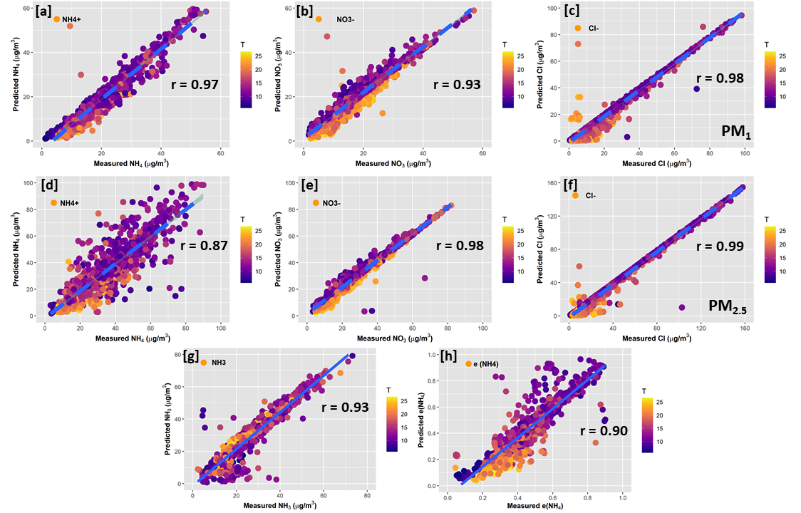

Figure S1: Comparison of ISORROPIA-II predicted and MARGA-2S measured NH₄⁺, NO₃⁻, and Cl⁻ of PM₁ (a, b, c) and PM_{2.5} (d, e, f), gas-phase NH₃ (g) and (h) gas-to-particle partitioning ratio [ε(NH₄⁺)]. The correlation (r) between the predicted and measured species concentrations are reported on each panel. Data are color-coded by ambient air temperatures (T).

