Supporting Information
Boosting immunogenic cell death via Hollow MnO₂ based multiple stimuli-responsive drug delivery systems for improved cancer immunotherapy
Yueyao Wu^{a#}, Runtian Wang^{b#}, Peiliang Shenª, Weijia Zhouª, Chao Chenª, Kaiyong Yangª, Jingjing Yang^{a,c}, Yujun Song^{c*}, Xin Han^{a,b*} and Xiaoxiang Guan^{b,d*}
ª Jiangsu Key Laboratory for Pharmacology and Safety Evaluation of Chinese Materia Medica, School of Medicine & Holistic Integrative Medicine, Nanjing University of Chinese Medicine, Nanjing 210023, China.
^{b} Department of Oncology, The First Affiliated Hospital of Nanjing Medical University, Nanjing 210029, China.
^{c}College of Engineering and Applied Sciences, State Key Laboratory of Analytical Chemistry for Life Science, Nanjing University, Nanjing, 210023, China.
^{d}Jiangsu Key Lab of Cancer Biomarkers, Prevention and Treatment, Collaborative Innovation Center for Personalized Cancer Medicine, Nanjing Medical University, Nanjing 211166, China.

*Corresponding author(s). Xiaoxiang Guan, Xin Han, Yujun Song
E-mail address(es): xguan@njmu.edu.cn
xhan0220@njucm.edu.cn
ysong@nju.edu.cn

# These authors contribute equally to this work.

Supporting schemes
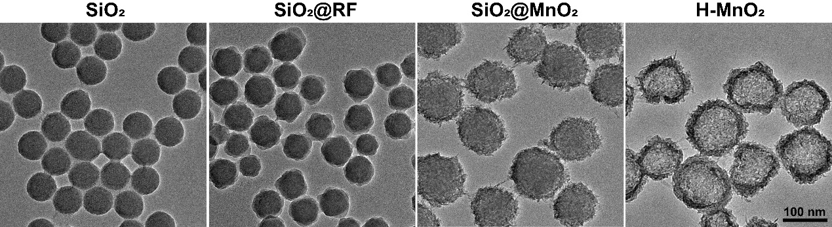
Figure S1. Synthesis process of hollow MnO₂.

Figure S2. UV–vis-NIR spectra of MnO₂-Ce6-HA and MnO₂-MTZ-HA.

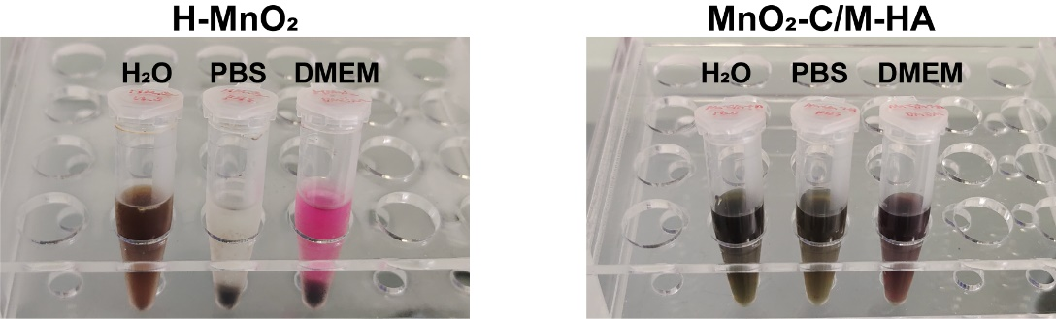
Figure S3. Physiological stability evaluation: Digital images of H-MnO₂ and MnO₂-C/M-HA dispersed in H₂O, PBS and DMEM solution for 24 h.

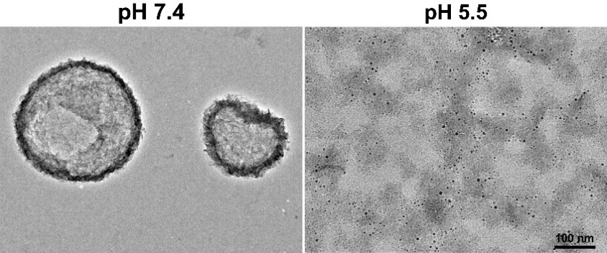
Figure S4. TEM image of H-MnO₂ at pH 7.4 and pH 5.5.

Figure S5. Fluorescence microscopic images of 4T1 cells incubated with Free Ce6 or MnO₂-Ce6-HA at different time points. Scale bar: 50 μm.

Figure S6. Cell viability of 4T1 with different concentrations of MnO₂-HA for 24 h.

Figure S7. Cell viability of 4T1 with different concentrations of MnO₂-C/M-HA with or without 660 nm (1.0 W·cm⁻², 15 min) for 24 h.

Figure S8. The cytotoxicity of 4T1 cells of varying formulations with or without 660 nm (1.0 W·cm⁻², 15 min) for 24 h in hypoxia.

Figure S9. Fluorescence microscope images of ROS generation by DCFH-DA staining in cells in hypoxia. Scale bar: 100 μm.

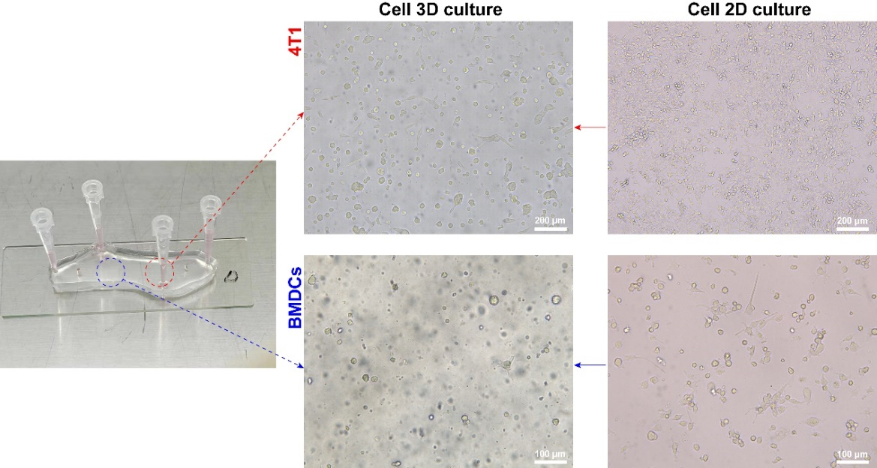
Figure S10. Schematic diagram of co-culture by non-contact communication cell chip.

Figure S11. Local structure of non-contact communication cell chip.

Figure S12. Immunofluorescence of CD11c in 3D-cell cultures of BMDCs. Scale bar: 50 μm.

Figure S13. Immunofluorescence of CD80/CD86 in 3D-cell cultures of BMDCs. Scale bar: 50 μm.

Figure S14. Ex vivo fluorescence images (12 h post-injection) of 4T1 tumor-bearing mice organs or tissue treated with free Ce6 and MnO₂-C/M-HA.

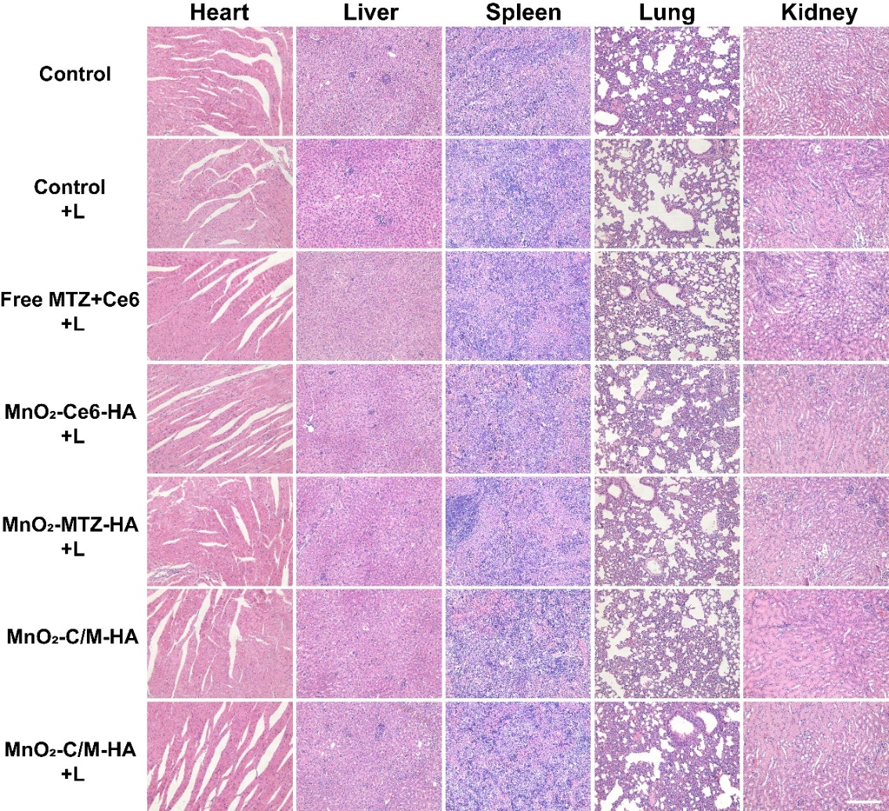
Figure S15. H&E staining of heart, liver, spleen, lung, and kidney at the end of antitumor study. Scale bar: 100 μm.

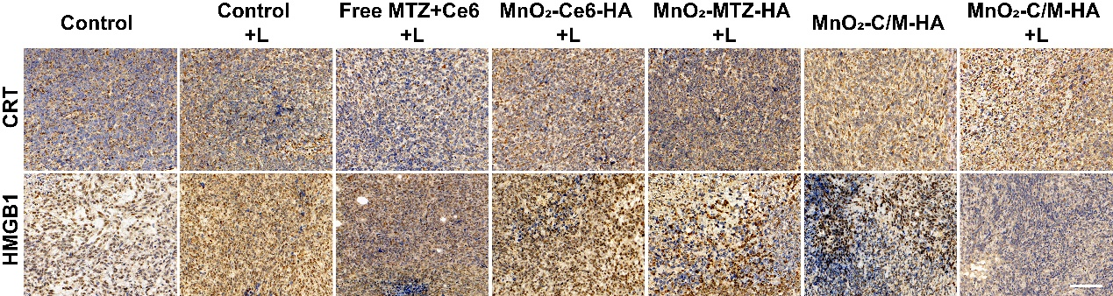
Figure S16. Immunohistochemical assay of CRT and HMGB1 in the tumor tissues after various treatments. Scale bar: 200 µm.

Figure S17. Representative flow cytometry plots showing mature DCs (CD11c⁺CD80⁺CD86⁺) after various treatments.

Figure S18. Representative flow cytometry plots showing cytotoxic T lymphocytes (CD3⁺CD8⁺) after various treatments.

Table S1. Antibodies were used for WB, FC or IF/IHC in this study.
Antibodies | Company | Catalog No. | Application
Calreticulin Rabbit Polyclonal antibody | Proteintech | 27298-1-AP | WB, IF, IHC
HMGB1 Rabbit Polyclonal antibody | Proteintech | 10829-1-AP | WB, IF, IHC
CoraLite 488-Goat anti-Rabbit IgG | Proteintech | SA00013-2 | IF
Cy3-Goat anti-Rabbit IgG | Proteintech | SA00009-2 | IF
Goat anti-Rabbit IgG | YIFEIXUE | YFSA02 | WB
Goat anti-Mouse IgG | YIFEIXUE | YISA01 | WB
GADPH Mouse Monoclonal antibody | Bioworld | AP0063 | WB
PE/Cyanine7 anti-mouse CD11c | Biolegend | 117317 | FC, IF
APC anti-mouse CD80 | Biolegend | 104713 | FC, IF
PE anti-mouse CD86 | Biolegend | 159203 | FC, IF
Brilliant Violet 421TM anti-mouse CD86 | Biolegend | 105031 | FC
APC anti-mouse CD3 | Biolegend | 100236 | FC
PE anti-mouse CD8a | Biolegend | 100708 | FC
WB: Western Blot. FC: Flow cytometry.
IF: Immunofluorescence. IHC: Immunohistochemistry.

