Supplementary Information:
Hearing dynamical Floquet-Thouless pump of sound pulse
Ping Hu¹, Hongwei Wu^{1*}, Pengxiang Xie¹, Yue Zhuo¹, Wenjun Sun¹, Zongqiang Sheng¹, Yiming Pan^{2*}
School of Mechanics and Photoelectric Physics, Anhui University of Science and Technology, Huainan 232001, China
Department of Physics, Technion, Haifa 3200003, Israel
Supplementary Notes

1.Derivation from Westervelt equations to TBA Schrodinger equation.
We would like to derive the governing wave equation for the sound propagation in our topological acoustic lattice composed of acrylic sheets in the air at room temperature (T=20 ⁰C). We suppose that our acoustic lattice is an isotropic and perfectly elastic, yet spatially inhomogeneous medium. There are three primary variables that describe acoustic dynamics¹: the particle velocity u, the mass density $ρ$, and the pressure $P$. As the three variables have values that fluctuate around a mean, we can take the small-amplitudes assumption. This assumption indicates that they are typically decomposed into the average values, and fluctuating components, in which the particle velocity is small, $u=u_{0}+\tilde{u}$, and there are only small perturbations (fluctuations) to the equilibrium density and pressure, $ρ=ρ_{0}+\tilde{ρ}, P=P_{0}+p$. For our acoustic lattice system, we assume the mean values of the velocity is zero $u_{0}=0$, the ambient density of the undisturbed air is $ρ_{0}=1.21\frac{kg}{m^{3}}$, and the ambient pressure of the undisturbed air is $P_{0}=1 atm$.
Essentially The acoustic wave is a pressure fluctuation. A change in local pressure leads immediate fluid to compress, resulting in subsequent pressure changes. Our acoustic lattice propagates a sound wave as a result of this mechanism. Therefore, instead of considering the full equations of the three variables, we just discuss the single-variable acoustic wave equation for the sound pressure fluctuation ($p$), which is given by the Westervelt equation (1963):
$$∇^{2}p-\frac{1}{{c_{0}}^{2}}\frac{∂^{2}p}{∂t^{2}}+\frac{δ}{{c_{0}}^{4}}\frac{∂^{3}p}{∂t^{3}}=-\frac{γ}{ρ_{0}{c_{0}}^{4}}\frac{∂^{2}p^{2}}{∂t^{2}}, \left(1\right)$$
where $c_{0}=\sqrt{{∂p}/{∂\tilde{ρ}}}$ is the speed of sound from the first-order term of the Taylor series expansion of the equation of state $p=p\left(\tilde{ρ}\right)$, and $γ$ is the nonlinearity coefficient from the second-order term of the Taylor series expansion. The symbol $δ$ is the sound diffusivity that has two contributions from the viscosities and heat conditions. The derivations of the Westervelt equation from the equations of motion, continuity equation, and constitutive equation can be found in the textbook of Hamilton and Blackstock (1998). Our starting points the Westervelt equation, from which we would derive the Schrödinger-like coupled-mode equations.
To further simplify the preceding equation, we must take into account the specific configuration of the acoustic lattice. The first is that the acoustic nonlinearity can be disregarded ($\frac{∂^{2}p^{2}}{∂t^{2}}≈0$) since the small-amplitude pressure is weak, and the linearization of the equation adequately describes the sound propagation,
$$∇^{2}p-\frac{1}{{c_{0}}^{2}}\frac{∂^{2}p}{∂t^{2}}+\frac{δ}{{c_{0}}^{4}}\frac{∂^{3}p}{∂t^{3}}=0, \left(2\right)$$
Second, we simplify this linear Westervelt equation by the slow-varying envelope approximation. Consider a monochromatic pressure wave $p=\tilde{p}e^{-iωt}$ with the frequency $ω$, so that the wave equation is obtained
$$∇^{2}\tilde{p}+\left(\frac{ω^{2}}{{c_{0}}^{2}}+i\frac{ω^{3}δ}{{c_{0}}^{4}}\right)\tilde{p}=0, \left(3\right)$$
Then, we assume the sound pressure mainly propagates along the z-direction, thus we can approximate the pressure as $\tilde{p}={\tilde{p}}_{z}\left(x,y,z\right)e^{ik_{z}z}$ with the wave number $k_{z}$. We calculate each terms in Eq.(3) and presented the procedure in the following:
$$\begin{matrix}∇^{2}\tilde{p}=\left(∂_{x}^{2}+∂_{y}^{2}+∂_{z}^{2}\right){\tilde{p}}_{z}\left(x,y,z\right)e^{ik_{z}z} \\ =e^{ik_{z}z}\left(∂_{x}^{2}+∂_{y}^{2}+∂_{z}^{2}+2ik_{z}∂_{z}-k_{z}^{2}\right){\tilde{p}}_{z}\left(x,y,z\right) \\ \begin{matrix}=e^{ik_{z}z}\left(∂_{x}^{2}+∂_{y}^{2}+2ik_{z}∂_{z}-k_{z}^{2}\right){\tilde{p}}_{z}\left(x,y,z\right) \\ \left(\frac{ω^{2}}{{c_{0}}^{2}}+i\frac{ω^{3}δ}{{c_{0}}^{4}}\right)\tilde{p}=e^{ik_{z}z}\left(\frac{ω^{2}}{{c_{0}}^{2}}+i\frac{ω^{3}δ}{{c_{0}}^{4}}\right){\tilde{p}}_{z}\left(x,y,z\right) \end{matrix} \end{matrix}$$
where, in the last step of the first expression, we take the slow-varying envelope approximation, $\left|∂_{z}^{2}{\tilde{p}}_{z}\right|≪\left|2ik_{z}∂_{z}{\tilde{p}}_{z}\right|$. Therefore, we obtain the paraxial wave equation
$$i∂_{z}{\tilde{p}}_{z}=-\frac{\left(∂_{x}^{2}+∂_{y}^{2}\right)}{2k_{z}}{\tilde{p}}_{z}-\frac{1}{2k_{z}}\left(\frac{ω^{2}}{{c_{0}}^{2}}-k_{z}^{2}+i\frac{ω^{3}δ}{{c_{0}}^{4}}\right){\tilde{p}}_{z}, \left(4\right)$$
In the quantum-optical analogy ($z→t$), the acoustic wave propagation along the z direction is described by the Schrodinger-type paraxial equation for the longitudinal monochromatic sound pressure. In this sense, the evolution of a sound beam in space resembles the wavefunction of an electron, with z replacing the real time t. The first term in the RHS of (4) mimics the kinetic energy term, while the second term mimics the potential term ($V\left(x,y,z\right)=-\frac{1}{2k_{z}}\left(\frac{ω^{2}}{{c_{0}}^{2}}-k_{z}^{2}+i\frac{ω^{3}δ}{{c_{0}}^{4}}\right)$) in the Schrödinger equation.
Now, let us derive the coupled mode equations from the paraxial wave equation of the Schrödinger type (4). Notice that the speed of sound $c_{0}=\sqrt{{∂p}/{∂\tilde{ρ}}}$ varies depending on the substance; for instance, in air $c_{0,air}=343\frac{m}{s}$, whereas in an acrylic sheet of Polymethyl methacrylate (PMMA) $c_{0, acr}=1430\frac{m}{s}$. [cited from https://www.rshydro.co.uk/sound-speeds/]. We investigate the periodic distribution of these acrylic sheets in space; the modulation of speed of sound in the array of location (x, z), is then analytically determined
$$c_{0}=c_{0}\left(x,z\right)=\left\{\begin{aligned}c_{0, air}, &(x,z)∈Ω_{air} \\ c_{0, acr}, &(x,z)∈Ω_{acr}\end{aligned}\right. \left(5\right)$$
For our acoustic lattice configuration, we only consider the two dimensions of the space (x, z). Notice that in our COMSOL Multiphysics finite-element-method (FEM) simulation, we set the rigid boundary for sound pressure in solid for replacing the acrylic sheets; hence, the speed of sound in the region $Ω_{acr}$ occupied by these sheets is approximately close to infinity.
Let us examine the governing equation (4). Considering the periodicity of the sound speed $c_{0}=c_{0}\left(x,z\right)$ (Eq. 5), we can consider that the potential term is given by
$$V\left(x,z\right)=-\frac{1}{2k_{z}}\left(\frac{ω^{2}}{{c_{0}}^{2}}-k_{z}^{2}+i\frac{ω^{3}δ}{{c_{0}}^{4}}\right)=\sum_{n}{V_{0}\left(x-x_{n}\left(z\right)\right)} \left(6\right)$$
where $x_{n}$ is the location of the n^{th} curved acoustic waveguide in an array and the center trajectory of the waveguide is z-dependent $x_{n}=x_{n}$ (z). $V_{0}$ is the fundamental potential of the single curved acoustic waveguide.
On each curved waveguide, we assume that the fundamental acoustic guiding modes are given by $W_{0}\left(x-x_{n}\left(z\right), z\right)$ (see Movie [x], the CW guiding wave in a curved waveguide), which can be utilized as a normalized basis for constructing the Wannier functions. Therefore, the longitudinal monochromatic sound pressure ${\tilde{p}}_{z}$ can be decomposed as follows
$${\tilde{p}}_{z}=\sum_{n}{ψ_{n}\left(z\right) W_{0}\left(x-x_{n}\left(z\right), z\right)}=\sum_{n}{ψ_{n}W_{0,n}} \left(7\right)$$
Substituting (7) into (4), let us perform the following calculations:
$$\begin{matrix}i∂_{z}{\tilde{p}}_{z}=\sum_{n}{\left(i∂_{z}ψ_{n}\right) W_{0,n}+ψ_{n}\left(i∂_{z}W_{0,n}\right) } \\ -\frac{∂_{x}^{2}}{2k_{z}}{\tilde{p}}_{z}=\sum_{n}{ψ_{n}\left(-\frac{∂_{x}^{2}}{2k_{z}}W_{0,n}\right)} \\ \left(-\frac{1}{2k_{z}}\left(\frac{ω^{2}}{{c_{0}}^{2}}-k_{z}^{2}+i\frac{ω^{3}δ}{{c_{0}}^{4}}\right)\right){\tilde{p}}_{z}=\left(-\frac{1}{2k_{z}}\left(\frac{ω^{2}}{{c_{0}}^{2}}-k_{z}^{2}+i\frac{ω^{3}δ}{{c_{0}}^{4}}\right)\right)\sum_{n}{ψ_{n}W_{0,n}}\end{matrix}$$
So that the wave equation is given by
$$\begin{matrix}\sum_{n}{\left(i∂_{z}ψ_{n}\right) W_{0,n} } \\ =\sum_{n}{-ψ_{n}\left(i∂_{z}W_{0,n}+\frac{∂_{x}^{2}}{2k_{z}}W_{0,n}\right)}-\frac{1}{2k_{z}}\left(\frac{ω^{2}}{{c_{0}}^{2}}-k_{z}^{2}+i\frac{ω^{3}δ}{{c_{0}}^{4}}\right)\sum_{n}{ψ_{n}W_{0,n}}\end{matrix}$$
We take the integration by $\int{dx W_{0,m}^{*}}$ on the LHS of the equation,
$$\begin{matrix}\int{dx W_{0,m}^{*}\left(\sum_{n}{\left(i∂_{z}ψ_{n}\right) W_{0,n} }\right)}= \sum_{n}{\left(i∂_{z}ψ_{n}\right) \int{dx W_{0,m}^{*}W_{0,n}} } \\ \begin{matrix}=\sum_{n}{\left(i∂_{z}ψ_{n}\right)}\int{dx W_{0}^{*}\left(x-x_{m}\left(z\right), z\right)W_{0}\left(x-x_{n}\left(z\right), z\right)} \\ =\sum_{n}{\left(i∂_{z}ψ_{n}\right)}δ_{m,n}=i∂_{z}ψ_{m} \end{matrix} \end{matrix}$$
where we use the orthogonality of the Wannier basis. Using the same trick, we also simplify the wave equation and obtain
$$i∂_{z}ψ_{m}=\sum_{n}{C_{n,m}}ψ_{n}, \left(8\right)$$
We take the integration by $\int{dx W_{0,m}^{*}}$ on the RHS of the equation,
$$\begin{matrix}\int{dxW_{0,m}^{*}\left(\sum_{n}{-ψ_{n}\left(i∂_{z}W_{0,n}+\frac{∂_{x}^{2}}{2k_{z}}W_{0,n}\right)}-\frac{1}{2k_{z}}\left(\frac{ω^{2}}{{c_{0}}^{2}}-k_{z}^{2}+i\frac{ω^{3}δ}{{c_{0}}^{4}}\right)ψ_{n}W_{0,n}\right)} \\ =\sum_{n}{\left(-\int{dxW_{0,m}^{*}\left(i∂_{z}W_{0,n}+\frac{∂_{x}^{2}}{2k_{z}}W_{0,n}\right)}-\frac{1}{2k_{z}}\left(\frac{ω^{2}}{{c_{0}}^{2}}-k_{z}^{2}+i\frac{ω^{3}δ}{{c_{0}}^{4}}\right)\int{dxW_{0,m}^{*}W_{0,n}}\right)ψ_{n}} \\ \begin{matrix}=\sum_{n}{\left(-\int{dxW_{0,m}^{*}\left(i∂_{z}+\frac{∂_{x}^{2}}{2k_{z}}\right)}W_{0,n}-\frac{1}{2k_{z}}\left(\frac{ω^{2}}{{c_{0}}^{2}}-k_{z}^{2}+i\frac{ω^{3}δ}{{c_{0}}^{4}}\right)δ_{m,n}\right)ψ_{n}} \\ =\sum_{n}{C_{n,m}}ψ_{n} \end{matrix}\end{matrix}$$
Then, we obtain the coupling coefficients between the acoustic waveguides
$$C_{n,m}=-\frac{1}{2k_{z}}\left(\frac{ω^{2}}{{c_{0}}^{2}}-k_{z}^{2}+i\frac{ω^{3}δ}{{c_{0}}^{4}}\right)δ_{m,n}-\int{dxW_{0,m}^{*}\left(i∂_{z}+\frac{∂_{x}^{2}}{2k_{z}}\right)}W_{0,n} \left(9\right)$$
Assuming that the coupling between the curved waveguides is weak, so the overlap integrals vanish for $\left|m-n\right|>1$, i.e., $C_{n,m}=0$. In other words, we disregard the high-order couplings except for the nearest-neighboring coupling. Consequently, we arrive at the tight-binding-approximated Schrödinger equation
$$\begin{matrix}i∂_{z}ψ_{m}=\sum_{n}{C_{n,m}}ψ_{n}=C_{m,m} ψ_{m}+C_{m+1,m} ψ_{m+1}+C_{m-1,m} ψ_{m-1} \\ =β_{m}\left(z\right)ψ_{m}+κ_{m+1,m}\left(z\right)ψ_{m+1}+κ_{m-1,m}\left(z\right)ψ_{m-1} \end{matrix} \left(10\right)$$
where the complex propagation constant and the nearest-neighboring coupling coefficients are explicitly given by
$$\begin{matrix}β_{m}\left(z\right)=-\frac{1}{2k_{z}}\left(\frac{ω^{2}}{{c_{0}}^{2}}-k_{z}^{2}+i\frac{ω^{3}δ}{{c_{0}}^{4}}\right)-\int{dxW_{0,m}^{*}\left(i∂_{z}+\frac{∂_{x}^{2}}{2k_{z}}\right)}W_{0,m} \\ κ_{m+1,m}\left(z\right)=-\int{dxW_{0,m}^{*}\left(i∂_{z}+\frac{∂_{x}^{2}}{2k_{z}}\right)}W_{0,m+1} \\ κ_{m-1,m}\left(z\right)=-\int{dxW_{0,m}^{*}\left(i∂_{z}+\frac{∂_{x}^{2}}{2k_{z}}\right)}W_{0,m-1} \end{matrix}$$
We rewrite the TBA Schrödinger equation in abbreviated form:
$$i∂_{z}ψ_{i}=β_{i}\left(z\right)ψ_{i}+κ_{i+1,i}\left(z\right)ψ_{i+1}+κ_{i-1,i}\left(z\right)ψ_{i-1}. (11)$$
Taking into account our specific setup of the acoustic waveguide array (see Fig. 1a in the main text), we may design the coupling coefficients and propagation constant
$$\begin{matrix}β_{i}=β_{0}+{\left(-1\right)}^{i}∆β\left(z\right) \\ κ_{i+1,i}=κ_{0}+∆κ(z){(-1)}^{i} \\ κ_{i-1,i}=κ_{0}+∆κ(z){(-1)}^{i-1} \end{matrix}$$
where $β_{0}=\left(β_{r}-i\frac{α}{2}\right)$ is the averaged complex propagation constant and $κ_{0}$ is the averaged coupling strength between the waveguides. Note that $α$ is the attenuation factor relating to the sound diffusivity ($δ$) as presented in the Westervelt equation (1). The staggered terms are provided by $∆β\left(z\right)=∆β_{0}\sin{(Ωz)}$,$∆κ\left(z\right)=∆κ_{0}\cos{(Ω_{F}z)\cos{(Ωz)}}$, in which the modulation frequencies - the Floquet frequency $Ω_{F}=2π/T_{F}$ (corresponding to Floquet cycle $T_{F}$) and the adiabatic frequency $Ω=2π/T$ (corresponding to adiabatic cycle $T$) are introduced by acoustic waveguide fabrication.
Compared to the second quantization formulation of the equation (11), the corresponding TBA Hamiltonian is obtained
$$H=\sum_{i}{(β_{0}+∆β(z){(-1)}^{i})c_{i}^{†}c_{i}+\sum_{i}{(κ_{0}+∆κ(z){(-1)}^{i})c_{i+1}^{†}c_{i}+h.c.}}, (12)$$
where i is the i^{th} waveguide in the array, and $c_{i}, c_{i}^{†}$ are the corresponding destruction and creation operators of the i^{th} waveguide mode. Fig. S2(b) depict the quasienergy band structure of the Floquet-Thouless Hamiltonian, which is solved by the quasienergy approach in the Floquet-Bloch theorem².
Notably, the tight-binding Hamiltonian is derived from the Westervelt equation (1) using the approximations of monochromicality, paraxiality, and linearity. With a sound pulse input, however, the monochromical assumption is invalid, so we must return to simulate the dynamics of the linear Westervelt equation (2), which is the starting point of our FEM simulation of the dynamical Floquet-Thouless pump.

2. The coupling strengths and propagation constants
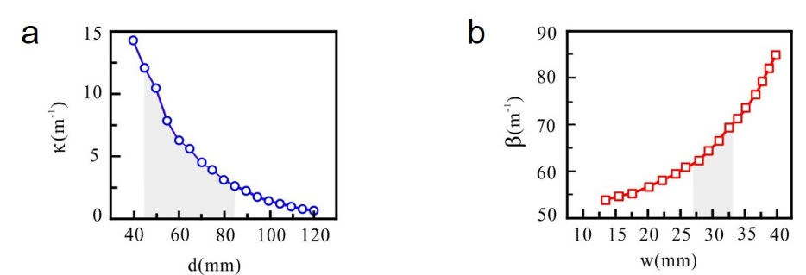
Fig.S1. The propagation constants and coupling strengths as a function of the waveguide’s width and spacing between two neighboring waveguides. (a) For the coupling strengths versus the gap d, we choose the waveguide spacing ranging from 45 mm to 85 mm. (b) The propagation constant vs the clapboard width w, in our simulations, our waveguide width varies from 27mm to 33mm.

3.Comparisons between pumping zero modes and π modes
The Rice-Mele (RM) model is implemented for pumping zero modes by modulating the waveguide width with frequency $Ω=2π/T$. As shown in Fig. S2 (a), The modulation of the width can be described in terms of the propagation constant, in our simulations, our waveguide width varies from 27mm to 33mm. The simulation result depicted in Fig. S2(a) demonstrates that the acoustic energy can be steadily pumped from one side to the other.
Similarly, as depicted in Fig. S2(b), we also designed the π-mode pumping in the array.
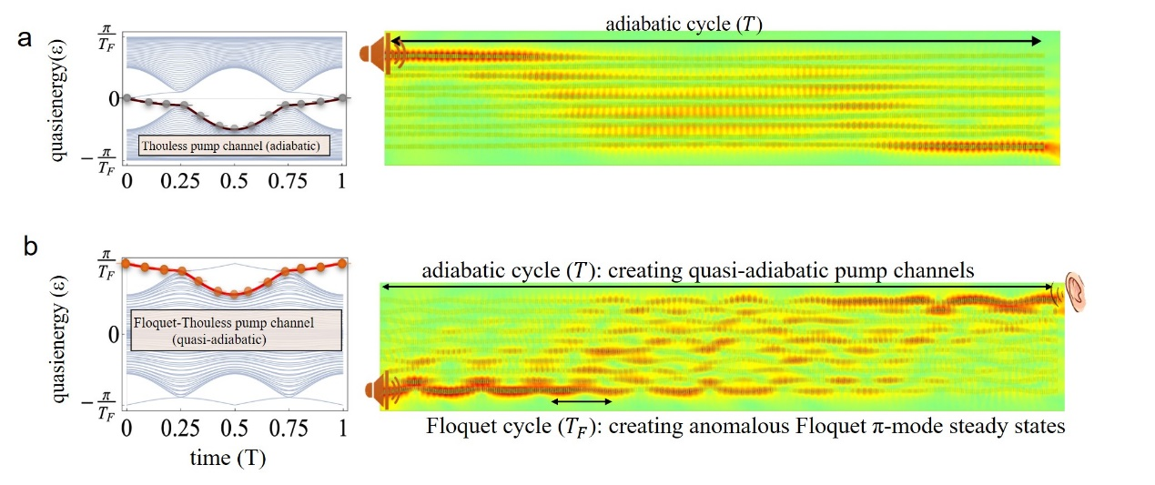
Fig.S2. Comparisons between pumping zero modes and π modes. (a) The Thouless pump (zero modes) channels in the quasienergy spectrum and the FEM simulation of the adiabatic Thouless pump (i.e., zero mode pump) based on the Rice-Mele model. (b) The Floquet-Thouless pump (π modes) channels in the quasienergy spectrum and the FEM simulation of the Floquet-Thouless pump (i.e., π mode pump) on the acoustic waveguide array.

4. Thouless pumping of acoustic pulse signal
Fig S3(a) shows a visual comparison of the difference between $π$ mode and zero modes for pulse signal transmission. Fig. S3(b) visually shows its pumping process for a pulse signal. Movie [V-4] shows the dynamical pumping over time.
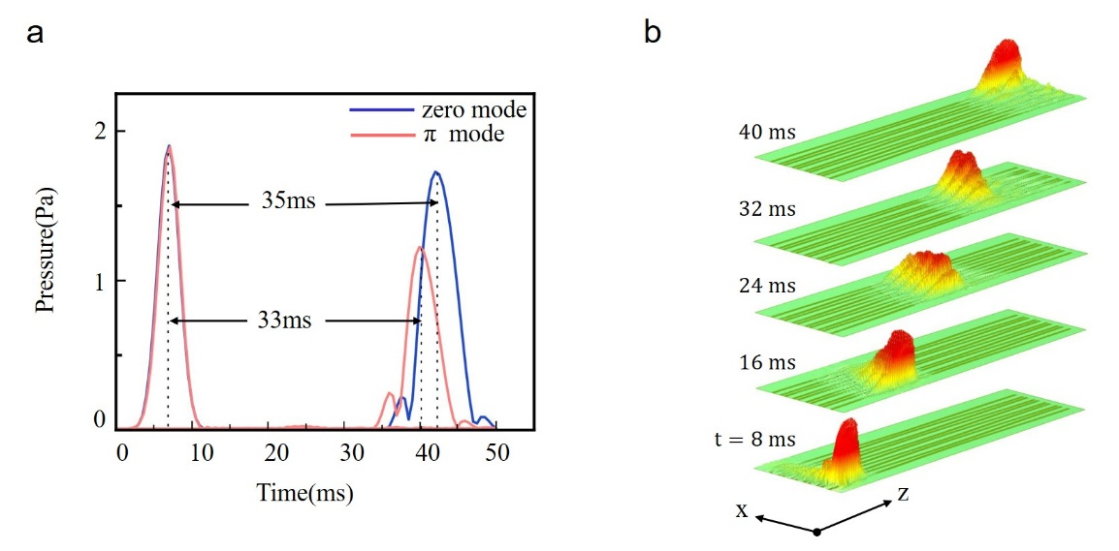
Fig.S3. Adiabatic Thouless pumping of the acoustic pulse signal. (a) Comparison of zero mode pumping and Floquet pi mode for pulse signal transmission. (b) Simulation diagram of a pulse pumping in zero-mode pump channel.

5. Comparison between experimental data and FEM simulation at the output
To investigate the pumping capability of the system over a broad acoustic frequency range, we conduct experimental measurements and finite-element simulations at two input frequencies of 2850 Hz and 2950 Hz, respectively. As shown in Fig. S4(b) and Fig. S4(c), the experimental data and simulations at the output of the tenth Floquet cycle (as shown in Fig. S4(a)) are well matched.
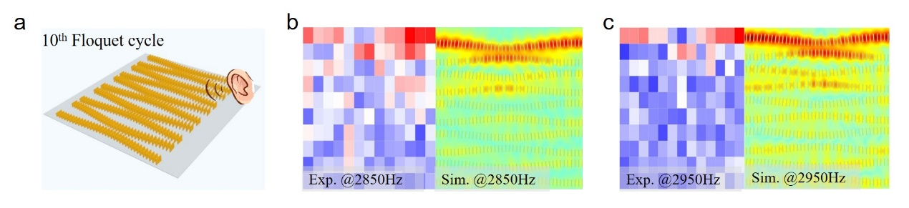
Fig.S4. The experimental data and simulations matched well at the output of the last Floquet cycle. (a) The array structure of the tenth Floquet cycle. (b) Comparison between the experimental data and FEM simulation at an input sound frequency of 2850 Hz. (c) Comparison between the experimental data and FEM simulation at an input sound frequency of 2950 Hz.

6. Movies
We create several movies to demonstrate the dynamical Floquet-Thouless pumping of sound pulse. See the separated *.avi files:
Video-1: Floquet-Thouless pulse pumping without defects.
Video-2: Floquet-Thouless pulse pumping with squared defects in the center of the array.
Video-3: Floquet-Thouless pulse pumping with circular defects in the center of the array.
Video-4: Thouless pumping of sound pulse in the adiabatic limit.
Video-5: Sound pulse propagation in a single acoustic waveguide.
Video-6: The fundamental guiding mode of a single waveguide is the Wannier basis for the second quantization of the Westervelt equation.

References
1. Blackstock, D. T. & Hamilton, M. F. Nonlinear acoustics. (Academic Press, 1998).
2. Pan, Y., Dikopoltsev, A., Lustig, E., Cheng, Q. & Segev, M. Anomalous Floquet Thouless pumping. Conference on Lasers and Electro-Optics (CLEO) (2021).

