ANNEXES
Annex 1: Full search strategy

PubMed searching strategy
1 | (“basic reproduction number” or “basic reproduction ratio” or “basic reproduction rate” or “reproduction number” or “reproduction ratio” or “reproduction rate” or R₀)
2 | (“Incidence rate” or Incidence or “new case” or magnitude or burden or “number of new cases” or IR or “Incidence density” or “cumulative incidence”)
3 | 1 OR 2
4 | (COVID-19 or coronavirus or “SARS-COV-2” or “COVID19 virus” or COVID19 or 2019-nCoV or “2019-nCoV disease” or “2019-nCoV infection” or “novel coronavirus” or “2019 novel coronavirus disease” or “2019 novel coronavirus infection” or “2019 novel coronavirus” or “coronavirus disease 2019 virus” or “coronavirus disease 2019” or “coronavirus disease-19” or “ Coronavirus Infection*” or “SARS-CoV-2” or “Wuhan coronavirus” or “Wuhan seafood market pneumonia virus”)
5 | 3 AND 4

Web of Science searching strategy
1 | TS= (“basic reproduction number” or “basic reproduction ratio” or “basic reproduction rate” or “reproduction number” or “reproduction ratio” or “reproduction rate” or R₀)
2 | TS= (“Incidence rate” or Incidence or “new case” or magnitude or burden or “number of new cases” or IR or “Incidence density” or “cumulative incidence”)
3 | 1 OR 2
4 | TS= (COVID-19 or coronavirus or “SARS-COV-2” or “COVID19 virus” or COVID19 or 2019-nCoV or “2019-nCoV disease” or “2019-nCoV infection” or “novel coronavirus” or “2019 novel coronavirus disease” or “2019 novel coronavirus infection” or “2019 novel coronavirus” or “coronavirus disease 2019 virus” or “coronavirus disease 2019” or “coronavirus disease-19” or “ Coronavirus Infection*” or “SARS-CoV-2” or “Wuhan coronavirus” or “Wuhan seafood market pneumonia virus”)
5 | 3 AND 4

Scopus searching strategy
1 | ALL (“basic reproduction number” or “basic reproduction ratio” or “basic reproduction rate” or “reproduction number” or “reproduction ratio” or “reproduction rate” or R₀)
2 | ALL (“Incidence rate” or Incidence or “new case” or magnitude or burden or “number of new cases” or IR or “Incidence density” or “cumulative incidence”)
3 | 1 OR 2
4 | ALL (COVID-19 or coronavirus or “SARS-COV-2” or “COVID19 virus” or COVID19 or 2019-nCoV or “2019-nCoV disease” or “2019-nCoV infection” or “novel coronavirus” or “2019 novel coronavirus disease” or “2019 novel coronavirus infection” or “2019 novel coronavirus” or “coronavirus disease 2019 virus” or “coronavirus disease 2019” or “coronavirus disease-19” or “ Coronavirus Infection*” or “SARS-CoV-2” or “Wuhan coronavirus” or “Wuhan seafood market pneumonia virus”)
5 | 3 AND 4

CINAHL Searching strategy
S1 | Tx “basic reproduction number” or “basic reproduction ratio” or “basic reproduction rate” or “reproduction number” or “reproduction ratio” or “reproduction rate” or R₀
S2 | Tx “Incidence rate” or Incidence or “new case” or magnitude or burden or “number of new cases” or IR or “Incidence density” or “cumulative incidence”
S3 | S1 OR S2
S4 | Tx COVID-19 or coronavirus or “SARS-COV-2” or “COVID19 virus” or COVID19 or 2019-nCoV or “2019-nCoV disease” or “2019-nCoV infection” or “novel coronavirus” or “2019 novel coronavirus disease” or “2019 novel coronavirus infection” or “2019 novel coronavirus” or “coronavirus disease 2019 virus” or “coronavirus disease 2019” or “coronavirus disease-19” or “ Coronavirus Infection*” or “SARS-CoV-2” or “Wuhan coronavirus” or “Wuhan seafood market pneumonia virus”
S5 | S3 AND S4

Annex 2: JBI quality appraisal and selection tool
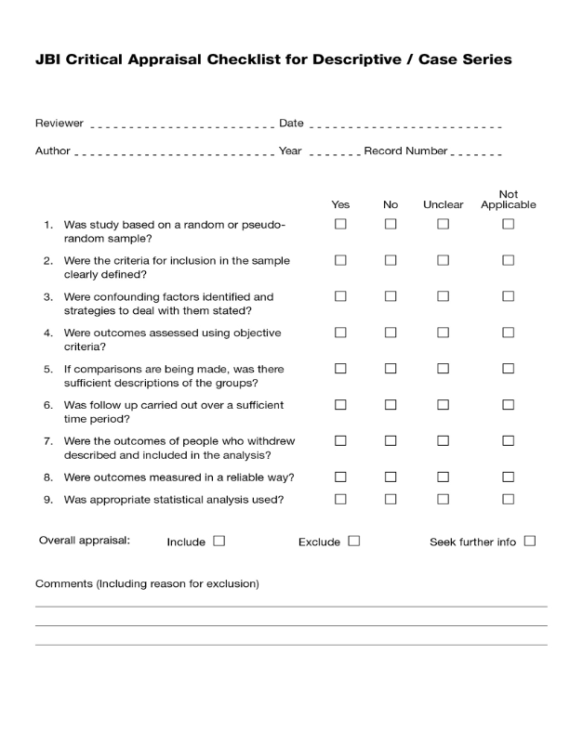
Insert page brthis is a test message
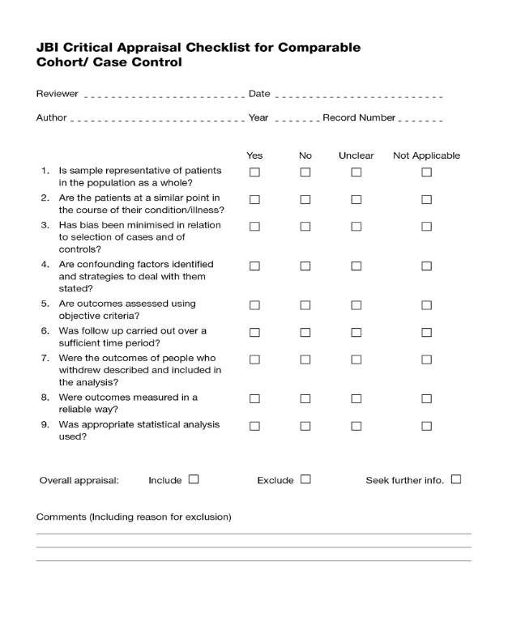
Insert page break

Annex 3: JBI-data extraction instruments
