Supporting Information

NOx Removal and Copper Recovery from the Leaching process for Waste Printed Circuit Boards: Performance Evaluation and Potential Environmental Impact Assessment
Tse-Lun Chen^{1,2}, Yen-Syun Chen¹, Po-Chi Tseng¹, Yi-Hung Chen³, Ching-Hsiang Hsu^{4,} and Pen-Chi Chiang^{1,*}
¹ Graduate Institute of Environmental Engineering, National Taiwan University, 10673, Taipei, Taiwan.
² Institute of Environmental Engineering, ETH Zürich, Zürich 8093, Switzerland
³ Department of Chemical Engineering and Biotechnology, National Taipei University of Technology, 10608, Taipei, Taiwan.
⁴ UWin Nanotech Company Limited., 236, New Taipei City, Taiwan.

The number of figures: 6
The number of tables: 3

Text S1:
In this study, 2.5 grams of copper foil were used in each batch experiment and the theoretical NO_{x} produced per batch was 0.0159 mol that calculated according to eq. S1:
$$\frac{2.5 (g)}{63 (\frac{g}{mol})}×\frac{2 (mol)}{1 (mol)}=0.0159 mol (S1)$$
The stoichiometric ratio of H₂O_{2(l)}, ClO_{2(l)}, and O_{3(g)} to react with NO_{x} are 1.5, 0.6 and 1.0, respectively. The corresponding oxidants/NOx ratios were 2.0, 1.0 and 1.5. Thus, the volumes of h H₂O_{2(l)}, ClO_{2(l)} added in each run were 0.28 mL and 53.67 mL based on the calculations as follows:
$${[H}_{2}O_{2}]=\frac{\frac{35.5}{100}}{34 (g/mol)×1.1 (\frac{{cm}^{3}}{g})}=9.5×{10}^{3} M (S2)$$
$$V_{H_{2}O_{2}}=0.00161 mol/11.49 mol/L×1000\frac{mL}{L}×2=0.28 mL (S3)$$

$$\left[ClO_{2}\right]=\frac{\frac{0.2\frac{g}{67.45g}}{mol}}{100 g×1 \frac{{cm}^{3}}{g}}×\frac{1000{ cm}^{3}}{1 L}=0.029 M (S4)$$
$$V_{ClO_{2}}=0.00161 mol/0.030mol/L×1000\frac{mL}{L}×1=53.67 mL (S5)$$
On the other hand, note that ozone was added continuously through the ozone generator,
$$[O_{3}]=\frac{\frac{83.8 g\frac{1}{48}g}{mol}}{1 m^{3}}×\frac{1{ m}^{3}}{1000 L}=0.00175 M (S6)$$
$$Q_{O_{3}}=\frac{0.0159 mol/0.00175mol/L×1000\frac{mL}{L}×1.5}{35 (min}=39.4 mL/min (S7)$$

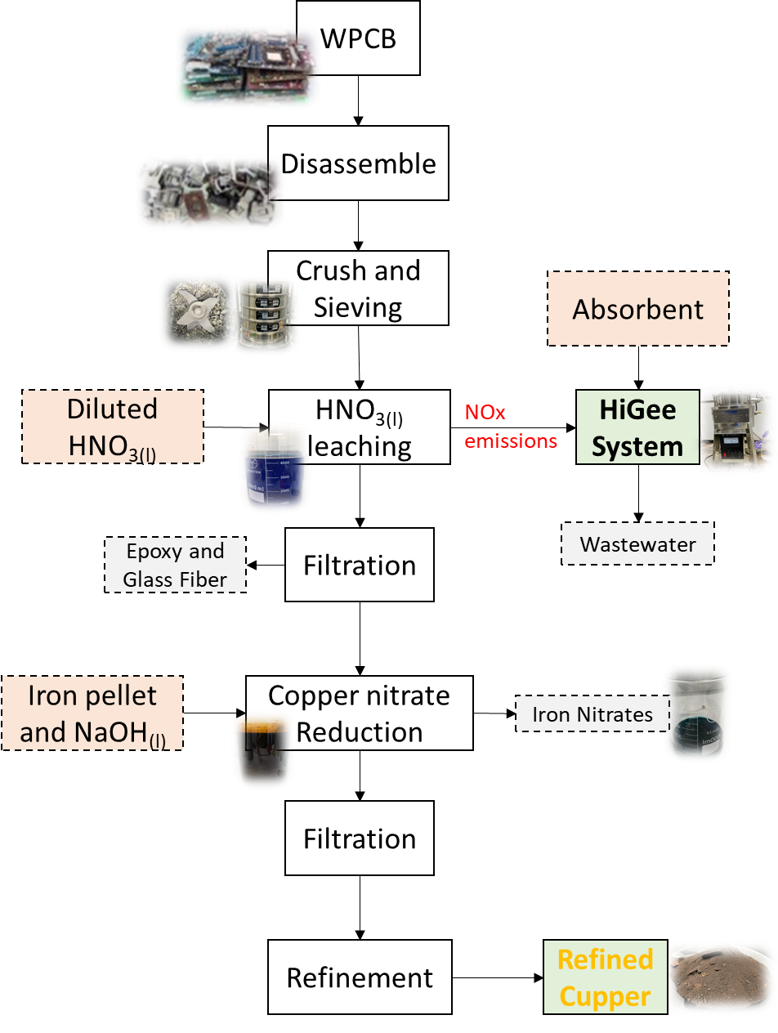
Fig. S1 Copper recovery and NOx emissions control process for WPCB treatment.

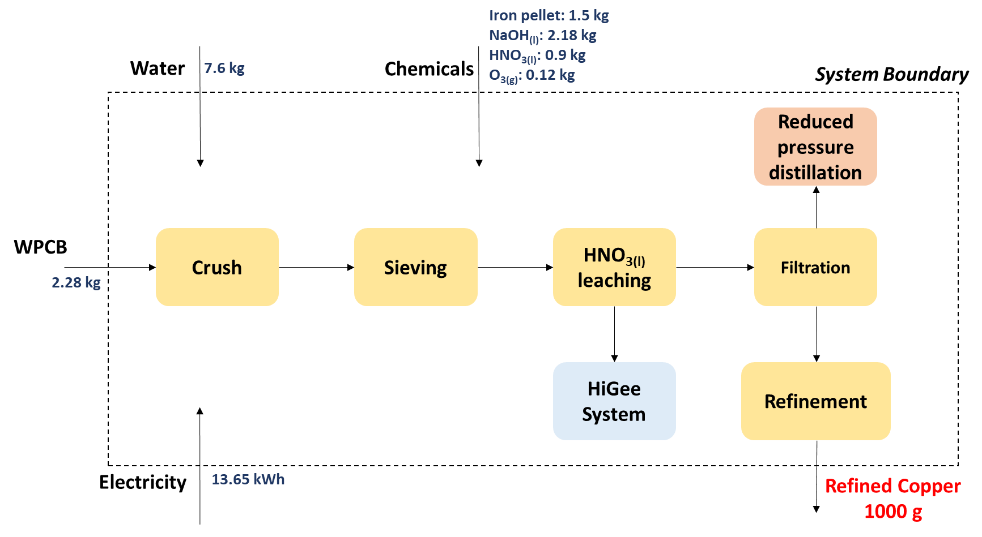
Fig. S2 System boundary of copper recovery and NOx emissions control during WPCB treatment to assessing the environmental impact. (Assumptions: functional unit is recovery of 1,000 g refined copper with NOx removal ratio of 85%, nitric acid recovery ratio of 80%, and copper recovery ratio of 100%)

Fig. S3 Boxplot of NOx, NO and NO₂ concentration during copper leaching.

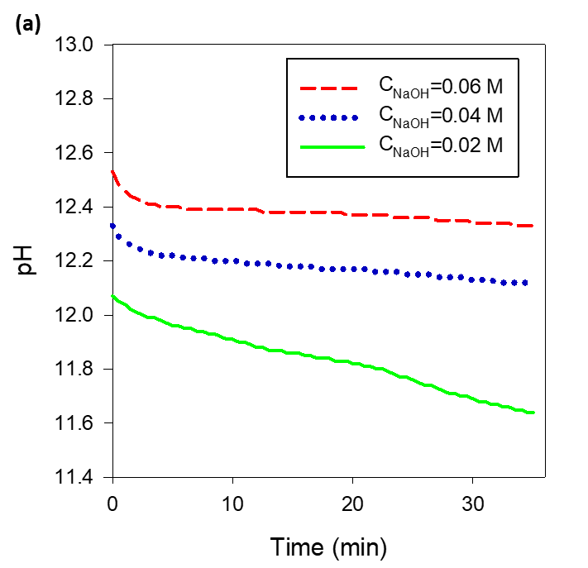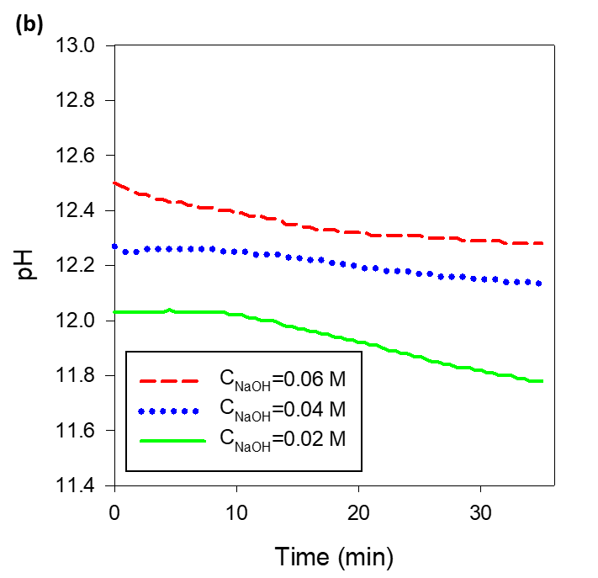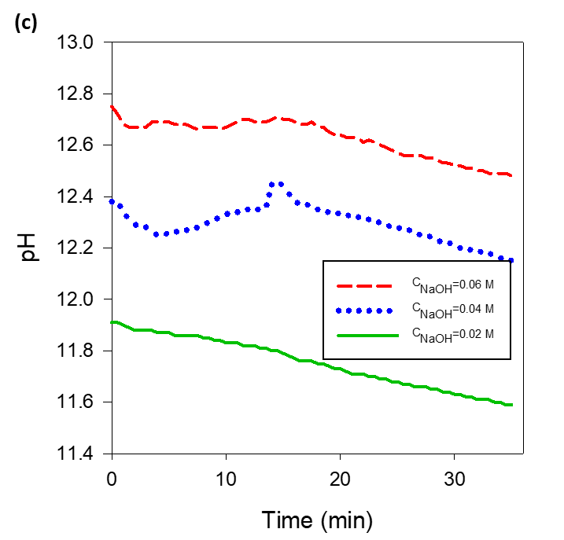
Fig. S4 Time dependent pH variation of (a) H₂O_{2(aq)}, (b) ClO_{2(aq)}, and (c) O_{3(g)} with different concentration of NaOH_{(aq)}.

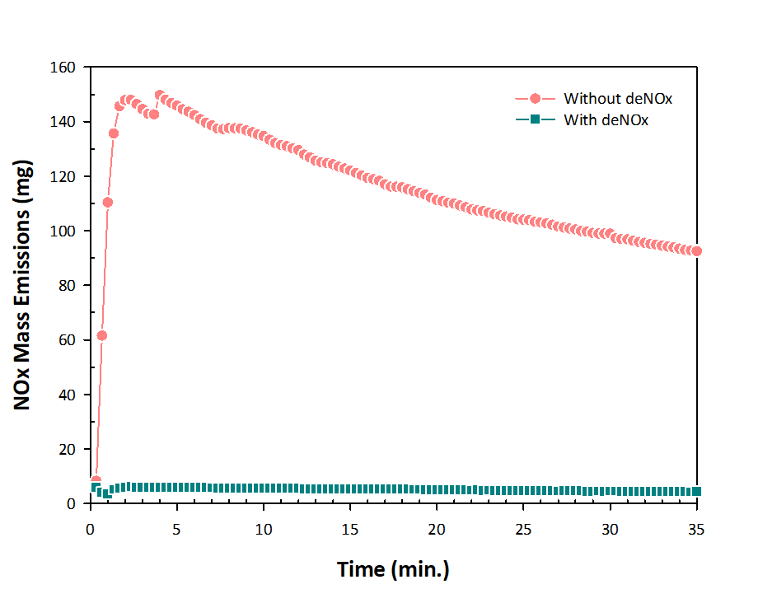
Fig. S5 NOx emissions mass contents during the crushed and sieved WPCB of HNO_{3(l)} leaching. (Experimental conditions: 5 g WPCB with nitric acid leaching, RPB was operating at β = 131 and G/L ratio = 0.83 with 0.06 M NaOH_{(aq)} addition)

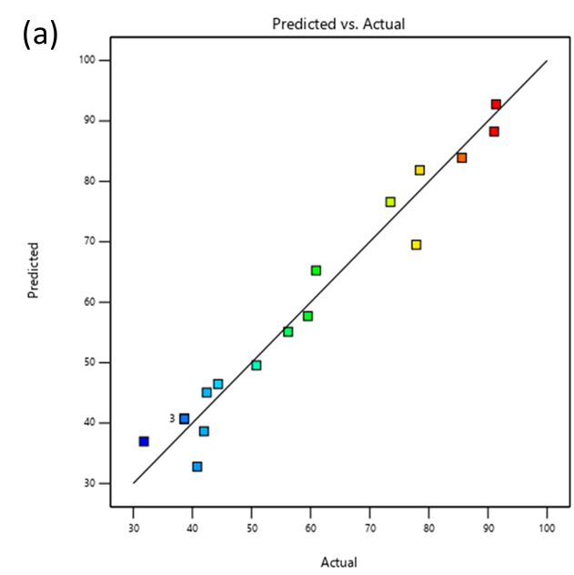
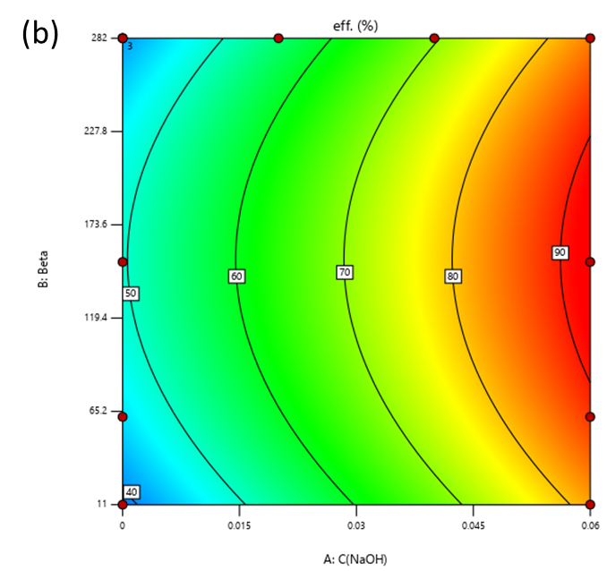
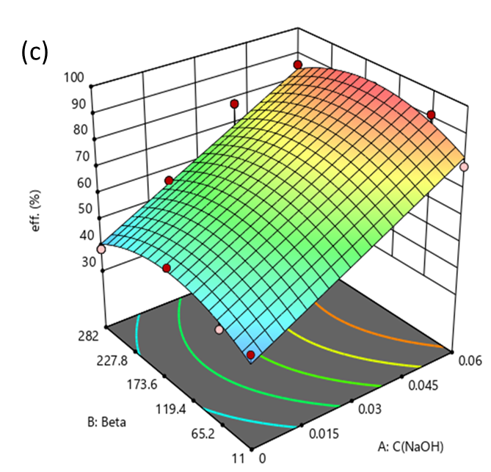

Fig. S6 (a) Comparison between actual (experimental) and predicted value, (b) Contour plot for removal efficiency for G/L ratio = 0.83, and (c) 3-D response surface plot for NO_{x} removal efficiency in G/L ratio = 0.83.

Table S1. Data inventory of input and output materials.
Process | Materials/utilities | Consumption | Outputs
Crush | WPCB | 2,280 g | WPCB powder
Crush | Crusher | 0.8 kWh | WPCB powder
Sieving | WPCB powder | 2,280 g | WPCB powder
Sieving | Sieve sorter | 0.25 kWh | WPCB powder
Copper leaching by HNO_{3(l)} | WPCB powder | 2,000 g | Copper nitrate solution  Glass fiber powder  Epoxy resin powder
Copper leaching by HNO_{3(l)} | Tap water | 4.02 L
Copper leaching by HNO_{3(l)} | 68 vol.% HNO_{3(l)} | 2.68 L
Filtration | Pump | 0.25 kWh
NOx removal using an RPB reactor | RPB reactor | 1.6 kWh | Waste water
NOx removal using an RPB reactor | Auxiliary equipment | 1.2 kWh | Waste water
NOx removal using an RPB reactor | Tap water | 1.6 L | Waste water
Copper nitrate Reduction | NaOH_{(g)} | 90.45 g | Copper powder  Iron nitrate solution
Copper nitrate Reduction | Tap water | 2.01 L | Copper powder  Iron nitrate solution
Copper nitrate Reduction | Iron powders | 1,500 g | Copper powder  Iron nitrate solution
Copper nitrate Reduction | Mixing heater | 3.2 kWh | Copper powder  Iron nitrate solution
Filtration | Pump | 0.25 kWh | Copper powder  Iron nitrate solution
Drying | Heater | 0.6 kWh | Dried copper powder
Refinement | Microwave oven | 5.5 kWh | Refined copper

Table S2. ANOVA results of establishing response surface model.
Source | Sum of Squares | Df | Mean Square | F-value | p-value
Model | 6624.12 | 6 | 1104.02 | 47.76 | < 0.0001 | significant
A-C_{NaOH} | 1522.39 | 1 | 1522.39 | 65.85 | < 0.0001
B-β | 7.49 | 1 | 7.49 | 0.3239 | 0.0007
C-G/L | 440.89 | 1 | 440.89 | 19.07 | 0.0011
AC | 437.15 | 1 | 437.15 | 18.91 | 0.0012
B² | 157.50 | 1 | 157.50 | 6.81 | 0.0243
C² | 163.00 | 1 | 163.00 | 7.05 | 0.0224
Residual | 254.30 | 11 | 23.12
Lack of Fit | 254.30 | 9 | 28.26
Pure Error | 0.0000 | 2 | 0.0000
Cor Total | 6878.42 | 17

Table S3. Input-output results from LCA analysis under three scenarios as the functional unit of 1 kg copper recovery from WPCB (Scenario 1: Copper recovery of 100% without NOx removal process, scenario 2: Copper recover ratio of 100% with NOx removal ratio of 85%, scenario 3: copper recover ratio of 95% with NOx removal ratio of 85%, and scenario 4: copper recovery ratio of 80% with NOx removal ratio of 85%)
 | items | units | Scenario 1 | Scenario 2 | Scenario 3 | Scenario 4
Input | WPCB | kg | 2.28 | 2.28 | 2.4 | 2.85
Input | Tap water | kg | 6 | 3.4 | 3.58 | 4.25
Input | Electricity | kWh | 10.85 | 13.65 | 14.37 | 17.1
Input | Iron powder | kg | 1.5 | 1.5 | 1.58 | 1.88
Input | Nitric acid | kg | 0.9 | 0.18 | 0.19 | 0.23
Input | NaOH_{(s)} | kg | 0.9 | 2.18 | 2.29 | 2.73
Input | O_{3(g)} | kg | - | 0.12 | 0.13 | 0.15
Input | NOx_{(g)} | kg | 0.0481 | -0.041 | -0.043 | -0.05
Output | Refined copper | kg | 1 | 1 | 1 | 1
Output | Waste water | kg | 5.0 | 3.4 | 3.8 | 4.25
Output | NO_{x(g)} | kg | 0.0481 | 0.0071 | 0.0074 | 0.0089
Output | Glass fiber powder (waste) | kg | 0.5 | 0.5 | 0.53 | 0.63
Output | Epoxy resin powder (waste) | kg | 0.4 | 0.4 | 0.42 | 0.50

