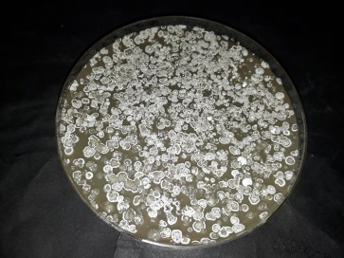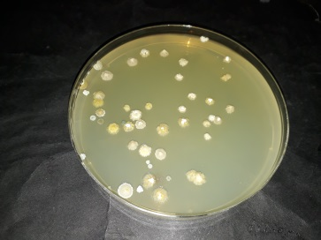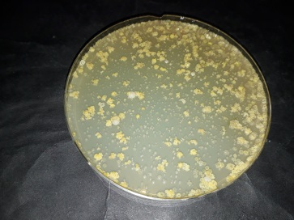
Supp. Figure 1. Some examples from Actinomycete and Streptomyces isolation plates

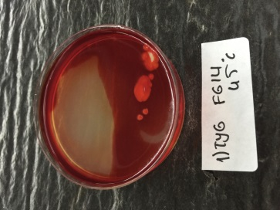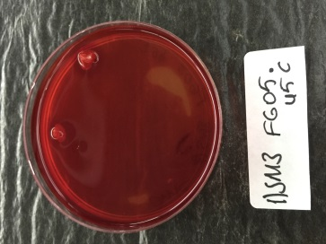
Supp. Figure 2. a)1) Cellulase test result of TYG FG14 isolate (positive result), b) Cellulase test result of 1 SM3 FG05 isolate (negative result)
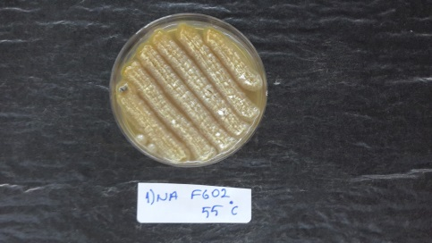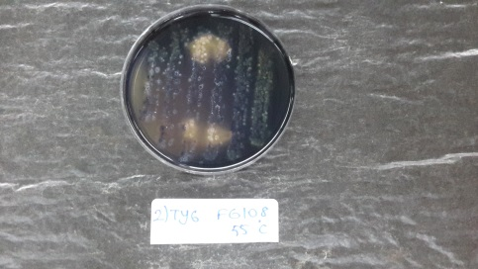
Supp. Figure 3. a) 1) Starch test result of NA FG02 isolate (positive result), b) Starch test result of TYG FG108 isolate (negative result)
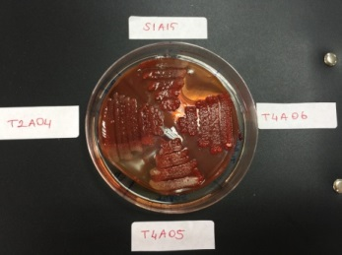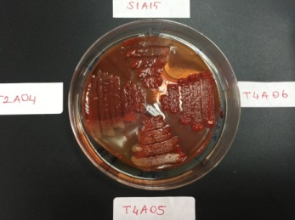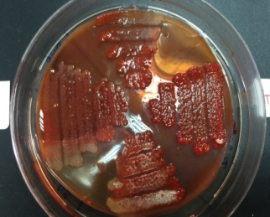
Supp. Figure 4. Xylane degradation test results

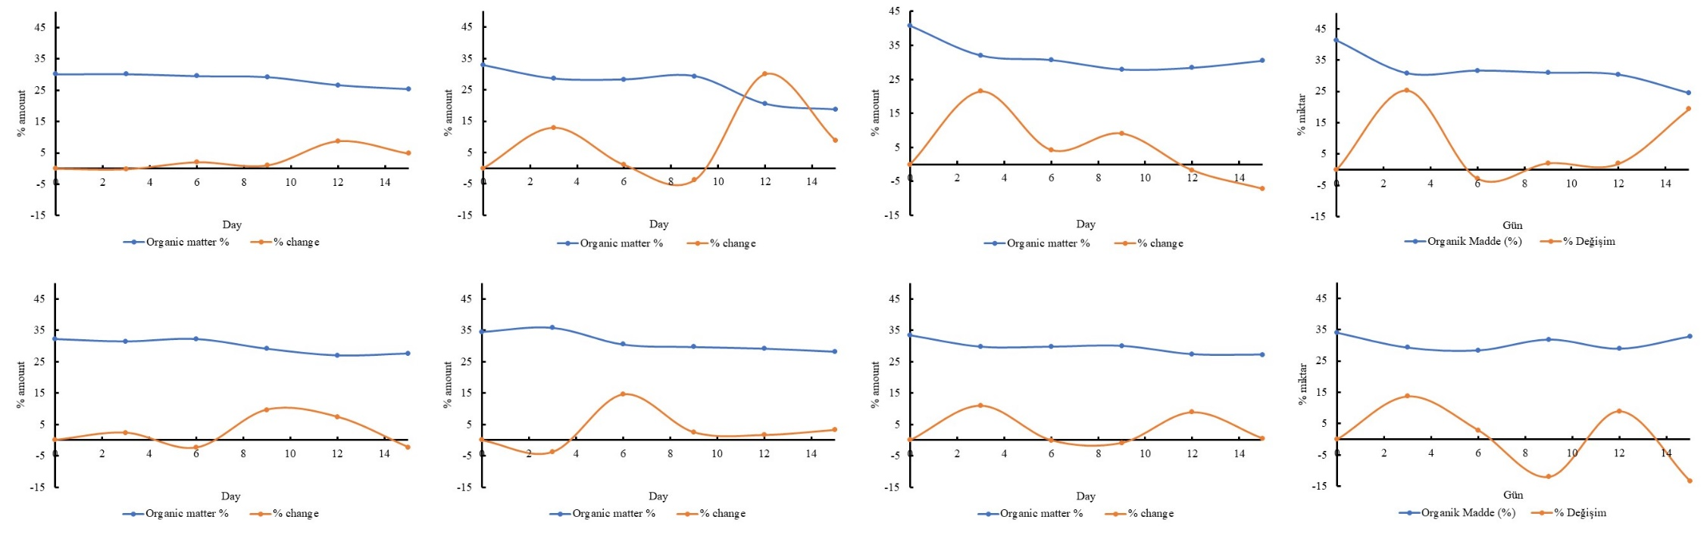

Supplementary Figure 5. Organic matter and change % of sytems Control, A, B and C (on the top from left to right) and systems AB, AC, BC and ABC (on tjhe bottom from left to right)

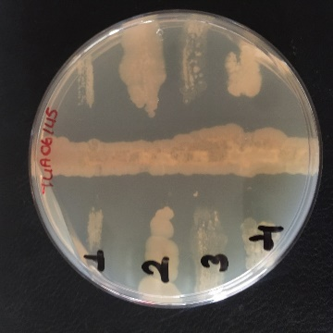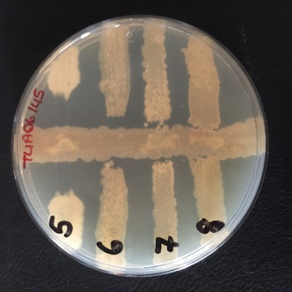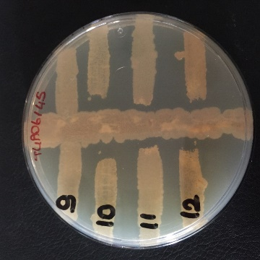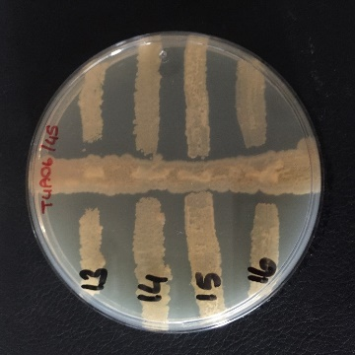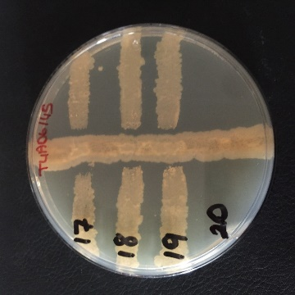
Supplementary Figure 6. Petri Images of Antagonistic Effect Test of Isolates

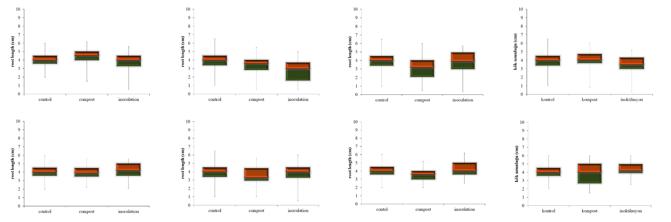

Supplementary Figure 7. Changes occurred in root lengths of compst and inoculated cucumber Systems Control, A, B and C on the top and Systems AB, AC, BC and ABC on the bottom. (All alignments (top and bottom) were given from left to right).

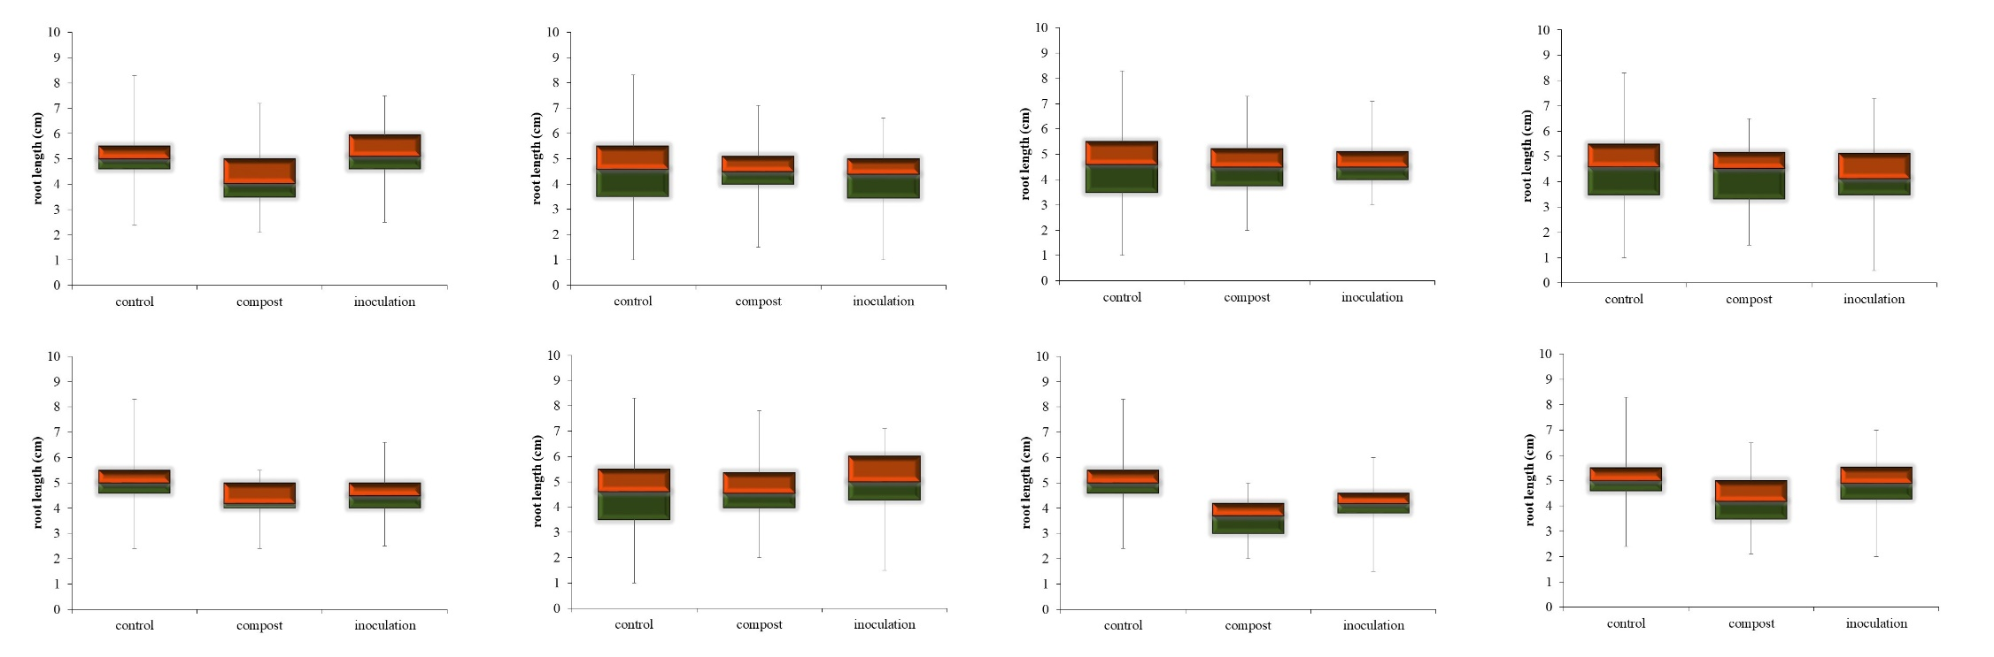

Supplementary Figure 8. Changes occurred in root lengths of compst and inoculated wheat Systems Control, A, B and C on the top and Systems AB, AC, BC and ABC on the bottom. (All alignments (top and bottom) were given from left to right).

Supplementary Figure 9. Percentage distribution graph of the 10 highest bacterial classes of all compost systems

