Strong-coupled Co_{0.85}Se/rGO composite as high-efficient electrocatalyst for oxygen evolution
Zhongbao Feng^{a,b}∗, Lili Ren^{c}, Yanting Liu^{d}, Bo Gao^{a,b}
ªKey Laboratory for Ecological Metallurgy of Multimetallic Mineral (Ministry of Education), Northeastern University, Shenyang 110819, PR China
^{b}School of Metallurgy, Northeastern University, Shenyang, Liaoning 110819, PR China
^{c}Shenyang Aircraft Industry (Group) Co. Ltd., Shenyang, 410007, China
^{d}Zhongye Changtian International Engineering Co. Ltd., Changsha, 110034, China
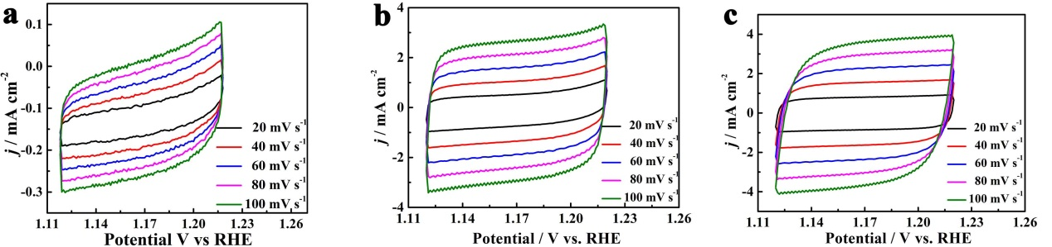
Fig. S1 CV curves of a) Co_{0.85}Se/rGO, b) Co_{0.85}Se, c) NF in the capacitance current range at various scan rates
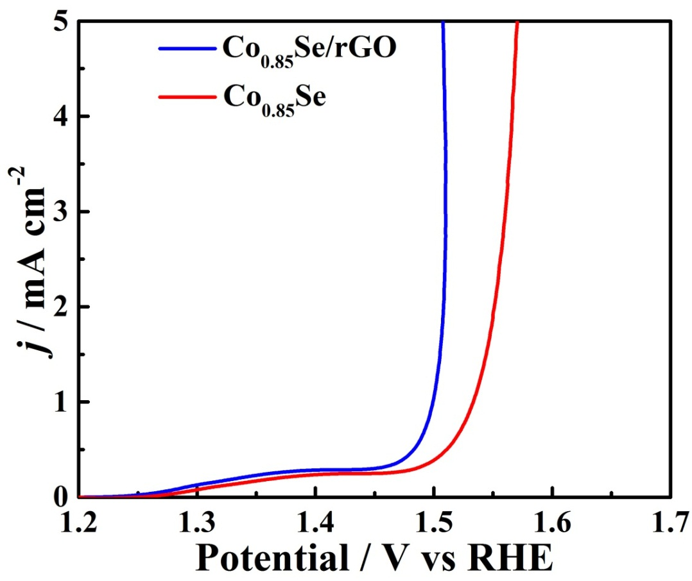
Fig. S2 LSV plots of Co_{0.85}Se/rGO and Co_{0.85}Se normalized by ECSA in 1.0 M KOH electrolyte
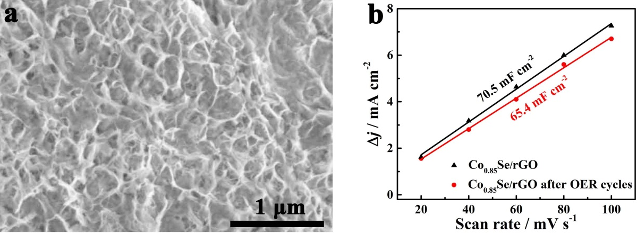 Fig. S3 a) SEM image of Co_{0.85}Se /rGO after 24 h OER long-term stability test, b) capacitive current densities of fresh and used Co_{0.85}Se/rGO after OER long-term stability as a function of scan rate (Δj = |j_{a} - j_{c}|/2)
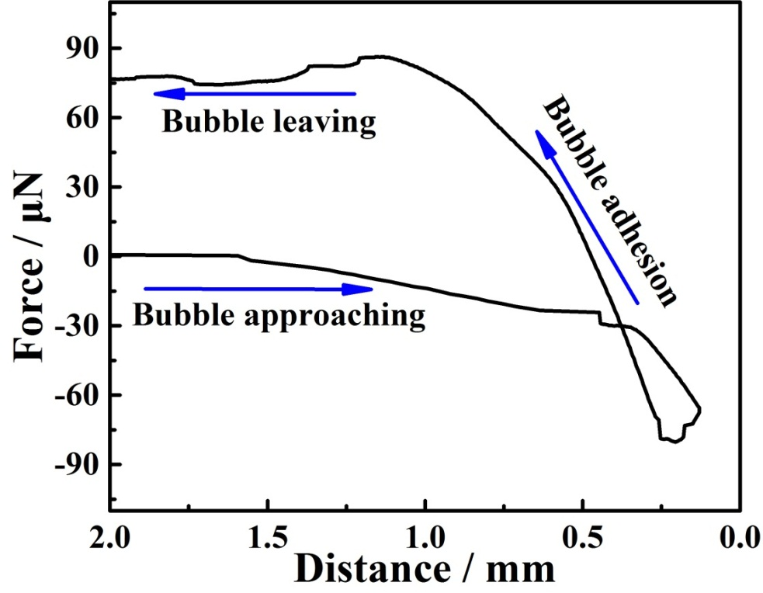
Fig. S4 Adhesive force measurements of the gas bubbles towards Co_{0.85}Se surface

Table S1 Comparision of OER performance of Co_{0.85}Se/rGO with other non-noble metal-based electrocatalysts.
Samples | Electrolyte | η (mV)@  j (mA cm⁻² ) | Tafel slope  (mV dec⁻¹) | Working electrode | Ref.
CoSe₂-D_{Fe}-V_{Co} | 1.0 M KOH | ≈400@100 | 53.5 | Glassy carbon | [S]
CoSe₂ | 1.0 M KOH | 284@10 | 46.3 | Glassy carbon | [S]
CoSe₂ | 1.0 M KOH | 310@10 | 40.1 | Glassy carbon | [S]
O–CoSe₂ | 1.0 M KOH | 252@10 | 62 | Glassy carbon | [S]
CoSe@NCNT/NCN | 1.0 M KOH | 301@10 | 75 | Glassy carbon | [S]
CoSe₂-NCNT NSA | 1.0 M KOH | 290@10 | 50.9 | Carbon cloth | [S]
CoSe₂ | 1.0 M KOH | 287@10 | 54.3 | Glassy carbon | [S]
o-CoSe₂-O | 1.0 M KOH | 251@10 | 73 | Glassy carbon | [S]
Co_{0.85}Se/rGO | 1.0 M KOH | 274@100  243@10 | 26.5 | NF | This work
References

∗ Corresponding author. E-mail address: fengzb@smm.neu.edu.cn (Z.B. Feng)
[S] Y. Dou, C.T. He, L. Zhang, H. Yin, M. Al-Mamun, J. Ma, H. Zhao, Approaching the activity limit of CoSe₂ for oxygen evolution via Fe doping and Co vacancy, Nat. Commun., 2020, 11, 1-9. .
[S] Y. Zhang, C. Zhang, Y. Guo, D. Liu, Y. Yu, B. Zhang, Selenium vacancy-rich CoSe₂ ultrathin nanomeshes with abundant active sites for electrocatalytic oxygen evolution. J. Mate. Chem. A, 2019, 7, 2536-2540.
[S] C. Zhang, B. Tang, X. Gu, L. Feng, Surface chemical state evaluation of CoSe₂ catalysts for the oxygen evolution reaction, Chem. Commun., 2019, 55, 10928-10931.
[S] B. Jia, Z. Xue, Q. Liu, Q. Liu, K. Liu, M. Liu, T.S. Chan, Y. Li, Z. Li, C.Y. Su, G. Li, Hierarchical nanotubes constructed from CoSe₂ nanorods with an oxygen-rich surface for an efficient oxygen evolution reaction, J. Mater. Chem. A, 2019, 7, 15073-15078.
[S] M. Yang, Y. Yang, K. Wang, S. Li, F. Feng, K. Lan, P. Jiang, X. Huang, H. Yang, R. Li, Facile synthesis of CoSe nanoparticles encapsulated in N-doped carbon nanotubes-grafted N-doped carbon nanosheets for water splitting, Electrochim. Acta, 2020,.337, 135685.
[S] W. Liu, D. Zheng, L. Zhang, R. Yin, X. Xu, W. Shi, F. Wu, X. Cao, X. Lu, Bioinspired interfacial engineering of a CoSe₂ decorated carbon framework cathode towards temperature-tolerant and flexible Zn–air batteries, Nanoscale, 2021, 13, 3019-3026.
[S] Z. Li, Z. Jiang, W. Zhu, C. He, P. Wang, X. Wang, T. Li, L. Tian, Facile preparation of CoSe₂ nano-vesicle derived from ZIF-67 and their application for efficient water oxidation, Appl. Sur. Sci., 2020, 504, 144368.
[S] X. Wang, L. Zhuang, Y. Jia, H. Liu, X. Yan, L. Zhang, D. Yang, Z. Zhu, X. Yao, Plasma-triggered synergy of exfoliation, phase transformation, and surface engineering in cobalt diselenide for enhanced water oxidation, Angew. Chem. Int.l Edit., 2018, 57, 16421-16425.

