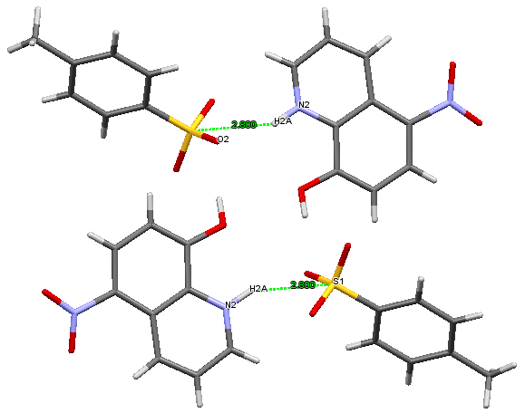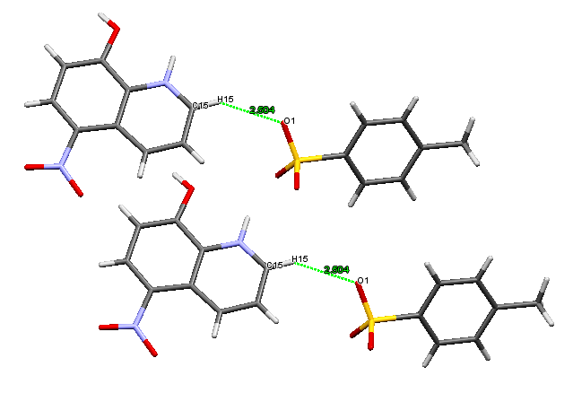
a
b
Fig.S1 Crystal (II) packing showing a) N-H…S b) C-H…O interactions (Hydrogen bonds are shown as dashed lines)

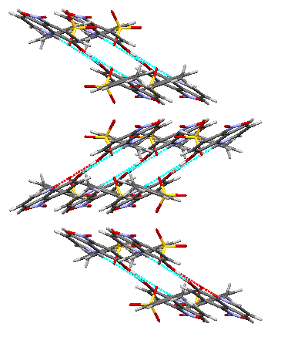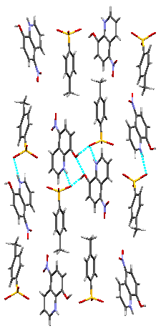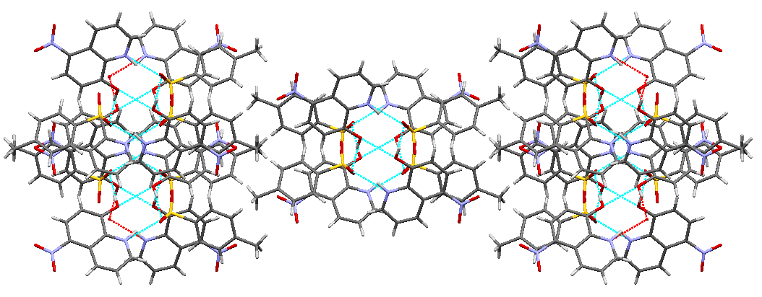
a
b
c
Fig.S2 Crystal packing showing interactions viewed along ‘a’, ‘b’ and ‘c’ axes (Hydrogen bonds are shown as dashed lines)

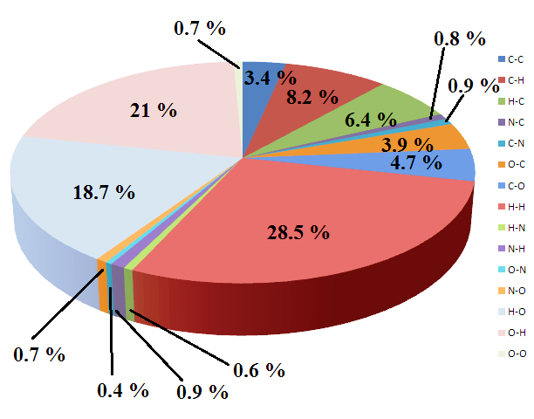
Fig.S3 Relative contributions of various intermolecular interactions in HNT

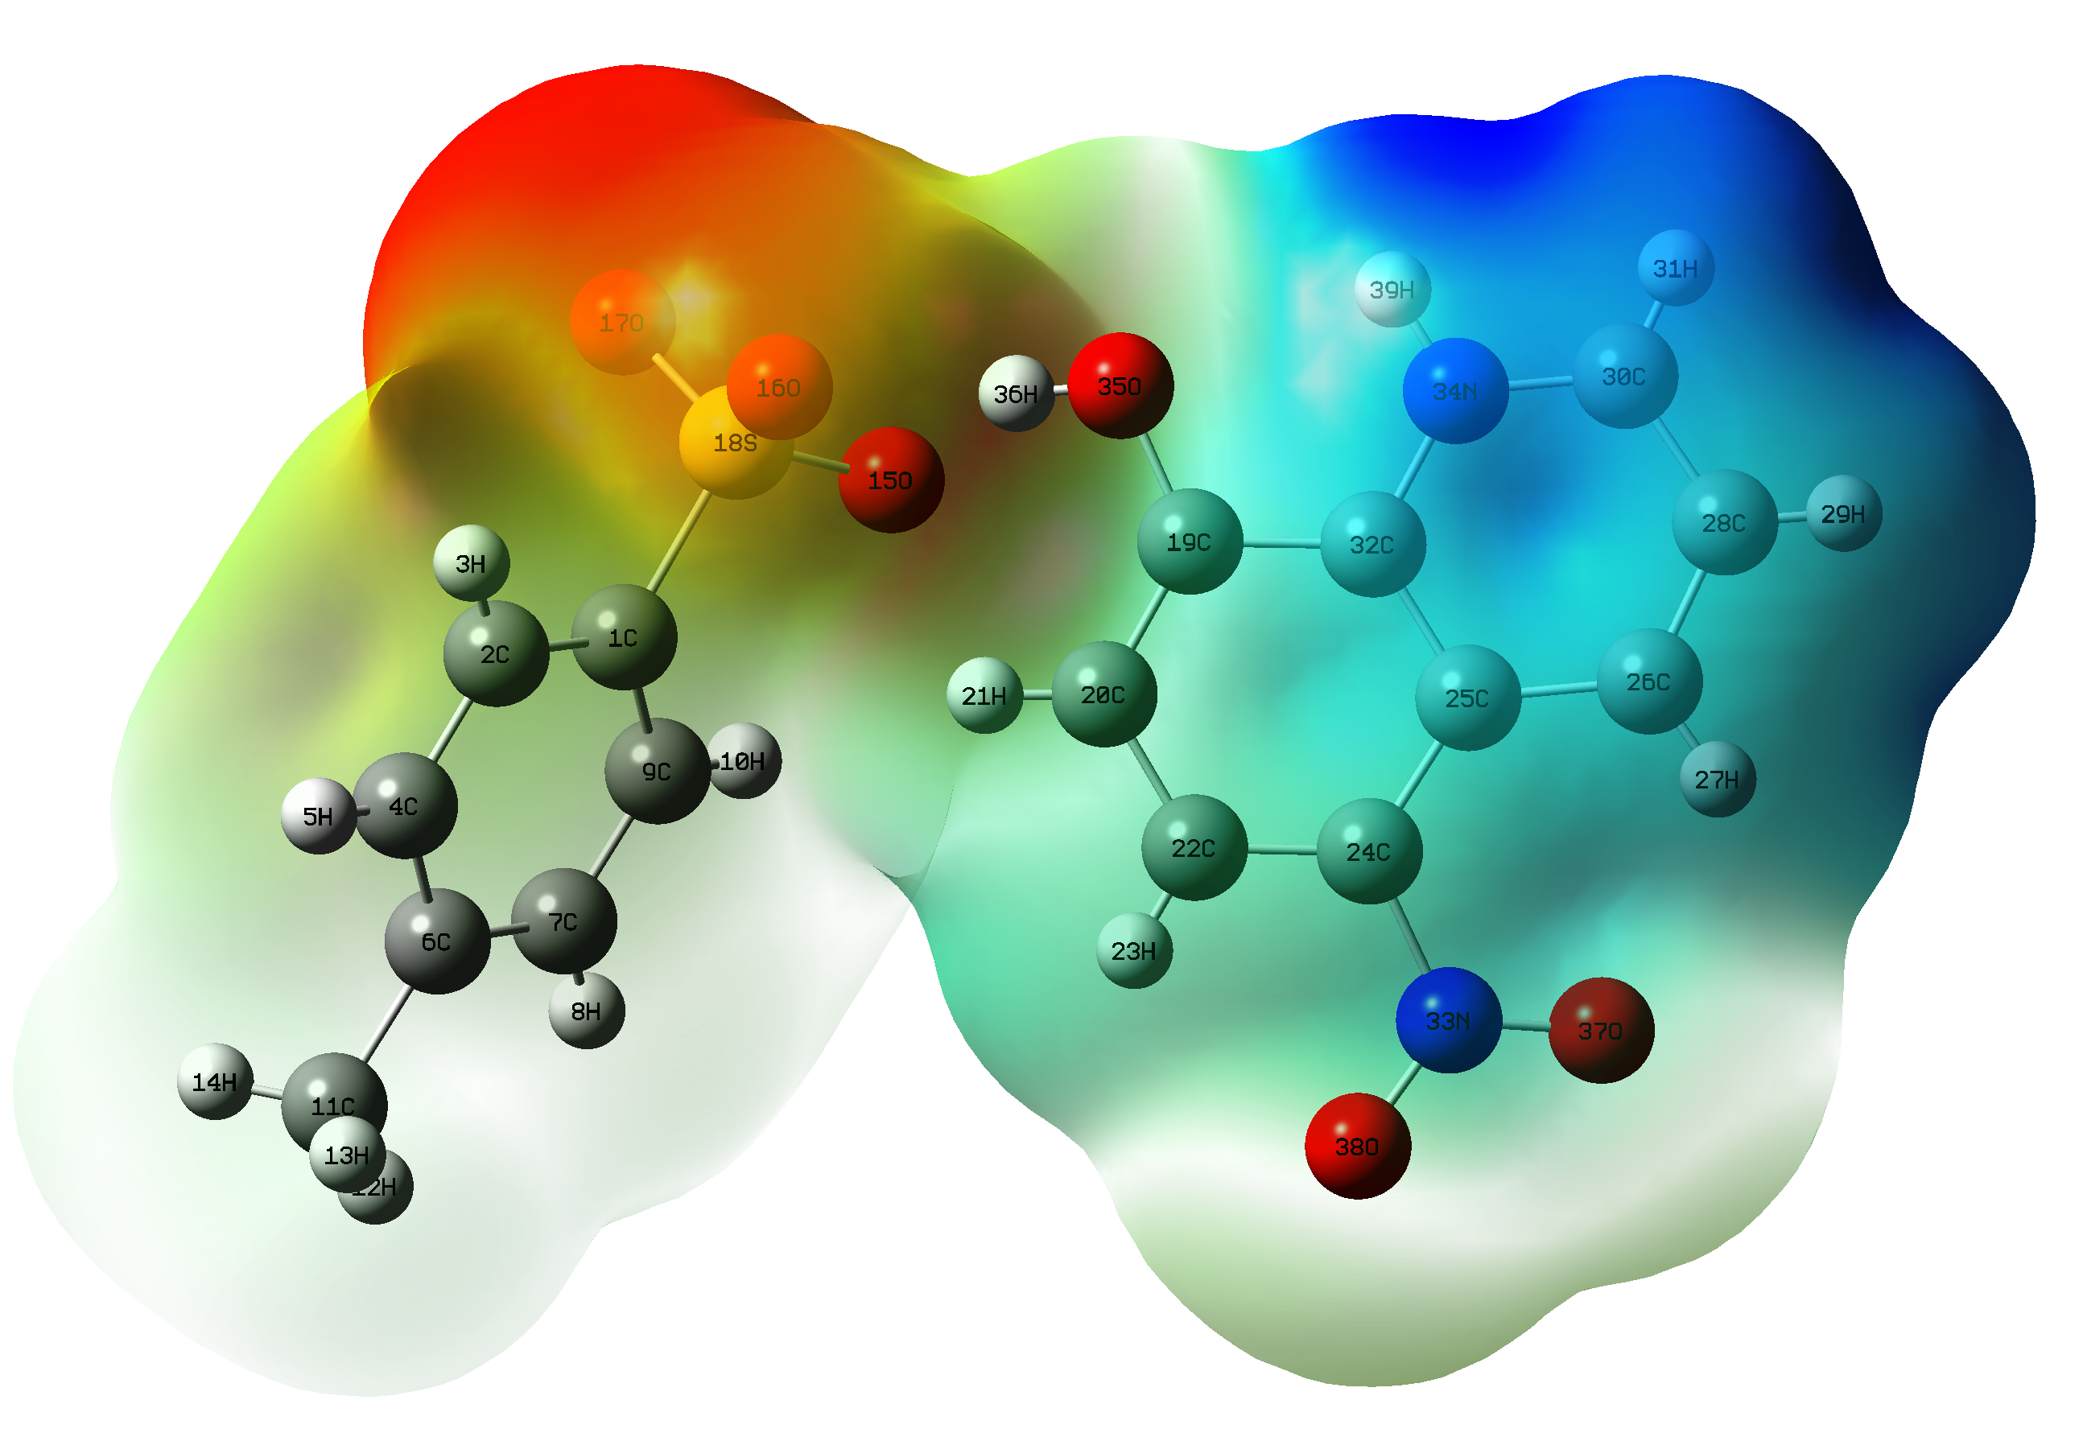
Fig.S4 Molecular electrostatic potential surface of HNT

