(Supplementary Figures)
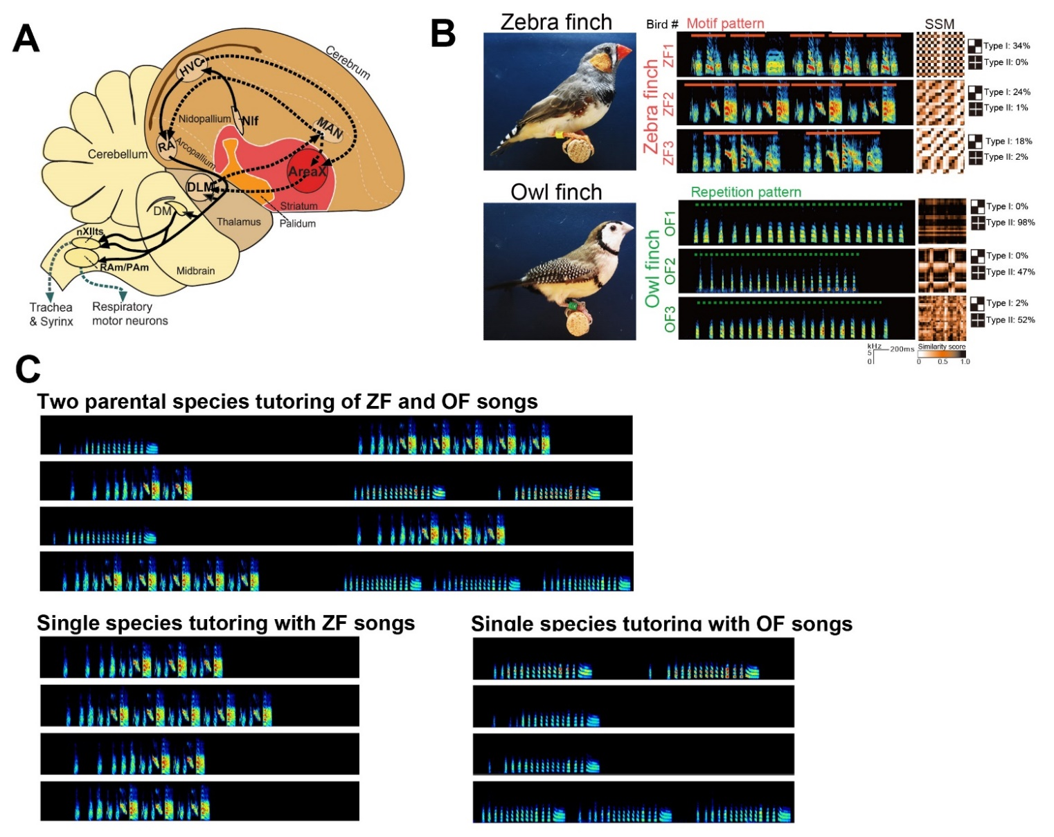

Figure S1: Song pathways and differences in zebra finch (ZF) and owl finch (OF) songs
(A) Diagram of song circuits for song learning and production. Black solid lines denote connections of the posterior vocal pathway and black dashed lines show the anterior forebrain pathway (AFP).
(B) Examples of song patterns and syllable similarity matrices (SSMs) typical of ZFs and OFs normally raised with conspecifics during the sensitive period of song learning. Type I and II matrices indicate the percentage of appearance frequency of syllable transitions associated with the motif and repetition in SSMs.
(C) Song spectrograms used for playback as tutor song models for two parental species tutoring (top), single species tutoring with ZF songs (bottom left), and with OF songs (bottom right).

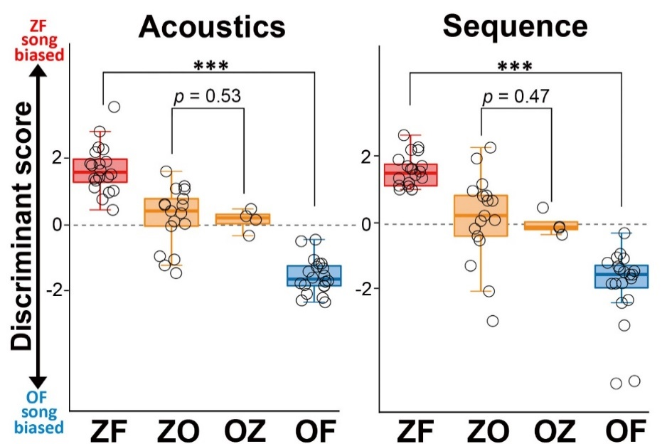

Figure S2: Comparison of the discriminant scores of the songs
Discriminant scores of acoustics (left) and sequence (right) in songs of ZFs (n = 20), OFs (n = 20), ZOs (n = 17), and OZs (n = 4). The ZFs and OFs represented here were different individuals from those used for the initial classification of LDA. p*** < 1.0 ×10⁻⁷, Kruskal–Wallis test.

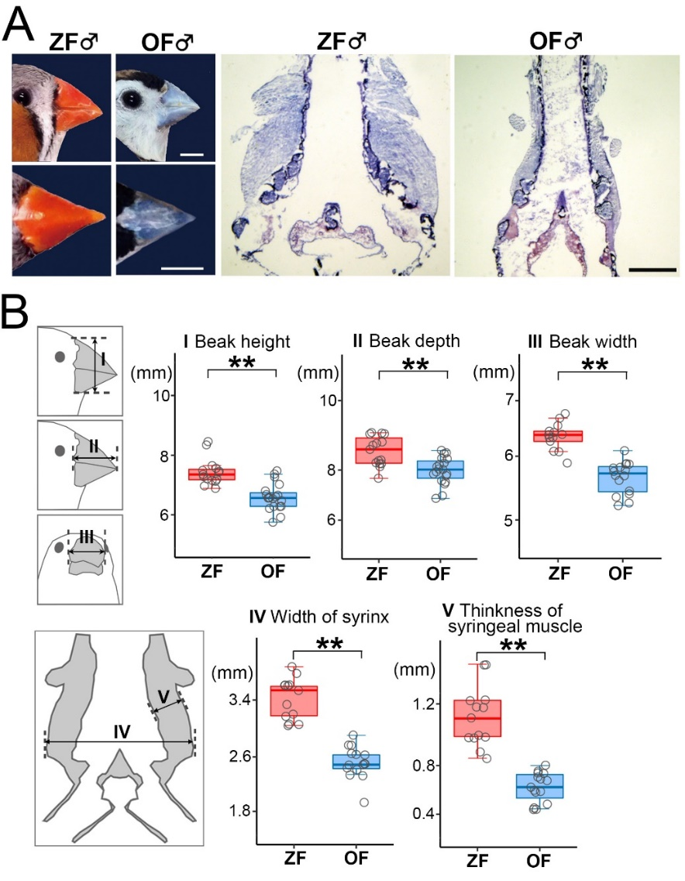

Figure S3: Differences in the morphology of the peripheral vocal organs between zebra finches (ZFs) and owl finches (OFs)
(A) Photos of beaks (left) and syrinxes (right). Scale bars = 5 mm (for beaks) and 1 mm (for syrinxes).
(B) Quantitative comparison of morphological characteristics of the beak (height, depth, and width) and syrinx (width and muscle thickness) of ZFs versus OFs. **p = 0.01; Kruskal–Wallis corrected with Bonferroni.

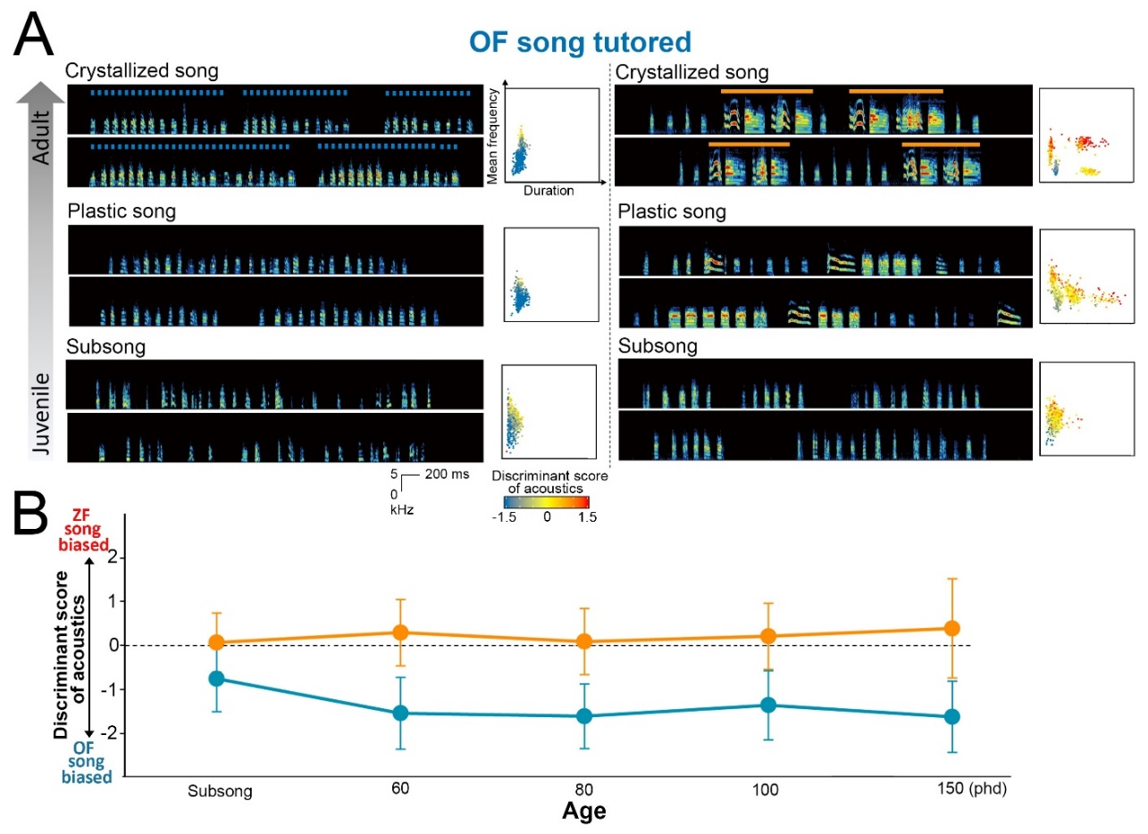

Figure S4: Song development of ZO F₁ hybrids tutored using OF songs
A: (Upper panels) Song development and syllable scatter plots of two ZO F₁ hybrids tutored using OF songs, which sang OF-biased and intermediated type songs.
B: Developmental trajectory of the song acoustic biases in the two hybrid birds above. Data plotted represent mean ± SD.

