Supplementary Materials
Intrinsic Mechanical Effects on the Activation of Carbon Catalysts
Bowen Liu,# Shuaishuai Xu,# Xinying Luo, Junjie Xiong, Zhongliang Yu, Yang Gao, Lipeng Zhang,* Qinghua Zhang, Shenlong Zhao, Binwei Zhang, Zhenhai Xia, Liming Dai,* Bin Wang*
B. Liu, S. Xu, X. Luo, J. Xiong, Z. Yu, Y. Gao, B. Wang
CAS Key Laboratory of Nanosystem and Hierarchical Fabrication, National Center for Nanoscience and Technology (NCNST), Beijing 100190, China
Email: wangb@nanoctr.cn
B. Liu, X. Luo, J. Xiong, B. Wang
University of Chinese Academy of Sciences, Beijing 100049, China
L. Zhang
State Key Laboratory of Organic-Inorganic Composites, Beijing Advanced Innovation Center for Soft Matter Science and Engineering, College of Chemical Engineering, Beijing University of Chemical Technology, Beijing 100029, China
Email: zhanglp@buct.edu.cn
Q. Zhang
Beijing National Laboratory for Condensed Matter Physics, Institute of Physics, Chinese Academy of Sciences, Beijing 100190, China
S. Zhao, B. Zhang, Z. Xia, L. Dai
ARC Centre of Excellence for Carbon Science and Innovation, University of New South Wales, Sydney, NSW 2052, Australia
E-mail: l.dai@unsw.edu.au

Figure S1. Visualization of the geometry deformation of the supporting PC substrate to extract the strain on HOPG lamina, which was demonstrated to be unreliable in our experiments. (a) The red line represents the fitted curve with shortened distance between two clamps from 0 to 7 mm. (b) Correlation between the strain ε of PC substrate and the clamp shortening distance △L.
The following equations are used to calculate the strain of the PC substrate.

$y=y_{0}+\frac{2A}{π}\frac{w}{{4(x−x_{c})}^{2}+w^{2}}$ (1)
$R=\frac{{(1+{y'}^{2})}^{\frac{3}{2}}}{\left|y''\right|}$ (2)
$ε=\frac{h}{2R}$ (3)
Formula (1) is the Lorentz function applied to fit the curves in Figure S1 and the detailed parameters are summarized in Table S1. Formula (2) is the curvature calculation formula where y’ and y” represent the first and second derivative of y in (1), respectively. In formula (3), ε, h, and R represent the strain, thickness (0.5mm), and radius of curvature of PC substrate, respectively.
Table S1. The detailed parameters of the fitted curves in Figure S1.
△L(mm) | y₀ | x_{c} | w | A
1 | -5.96499 | 8.50563 | 22.46984 | 288.06435
2 | -6.31559 | 8.04957 | 18.31473 | 276.02529
3 | -8.19676 | 7.45039 | 17.22089 | 336.14398
4 | -12.30076 | 7.02653 | 17.77999 | 480.19753
5 | -13.99708 | 6.50071 | 16.62701 | 508.76788
6 | -15.57223 | 6.07182 | 15.62804 | 525.74331
7 | -17.07801 | 5.51112 | 14.76832 | 543.64393

Figure S2. Raman spectra of HOPG lamina under the uniaxial tensile strain from 0.0 % to 3.1 %. The slight variations and no-evidence-from-the-literature made us give up the idea to use Raman signals to identify the strain applied on HOPG.

Figure S3. The specific topography pictures of the compression configuration with the shortened distance of two clamps (△L) from 0.0 to 0.8 mm and the corresponding fitted curve of clamp shortening distance and strain. The bending direction of the PC substrate was changed reversely to realize the compressive process. These topography pictures were collected by Confocal Laser Microscope in Renishaw inVia Raman spectrometer. As the curvature increases, the clarity on both sides of the focal point of Raman laser (the bright blue spot) changes due to the obvious difference in focal length caused by the curvature of the plane of focus.
Figure S4. The HAADF-STEM image of clean-HOPG at the same area with figure 3a.

Figure S5. Repeated LSV measurement to ensure the curves are in complete agreement before testing the strain effects.

Figure S6. Correlation between onset potentials at 1 μA cm⁻² and the different tensile strain of HOPG indicates a negligible negative correlation relative to the tensile strain.

Figure S7. Compressive strain effect on the clean-HOPG catalyst. (a) ORR results obtained for the clean-HOPG with the increased compressive strain ε from 0.0% to -0.8%. (the negative sign means compression) (b) Correlation between current densities of ORR at 0.4 and 0.5 V versus RHE and the different compressive strain.

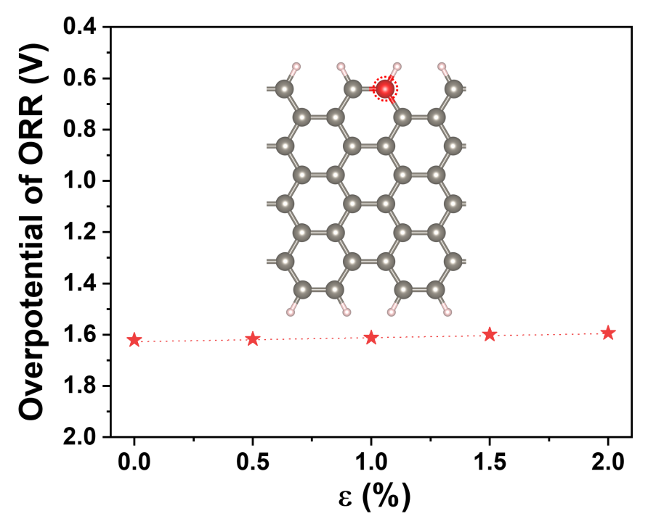
Figure S8. Correlation between overpotential of ORR and tensile strain. Inset demonstrates schematic of corresponding optimal sites in the graphene model with an armchair edge. The overpotential values are much larger than the ones on a zigzag geraphene model as shown in Figure 2c, so this the armchair edge model was not used in further simulations.

Figure S9. The free energy diagrams for the ORR at C1 site under different strains in graphene model with a zigzag edge.

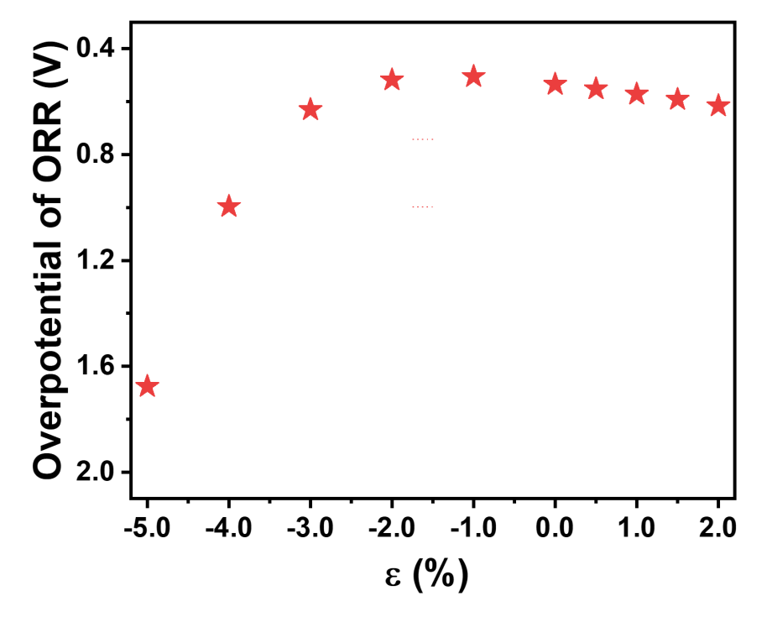
Figure S10. Correlation between the overpotential of ORR and strain in the range of -5.0 % to 2.0 %.

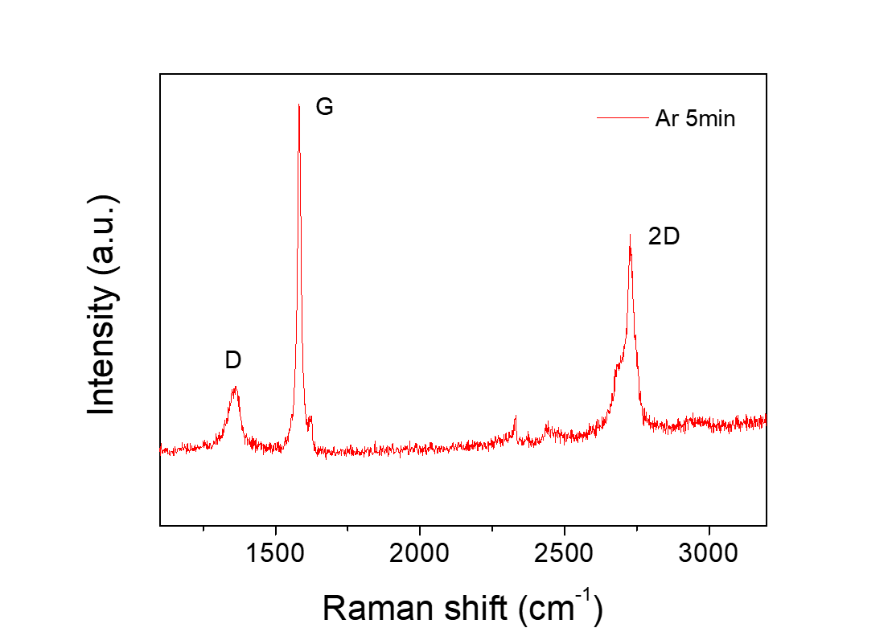
Figure S11. Raman spectrum of the defective HOPG (D-HOPG). The HOPG was treated by Ar plasma under a flow of 100 sccm at 200W for 5 min.

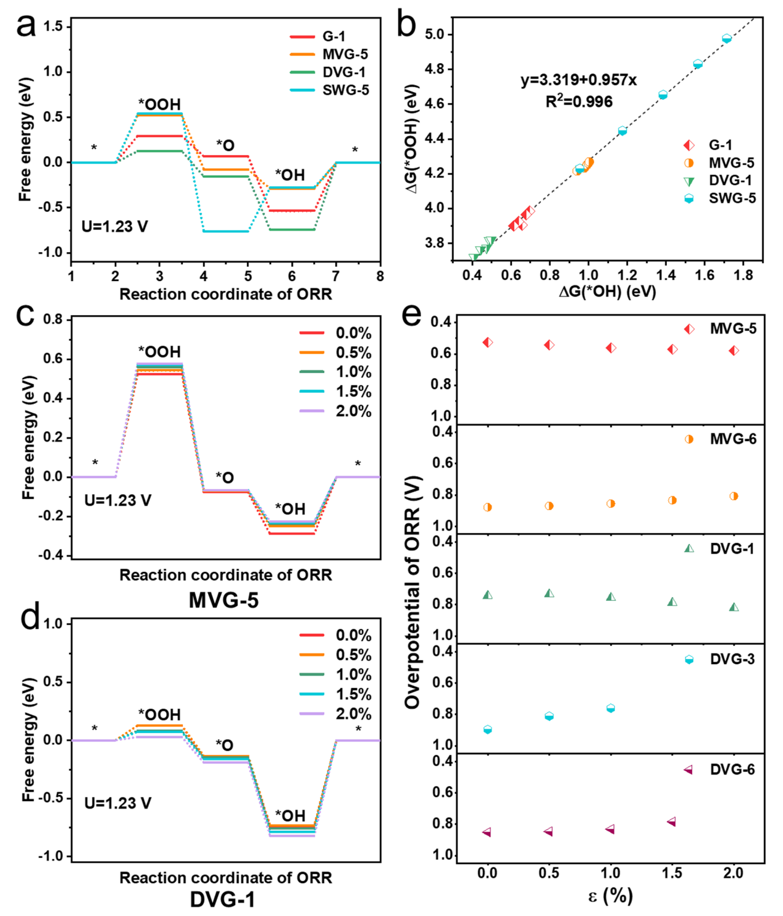
Figure S12. (a) Free energies and ORR reaction pathways at the optimal active site (marked with a red circle in Figure 4a) on each structure under strain-free conditions. (b) Linear relationship between adsorption free energy of *OOH and *OH during the ORR process for the given four optimal active sites under varied strains. Free energy diagrams for the ORR at the optimal active site under different strains (c, MVG-5) and (d, DVG-1). (e) The relationship between overpotential of different sites and strain in the MVG and DVG structures. For DVG-3 (ε=1.5% and ε=2.0%) and DVG-6 (ε=2.0%) the *O cannot be adsorbed on C sites normally, due to the excessive energy of the system,
Figure S13. Free energies and ORR reaction pathways of different sites for SWG structure under different strains.

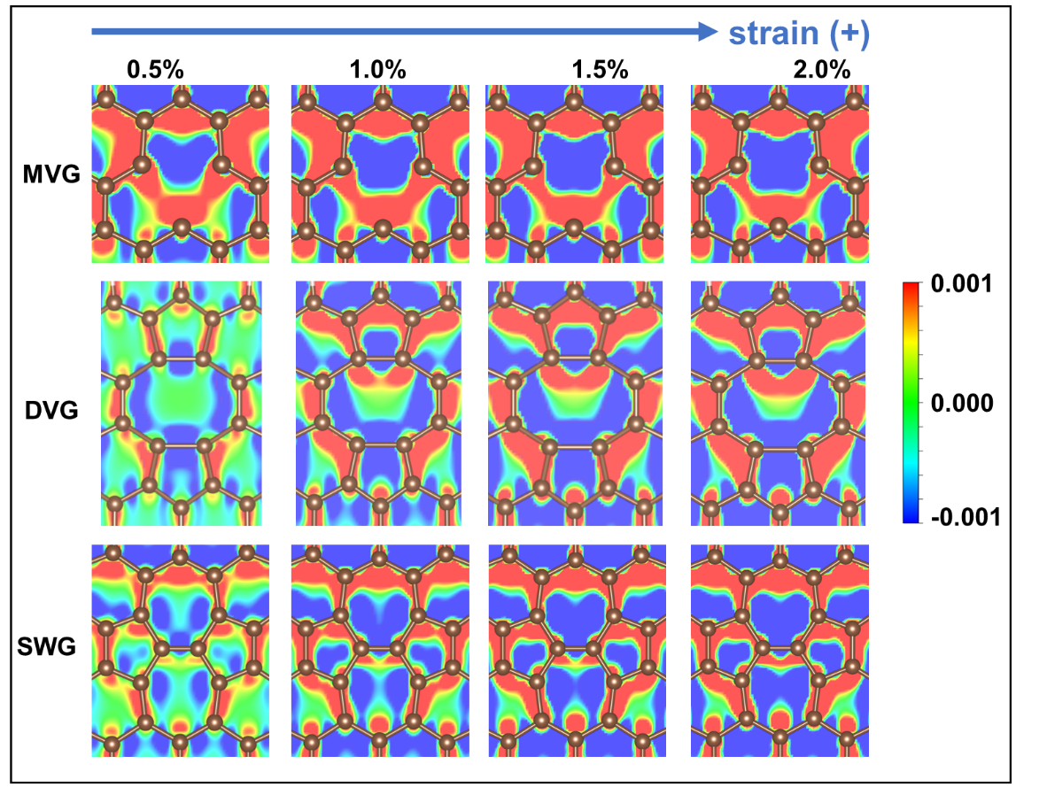
Figure S14. Variation of the charge density with strain in the defect structures.

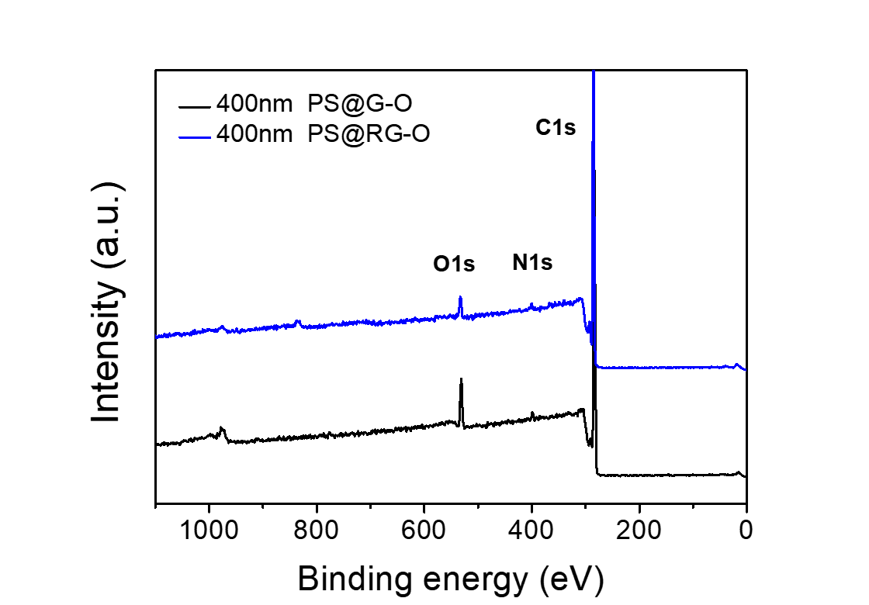
Figure S15. XPS survey spectra of 400nm PS@G-O and 400nm PS@RG-O.

Table S2. The content of C, N, and O for n-PS@G-O and n-PS@RG-O (n=400 nm, 1.3 μm, and 2.5 μm).
Sample | C % | N % | O %
400nm PS@G-O | 92.528 | 1.564 | 5.907
400nm PS@RG-O | 95.957 | 1.695 | 2.348
1.3μm PS@G-O | 93.751 | 1.527 | 4.722
1.3μm PS@RG-O | 95.114 | 1.636 | 3.25
2.5μm PS@G-O | 93.522 | 1.889 | 4.589
2.5μm PS@RG-O | 94.547 | 1.962 | 3.492

Figure S16. SEM images of n-PS, n-PS@G-O and n-PS@RG-O (n=400 nm, 1.3 μm, and 2.5 μm).

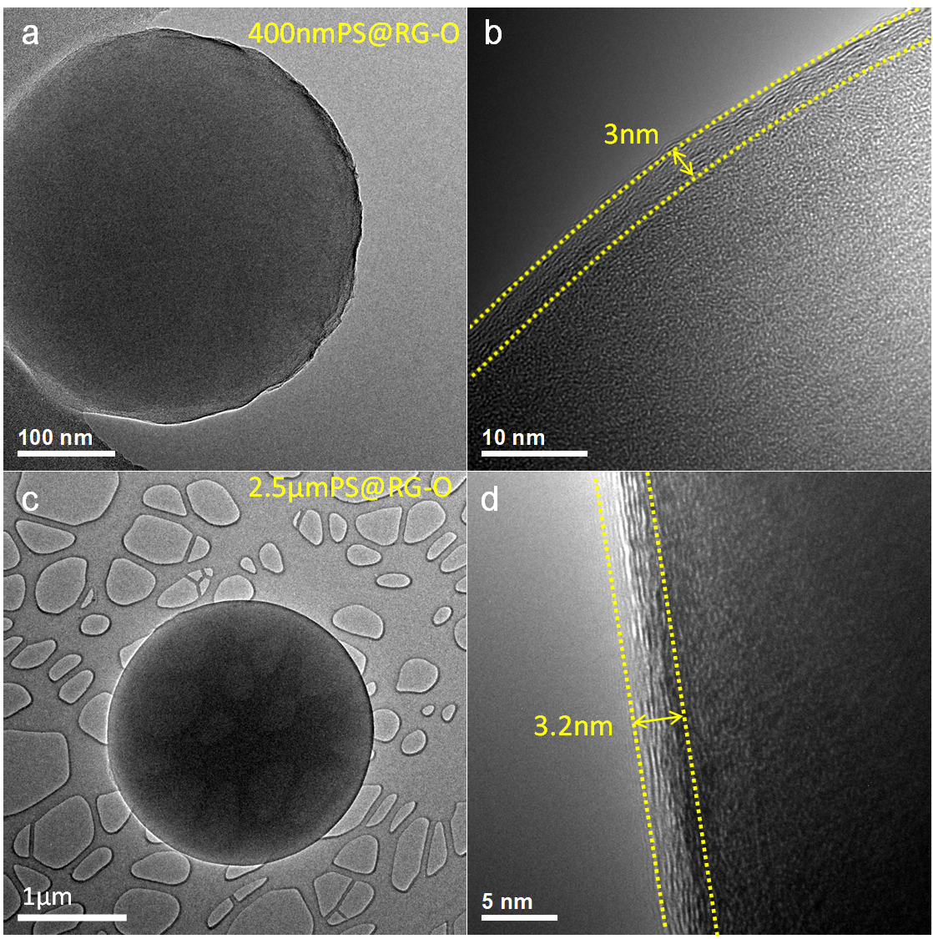
Figure S17. TEM and HRTEM images of 400 nm PS@G-O (a, b) and 2.5 μm PS@RG-O (c, d).

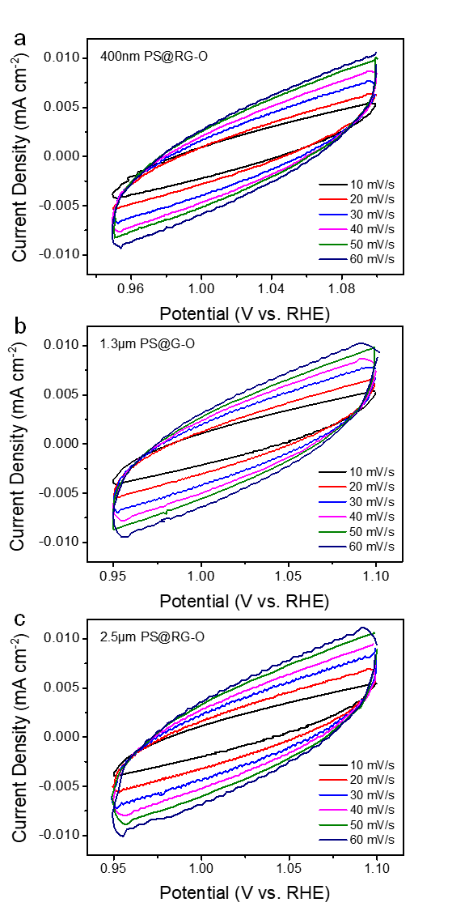
Figure S18. The electrochemical double layer capacitance (C_{dl}) estimation. Cyclic voltammetry (CV) data of (a) 400nm PS@RG-O, (b) 1.3μm PS@RG-O, and (c) 2.5μm PS@RG-O at various scan rates (10-60 mV s⁻¹).

