Supplementary Material Table of Contents
Supplementary Figure 1. Workflow of epigenome-wide association study and pyrosequencing analysis for diabetic CKD progression. CKD, chronic kidney disease; CGI, CpG island; PheWAS, phenome-wide association study; DNMT, DNA methyltransferase; RT-qPCR, reverse-transcription quantitative polymerase chain reaction; RA, Reactome; PPI, protein-protein interaction.
Supplementary Figure 2. Circos plot of the epigenome-wide association study for diabetic CKD progression. Results are presented as CpG-specific association test results (−log10(P-value)) ordered by genomic position. Red and blue symbols are presented as hyper-methylated and hypo-methylated CpG sites, respectively. CpG sites at loci reaching epigenome-wide significance (FDR <0.05 and |∆ M-value| >0.30).

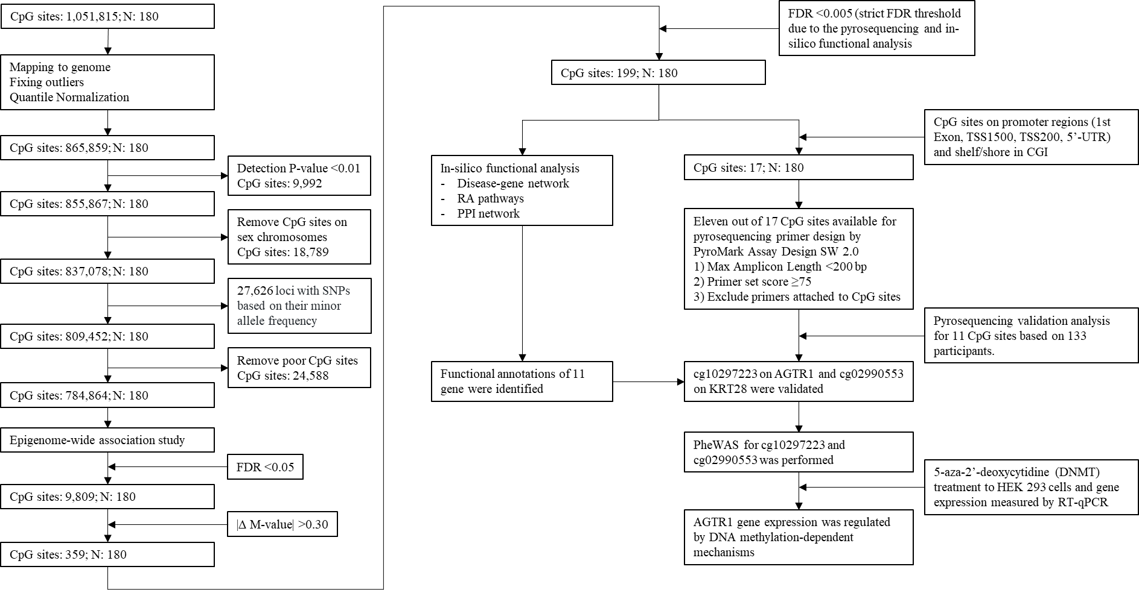
Supplementary Figure 1. Workflow of epigenome-wide association study and pyrosequencing analysis for diabetic CKD progression. CKD, chronic kidney disease; CGI, CpG island; PheWAS, phenome-wide association study; DNMT, DNA methyltransferase; RT-qPCR, reverse-transcription quantitative polymerase chain reaction; RA, Reactome; PPI, protein-protein interaction.

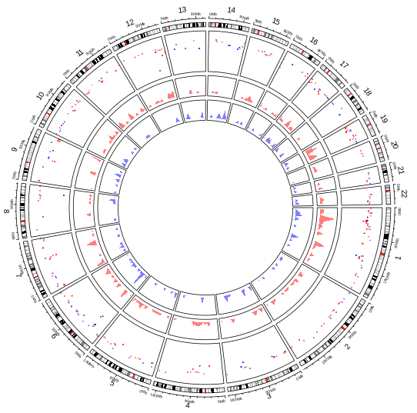
Supplementary Figure 2. Circos plot of the epigenome-wide association study for diabetic CKD progression. Results are presented as CpG-specific association test results (−log10(P-value)) ordered by genomic position. Red and blue symbols are presented as hyper-methylated and hypo-methylated CpG sites, respectively. CpG sites at loci reaching epigenome-wide significance (FDR <0.05 and |∆ M-value| >0.30).

