Supplementary Information

The emergent pattern of infant stage ocean warming in satellite measurements

Contents of this file
Tables S1 and S2
Figs. S1 to S6
References

Table S1: List of CMIP6 models and simulations used in our study. The crosses indicate whether a model simulation is available and used in our analysis.

Model | Institutes | piControl+Abrupt4xCO2 | Historical+SSP245 | 1pctCO2
ACCESS-CM2 | Commonwealth Scientific and Industrial Research Organisation; Australian Research Council Centre of Excellence for Climate System Science, Australia | + | + | +
ACCESS-ESM1-5 | Commonwealth Scientific and Industrial Research Organisation; Australian Research Council Centre of Excellence for Climate System Science, Australia |  | + | +
AWI-ESM-1-1-LR | Alfred Wegener Institute, Helmholtz Centre for Polar and Marine Research, Germany |  |  | +
AWI-CM-1-1-MR | Alfred Wegener Institute, Helmholtz Centre for Polar and Marine Research, Germany | + | + | +
BCC-CSM2-MR | Beijing Climate Center, China | + | + | +
BCC-ESM1 | Beijing Climate Center, China | + |  | +
CAMS-CSM1-0 | Chinese Academy of Meteorological Sciences, China (CAMS) |  | + | +
CanESM5 | Canadian Centre for Climate Modelling and Analysis; Environment and Climate Change Canada, Canada | + | + | +
CESM2 | National Center for Atmospheric Research; Climate and Global Dynamics Laboratory, USA | + |  | +
CESM2-FV2 | National Center for Atmospheric Research; Climate and Global Dynamics Laboratory, USA |  |  | +
CESM2-WACCM | National Center for Atmospheric Research; Climate and Global Dynamics Laboratory, USA | + | +
CESM2-WACCM-FV2 | National Center for Atmospheric Research; Climate and Global Dynamics Laboratory, USA |  |  | +
CIESM | Department of Earth System Science, Tsinghua University, China |  | + | +
CMCC-ESM2 | Euro-Mediterranean Center on Climate Change, Italy |  | +
CMCC-CM2-SR5 | Fondazione Centro Euro-Mediterraneo sui Cambiamenti Climatici, Italy | + | +
CNRM-CM6-1 | Centre National de Recherches Meteorologiques; Centre Europeen de Recherche et de Formation Avancee en Calcul Scientifique, France |  |  | +
CNRM-CM6-1-HR | Centre National de Recherches Meteorologiques; Centre Europeen de Recherche et de Formation Avancee en Calcul Scientifique, France |  |  | +
CNRM-ESM2-1 | Centre National de Recherches Meteorologiques; Centre Europeen de Recherche et de Formation Avancee en Calcul Scientifique, France |  |  | +
EC-Earth3-CC | Swedish Meteorological and Hydrological  Institute/SMHI Sweden |  | + | +
EC-Earth3-Veg | Swedish Meteorological and Hydrological  Institute/SMHI Sweden |  | +
FGOALS-f3-L | Chinese Academy of Sciences China |  | +
FGOALS-g3 | Chinese Academy of Sciences China |  | +
FIO-ESM-2-0 | First Institute of Oceanography, Ministry of Natural Resources; Qingdao National Laboratory for Marine Science and Technology, China | + | + | +
GFDL-CM4 | National Oceanic and Atmospheric Administration; Geophysical Fluid Dynamics Laboratory, Princeton, USA | + | + | +
GFDL-ESM4 | National Oceanic and Atmospheric Administration; Geophysical Fluid Dynamics Laboratory, Princeton, USA | + | + | +
GISS-E2-1-G | Goddard Institute for Space Studies, USA |  |  | +
GISS-E2-1-H | Goddard Institute for Space Studies, USA |  |  | +
GISS-E2-2-G | Goddard Institute for Space Studies, USA | + |  | +
GISS-E2-2-H | Goddard Institute for Space Studies, USA | +
ICON-ESM-LR | Max Planck Institute for Meteorology, Germany | + |  | +
IITM-ESM | Centre for Climate Change Research, Indian Institute of Tropical Meteorology Pune, India |  | + | +
INM-CM4-8 | Institute for Numerical Mathematics, Russian Academy of Science, Russia | +
INM-CM5-0 | Institute for Numerical Mathematics, Russian Academy of Science, Russia | +
IPSL-CM6A-LR | Institute Pierre Simon Laplace France |  |  | +
MCM-UA-1-0 | Department of Geosciences, University of Arizona, USA |  |  | +
MIROC-ES2L | Japan Agency for Marine-Earth Science and Technology; The University of Tokyo; National Institute for Environmental Studies; RIKEN Center for Computational Science, Japan |  |  | +
MIROC6 | Japan Agency for Marine-Earth Science and Technology; Atmosphere and Ocean Research Institute, The University of Tokyo; National Institute for Environmental Studies; RIKEN Center for Computational Science, Japan | + | + | +
MPI-ESM-1-2-HAM | ETH Zurich, Switzerland; Max Planck Institut fur Meteorologie, Germany; Forschungszentrum Julich, Germany; University of Oxford, UK; Finnish Meteorological Institute, Finland; Leibniz Institute for Tropospheric Research, Germany; Center for Climate Systems Modeling (C2SM) at ETH Zurich, Switzerland | + |  | +
MPI-ESM1-2-HR | Max Planck Institute for Meteorology, Germany | + |  | +
MPI-ESM1-2-LR | Max Planck Institute for Meteorology, Germany | + | + | +
MRI-ESM2-0 | Meteorological Research Institute, Japan | + | + | +
NESM3 | Nanjing University of Information Science and Technology, China | + | + | +
NorESM2-LM | Norwegian Meteorological Institute, Norway |  | + | +
NorCPM1 | Norwegian Climate Centre, Norway |  |  | +
NorESM2-MM | Norwegian Meteorological Institute, Norway |  | + | +
SAM0-UNICON | Seoul National University, Seoul 08826, Republic of Korea (SNU) |  |  | +
UKESM1-0-LL | Met Office Hadley Centre, Fitzroy Road, Exeter, UK |  |  | +

Table S2: List of models used in the analysis of mid-Pliocene sea surface temperature anomalies.

Model Name | List of institutes which contribute to the simulations | Data reference
CESM2 | National Center for Atmospheric Research, USA | Danabasoglu, Gokhan (2020)
COSMOS | Alfred Wegener Institute, Helmholtz Centre for Polar and Marine Research, Germany | Stepanek et al. (2020)
EC-Earth3-LR | Stockholm University, Sweden | EC-Earth Consortium (EC-Earth) (2020)
GISS-E2-1-G | National Aeronautics and Space Administration; Goddard Institute for Space Studies, USA | NASA Goddard Institute for Space Studies (NASA/GISS) (2019).
HadGEM3-GC31-LL | Hadley Centre for Climate Prediction and Research/Met Office, UK | Williams et al. (2020)
IPSL-CM6A-LR | Laboratoire des sciences du climat et de l'environnement, France | Boucher et al. (2019)
NorESM1-F | Norwegian Research Centre; Bjerknes Centre for Climate Research | Guo et al. (2019)

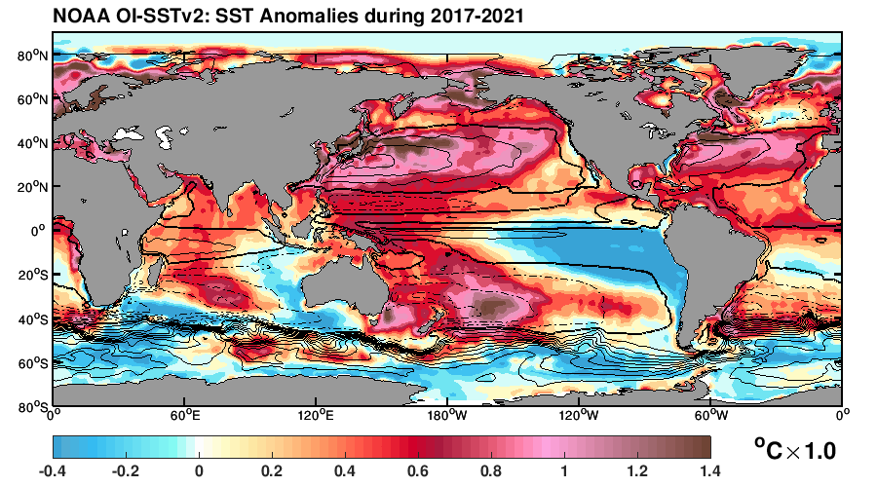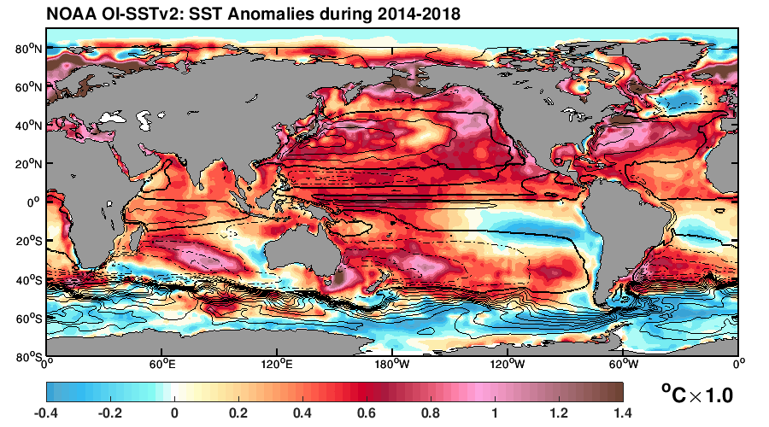
Fig. S1. Persistent pattern of strong subtropical ocean warming during two most recent 5 year time periods. Sea surface temperature (SST) anomalies during 2017-2021 (upper panel), and 2014-2018 (bottom panel), with respect to the first 5-years (1982-1986) of satellite observations. To illustrate the position of subtropical ocean gyres for comparison, the climatology barotropic streamfunction based on the AWI-ESM preindustrial control simulation is overlapped by the black contours. Solid lines indicate clockwise flow, dashed lines indicate anti-clockwise flow. Thickened black lines mark the zeros-crossing of barotropic streamfunction.

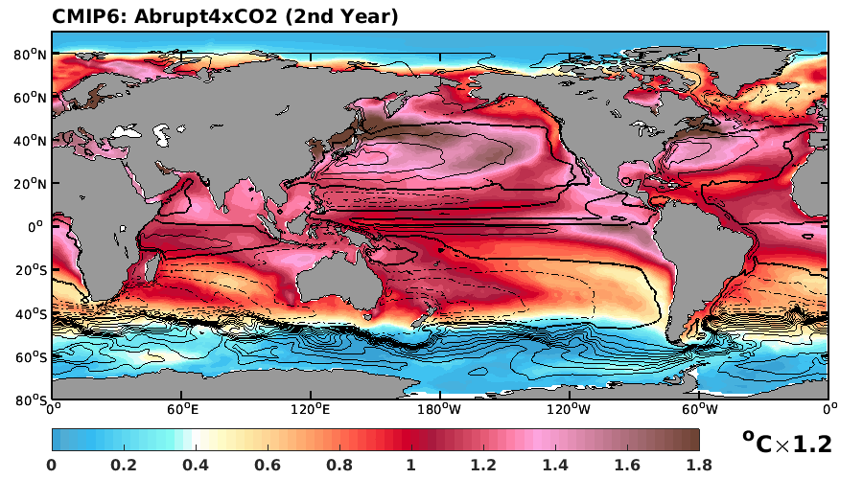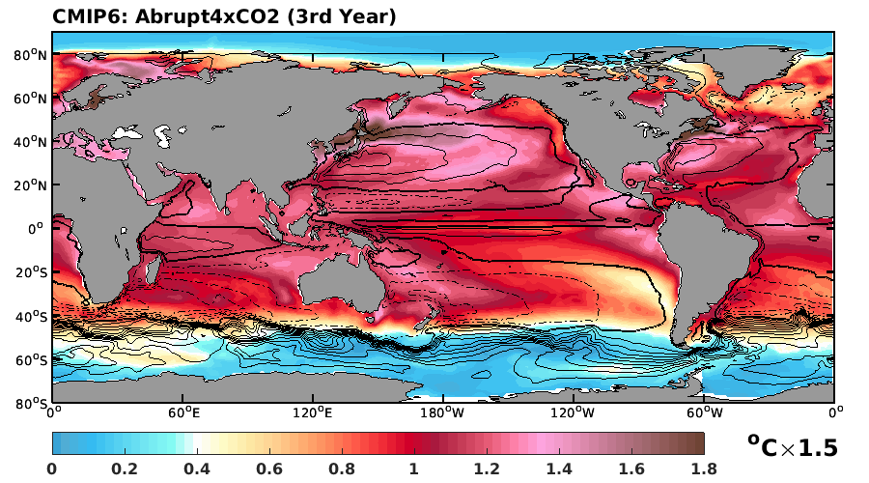

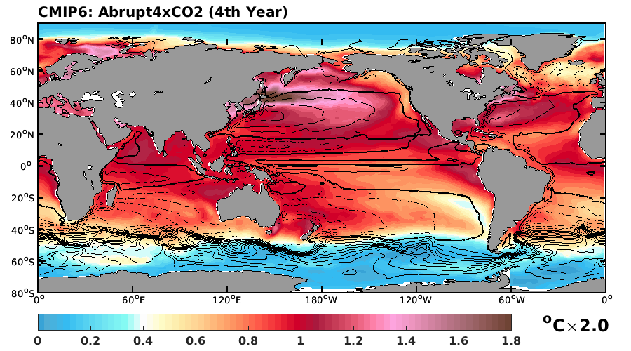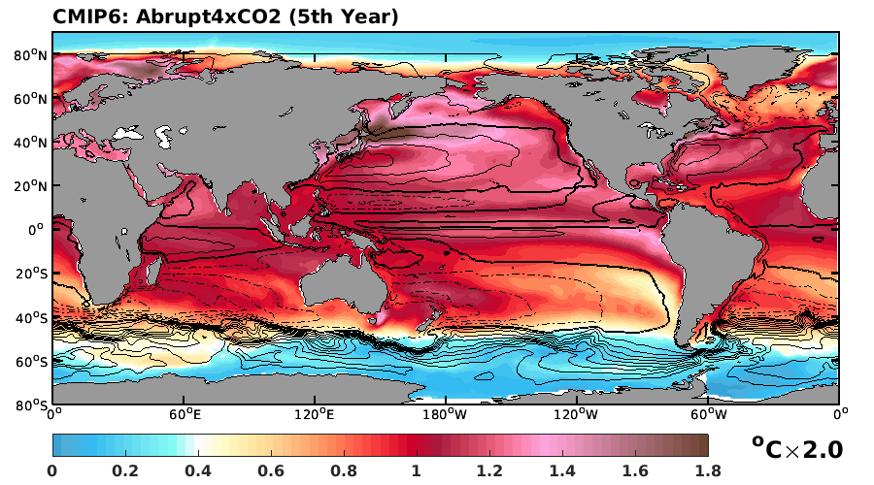

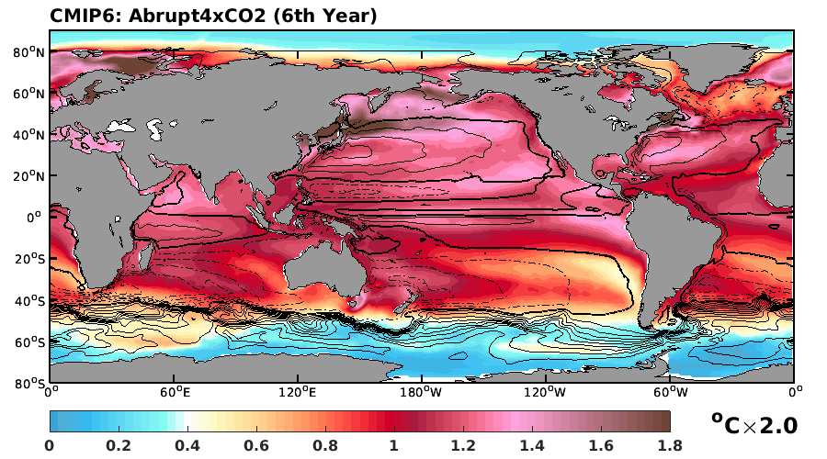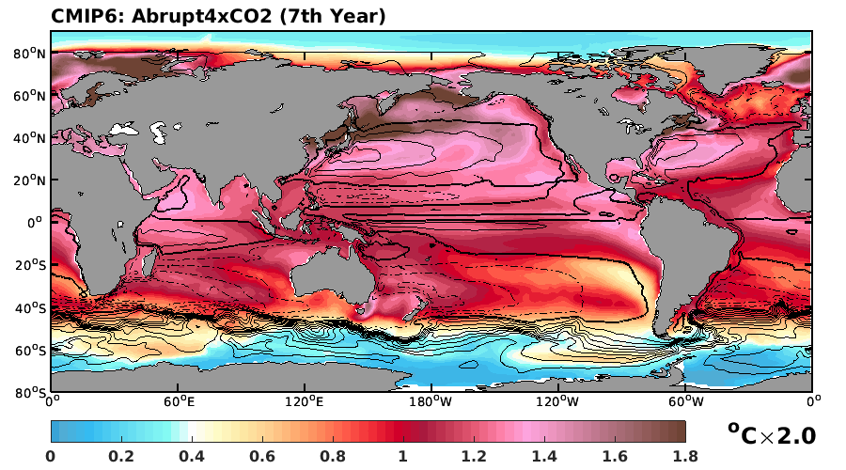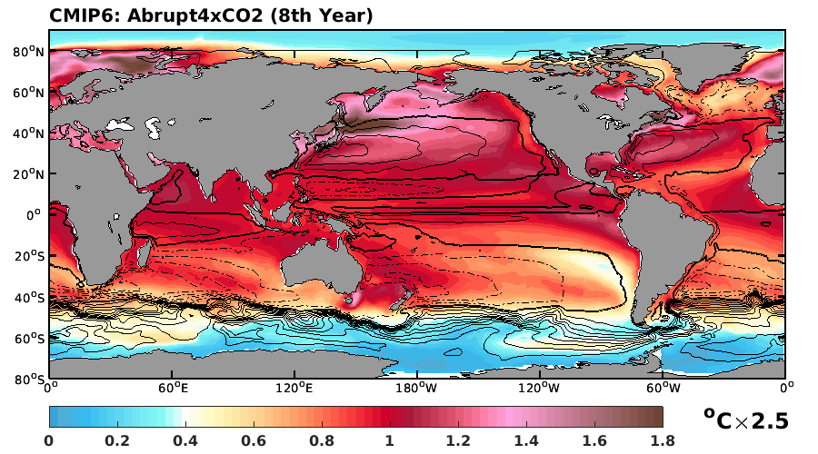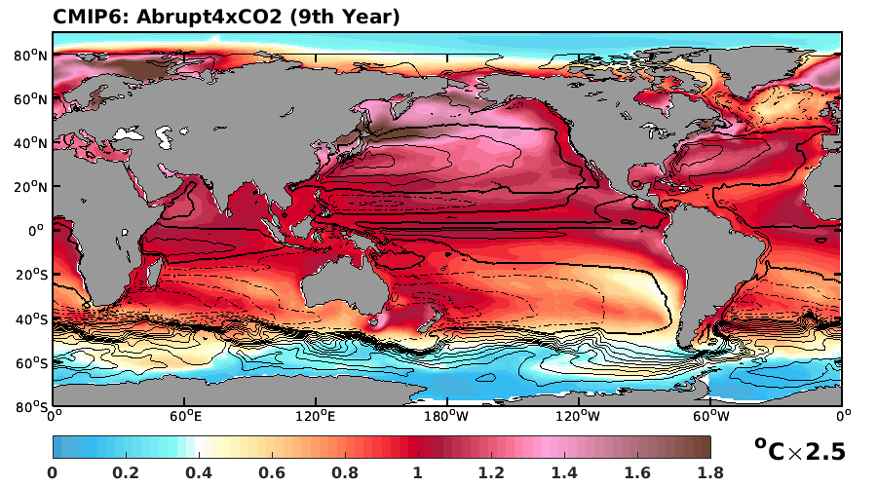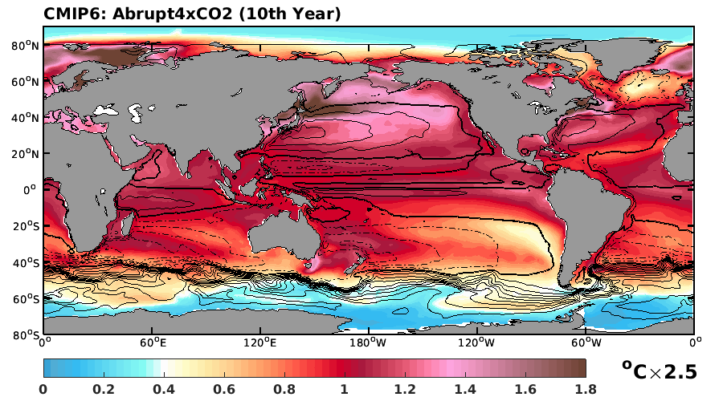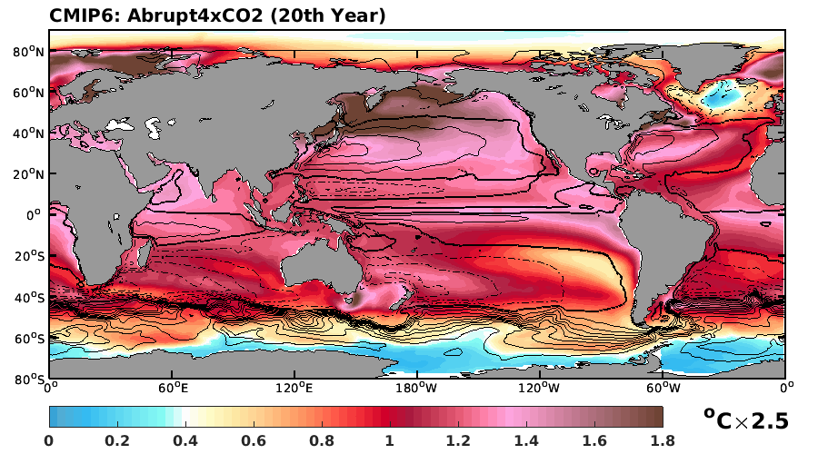
Fig. S2. As Fig. 1b of the manuscript, but for temporal evolution of the ocean warming pattern in CMIP6 abrupt4xCO2 experiment. Shown are annual mean SST anomaly for the first 20 model years of the CMIP6 abrupt4xCO2 experiment. Results are based on ensemble mean of CMIP6 models listed in Table S1. An ocean warming pattern similar to observation (Fig. 1a) can only be found at the very beginning of the CO₂ induced warming, when the deeper ocean temperature is not yet affected by CO₂ forcing. Over time, subpolar warming, which has a larger amplitude than subtropical warming, first develops in the North Pacific Ocean, where deep-water overturning circulation is absent.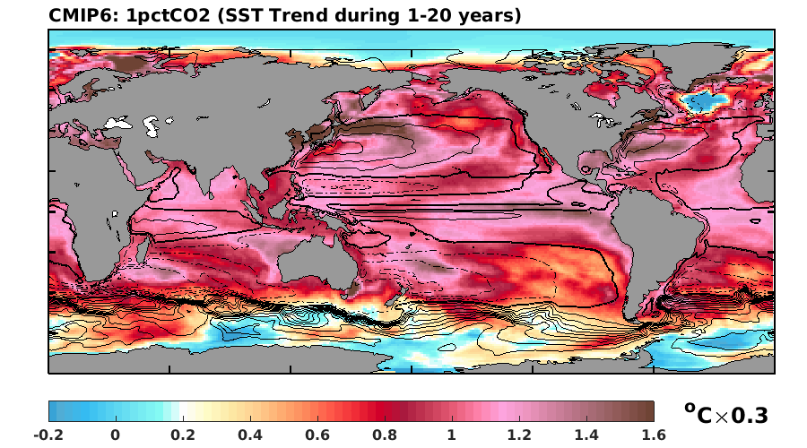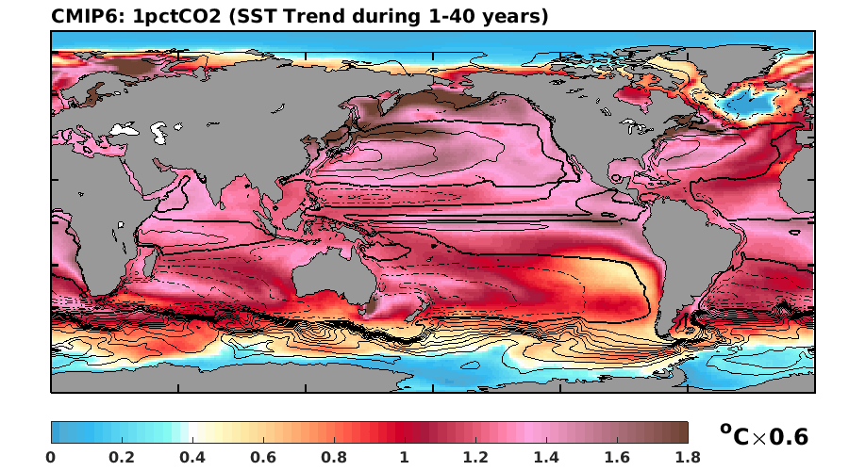
Fig. S3. Ocean warming trends during two periods at the start of the CMIP6 1pctCO2 experiment. Results are based on ensemble mean of CMIP6 models listed in Table S1. The pattern of westward intensified subtropical warming is only apparent at the beginning of the simulation and then vanishes. This simulation shows that even under relatively weak CO₂ (relative to that in abrupt4xCO2) forcing, pattern of infant stage ocean warming can still be detected.

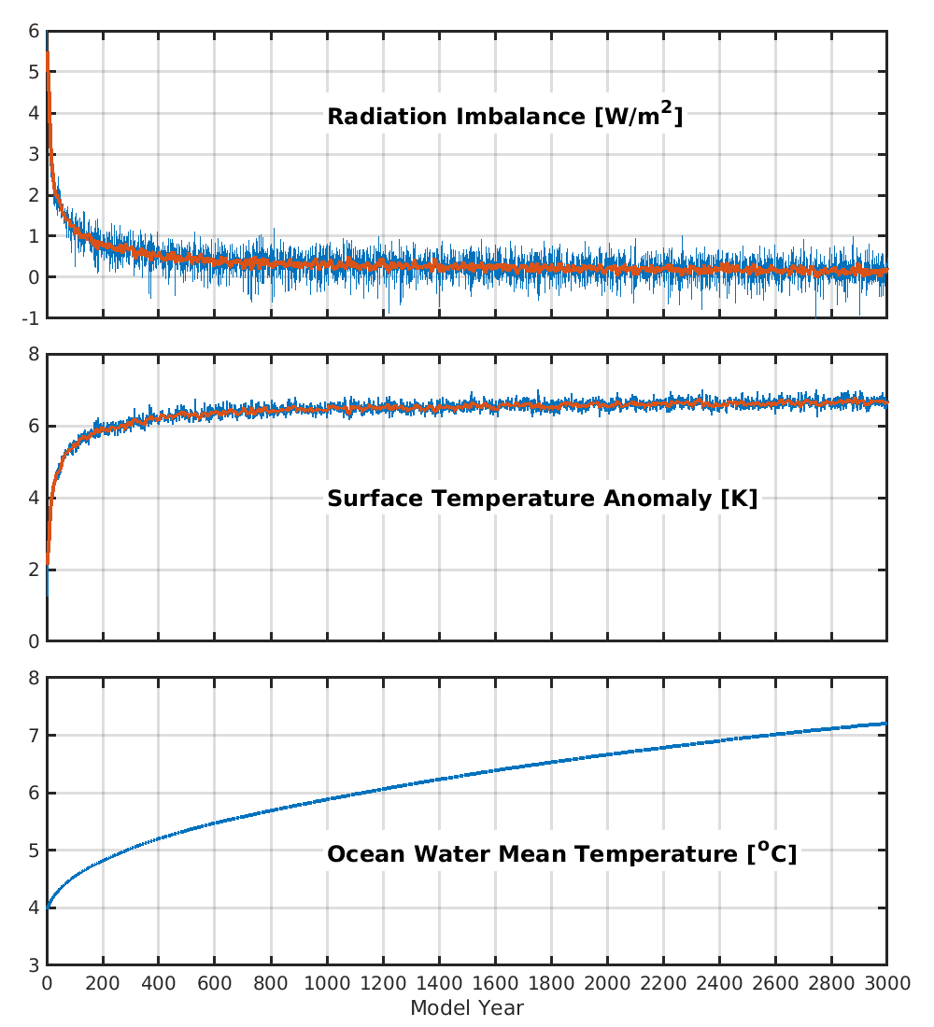
Fig. S4. Temporal evolutions of global mean radiative imbalance at the top of atmosphere (top panel), anomaly of near-surface air temperature (middle), and sea water mean temperature (bottom panel) during the 3,000 years of abrupt4xCO2 experiment performed using AWI-ESM. After 3,000 years of model integration, radiative imbalance at the top of atmosphere is well below 0.15 W/m². However, the global mean ocean temperature is still warming at an approximate rate of 0.04 K/century. Long-term ocean warming is primarily occurring in the deep ocean and at the surface of Southern Ocean and subpolar Northern Atlantic Ocean (Fig. S4), where the surface water is connected to the deep ocean (Yang et al., 2019).

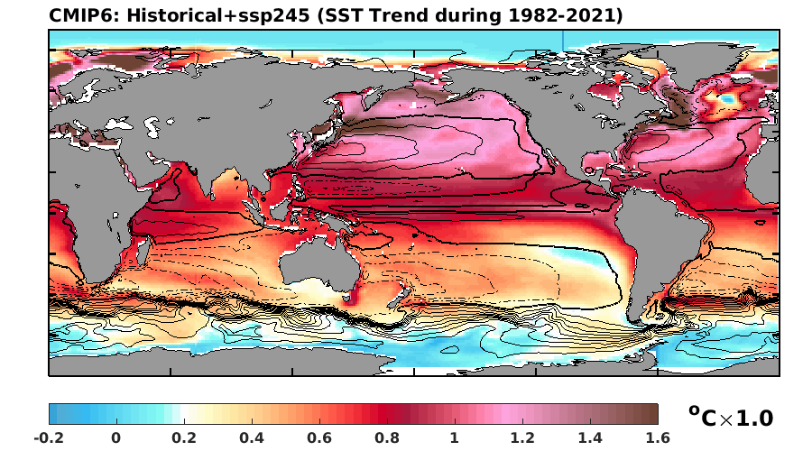
Fig. S5. Ocean warming trend (1982-2021) simulated by the CMIP6 historical (1982-2014) and ssp245 (from 2015 onwards) experiments. Results are based on the ensemble mean of CMIP6 models listed in Table S1. Strong warming is present over the eastern equatorial Pacific Ocean and North Pacific subpolar ocean, that represents a developed ocean warming pattern similar to the pattern of 20th year of the abrupt4xCO2 experiment (Fig. S2).

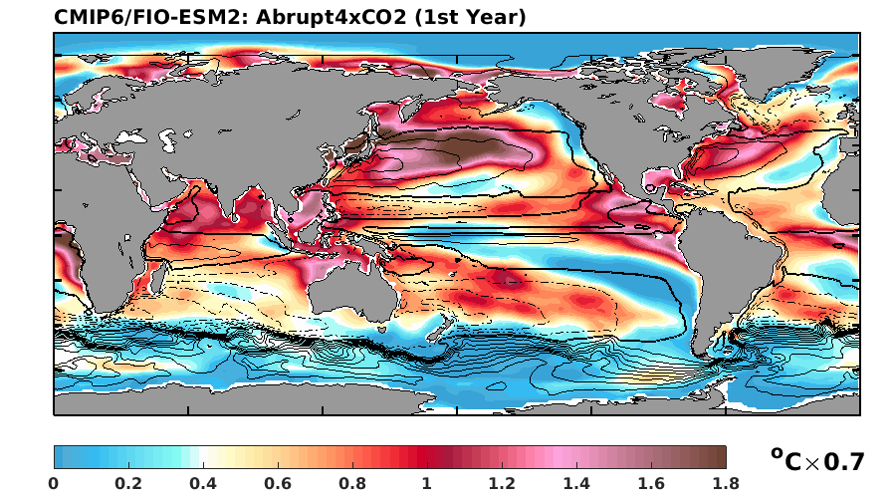
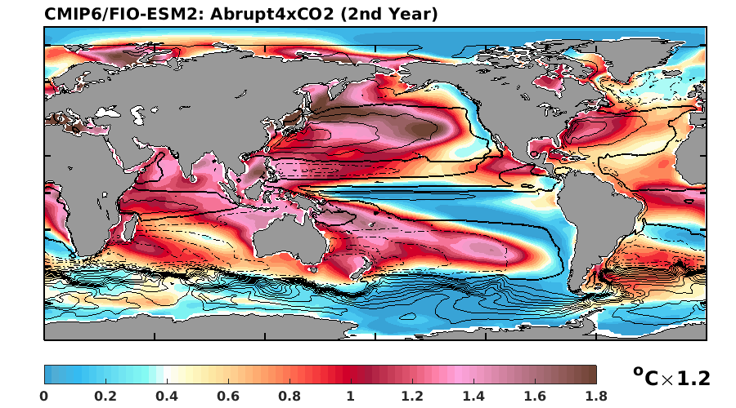
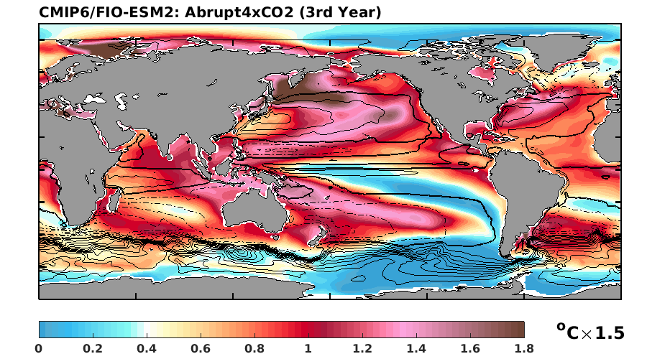
Fig. S6. Ocean warming patterns in the first three years of the abrupt4xCO2 experiment performed by FIO-ESM2.0. Results are based on ensemble mean of three ensemble members of FIO-ESM2.0 abrupt4xCO2 simulations participating the CMIP6. To emphasize the spatial pattern, we used the same color bar as for Fig. 1. However, SST amplitudes are scaled to fit the color bar. The scale factor is given at the right side of the color bar range.

References

Boucher, Olivier; Denvil, Sébastien; Levavasseur, Guillaume; Cozic, Anne; Caubel, Arnaud; Foujols, Marie-Alice; Meurdesoif, Yann; Braconnot, Pascale; Contoux, Camille; Kageyama, Masa; Khodri, Myriam (2019). IPSL IPSL-CM6A-LR model output prepared for CMIP6 PMIP midPliocene-eoi400. Version 20190118. Earth System Grid Federation. https://doi.org/10.22033/ESGF/CMIP6.5230

Danabasoglu, Gokhan (2020). NCAR CESM2 model output prepared for CMIP6 PMIP midPliocene-eoi400. Version 20200110. Earth System Grid Federation. https://doi.org/10.22033/ESGF/CMIP6.7675

EC-Earth Consortium (EC-Earth) (2020). EC-Earth-Consortium EC-Earth3-LR model output prepared for CMIP6 PMIP midPliocene-eoi400. Version 20210401. Earth System Grid Federation. https://doi.org/10.22033/ESGF/CMIP6.4804

Guo, Chuncheng; Bentsen, Mats; Bethke, Ingo; Ilicak, Mehmet; Tjiputra, Jerry; Toniazzo, Thomas; Schwinger, Jörg; Otterå, Odd Helge (2019). NCC NorESM1-F model output prepared for CMIP6 PMIP midPliocene-eoi400. Version 20190920. Earth System Grid Federation. https://doi.org/10.22033/ESGF/CMIP6.11592

NASA Goddard Institute for Space Studies (NASA/GISS) (2019). NASA-GISS GISS-E2.1G model output prepared for CMIP6 PMIP midPliocene-eoi400. Version 20190626. Earth System Grid Federation. https://doi.org/10.22033/ESGF/CMIP6.7227

Stepanek, C., Samakinwa, E., Knorr, G., and Lohmann, G.: Contribution of the coupled atmosphere–ocean–sea ice–vegetation model COSMOS to the PlioMIP2, Clim. Past, 16, 2275–2323, https://doi.org/10.5194/cp-16-2275-2020, 2020.

Williams, Charlie; Lunt, Dan; Singarayer, Joy; Guarino, Maria Vittoria (2020). NERC HadGEM3-GC31-LL model output prepared for CMIP6 PMIP midPliocene-eoi400. Version 20201222^{[1]}.Earth System Grid Federation. https://doi.org/10.22033/ESGF/CMIP6.12130

