Supplemental Data
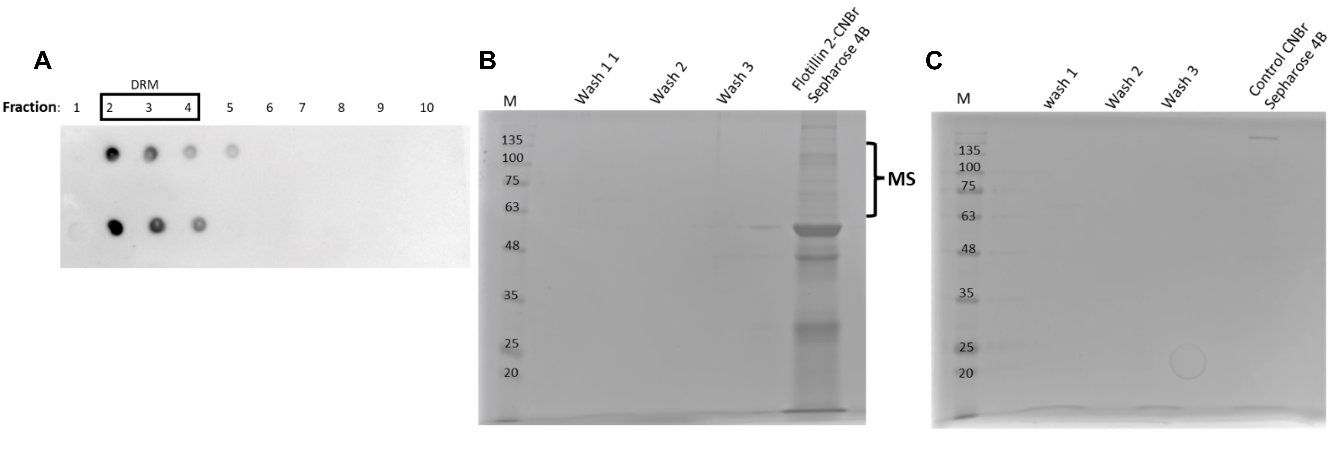
Figure S1. Isolation of HeLa cells DRM fraction and “fishing out” flotillin partner protein(s) on flotillin-2 conjugated to CNBr-activated Sepharose 4B. A. Isolation of DRM fraction and detection of GM1 via Cholera toxin B subunit conjugated to horseradish peroxidase. Separation of pull-down samples on SDS-PAGE gels stained with Coomassie Blue. B. Flotillin-2 bound resin. C. Control resin without flotillin-2. DRM fraction from HeLa cells diluted 1:1 with 2% octyl glucoside in 40 mM Tris-HCl, pH 7.4, 300 mM NaCl, and Protease Inhibitor Cocktail (Merck/Sigma-Aldrich) were incubated overnight with flotillin-2-Sepharose resin at 4°C. Then the resin was thoroughly washed with the same buffer, suspended in the sample buffer, and subjected to SDS-PAGE.
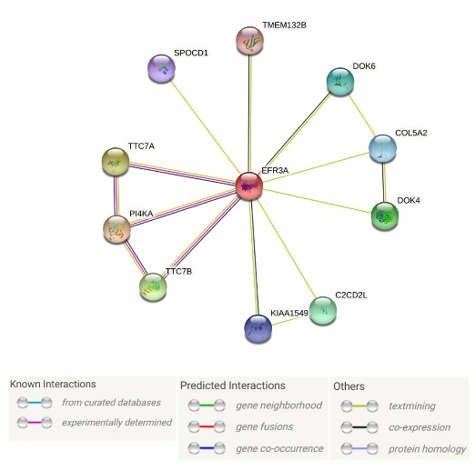
Figure S2. Interaction of flotillin-2 with EFR3A protein has not been reported yet. Data based on https://string-db.org
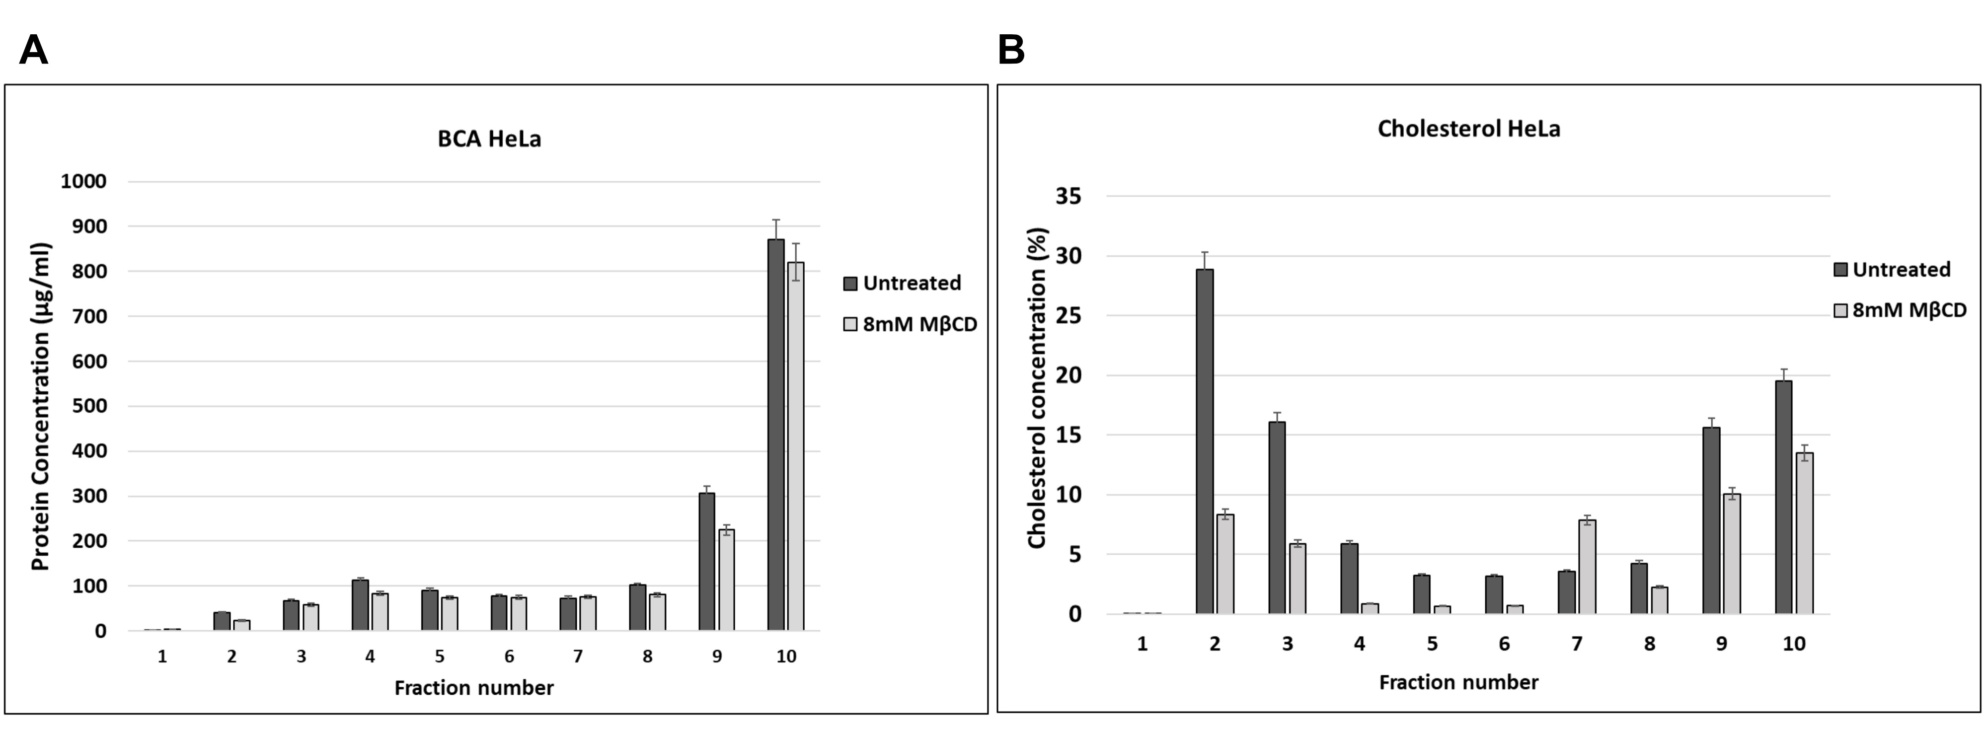

Figure S3. Protein and cholesterol levels in DRM fractions. Total protein (A) and cholesterol (B) content in the gradient fractions upon DRM isolation from cyclodextrin-treated and untreated HeLa cells.
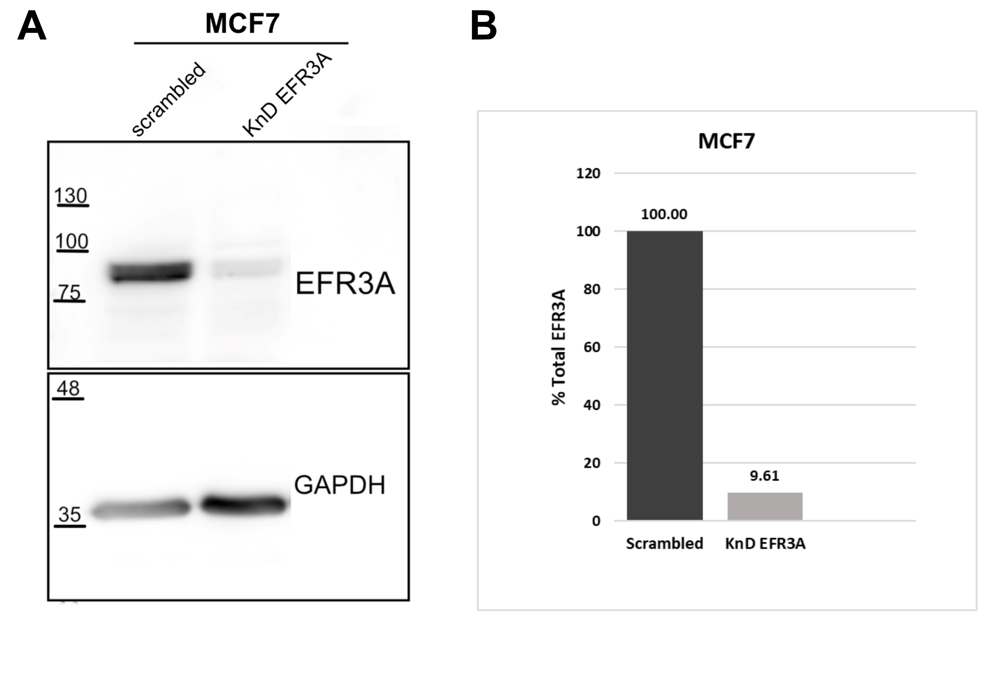
Figure S4. Silencing expression of EFR3A gene in MCF7 cell line. Stable cell lines were obtained using EFR3A shRNA Lentiviral Particles or “scrambled” shRNA Lentiviral Particles as described in the Methods section. A. Cell extracts of control or transduced cell lines were submitted to SDS PAGE and Western blotting was probed with anti-EFR3A antibodies. GAPDH visualization was used as a loading control. B. Quantitation of the EFR3A fractions showed in A.

Figure S5. Examples of FLIM images of cell plasma membranes of A) scrambled MCF7, B) KnD EFR3A, and C) quantitation of FLIM data of EFR3A KnD and “scrambled” cells. For FLIM measurements of the fluorescence lifetime of the membrane-order sensitive probe, di-4 ANEPPDHQ (Invitrogen) control ”scrambled” and EFR3A KnD HeLa cells were grown on LabTek chambers in DMEM medium with 10% FBS. After 24h cells were washed twice and stained with 2 μM di-4, probed in DMEM medium for 5 min. Cells were washed twice in HBBS buffer with 10 mM HEPES pH 7.4. and measurements were performed.

MovieS1 KnD, and MovieS2 Scr1 EGF-induced Ca²⁺ influx. Example of recording of the real-time observations. Further details as in the legend to Fig. 9.

