Supplemental Data
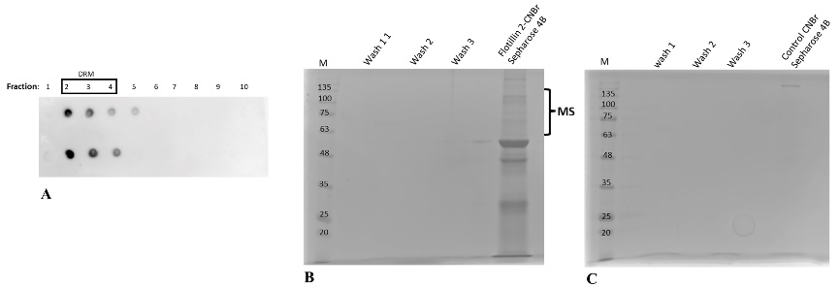
Figure S1. Isolation of HeLa cells DRM fraction and “fishing out” flotillin partner protein(s) on flotillin-2 conjugated to CNBr-activated Sepharose 4B. A. Isolation of DRM fraction and detection of GM1 via Cholera toxin B subunit conjugated to horseradish peroxidase. Separation of pull-down samples on SDS-PAGE gels stained with Coomassie Blue. B. Flotillin-2 bound resin. C. Control resin without flotillin-2. DRM fraction from HeLa cells diluted 1:1 with 2% octyl glucoside in 40 mM Tris-HCl, pH 7.4, 300 mM NaCl and Protease Inhibitor Cocktail (Merck/Sigma-Aldrich) were incubated overnight with flotillin-2-Sepharose resin at 4°C. Then the resin was thoroughly washed with the same buffer and suspended in sample buffer and subjected to SDS-PAGE.
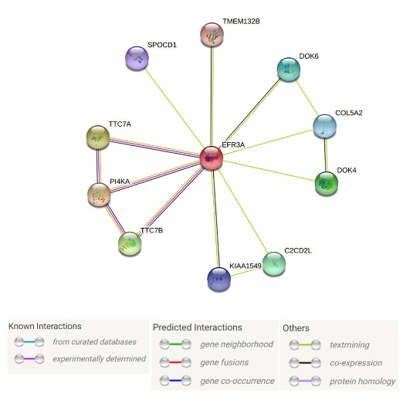
Figure S2. Interaction of flotillin-2 with EFR3A protein has not been reported yet. Data based on https://string-db.org
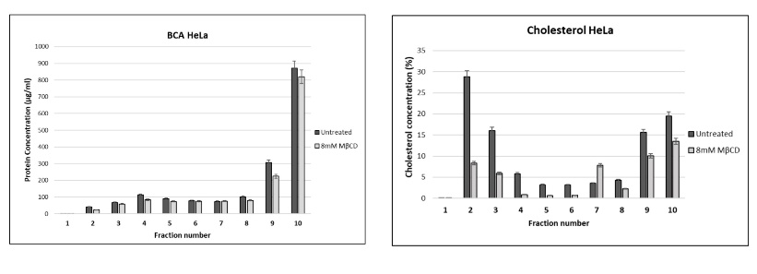
Figure S3. Protein and cholesterol level in DRM fractions. Total protein (B) and cholesterol (C) content in the gradient fractions upon DRM isolation from cyclodextrin-treated and untreated HeLa cells.
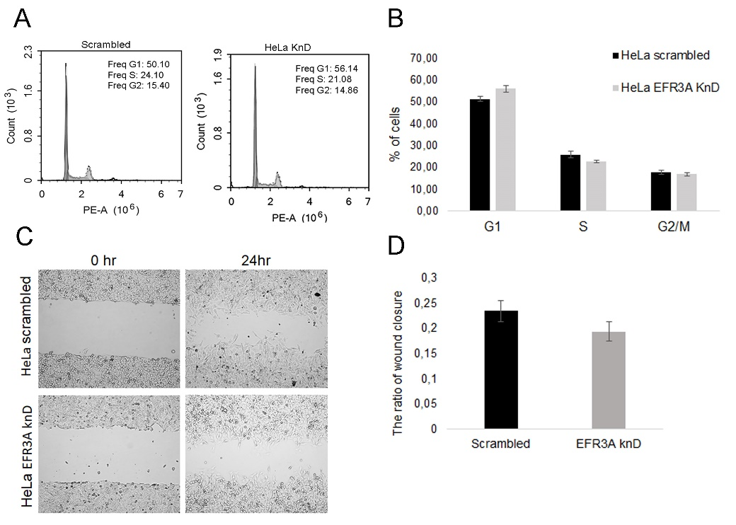

Figure S4. Silencing of EFR3A gene expression affects G1 and G2/M length and cell mobility. A. Cell cycle phase distribution in HeLa cells was evaluated via PI staining followed by flow cytometry presented as histograms. B. Quantitation of flow cytometry analysis. Error bars represent the SEM of three independent experiments. *P<0.05. The percentage of G1 phase cells increased within 48 h to 56%.
C. Representative images from the wound healing assay showing changes in HeLa cells with decreased EFR3A gene expression in comparison to control “scrambled” cells under stimulation with EGFR (50 ng/ml) for 48 h. D. Quantitative analysis from the wound healing assay in the form of a bar graph showing the ratio of wound closure in EFR3A KnD vs “scrambled” cells. The observed reduced motility in cells with decreased expression of EFR3A in comparison to “scrambled” cells was found to be statistically insignificant (p value = 0.158).

MovieS1 KnD, and MovieS2 Scr1 EGF-induced Ca²⁺ influx. Example of recording of the real-time observations. Further details as in the legend to Fig. 8.

