Supporting Information

Manganese-catalysed Selective Upgrading of Primary Alcohols with Ethanol under Solvent-free Conditions

Zhihui Shao¹ • Xinyan Li¹ • Xiaoyu Zhang¹ • Mingqin Zhao¹

¹ Flavors and Fragrance Engineering & Technology Research Center of Henan Province, Henan Agricultural University, Zhengzhou 450000, China.

Table of Contents
General Considerations 3
General Procedure A: Experimental Procedures for the Optimization of Reaction Conditions 4
General Procedure B: Experimental Procedures for the Optimization of the cross-coupling of ethanol with n-hexyl alcohol 5
General Procedure C: Experimental Procedures for the Reaction of Benzyl Alcohols with EtOH 6
General Procedure D: Experimental Procedures for the Reaction of Aliphatic Alcohols with EtOH 7
General Procedure E: Experimental Procedures for Gram-scale Upgrading of Ethanol with Benzyl Alcohol 8
General Procedure F: Experimental Procedures for catalyst recycling 9
General Procedure G: Homogenity test with phosphine or mercury additives 10
General Procedure H: Experimental Procedures for the collectioin of evolved gas and analysis of gas phase components 13
General Procedure I: Experimental Procedures for the Synthesis of Standard Products 14
Characterization Data of Products 15
Reference 22
NMR Spectra 23

General Considerations
The synthesis of ligands and preparation of catalysts in this work were reported in our previous publication(Fu et al., 2017). Air and moisture sensitive reactions were carried out in glovebox or in over-dried glassware sealed with rubber septa using standard schlenk techniques. Most solvents used were dried over solvent purification system (Innovative Technology PS-MD-5) and alcohol solvents were dried over calcium hydride. Deuterated solvents were purchased from Cambridge Isotope Laboratories, vented and distilled over calcium hydride. All chemicals were purchased from commercial sources with purity over 95% and used without further purification. NMR spectra were received using a Bruker 400 MHz spectrometer. Chemical shifts are reported in ppm relative to the deuterated solvent. GC analysis were carried out on SHIMADAZU GC 2010 PLUS system. (Column: SH-Rtx-200, 30 m x 0.25 mm x 0.25 μm). GC/MS analyses were carried out on an GC-MS-QP2010 SE W system equipped with aSH-Rxi-5Sil MS 30 meter, 0.25 mmID, 0.25 um df. High resolution exact mass measurements (HRMS) were performed on Thermo SCIENTIFIC Q EXACTIVE.

General Procedure A: Experimental Procedures for the Optimization of Reaction Conditions
All dehydrogenation experiments were carried out in a 15 mL pressure seal tube. In the argon atmosphere glovebox, benzyl alcohol 1a (1-7 mmol), ethanol 2a (1-8 mmol), manganese catalysts (0.005 mmol, 0.5 mol%), base (0.8-1.2 equiv.) were added sequentially to the seal tube equipped with a magnetic stir bar, The reaction mixture was stirred at given temperature for 16 hours and cooled to room temperature. After the gas was released, the yield of product 3a was determined by GC with biphenyl as the internal standard.
Table S1. Optimization of the cross-coupling of ethanol with benzyl alcoholª.
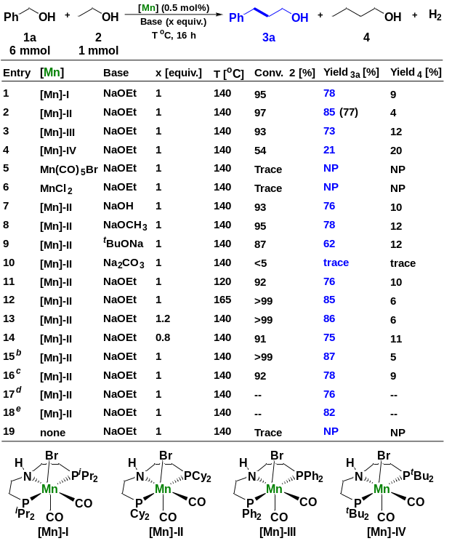
ªReaction conditions: Unless otherwise specified, reactions were performed on a 6 mol scale of benzyl alcohol 1a, 1 mmol ethanol 2, using 1 equiv of base, 0.5 mol% of Mn-precatalyst at 140 ºC for 16 h. The yields were determined by GC using biphenyl as the internal standard. Numbers in parentheses show the isolated yield. ^{b} 7 mmol benzyl alcohol 1a was used. ^{c} 5 mmol benzyl alcohol 1a was used. ^{d} 1 mol scale of benzyl alcohol 1a, 6 mmol ethanol 2 was used. ^{e} 1 mol scale of benzyl alcohol 1a, 8 mmol ethanol 2 was used.

General Procedure B: Experimental Procedures for the Optimization of the cross-coupling of ethanol with n-hexyl alcohol
All dehydrogenation experiments were carried out in a 15 mL pressure seal tube. In the argon atmosphere glovebox, n-hexyl alcohol 1a (6 mmol), ethanol 2a (1-6 mmol), manganese catalysts (0.005 mmol, 0.5 mol%), base (1.0 equiv.) were added sequentially to the seal tube equipped with a magnetic stir bar, The reaction mixture was stirred at given temperature for 16 hours and cooled to room temperature. After the gas was released, the yield of products were determined by GC with biphenyl as the internal standard.
Table S2. Optimization of the cross-coupling of ethanol with n-hexyl alcoholª.
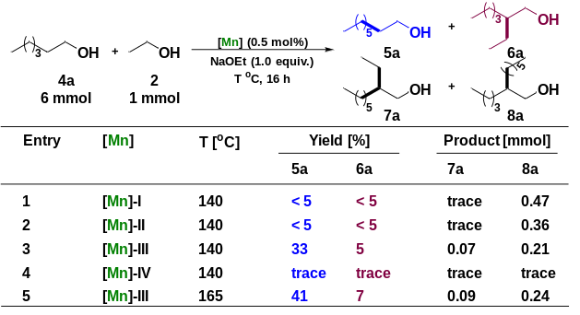
ª Reaction conditions: Unless otherwise specified, reactions were performed on a 6 mol scale of benzyl alcohols 1, 1 mmol ethanol 2, using 1 equiv. of NaOEt, 0.5 mol% of [Mn]-III at T ºC for 16 h. The yields were determined by GC using biphenyl as the internal standard.

General Procedure C: Experimental Procedures for the Reaction of Benzyl Alcohols with EtOH
All experiments were carried out in a 15 mL pressure seal tube. In the argon atmosphere glovebox, benzyl alcohols (6 mmol), EtOH (1.0 mmol), [Mn]-II (0.5 mol%), NaOEt (1 equiv.) were added sequentially to the seal tube equipped with a magnetic stir bar. The reaction mixture was stirred at 140 ºC for 16 hours and cooled to room temperature. After the gas was released, the yield of products was determined by GC with biphenyl as the internal standard or isolated via preparative HPLC.

General Procedure D: Experimental Procedures for the Reaction of Aliphatic Alcohols with EtOH
All experiments were carried out in a 15 mL pressure seal tube. In the argon atmosphere glovebox, aliphatic alcohols (6 mmol), EtOH (1.0 mmol), [Mn]-III (0.5 mol%), NaOEt (1 equiv.) were added sequentially to the seal tube equipped with a magnetic stir bar. The reaction mixture was stirred at 165 ºC for 16 hours and cooled to room temperature. After the gas was released, the yield of products was determined by GC with biphenyl as the internal standard.

General Procedure E: Experimental Procedures for Gram-scale Upgrading of Ethanol with Benzyl Alcohol
The dehydrogenation coupling experiments were carried out in a 100 mL pressure seal tube. In the argon atmosphere glovebox, [Mn]-II (0.25 mmol, 0.03 mol%), NaOEt (8 mmol, 1 equiv.), benzyl alcohol (30 mmol) and EtOH (8 mmol) were added sequentially to the seal tube equipped with a magnetic stir bar, The reaction mixture was stirred at 140 ºC for 16 hours and cooled to room temperature, the evolved gas was released from the system in the argon atmosphere glovebox. After three consecutive reactions, the reaction mixture was cooled to room temperature. The yield of product was determined by GC with biphenyl as the internal standard and isolated by vacuum distillation.
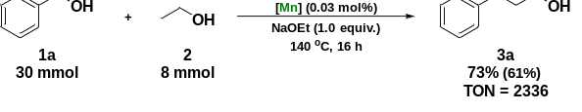
Fig. S1. Gram-scale upgrading of ethanol with benzyl alcohol.

General Procedure F: Experimental Procedures for catalyst recycling
The dehydrogenation coupling experiments were carried out in a 25 mL pressure seal tube. In the argon atmosphere glovebox, [Mn]-II (0.5 mmol, 0.5 mol%), NaOEt (1 mmol, 1 equiv.), benzyl alcohol (6 mmol) and EtOH (1 mmol) were added sequentially to the seal tube equipped with a magnetic stir bar, The reaction mixture was stirred at 140 ºC for 16 hours and cooled to room temperature, the evolved gas was released from the system in the argon atmosphere glovebox. After releasing the gas, 1 mmol ethanol and 1 mmol NaOEt and 0.5 mL dioxane was added to the reaction system and the reaction mixture was stirred at 140 ºC for another 16 h. After cooling down, the evolved gas during the reaction process was released again in the argon atmosphere glovebox at room temperature. Then, 1 mmol ethanol and 1 mmol NaOEt was continued to added to the reaction system and the reaction mixture was stirred at 140 ºC for 16 h. After three consecutive reactions, the reaction mixture was cooled to room temperature. The conversion and yield of the three recycle experiment were determined by GC with biphenyl as the internal standard.
Table S3. Optimization of the cross-coupling of ethanol with benzyl alcohol
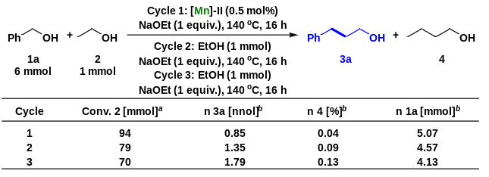
ª Conversion was based on the amount of ethanol before the reaction and determined by GC using biphenyl as the internal standard. ^{b} The amount of substance in products 3a, 4 and the remaining amount of starting material 1a are determined by GC using biphenyl as the internal standard.

General Procedure G: Homogenity test with phosphine or mercury additives
All dehydrogenation experiments were carried out in a 15 mL pressure seal tube. In the argon atmosphere glovebox, benzyl alcohol 1a (1-7 mmol), ethanol 2a (1-6 mmol), [Mn]-II (0.005 mmol, 0.5 mol%), NaOEt (1 equiv.) and phosphines or mercury (equiv. respect to complex I) were added sequentially to the seal tube equipped with a magnetic stir bar, The reaction mixture was stirred at given temperature for 16 hours and cooled to room temperature. After the gas was released, the yield of product 3a was determined by GC with biphenyl as the internal standard.

Table S4. Homogenity test for the synthesis of phenylpropanol
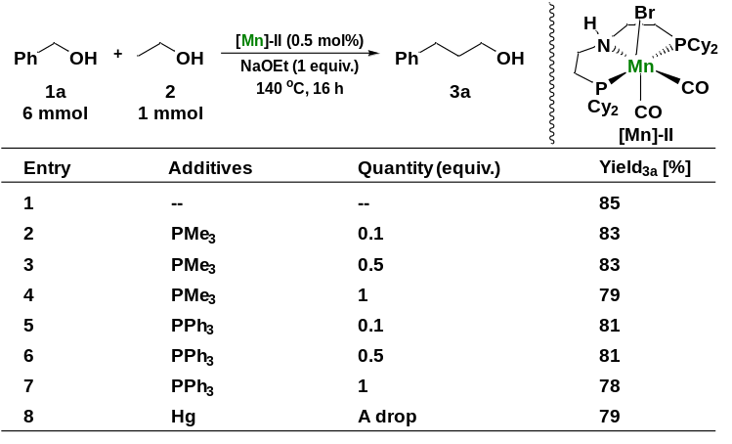
Reaction conditions: Unless otherwise specified, reactions were performed on a 6 mol scale of benzyl alcohol 1a, 1 mmol ethanol 2, using 1 equiv of NaOEt, 0.5 mol% of [Mn]-II with phosphines or mercury at 140 ºC for 16 h. The yields were determined by GC using biphenyl as the internal standard.

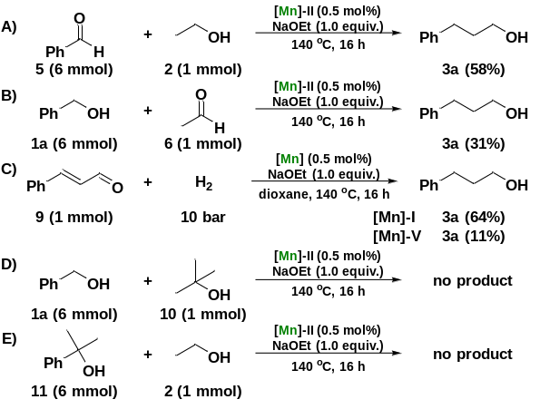
Fig. S2. Control experiments

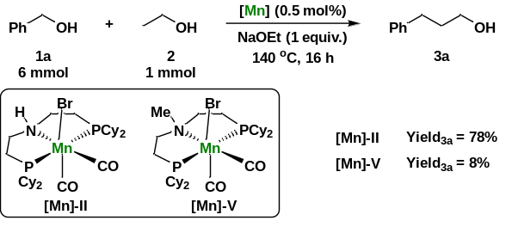
Fig. S3. Comparison of catalytic activity using [Mn]-II and N-methyl-substituted PNP pincer manganese complex [Mn]-V.

General Procedure H: Experimental Procedures for the collectioin of evolved gas and analysis of gas phase components
The experiments were carried out in a 15 mL pressure seal tube. In the argon atmosphere glovebox, benzyl alcohols (6 mmol), EtOH (1.0 mmol), [Mn]-II (0.5 mol%), NaOEt (1 equiv.) were added sequentially to the seal tube equipped with a magnetic stir bar. The reaction mixture was stirred at 140 ºC for 16 hours. After cooling to room temperature, the evolved gas was released from the system, which was collected and measured by GC (Fig. S4).
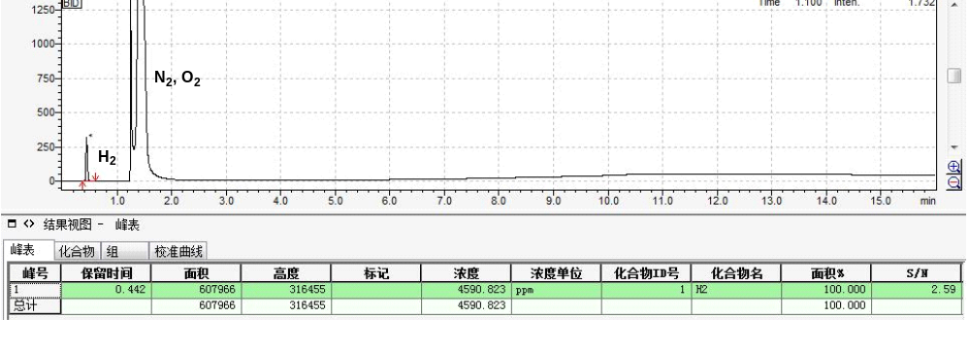
Fig. S4. GC analysis of the gas phase

General Procedure I: Experimental Procedures for the Synthesis of Standard Products
To an oven-dried 50 mL flask equipped with stir bar was added LiAlH₄ (1.5 mmol, 1.5 equiv) followed by dry THF (10 mL) under nitrogen atmosphere. The flask was cooled to 0 ºC via an ice-water bath and the suspension was stirred for 10 minutes. After this time, acids (1 mmol, 1 equiv) in dry THF (5 mL) was added very slowly dropwise to the flask. The mixture was stirred at 0 °C for 2 h and then quenched at 0 °C by very careful addition of deionized water (1.0 mL), 2 M NaOH (1 mL), and additional deionized water (1 mL). The quenched solution was allowed to stir for about 10 minutes, resulting in a white suspension. The solids were removed by filtration, washing the solids with diethyl ether (30 mL). The filtrate was transferred to a separatory funnel and washed with saturated NaHCO₃ (2 X 20 mL), deionized water (10 mL) and brine (10 mL). The organic layer was dried over Na₂SO₄ and the solvent was removed in vacuo by rotary evaporation affording the pure alcohols.

Characterization Data of Products
3-phenylpropan-1-ol 3a(Kobayashi et al., 2020)
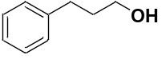
The yield of product (85%) was determined by GC using biphenyl as the internal standard (Standard compound of 3a was obtained according to the procedure C). ¹H NMR (400 MHz, CDCl₃) δ 7.45 – 7.39 (m, 2H), 7.38 – 7.27 (m, 3H), 3.75 (td, J = 6.6, 2.0 Hz, 2H), 3.55 (d, J = 13.4 Hz, 1H), 2.87 – 2.77 (m, 2H), 2.06 – 1.96 (m, 2H). ¹³C NMR (101 MHz, CDCl₃) δ 142.10 (s), 128.57 (d, J = 5.2 Hz), 125.98 (s), 61.98 (s), 34.33 (s), 32.24 (s).

3-(p-tolyl)propan-1-ol 3b(Kobayashi et al., 2020)
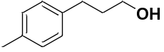
The yield of product (89%) was determined by GC using biphenyl as the internal standard (Standard compound of 3b was obtained according to the procedure C). ¹H NMR (400 MHz, CDCl₃) δ 7.01 (s, 4H), 3.56 (t, J = 6.5 Hz, 2H), 2.60 – 2.54 (m, 2H), 2.23 (s, 3H), 1.82 – 1.70 (m, 3H). ¹³C NMR (101 MHz, CDCl₃) δ 138.77 (s), 135.33 (s), 129.12 (s), 128.34 (s), 62.28 (s), 34.36 (s), 31.66 (s), 21.02 (s).

3-(4-methoxyphenyl)propan-1-ol 3c(Kobayashi et al., 2020)
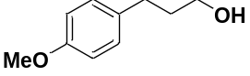
The yield of product (84%) was determined by GC using biphenyl as the internal standard (Standard compound of 3c was obtained according to the procedure C). ¹H NMR (400 MHz, CDCl₃) δ 7.14 (d, J = 8.5 Hz, 2H), 6.94 – 6.80 (m, 2H), 3.81 (s, 3H), 3.67 (t, J = 6.5 Hz, 2H), 2.71 – 2.62 (m, 2H), 1.88 (tt, J = 13.2, 6.6 Hz, 2H). ¹³C NMR (101 MHz, CDCl₃) δ 157.78 (s), 134.02 (s), 129.35 (s), 113.85 (s), 62.06 (s), 55.28 (s), 34.46 (s), 31.17 (s).

3-(4-isopropylphenyl)propan-1-ol 3d(Kišić et al., 2015)
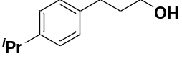
The yield of product (81%) was determined by GC using biphenyl as the internal standard (Standard compound of 3d was obtained according to the procedure C). ¹H NMR (400 MHz, CDCl₃) δ 7.02 (q, J = 8.2 Hz, 4H), 3.52 (t, J = 6.5 Hz, 2H), 2.82 – 2.69 (m, 1H), 2.61 – 2.49 (m, 2H), 2.27 (s, 1H), 1.83 – 1.64 (m, 2H), 1.15 (t, J = 9.2 Hz, 6H). ¹³C NMR (101 MHz, CDCl₃) δ 146.43 (s), 139.23 (s), 128.42 (s), 126.49 (s), 62.26 (s), 34.30 (s), 33.77 (s), 31.72 (s), 24.16 (s).

3-(4-(tert-butyl)phenyl)propan-1-ol 3e(Kobayashi et al., 2020)
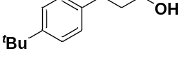
The yield of product (79%) was determined by GC using biphenyl as the internal standard (Standard compound of 3e was obtained according to the procedure C). ¹H NMR (400 MHz, CDCl₃) δ 7.21 (d, J = 8.3 Hz, 2H), 7.03 (d, J = 8.2 Hz, 2H), 3.54 (t, J = 6.5 Hz, 2H), 2.64 – 2.50 (m, 2H), 2.31 (s, 1H), 1.84 – 1.69 (m, 2H), 1.21 (s, 9H). ¹³C NMR (101 MHz, CDCl₃) δ 148.69 (s), 138.85 (s), 128.17 (s), 125.34 (s), 62.27 (s), 34.33 (d, J = 18.9 Hz), 31.56 (d, J = 9.4 Hz).

3-(4-chlorophenyl)propan-1-ol 3g(Kobayashi et al., 2020)
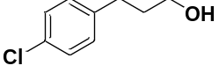
The yield of product (71%) was determined by GC using biphenyl as the internal standard (Standard compound of 3g was obtained according to the procedure C). ¹H NMR (400 MHz, CDCl₃) δ 7.27 (d, J = 8.4 Hz, 2H), 7.15 (d, J = 8.3 Hz, 2H), 3.68 (t, J = 6.3 Hz, 2H), 2.75 – 2.65 (m, 2H), 1.94 – 1.83 (m, 2H), 1.47 (s, 1H). ¹³C NMR (101 MHz, CDCl₃) δ 140.26 (s), 131.58 (s), 129.79 (s), 128.49 (s), 62.01 (s), 34.08 (s), 31.40 (s).

3-(4-bromophenyl)propan-1-ol 3h(Szostak et al., 2012)
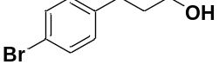
The yield of product (68%) was determined by GC using biphenyl as the internal standard (Standard compound of 3h was obtained according to the procedure C). ¹H NMR (400 MHz, CDCl₃) δ 7.42 (d, J = 8.3 Hz, 2H), 7.09 (d, J = 8.2 Hz, 2H), 3.68 (d, J = 1.6 Hz, 2H), 2.71 – 2.66 (m, 2H), 1.92 – 1.83 (m, 2H), 1.55 (s, 1H). ¹³C NMR (101 MHz, CDCl₃) δ 140.79 (s), 131.44 (s), 130.22 (s), 119.59 (s), 61.98 (s), 34.01 (s), 31.46 (s).

3-(4-iodophenyl)propan-1-ol 3i(Cheung et al., 2009)
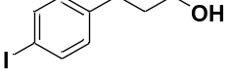
The yield of product (62%) was determined by GC using biphenyl as the internal standard (Standard compound of 3i was obtained according to the procedure C). ¹H NMR (400 MHz, CDCl₃) δ 7.49 (d, J = 8.2 Hz, 2H), 6.85 (d, J = 8.1 Hz, 2H), 3.53 (t, J = 6.4 Hz, 2H), 2.57 – 2.50 (m, 2H), 2.16 (s, 1H), 1.77 – 1.70 (m, 2H). ¹³C NMR (101 MHz, CDCl₃) δ 141.51 (s), 137.43 (s), 130.62 (s), 90.93 (s), 61.87 (s), 33.96 (s), 31.57 (s).

3-(4-(trifluoromethyl)phenyl)propan-1-ol 3j(Kobayashi et al., 2020)
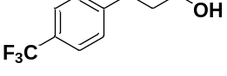
The yield of product (74%) was determined by GC using biphenyl as the internal standard (Standard compound of 3j was obtained according to the procedure C). ¹H NMR (400 MHz, CDCl₃) δ 7.45 (d, J = 8.1 Hz, 2H), 7.22 (d, J = 8.0 Hz, 2H), 3.59 (t, J = 6.4 Hz, 2H), 2.73 – 2.64 (m, 2H), 1.81 (dq, J = 9.2, 6.4 Hz, 2H), 1.72 – 1.55 (m, 1H). ¹³C NMR (101 MHz, CDCl₃) δ 146.02 (s), 128.75 (s), 128.26 (q, J = 32.1 Hz), 125.31 (q, J = 3.7 Hz), 124.37 (q, J = 271.7 Hz), 61.88 (s), 33.85 (s), 31.89 (s).

4-(3-hydroxypropyl)benzonitrile 3k(Sifferlen et al., 2013)
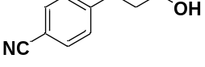
The yield of product (61%) was determined by GC using biphenyl as the internal standard (Standard compound of 3k was obtained according to the procedure C). ¹H NMR (400 MHz, CDCl₃) δ 7.52 – 7.46 (m, 2H), 7.23 (d, J = 8.2 Hz, 2H), 3.62 – 3.55 (m, 2H), 2.70 (t, J = 7.8 Hz, 2H), 1.98 – 1.77 (m, 3H). ¹³C NMR (101 MHz, CDCl₃) δ 147.79 (s), 132.22 (s), 129.30 (s), 119.11 (s), 109.61 (s), 61.62 (s), 33.60 (s), 32.23 (s).

3-([1,1'-biphenyl]-4-yl)propan-1-ol 3l(Zhang and Muñiz, 2017)
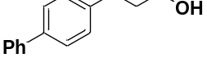
The yield of product (78%) was determined by GC using biphenyl as the internal standard (Standard compound of 3l was obtained according to the procedure C). ¹H NMR (400 MHz, CDCl₃) δ 7.51 – 7.46 (m, 2H), 7.42 (d, J = 8.2 Hz, 2H), 7.33 (dd, J = 10.4, 4.8 Hz, 2H), 7.23 (t, J = 7.3 Hz, 1H), 7.20 – 7.11 (m, 2H), 3.59 (t, J = 6.4 Hz, 2H), 2.71 – 2.56 (m, 2H), 1.87 – 1.75 (m, 3H). ¹³C NMR (101 MHz, CDCl₃) δ 141.05 (d, J = 6.4 Hz), 138.88 (s), 128.86 (d, J = 12.6 Hz), 127.28 – 126.94 (m), 62.26 (s), 34.21 (s), 31.74 (s).

3-(o-tolyl)propan-1-ol 3m(Kobayashi et al., 2020)
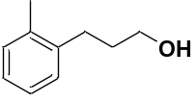
The yield of product (83%) was determined by GC using biphenyl as the internal standard (Standard compound of 3m was obtained according to the procedure C). ¹H NMR (400 MHz, CDCl₃) δ 7.09 – 6.95 (m, 4H), 3.57 (t, J = 6.5 Hz, 2H), 2.61 – 2.53 (m, 2H), 2.21 (s, 3H), 2.13 (dd, J = 16.4, 8.8 Hz, 1H), 1.74 (tt, J = 13.1, 6.5 Hz, 2H). ¹³C NMR (101 MHz, CDCl₃) δ 140.11 (s), 136.00 (s), 130.29 (s), 128.86 (s), 126.05 (d, J = 2.9 Hz), 62.46 (s), 33.05 (s), 29.50 (s), 19.33 (s).

3-(m-tolyl)propan-1-ol 3n(Kobayashi et al., 2020)
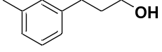
The yield of product (86%) was determined by GC using biphenyl as the internal standard (Standard compound of 3n was obtained according to the procedure C). ¹H NMR (400 MHz, CDCl₃) δ 7.07 (t, J = 7.5 Hz, 1H), 6.93 – 6.87 (m, 3H), 3.53 (t, J = 6.5 Hz, 2H), 2.59 – 2.52 (m, 2H), 2.27 (d, J = 3.0 Hz, 1H), 2.22 (s, 3H), 1.76 (dq, J = 9.2, 6.5 Hz, 2H). ¹³C NMR (101 MHz, CDCl₃) δ 141.89 (s), 137.99 (s), 129.32 (s), 128.36 (s), 126.66 (s), 125.50 (s), 62.21 (s), 34.29 (s), 32.08 (s), 21.46 (s).

3-(naphthalen-1-yl)propan-1-ol 3o(Kobayashi et al., 2020)
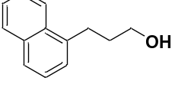
The yield of product (63%) was determined by GC using biphenyl as the internal standard (Standard compound of 3o was obtained according to the procedure C). ¹H NMR (400 MHz, CDCl₃) δ 8.15 (d, J = 7.8 Hz, 1H), 8.01 – 7.89 (m, 1H), 7.81 (d, J = 8.1 Hz, 1H), 7.58 (ddd, J = 7.1, 5.9, 3.3 Hz, 2H), 7.51 – 7.45 (m, 1H), 7.42 (d, J = 6.9 Hz, 1H), 3.78 (t, J = 6.4 Hz, 2H), 3.28 – 3.18 (m, 2H), 2.66 (s, 1H), 2.08 (tt, J = 13.0, 6.4 Hz, 2H). ¹³C NMR (101 MHz, CDCl₃) δ 138.11 (s), 134.04 (s), 131.98 (s), 128.92 (s), 126.80 (s), 126.02 (d, J = 17.7 Hz), 125.65 (d, J = 7.3 Hz), 123.92 (s), 62.41 (s), 33.57 (s), 29.27 (s).

3-(naphthalen-2-yl)propan-1-ol 3p(Kobayashi et al., 2020)
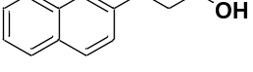
The yield of product (76%) was determined by GC using biphenyl as the internal standard (Standard compound of 3p was obtained according to the procedure C). ¹H NMR (400 MHz, CDCl₃) δ 7.72 – 7.62 (m, 3H), 7.51 (s, 1H), 7.39 – 7.27 (m, 2H), 7.22 (dd, J = 8.4, 1.5 Hz, 1H), 3.56 (t, J = 6.5 Hz, 2H), 2.78 – 2.68 (m, 2H), 1.89 – 1.77 (m, 3H). ¹³C NMR (101 MHz, CDCl₃) δ 139.42 (s), 133.69 (s), 132.07 (s), 128.03 (s), 127.69 (s), 127.42 (d, J = 12.4 Hz), 126.49 (s), 126.02 (s), 125.25 (s), 62.21 (s), 34.11 (s), 32.25 (s).

3-(benzo[d][1,3]dioxol-5-yl)propan-1-ol 3q(Kobayashi et al., 2020)
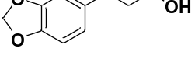
The yield of product (58%) was determined by GC using biphenyl as the internal standard (Standard compound of 3q was obtained according to the procedure C). ¹H NMR (400 MHz, CDCl₃) δ 6.61 (dd, J = 13.6, 4.5 Hz, 2H), 6.54 (d, J = 7.9 Hz, 1H), 5.81 (s, 2H), 3.54 (t, J = 6.5 Hz, 2H), 2.55 – 2.48 (m, 2H), 1.75 (dd, J = 14.8, 6.9 Hz, 2H). ¹³C NMR (101 MHz, CDCl₃) δ 147.58 (s), 145.61 (s), 135.71 (s), 121.12 (s), 108.90 (s), 108.17 (s), 100.77 (s), 61.97 (s), 34.42 (s), 31.79 (s).

3-(thiophen-2-yl)propan-1-ol 3s(Kobayashi et al., 2020)
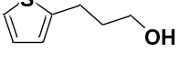
The yield of product (63%) was determined by GC using biphenyl as the internal standard (Standard compound of 3s was obtained according to the procedure C). ¹H NMR (400 MHz, CDCl₃) δ 7.15 (dd, J = 5.1, 1.1 Hz, 1H), 6.95 (dd, J = 5.0, 3.5 Hz, 1H), 6.84 (dd, J = 3.3, 0.9 Hz, 1H), 3.71 (t, J = 6.3 Hz, 2H), 2.96 (t, J = 7.6 Hz, 2H), 2.00 – 1.92 (m, 2H). ¹³C NMR (101 MHz, CDCl₃) δ 144.71 (s), 126.83 (s), 124.37 (s), 123.13 (s), 61.75 (d, J = 5.9 Hz), 34.47 (s), 26.18 (s).

3-(pyridin-3-yl)propan-1-ol 3t(Wypych et al., 2008)
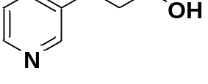
The yield of product (74%) was determined by GC using biphenyl as the internal standard (Standard compound of 3t was obtained according to the procedure C). ¹H NMR (400 MHz, CDCl₃) δ 8.34 – 8.26 (m, 2H), 7.42 (d, J = 7.8 Hz, 1H), 7.10 (dd, J = 7.7, 4.9 Hz, 1H), 3.56 (td, J = 6.3, 1.1 Hz, 2H), 3.45 – 3.21 (m, 1H), 2.61 (t, J = 7.7 Hz, 2H), 1.77 (qd, J = 7.4, 1.0 Hz, 2H). ¹³C NMR (101 MHz, CDCl₃) δ 149.63 (s), 147.00 (s), 137.50 (s), 136.21 (s), 123.46 (s), 61.25 (s), 33.86 (s), 29.20 (s).

3-(pyridin-2-yl)propan-1-ol 3u(Call et al., 2017)
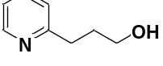
The yield of product (27%) was determined by GC using biphenyl as the internal standard (Standard compound of 3u was obtained according to the procedure C). ¹H NMR (400 MHz, CDCl₃) δ 8.52 – 8.46 (m, 1H), 7.61 (td, J = 7.7, 1.8 Hz, 1H), 7.19 (d, J = 7.8 Hz, 1H), 7.15 – 7.09 (m, 1H), 4.47 (s, 1H), 3.71 (t, J = 5.9 Hz, 2H), 2.97 (t, J = 6.9 Hz, 2H), 2.03 – 1.94 (m, 2H). ¹³C NMR (101 MHz, CDCl₃) δ 161.48 (s), 148.69 (s), 136.80 (s), 123.19 (s), 121.17 (s), 62.16 (s), 35.29 (s), 31.71 (s).

octan-1-ol 5a(Kobayashi et al., 2020)
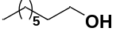
The yield of product (41%) was determined by GC using biphenyl as the internal standard. ¹H NMR (400 MHz, CDCl₃) δ 3.58 (td, J = 6.7, 0.8 Hz, 2H), 2.55 (ddd, J = 21.4, 12.2, 6.7 Hz, 1H), 1.59 – 1.47 (m, 2H), 1.38 – 1.17 (m, 10H), 0.86 (t, J = 6.8 Hz, 3H). ¹³C NMR (101 MHz, CDCl₃) δ 62.74 (s), 32.71 (s), 31.81 (s), 29.34 (d, J = 13.3 Hz), 25.76 (s), 22.62 (s), 14.02 (s).

hexan-1-ol 5b(Song et al., 2018)
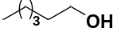
The yield of product (45%) was determined by GC using biphenyl as the internal standard. ¹H NMR (400 MHz, CDCl₃) δ 3.35 – 3.24 (m, 2H), 2.90 – 2.57 (m, 1H), 1.32 – 1.23 (m, 2H), 1.10 – 0.97 (m, 6H), 0.67 – 0.57 (m, 3H). ¹³C NMR (101 MHz, CDCl₃) δ 62.58 (s), 32.61 (s), 31.63 (s), 25.42 (s), 22.58 (s), 13.91 (s).

3-cyclopentylpropan-1-ol 5f(Yan et al., 2018)
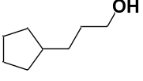
The yield of product (36%) was determined by GC using biphenyl as the internal standard. ¹H NMR (400 MHz, CDCl₃) δ 3.53 (t, J = 6.8 Hz, 2H), 2.60 – 2.52 (m, 1H), 1.73 – 1.63 (m, 3H), 1.57 – 1.38 (m, 6H), 1.31 – 1.23 (m, 2H), 1.06 – 0.94 (m, 2H). ¹³C NMR (101 MHz, CDCl₃) δ 62.99 (s), 39.95 (s), 32.67 (s), 32.16 (s), 31.91 (s), 25.14 (s).

3-cyclohexylpropan-1-ol 5g(You et al., 2022)
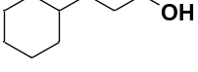
The yield of product (40%) was determined by GC using biphenyl as the internal standard. ¹H NMR (400 MHz, CDCl₃) δ 3.49 (t, J = 6.9 Hz, 2H), 3.18 (s, 1H), 1.68 – 1.53 (m, 5H), 1.48 (dt, J = 13.9, 6.8 Hz, 2H), 1.20 – 1.02 (m, 6H), 0.86 – 0.74 (m, 2H). ¹³C NMR (101 MHz, CDCl₃) δ 62.92 (s), 37.50 (s), 33.39 (d, J = 9.0 Hz), 29.99 (s), 26.65 (s), 26.34 (s).

2-ethylhexan-1-ol 6a(Kobayashi et al., 2020)
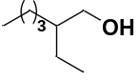
The yield of product (7%) was determined by GC using biphenyl as the internal standard. ¹H NMR (400 MHz, CDCl₃) δ 3.29 – 3.20 (m, 2H), 2.17 (s, 1H), 1.18 – 0.94 (m, 9H), 0.69 – 0.50 (m, 6H). ¹³C NMR (101 MHz, CDCl₃) δ 65.05 (s), 41.91 (s), 30.08 (s), 29.09 (s), 23.28 (s), 23.07 (s), 14.02 (s), 10.98 (s).

Reference
Call A, Casadevall C, Acuña-Parés F, Casitas A and Lloret-Fillol J (2017) Dual cobalt–copper light-driven catalytic reduction of aldehydes and aromatic ketones in aqueous media. Chemical Science 8:4739-4749. http://dx.doi.org/10.1039/C7SC01276D.
Cheung S-Y, Chow H-F, Ngai T and Wei X (2009) Synthesis of Organometallic Poly(dendrimer)s by Macromonomer Polymerization: Effect of Dendrimer Size and Structural Rigidity on the Polymerization Efficiency. Chemistry – A European Journal 15:2278-2288. https://doi.org/10.1002/chem.200802306.
Fu S, Shao Z, Wang Y and Liu Q (2017) Manganese-Catalyzed Upgrading of Ethanol into 1-Butanol. J Am Chem Soc 139:11941-11948. https://doi.org/10.1021/jacs.7b05939.
Kišić A, Stephan M and Mohar B (2015) ansa-Ruthenium(II) Complexes of R2NSO2DPEN-(CH2)n(η6-Aryl) Conjugate Ligands for Asymmetric Transfer Hydrogenation of Aryl Ketones. Advanced Synthesis & Catalysis 357:2540-2546. https://doi.org/10.1002/adsc.201500288.
Kobayashi M, Itoh S, Yoshimura K, Tsukamoto Y and Obora Y (2020) Iridium Complex-Catalyzed C2-Extension of Primary Alcohols with Ethanol via a Hydrogen Autotransfer Reaction. The Journal of Organic Chemistry 85:11952-11958. https://doi.org/10.1021/acs.joc.0c01540.
Sifferlen T, Koberstein R, Cottreel E, Boller A, Weller T, Gatfield J, Brisbare-Roch C, Jenck F and Boss C (2013) Structure–activity relationship studies and sleep-promoting activity of novel 1-chloro-5,6,7,8-tetrahydroimidazo[1,5-a]pyrazine derivatives as dual orexin receptor antagonists. Part 2. Bioorganic & Medicinal Chemistry Letters 23:3857-3863. https://doi.org/10.1016/j.bmcl.2013.04.071.
Song S, Wang D, Di L, Wang C, Dai W, Wu G, Guan N and Li L (2018) Robust cobalt oxide catalysts for controllable hydrogenation of carboxylic acids to alcohols. Chinese Journal of Catalysis 39:250-257. https://doi.org/10.1016/S1872-2067(17)63003-1.
Szostak M, Spain M and Procter DJ (2012) Electron Transfer Reduction of Carboxylic Acids Using SmI2–H2O–Et3N. Organic Letters 14:840-843. https://doi.org/10.1021/ol203361k.
Wypych J-C, Nguyen TM, Bénéchie M and Marazano C (2008) Reaction of Aldimine Anions with Vinamidinium Chloride: Three-Component Access to 3-Alkylpyridines and 3-Alkylpyridinium Salts and Access to 2-Alkyl Glutaconaldehyde Derivatives. The Journal of Organic Chemistry 73:1169-1172. https://doi.org/10.1021/jo702311k.
Yan S-Y, Han Y-Q, Yao Q-J, Nie X-L, Liu L and Shi B-F (2018) Palladium(II)-Catalyzed Enantioselective Arylation of Unbiased Methylene C(sp3)−H Bonds Enabled by a 2-Pyridinylisopropyl Auxiliary and Chiral Phosphoric Acids. Angewandte Chemie International Edition 57:9093-9097. https://doi.org/10.1002/anie.201804197.
You Y, Wu J, Yang L and Wu T (2022) Nickel-catalyzed reductive defluorination of iodo allylic gem-difluorides: allenyl monofluoride synthesis. Chemical Communications 58:1970-1973. http://dx.doi.org/10.1039/D1CC06457F.
Zhang H and Muñiz K (2017) Selective Piperidine Synthesis Exploiting Iodine-Catalyzed Csp3–H Amination under Visible Light. ACS Catalysis 7:4122-4125. https://doi.org/10.1021/acscatal.7b00928.

NMR Spectra
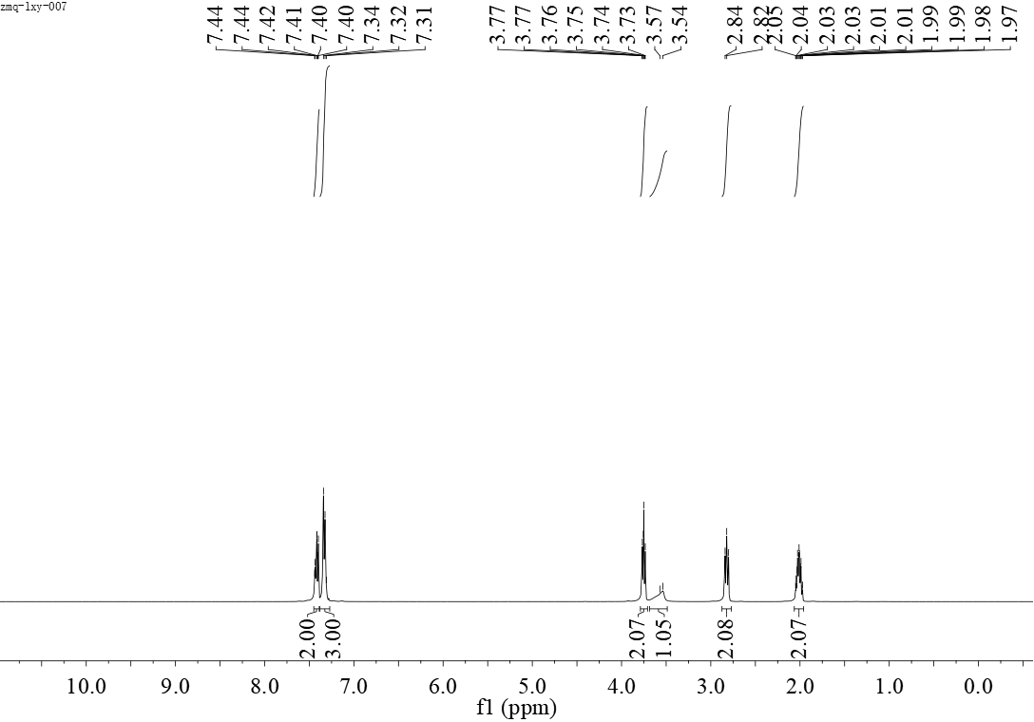
¹H NMR-spectrum (400 MHz, CDCl₃) of 3a

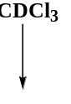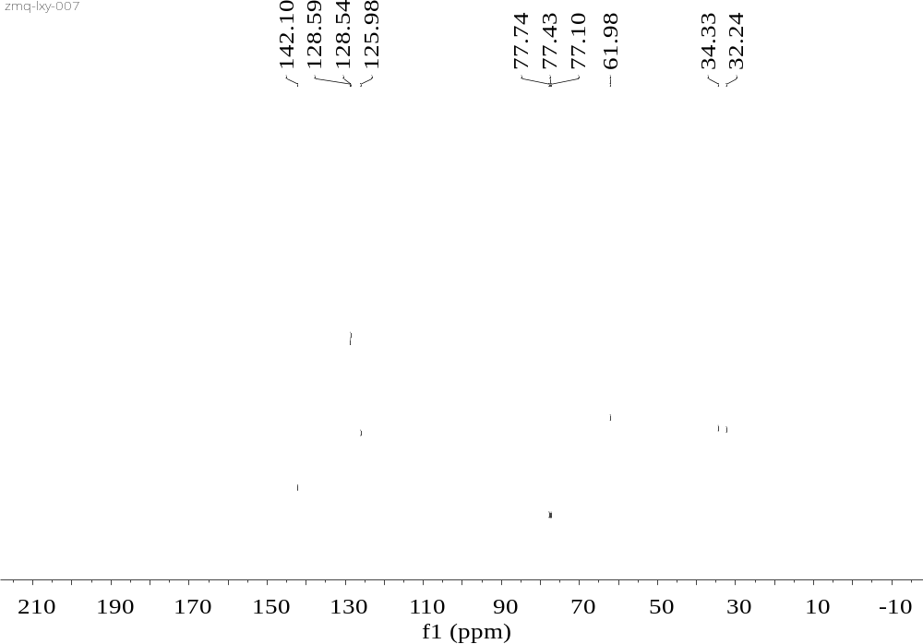
¹³C NMR-spectrum (101 MHz, CDCl₃) of 3a

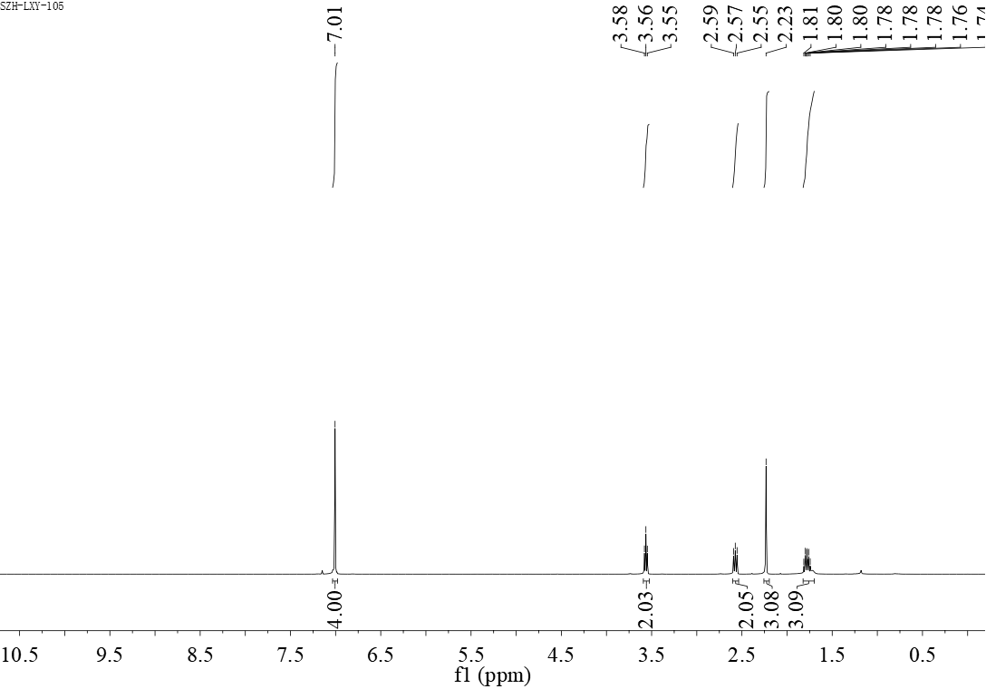
¹H NMR-spectrum (400 MHz, CDCl₃) of 3b

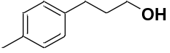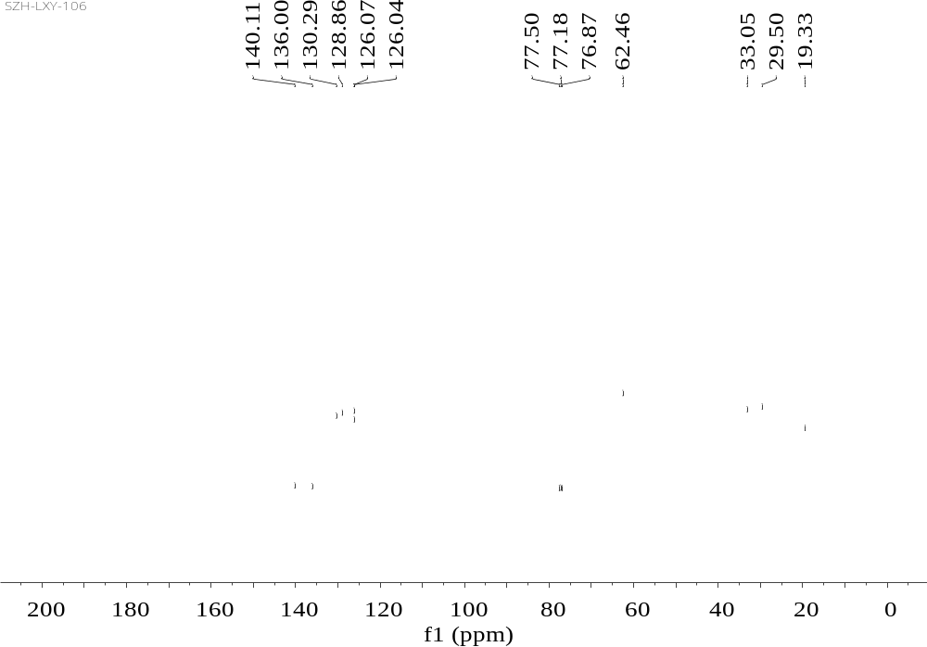
¹³C NMR-spectrum (101 MHz, CDCl₃) of 3b
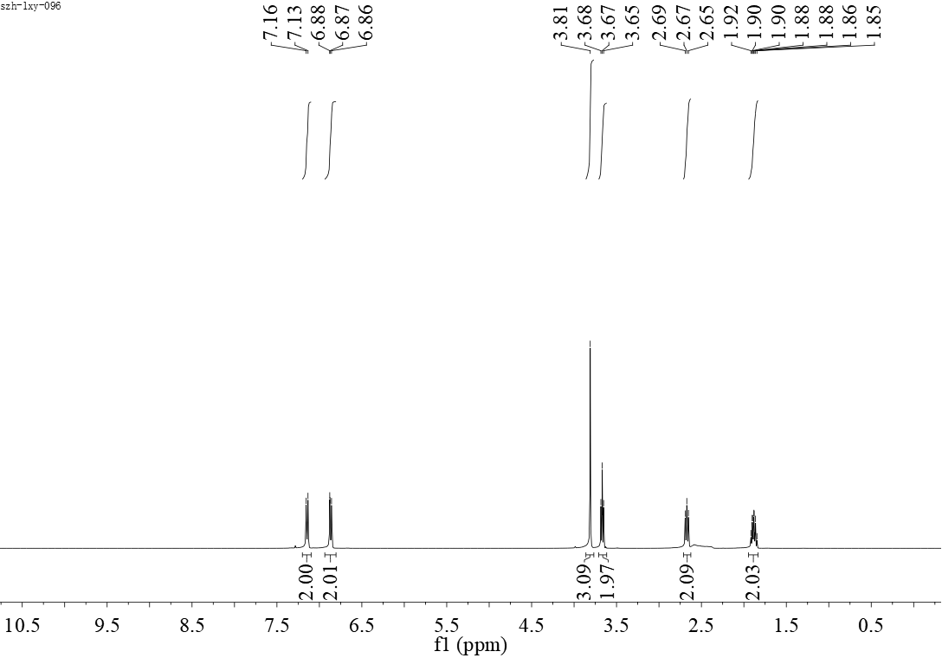
¹H NMR-spectrum (400 MHz, CDCl₃) of 3c

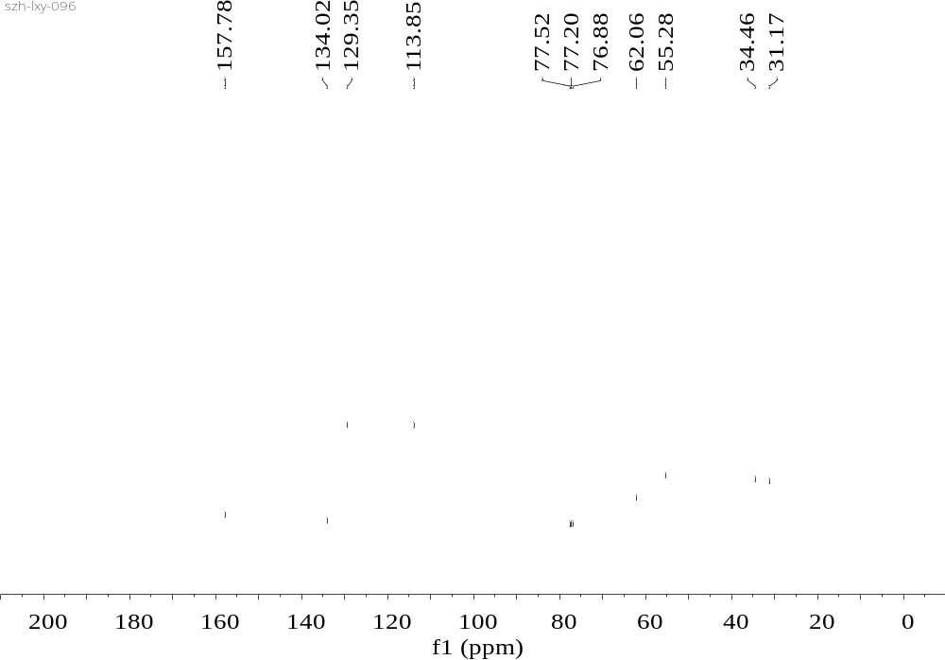
¹³C NMR-spectrum (101 MHz, CDCl₃) of 3c

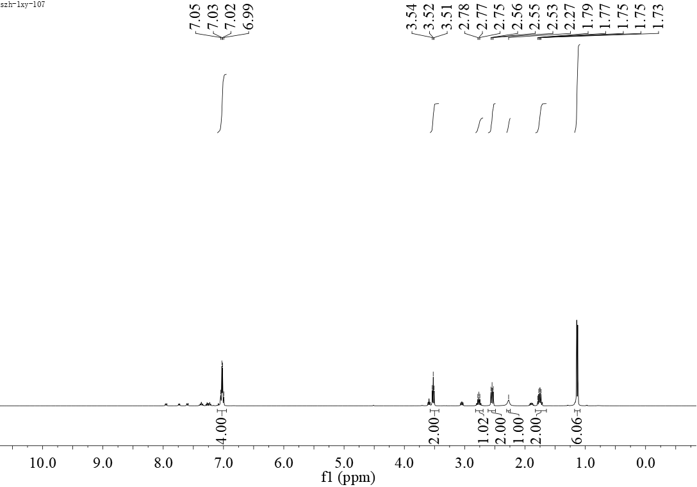
¹H NMR-spectrum (400 MHz, CDCl₃) of 3d

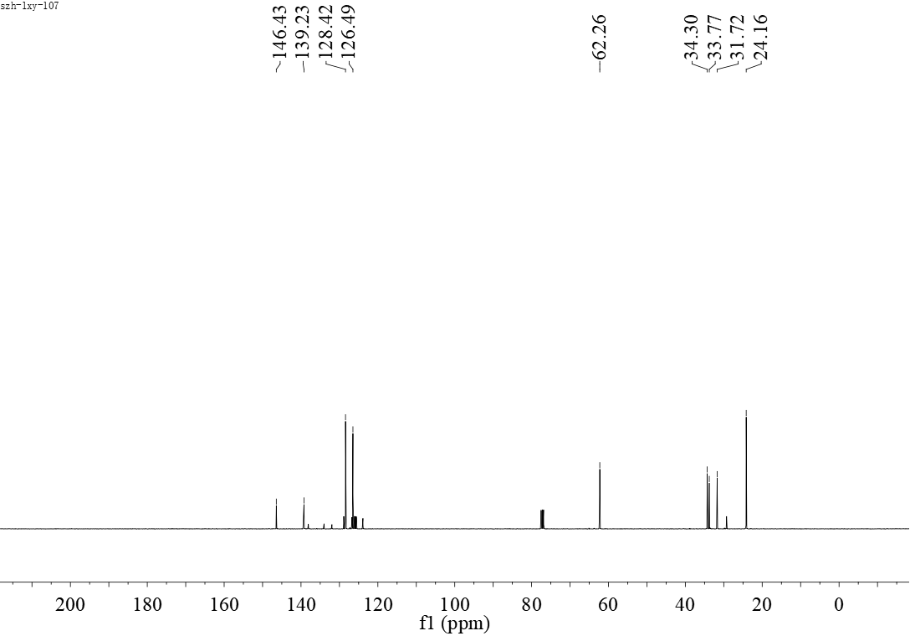
¹³C NMR-spectrum (101 MHz, CDCl₃) of 3d
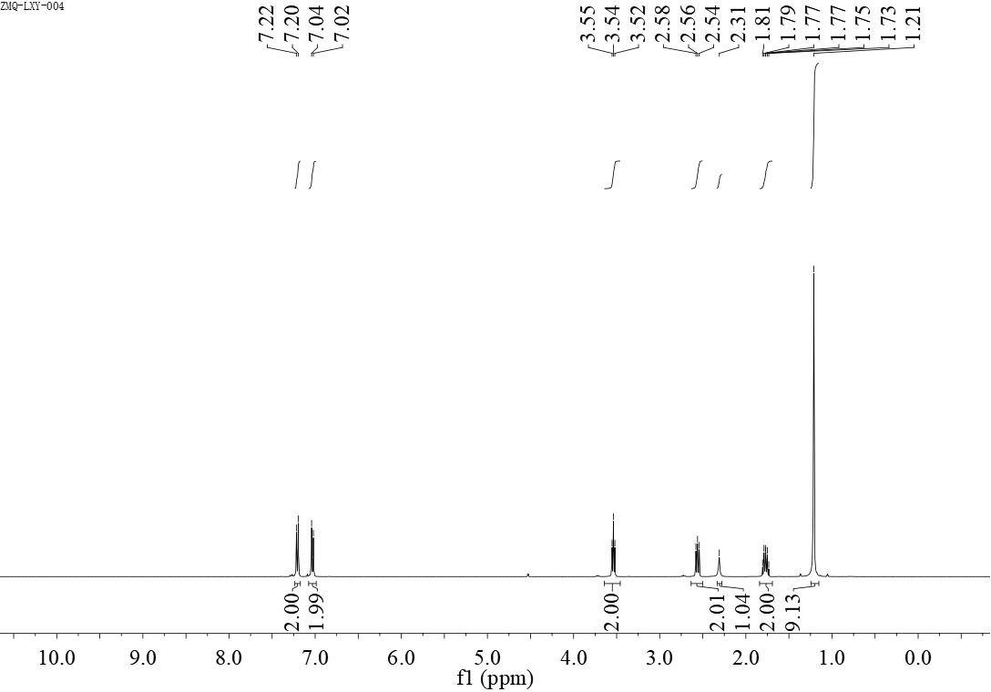
¹H NMR-spectrum (400 MHz, CDCl₃) of 3e

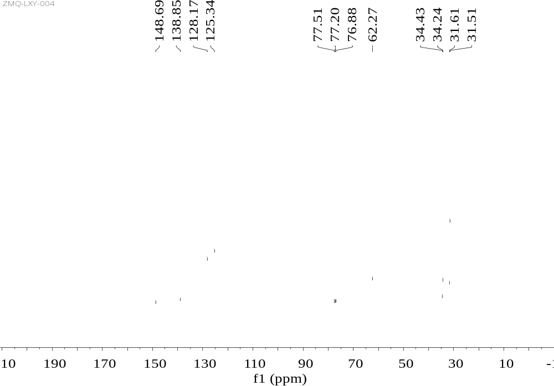
¹³C NMR-spectrum (101 MHz, CDCl₃) of 3e

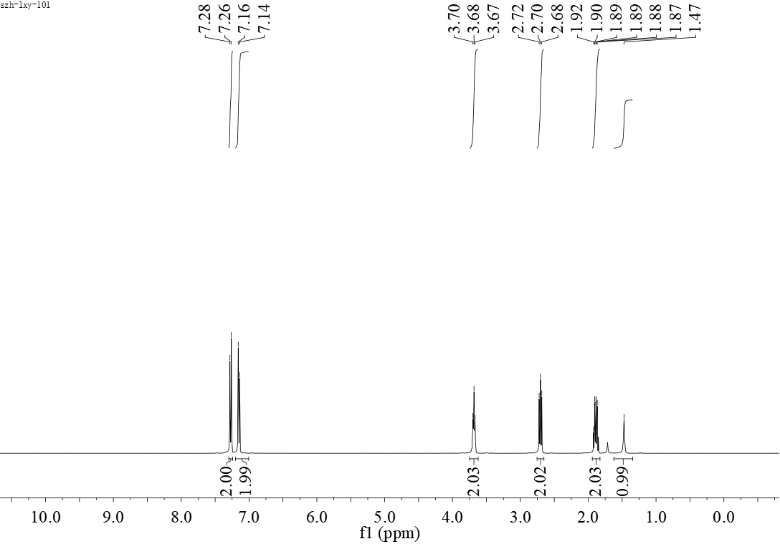
¹H NMR-spectrum (400 MHz, CDCl₃) of 3g

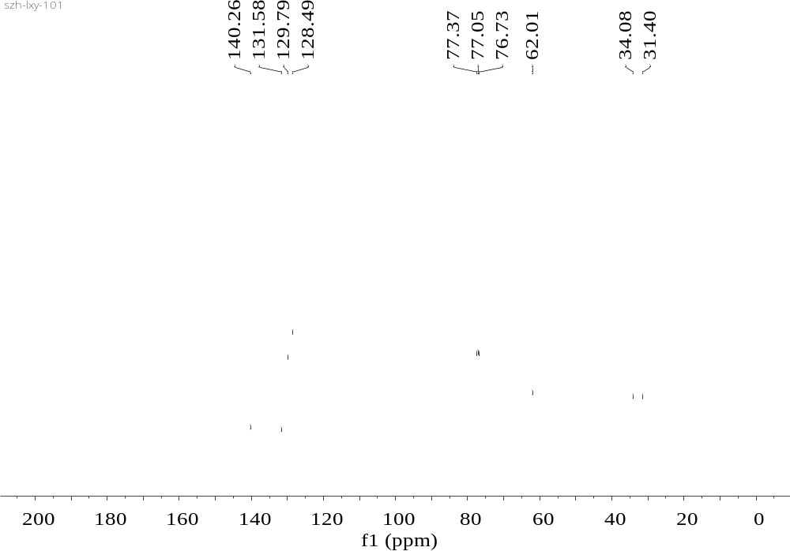
¹³C NMR-spectrum (101 MHz, CDCl₃) of 3g
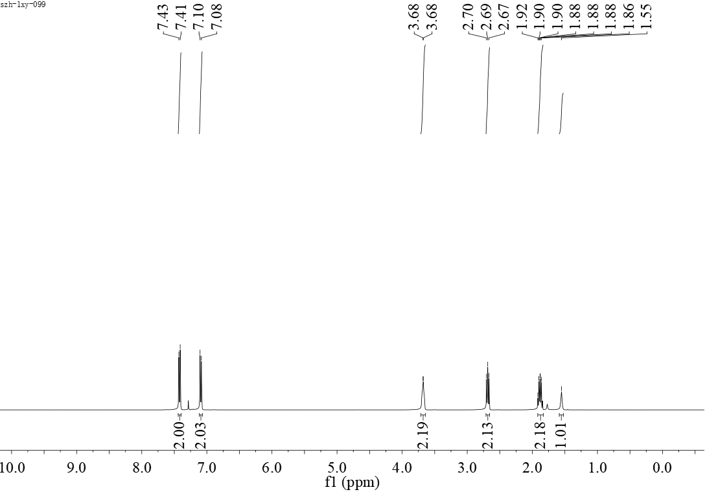
¹H NMR-spectrum (400 MHz, CDCl₃) of 3h

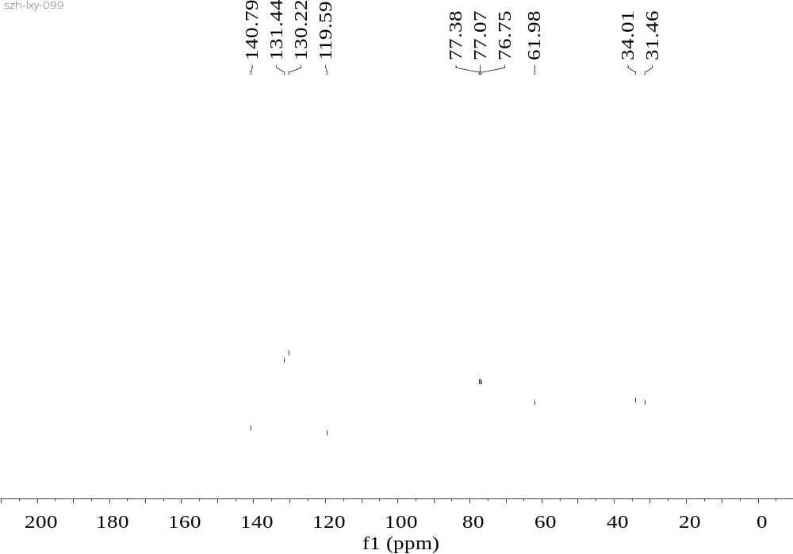
¹³C NMR-spectrum (101 MHz, CDCl₃) of 3h
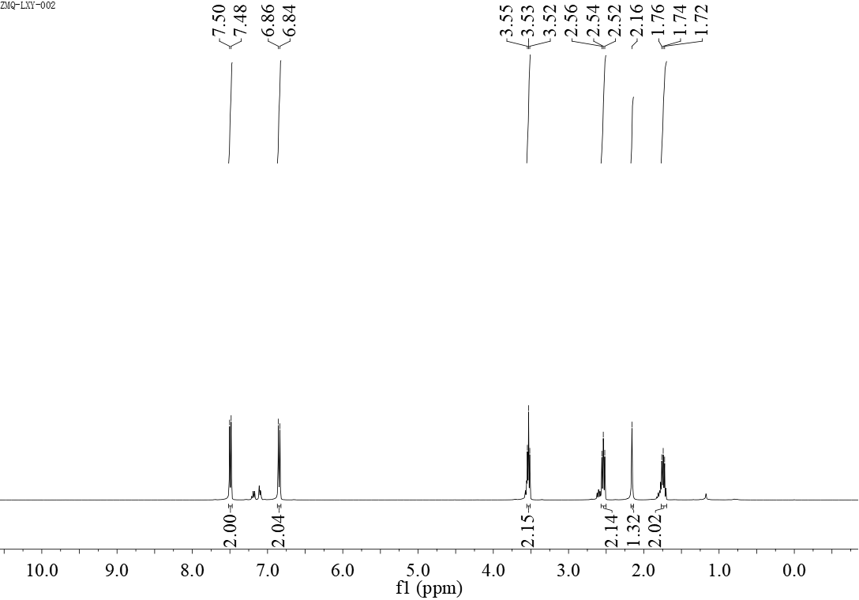
¹H NMR-spectrum (400 MHz, CDCl₃) of 3i

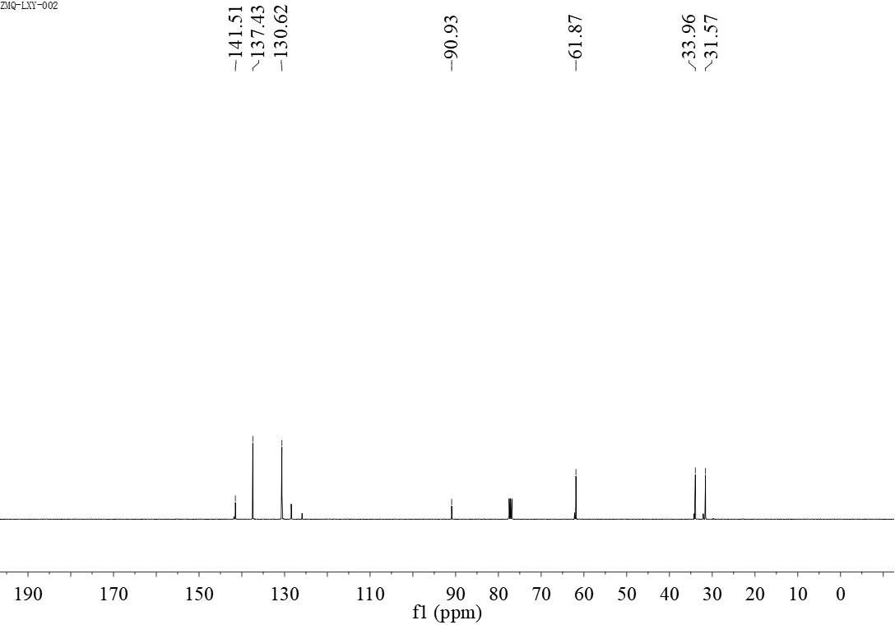
¹³C NMR-spectrum (101 MHz, CDCl₃) of 3i
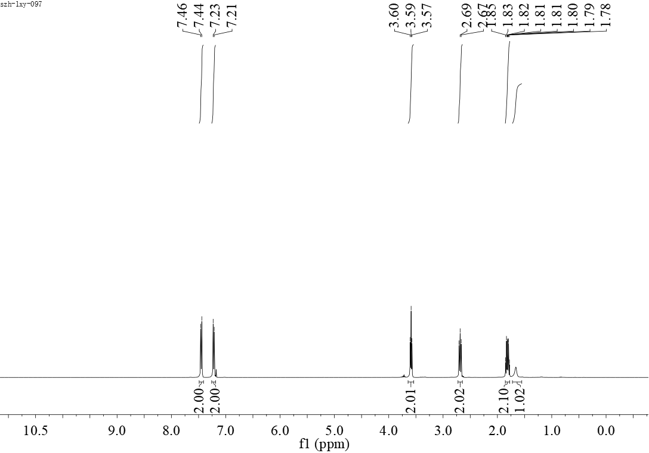
¹H NMR-spectrum (400 MHz, CDCl₃) of 3j

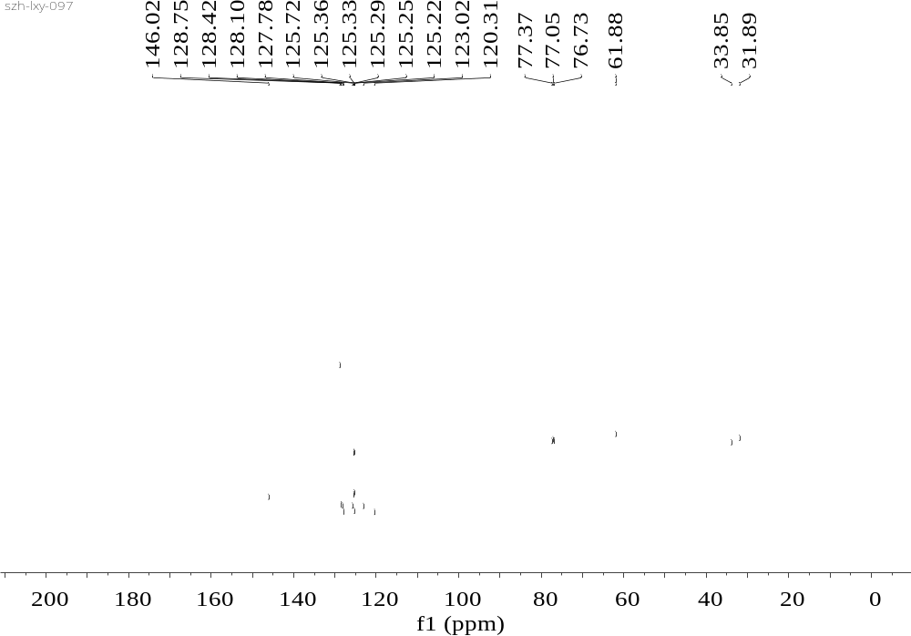
¹³C NMR-spectrum (101 MHz, CDCl₃) of 3j
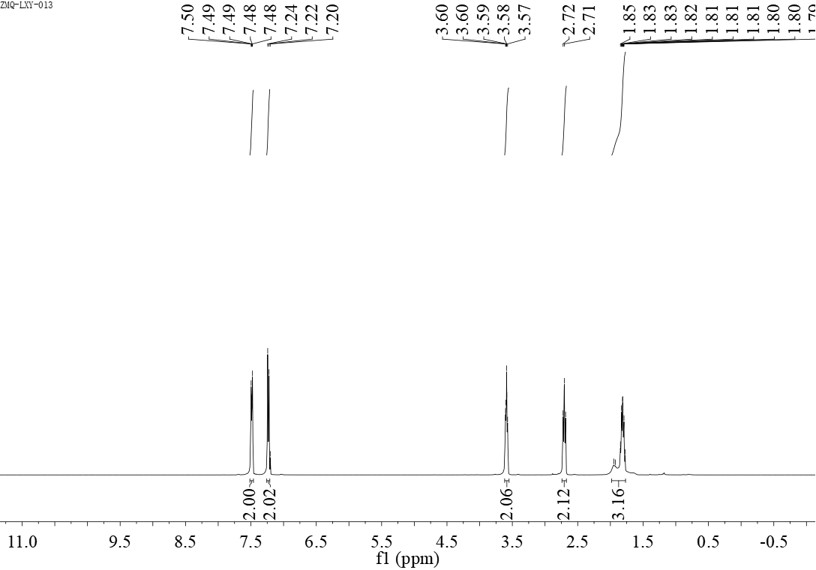
¹H NMR-spectrum (400 MHz, CDCl₃) of 3k

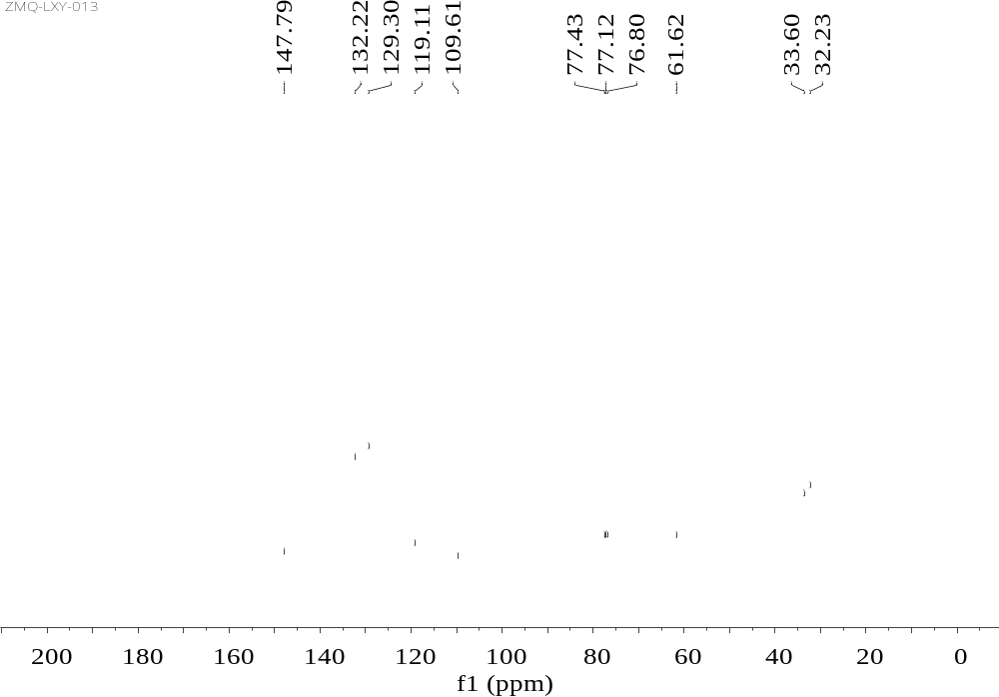
¹³C NMR-spectrum (101 MHz, CDCl₃) of 3k

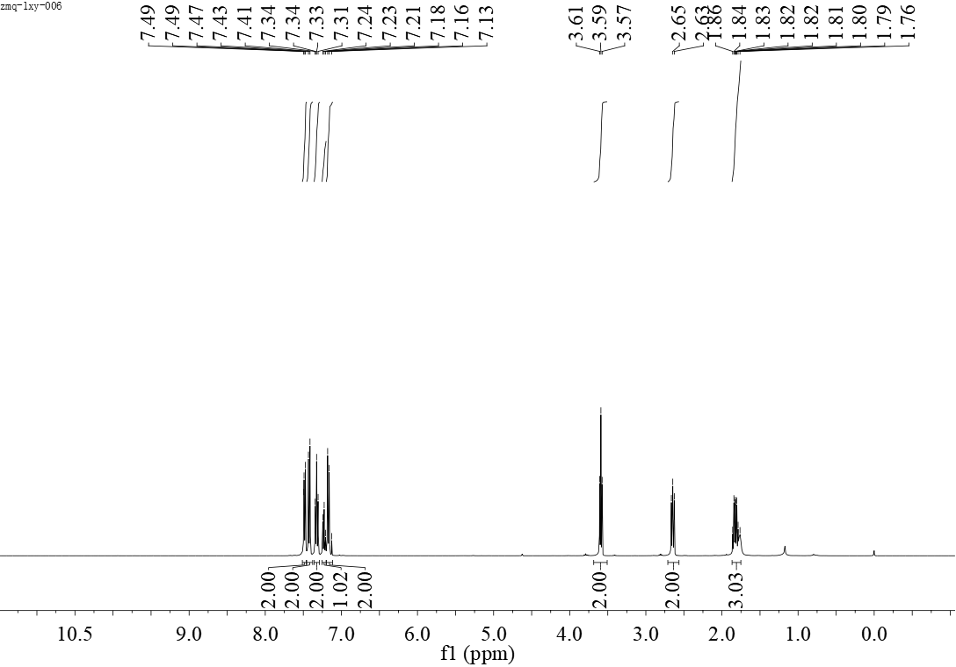
¹H NMR-spectrum (400 MHz, CDCl₃) of 3l

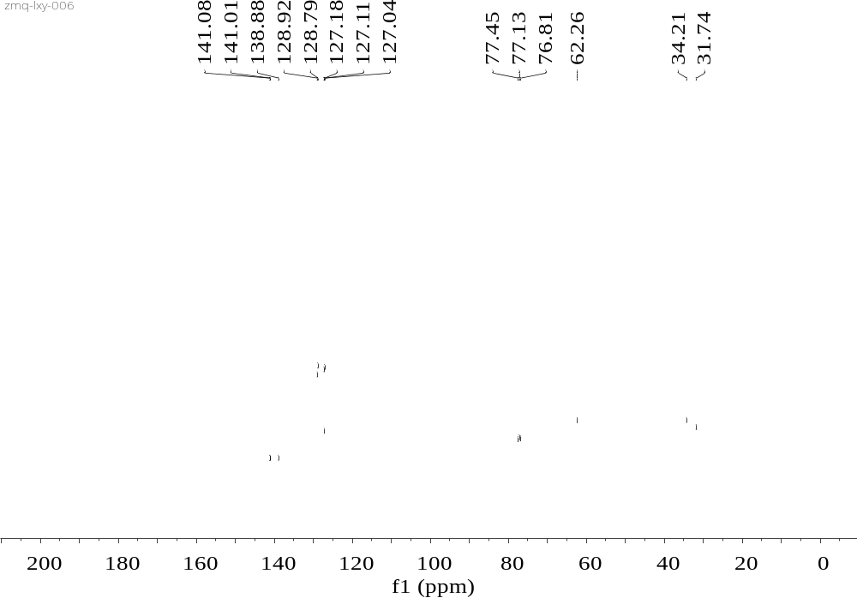
¹³C NMR-spectrum (101 MHz, CDCl₃) of 3l
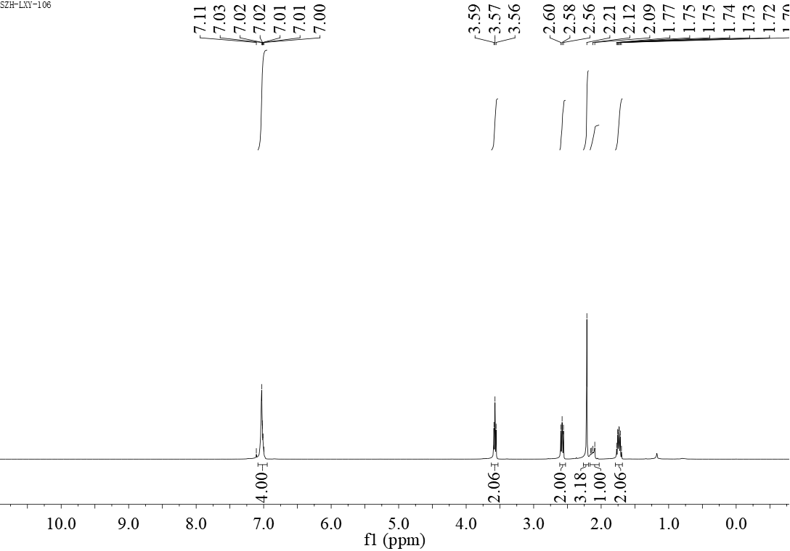
¹H NMR-spectrum (400 MHz, CDCl₃) of 3m

¹³C NMR-spectrum (101 MHz, CDCl₃) of 3m
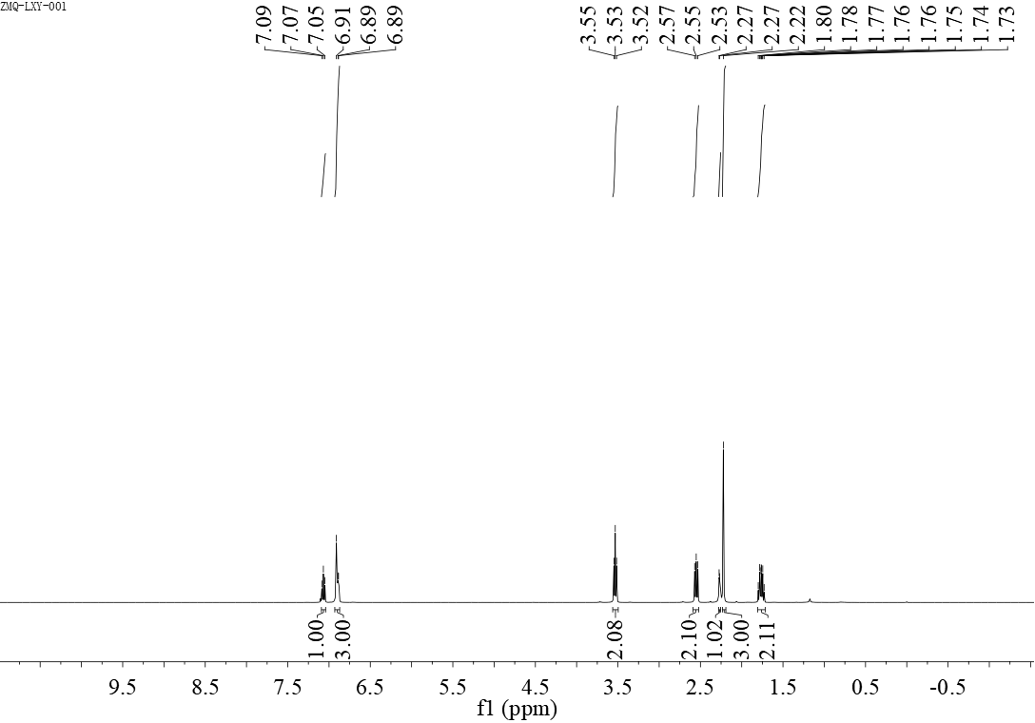¹H NMR-spectrum (400 MHz, CDCl₃) of 3n

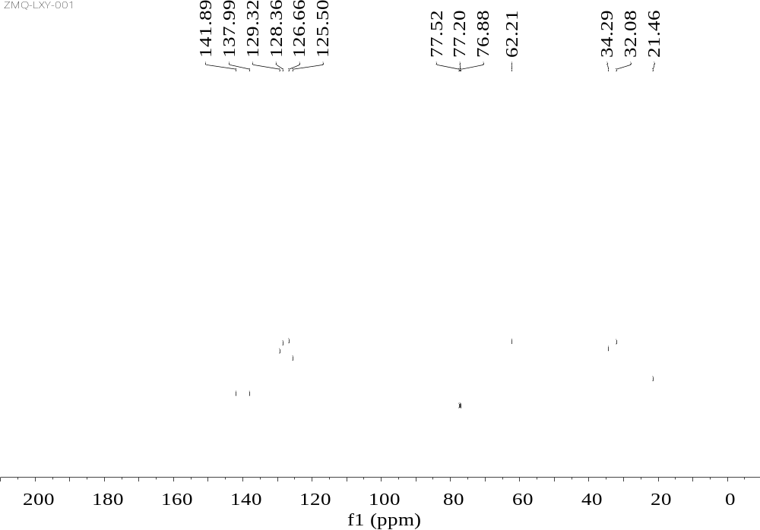
¹³C NMR-spectrum (101 MHz, CDCl₃) of 3n
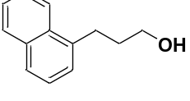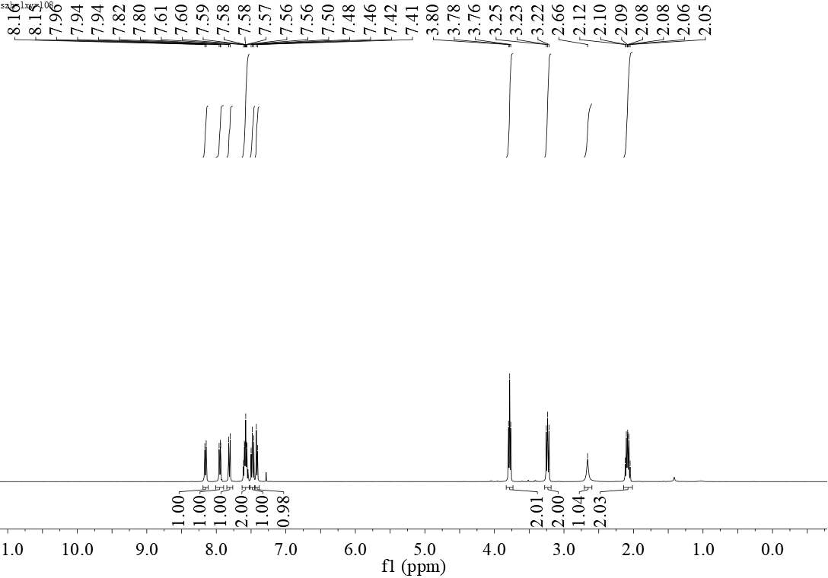
¹H NMR-spectrum (400 MHz, CDCl₃) of 3o

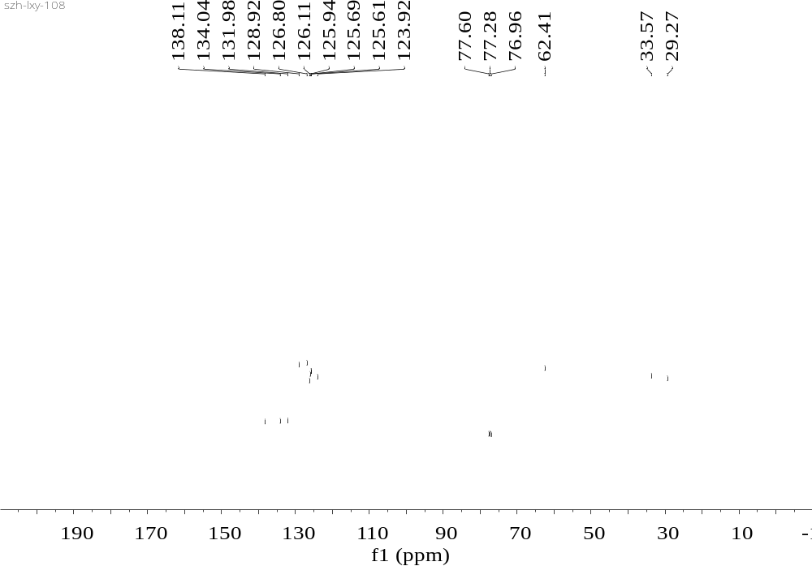
¹³C NMR-spectrum (101 MHz, CDCl₃) of 3o

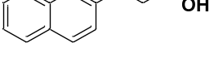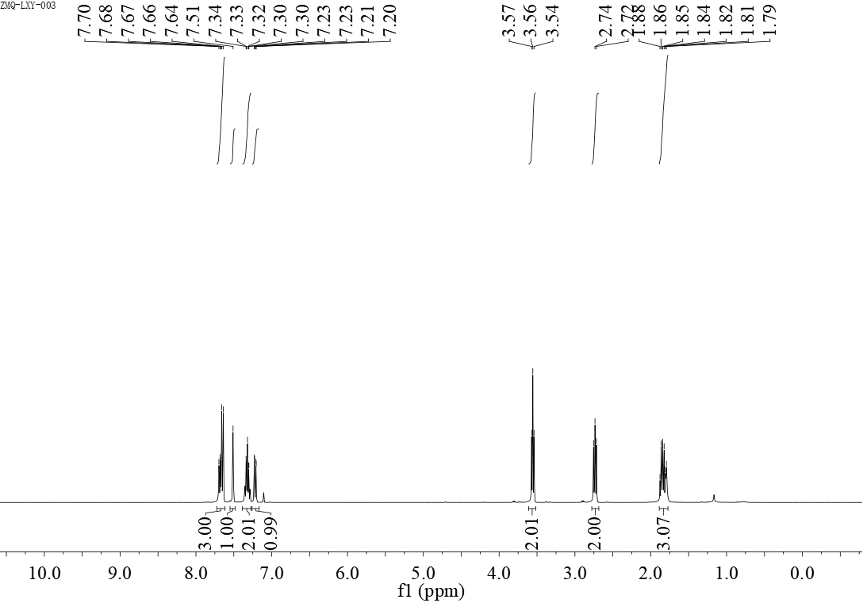
¹H NMR-spectrum (400 MHz, CDCl₃) of 3p

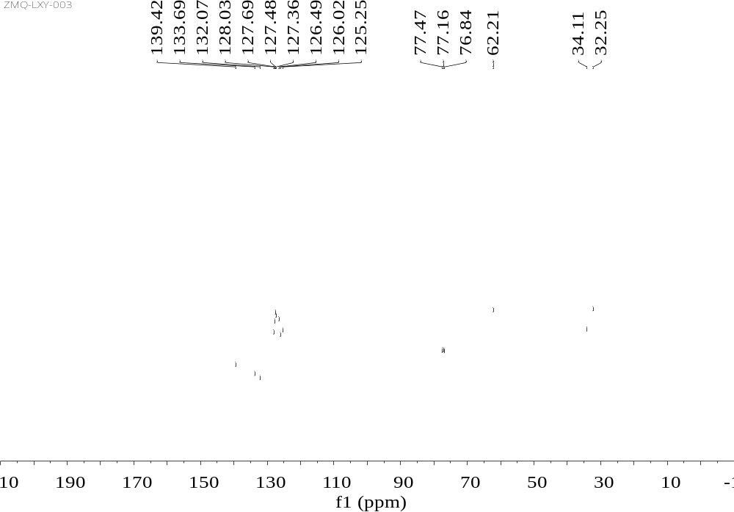
¹³C NMR-spectrum (101 MHz, CDCl₃) of 3p
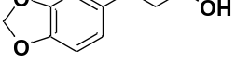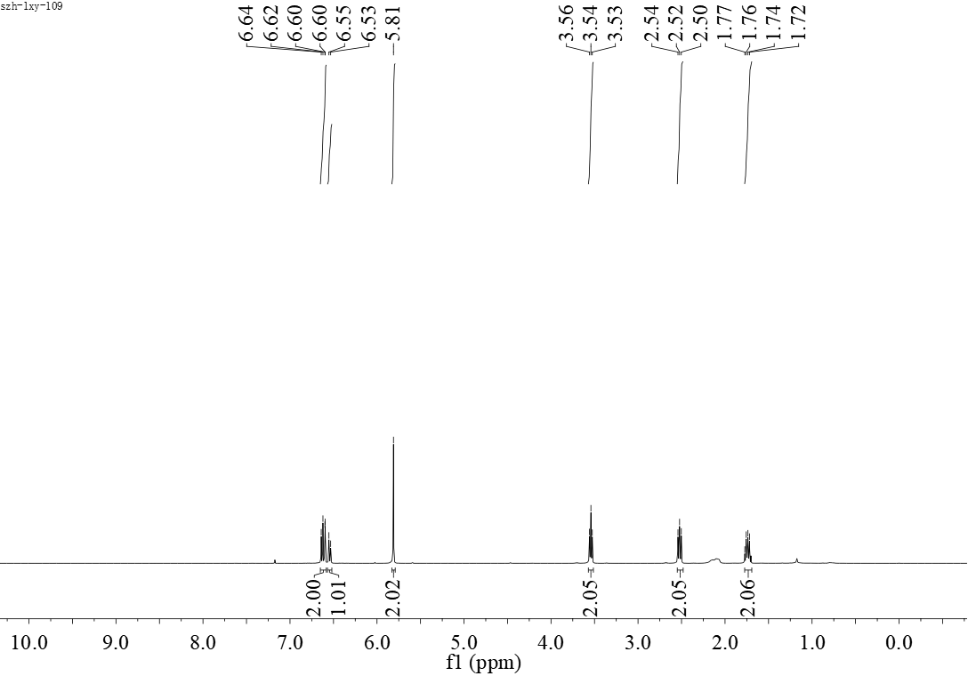
¹H NMR-spectrum (400 MHz, CDCl₃) of 3q

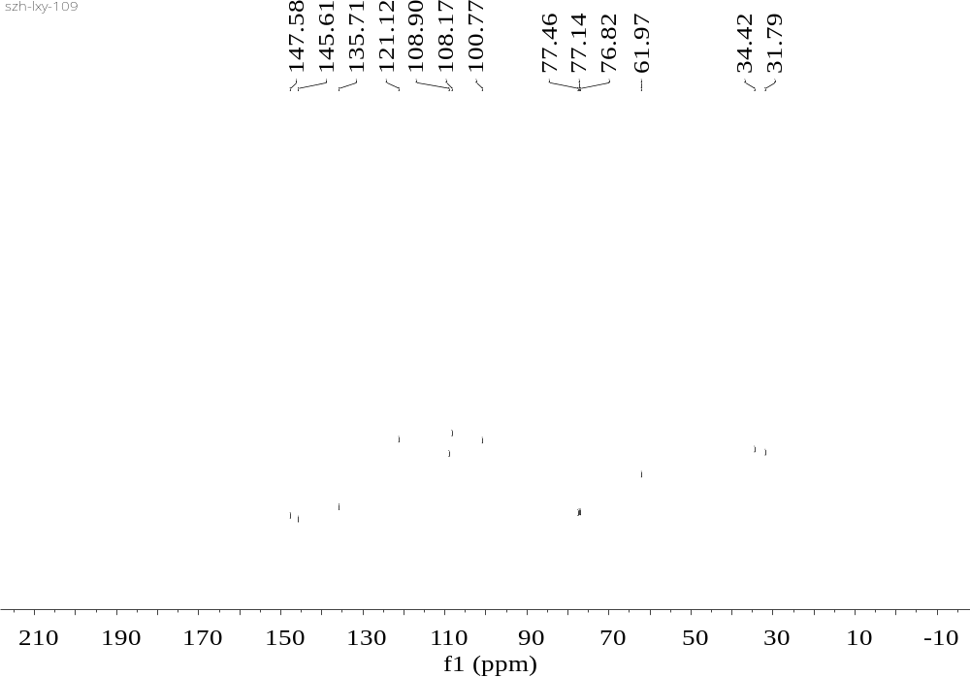
¹³C NMR-spectrum (101 MHz, CDCl₃) of 3q
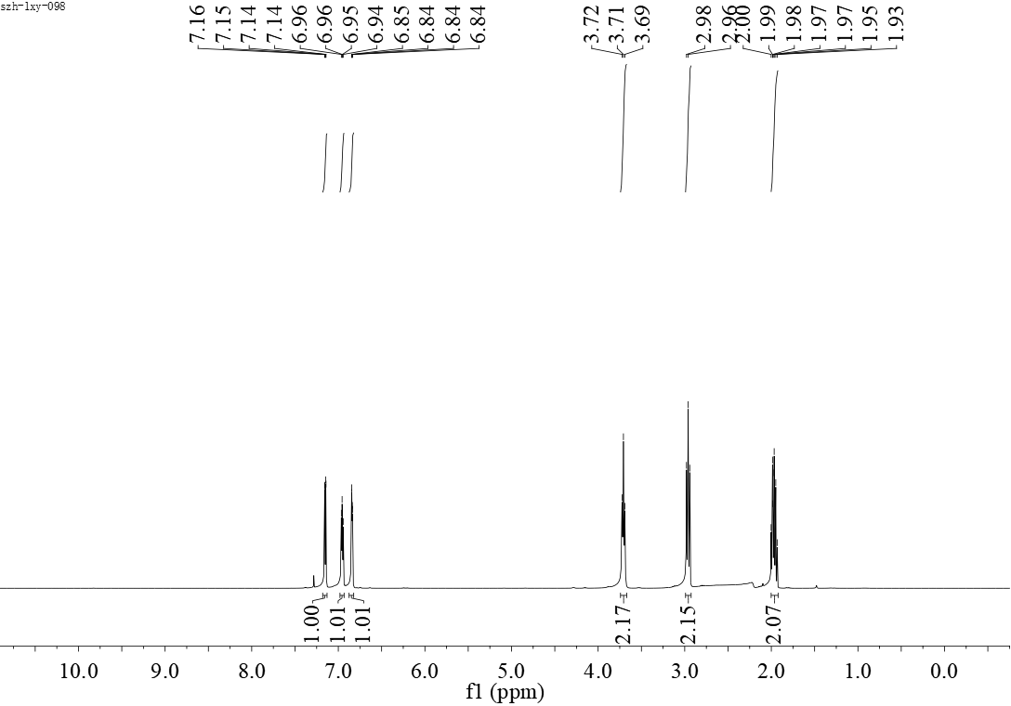
¹H NMR-spectrum (400 MHz, CDCl₃) of 3s

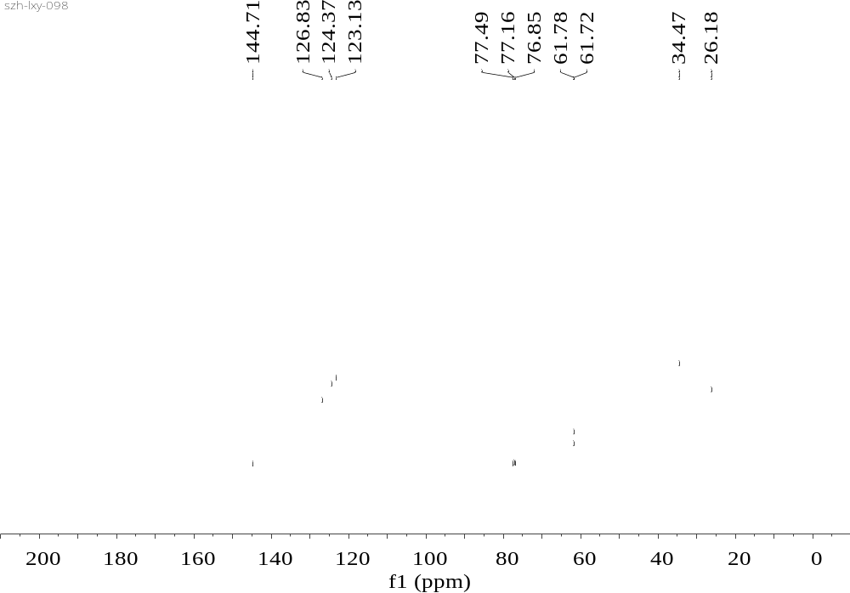
¹³C NMR-spectrum (101 MHz, CDCl₃) of 3s
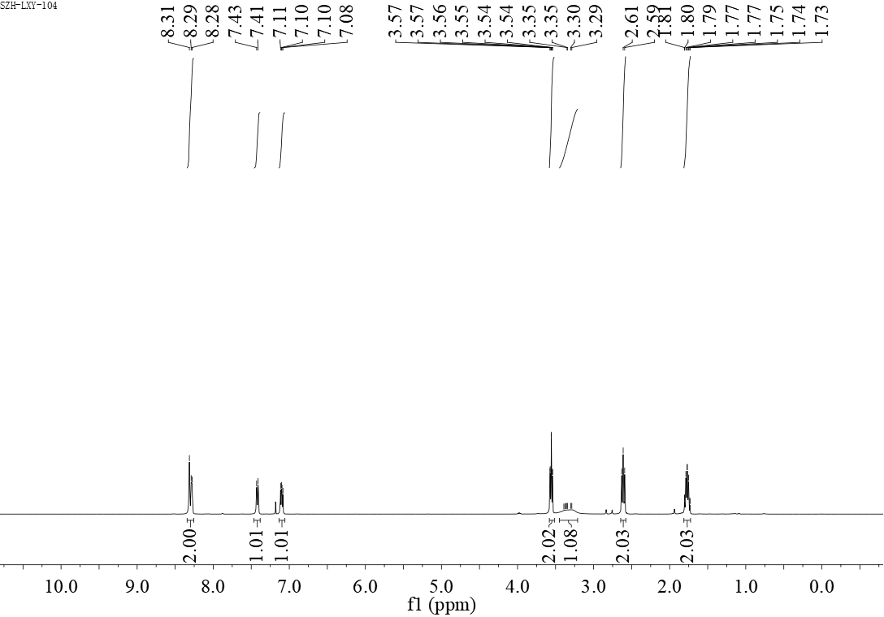
¹H NMR-spectrum (400 MHz, CDCl₃) of 3t

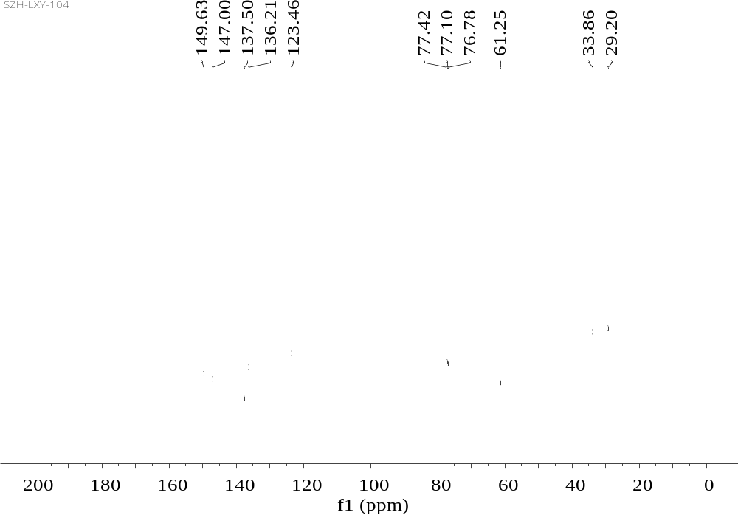
¹³C NMR-spectrum (101 MHz, CDCl₃) of 3t

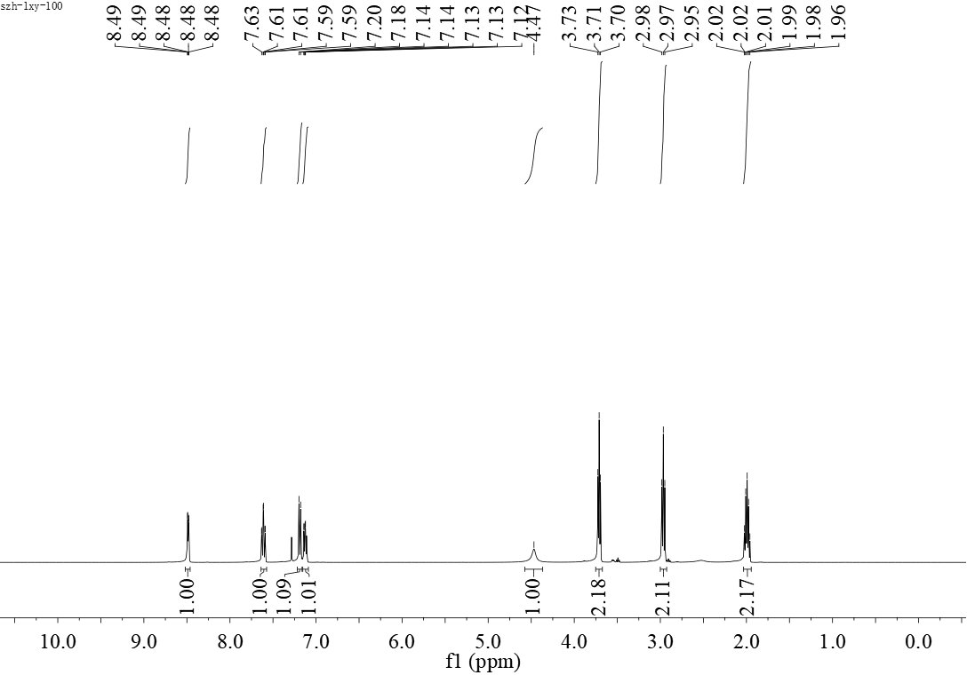
¹H NMR-spectrum (400 MHz, CDCl₃) of 3u

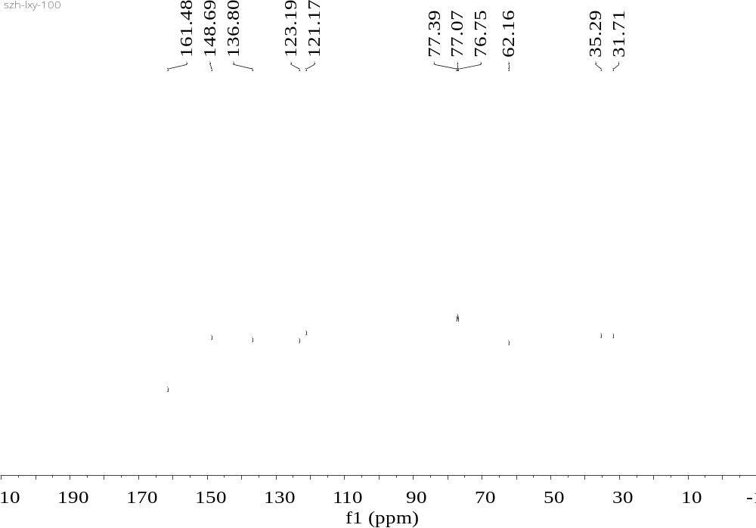
¹³C NMR-spectrum (101 MHz, CDCl₃) of 3u

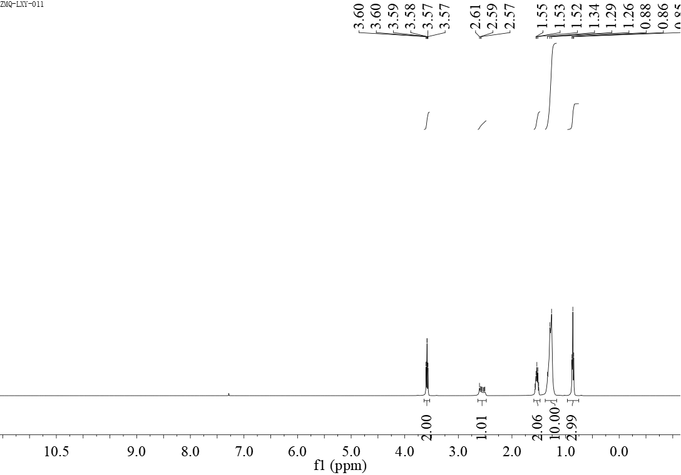
¹H NMR-spectrum (400 MHz, CDCl₃) of 5a

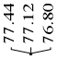
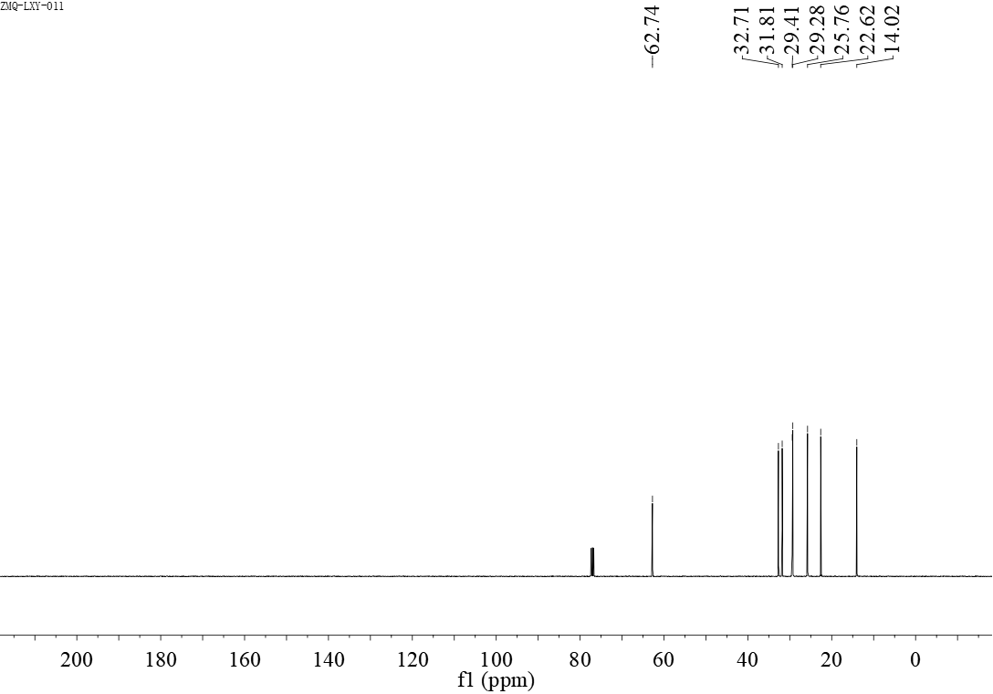
¹³C NMR-spectrum (101 MHz, CDCl₃) of 5a

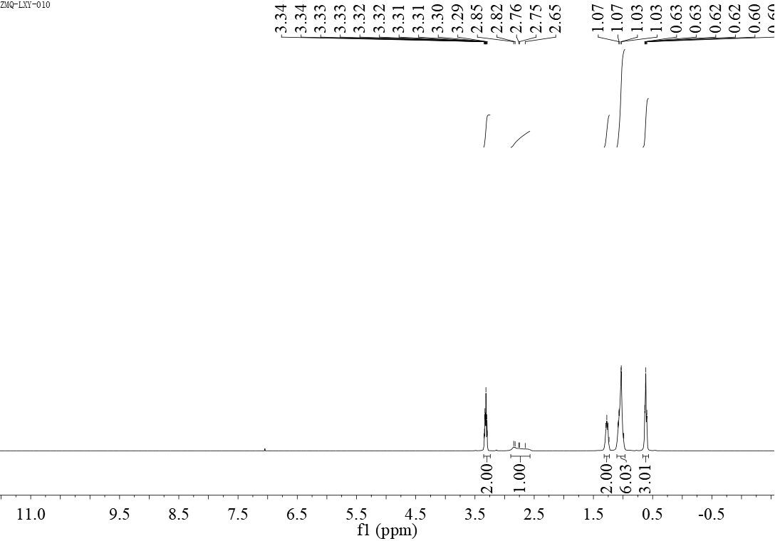
¹H NMR-spectrum (400 MHz, CDCl₃) of 5b

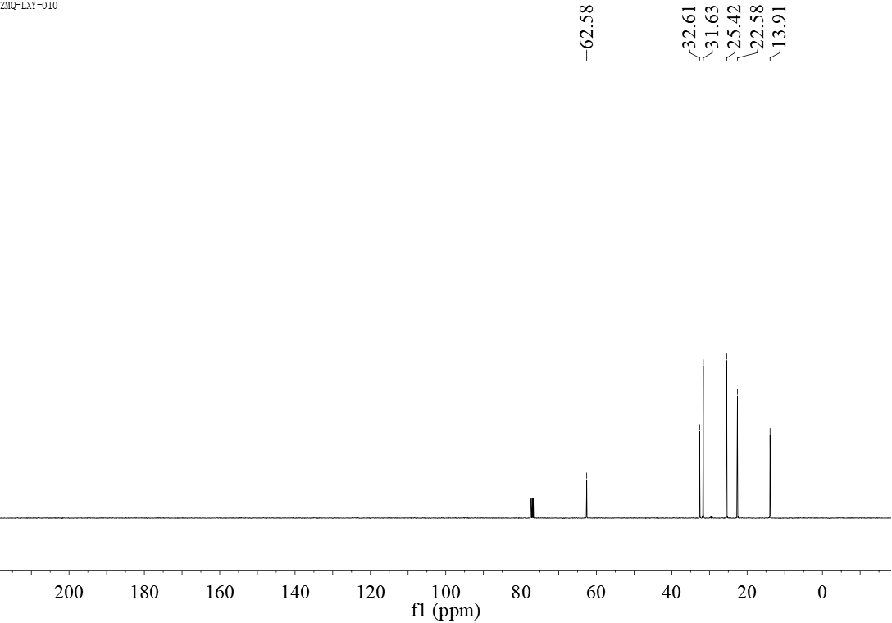
¹³C NMR-spectrum (101 MHz, CDCl₃) of 5b

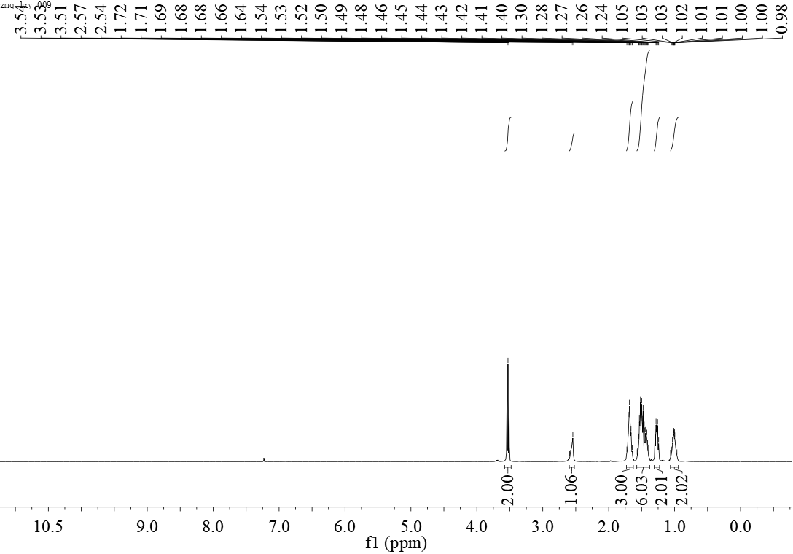
¹H NMR-spectrum (400 MHz, CDCl₃) of 5f

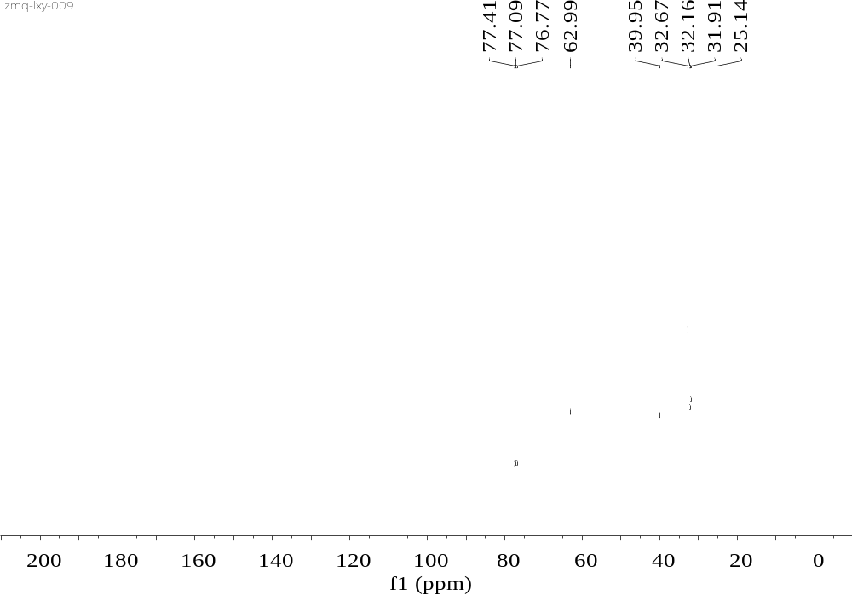
¹³C NMR-spectrum (101 MHz, CDCl₃) of 5f
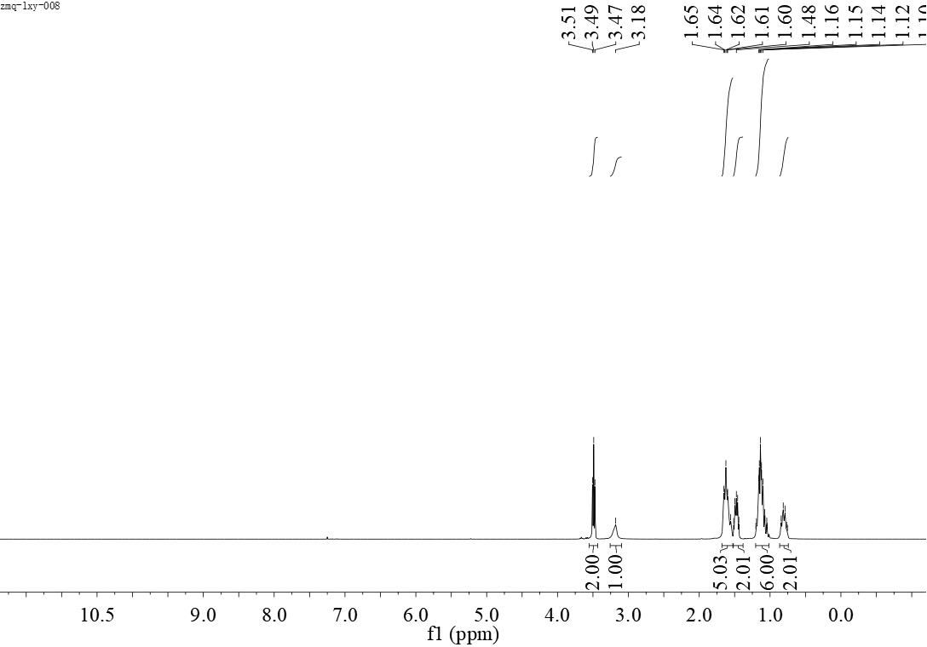
¹H NMR-spectrum (400 MHz, CDCl₃) of 5g

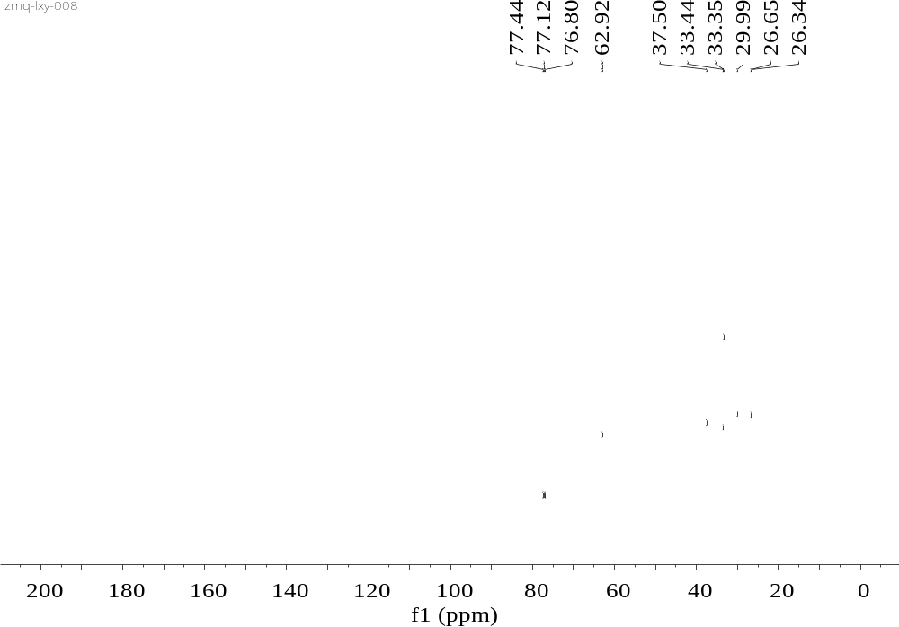
¹³C NMR-spectrum (101 MHz, CDCl₃) of 5g

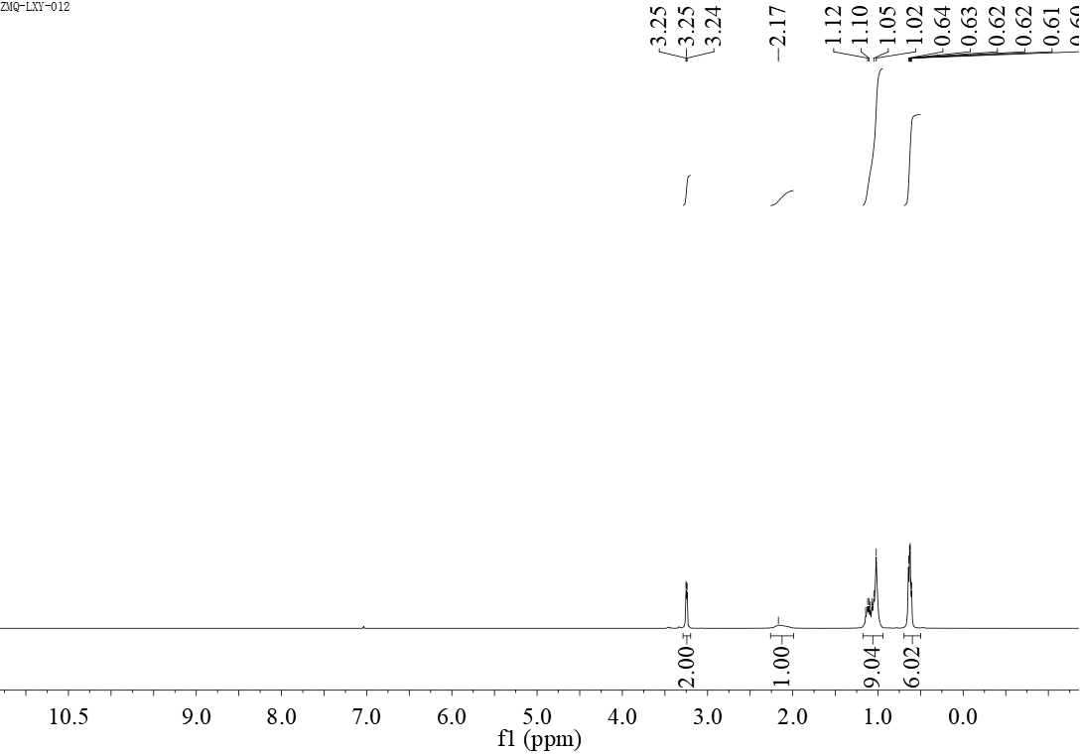
¹H NMR-spectrum (400 MHz, CDCl₃) of 6a

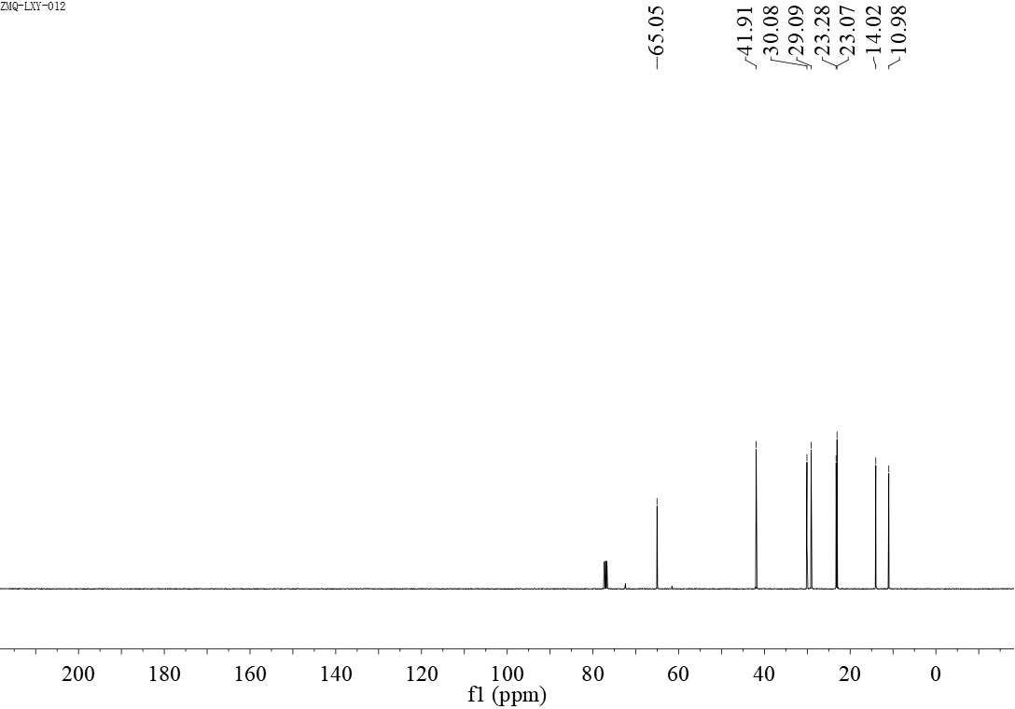
¹³C NMR-spectrum (101 MHz, CDCl₃) of 6a

