Supplementary Information

Multi-responsive 3D Structured PVDF Cube Switch for Security System Using Piezoelectric Anisotropy

Yujun Song^{1#}, Hyeongjin Jo^{1#}, and Ji-Hyeon Song^{1*}

¹Department of Mechanical Engineering, Dankook University, Yongin 16890, South Korea
# Equally contributed
* Corresponding author, E-mail: jhsong@dankook.ac.kr

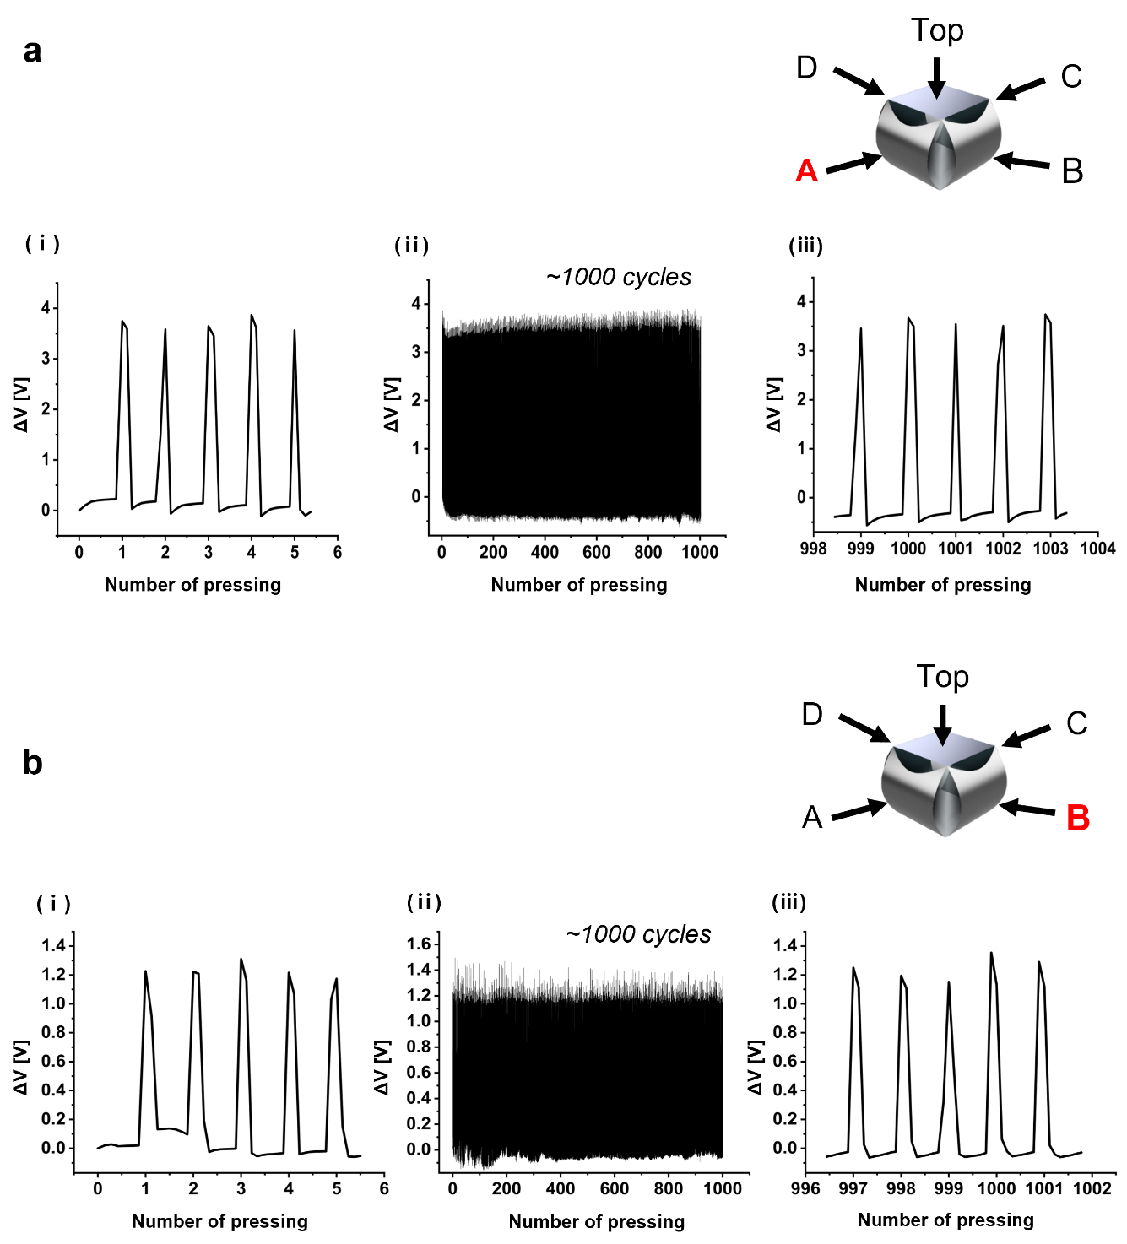
Figure S1. Cyclic test with pressing displacement 3 mm for over 1000 times. a) A side and b) B side and its response in (ⅰ) first five cycles, (ⅱ) overall responses, and (ⅲ) after 1000 cycles.

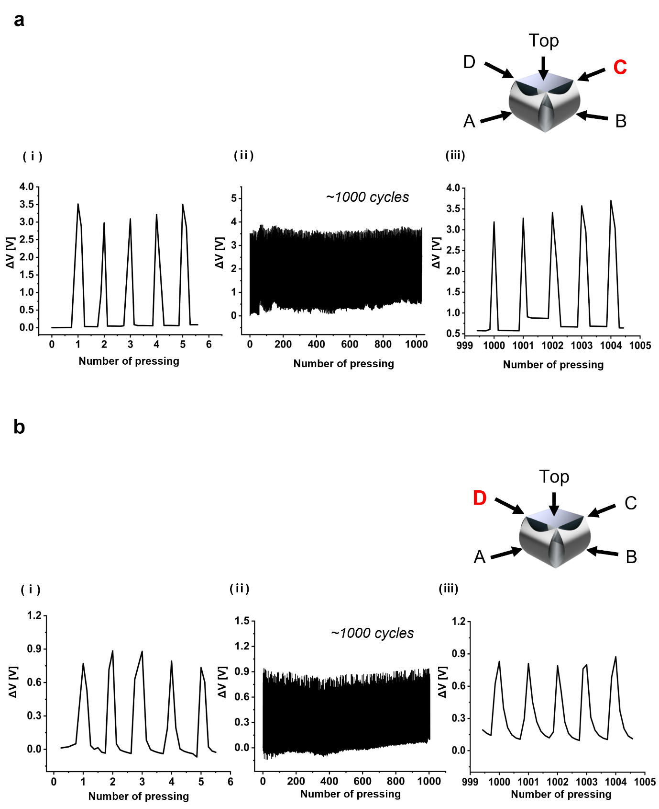
Figure S2. Cyclic test with pressing displacement 3 mm for over 1000 times. a) C side and b) D side and its response in (ⅰ) first five cycles, (ⅱ) overall responses, and (ⅲ) after 1000 cycles.

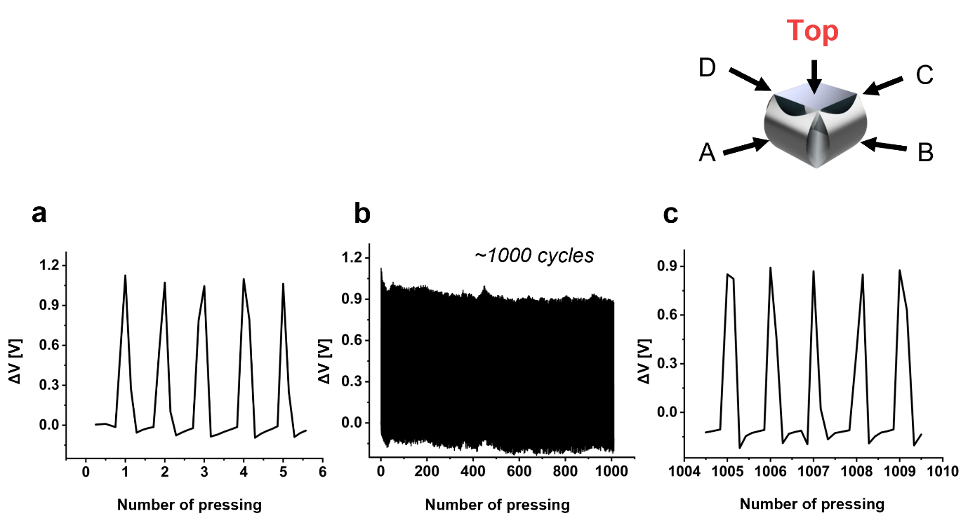
Figure S3. Cyclic test with pressing displacement 3 mm for over 1000 times. a) Top side and its response in (ⅰ) first five cycles, (ⅱ) overall responses, and (ⅲ) after 1000 cycles.

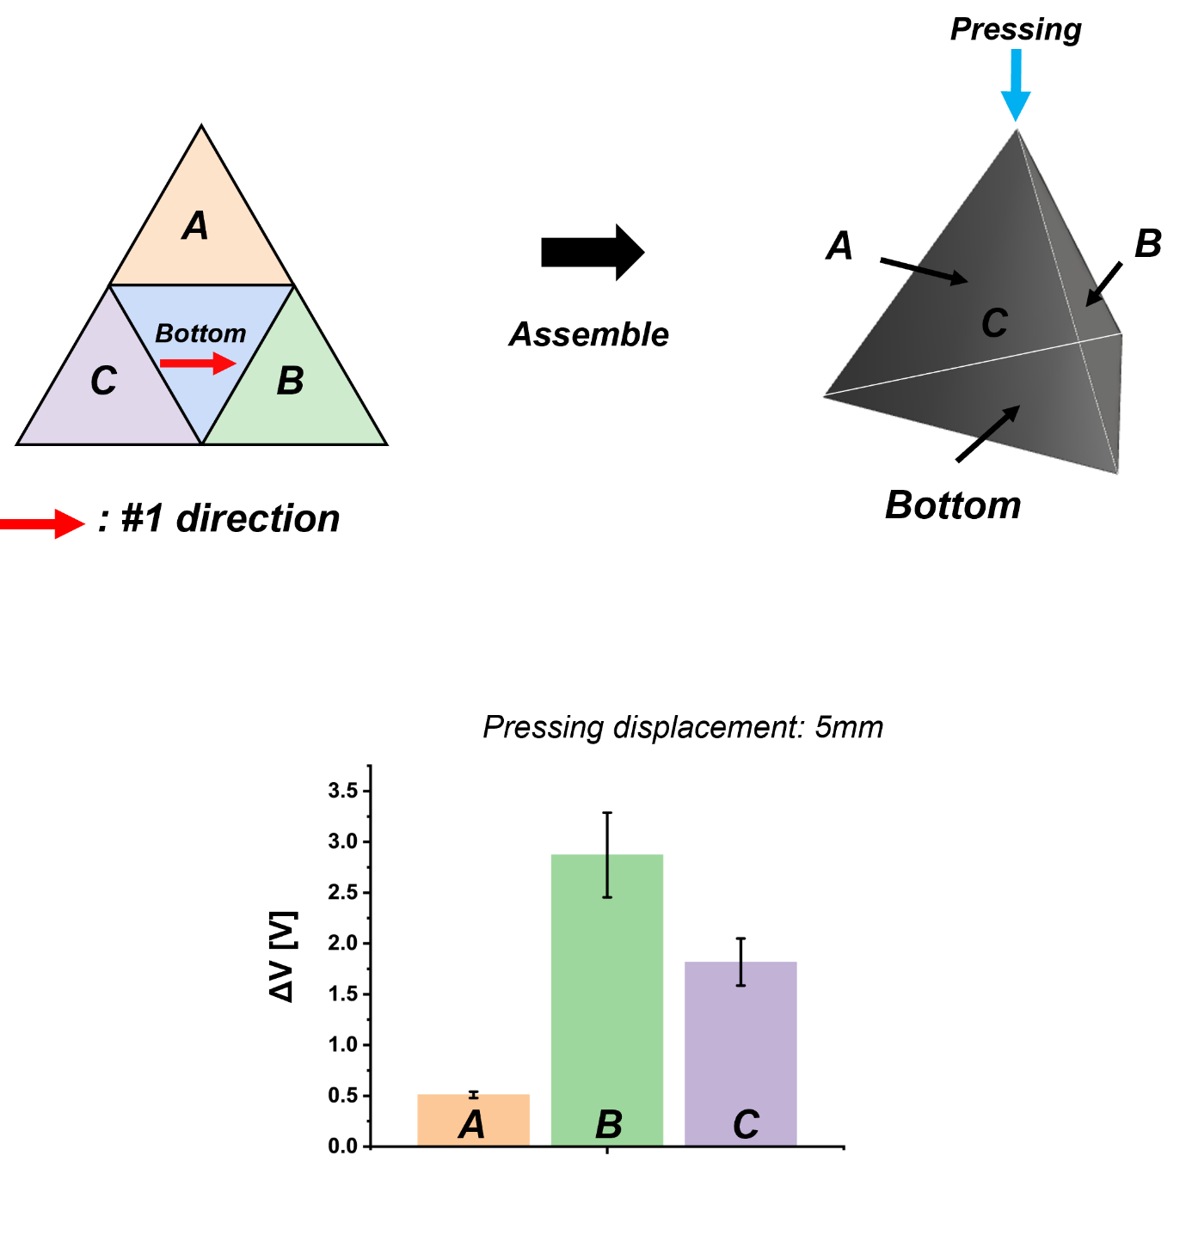
Figure S4. Schematic illustration of tetrahedron planar figure, its assembled feature, and its response

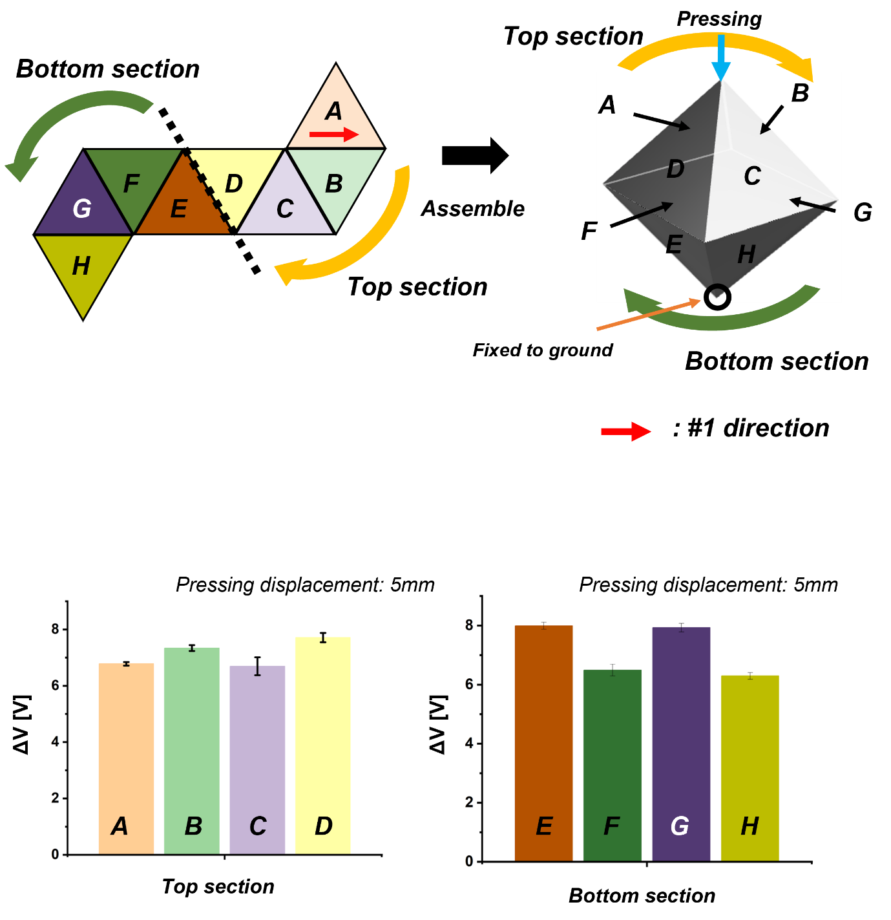
Figure S5. Schematic illustration of octahedron planar figure, its assembled feature, and its response

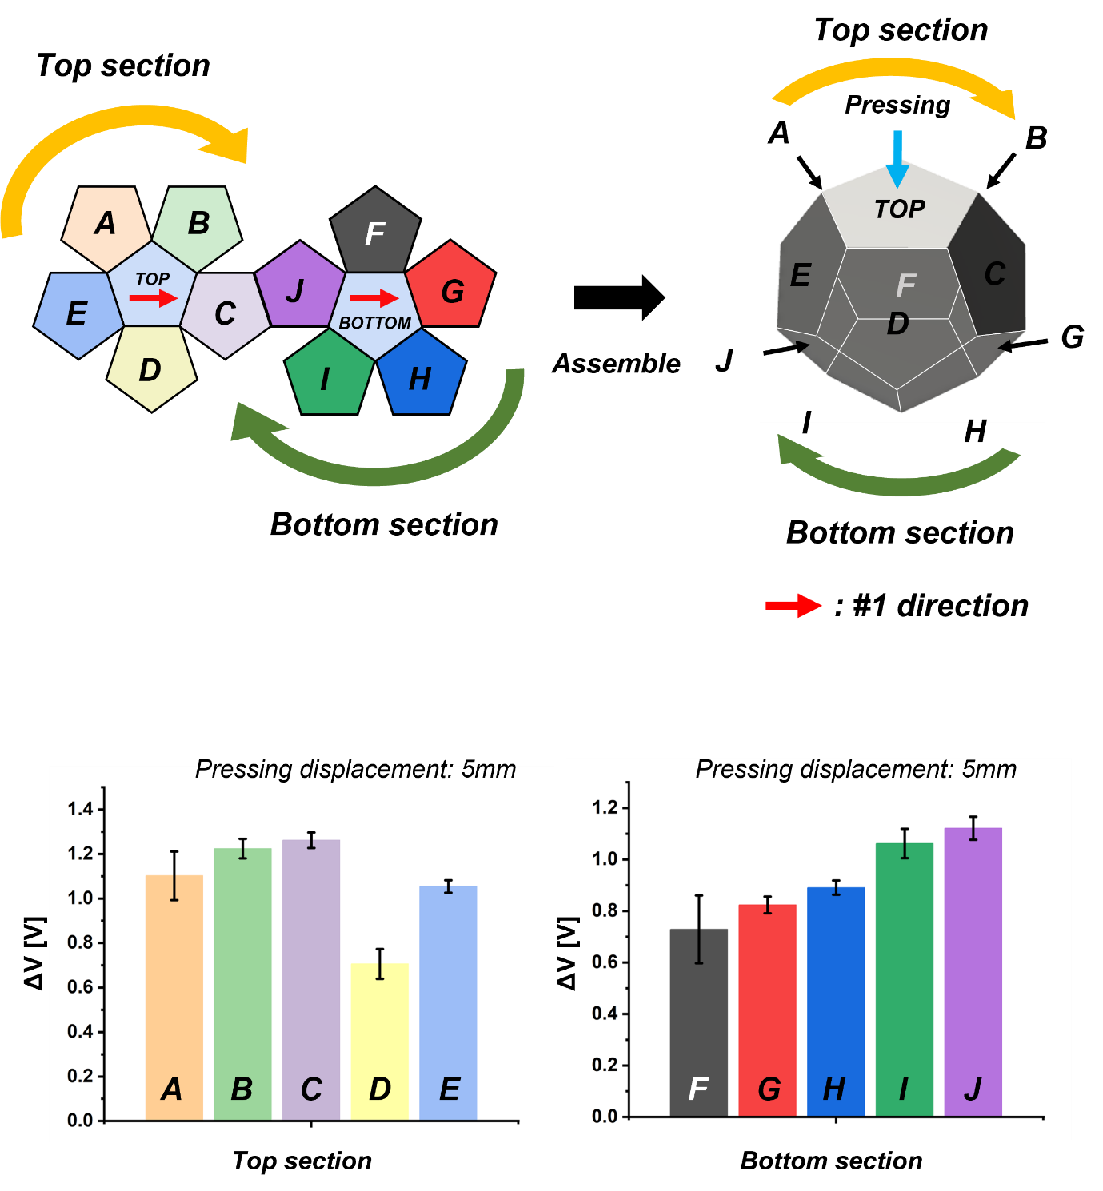
Figure S6. Schematic illustration of dodecahedron planar figure, its assembled feature, and its response

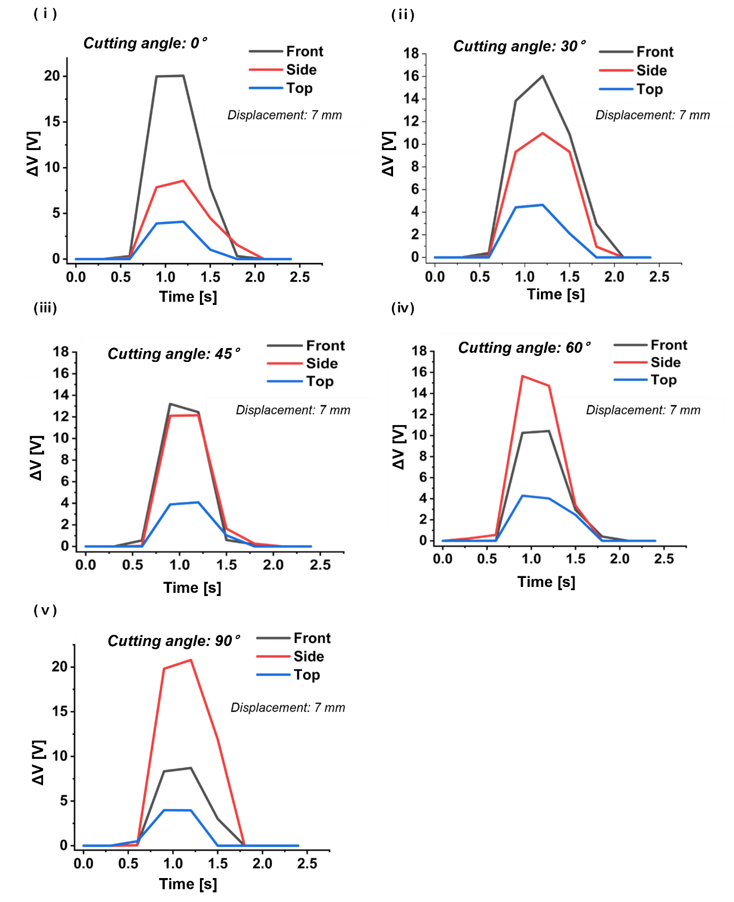
Figure S7. Voltage responses from the cube sides with angle variations. The front cube side with cutting angles of (ⅰ) 0°, (ⅱ) 30°, (ⅲ) 45°, (ⅳ) 60°, and (ⅴ) 90°

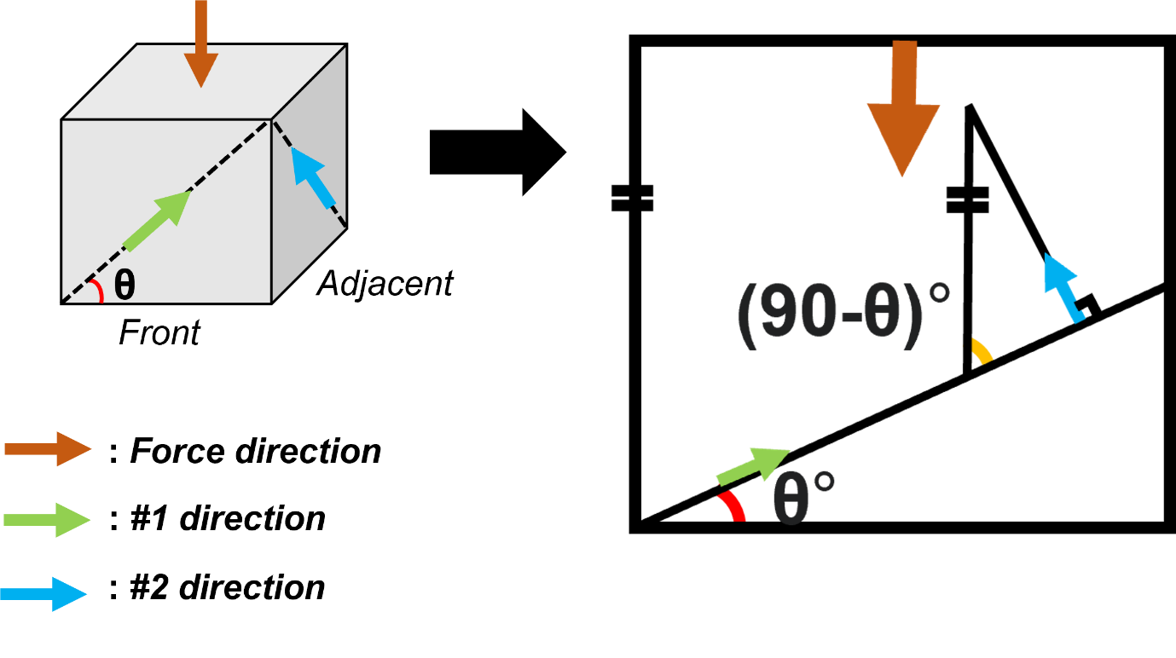
Figure S8. The geometry relation between two adjacent sides of the cube

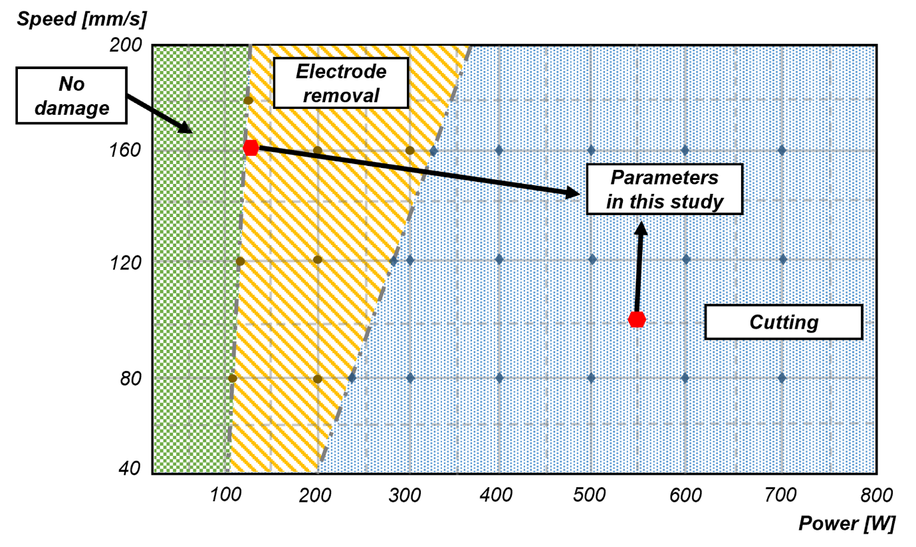
Figure S9. Laser cutting parameter table

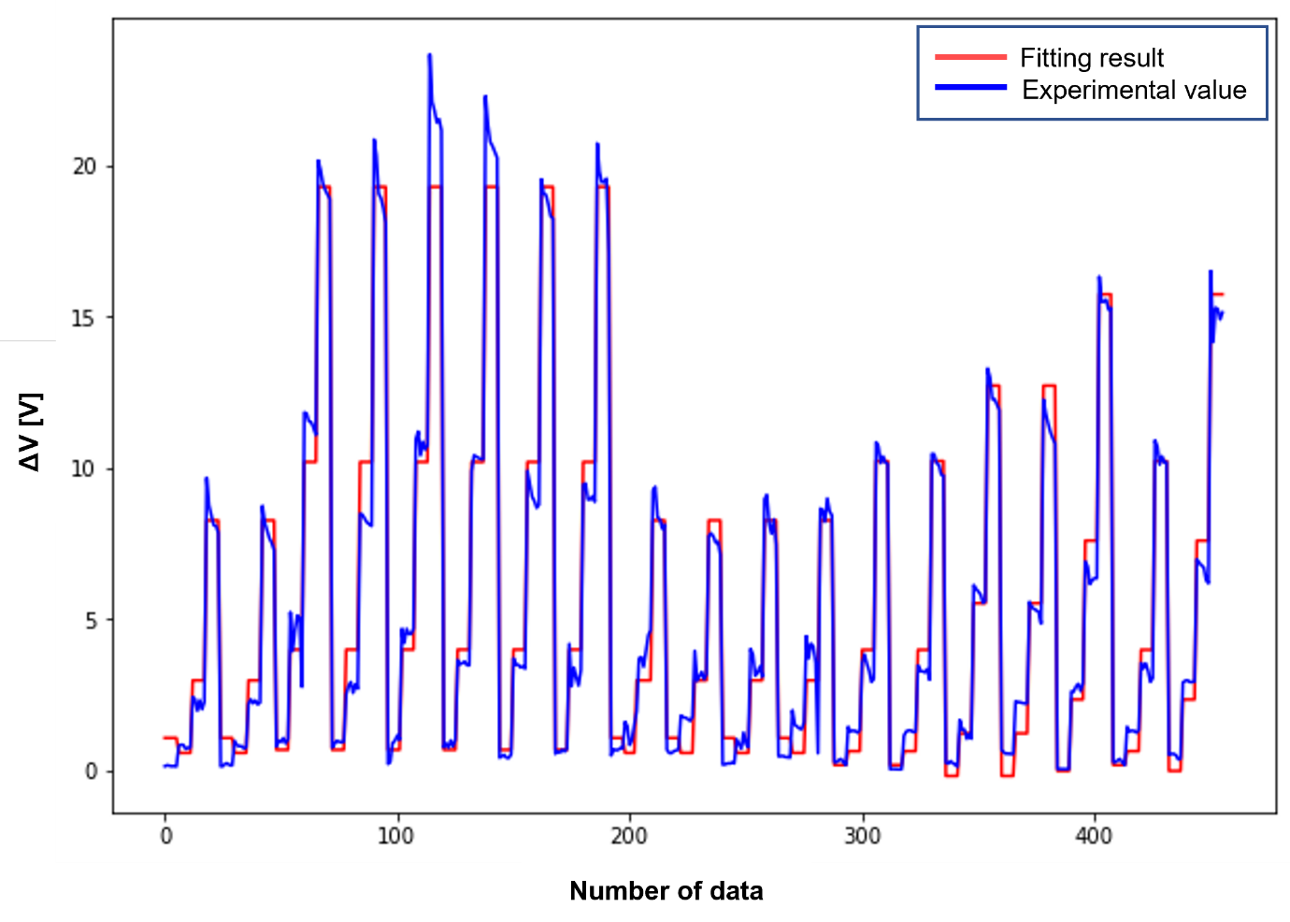
Figure S10. Fitting result
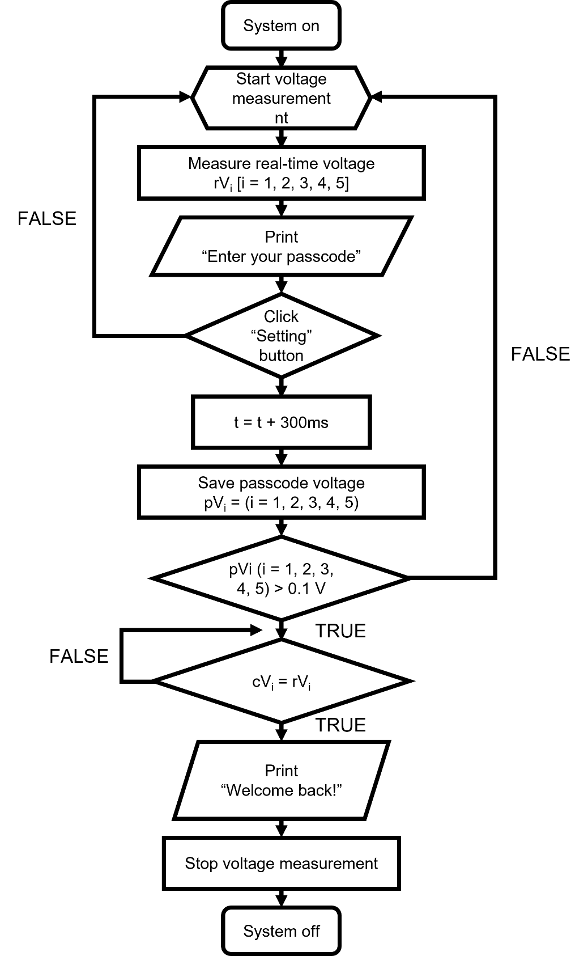
Figure S11. Working mechanism of the security system

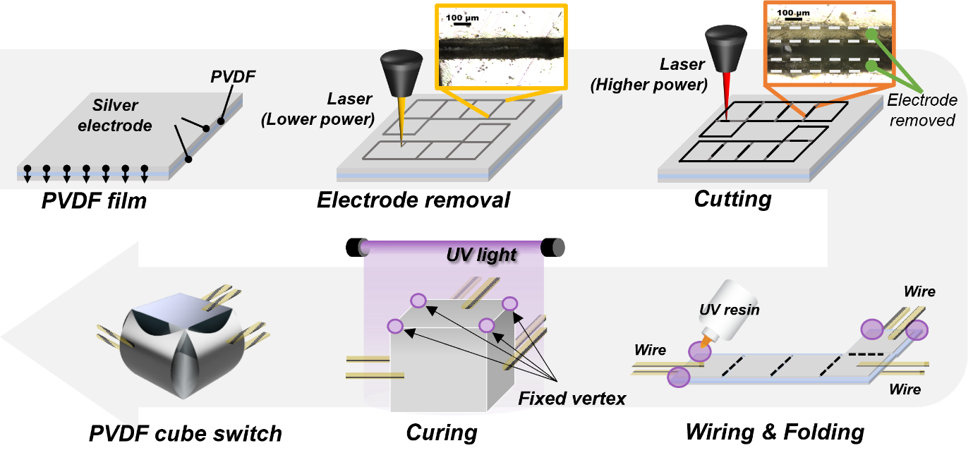
Figure S12. Fabrication process

