Adsorption and desorption of the flavonoids on activated carbon impregnated with different metal ions
Li Lu^{1&}, Shuang Cao^{1&}, Zhexuan Li¹, Jingdan Huang¹, Yukai Jiang¹, Changyong Deng¹, Ziwei Liu*
¹School of Chemical Engineering & Pharmacy, Wuhan Institute of Technology, Xiongchu Avenue, No. 693 Wuhan, China.
& These authors contributed equally to this work and should be considered co-first authors.
*Corresponding author:
Prof. Ziwei Liu, School of Chemical Engineering & Pharmacy, Wuhan Institute of Technology, Xiongchu Avenue, No. 693 Wuhan, China.
Morphological and structural characterization of AC
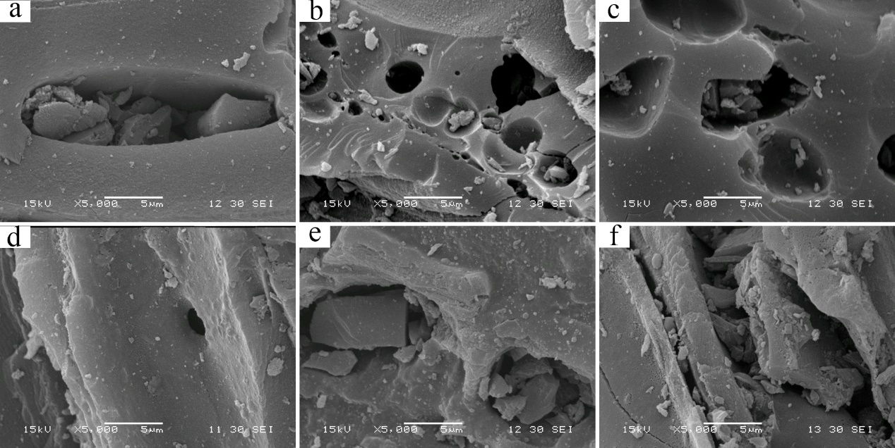
Figure S1 SEM images of modified and unmodified activated carbon ($×$5000). a. SEM image of Untreated blank activated carbon. b. SEM image of activated carbon calcined but not impregnated with metal ions. c-f. SEM images of activated carbon calcined and impregnated with Mg, Al, Fe, and Zn metal ions.

Particle size analysis of AC
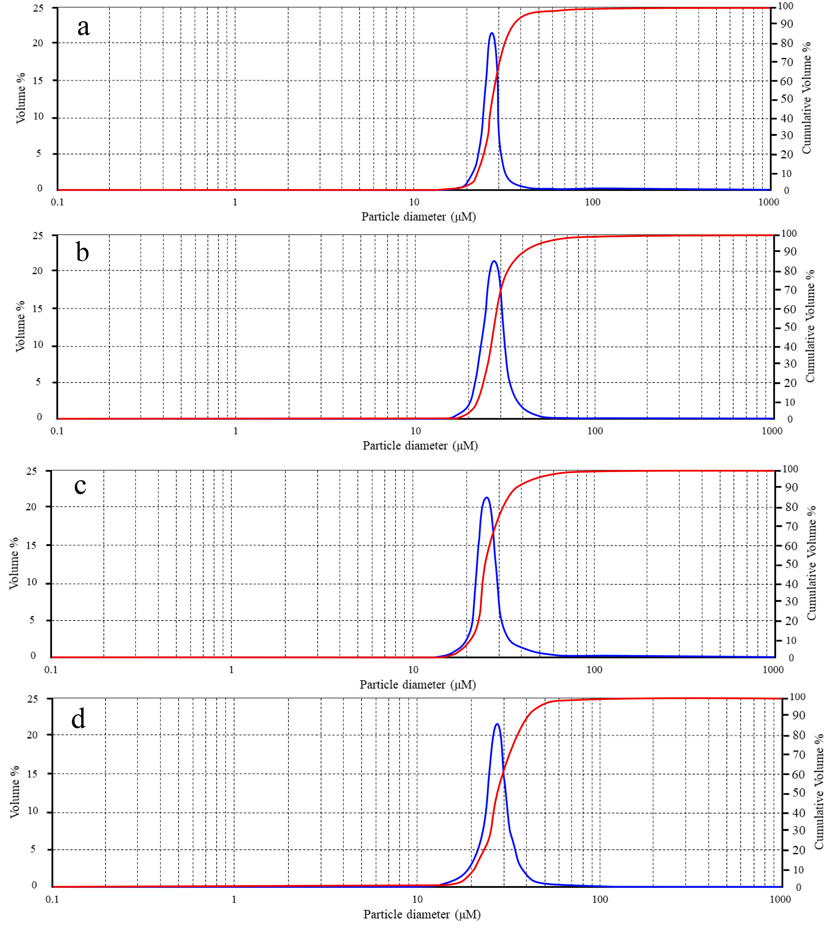
Figure S2 a, b, c, d. Particle size analysis of activated carbon calcined and impregnated with Mg Al Fe Zn ions.

Specific surface area and pore size distribution of AC
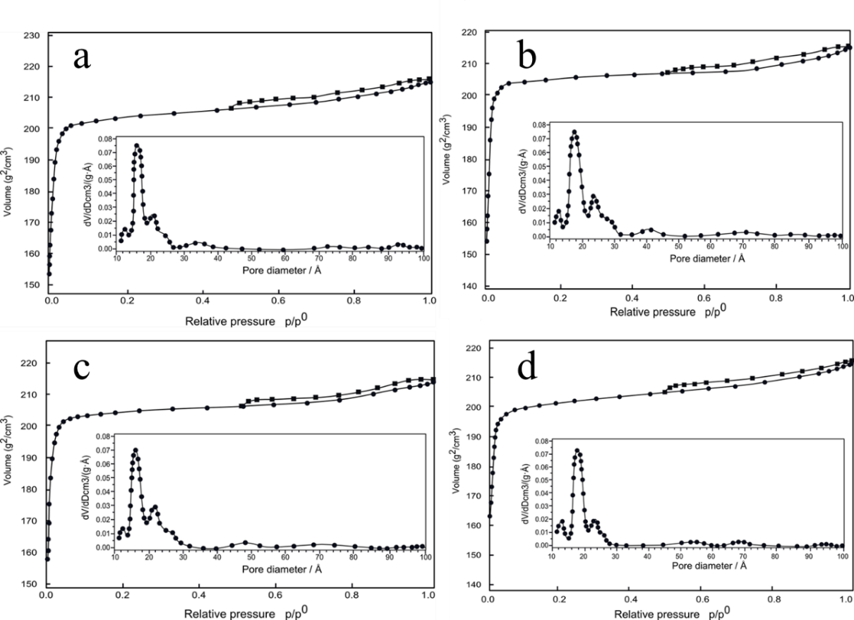
Figure S3 BET Analysis and Pore Size Distribution of four impregnated metal ions. a, b, c, d. BET Analysis and Pore Size Distribution of activated carbon calcined and impregnated with Mg Al Fe Zn ions.

