Supplementary Figures

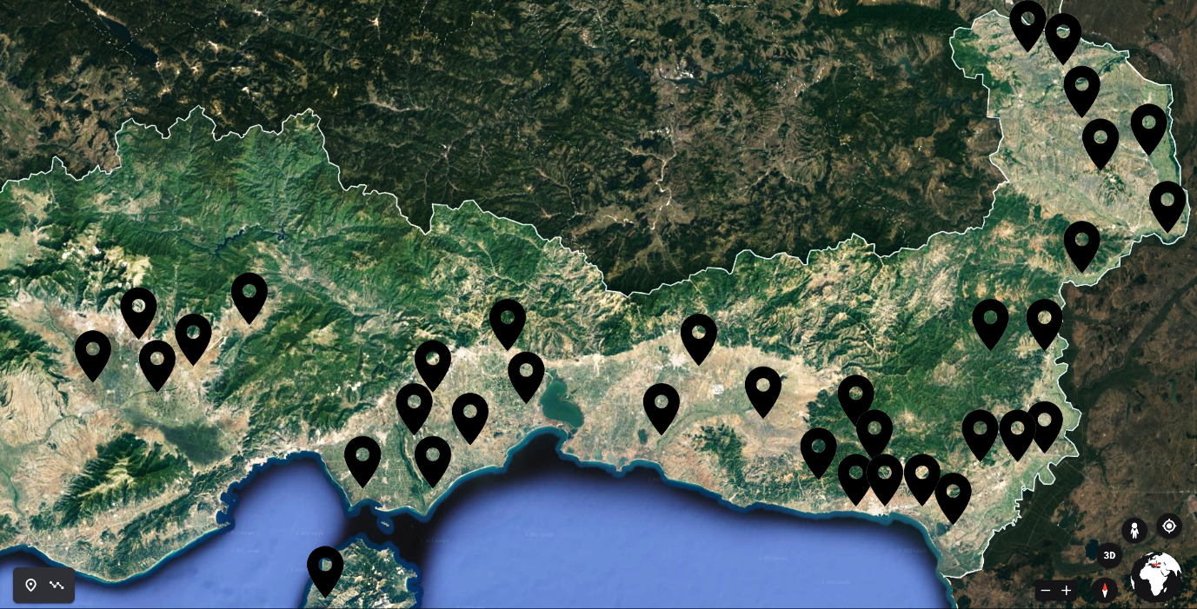
Supplementary Figure 1. Physical map of the collection sites in the Thrace region of Greece. The area is bordered to the north with Bulgaria and to the East with Turkey. Location black marks indicate the collection sites.

Supplementary Table 1. Mosquito pool composition from original trap specimens. Numbers refer to the number of individuals per mosquito species in a pool
Pool  Species | A | B | C | D | E
Aedes albopictus | 2 | 4 | 6 | 1 | 2
Aedes caspius | 20 | 30 | 2 | 10 | 41
Aedes detritus | 10 | 2 | 8 | 5 | 4
Aedes pulchritarsis | 5 | 1 | 3 | 2 | 1
Aedes rusticus | 0 | 0 | 0 | 1 | 1
Aedes vexans | 2 | 3 | 1 | 4 | 10
Anopheles algeriensis | 2 | 5 | 10 | 30 | 1
Anopheles pseudopictus | 8 | 5 | 13 | 10 | 0
Coquillettidia richardii | 10 | 5 | 2 | 1 | 3
Culex perexiguus | 0 | 0 | 0 | 1 | 1
Culex pipiens | 30 | 2 | 35 | 8 | 24
Culex theileri | 0 | 0 | 0 | 1 | 5
Culex modestus | 5 | 3 | 10 | 22 | 0
Culiseta annulata | 0 | 0 | 0 | 1 | 2
Culiseta longiareolata | 6 | 40 | 10 | 2 | 2
Uranotaenia unguiculata | 0 | 0 | 0 | 1 | 3

Supplementary Table 2. Viruses identified in the study with their NCBI GenBank accession number.

Virus | Accession number | Virus | Accession number
Evros Rhabdovirus 1 | MW520364  MW520365 | Culex perexiguus rhabdovirus | MW520390
Orestiada partiti-like virus | MW520366 | Culex phasma-like virus | MW520391  MW520393
Evros bunya-like virus | MW520367  MW520368 | Drama totivirus | MW520394
Abdera bunya-like virus | MW520369 | Makri bunya-like virus | MW520395
Ferres luteo sobemo-like virus | MW520370 | Thrace picorna-like virus 2 | MW520396
Evros rhabdovirus 2 | MW520371  MW520372 | Nea chili luteo-like virus | MW520397  MW520398
Thassos sobemo-like virus | MW520373  MW520374 | Soufli chryso-like virus | MW520399  MW520401  MW520403  MW520405
Xanthi totivirus | MW520375 | Xanthi chryso-like virus | MW520400  MW520402  MW520404  MW520406
Xanthi tymo-like virus | MW520376 | Alexandroupolis virga-like virus | MW520407  MW520408
Xanthi rhabdovirus | MW520377 | Xanthi narna-like virus | MW520409
Soufli partiti-like virus | MW520378  MW520379 | Xanthi partiti-like virus | MW520410 MW520411
Evros sobemo-like virus | MW520380  MW520381 | Dragana partiti-like virus | MW520412 MW520413
Pythion sobemo-like virus | MW520382  MW520383 | Evros chryso-like virus | MW520414
Didymoteicho chaq virus | MW520384 | Aedes detritus orthomyxo-like virus | MW520415 MW520418
Anopheles bunya-like virus | MW520385 | Culex modestus orthomyxo-like virus | MW520419 MW520422
Rhodopi bunya-like virus | MW520386 | Culex pipiens orthomyxo-like virus | MW520423  MW520428
Culex modestus totivirus | MW520387 | Thrace picorna-like virus 1 | MW520429
Culex impudicus luteo-like virus | MW520388  MW520389

