Supplemental Appendix to:

Compare three diagnostic criteria of progressive fibrosing interstitial lung disease.

Chen et al.

Table E1. Baseline characteristics of total cohort.

Table E2. Baseline characteristics of patients with and without 6-month follow-up.

Table E3. Baseline characteristics of patients with and without 12-month follow-up.

Table E4. Baseline characteristics of patients with and without 24-month follow-up.

Figure S1. The typical images of HRCT assessment.

Figure S2. Compare survival rate of CTD with non-CTD patients.

Table E1. Baseline characteristics of total cohort.
Variable | Value
Total sample size | 2476
- CTD-ILD | 1241 (50%)
- Unclassifiable ILD | 597 (24%)
- HP | 235 (9%)
- Other ILD | 403 (16%)
Age, years | 60 ± 14
Male sex | 1019 (41%)
Ever-smoker | 1388 (56%)
Smoking pack-years (IQR) | 18 (7-34)
FVC, %-predicted | 75 ± 20
DLCO, %-predicted | 60 ± 20
6MWD, meters | 420 ± 127
UCSD total score | 38 ± 28

Abbreviations: 6MWD, 6-minute walk distance; CTD-ILD, connective tissue disease-associated ILD; DLCO, diffusing capacity of the lung for carbon monoxide; FVC, forced vital capacity; HP, hypersensitivity pneumonitis; ILD, interstitial lung disease; IPF, idiopathic pulmonary fibrosis; IQR, interquartile range; SD, standard deviation; UCSD, University of California, San Diego Shortness of Breath Questionnaire.

Table E2. Baseline characteristics of patients with and without 6-month follow-up.

Variable | Patients with 6-month data available |  | Patients without 6-month data available
Total patients | 924 |  | 2407
Age, years | 61 ± 12 |  | 63 ± 13
Male sex | 465 (50.3%) |  | 1182 (49.1%)
Ever-smoker | 577 (62.4%) |  | 1463 (60.8%)
Smoking pack-years | 20 (7-35) |  | 21 (8-37)
FVC, %-predicted | 73 ± 19 |  | 76 ± 20
DLCO, %-predicted | 56 ± 18 |  | 59 ± 21
6MWD, meters | 423 ± 130 |  | 413 ± 126
UCSD SOBQ total score | 38 ± 27 |  | 36 ± 28

Data shown are number (%), mean ± standard deviation, or median (interquartile range).

Abbreviations: 6MWD, 6-minute walk distance; DLCO, diffusing capacity of the lung for carbon monoxide; UCSD-SOBQ, University of California, San Diego Shortness of Breath Questionnaire.

Table E3. Baseline characteristics of patients with and without 12-month follow-up.

Variable | Patients with 12-month data available |  | Patients without 12-month data available
Total patients | 1527 |  | 1804
Age, years | 61 ± 13 |  | 63 ± 14
Male sex | 755 (49.4%) |  | 892 (49.4%)
Ever-smoker | 941 (61.6%) |  | 1099 (60.9%)
Smoking pack-years | 20 (7-35) |  | 21 (8-38)
FVC, %-predicted | 75 ± 19 |  | 76 ± 21
DLCO, %-predicted | 58 ± 20 |  | 57 ± 21
6MWD, meters | 429 ± 124 |  | 400 ± 130
UCSD SOBQ total score | 35 ± 26 |  | 38 ± 28

Data shown are number (%), mean ± standard deviation, or median (interquartile range).

Abbreviations: 6MWD, 6-minute walk distance; DLCO, diffusing capacity of the lung for carbon monoxide; UCSD-SOBQ, University of California, San Diego Shortness of Breath Questionnaire.

Table E4. Baseline characteristics of patients with and without 24-month follow-up.

Variable | Patients with 24-month data available |  | Patients without 24-month data available
Total patients | 1752 |  | 1579
Age, years | 61 ± 13 |  | 63 ± 14
Male sex | 855 (48.8%) |  | 792 (50.2%)
Ever-smoker | 1064 (60.7%) |  | 976 (61.8%)
Smoking pack-years | 20 (8-35) |  | 21 (8-38)
FVC, %-predicted | 75 ± 19 |  | 76 ± 21
DLCO, %-predicted | 59 ± 20 |  | 57 ± 21
6MWD, meters | 430 ± 125 |  | 394 ± 130
UCSD SOBQ total score | 34 ± 26 |  | 39 ± 28

Data shown are number (%), mean ± standard deviation, or median (interquartile range).

Abbreviations: 6MWD, 6-minute walk distance; DLCO, diffusing capacity of the lung for carbon monoxide; UCSD-SOBQ, University of California, San Diego Shortness of Breath Questionnaire.

FigureS1. The typical images of HRCT assessment.
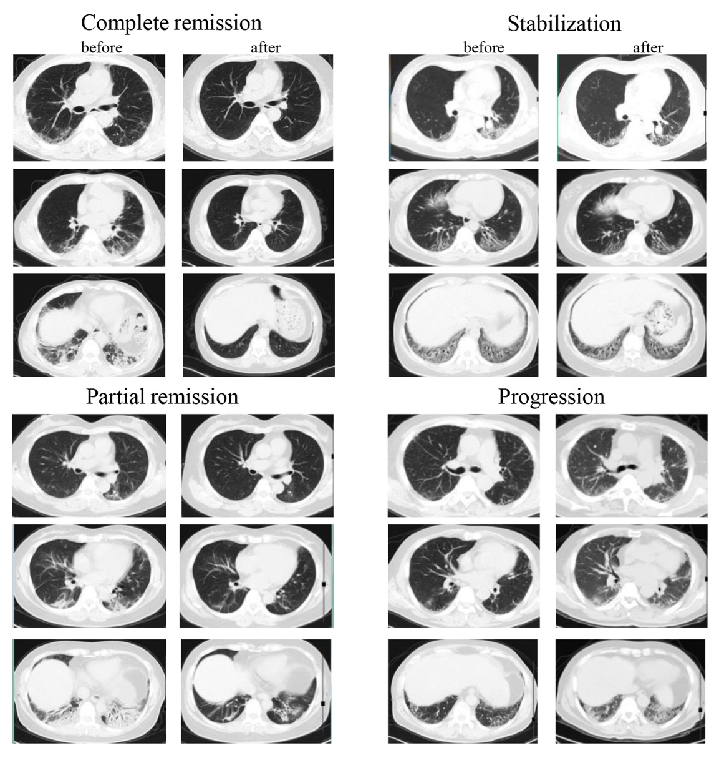

Figure S2. Compare survival rate of CTD with non-CTD patients.

Abbreviations: CTD-ILD, connective tissue disease-associated ILD.

